北京航空航天大学 2013－2014 学年 第一学期 《计算机组成与体系结构》期末考试

Class number班级__________ Student ID学号 ___________

Student Name姓名______________ Score成绩 ____________

答题页1 （答案全部填写在答题页中，其它地方无效）

Problem 1.（20 points）

1____ 2____ 3____ 4____ 5____ 6____ 7____ 8____ 9____ 10_____ 11_____ 12_____ 13_____ 14_____ 15_____ 16_____ 17_____ 18_____ 19_____

|  |  |  |
| --- | --- | --- |
| Function | Intel IA32 | Intel x86 64 |
| sizeof (char) |  |  |
| sizeof (int) |  |  |
| sizeof (void*) |  |  |
| sizeof (long) |  |  |

20

Problem 2.（10 points）

|  |  |  |
| --- | --- | --- |
| Value | Floating Point Bits | Rounded value |
| 9/32 | 001 00 | 1/4 |
| 1 |  |  |
| 12 |  |  |
| 11 |  |  |
| 1/8 |  |  |
| 7/32 |  |  |

Problem 3.（8 points）

|  |  |
| --- | --- |
| Code Block | Function Name |
| A |  |
| B |  |
| C |  |
| D |  |

Problem 4.（11 points）

Cases ____________________ should have "break".

0x400590: ________________ 0x400598: ________________

0x4005a0: ________________ 0x4005a8: ________________

0x4005b0: ________________ 0x4005b8: ________________

0x4005c0: ________________ 0x4005c8: ________________

0x4005d0: ________________ 0x4005d8: ________________

Problem 5.（12 points）

A: x = ______

B: string "0123456" is stored at ___________

C: buf[0] = 0x_____ _____ _____ _____

buf[1] = 0x_____ _____ _____ _____

buf[2] = 0x_____ _____ _____ _____

buf[3] = 0x_____ _____ _____ _____

buf[4] = 0x_____ _____ _____ _____

答题页2

D: Value at %ebp is ___________

E: Value at %esp is ___________

F:

Problem 6.（9 points）

Answer: a=_____, b=_____, c=_____

Problem 7.（10 points）

(a). Cache size is _____ bytes

(b). Tag is _____ bits

(c).

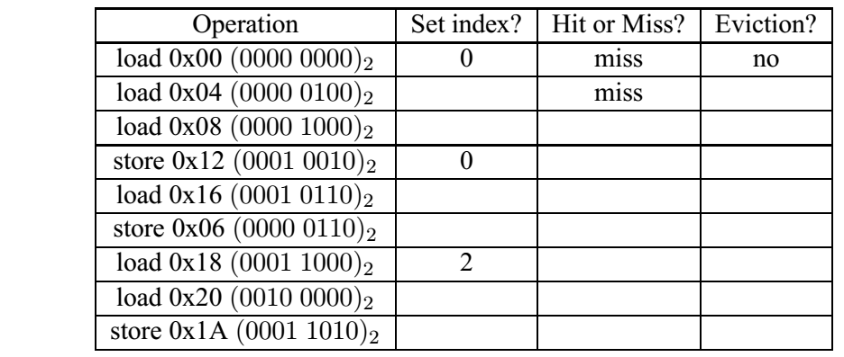

Problem 8.（10 points）

1. ____________________
2. ____________________
3. ____________________

Problem 9.（10 points）

1. a. Physical address of PDE: ___________

b. Physical address of PTE: ___________

c. Success: The physical address accessed is ___________

or

Failure: Address of table entry causing failure is ___________

2. a. Physical address of PDE: ___________

b. Physical address of PTE: ___________

c. Success: The physical address accessed is ___________

or

Failure: Address of table entry causing failure is ___________

### Problem 1.

1. Consider the following code, what is the output of the printf? 下面代码的输出是什么？

int x = 0x15213F10 >> 4;

char y = (char) x;

unsigned char z = (unsigned char) x;

printf("%d, %u", y, z);

(a) -241, 15

(b) -15, 241

(c) -241, 241

(d) -15, 15

2. In two’s compliment, what is −TMin? 补码中，−TMin的值是多少？

(a) TMin

(b) TMax

(c) 0

(d) −1

3. Let int x = −31/8 and int y = −31 >> 3. What are the values of x and y?

(a) x = −3, y = −3

(b) x = −4, y = −4

(c) x = −3, y = −4

(d) x = −4, y = −3

4. In C, the expression ”15213U > −1” evaluates to:

(a) True (1)

(b) False (0)

5. In two’s compliment, what is the minimum number of bits needed to represent the number -1 and the number 1 respectively? 补码中，表示数字 -1和1需要的最小位数分别是多少？

(a) 1 and 2

(b) 2 and 2

(c) 2 and 1

(d) 1 and 1

6. Consider the following program. Assuming the user correctly types an integer into stdin, what will the program output in the end? 假设用户正确输入了一个整数，下面代码的输出是什么？

#include <stdio.h>

int main() {

int x = 0;

printf ("Please input an integer:");

scanf ("%d",x);

printf ("%d", (!!x)<<31);

}

(a) 0

(b) T Min

(c) Depends on the integer read from stdin 取决于用户输入的整数

(d) Segmentation fault 段错误

7. Which of the following registers stores the return value of functions in Intel x86 64?

Intel x86 64系统中哪个寄存器保存函数的返回值？

(a) %rax

(b) %rcx

(c) %rdx

(d) %rip

(e) %cr3

8. The leave instruction is effectively the same as which of the following: Leave指令相当于：

(a) mov %ebp, %esp

pop %ebp

(b) pop %eip

(c) mov %esp, %ebp

pop %esp

(d) ret

9. Select the two’s complement negation of the following binary value: 0000101101:

二进制数0000101101负值的补码是：

(a) 1111010011

(b) 1111010010

(c) 1000101101

(d) 1111011011

10. Which line of C-code will perform the same operation as leal 0x10(%rax,%rcx,4),%rax?

下面哪行c代码和 leal 0x10(%rax,%rcx,4),%rax 操作相同？

(a) rax = 16 + rax + 4 * rcx

(b) rax = *(16 + rax + 4 * rcx)

(c) rax = 16 + * (rax + 4 * rcx)

(d) *(16 + rcx + 4 * rax) = rax

(e) rax = 16 + 4 * rax + rcx

11. Which of the following assembly instructions is invalid in Intel IA32 Assembly?

IA32系统中，下面哪条汇编指令是非法的？

(a) pop %eip

(b) pop %ebp

(c) mov (%esp),%ebp

(d) lea 0x10(%esp),%ebp

12. For the Unix linker, which of the following accurately describes the difference between global symbols and local symbols?

对UNIX链接器，下面哪个说法准确描述了全局符号和本地符号的差异？

1. There is no functional difference as to how they can be used or how they are declared.

它们的使用和声明没有功能上的区别。

1. Global symbols can be referenced by other modules (files), but local symbols can only be referenced by the module that defines them.

全局符号可以被其它模块引用，而本地符号只能被定义它们的模块引用。

1. Global symbols refer to variables that are stored in .data or .bss, while local symbols refer to variables that are stored on the stack.

全局符号指的是保存在.data或.bss中的变量，而本地符号指的是保存在栈里的变量。

1. Both global and local symbols can be accessed from external modules, but local symbols are declared with the “static” keyword.

全局符号和本地符号都可以被外部模块访问，但本地符号用“static”关键字声明。

1. Which of the following is true concerning dynamic memory allocation?

关于动态存储器分配，下列哪项是正确的？

1. External fragmentation is caused by chunks which are marked as allocated but actually cannot being used.

外部碎片是由标记为已分配但实际上不能被使用的片引起的。

1. Internal fragmentation is caused by padding for alignment purposes and by overhead to maintain the heap data structure (such as headers and footers).

内部碎片是由为了对齐目的的填充和保持堆数据结构（如头部和脚部）的开销引起的。

1. Coalescing while traversing the list during calls to malloc is known as immediate coalescing.

调用malloc过程中遍历链表时的合并是立即合并。

1. Garbage collection, employed by calloc, refers to the practice of zeroing memory before use.

calloc采用的垃圾收集是指存储器使用前归零。

For the next 3 questions, consider the following code running on a 32-bit Linux system.

下面3个问题，考虑运行在32位linux系统上的代码

int main()

{

long a, *b, c;

char **p;

p = calloc(8, sizeof(char)); /*calloc returns 0x1dce1000*/

a = (long) (p + 0x100);

b = (long*) (*p + 0x200);

c = (int) (b + 0x300);

printf("p=%p a=%x b=%p c=%x\n", p, a, b, c);

exit(0);

}

14. When printf is called, what is the hex value of variable a? printf被调用时，变量a的值是？

(a) Can’t tell

(b) 0x1dce1100

(c) 0x1dce1400

(d) 0x1dce1800

15. When printf is called, what is the hex value of variable b? printf被调用时，变量b的值是？

(a) Can’t tell

(b) 0x1dce1200

(c) 0x1dce2000

(d) 0x200

(e) 0x800

16. When printf is called, what is the hex value of variable c? printf被调用时，变量c的值是？

(a) Can’t tell

(b) 0x1dce2a00

(c) 0x1dce4400

(d) 0xc00

(e) 0xe00

17. Which of the following is not a default action for any signal type?

下面哪项不是对某个信号类型的默认行为？

(a) The process terminates. 进程终止。

(b) The process reaps the zombies in the waitlist. 进程回收等待列表中的僵死进程。

(c) The process stops until restarted by a SIGCONT signal.

进程停止直到被SIGCONT信号重启。

(d) The process ignores the signal. 进程忽略信号。

(e) The process terminates and dumps core. 进程终止并转储存储器。

18. A system uses a two-way set-associative cache with 16 sets and 64-byte blocks. Which set does the byte with the address 0xdeadbeef map to?

一个系统使用2路组相联高速缓存，有16组和64字节的块。地址0xdeadbeef映射到哪组？

(a) Set 7

(b) Set 11

(c) Set 13

(d) Set 14

19. When it suceeds, longjmp is called once and returns how many times?

调用成功时，longjmp被调用一次，返回多少次？

(a) 0

(b) 1

(c) 2

(d) 3

20. Please fill in the return value for the following function calls on both an Intel IA32 and Intel x86 64 system.

在答题页1的表中填写函数调用在Intel IA32和Intel x86 64系统中的返回值。

### Problem 2.

Consider the following 5-bit floating point representation based on the IEEE floating point format. This format does not have a sign bit – it can only represent nonnegative numbers.

考虑下面基于IEEE浮点格式的5位浮点表示，没有符号位，只能表示非负数。

• There are k = 3 exponent bits. The exponent bias is 3.

有k = 3个阶码位，偏置值是3

• There are n = 2 fraction bits.

有n = 2个小数位

Below, you are given some decimal values, and your task is to encode them in floating point format. In addition, you should give the rounded value of the encoded floating point number. To get credit, you must give these as whole numbers (e.g., 17) or as fractions in reduced form (e.g., 3/4). Any rounding of the significand is based on *round-to-even*.

下面给出了一些十进制数值，你的任务是将它们编码为浮点格式。另外，给出被编码的浮点数舍入后的值。给出整数（例如17）或者分数（例如3/4）。使用舍入到偶数的原则。

|  |  |  |
| --- | --- | --- |
| Value | Floating Point Bits | Rounded value |
| 9/32 | 001 00 | 1/4 |
| 1 |  |  |
| 12 |  |  |
| 11 |  |  |
| 1/8 |  |  |
| 7/32 |  |  |

### Problem 3.

Consider the following data structure declaration:

struct ms_pacman{

short wire;

int resistor;

union transistor{

char bjt;

int *mosfet;

long vacuum_tube[2];

} transistor;

struct ms_pacman *connector;

};

Below are given four C functions and four x86-64 code blocks.

下面给出4个c函数和4段x86-64代码。

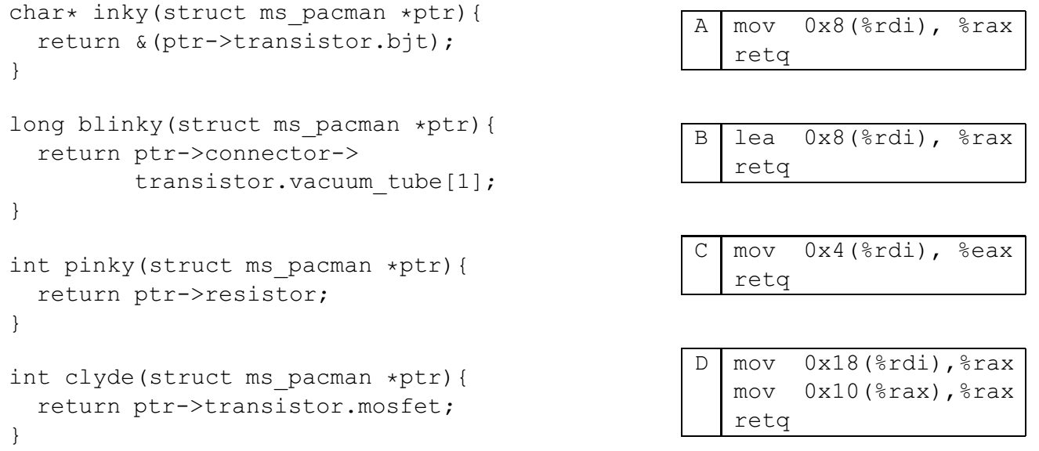

In the following table, next to the name of each x86-64 code block, write the name of the C function that it implements.

下表中，在x86-64代码块名字的右边写出对应c函数名。

|  |  |
| --- | --- |
| Code Block | Function Name |
| A |  |
| B |  |
| C |  |
| D |  |

### Problem 4.

Consider the following C code and assembly code:

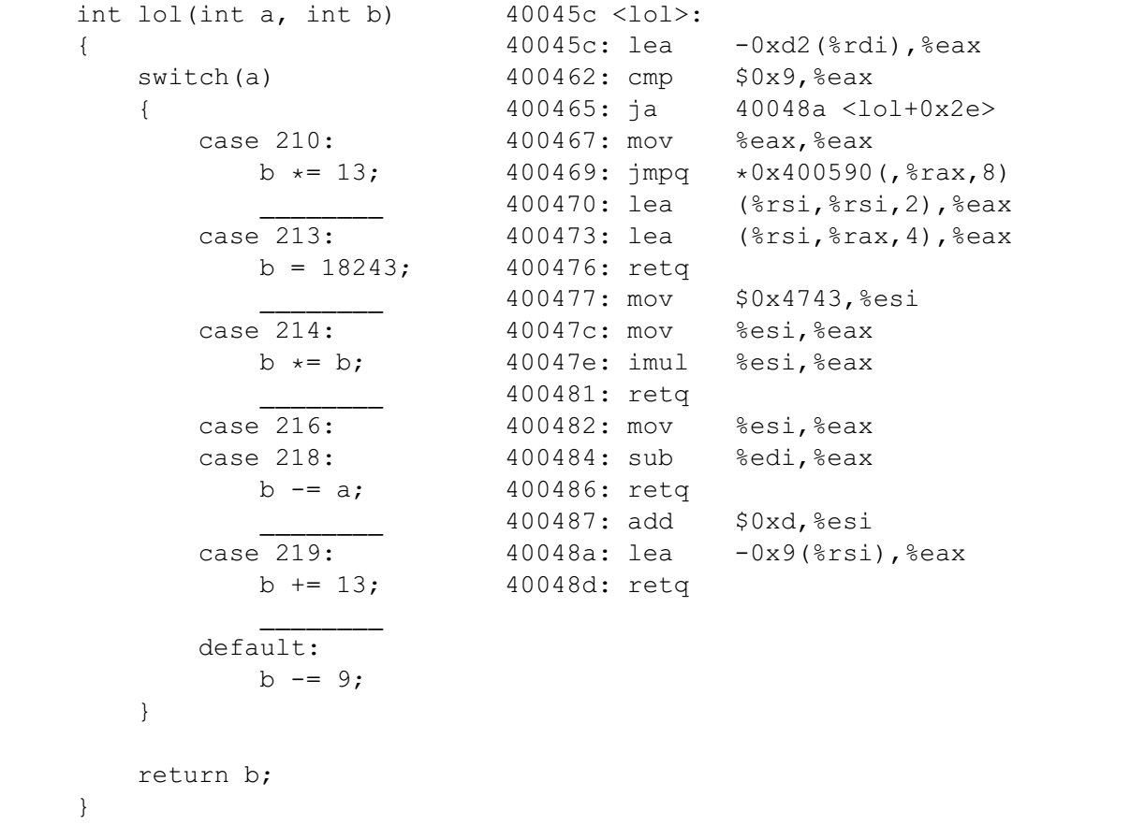

Using the available information, fill in the jump table below. (Feel free to omit leading zeros.) Also, for each case in the switch block which should have a break, write break on the corresponding blank line.

使用可获得的信息，填写下面的跳转表。（可以省略前导零。）在c代码中添加应有的break。

Hint提示: 0xd2 = 210 and 0x4743 = 18243.

0x400590: ________________ 0x400598: ________________

0x4005a0: ________________ 0x4005a8: ________________

0x4005b0: ________________ 0x4005b8: ________________

0x4005c0: ________________ 0x4005c8: ________________

0x4005d0: ________________ 0x4005d8: ________________

### Problem 5.

This problem concerns the following C code, compiled on a 32-bit machine:

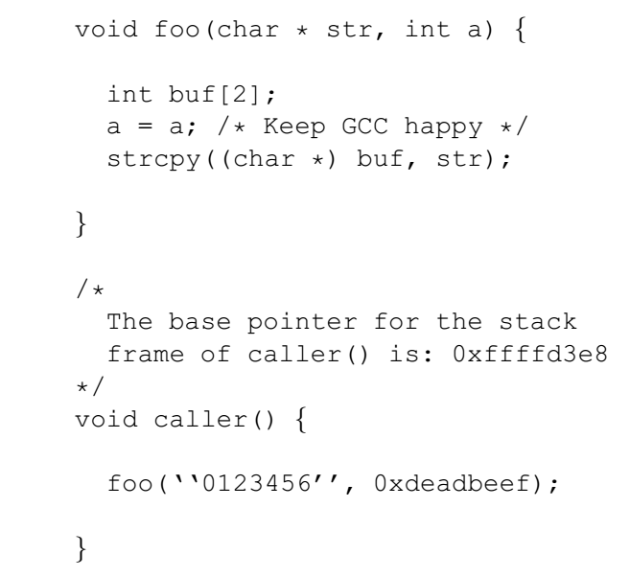

Here is the corresponding machine code on a 32-bit Linux/x86 machine:

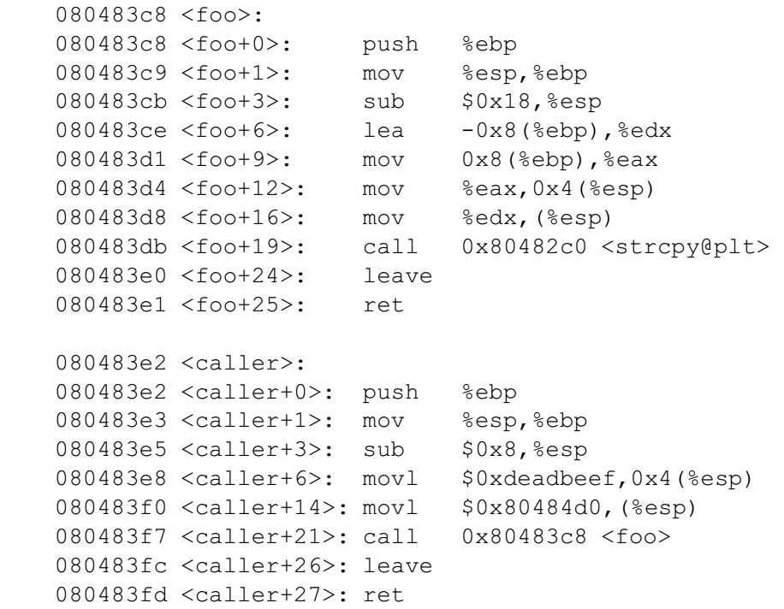

Here are some notes to help you work the problem:

• strcpy(char *dst, char *src) copies the string at address src (including the terminating ‘\0’ character) to address dst.

• Keep endianness in mind.

• You will need to know the hex values of the following characters:

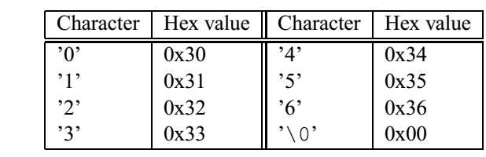

Now consider what happens on a Linux/x86 machine when caller calls foo.

1. Just before foo calls strcpy, what integer x, if any, can you guarantee that buf[x] == a ?

foo调用strcpy之前，使得buf[x] == a的整数x值为多少？

1. At what memory address is the string “0123456” stored (before it is strcpy’d)?

在被strcpy拷贝之前，字符串“0123456”保存在哪个地址处？

1. Just after strcpy returns to foo, fill in the following with hex values:

strcpy返回到foo之后，在答题页中填写各地址处的十六进制值。

1. Immediately before the call to strcpy, what is the the value at %ebp (not what is %ebp)?

strcpy调用前，%ebp处的值是？

1. Immediately before foo’s ret call, what is the value at %esp (what’s on the top of the stack)?

foo中ret指令调用前，%esp处的值是？

1. Will a function that calls caller() segfault or notice any stack corruption? Explain.

调用caller()的函数会段错误或栈损坏吗？请解释。

### Problem 6.

Consider the executable object file a.out, which is compiled and linked using the command

unix> gcc -o a.out main.c foo.c

and where the files main.c and foo.c consist of the following code:

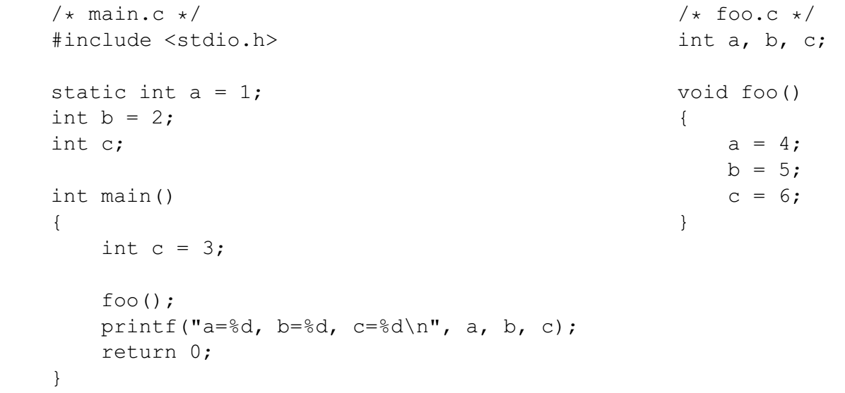

What is the output of a.out?

### Problem 7.

Make the following assumptions: 假设

• There is only one level of cache 只有一级高速缓存

• Physical addresses are 8 bits long (m = 8) 物理地址为8位

• The block size is 4 bytes (B = 4) 块大小为4字节

• The cache has 4 sets (S = 4) 高速缓存有4组

• The cache is direct mapped (E = 1) 高速缓存为直接映射

1. What is the total capacity of the cache? (in number of data bytes)

高速缓存总容量是多少字节？

1. How long is a tag? (in number of bits)

标记有几位？

1. Assuming that the cache starts clean (all lines invalid), please fill in the following tables, describing what happens with each operation.

假设高速缓存开始是空的，填表描述每个操作发生了什么。

### Problem 8.

Consider the following three different snippets of C code. Assume that an arbitrary number of SIGINT signals, and only SIGINT signals, can be sent to the code snippets randomly from some external source.

考虑下面3段C代码，假设任意数量的SIGINT信号，并且只有SIGINT信号，可以从某个外部源随机发送到代码段。

What are the values of i that could possibly be printed by the printf command at the end of each program?

各段代码打印的i值可能有哪些？

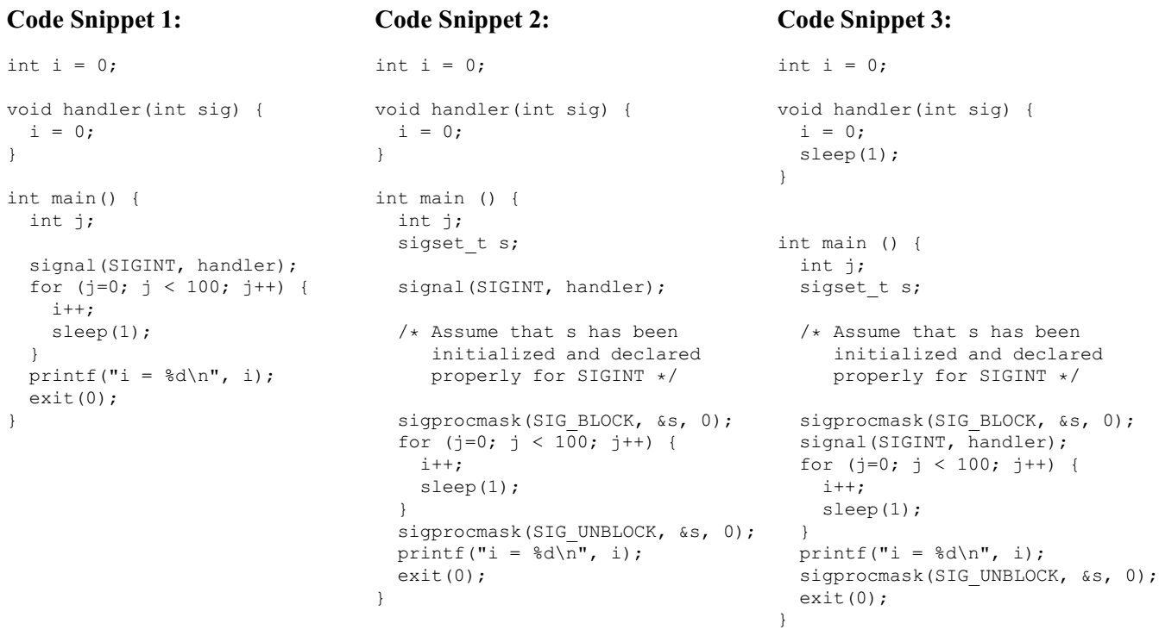

### Problem 9.

This problem deals with virtual memory address translation using a multi-level page table, in particular the 2-level page table for a 32-bit Intel system with 4 KByte pages tables.

这道题涉及多级页表的虚拟地址翻译，使用32位Intel系统，4 KB页表。

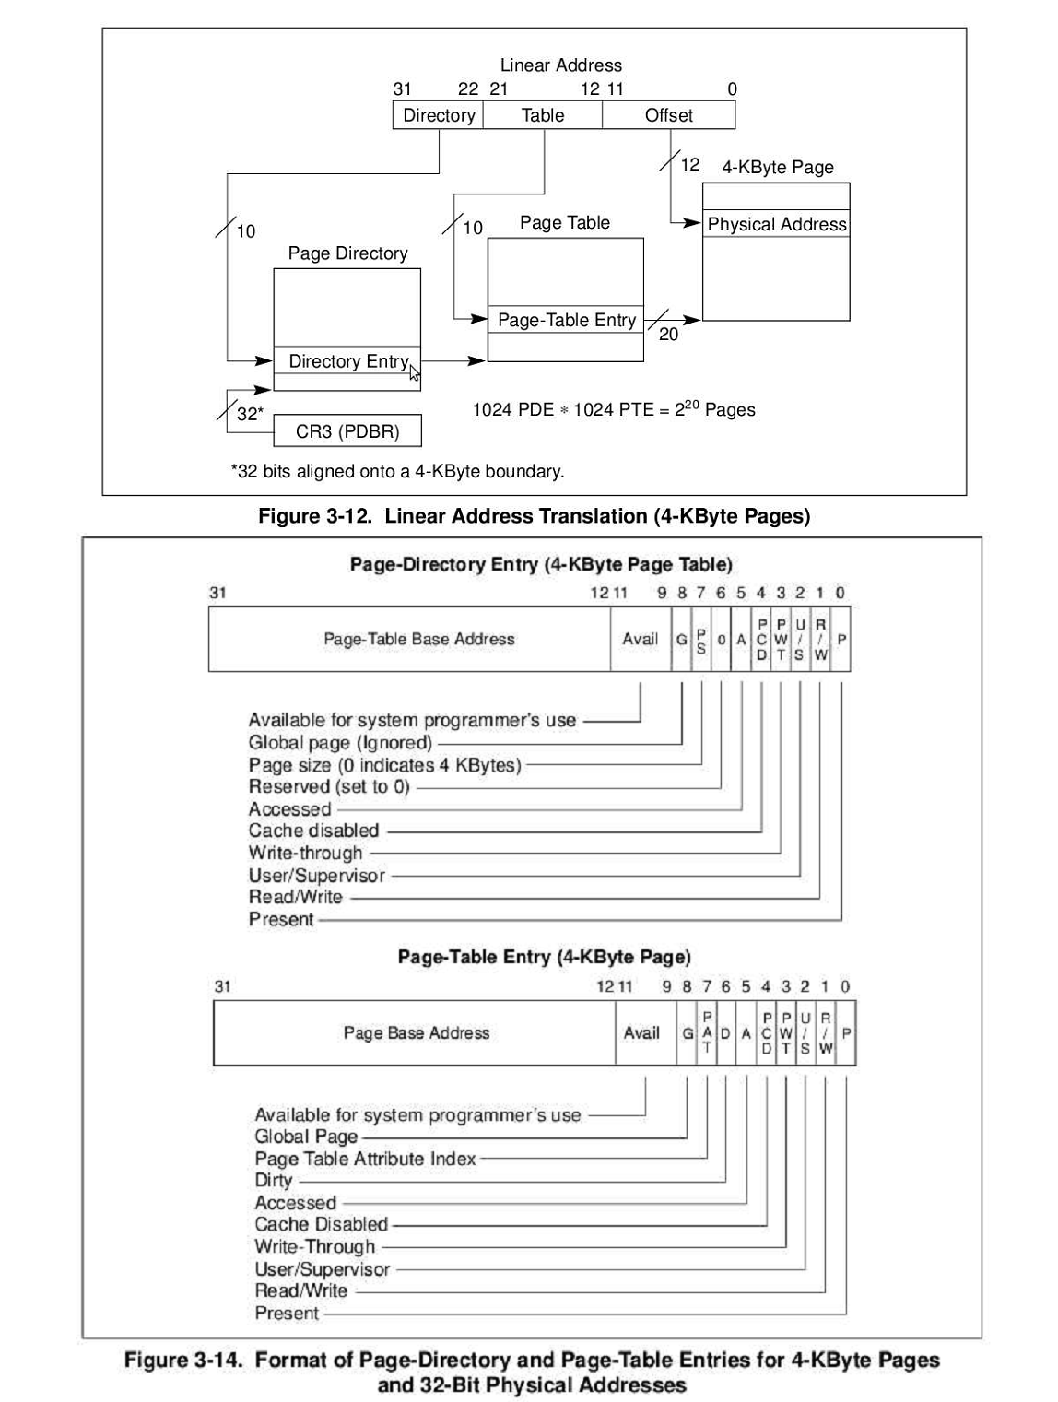

The contents of the relevant sections of memory are shown on this table. Any memory not shown can be assumed to be zero. The Page Directory Base Address is 0x0c23b000.

下表给出了相关部分的存储器内容。没有显示的存储器假设为零。页目录基地址为0x0c23b000。

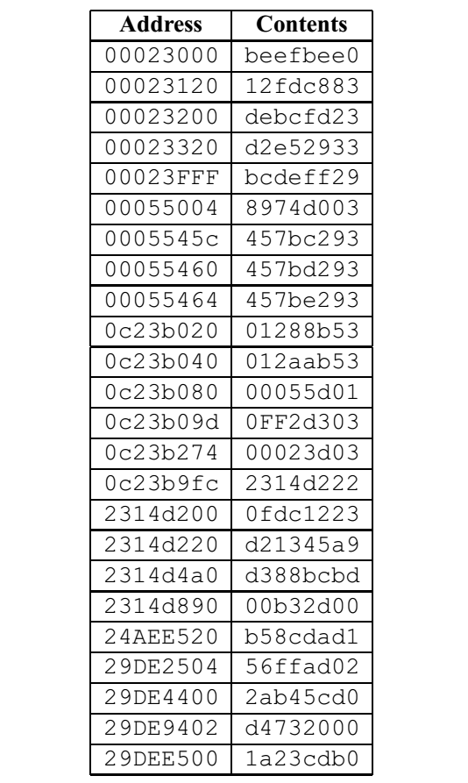

For each of the following problems, perform the virtual to physical address translation. If an error occurs at any point in the address translation process that would prevent the system from performing the lookup, then indicate this by writing “FAILURE” and noting the physical address of the table entry that caused the failure.

对下面每个问题，进行虚拟地址到物理地址翻译。如果过程中发生错误，则写“FAILURE”和发生错误的表条目的物理地址。

For example, if you were to detect that the present bit in the PDE is set to zero, then you would leave the PTE address in (b) empty, and write “FAILURE” in (c), noting the physical address of the offending PDE.

例如，如果你检测到PDE有效位为零，那么(b)中的PTE为空，(c)中写“FAILURE”，记下违规的PDE条目的物理地址。

1. Read from virtual address 0x080016ba:

a. Physical address of PDE: ___________

b. Physical address of PTE: ___________

c. Success: The physical address accessed is ___________

or

Failure: Address of table entry causing failure is ___________

2. Read from virtual address 0x9fd28c10:

a. Physical address of PDE: ___________

b. Physical address of PTE: ___________

c. Success: The physical address accessed is ___________

or

Failure: Address of table entry causing failure is ___________