**Design this App**

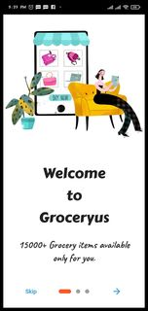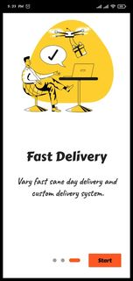

**Onboarding Screen-**

Short summary to provide what kinds of service in this Application (App)

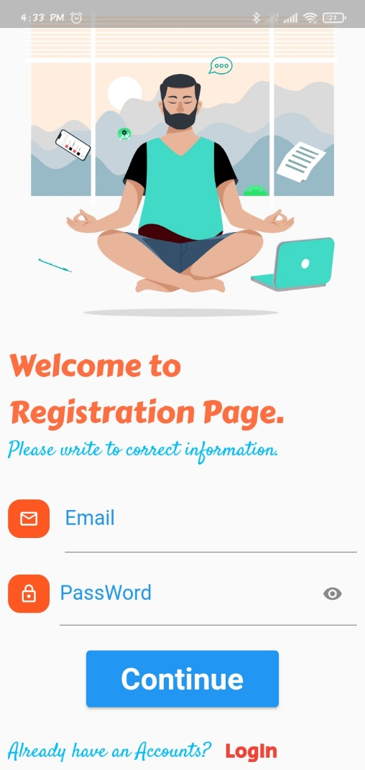 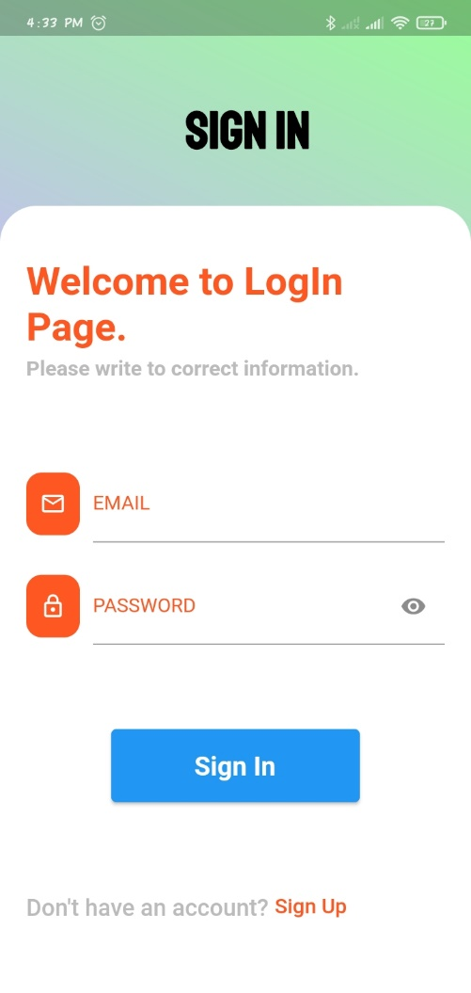

**Registration And LogIn Screen---**

User first of all Registration And then login this app . Start to use.

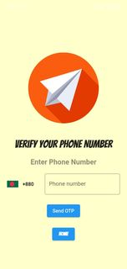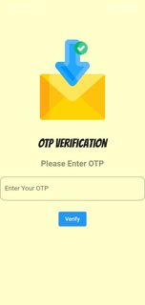

**OTP Verification Screen—**

This is another login system. It’s a one time password system. User can entry phone number and got a OTP code and ready to use this app.

**Splash Screen—**

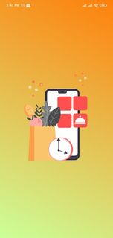

It’s a Design or Animation ,when login process complete…

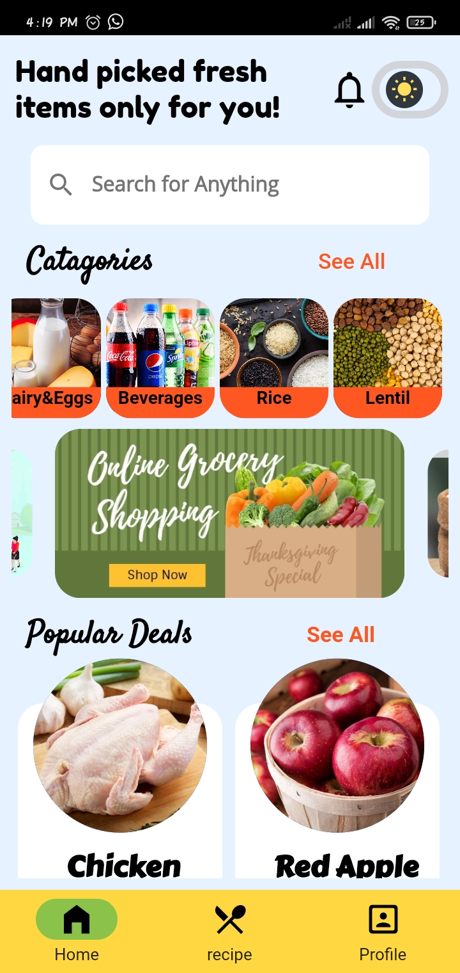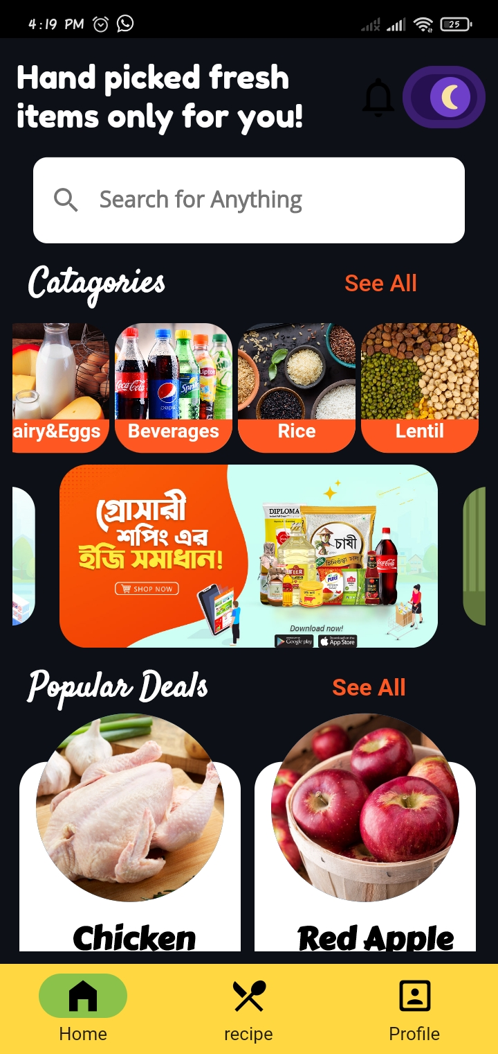

**Home Screen---**

There all product in this screen.. Also a Dark Mode in an One page.

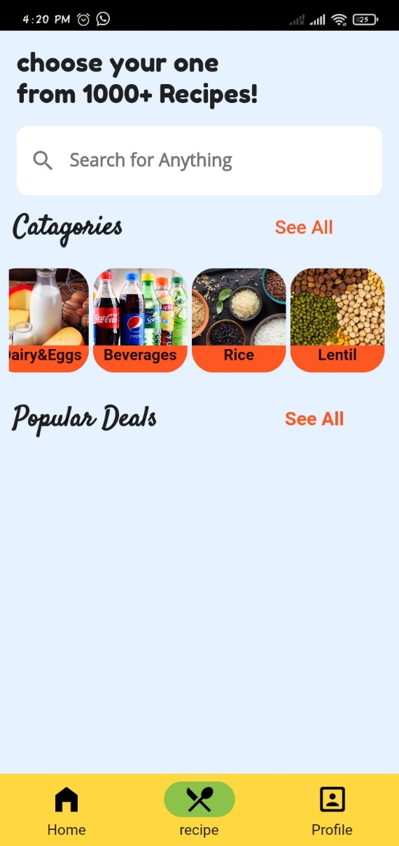

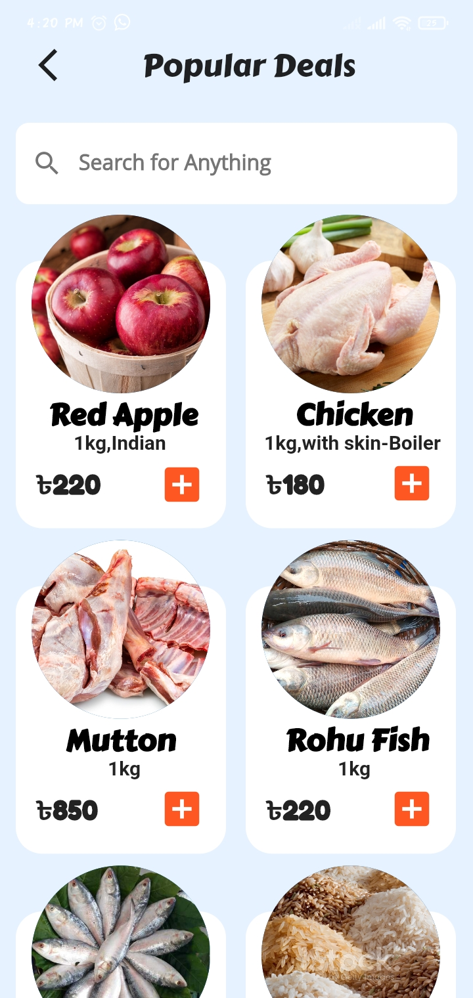

Other Screen

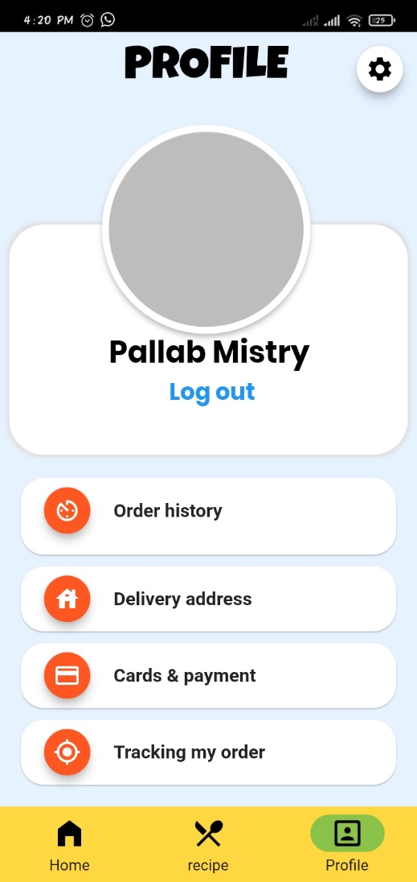 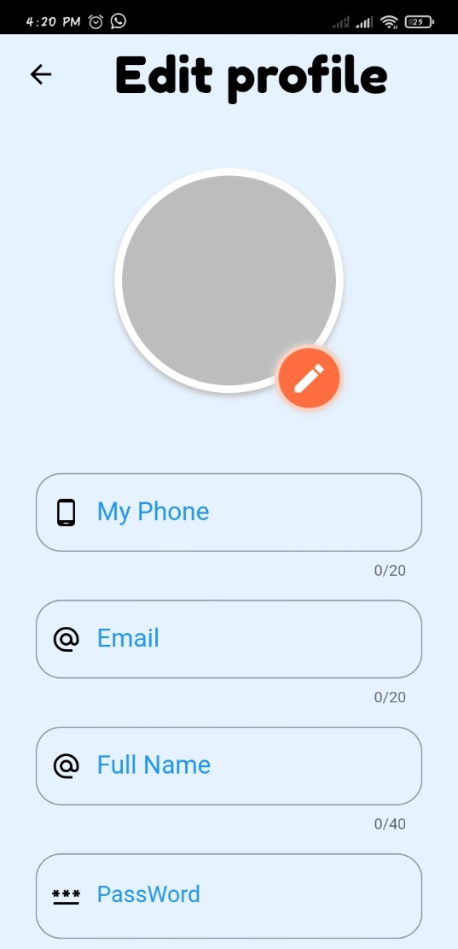

**Profile Edit Screen---**

This page user set there Picture and other information .

LogOut Option in this App.

