WEB BASED AND MOBILE VIRTUAL AND AUGMENTED REALITY SOLUTIONS 2026
Project Name | Symphonic Hero
Your Name | Oto Jauja
Goal | Play the Timpani drums with a real symphonic orchestra.
Target Hardware | Meta Quest 2 / 3
Visual & Audio Design
Environment Description | Concert hall stage, a part of the symphonic orchestra, Timpani drums infront lights on stage, people in the crowd
Reference Images, Mood Board | 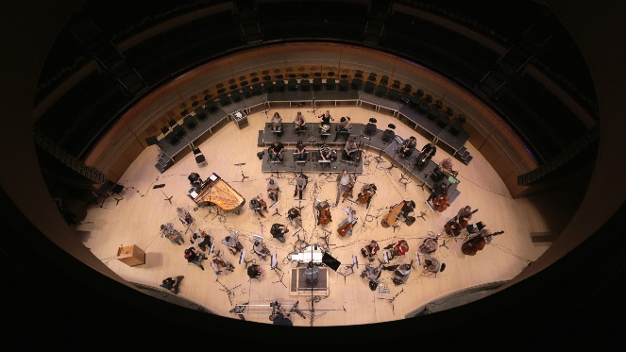  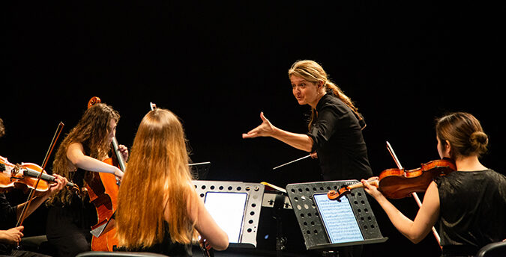  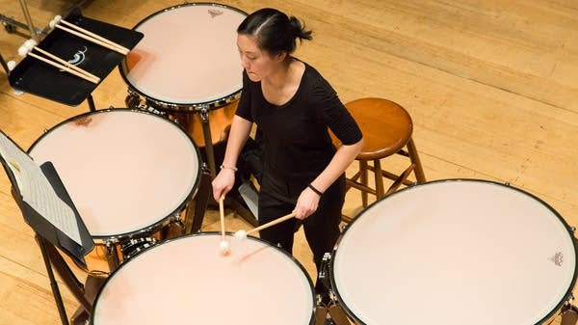
User Experience
User Persona, target audience. | Practicing drum students, Timpani players, students.
User Journey | Step 1 -> Spawn infront of the timpani; Step 2 -> Picks up the timpani drumsticks; Step 3 -> Starts the experience and the symphonic music starts; Step 4 -> Real notes appear infront of the player; Step 5 -> User has to follow the conductor and the notes to hit the timpani, simulating a real concert
Interaction Model: | Movement: Stationary  Interaction: Gaze cursor, grabbable with hands or controller
Technical Implementation
Tech Stack | Visual Studio Code, WebGL, Blender, A-frame, JavaScript, A-frame components, Meta Quest 2
Assets List | Visuals: 3D models, textures, UI elements  Sound: Ambient orchestra music, ambient sounds, sound effects  Tools/code: scripts, shaders
Calendar  (Reached specific goals at the end of day) | 10.01.2026  Early Alpha Rough prototype  15.01.2026  Some UI elements  360 video playing  Hitting the Timpani functionality  16.01.2026  Finalize Prototype  Finish UI  Start making or finding realistic models to make the experience feel as real as possible  22.01.2026  Finalized project demonstration.

