WEB BASED AND MOBILE VIRTUAL AND AUGMENTED REALITY SOLUTIONS 2026
Project Name | Immersive Animal World
Your Name | Hugues Lejeune
Goal | Explore realistic animal habitats and learn about wildlife behavior, ecosystems, and conservation.
Target Hardware | WebXR compatible headsets. Optionally mobile phones
Visual & Audio Design | 3D animal models (brown bear) with natural animations  Stylized but scientifically accurate environments  Spatialized ambient sounds (wind, water, insects, birds)  Animal vocalizations based on real recordings
Environment Description | Users explore animal habitats (forest…).  Environment is populated with animals behaving according to simplified rules (feeding, resting, moving). Informational hotspots allow users to learn about species, ecosystems, and conservation issues.
Reference Images, Mood Board | 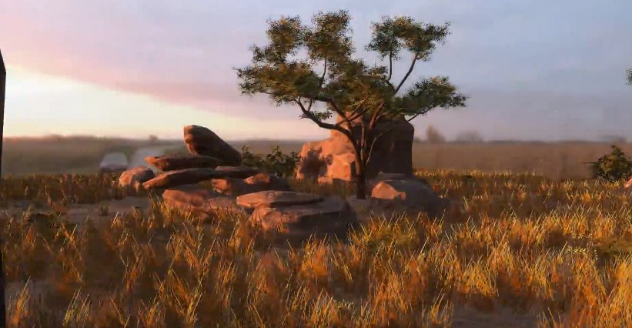  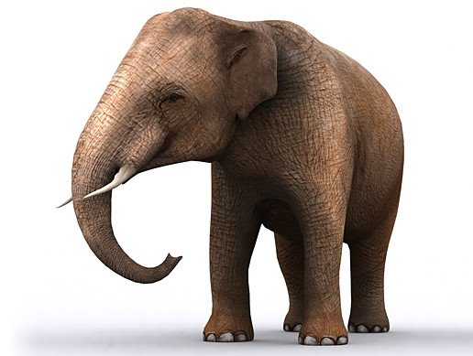
User Experience
User Persona, target audience. | Students, educators, casual learners, wildlife enthusiasts.
User Journey | Step 1: User launches the application (web or mobile).  Step 2: User enters a virtual lobby with biome selection portals.  Step 3: User selects an animal world (e.g., Savannah).  Step 4: User spawns inside the environment.  Step 5: User moves around and observes animals in their habitat.  Step 6: User interacts with animals or information points.  Step 7: User unlocks educational content (facts, short audio explanations).  Step 8: User exits or switches to another environment.
Interaction Model: | Movement: Teleportation + optional smooth locomotion  Interaction: Gaze-based selection or controller raycast + Trigger or grip interaction
Technical Implementation
Tech Stack | Engine: AFrame  Languages: HTML, JS  Tools: VSCode, Blender
Assets List | Visuals: 3D animal models, environment meshes, UI elements  Sound: animal sound effects, ambient sounds, voice-over narration (optional)  Tools/Code: sky and water shaders
Calendar  (Reached specific goals at the end of day) | 10.01.2026  App with one brown bear and at least an idle animation  15.01.2026  Forest environment done  16.01.2026  Brown bear with full animations (idle, eating, walking…), in a forest environment  22.01.2026  Finalized project demonstration.

