WEB BASED AND MOBILE VIRTUAL AND AUGMENTED REALITY SOLUTIONS 2026
Project Name | Attention Armada
Your Name | Liāna Ozoliņa
Goal | Pixelated WebVR “Space Invaders” inspired shooter about the attention economy with active play
Target Hardware | Meta Quest 2
Visual & Audio Design
Environment Description | Pixelated space. Black with brightly colored low-poly models.
Reference Images, Mood Board | 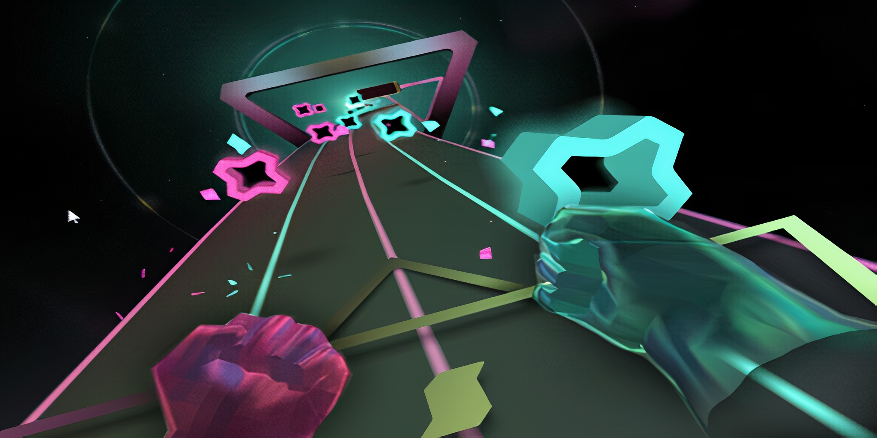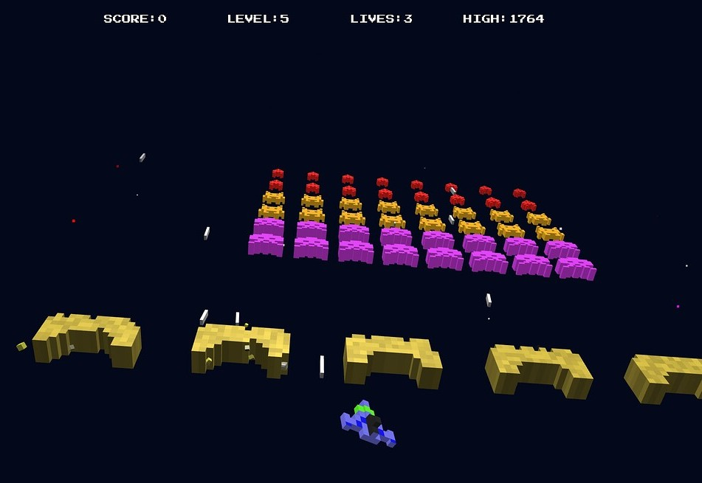  
User Experience
User Persona, target audience. | Youth overstimulated by online spaces.
User Journey | Step 1: Player connects. The player chooses their spaceship's color. Rules are shown.  Step 2: The player can shoot at targets for practice. Shooting at an alarm clock starts the game.  Step 3: Targets come at the player. Good ones that give points and bad ones, that remove points. Targets represent good and bad habits relating to the “attention economy”  Step 4: There is a limited time in the day for points to be gathered or lost. And a limited number of projectiles the player can shoot, representing the attention people can spare in a single day. When time ends or projectiles run out, the game ends and gives a score.
Interaction Model: | Interaction PC: Orbital cursor + wasd movement + Click to shoot projectile  Interaction VR: Space ship parented between both VR controllers + Trigger to shoot projectile
Technical Implementation
Tech Stack | Complete set of software, tools, languages, frameworks, and infrastructure used to build, run, and maintain a digital product
Assets List | Visuals: 2D/3D models, textures, UI elements, animations, environments…  Sound: music, sound effects, ambient sounds…  Tools/code: scripts, shaders…
Calendar  (Reached specific goals at the end of day) | 10.01.2026  15.01.2026  16.01.2026  22.01.2026  Finalized project demonstration.

