***PROBLEM SOLUTION DOCUMENT***

|  |  |  |
| --- | --- | --- |
| **Information Ticket iMonitoring (Diisi oleh Lead)** | | |
| No. Ticket | : | 2504000045 |
| Submit date | : | 08/04/25 |
| Nama Client/User | : | DIPO STAR FINANCE/WAWAN HERMAWAN |

|  |  |  |
| --- | --- | --- |
| **LEVEL OF INTEREST AND IMPACT (Diisi oleh Lead)** | | |
| Urgency | ☐ | *NON URGENT*  *(Perubahan terjadwal dan tidak memiliki batasan waktu tertentu)* |
| ☒ | *URGENT*  *(Perubahan yang telah terjadwal namun memiliki batasan waktu tertentu)* |
| ☐ | *EMERGENCY*  *(Perubahan yang perlu dilakukan dengan segera dan setiap saat)* |
| Impact | ☒ | MINOR  *(Perubahan tidak berdampak langsung kepada operasional dan keamanan informasi)* |
| ☐ | MAJOR  *(Perubahan berdampak langsung operasional dan keamanan informasi)* |

**SIGN OF APPROVAL**

|  |  |  |
| --- | --- | --- |
| **Prepare By:** | **Sign** | **Date** |
| [Fauzan] |  | 14-04-2025 |

|  |  |  |
| --- | --- | --- |
| **Assessment By :** | **Sign** | **Date** |
| [Sepria Yunita] |  |  |
| [Senior Support] |  |  |

* Ttd setelah semua proses selesai dan package siap dikirimkan ke client)

**DAFTAR ISI**

**1 BACKGROUND 5**

1.1 Explanation Of Problems And Solutions * (Diisi Oleh Lead) 5

1.2 Impact Analysis* (Diisi oleh lead) 5

**2 IMPLEMENTATION PLAN SYSTEM (EQUIPPED BY STAFF SUPPORT) 5**

2.1 detail solution 5

2.1.1 *Solution (Diisi Penjelasan Detail Tentang Solusi Dan Penambahan Solusi Oleh Dev Support) 5*

2.1.2 *List Of Impact Module/ Functions/Process/Reporting 5*

2.2 CAPTURE SCRIPT CHANGES IN DATABASE/UI 5

2.2.1 *Before 5*

2.2.2 *After 5*

2.3 LIST OBJECT 5

**3 IMPLEMENTATION 6**

3.1 Implementasi UAT* 6

3.2 Implementasi Production* 6

**4 RUNDOWN 7**

4.1 Rundown Activity : 7

4.2 Rollback* 7

4.2.1 *Rollback UAT 7*

4.2.2 *Rollback Production 7*

**5 TESTING RESULT 8**

5.1 Skenario Testing (Equipped By Staff Support) 8

5.2 Skenario Testing (To Be Field By Qa) 8

# **BACKGROUND**

## ***EXPLANATION OF PROBLEMS AND SOLUTIONS * (*DIISI OLEH LEAD*)***

|  |  |  |
| --- | --- | --- |
| No. Ticket | : | 2504000045 |
| Problem | : | Selisih data iFinancing dengan Accounting : IFINAMS.DBO.rpt._ext_costprice_depreamt_overdue |
| RCA | : | Dear IMS,  Bu Ricana Rindu (Tim DWH) menginfokan bahwa ada selisih antara iFinancing dengan Accounting : IFINAMS.DBO.rpt._ext_costprice_depreamt_overdue.  Detail in attachment |
| Solution/Workaround | : | Cek dari hasil Query IFIN dengan hasil tarikan dari SAP, apakah ada data expense yang manual by sap. |
|  |  |  |

## ***IMPACT ANALYSIS* (*DIISI OLEH LEAD*)***

|  |  |  |
| --- | --- | --- |
| *Impact Analysis* | : | Recon Data Expense |
| Module / *Functions that must be tested* | : | Cek dari hasil Query IFIN dengan hasil tarikan dari SAP, apakah ada data expense yang manual by sap. |

# **IMPLEMENTATION PLAN SYSTEM (EQUIPPED BY STAFF SUPPORT)**

## ***DETAIL SOLUTION***

### ***SOLUTION* (DIISI PENJELASAN DETAIL TENTANG SOLUSI DAN PENAMBAHAN SOLUSI OLEH DEV SUPPORT)**

### **LIST OF IMPACT MODULE/ FUNCTIONS/PROCESS/REPORTING**

## ***LIST OBJECT***

| **No** | **Old/New** | **File/Object Name** | **Type** | **Copy Form** | **Deployment Path** | **Notes** |
| --- | --- | --- | --- | --- | --- | --- |
| 1 | Old |  | ASPX | - |  | - |
| 2 | Old |  | CS | - |  | - |

## CAPTURE SCRIPT CHANGES IN DATABASE/UI

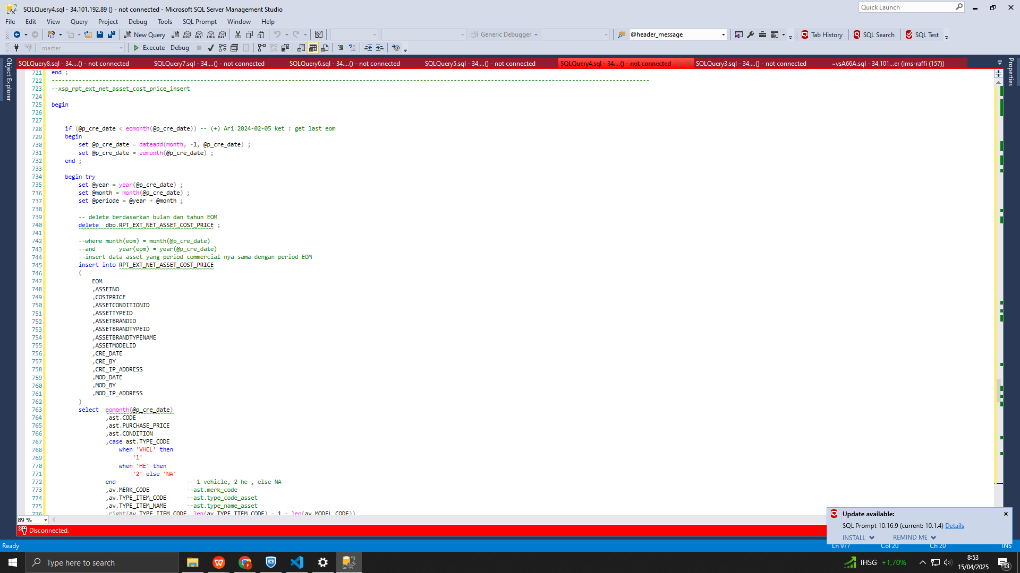

### *BEFORE*

### *AFTER*

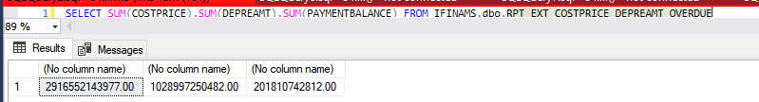

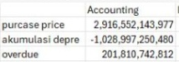

# **IMPLEMENTATION** Instruction

## ***IMPLEMENTASI UAT\****

Server UAT :

|  |  |  |  |
| --- | --- | --- | --- |
| **No** | ***Task*** | **Notes** | **PIC** |
|  |  |  | IT |
|  |  |  | IT |
|  |  |  | IT |
|  |  |  |  |

## ***IMPLEMENTASI PRODUCTION\****

Server PRD :

|  |  |  |  |
| --- | --- | --- | --- |
| **No** | ***Task*** | **Notes** | **PIC** |
|  | Siapkan script |  |  |
|  | Rollback script tersebut, pastikan semua data yang tampil sama dengan data yang dikirimkan accounting |  |  |
|  | Commit script |  |  |
|  |  |  |  |

## ***ROLLBACK\****

### ***ROLLBACK UAT***

| **No** | ***Task*** | ***Notes*** | **PIC** |
| --- | --- | --- | --- |
|  |  |  |  |
|  |  |  |  |

### 

### 

### ***ROLLBACK PRODUCTION***

| **No.** | ***Task*** | ***Notes*** | **PIC** |
| --- | --- | --- | --- |
|  |  |  |  |
|  |  |  |  |

# **TESTING RESULT**

## ***SKENARIO* TESTING *(EQUIPPED BY* STAFF SUPPORT*)***

| **No** | ***Menu*** | ***Activity*** | ***Capture*** |
| --- | --- | --- | --- |
|  | ifinams | pastikan semua data yang tampil sama dengan data yang dikirimkan accounting |  |
| 2 |  |  |  |
| 3 |  |  |  |
|  |  |  |  |

## ***SKENARIO* TESTING *(TO BE FIELD BY* QA*)***

| **No** | ***Menu*** | ***Activity*** | ***Capture*** |
| --- | --- | --- | --- |
| 1 |  |  |  |
| 2 |  |  |  |