*PROBLEM SOLUTION DOCUMENT*

|  |  |  |
| --- | --- | --- |
| Information Ticket iMonitoring (Diisi oleh Lead) | | |
| No. Ticket | : | 2504000117 |
| Submit date | : | 25/04/2025 |
| Nama Client/User | : | DIPO STAR FINANCE/EDDY RAKHMAN |

|  |  |  |
| --- | --- | --- |
| LEVEL OF INTEREST AND IMPACT (Diisi oleh Lead) | | |
| Urgency | ☐ | *NON URGENT*  *(Perubahan terjadwal dan tidak memiliki batasan waktu tertentu)* |
| ☒ | *URGENT*  *(Perubahan yang telah terjadwal namun memiliki batasan waktu tertentu)* |
| ☐ | *EMERGENCY*  *(Perubahan yang perlu dilakukan dengan segera dan setiap saat)* |
| Impact | ☒ | MINOR  *(Perubahan tidak berdampak langsung kepada operasional dan keamanan informasi)* |
| ☐ | MAJOR  *(Perubahan berdampak langsung operasional dan keamanan informasi)* |

SIGN OF APPROVAL

|  |  |  |
| --- | --- | --- |
| Prepare By: | Sign | Date |
| [Fauzan] |  | 25/04/2025 |

|  |  |  |
| --- | --- | --- |
| Assessment By : | Sign | Date |
| [Sepria Yunita] |  | 25/04/2025 |
| [Senior Support] |  |  |

* Ttd setelah semua proses selesai dan package siap dikirimkan ke client)

DAFTAR ISI

1 BACKGROUND 5

1.1 Explanation Of Problems And Solutions * (Diisi Oleh Lead) 5

1.2 Impact Analysis* (Diisi oleh lead) 5

2 IMPLEMENTATION PLAN SYSTEM (EQUIPPED BY STAFF SUPPORT) 5

2.1 detail solution 5

2.1.1 *Solution (Diisi Penjelasan Detail Tentang Solusi Dan Penambahan Solusi Oleh Dev Support) 5*

2.1.2 *List Of Impact Module/ Functions/Process/Reporting 5*

2.2 CAPTURE SCRIPT CHANGES IN DATABASE/UI 5

2.2.1 *Before 5*

2.2.2 *After 5*

2.3 LIST OBJECT 5

3 IMPLEMENTATION 6

3.1 Implementasi UAT* 6

3.2 Implementasi Production* 6

4 RUNDOWN 7

4.1 Rundown Activity : 7

4.2 Rollback* 7

4.2.1 *Rollback UAT 7*

4.2.2 *Rollback Production 7*

5 TESTING RESULT 8

5.1 Skenario Testing (Equipped By Staff Support) 8

5.2 Skenario Testing (To Be Field By Qa) 8

# BACKGROUND

## *EXPLANATION OF PROBLEMS AND SOLUTIONS * (*DIISI OLEH LEAD*)*

|  |  |  |
| --- | --- | --- |
| No. Ticket | : | 2504000117 |
| Problem | : | Request Ubah Status Maturity - PT. Andika Energindo (Agr 0002083/4/10/03/2024) |
| RCA | : | Request Ubah Status Maturity - PT. Andika Energindo (Agr 0002083/4/10/03/2024) dari POST menjadi HOLD karena unit akan dilakukan extend 2 bulan. |
| Solution/Workaround | : | MTN BERULANG - UPDATE KONTRAK YANG SUDAH TERMINATE KARNA MATURITY STOP BY EOD, SEBELUM LAKUKAN MAINTENANCE DATA PASTIKAN SCHEDULE BILLING DI PROVIDE OLEH USER BENAR DAN PASTIKAN STATUS ASSET ADA DIPOSISI MANA |
|  |  |  |

## *IMPACT ANALYSIS* (*DIISI OLEH LEAD*)*

|  |  |  |
| --- | --- | --- |
| *Impact Analysis* | : | MTN BERULANG - UPDATE KONTRAK YANG SUDAH TERMINATE KARNA MATURITY STOP BY EOD, SEBELUM LAKUKAN MAINTENANCE DATA PASTIKAN SCHEDULE BILLING DI PROVIDE OLEH USER BENAR DAN PASTIKAN STATUS ASSET ADA DIPOSISI MANA |
| Module / *Functions that must be tested* | : | MTN BERULANG - UPDATE KONTRAK YANG SUDAH TERMINATE KARNA MATURITY STOP BY EOD, SEBELUM LAKUKAN MAINTENANCE DATA PASTIKAN SCHEDULE BILLING DI PROVIDE OLEH USER BENAR DAN PASTIKAN STATUS ASSET ADA DIPOSISI MANA |

# IMPLEMENTATION PLAN SYSTEM (EQUIPPED BY STAFF SUPPORT)

## *DETAIL SOLUTION*

### *SOLUTION* (DIISI PENJELASAN DETAIL TENTANG SOLUSI DAN PENAMBAHAN SOLUSI OLEH DEV SUPPORT)

### LIST OF IMPACT MODULE/ FUNCTIONS/PROCESS/REPORTING

## *LIST OBJECT*

| No | Old/New | File/Object Name | Type | Copy Form | Deployment Path | Notes |
| --- | --- | --- | --- | --- | --- | --- |
| 1 | Old |  | ASPX | - |  | - |
| 2 | Old |  | CS | - |  | - |

## CAPTURE SCRIPT CHANGES IN DATABASE/UI

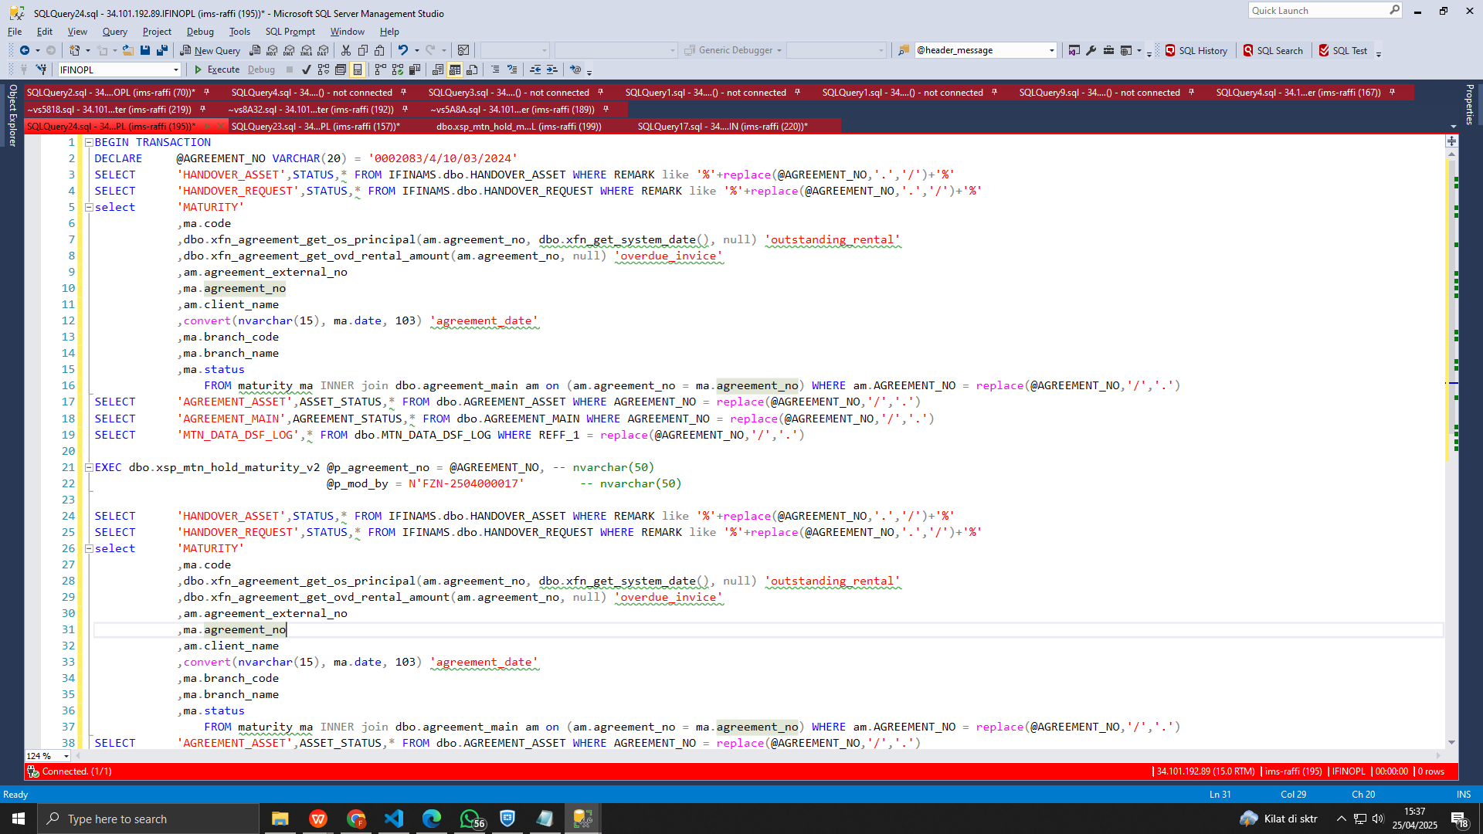

### *BEFORE*

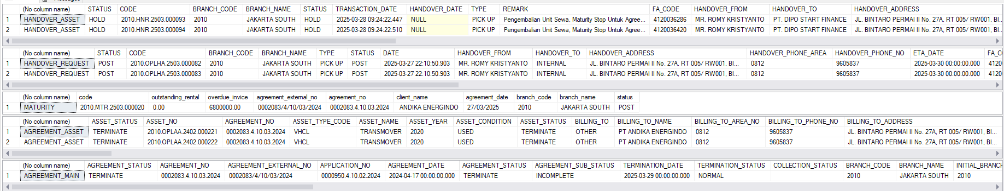

### *AFTER*

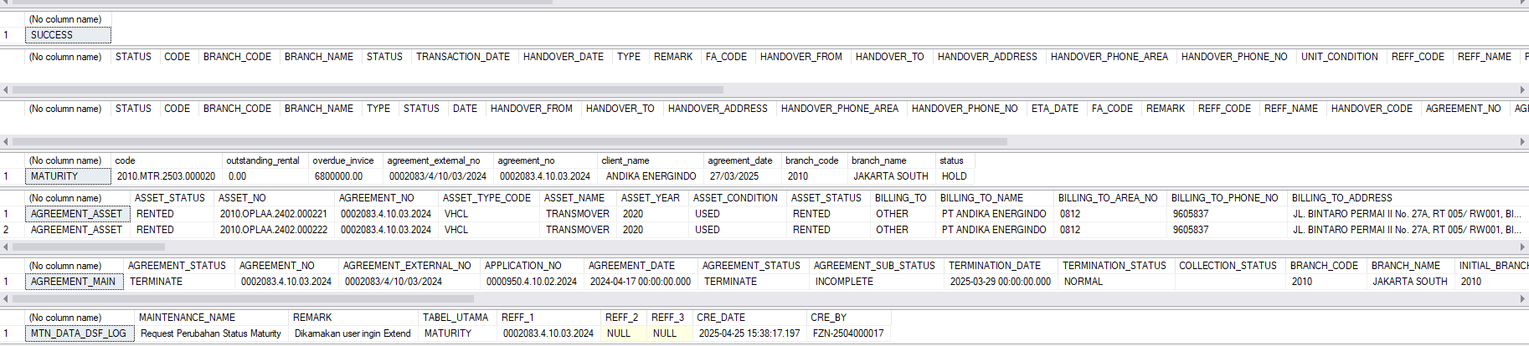

# IMPLEMENTATION Instruction

## *IMPLEMENTASI UAT\**

Server UAT :

|  |  |  |  |
| --- | --- | --- | --- |
| No | *Task* | Notes | PIC |
|  |  |  | IT |
|  |  |  | IT |
|  |  |  | IT |
|  |  |  |  |

## *IMPLEMENTASI PRODUCTION\**

Server PRD :

|  |  |  |  |
| --- | --- | --- | --- |
| No | *Task* | Notes | PIC |
|  | Siapkan script |  |  |
|  | Rollback script pastikan asset status = RENTED |  |  |
|  | Commit script |  |  |
|  |  |  |  |

## *ROLLBACK\**

### *ROLLBACK UAT*

| No | *Task* | *Notes* | PIC |
| --- | --- | --- | --- |
|  |  |  |  |
|  |  |  |  |

### 

### 

### *ROLLBACK PRODUCTION*

| No. | *Task* | *Notes* | PIC |
| --- | --- | --- | --- |
|  |  |  |  |
|  |  |  |  |

# TESTING RESULT

## *SKENARIO* TESTING *(EQUIPPED BY* STAFF SUPPORT*)*

| No | *Menu* | *Activity* | *Capture* |
| --- | --- | --- | --- |
|  | Maturity-opl | Pastikan asset sudah bisa diextend |  |
| 2 |  |  |  |
| 3 |  |  |  |
|  |  |  |  |

## *SKENARIO* TESTING *(TO BE FIELD BY* QA*)*

| No | *Menu* | *Activity* | *Capture* |
| --- | --- | --- | --- |
| 1 |  |  |  |
| 2 |  |  |  |