*PROBLEM SOLUTION DOCUMENT*

|  |  |  |
| --- | --- | --- |
| Information Ticket iMonitoring (Diisi oleh Lead) | | |
| No. Ticket | : | 2504000146 |
| Submit date | : | 29/04/2025 |
| Nama Client/User | : | DIPO STAR FINANCE/WINDY NURBANI |

|  |  |  |
| --- | --- | --- |
| LEVEL OF INTEREST AND IMPACT (Diisi oleh Lead) | | |
| Urgency | ☐ | *NON URGENT*  *(Perubahan terjadwal dan tidak memiliki batasan waktu tertentu)* |
| ☒ | *URGENT*  *(Perubahan yang telah terjadwal namun memiliki batasan waktu tertentu)* |
| ☐ | *EMERGENCY*  *(Perubahan yang perlu dilakukan dengan segera dan setiap saat)* |
| Impact | ☒ | MINOR  *(Perubahan tidak berdampak langsung kepada operasional dan keamanan informasi)* |
| ☐ | MAJOR  *(Perubahan berdampak langsung operasional dan keamanan informasi)* |

SIGN OF APPROVAL

|  |  |  |
| --- | --- | --- |
| Prepare By: | Sign | Date |
| [Fauzan] |  | 29/04/2025 |

|  |  |  |
| --- | --- | --- |
| Assessment By : | Sign | Date |
| [Sepria Yunita] |  | 29/04/2025 |
| [Senior Support] |  |  |

* Ttd setelah semua proses selesai dan package siap dikirimkan ke client)

DAFTAR ISI

1 BACKGROUND 5

1.1 Explanation Of Problems And Solutions * (Diisi Oleh Lead) 5

1.2 Impact Analysis* (Diisi oleh lead) 5

2 IMPLEMENTATION PLAN SYSTEM (EQUIPPED BY STAFF SUPPORT) 5

2.1 detail solution 5

2.1.1 *Solution (Diisi Penjelasan Detail Tentang Solusi Dan Penambahan Solusi Oleh Dev Support) 5*

2.1.2 *List Of Impact Module/ Functions/Process/Reporting 5*

2.2 CAPTURE SCRIPT CHANGES IN DATABASE/UI 5

2.2.1 *Before 5*

2.2.2 *After 5*

2.3 LIST OBJECT 5

3 IMPLEMENTATION 6

3.1 Implementasi UAT* 6

3.2 Implementasi Production* 6

4 RUNDOWN 7

4.1 Rundown Activity : 7

4.2 Rollback* 7

4.2.1 *Rollback UAT 7*

4.2.2 *Rollback Production 7*

5 TESTING RESULT 8

5.1 Skenario Testing (Equipped By Staff Support) 8

5.2 Skenario Testing (To Be Field By Qa) 8

# BACKGROUND

## *EXPLANATION OF PROBLEMS AND SOLUTIONS * (*DIISI OLEH LEAD*)*

|  |  |  |
| --- | --- | --- |
| No. Ticket | : | 2504000146 |
| Problem | : | raw data G4S SECURITY SERVICES dan PUTRA MULIA TELECOMMUNICATION  mohon dibantu untuk ditarik raw data client G4S SECURITY SERVICES dan PUTRA MULIA TELECOMMUNICATION atas agreement dan kolom terlampir. jika ada lebih dari 1 invoice dalam 1 agreement, invoice tersebut ditampilkan semua.  https://365dipostar.sharepoint.com/:x:/s/AttachmentForIfinancing/Ea3uk_6pNs5Fs2poTAwzGhoB_uo_hYfabnrNaicWNcsd7g?e=UegDgK |
| RCA | : | Tarik data sesuai dengan template dan kontrak yang dilampirkan user |
| Solution/Workaround | : | Tarik data sesuai dengan template dan kontrak yang dilampirkan user |
|  |  |  |

## *IMPACT ANALYSIS* (*DIISI OLEH LEAD*)*

|  |  |  |
| --- | --- | --- |
| *Impact Analysis* | : | Tarik data sesuai dengan template dan kontrak yang dilampirkan user |
| Module / *Functions that must be tested* | : | Tarik data sesuai dengan template dan kontrak yang dilampirkan user |

# IMPLEMENTATION PLAN SYSTEM (EQUIPPED BY STAFF SUPPORT)

## *DETAIL SOLUTION*

### *SOLUTION* (DIISI PENJELASAN DETAIL TENTANG SOLUSI DAN PENAMBAHAN SOLUSI OLEH DEV SUPPORT)

### LIST OF IMPACT MODULE/ FUNCTIONS/PROCESS/REPORTING

## *LIST OBJECT*

| No | Old/New | File/Object Name | Type | Copy Form | Deployment Path | Notes |
| --- | --- | --- | --- | --- | --- | --- |
| 1 | Old |  | ASPX | - |  | - |
| 2 | Old |  | CS | - |  | - |

## CAPTURE SCRIPT CHANGES IN DATABASE/UI

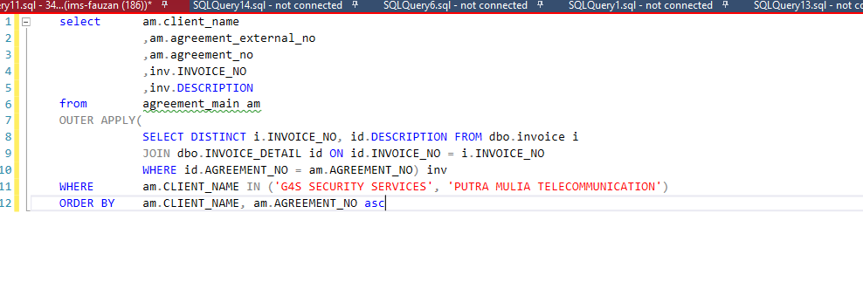

### *BEFORE*

### *AFTER*

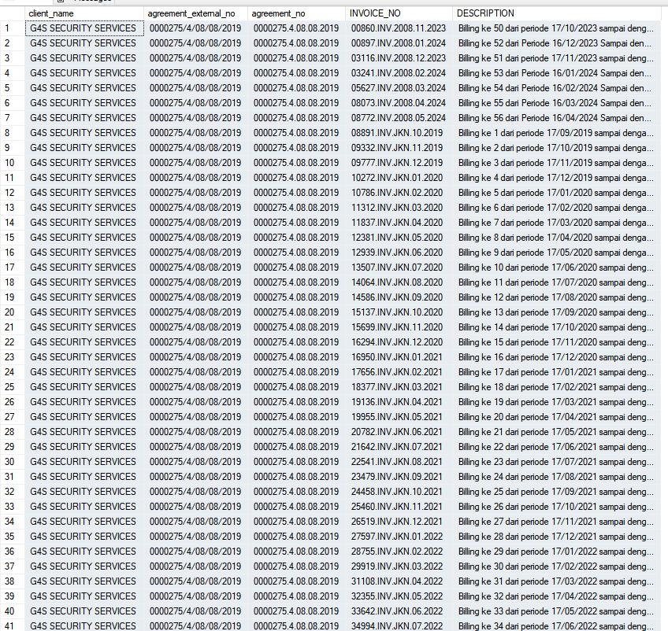

# IMPLEMENTATION Instruction

## *IMPLEMENTASI UAT\**

Server UAT :

|  |  |  |  |
| --- | --- | --- | --- |
| No | *Task* | Notes | PIC |
|  |  |  | IT |
|  |  |  | IT |
|  |  |  | IT |
|  |  |  |  |

## *IMPLEMENTASI PRODUCTION\**

Server PRD :

|  |  |  |  |
| --- | --- | --- | --- |
| No | *Task* | Notes | PIC |
|  |  |  |  |
|  |  |  |  |
|  |  |  |  |
|  |  |  |  |

## *ROLLBACK\**

### *ROLLBACK UAT*

| No | *Task* | *Notes* | PIC |
| --- | --- | --- | --- |
|  |  |  |  |
|  |  |  |  |

### 

### 

### *ROLLBACK PRODUCTION*

| No. | *Task* | *Notes* | PIC |
| --- | --- | --- | --- |
|  |  |  |  |
|  |  |  |  |

# TESTING RESULT

## *SKENARIO* TESTING *(EQUIPPED BY* STAFF SUPPORT*)*

| No | *Menu* | *Activity* | *Capture* |
| --- | --- | --- | --- |
|  |  |  |  |
| 2 |  |  |  |
| 3 |  |  |  |
|  |  |  |  |

## *SKENARIO* TESTING *(TO BE FIELD BY* QA*)*

| No | *Menu* | *Activity* | *Capture* |
| --- | --- | --- | --- |
| 1 |  |  |  |
| 2 |  |  |  |