
Reported By: Ibrahim Khan
Report Date: On Big Bang Day

Kaspersky EDR Events Report

Trillium Information
Security Systems

Event 1:
Summary:
Primary signatures indicate GuLoader (also known as CloudEyE), an advanced downloader used to deliver other threats. Some analysis engines also link it to Remcos RAT, a sophisticated Remote Access Trojan used for surveillance and data theft. A Trojan is a malicious program designed to electronically spy on the user’s activities (intercept keyboard input, take screenshots, capture a list of active applications, etc.). The collected information is sent to the cybercriminal by various means, including email, FTP, and HTTP. The system is safe and it was deleted successfully.

Name | Description
Status | Deleted
Severity | Critical
Type | Malware Trojan
Object Name | img20260107_10522882_PDF.exe
Affected Device | DESKTOP-M0LFS3H
OS | Windows 10
Date & Time | 01/12/2026 2:03:40 am
Source IP | 192.168.122.180
Destination IP | 107.173.47.136:2404 – C2
MD5 hash | bfce28f25954ddd39a295e3fd3c3f235
VirusTotal D Ratio | 40/69 security vendors flagged this file as malicious
Event Details

How the event was Detected
- Monitoring Systems: KasperskyEndpoint security for Windows detected
- IoC: MD5 hash was flagged as malicious.
- Malware Removal: Successfully deleted malicious files on affected machines.
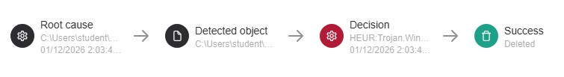

Event 2:
Summary:
It was identified as an Agent Tesla family malware which is a highly prevalent .NET-based Remote Access Trojan (RAT) and information stealer that has been active since 2014. It is primarily used to harvest sensitive data, such as credentials and financial information, from infected Windows systems. The system is safe and it was deleted successfully.

Name | Description
Status | Deleted
Severity | High
Type | Malware Trojan Win32 EXE
Object Name | Agent Tesla
Affected Device | DESKTOP-M0LFS3H
OS | Windows 10
Date & Time | 01/13/2026 6:20:59 am
Source IP | 192.168.122.180
Destination IP | Not found any specific
MD5 hash | ca94bc3c9564f8513f84921323ec2bd7
VirusTotal D Ratio | 55/70 security vendors flagged this file as malicious
Event Details

How the event was Detected
- Monitoring Systems: KasperskyEndpoint security for Windows detected
- IoC: MD5 hash was flagged as malicious.
- Malware Removal: Successfully deleted malicious files on affected machines.
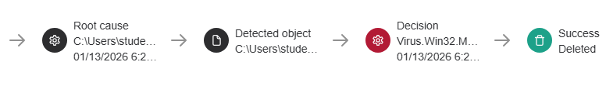

Event 3:
Summary:
It was identified as an Agent Tesla family malware which is a highly prevalent .NET-based Remote Access Trojan (RAT) and information stealer that has been active since 2014. It is primarily used to harvest sensitive data, such as credentials and financial information, from infected Windows systems. The system is safe and it was deleted successfully.

Name | Description
Status | Deleted
Severity | High
Type | Malware Virus win32
Object Name | Agent Tesla
Affected Device | DESKTOP-M0LFS3H
OS | Windows 10
Date & Time | 01/13/2026 6:20:59 am
Source IP | 192.168.122.180
Destination IP | Not found
MD5 hash | ca94bc3c9564f8513f84921323ec2bd7
VirusTotal D Ratio | 55/70 security vendors flagged this file as malicious
Event Details

How the event was Detected
- Monitoring Systems: KasperskyEndpoint security for Windows detected
- IoC: MD5 hash was flagged as malicious.
- Malware Removal: Successfully deleted malicious files on affected machines.
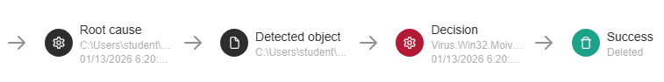

Event 4:
Summary:
It was identified as an AsyncRAT is an open-source remote administration tool originally released on GitHub in 2019. While it has legitimate administration capabilities, it is almost exclusively weaponized by cybercriminals to remotely control Windows systems, exfiltrate data, and drop secondary payloads like ransomware. The system is safe and it was deleted successfully.

Name | Description
Status | Deleted
Severity | High
Type | Malware RAT
Object Name | AsyncRAT
Affected Device | DESKTOP-M0LFS3H
OS | Windows 10
Date & Time | 01/13/2026 10:02:30 pm
Source IP | 192.168.122.180
Destination IP | Not found
MD5 hash | 8811ca4bf5d9450c49bd218d7e7785f9
VirusTotal D Ratio | 52/71 security vendors flagged this file as malicious
Event Details

How the event was Detected
- Monitoring Systems: KasperskyEndpoint security for Windows detected
- IoC: MD5 hash was flagged as malicious.
- Malware Removal: Successfully deleted malicious files on affected machines.


Event 5:
Summary:
This sample has been classified as part of the UNAMSILENTCRYPTOMINER malware family. "UNAM SILENTCRYPTOMINER" refers to an open-source, hidden cryptocurrency miner builder project developed by a user named "Unam Sanctam". It is a tool used to secretly mine cryptocurrencies like Monero (XMR) on an infected computer without the user's knowledge, and is often classified as malware or a Potentially Unwanted Application (PUA) by security software. The system is safe and it was deleted successfully.

Name | Description
Status | Deleted
Severity | Medium
Type | Malware CoinMiner
Object Name | Nursultan.exe
Affected Device | DESKTOP-M0LFS3H
OS | Windows 10
Date & Time | 01/13/2026 10:57:04 pm
Source IP | 192.168.122.180
Destination IP | https://pastebin.com/raw/N3gQggY6
MD5 hash | c028a5b136d43278d5138a86e0f5bc82
VirusTotal D Ratio | 53/71 security vendors flagged this file as malicious
Event Details

How the event was Detected
- Monitoring Systems: KasperskyEndpoint security for Windows detected
- IoC: MD5 hash was flagged as malicious.
- Malware Removal: Successfully deleted malicious files on affected machines.

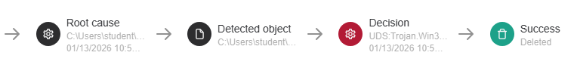

Event 6:
Summary:
This sample has been classified as Trojan-PSW programs are designed to steal user account information such as logins and passwords from infected computers. PSW is an acronym of Password Stealing Ware and potentially targeting the Chrome browser environment.

Name | Description
Status | Deleted
Severity | High
Type | Malware Trojan-PSW.Win64.ChromeInject
Object Name | XenosInjector.exe
Affected Device | DESKTOP-M0LFS3H
OS | Windows 10
Date & Time | 01/13/2026 11:59:09 pm
Source IP | 192.168.122.180
Destination IP
MD5 hash | a9d84696c67a0cbcca1f55a24647f57c
VirusTotal D Ratio | 20/67 security vendors flagged this file as malicious
Event Details

How the event was Detected
- Monitoring Systems: KasperskyEndpoint security for Windows detected
- IoC: MD5 hash was flagged as malicious.
- Malware Removal: Successfully deleted malicious files on affected machines.
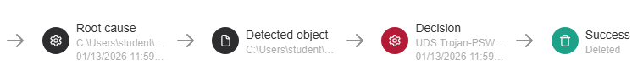

Event 7:
Summary:
It was identified as Redline stealer. This malware harvests information from browsers such as saved credentials, autocomplete data, and credit card information. A system inventory is also taken when running on a target machine, to include details such as the username, location data, hardware configuration, and information regarding installed security software. More recent versions of RedLine added the ability to steal cryptocurrency.

Name | Description
Status | Deleted
Severity | High
Type | Malware Redline Stealer
Object Name | 195dbe114df7a783dd938e8a2c208079.exe
Affected Device | DESKTOP-M0LFS3H
OS | Windows 10
Date & Time | 01/14/2026 1:36:03 am
Source IP | 192.168.122.180
Destination IP | 185.222.58.40:55615 – C2
MD5 hash | 195dbe114df7a783dd938e8a2c208079
VirusTotal D Ratio | 43/60 security vendors flagged this file as malicious
Event Details

How the event was Detected
- Monitoring Systems: KasperskyEndpoint security for Windows detected
- IoC: MD5 hash was flagged as malicious.
- Malware Removal: Successfully deleted malicious files on affected machines.
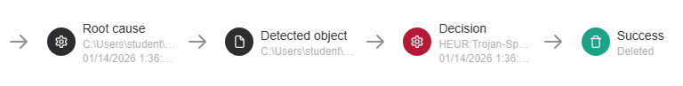

Event 8:
Summary:
This sample has been classified as Zelyanor.exe refers to SilentStealer, a type of information-stealing malware (infostealer). The detection name indicates that it was identified by Kaspersky's Proactive Defense Module, which flags programs based on suspicious behavioral patterns rather than just static file signatures.

Name | Description
Status | Deleted
Severity | High
Type | Malware SilentStealer
Object Name
Affected Device | DESKTOP-M0LFS3H
OS | Windows 10
Date & Time | 01/14/2026 1:37:57 am
Source IP | 192.168.122.180
Destination IP
MD5 hash | f75083c91a113dc31be05d64af2273c8
VirusTotal D Ratio | 1/70 security vendors flagged this file as malicious
Event Details

How the event was Detected
- Monitoring Systems: KasperskyEndpoint security for Windows detected
- IoC: identified by KPD Module flags the payload as malicious based on suspicious behavioral patterns.
- Malware Removal: Successfully deleted malicious files on affected machines.



Event 9:
Summary:
This sample has been classified as Snake Keylogger variant disguised as an e-Transfer payment notification. The malware executes as a .NET application with multiple layers of obfuscation and anti-analysis capabilities. Attempts to steal mail credentials through file system and registry access, specifically targeting Postbox and Outlook profiles.

Name | Description
Status | Deleted
Severity | High
Type | Malware Snake Keylogger
Object Name | e-Transfer_Payment_GVJ736382132026.cmd
Affected Device | DESKTOP-M0LFS3H
OS | Windows 10
Date & Time | 01/14/2026 3:06:25 am
Source IP | 192.168.122.180
Destination IP | 212.58.6.99, 104.21.67.152
MD5 hash | bb33d08592e4282baa15a38cd90e03ac
VirusTotal D Ratio | 30/71 security vendors flagged this file as malicious
Event Details

How the event was Detected
- Monitoring Systems: KasperskyEndpoint security for Windows detected
- IoC: MD5 hash was flagged as malicious.
- Malware Removal: Successfully deleted malicious files on affected machines.



Event 10:
Summary:
This sample has been classified as part of the COBALTSTRIKE malware family.
Cobalt Strike is a commercial adversary simulation framework. Beacons to establish persistent backdoors on target systems. While designed for legitimate penetration testing, its advanced capabilities for credential harvesting and lateral movement have made it a primary tool for ransomware groups and state-sponsored attackers

Name | Description
Status | Deleted
Severity | High
Type | Malware CobaltStrike
Object Name | bcd332c9a77700156ef02bffec7d0c5a09dbf5c6ee2e9.exe
Affected Device | DESKTOP-M0LFS3H
OS | Windows 10
Date & Time | 01/14/2026 3:24:33 am
Source IP | 192.168.122.180
Destination IP | 179.43.186.214:7889/zEk3
MD5 hash | 23d416e4ce37c8a405f59712fa55b8fb
VirusTotal D Ratio | 54/68 security vendors flagged this file as malicious
Event Details

How the event was Detected
- Monitoring Systems: KasperskyEndpoint security for Windows detected
- IoC: MD5 hash was flagged as malicious.
- Malware Removal: Successfully deleted malicious files on affected machines.

