

My learning

Catalog

Profile

Wishlist

Stats and city remove

**Profile**

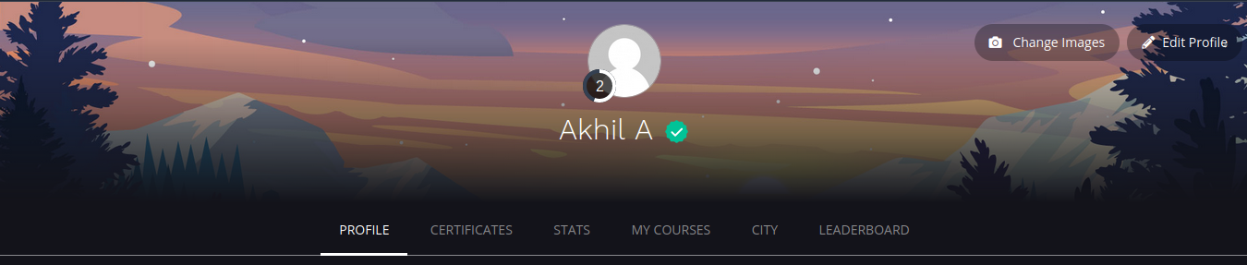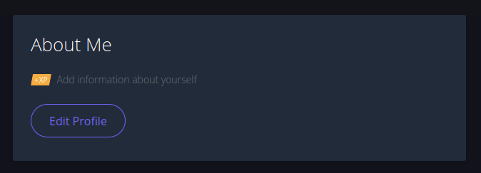

**Certification**

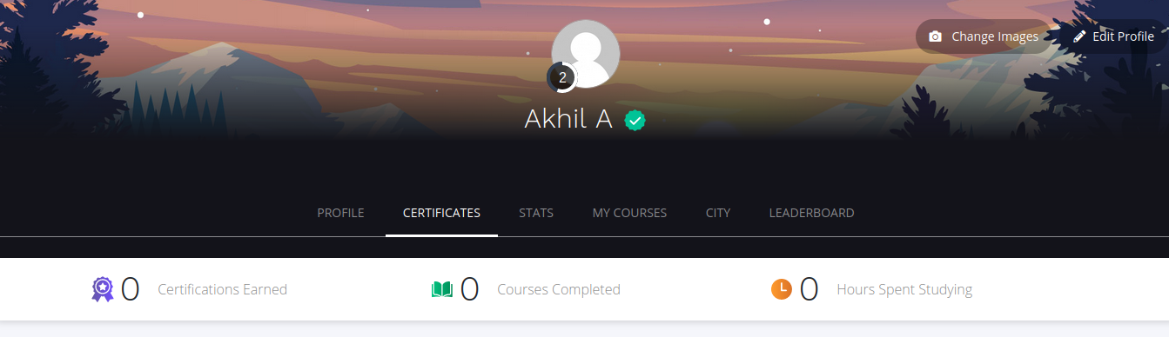

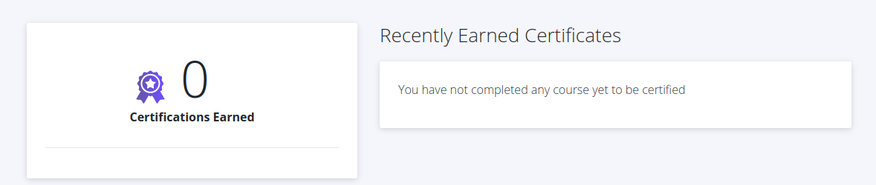

**My Learning**

Upper part and Implementation

**Wishlist**

Same as my learning

**Catalog**

Same as my learning