Main Heading: FP5.0 Module- 3 Assignment

Batch Name: Summer Internship 2018

Enrollment No:R171217008

SAPID:500061147

Name:Anirudh Chaudhary

Sem: II - III

Branch:﻿﻿﻿﻿﻿﻿﻿﻿﻿﻿﻿﻿﻿﻿﻿﻿﻿﻿﻿﻿﻿﻿B.Tech Computer Science(DevOps(1st Year-2nd Year))

***Assignment 1***

Consider a table "Employer" in Oracle database. Structure and sample data for this table is given below.

•Table Structure:

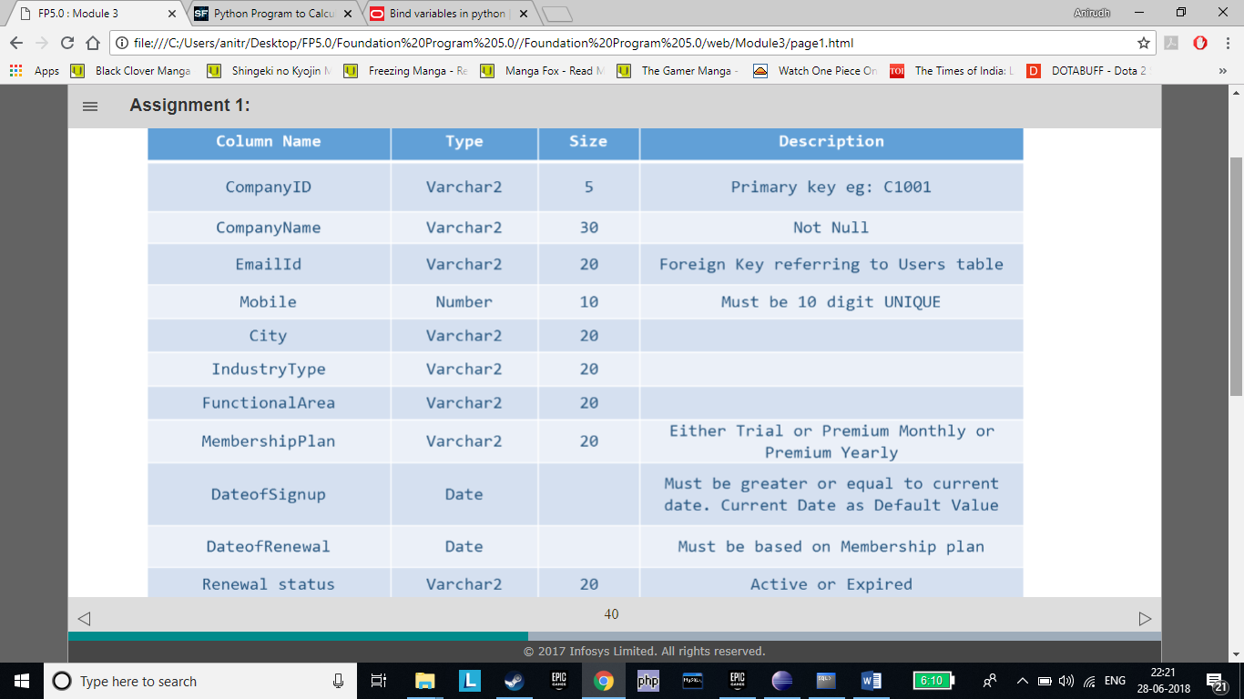

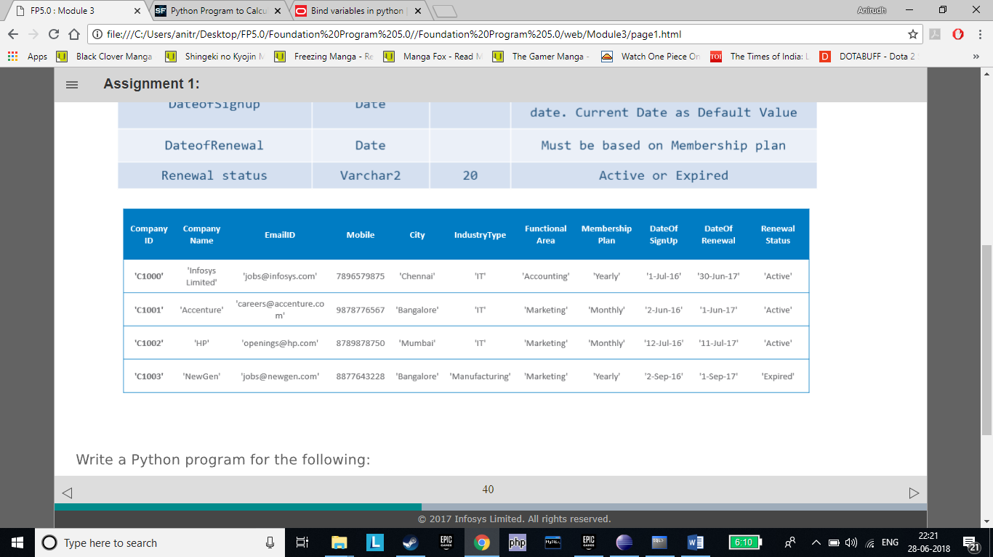

Write a Python program for the following:

1)Connect to Oracle database

2)Fetch all the rows from the table Employer

3)Display all the rows

4)Display the count of rows fetched

5)Display the description of all columns of the table

6)Close the connection

#

import cx_Oracle

con=cx_Oracle.connect(*'ani/mycycle.com'*)

cur=con.cursor()

cur.execute(*"SELECT * From employer"*)

print(cur.fetchall())

print(cur.rowcount)

print(cur.description)

con.close()

#

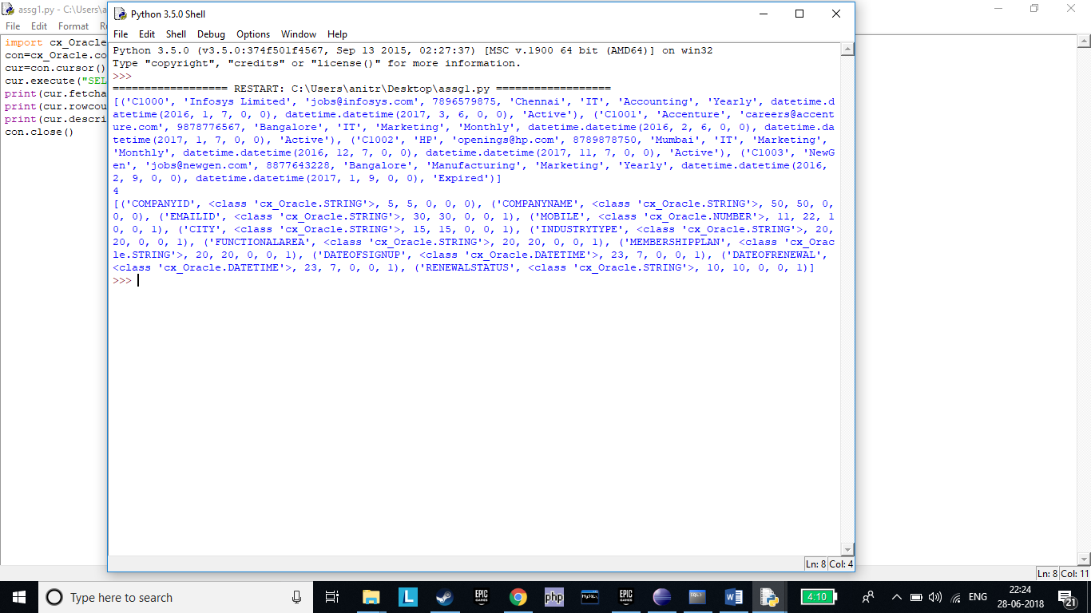

***Assignment 2***

InfoTech Systems wants to retrieve certain information regarding their employers. Help them implement the following business requirements:

1)Retrieve the name and email id of all 'IT' companies in 'Bangalore'.

2)Retrieve the name, mobile number and email id of all companies in a given city whose Renewal Status is 'Active'. Accept 'city' and as an input from user. Use positional bind variables.

3)Reverse the order of passing the parameter values in the above program and observe the output.

4)Implement the scenario in question# 2 using named bind variables.

5)Reverse the order of passing of the bind variables in the above program and observe the output. Are you

still getting the same result?

#

import cx_Oracle

con=cx_Oracle.connect(*'ani/mycycle.com'*)

cur=con.cursor()

cur.execute(*"""SELECT emailid From employer*

*where industrytype='IT' and city='Bangalore'"""*)

print(cur.fetchall())

status=*'Active'*

cit=input(*"ENTER CITY\n"*)

cur.execute(*"""SELECT companyname,mobile,emailid From employer*

*where renewalstatus= :param1 and city= :param2 """*,(status,cit))

print(cur.fetchall())

cur.execute(*"""SELECT companyname,mobile,emailid From employer*

*where renewalstatus= :param1 and city= :param2 """*,(cit,status))

print(cur.fetchall())

cur.execute(*"""SELECT companyname,mobile,emailid From employer*

*where renewalstatus= :param1 and city= :param2 """*,{*'param1'*:status,*'param2'*:cit})

print(cur.fetchall())

cur.execute(*"""SELECT companyname,mobile,emailid From employer*

*where renewalstatus= :param1 and city= :param2 """*,{*'param2'*:cit,*'param1'*:status})

print(cur.fetchall())

con.close()

#

We are still getting the same result as variables are being bound to the name.

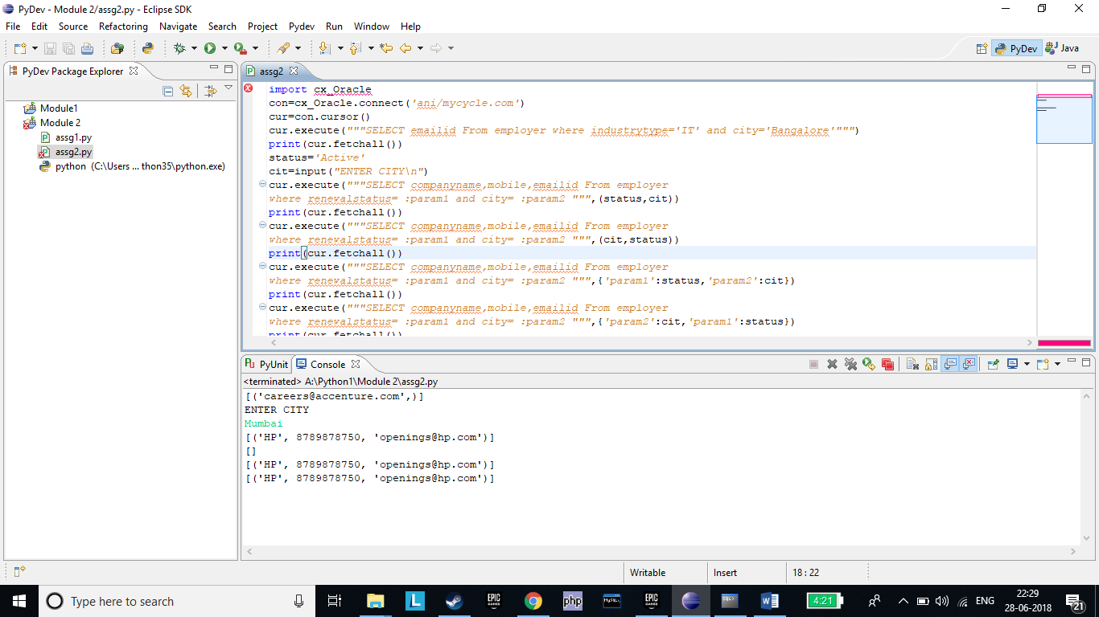

***Assignment 3***

InfoTech Systems is creating an online application for automating the task of job search between employer and job

seekers.

1.Create a table 'Users' from Python code. The column details are given below:

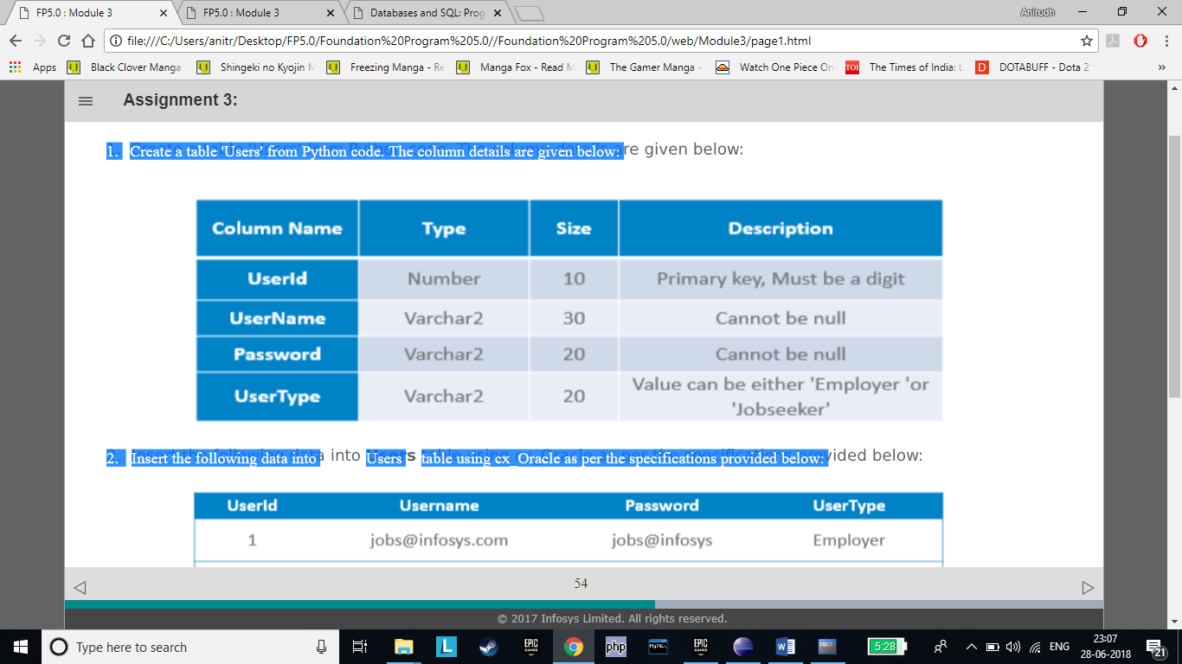

2. Insert the following data into Users table using cx_Oracle as per the specifications provided below:

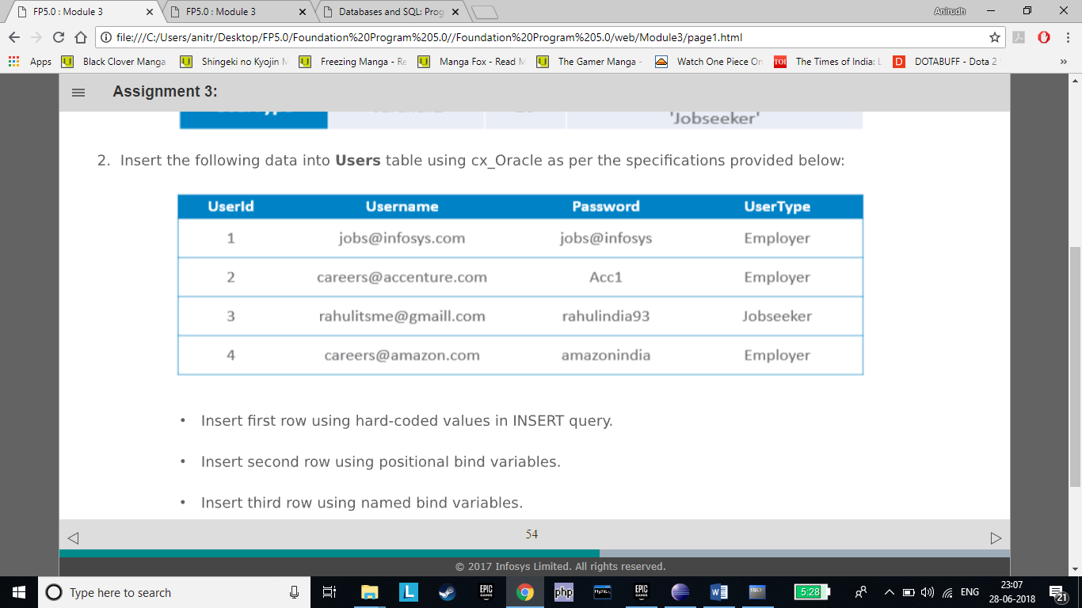

•Insert first row using hard-coded values in INSERT query.

•Insert second row using positional bind variables.

•Insert third row using named bind variables.

•Accept the values for fourth row from user and insert using bind variables.

•Fetch and display all the records from users table.

#

import cx_Oracle

con=cx_Oracle.connect(*'ani/mycycle.com'*)

cur=con.cursor()

cur.execute(*"""Create Table users(*

*userid number(10) primary key,*

*username varchar2(30) not null,*

*password varchar2(20) not null,*

*usertype varchar2(20) CHECK (usertype IN ('Employer','Jobseeker'))*

*)"""*)

cur.execute(*"""insert into users values(1,'jobs@infosys.com','jobs@infosys','Employer')"""*)

uid1=2

uname1=*'careers@accenture.com'*

upwd1=*'Acc1'*

utype1=*'Employer'*

cur.execute(*"""insert into users values(:A,:B,:C,:D)"""*,(uid1,uname1,upwd1,utype1))

uid2=3

uname2=*'rahulitsme@gmail.com'*

upwd2=*'rahulindia93'*

utype2=*'Jobseeker'*

cur.execute(*"""insert into users values(:par1,:par2,:par3,:par4)\n"""*,{*'par1'*:uid2,*'par2'*:uname2,*'par3'*:upwd2,*'par4'*:utype2})

uid3=int(input(*"ENTER USER ID\n"*))

uname3=input(*"ENTER USER NAME\n"*)

upwd3=input(*"ENTER USER PASSWORD\n"*)

utype3=input(*"ENTER USER TYPE\n"*)

cur.execute(*"""insert into users values(:var1,:var2,:var3,:var4)"""*,{*'var1'*:uid3,*'var2'*:uname3,*'var3'*:upwd3,*'var4'*:utype3})

cur.execute(*"SELECT * From users"*)

data=cur.fetchall()

for line in data:

print(line)

con.commit()

con.close()

#

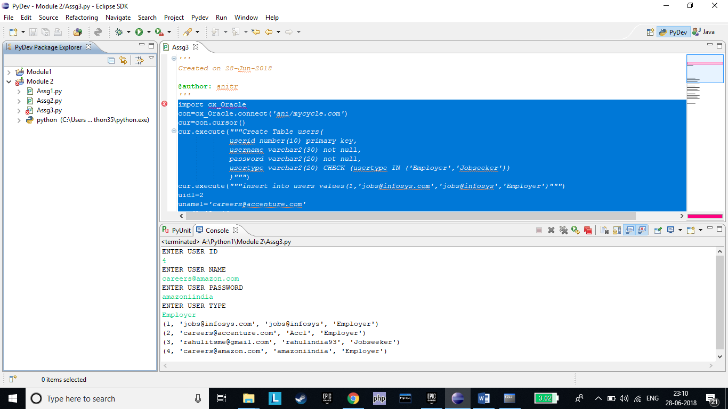

***Assignment 4***

Bloom Technology wants to maintain their employee's vehicle details to make parking facility flexible to the employees.

1.Create the following Vehicle table as a part of the application. Specifications are provided below:

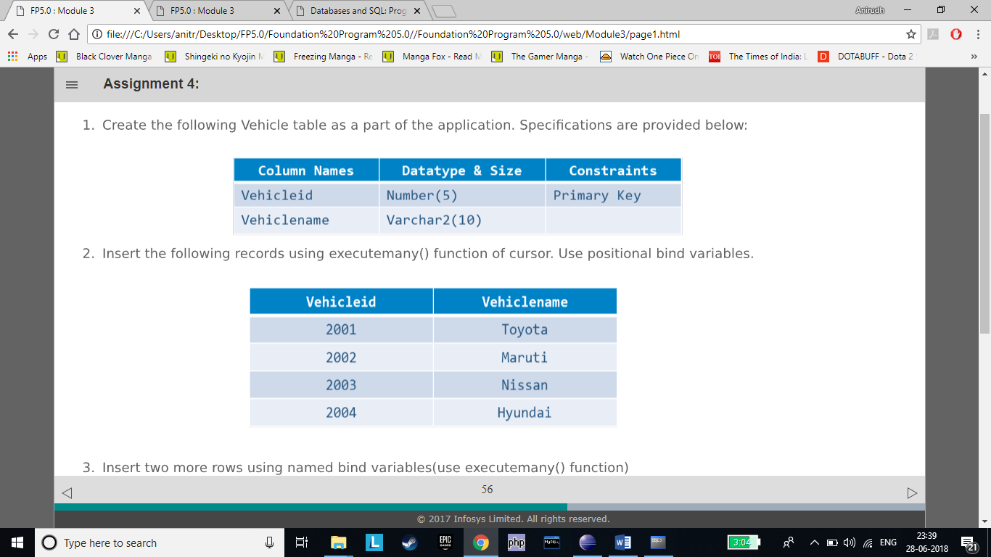

2.Insert the following records using executemany() function of cursor. Use positional bind variables.



3.Insert two more rows using named bind variable (use executemany() function)

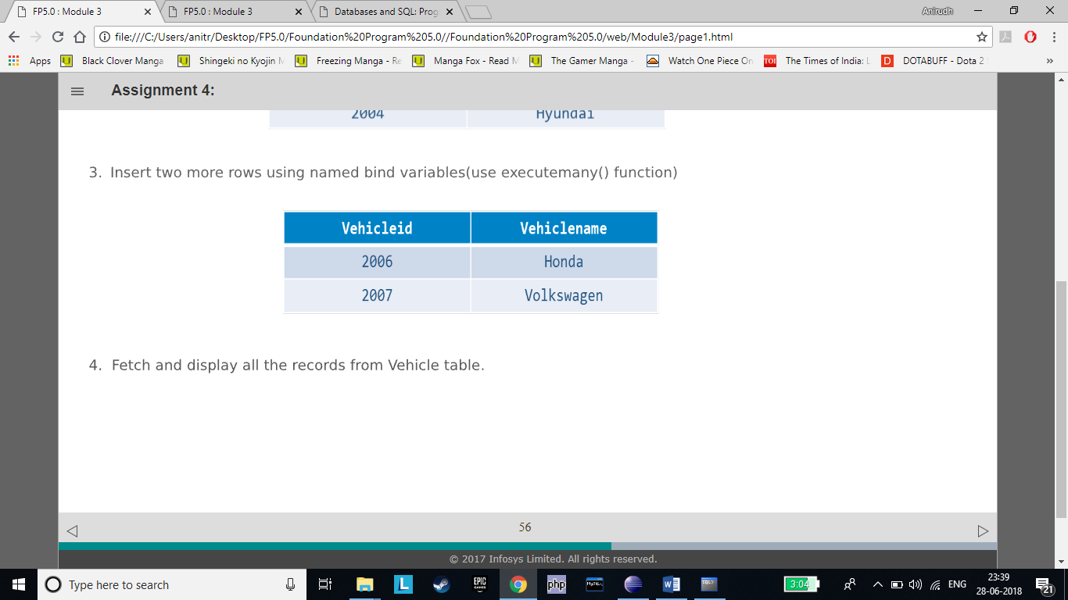

4. Fetch and display all the records from Vehicle table.

#

import cx_Oracle

con=cx_Oracle.connect(*'ani/mycycle.com'*)

cur=con.cursor()

cur.execute(*"""Create Table vehicle(*

*vehicleid number(5) primary key,*

*vehiclename varchar2(10) not null)"""*)

vid=2001

cur.executemany(*"""insert into vehicle values(:var1,:var2)"""*,

[(vid,*'Toyota'*),(vid+1,*'Maruti'*),(vid+2,*'Nissan'*),(vid+3,*'Hyundai'*)])

cur.executemany(*"""insert into vehicle values(:par1,:par2)"""*,

[{*'par1'*:vid+5,*'par2'*:*'Hondaa'*},

{*'par1'*:vid+6,*'par2'*:*'Volkswagen'*},

])

cur.execute(*"SELECT * From vehicle"*)

data=cur.fetchall()

for line in data:

print(line)

con.commit()

con.close()

#

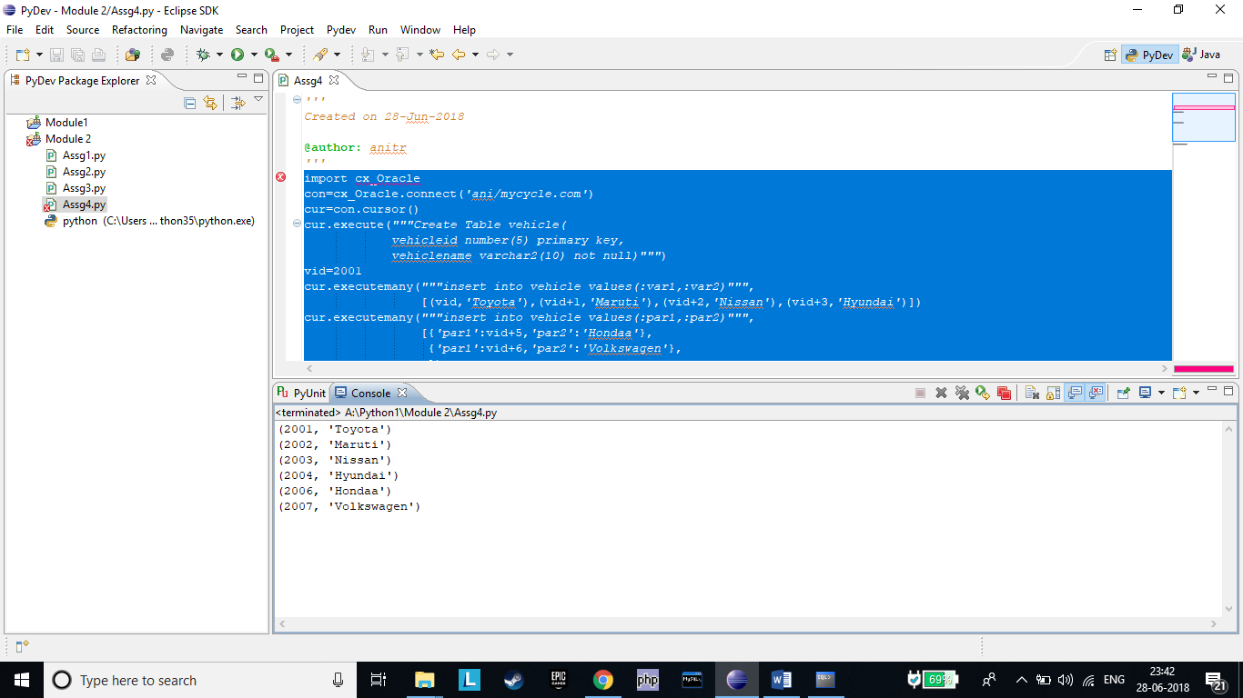

***Assignment 5***

Refer to the table 'users' created earlier. The existing table data for “users” table is given below:

1.Modify the username and usertype of the user with userid = 4 with the following values:

•Username: lookingforjob@yahoo.com

•UserType: Jobseeker

Fetch and observe the values of 'username' and 'usertype' of the user with 'userid = 4' before and after 'update' operation.

2.Change the password for userid = 1. Accept the new password as an input from user. Fetch and observe the value of 'password' of the user with 'userid = 1' before and after 'update' operation.

#

import cx_Oracle

con=cx_Oracle.connect(*'ani/mycycle.com'*)

cur=con.cursor()

cur.execute(*"SELECT * From user1 where userid=4"*)

data=cur.fetchall()

for line in data:

print(line)

cur.execute(*"UPDATE user1 set username= :var1 , usertype= :var2 where userid=4"*,{*'var1'*:*"lookingforjob@yahoo.com"*,*'var2'*:*"Jobseeker"*})

cur.execute(*"SELECT * From user1 where userid=4"*)

data=cur.fetchall()

for line in data:

print(line)

cur.execute(*"SELECT * From user1 where userid=1"*)

data=cur.fetchall()

for line in data:

print(line)

psw=input(*"ENTER NEW PASSWORD(USER 1)\n"*)

cur.execute(*"UPDATE user1 set password= :par1 where userid=1"*,{*'par1'*:psw})

cur.execute(*"SELECT * From user1 where userid=1"*)

data=cur.fetchall()

for line in data:

print(line)

con.commit()

con.close()

#

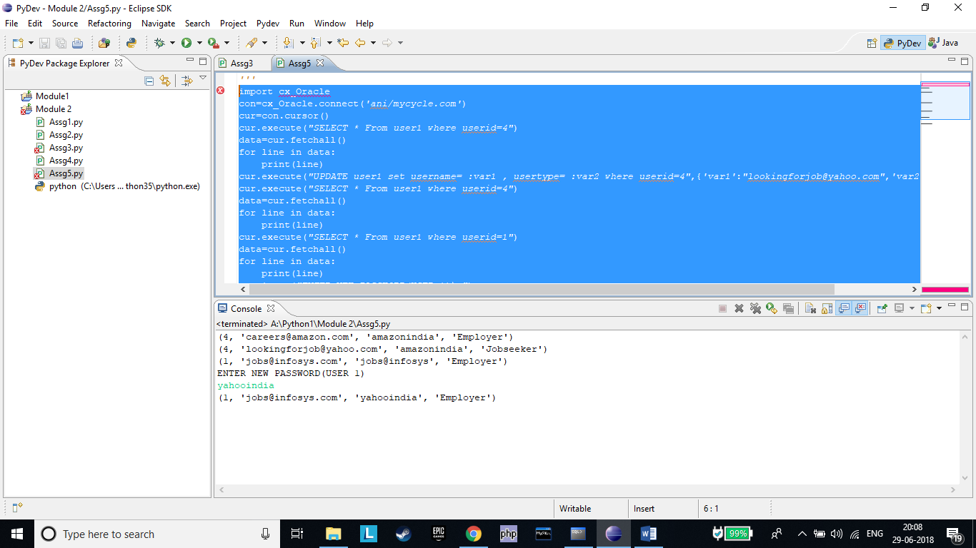

***Assignment 6***

Consider the 'Vehicle' table created earlier. Currently 'Vehicleid' is an integer field with values starting from

2001 onwards.

•Update the values of 'Vehicleid' to start from 1001 onwards as shown below.

- Hint – Use loops

•Update the Vehiclename to "Mahindra" for vehicle with vehicle id 1003.

•Fetch and display the values before and after the update operation.

#

import cx_Oracle

con=cx_Oracle.connect(*'ani/mycycle.com'*)

cur=con.cursor()

print(*"OLD TABLE"*)

cur.execute(*"SELECT * From vehicle"*)

data=cur.fetchall()

for line in data:

print(line)

oldid=2001

newid=1001

for line in data:

cur.execute(*"update vehicle set vehicleid= :var1 where vehicleid= :var2"*,{*'var1'*:newid,*'var2'*:oldid})

oldid+=1

newid+=1

cur.execute(*"update vehicle set vehiclename='Mahindra' where vehicleid=1003"*)

print(*"\nUPDATED TABLE"*)

cur.execute(*"SELECT * From vehicle"*)

data=cur.fetchall()

for line in data:

print(line)

con.commit()

con.close()

#

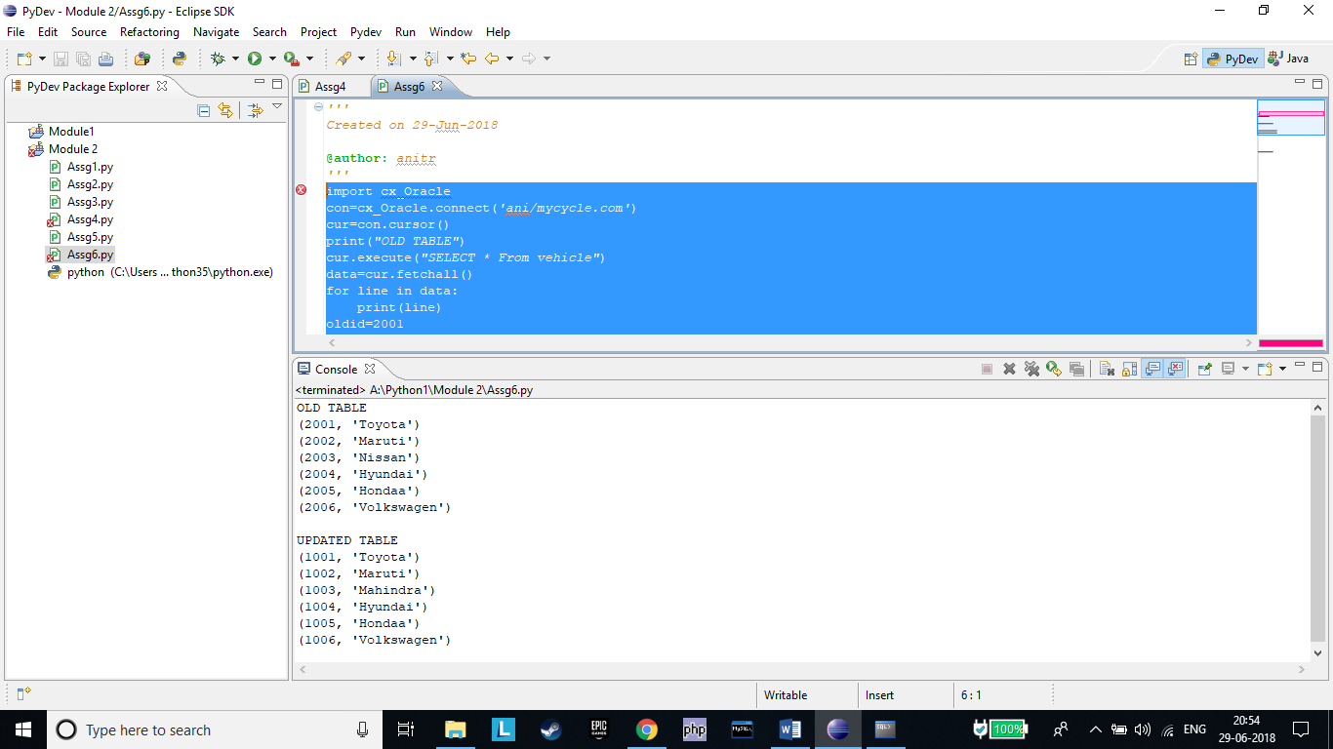

***Assignment 7***

1)Consider 'users' table. Delete the record of user with userid = 1.

2)Delete a record from 'Vehicle' table using named bind variables. Accept VehicleId as an input from the user.

#

import cx_Oracle

con=cx_Oracle.connect(*'ani/mycycle.com'*)

cur=con.cursor()

cur.execute(*"Delete From user1 where userid=1"*)

cur.execute(*"Select * from user1"*)

data=cur.fetchall()

for line in data:

print(line)

vid=int(input(*"ENTER VEHICLE ID\n"*))

cur.execute(*"Delete From vehicle where vehicleid= :var"*,(vid,))

cur.execute(*"Select * from vehicle"*)

data=cur.fetchall()

for line in data:

print(line)

con.commit()

con.close()

#

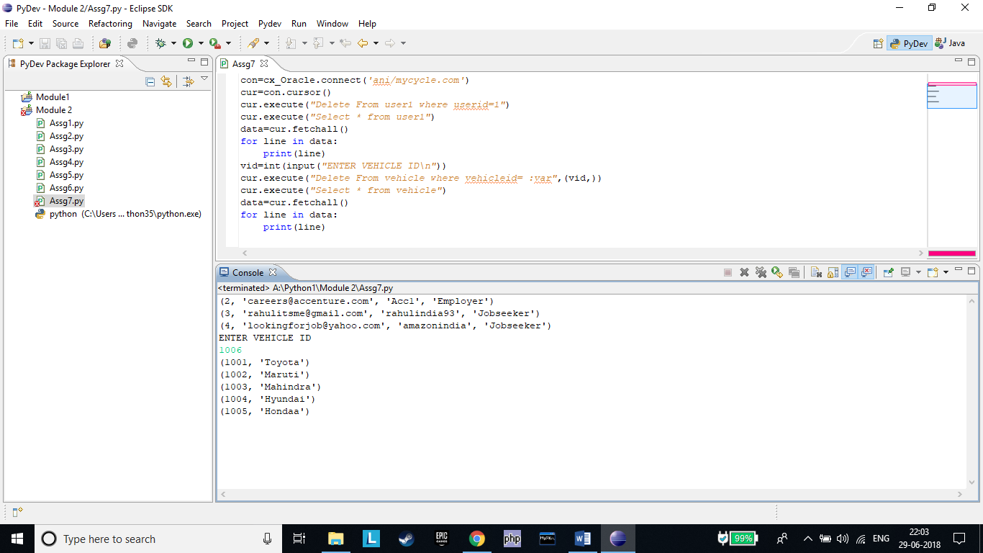

***Assignment 8***

Consider a scenario from a State Banking organization. The account table is created to store the account details of a customer (Assume every customer can have only one account). Use cx_Oracle module to implement the following requirements from Python code.(Do not execute the queries in database directly)

1.Create the table 'Account' as per below specifications:

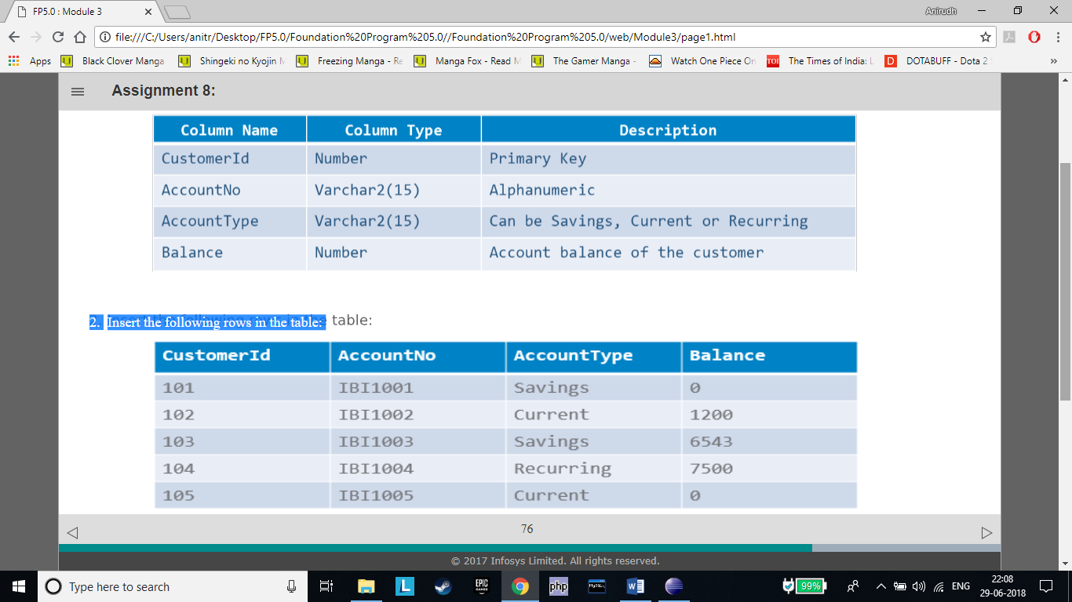

2.Insert the following rows in the table:



3.Display the customer id and account balance of the customer with maximum account balance.

4.Fetch the account balance of the customer with customer id 102 and store it in a Python variable – 'acct_bal'.

5.Increment 'acct_bal' with 2000 and update the 'Balance' field of the table (for that particular customer) with the new value.

6.Fetch and observe the updated account balance of the customer with customer id 102.

7.Delete the 'Current' accounts with zero balance

#

import cx_Oracle

con=cx_Oracle.connect(*'ani/mycycle.com'*)

cur=con.cursor()

cur.execute(*"""Create Table account(*

*customerid number(10) primary key,*

*accountno varchar2(15) not null,*

*accounttype varchar2(15) CHECK (accounttype IN ('Savings','Current','Recurring')),*

*balance number(10) not null*

*)"""*)

cid=101

acno=*'IBI100'*

cur.executemany(*"""insert into account values(:par1,:par2,:par3,:par4)"""*,

[{*'par1'*:cid,*'par2'*:acno+*'1'*,*'par3'*:*'Savings'*,*'par4'*:0},

{*'par1'*:cid+1,*'par2'*:acno+*'2'*,*'par3'*:*'Current'*,*'par4'*:1200},

{*'par1'*:cid+2,*'par2'*:acno+*'3'*,*'par3'*:*'Savings'*,*'par4'*:6543},

{*'par1'*:cid+3,*'par2'*:acno+*'4'*,*'par3'*:*'Recurring'*,*'par4'*:7500},

{*'par1'*:cid+4,*'par2'*:acno+*'5'*,*'par3'*:*'Current'*,*'par4'*:0}

])

print(*"ORIGINAL TABLE"*)

cur.execute(*"SELECT * from account"*)

data=cur.fetchall()

for line in data:

print(line)

print(*"\nCUSTOMER WITH MAX BALANCE"*)

cur.execute(*"select customerid,balance from account where balance=(select max(balance) from account)"*)

data=cur.fetchall()

for line in data:

print(line)

print(*"\nBALANCE OF ID 102"*)

cur.execute(*"select balance from account where customerid=102"*)

data=cur.fetchall()

for acct_bal in data:

print(acct_bal)

acct_bal=acct_bal[0]+2000

cur.execute(*"update account set balance=:var where customerid=102"*,(acct_bal,))

print(*"\nUPDATED BALANCE"*)

cur.execute(*"select balance from account where customerid=102"*)

data=cur.fetchall()

for line in data:

print(line[0])

cur.execute(*"DELETE FROM account where balance=0 and accounttype='Current'"*)

print(*"\nUPDATED TABLE"*)

cur.execute(*"SELECT * from account"*)

data=cur.fetchall()

for line in data:

print(line)

con.commit()

con.close()

#

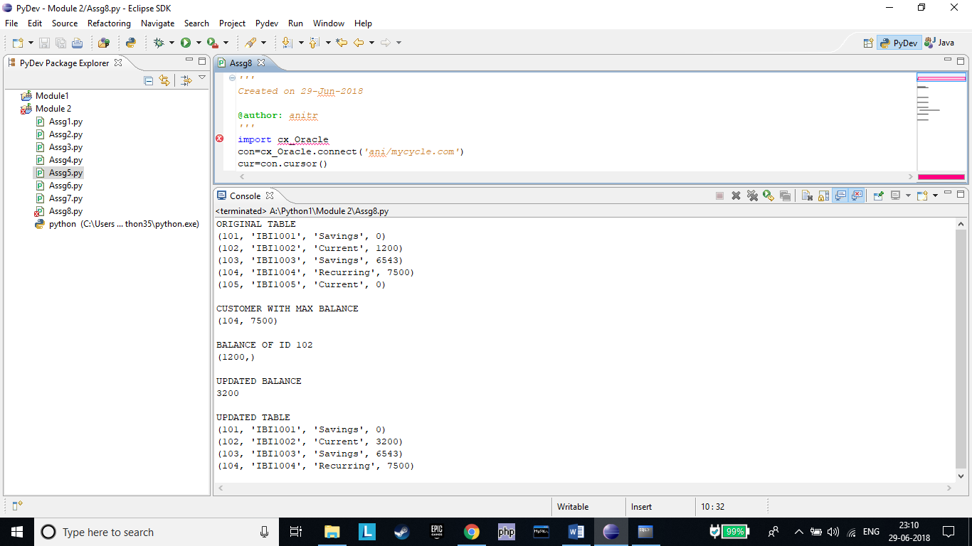

***Assignment 9***

•Consider 'users' table already created. It has following data:

There is a requirement to delete the record of user with 'userid' 2.

•Try to mention incorrect column name(e.g. user_id) and observe the error.

•Use exception handling to handle the exception appropriately. Display the error code and message.

•Try to give incorrect username for connection string and observe the error code and message.

•Provide a wrong table name while writing the query and observe the error message.

#

import cx_Oracle

con=cx_Oracle.connect(*'ani/mycycle.com'*)

cur=con.cursor()

try:

cur.execute(*"Delete from user1 where user_id=2"*)

except cx_Oracle.DatabaseError as e:

print(e)

id=*'rahulitsme@gmaill.com'*

try:

cur.execute(*"Delete from user1 where username=:var"*,{*'var'*:id})

except:

print(*"ERROR"*)

try:

cur.execute(*"select * from user"*)

except cx_Oracle.DatabaseError as f:

print(f)

else:

data=cur.fetchall()

for line in data:

print(line)

con.commit()

con.close()

#

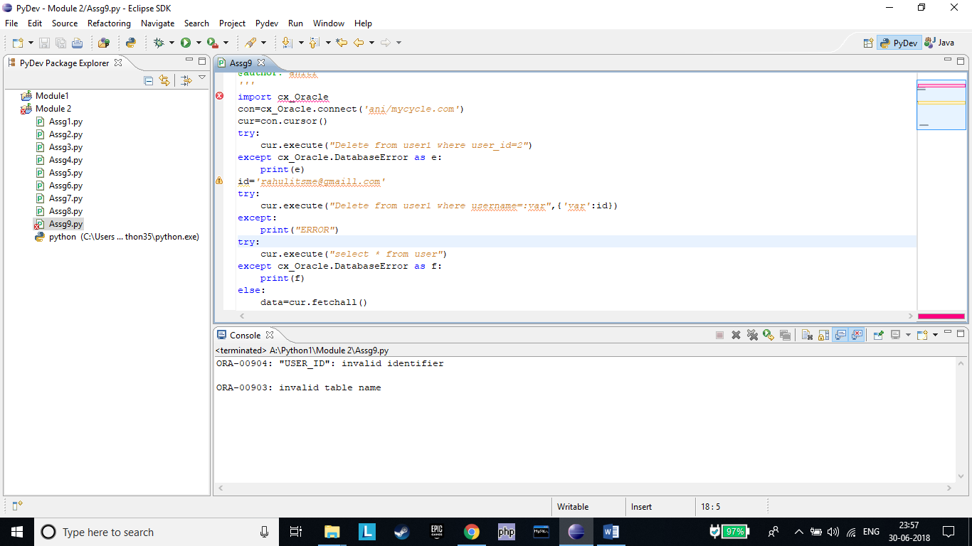

***Assignment 10***

Consider the 'product' table already created. There is a requirement to insert one more row in the table.

•The following Python program is written to insert the row to the 'product' table. Execute the program and

observe if there is any error.

Use exception handling to handle the error (if any) and display error message appropriately

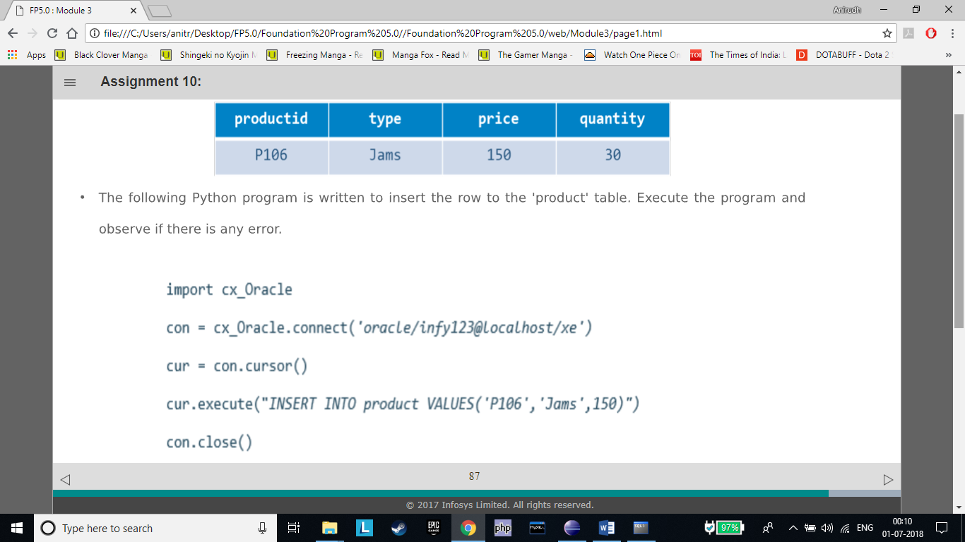

#

import cx_Oracle

con=cx_Oracle.connect(*'ani/mycycle.com'*)

cur=con.cursor()

try:

cur.execute(*"INSERT INTO product VALUES('P106','Jams',150)"*)

except cx_Oracle.DatabaseError as e:

print(*"ERROR OCUURED\n"*,e,*"\nINSERTING DEFAULT VALUE 0\n"*)

cur.execute(*"INSERT INTO product VALUES('P106','Jams',150,0)"*)

cur.execute(*"Select * from product"*)

data=cur.fetchall()

for line in data:

print(line)

con.close()

#

