FP5.0 Module-3 Project

Batch Name: Summer Internship 2018

Enrollment No:R171217008

SAPID:500061147

Name:Anirudh Chaudhary

Sem: II - III

Branch:﻿﻿﻿﻿﻿﻿﻿﻿﻿﻿﻿﻿﻿﻿﻿﻿﻿﻿﻿﻿﻿﻿B.Tech Computer Science(DevOps(1st Year-2nd Year))

***SPECIFICATIONS***

* The project is to extend the InstaDB project by integrating the Oracle database with a Python program.
* The Python Program should connect to InstaDB and allow the user to perform given queries.
* The data needs to be pulled from multiple tables using SQL queries and logic needs to be written in Python program to join the result from those queries to get the desired result. (However, you will learn a simpler way of achieving the same result in Module 5 using ˜Join" operator.)
* For query Which of my pictures has received maximum likes?:
  + Retrieve pic ids from "Pictures" Table where user-id = myUserId and store them in Python list
  + Iterate over that list, say using For loop of Python, and retrieve no. of likes for each of these pictures from "Likes" table, and store in another list
  + Find and display the picture id with maximum likes
* What needs to be done:
  + Write a Python program that connects to database created in InstaDB project
  + Program should show menu based choices from 1 to 8 for each of the given queries and execute the query based on users choice:
    - Max Likes
    - Min Likes
    - Who liked most
    - Music pictures
    - Popular Tag
    - Most liked User
    - Old Tagging
    - Delete Inactive Users
  + After displaying results of a query in console window, main menu should appear again and prompt for users choice
* Queries:
  + Max Likes - Which of my pictures (picture ids) has received maximum likes?
  + Min Likes - Which of my pictures (picture ids) has received minimum likes?
  + Who liked most - Who (user id) has liked pictures most?
  + Music pictures - Show all pictures related to music.
  + Popular Tag - What is the name of most popular tag?
  + Most liked User - Whose pictures (user id) have been liked most?
  + Old Tagging - Tag my pictures older than 3 years Old
  + Delete Inactive Users - Delete inactive users i.e. who have not done activity for past 1 yea

#

import cx_Oracle

con=cx_Oracle.connect(*'ani/mycycle.com'*)

cur=con.cursor()

def **maxlike**():

cur.execute(*"""select c.picid,likes,userid from (select picid,count(picid) as likes from instalike*

*group by picid order by count(picid)desc)c,instapic d where rownum=1 and c.picid=d.picid and userid=:var"""*,(user_id,))

data=cur.fetchall()

for line in data:

print(*"MOST LIKED PIC"*)

print(*"PICID:"*,line[0],*"\nLIKES:"*,line[1],*"\nUSERID:"*,line[2])

def **minlike**():

cur.execute(*"""select c.picid,likes,userid from (select picid,count(picid) as likes from instalike*

*group by picid order by count(picid))c,instapic d where rownum=1 and c.picid=d.picid and userid=:var"""*,(user_id,))

data=cur.fetchall()

for line in data:

print(*"MINLIKED PIC"*)

print(*"PICID:"*,line[0],*"\nLIKES:"*,line[1],*"\nUSERID:"*,line[2])

def **uselike**():

cur.execute(*"""select c.userid,likes from (select userid,count(userid) as likes from instalike*

*group by userid order by count(userid)desc) c,instapic d where rownum=1 and c.userid=d.userid"""*)

data=cur.fetchall()

for line in data:

print(*"USER WHO LIKED MOST PIC"*)

print(*"USERID"*,line[0],*"\nLIKES:"*,line[1])

def **tag**():

cur.execute(*"""select * from instapic where tag='Music'"""*)

data=cur.fetchall()

print(*"PICS RELATED TO MUSIC"*)

for line in data:

print(*"PICID:"*,line[0],*"CAPTION:"*,line[1],*"DATE:"*,line[2],*"USERID:"*,line[3])

def **poptag**():

cur.execute(*"""select * from (select tag,count(tag) as Popular from instapic group by tag order by count(tag)desc)*

*where rownum=1"""*)

data=cur.fetchall()

for line in data:

print(*"MOST POPULAR TAG"*)

print(*"TAG:"*,line[0],*"\nUSE COUNT:"*,line[1])

def **liked_user**():

cur.execute(*"""select c.userid,sum(likes) from (select userid,count(userid) as likes from instalike group by userid*

*order by count(userid)desc) where rownum=2"""*)

data=cur.fetchall()

for line in data:

print(*"MOST LIKED USER"*)

print(*"USERID"*,line[0],*"\nLIKES:"*,line[1])

def **tagold**():

cur.execute(*"""update instapic set tagold='Old' where post < sysdate - interval '3' year"""*)

cur.execute(*"""SELECT * from instapic"""*)

print(*"UPDATED TABLE"*)

data=cur.fetchall()

for line in data:

print(line)

def **delold**():

cur.execute(*"""delete from instapic a inner join instauser b where a.userid=b.userid and post<sysdate - interval '1' year"""*)

cur.execute(*"""SELECT * from instauser"""*)

print(*"UPDATED TABLE"*)

data=cur.fetchall()

for line in data:

print(line)

user_id=int(input(*"ENTER USERID\n"*))

cho=1

while cho!=0:

print(*"""\n____MENU___\n1.Max Likes \n2.Min Likes \n3.Who liked most\n4.Music pictures\n5.Popular Tag\n6.Most liked User*

*7.Old Tagging\n8.Delete Inactive Users\n0.Exit"""*)

cho=int(input(*"ENTER CHOICE\n"*))

if cho==1:

maxlike()

elif cho==2:

minlike()

elif cho==3:

uselike()

elif cho==4:

tag()

elif cho==5:

poptag()

elif cho==6:

liked_user()

elif cho==7:

tagold()

elif cho==8:

delold()

else:

print(*"EXIT\n"*)

con.close()

#

***SOURCE CODE SCREENSHOTS***

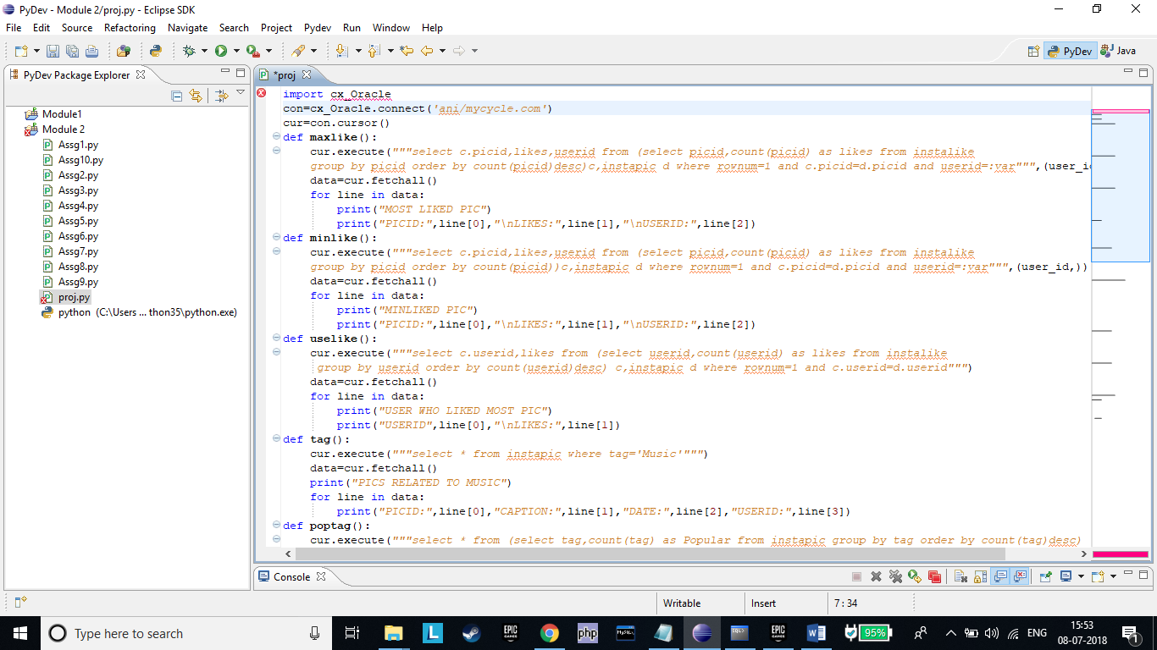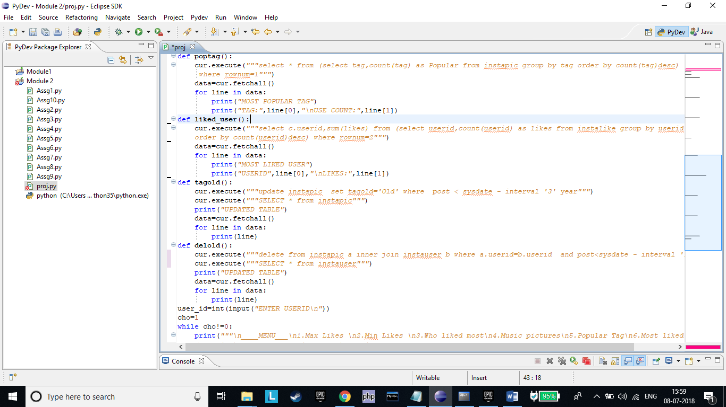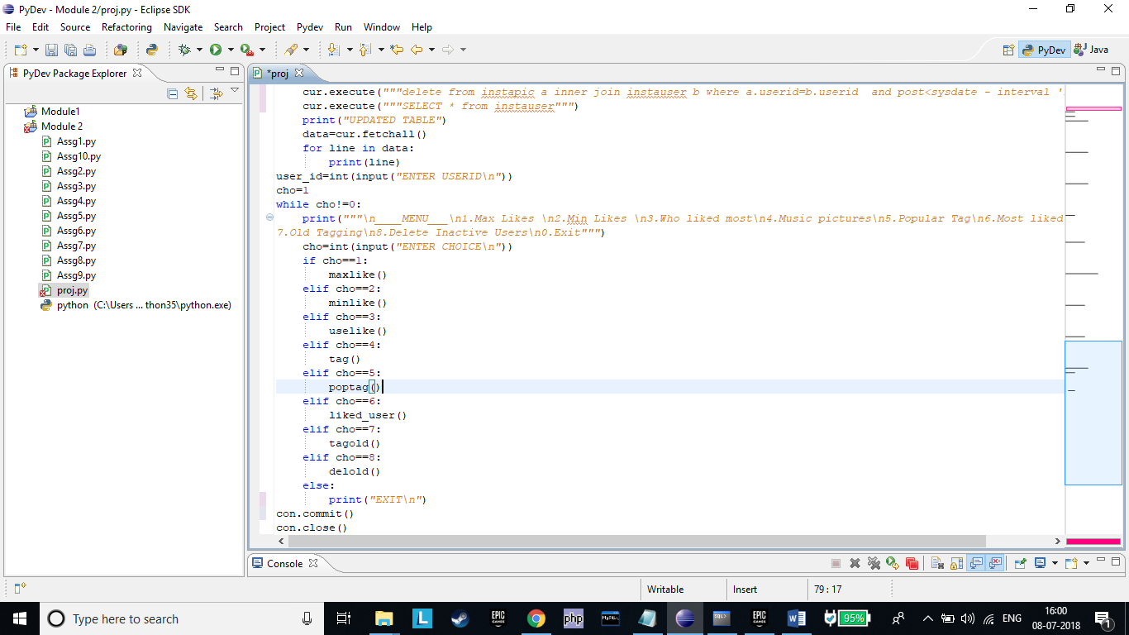

***OUTPUT SCREENSHOTS***

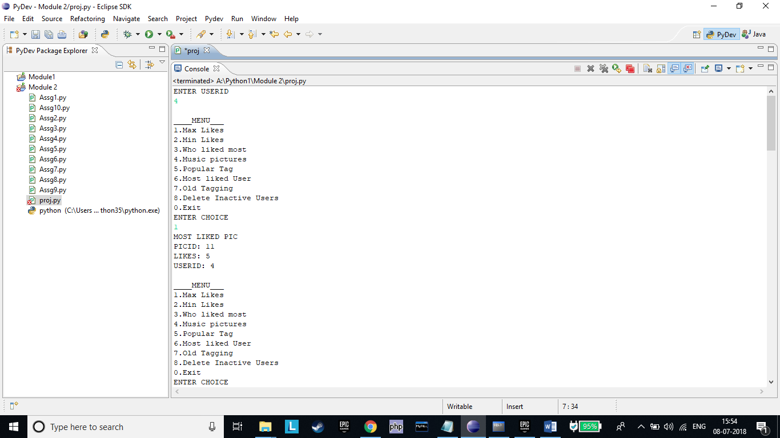

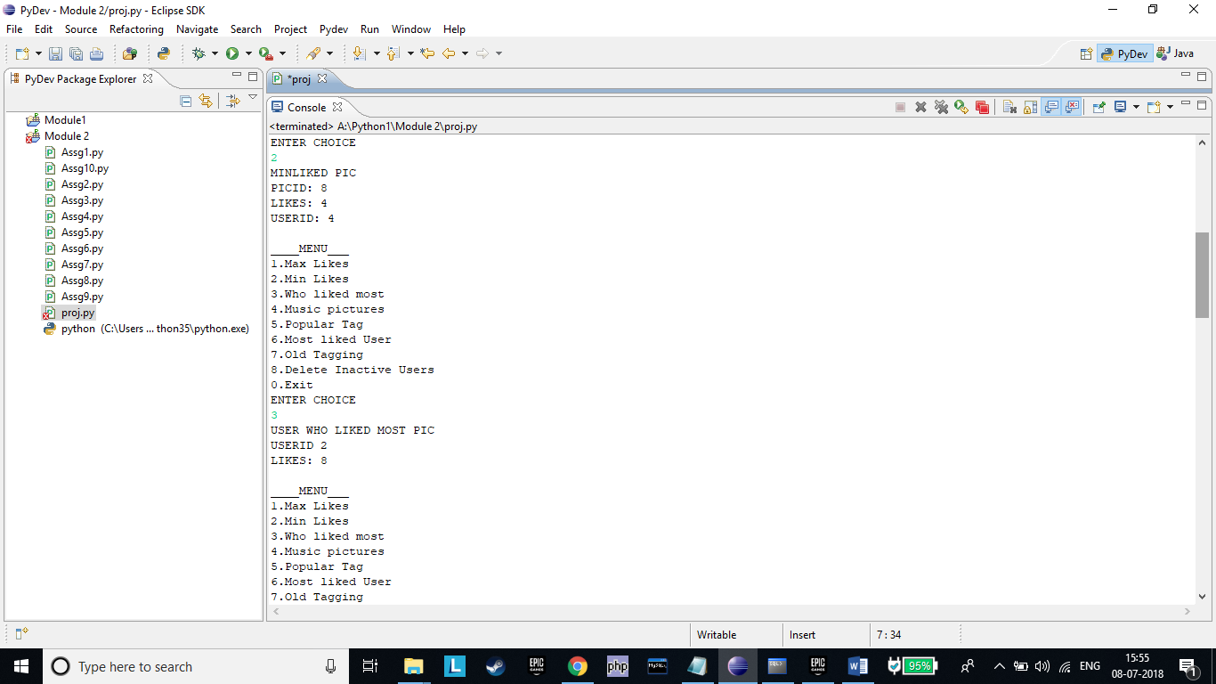

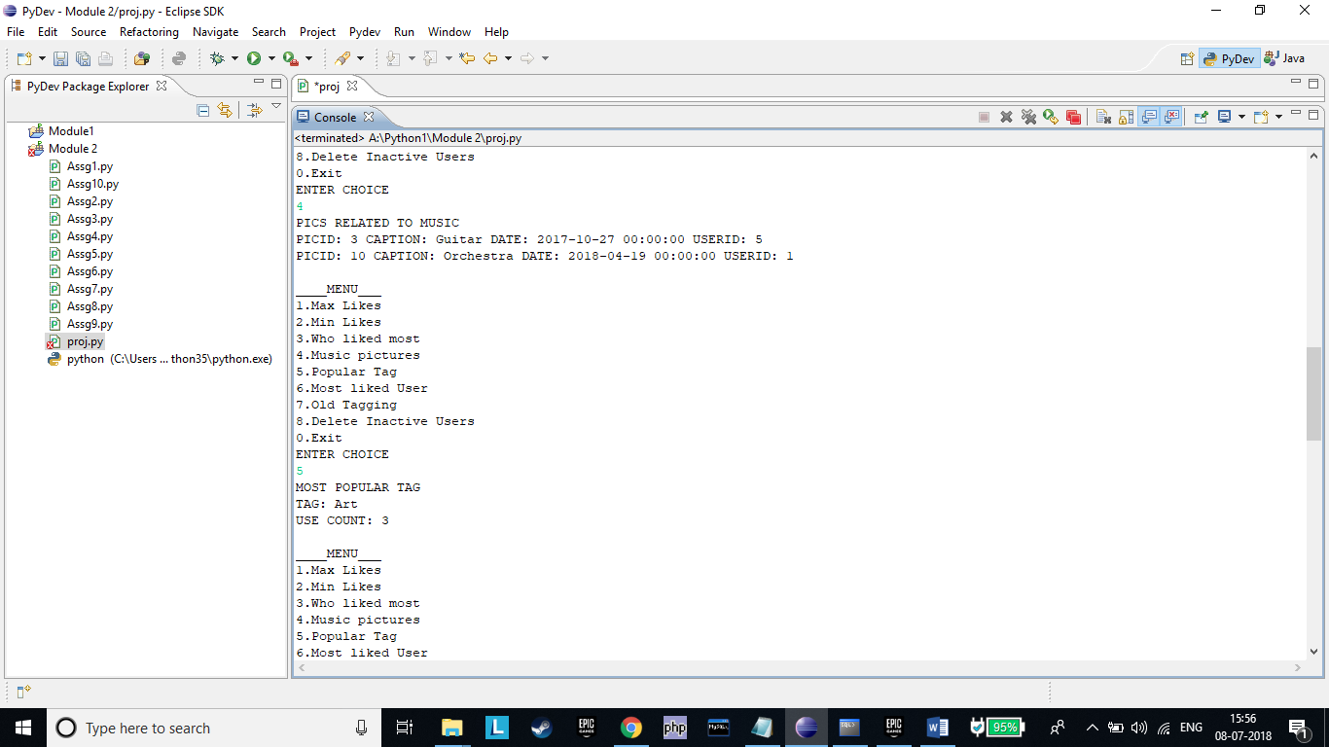

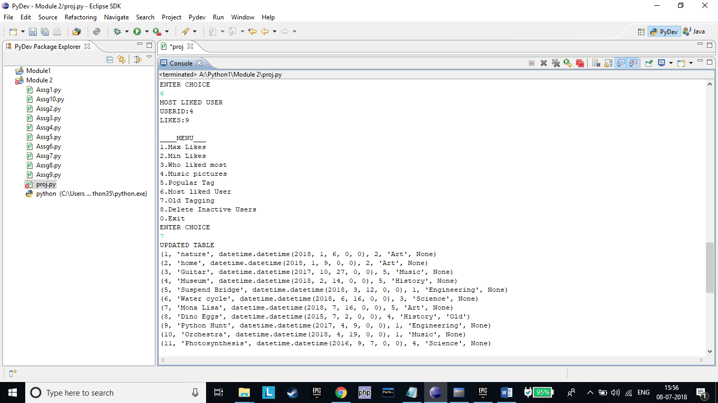

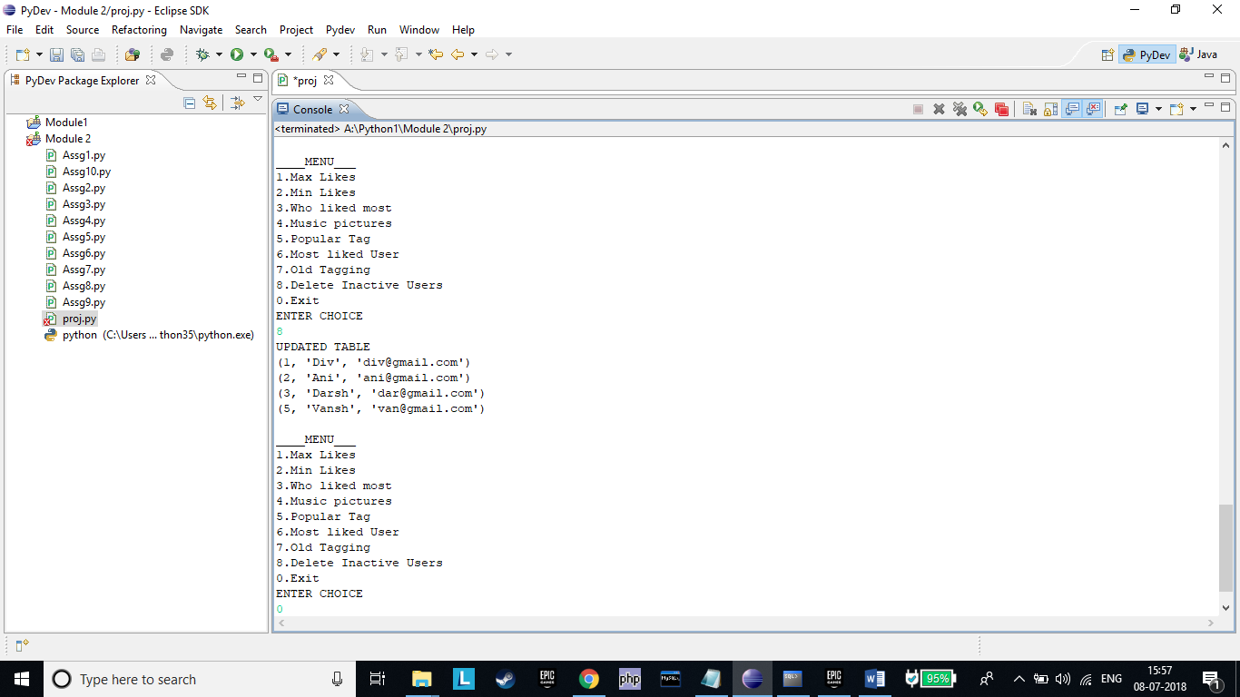

***SQL TABLES IN CLIENT***

