Main Heading: FP5.0 Module-1 Project

Batch Name: Summer Internship 2018

Enrollment No:R171217008

SAPID:500061147

Name:Anirudh Chaudhary

Sem: II - III

Branch:﻿﻿﻿﻿﻿﻿﻿﻿﻿﻿﻿﻿﻿﻿﻿﻿﻿﻿﻿﻿﻿﻿B.Tech Computer Science(DevOps(1st Year-2nd Year))

***Project Specifications***

The project is to write a Python program that reads a text file, scrambles the words in the file on following rules and writes the output to a new text file:

* Words less than or equal to 3 characters need not be scrambled
* Don't scramble first and last char, so Scrambling can become Srbmnacilg or Srbmnailcg or Snmbracilg , i.e. letters except first and last can be scrambled in any order
* Punctuation at the end of the word to be maintained as is i.e. "Surprising," could become "Spsirnirug," but not "Spsirn,irug"
* Following punctuation marks are to be supported - Comma Question mark, Full stop, Semicolon, Exclamation
* Do this for a file and maintain sequences of lines

***Solution***

***Source Code***

*'''*

*Created on 18-Jun-2018*

**@author:** *anirudh*

*'''*

# Open the file is input is not there create one

try:

in_text = open(*"in.txt"*, *"r"*)

out_text = open(*"out.txt"*, *"w"*)

except IOError:

print(*"File in.txt does not exist creating default one."*)

new_file = open(*"in.txt"*, *"w"*)

string = *"""*

*After completing this project, a learner should be able to understand and implement the following fundamental concepts of Python Programming in solving a real world problem.*

*Variables*

*Data Structures*

*String Lists*

*Control Structures*

*If / else statements, For loop*

*Functions*

*File Handling and Operations*

*"""*.strip()

new_file.write(string)

new_file.close()

in_text = open(*"in.txt"*, *"r"*)

out_text = open(*"out.txt"*,*"w"*)

# Function to shuffle the chars around

def **scramble**(word):

if len(word) == 1:

return word

else:

half = int(len(word) / 2)

# First half in reverse

first = word[:half][::-1]

# Last half in reverse

last = word[half:len(word)][::-1]

# First + Last in reverse

return (first+last)[::-1]

# Function to scramble the word

def **shuffle**(word):

if len(word) < 3:

return word

first = word[:1]

last = word[-1:]

mid = word[1:-1]

if last == *"."* or last == *","* or last == *"?":*

last = word[-2:]

mid = word[1:-2]

return (first) + (scramble(mid)) + (last)

# Read the input and write the scrambled words to the output

for line in in_text:

line = line.strip()

new_line = *""*

for word in line.split(*" "*):

new_line+=shuffle(word)+*" "*

print(new_line, file = out_text)

# Close open files

in_text.close()

out_text.close()

#Output Of in.txt and out.txt in the terminal only

re=open(*"in.txt"*,*"r"*)

out=open(*"out.txt"*,*"r"*)

print(*"---------original Text File---------\n"*,re.read(),*"\n"*)

print(*"---------Scrambled Text File---------\n"*,out.read())

re.close()

out.close()

***SCREENSHOT(IDLE SOURCE CODE)***

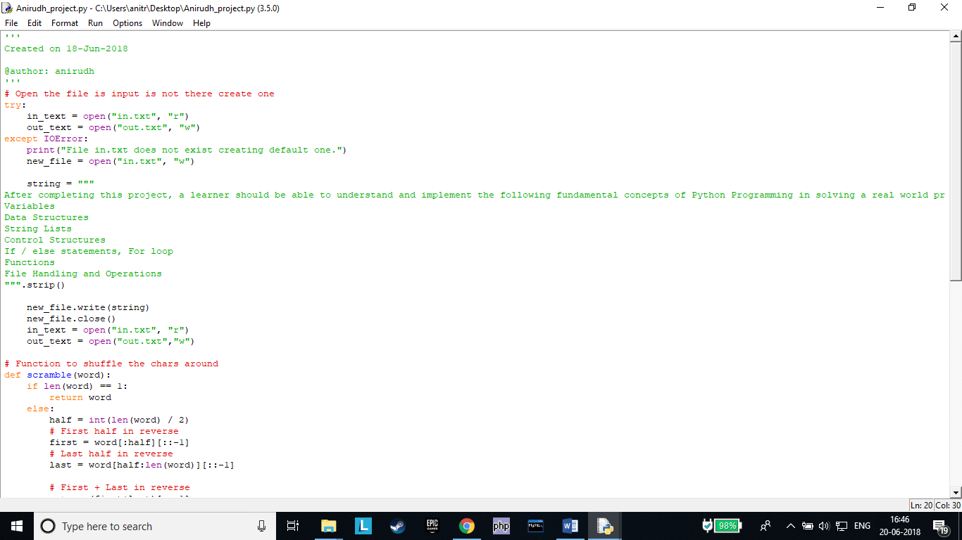

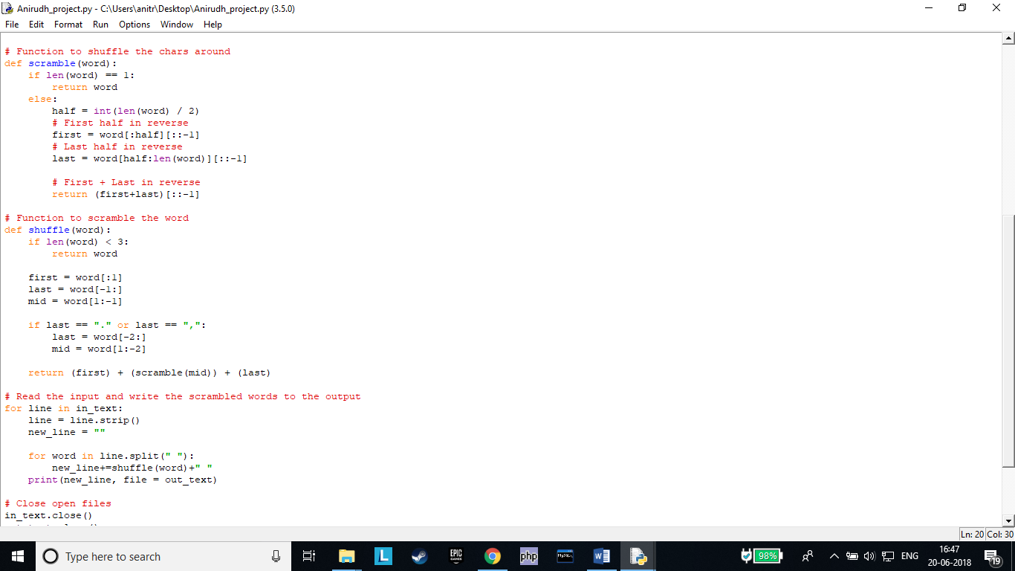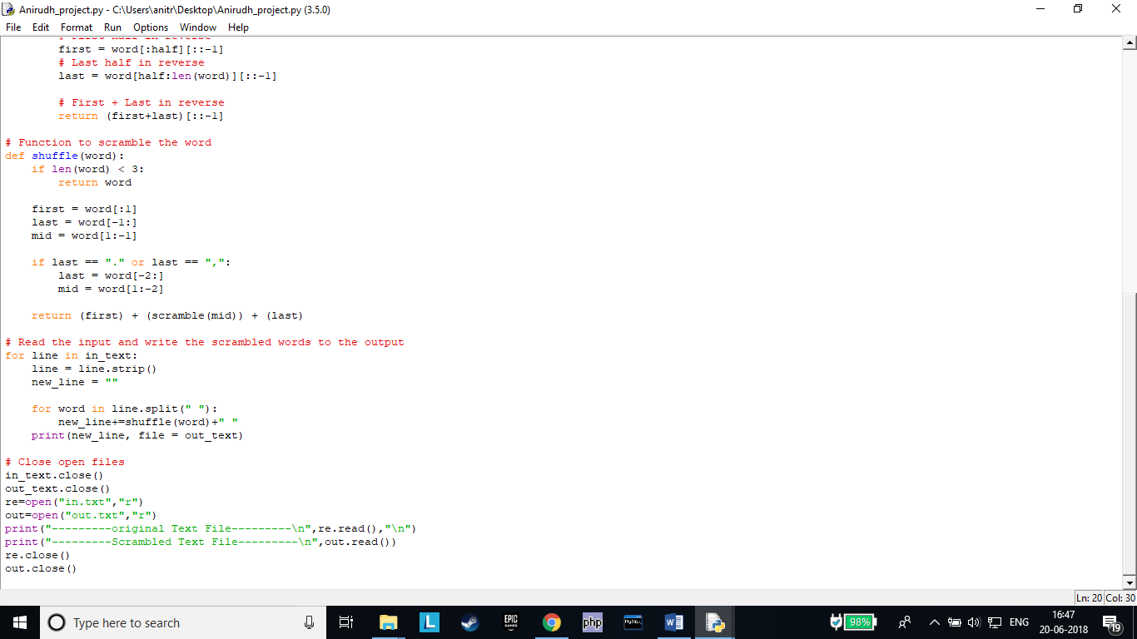

***SCREENSHOT( IDE(ECLIPSE) SOURCE CODE)***

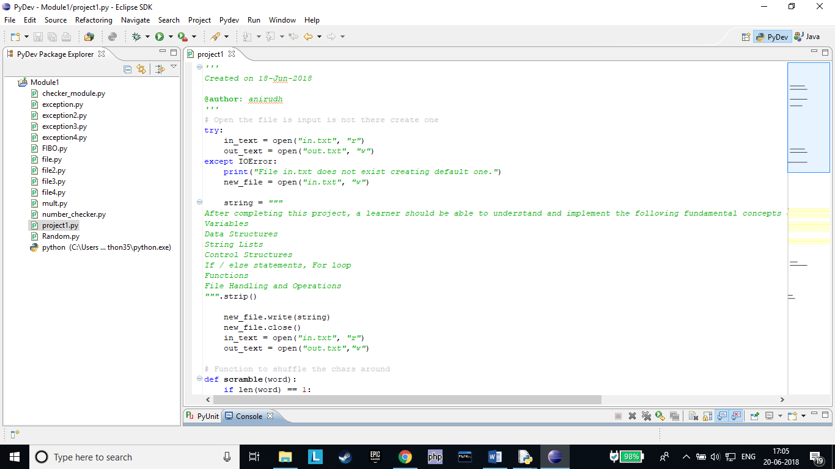

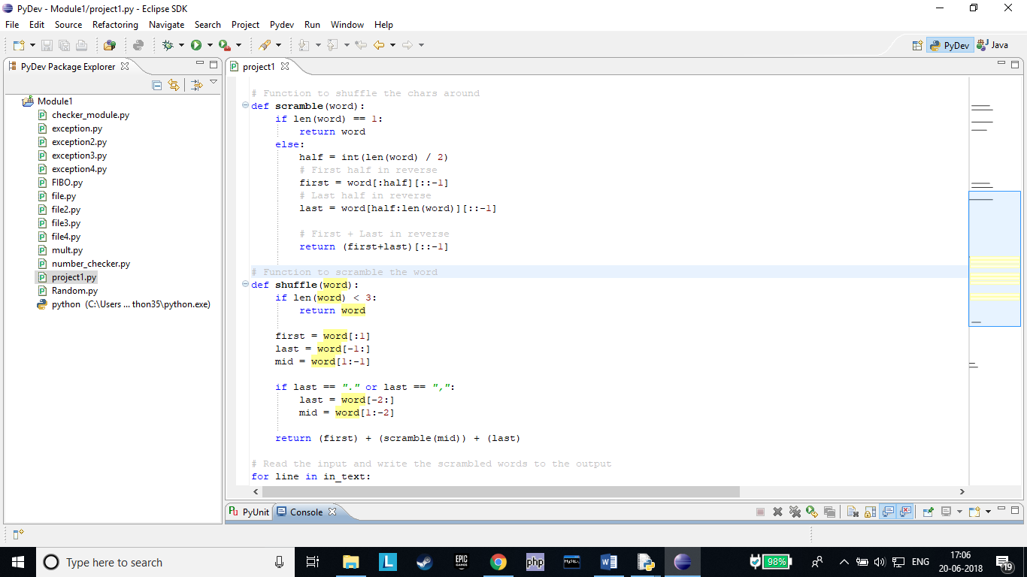

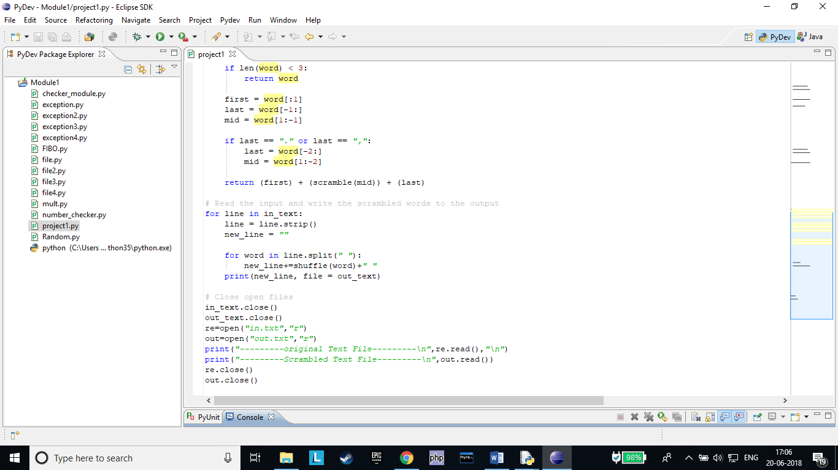

***OUTPUT OF DEFAULT SITUATION WHEN FILE DOES NOT EXIST!!***

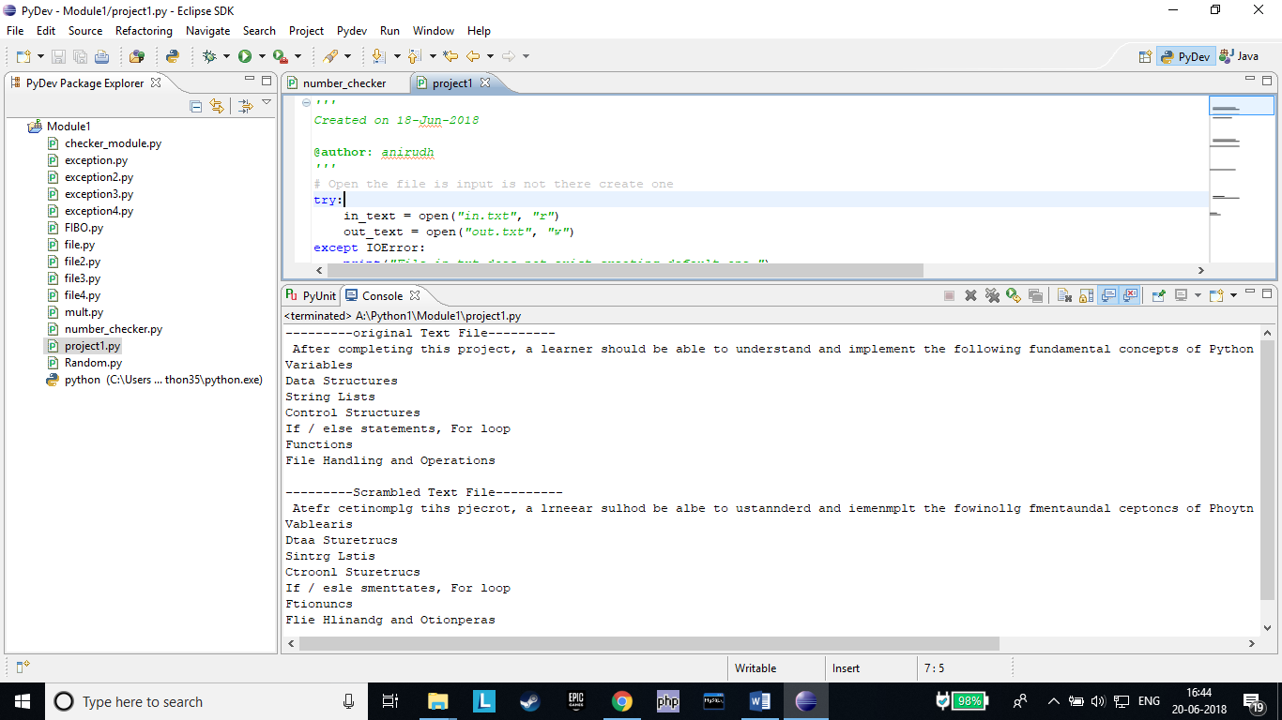

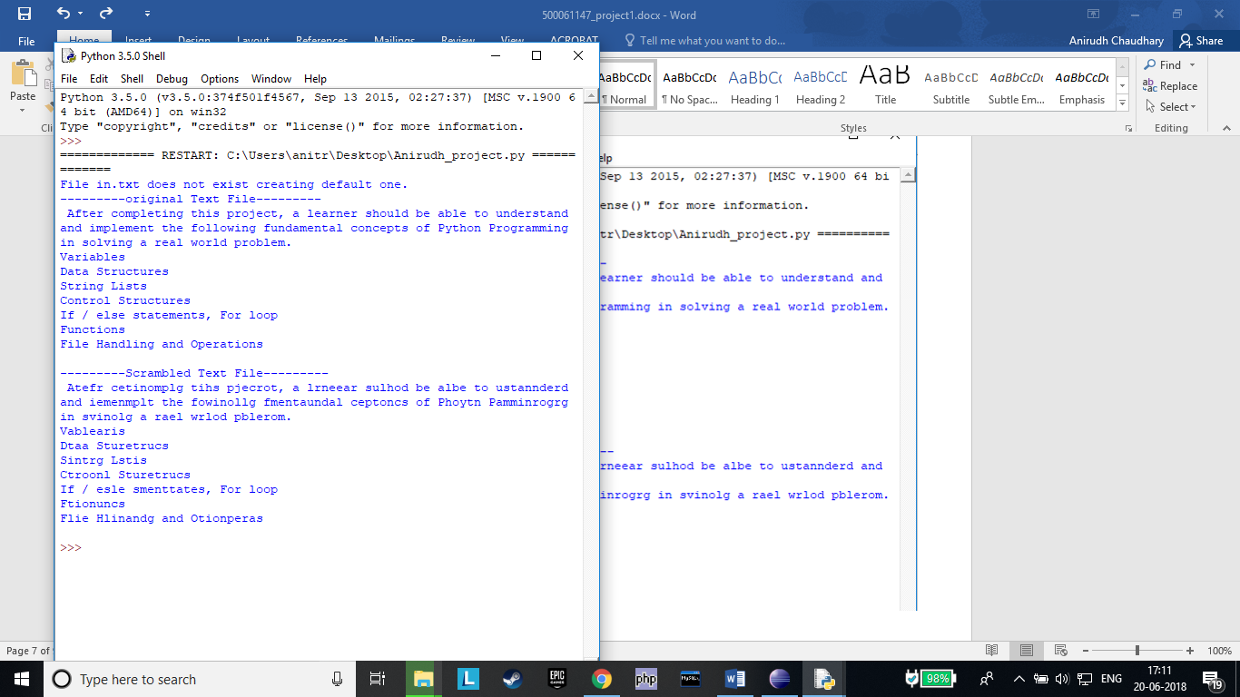

***DEFAULT CREATION OF INPUT AND OUTPUT FILES “in.txt” and “out.txt” RESPECTIVELY***

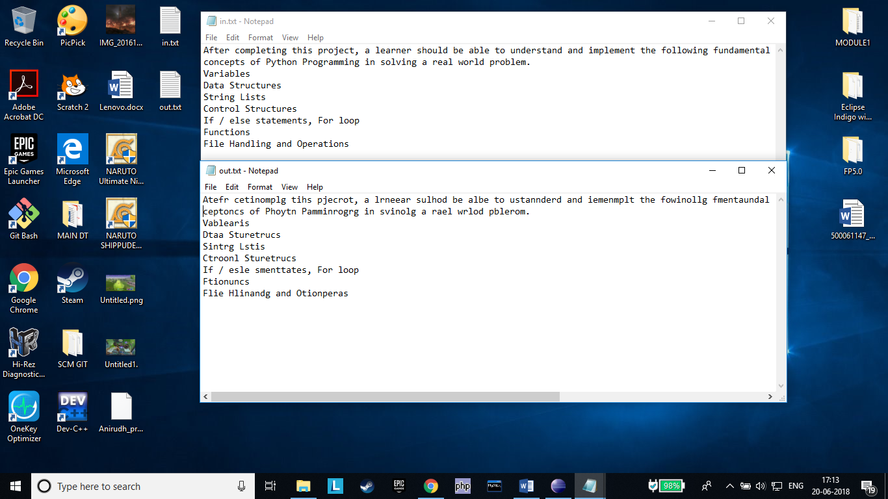

***SAMPLE DATA INPUT IN “in.txt”***

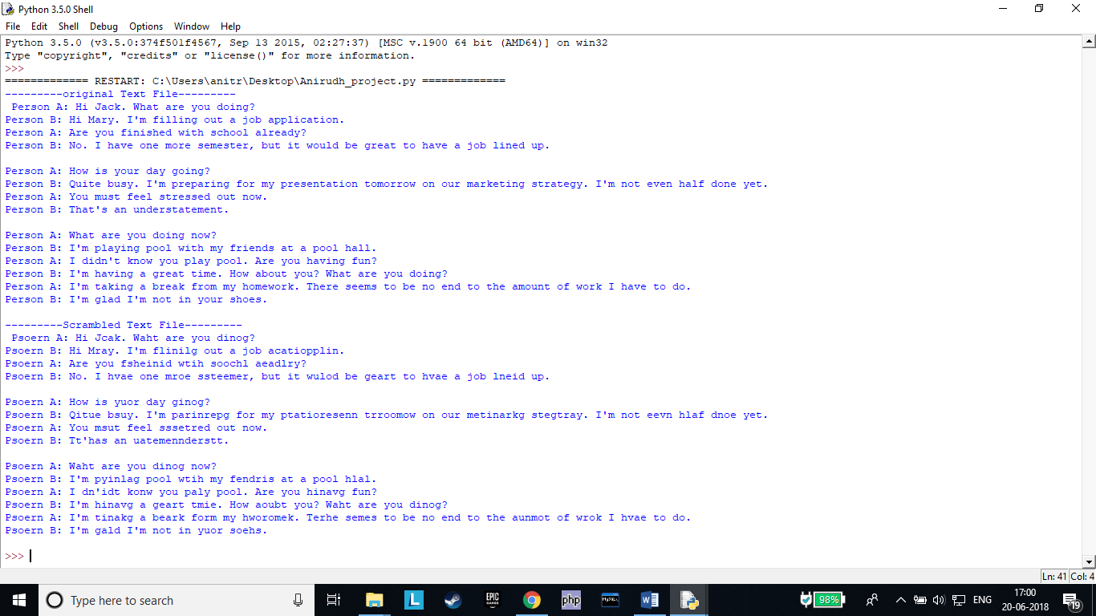

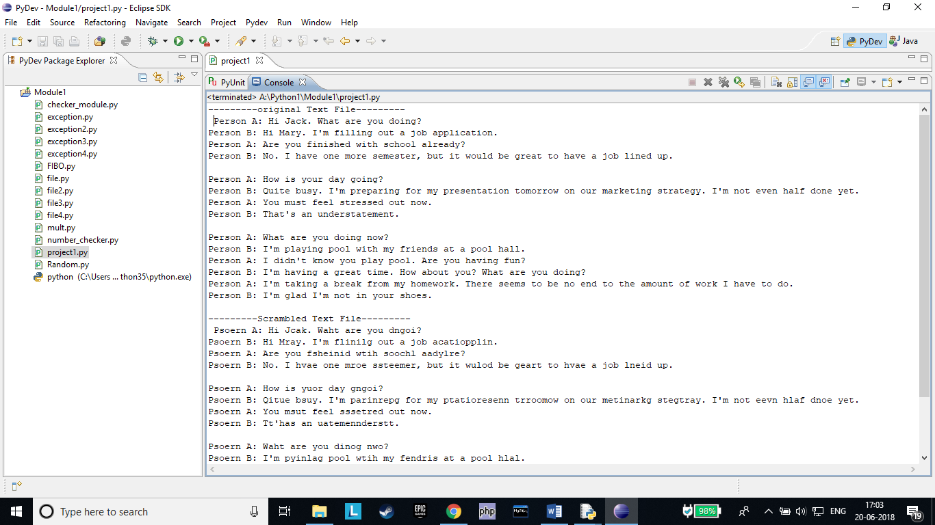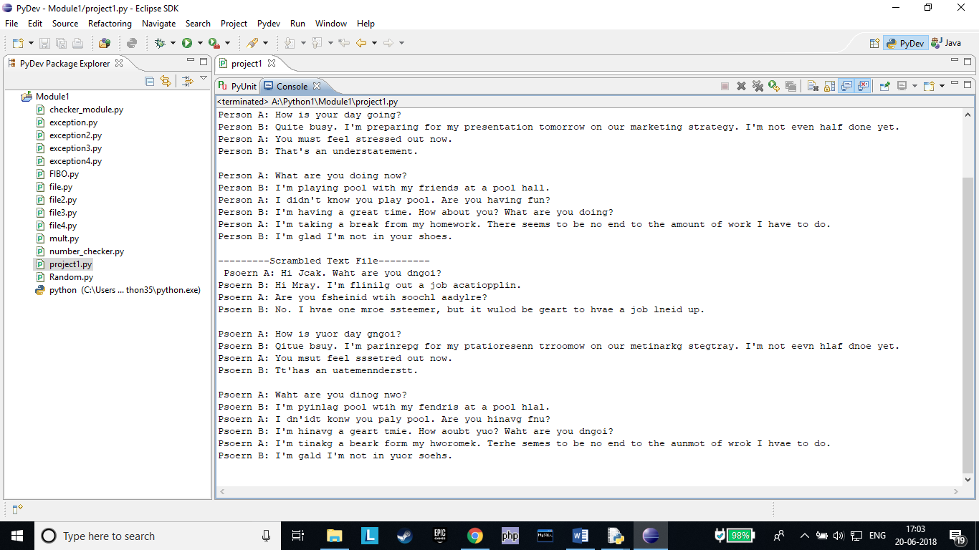

***INPUT AND OUTPUT IN THE TEXT FILES “in.txt” and “out.txt” RESPECTIVELY***

