**ANNEXURE**

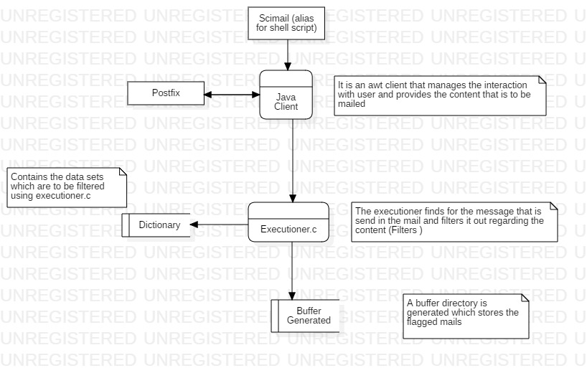

**DFD DIAGRAM**

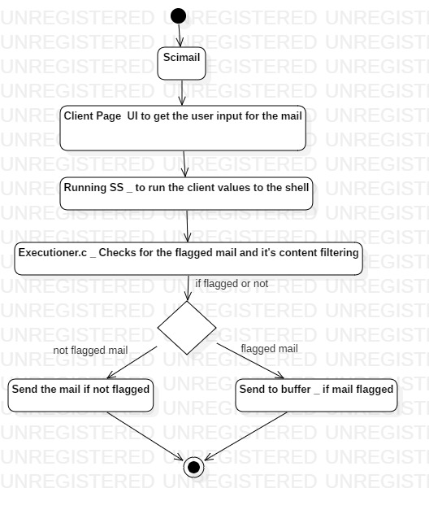

**ACTIVITY DIAGRAM**