**Email Server configuration and customization**

***A***

***Project Report***

*Submitted in partial fulfillment of the*

*requirements for the award of the degree of*

**BACHELOR OF TECHNOLOGY**

**In**

**COMPUTER SCIENCE & ENGINEERING**

**With Specialization in DevOps**

**By**

|  |  |
| --- | --- |
| **Name** | **Roll No.** |
| **Anirudh Chaudhary** | **R171217008** |
| **Darsh Asawa** | **R171217016** |
| **Saurabh Dimri** | **R171217052** |
| **Shivam Pandey** | **R171217053** |

***Under the guidance of***

**Dr. Monit Kapoor**

**Associate Professor**



**Department of Cybernetics**

**School of Computer Science**

**University of Petroleum & Energy Studies**

**Bidholi, Via Prem Nagar, Dehradun, UK**

**DECEMBER – 2019**

**CANDIDATE’S DECLARATION**

We hereby certify that the project work entitled **“Email Server Configuration and Customization”** in partial fulfillment of the requirements for the award of the Degree of BACHELOR OF TECHNOLOGY in COMPUTER SCIENCE AND ENGINEERING with specialization in DevOps and submitted to the Department of Cybernetics at School of Computer Science, University of Petroleum & Energy Studies, Dehradun, is an authentic record of our work carried out during a period from **August**, **2019** to **December**, **2019** under the supervision of **Dr. Monit Kapoor, Associate Professor, Head of Deparment , Department of Cybernetics, SOCS, UPES**.

The matter presented in this project has not been submitted by me/ us for the award of any other degree of this or any other University.

**(Anirudh Chaudhary R171217008)**

**(Darsh Asawa R171217016)**

**(Saurabh Dimri R171217052)**

**(Shivam Pandey R171217053)**

This is to certify that the above statement made by the candidate is correct to the best of my knowledge.

Date: 18th December 2019 **Dr. Monit Kapoor**

Head of Department

Cybernetics-SOCS, UPES

**Dr. Monit Kapoor**

Head of Department

Department of Cybernetics

University of Petroleum & Energy Studies

Dehradun – 248007 (Uttarakhand)

**ACKNOWLEDGEMENT**

We wish to express our deep gratitude to our guide **Dr. Monit Kapoor, Associate Professor, SOCS**, for all advice, encouragement and constant support he has given us throughout our project work. This work would not have been possible without his support and valuable suggestions. Each and every meeting with him turned out to be a new and great learning.

We are sincerely thankful to Ms. Kalpana Rangra, Assistant Professor, SOCS, for her great support and guidance.

We are also grateful to Dr. Manish Prateek, Dean SOCS, UPES for giving us the necessary facilities to carry out our project work successfully.

|  |  |  |  |  |
| --- | --- | --- | --- | --- |
| **Name** | **Anirudh Chaudhary** | **Darsh Asawa** | **Saurabh Dimri** | **Shivam Pandey** |
| **Roll No.** | **R171217008** | **R171217016** | **R171217052** | **R171217053** |

**ABSTRACT:**

E-mail system is one of the most universal Internet-based applications today. It enables users to send and receive e-mail messages among each other within and from outside of the local area network. E-mail system is used every day in almost all organizations as a communication tool between managers, employees, customers, and partners for better information flow and conduct business which requires communication with people outside the organization, or from different geographical locations. The e-mail system offers a fast, reliable and easy solution for such communication. SMTP (simple mail transfer protocol) is a transportation protocol used to transfer e-mail messages over the Internet. All e-mail servers use the SMTP to send e-mails from one e-mail server to another. POP3 or IMAP4 are also transportation protocols and are used for retrieving Email messages.

Email system consists of MTA (Mail Transfer Agent), software that transfer electronic mail messages from one computer to another by the use of SMTP. Mail Server and mail exchanger are used in the same context. Postfix, Microsoft Exchange Server, Sendmail are some of the mail transfer agents.

A lot of companies nowadays have their privacy factors, in which they prefer to keep their delicate data inside their organizations. Thus, data can be shared with trust and under supervision by the organization. More versatile than anything it can be used to communicate with people in different parts of the world, but for a different organization, different types of customizations are required. The customization done in the project are on the requirements that are generally required by the company to establish a smooth and reliable medium of communication with restriction of messages like maintaining the buffer log, automating the mail server to generate automatic backups, providing special restriction to unaccepted contents and to make the data searchable and easily accessible.

**Keywords**: SMTP, POP3, MTA, Mail server, Postfix, Logs, Buffer, Backups, unaccepted contents.

Table of Contents

1. INTRODUCTION: 1

1.1 SMTP 1

1.2 POSTFIX: 2

1.3 POP3: 2

1.4 SSL 2

1.5 TLS 2

1.6 CSR 2

2. PROBLEM STATEMENT: 3

3.1 POSTFIX SERVER 3

3.2 DEVELOPMENT OF SERVER 3

3.3 EMAIL ARCHIVING STANDARDS 3

4. OBJECTIVE: 4

5. METHODOLOGY: 4

6. SYSTEM REQUIREMENTS: 5

7. SCHEDULE (Pert Chart): 6

8. ALGORITHM: 6

9. OUTPUTS: 7

9.2 SENDING OF EMAILS 8

9.3 SCIMAIL-ADMIN 12

10. DIAGRAMS: 20

10.1 Activity diagram: 20

**10.1.1 Scimail:** 20

**10.1.2 Scimail-admin**: 21

10.2 Use Case Diagram: 22

FUTURE SCOPE 23

REFRENCES 24

**LIST OF FIGURES**

**S.No. Figure Page No**

|  |  |  |
| --- | --- | --- |
| 1 | Components of SMTP | 1 |
| 2 | Iterative model | 4 |
| 3 | Architecture of Email System | 5 |
| 4 | The Pert Chart | 6 |
| 5 | Outputs | 7-19 |
| 6 | Activity Diagram for scimail | 20 |
| 7 | Activity Diagram for scimail-admin | 21 |
| 8 | Use Case Diagram for Scimail | 22 |

# **INTRODUCTION:**

The use of the latest e-mail (electronic mail) as a means of communication in the virtual world is increasing rapidly. The basis on statistics report on e-mail account in 2014, totalled 4.1 billion email accounts was actively used. And this number kept increasing and till 2018, the number increased to 5.2 billion and still counting as of 2019.

An **email server** or a **mail server** is a computer that serves the functionality of a mail transfer agent (MTA). In Laymen language, email servers are nothing but an alternative computerized equivalent of neighbourhood mailman. Mail that is sent passes through various mail servers which are running special software. These mail servers are built over a list of standardized protocols for handling messaged and the multimedia content in it.

Most of the internet system uses **SMTP (Simple Mail Transfer Protocol) for** transfer of mail from one user to another. It is a push protocol i.e. it is used to send the mail. It is an application layer protocol w.r.t TCP/IP Model of networking. The default port used by SMTP is port (25).It is always on listening mode so that it actively initiates a connection process as soon as it listens for a TCP connection from a client.

After the successful establishment of the TCP connection, the client sends the mail instantly.

1.1 SMTP is of two types:

1. End-to-end method: It is the model which defines communication between different organizations.
2. Store-and-forward method: It is the model which defines communication within the organization.

[1]

In **SMTP**, there is a direct link between the sender's client SMTP (who wants to send the mail) and the destinations host SMTP. The client SMTP is the one which initiates the session, and the receiver-SMTP is the one which responds to the session.

The SMTP server keeps the mail until and unless it is successfully copied to the receiver's SMTP.

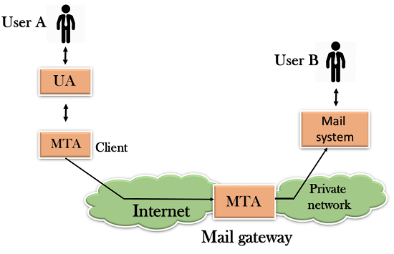

**Components of SMTP [2]**

Working of SMTP:

1. Composition of Mail.
2. Submission of Mail.
3. Delivery of Mail.
4. Receipt and Processing of Mail.
5. Access and Retrieval of Mail.

1.2 POSTFIX: It is a free and open mail transfer agent (MTA) that relays mail between different mail servers and the internet. It routes and delivers the email. It is released under the IBM Public License 1.0 which is a free software license.

It is a fast, easy to administer and secure way.

Estimation says that around 25% of public mail servers use postfix on the internet.

1.3 POP3: It stands for Post Office Protocol 3. It is the most recent version of a standard protocol used for receiving an email. It is a client-server protocol which helps in handling of received email that is held by your internet server. Also built into the Netscape and Microsoft Internet Explorer browsers.

The mail on the server is deleted by POP3 as soon as the user downloads it. The users or the administrator have the ability to save the mail for a while.

POP can be thought of as a "store-and-forward” service.

The receiving port of POP3 is 995.

1.4 SSL stands for **Secure Socket Layer.**

It is a standard technology for securing the internet connection and also safeguarding any kind of sensitive data that is sent between two systems.

It helps prevent criminals from reading and modifying any information transferred. SSL uses encryption algorithms to scramble data in transit, which helps in making sure that the transfer of data between users and sites is impossible to be read and also preventing hackers from reading it as it is sent over a connection.

SSL works over port number 465.

The information equipped with SSL is:

1. Common Name (CN)
2. organization (O)
3. Organization Unit (OU)
4. City/Locality (L)
5. State/Country/Region (S)
6. Country (C)
7. Email Address

SSL uses public-key, or asymmetric, cryptography to encrypt transmitted data during an SSL session. [3]

1.5 TLS **or Transport Layer Security** is an updated and more secure version of SSL. But till now, SSL is preferred as the security certificate.

TLS works over port number 587.

1.6 CSR stands for **Certificate Signing Request** is the first step towards getting your SSL certificate. This is generated on the same server on which you plan to install the certificate. The CSR contains information which is useful to create your certificate by Certificate Authority (CA). The certificate is signed with a corresponding private key, and there is a public key for your certificate and both of these keys are present in CSR.

# **2. PROBLEM STATEMENT:**

A lot of companies nowadays have their own privacy factors, in which they prefer to keep their delicate data inside their organizations. The Proposed work attempts to provide an improvement over basic email servers to add functionalities like content filtering, log maintenance (Back up/ Deletion of logs), buffer directory, and algorithm to inspect incoming traffic and provide ease of access to the flagged emails.

**3. LITERATURE REVIEW:**

## POSTFIX SERVER

Behrend et al. described a working-in-progress project called Postfix, a high-performance clustered, distributed e-mail system [4]. It used a collection of clusters distributed through a wide area to provide users with highly available and scalable services. Saito et al. described the motivation, design, and performance of PostFix, a scalable mail server. The goal of Postfix was to provide a highly available and scalable electronic mail service using a large cluster of commodity PCs. Their focus was on dynamic load balancing, automatic-configuration, and graceful degradation in the presence of failures [4].

## DEVELOPMENT OF SERVER

In its development, email standardization in communicating the message exchange, the shipping documents (text, images, files, audio, video), which was validated by the service either by companies, individuals and government. Legality email can check from the header, the sender mail domain with a mail relay must match. Moreover, the validity of the email account must register in the system Mail Server. [5]

## EMAIL ARCHIVING STANDARDS

It would be useful to refer to standards as approved practices especially at the initial stage of developing an email archiving program. General guidelines for establishing email archiving standards and procedures can be found in the following standards:

* ANSI/ARMA 9-2004, Requirements for Managing Electronic Messages as Records
* ANSI/ARMA TR2-2007, Procedures and Issues for Managing Electronic Messages as Records
* ANSI/AIIM/ARMA TR48-2006, Revised Framework for the Integration of Electronic Document
* Management Systems and Electronic Records Management Systems [6]

# **4. OBJECTIVE:**

* The Perform Customization of an email server to serve as per the constraints identified for an organization
* Maintain a log of all emails (sent/ received) from the server.
* To inspect sensitive content in the mail and add constraints respective to it.
* Maintain buffer directory to keep flagged mails.
* To automate the process of Backup and deletion of logs.
* Applying searching and sorting algorithm to buffer list for easy access.
* Providing the security to the process by signing SSL, TSL Certifications.

# **5. METHODOLOGY:**

The project follows the **Iterative model.**

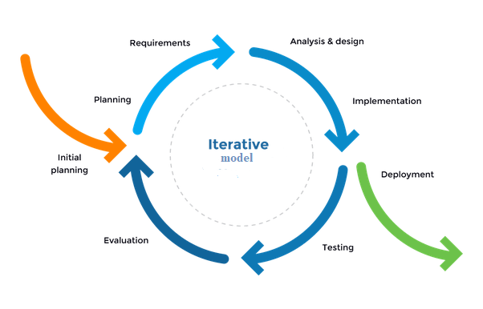

**Iterative Model [7]**

* **Study Period and Requirement Gathering**

Studying and gathering information for a basic E-Mail server configuration and specifications

required by an organization.

* **Designing Algorithm**

Designing and implementing the algorithm in C language (searching and sorting) and to filter the content.

* **Coding and Implementation**

Using the existing E-Mail server (POSTFIX) source code and to configure the code as per the requirements gathered.

* **Testing and Debugging**

Examining and testing the result by applying algorithms.

Making suitable changes if required.

Collecting the result after applying complete algorithms.

* **Review Phase**

Documentation of the implemented code.

Completion of the project.

**Email Architecture**

The e-mail system is an integration of several components such as hardware and software, services and protocol that support the communication between user and server, or vice versa. Based on working mail server can classify into two components: Outgoing Server (Sending Mail) used to send the email via SMTP port 25; Incoming Server (Receiving Mail) is useful to handle the process of accessing the mail on the server using the POP3 protocol.

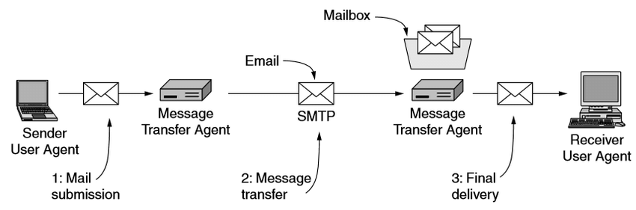

**Architecture of Email System [8]**

# **6. SYSTEM REQUIREMENTS:**

* Hardware Requirements
* Computer system
* Minimum 1GB Ram
* Minimum 40GB Hard disk
* Software Requirements
* Linux OS (Ubuntu LTS Distribution)
* GCC
* Postfix/SMTP/POP3
* SSL

# **7. SCHEDULE (Pert Chart):**

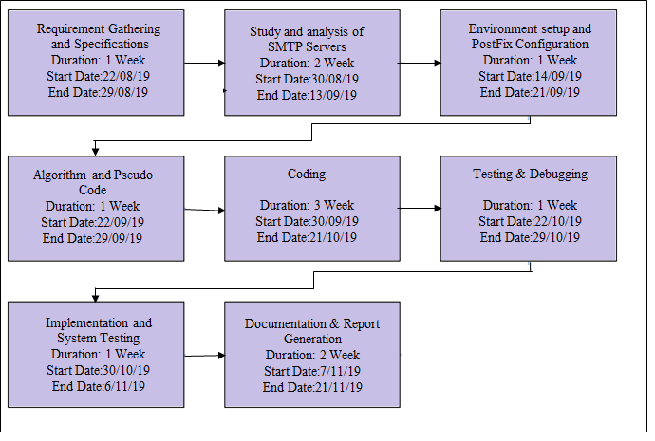

# **8. ALGORITHM:**

Linear search algorithm is a simple algorithm. In this algorithm, we search an element or value in a given array by traversing the array from the starting, till the desired element or value is found. [9]

In our project, we are using linear search algorithm to compare the values between two different files, i.e. the mail file (containing the entered values by the client for sending of mail) and the dictionary (containing the sensitive word). We are using it to check if the mail contains any sensitive content by comparing the strings present in dictionary with the content of mail.

If any string or value in dictionary is in the mail content then the mail is having sensitive content and it is then flagged for administration purposes.

# **9. OUTPUTS:**

**9.1 SETTING OF ALIAS**

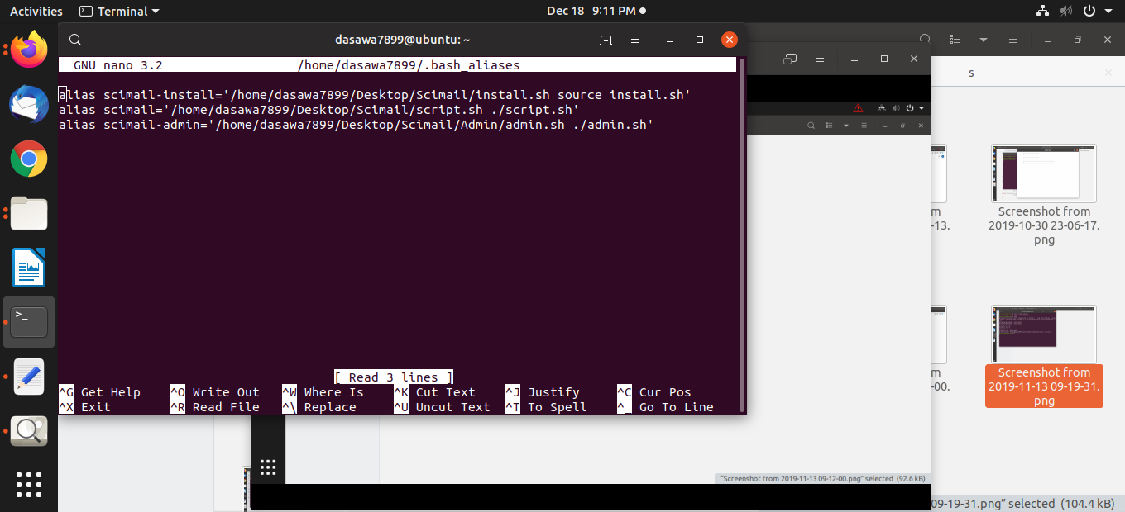

**Fig 1: Setting of alias named ‘scimail’, ‘scimail-install’ and ‘scimail-admin’**

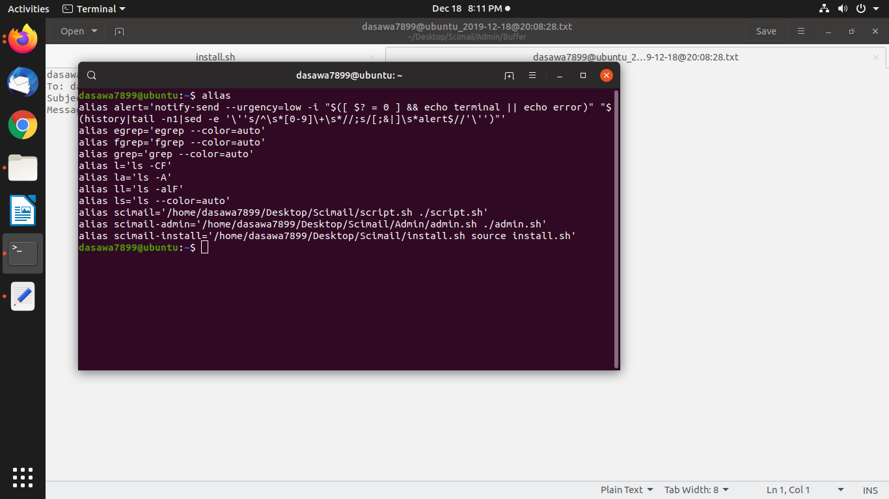

**Fig 2: Aliases**

## **9.2 SENDING OF EMAILS**

**Sample Mail 1: Mail with sensitive content**

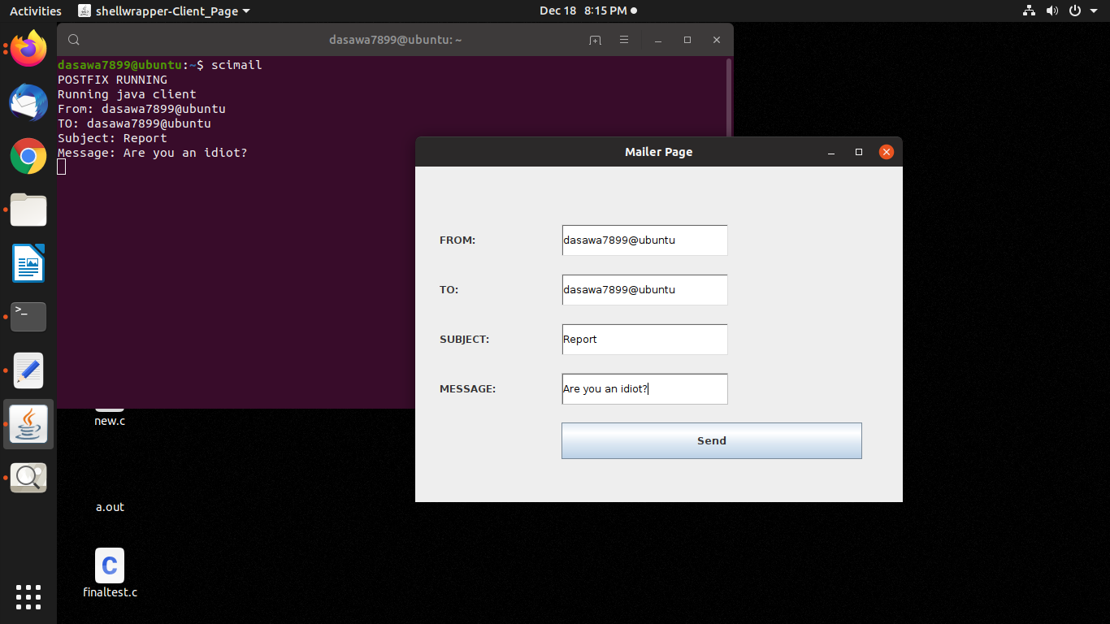

**Fig 3: Execution of scimail command and the Java Client**

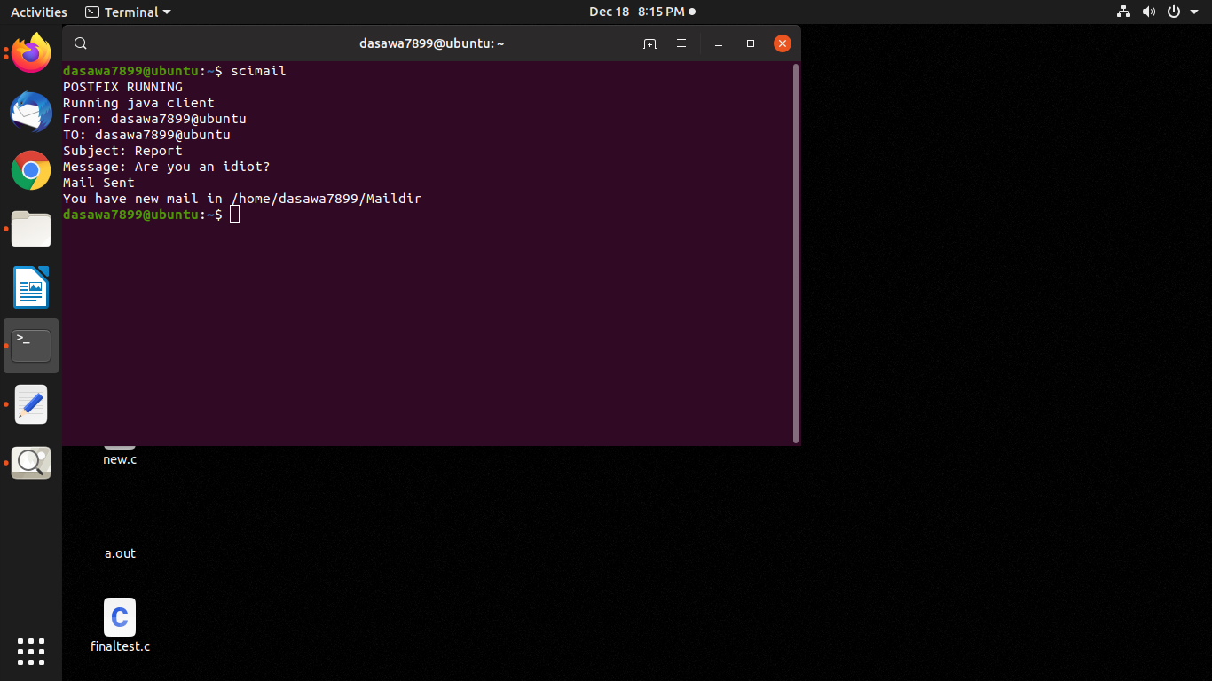

**Fig 4: Mail sent via postfix (using SMTP)**

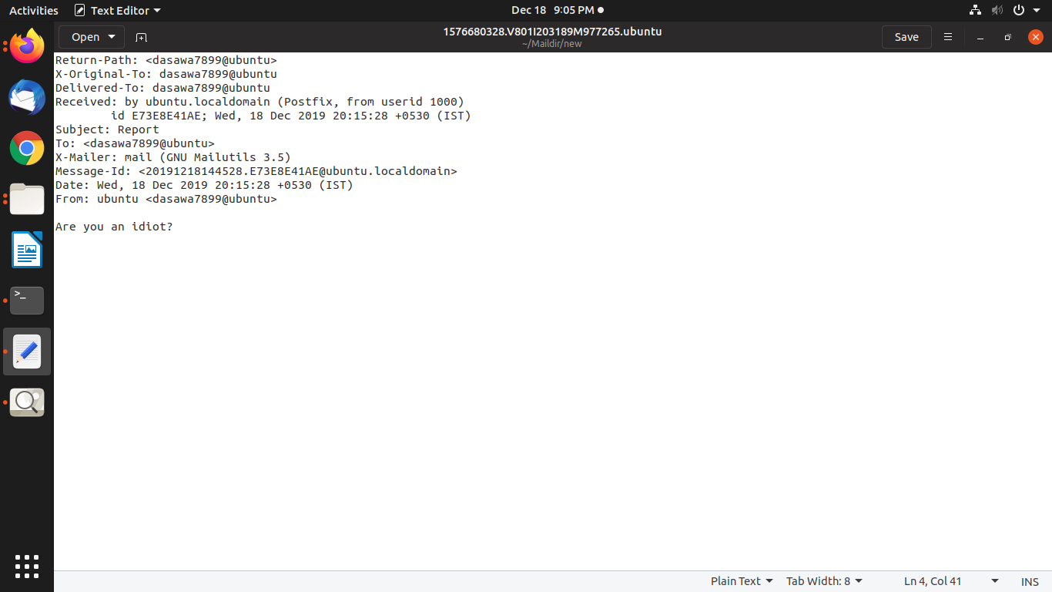

**Fig 5: Mail received in Maildir**



**Fig 6: Sensitive content found, new file created in buffer directory**

**Sample Mail 2: Mail without sensitive content**

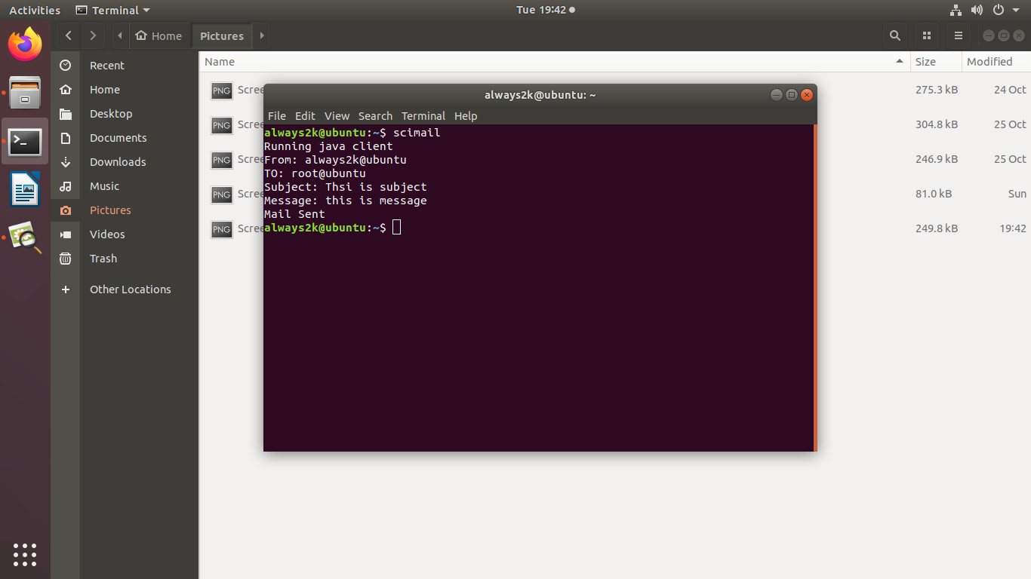

**Fig 7: Execution of scimail command**

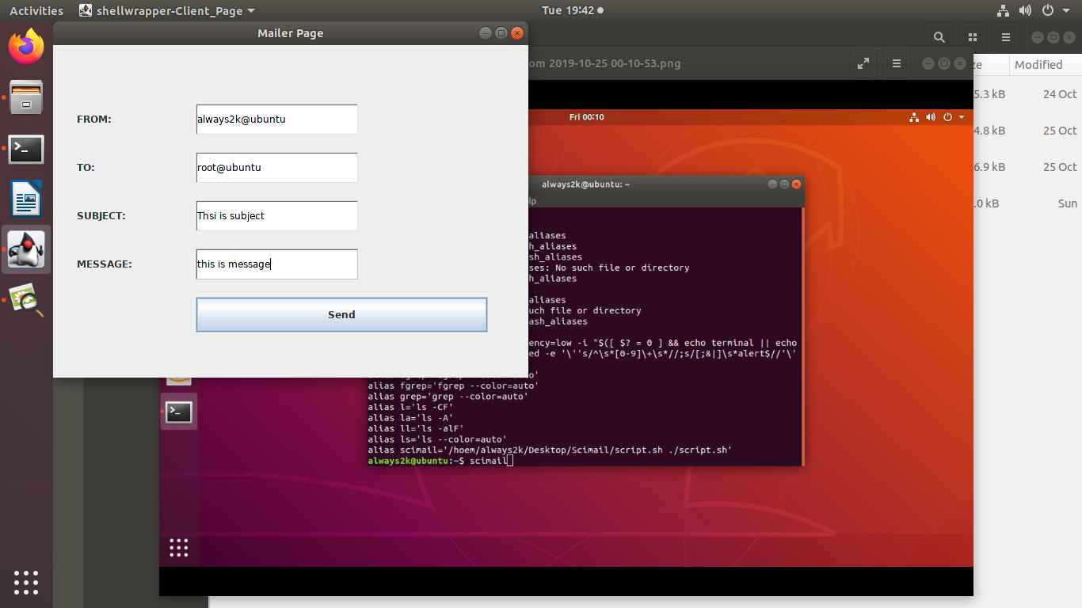

**Fig 8: Java AWT interface**



**Fig 9: Mail sent via Postfix (using SMTP)**

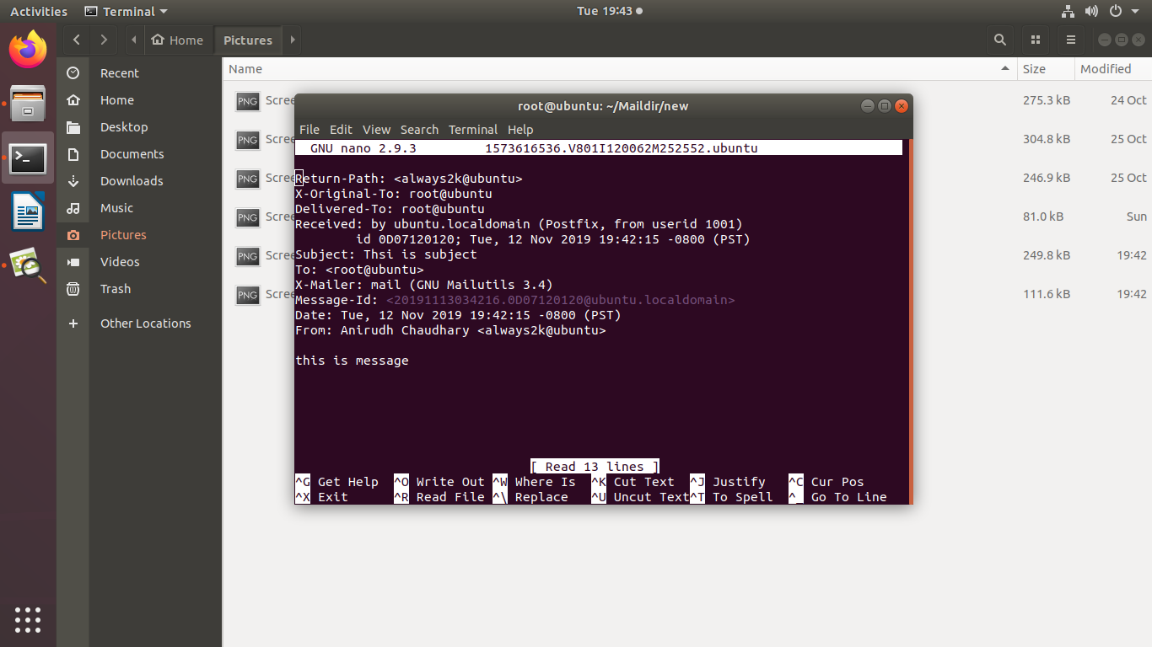

**Fig 10: Mail Received via postfix**

**\*\*Since the content is not sensitive, therefore no file will be created in buffer directory**

## **9.3 SCIMAIL-ADMIN**

Scimail-admin is an alias to execute admin.sh script. Admin.sh is a script which helps in authorization of admin and provides functionality for admin panel via use of other programs.

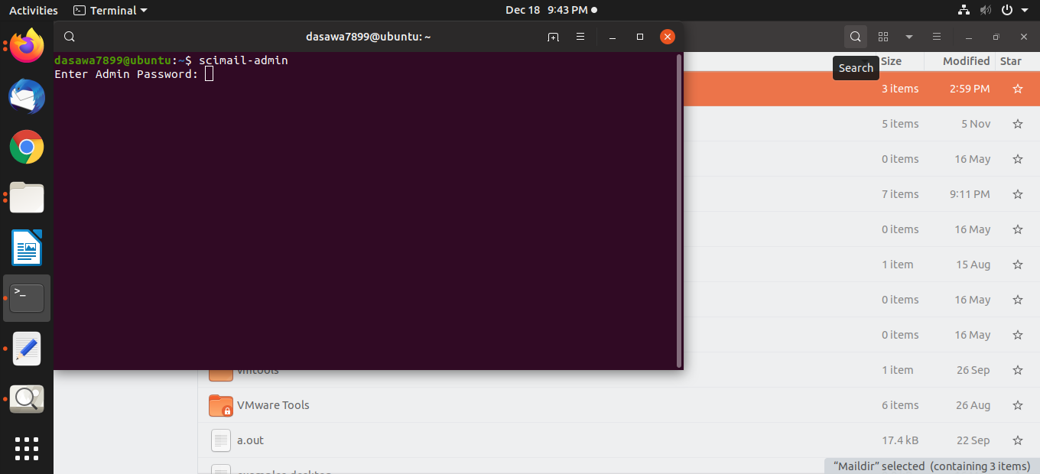

**Fig 1: Execution of scimail-admin alias, requests for admin authorization.**

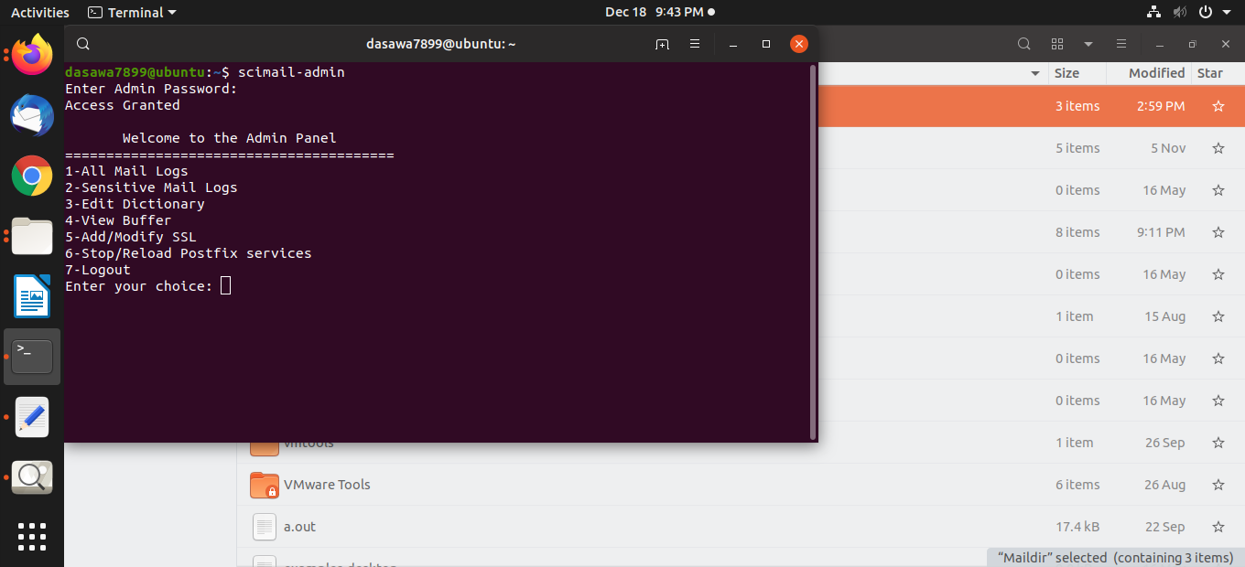

**Fig 2: If access granted, Admin receives a panel for operating.**

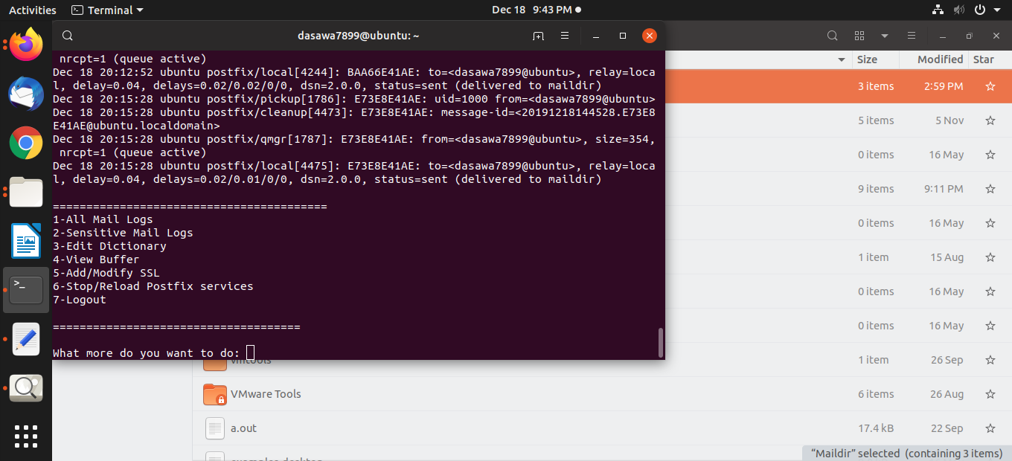

**Fig 3: If admin chooses ‘1’ for viewing ‘All Mail Logs’,**

**Logs for sending of mails are displayed.**

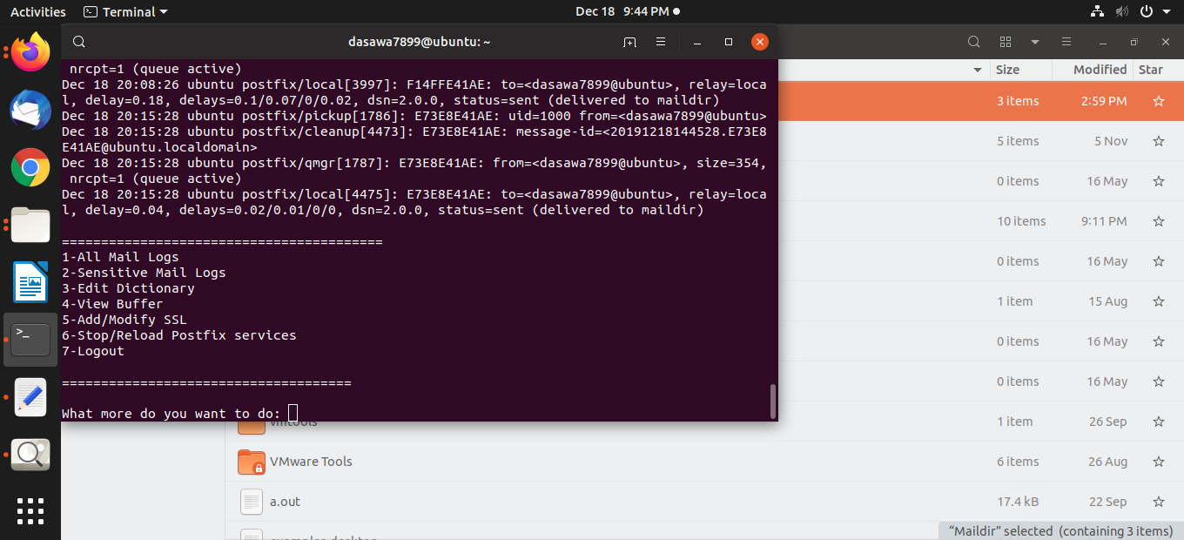

**Fig 4: If the admin chooses option ‘2’ for viewing ‘Sensitive Mail Logs’,**

**Logs for sending of flagged emails are displayed.**

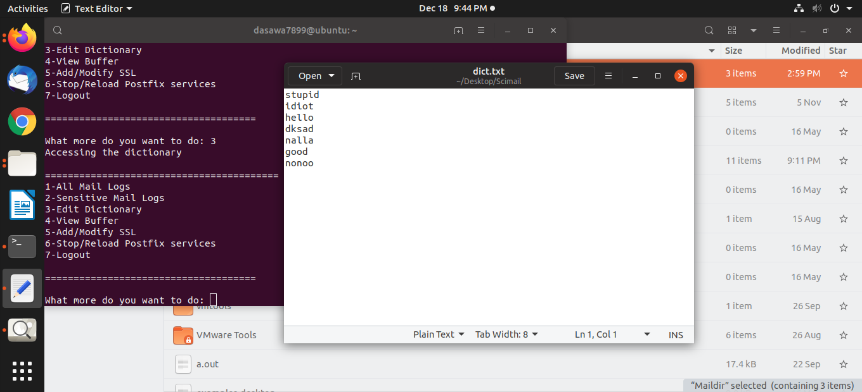

**Fig 5: If the admin chooses the option ‘3’ i.e. ‘Edit Dictionary’,**

**Dictionary opens up in a text editor with access to read and write.**

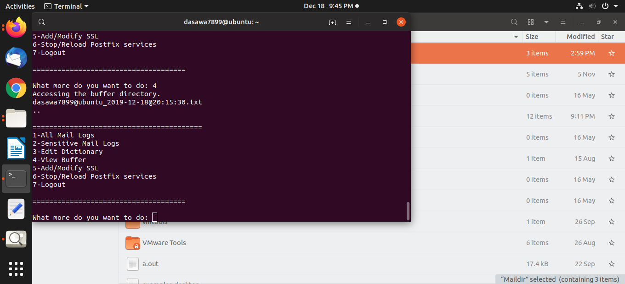

**Fig 6: If the admin chooses the option ‘4’ i.e. ‘View Buffer’,**

**The names of the flagged mails present in the buffer directory are displayed.**

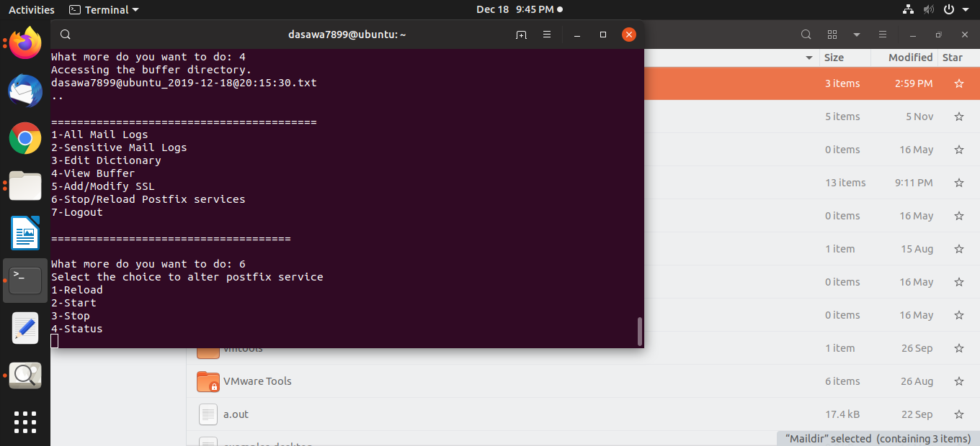

**Fig 7: If the admin chooses to operate on postfix services**

**And selects the option ‘6’, admin is provided with 4 different options.**

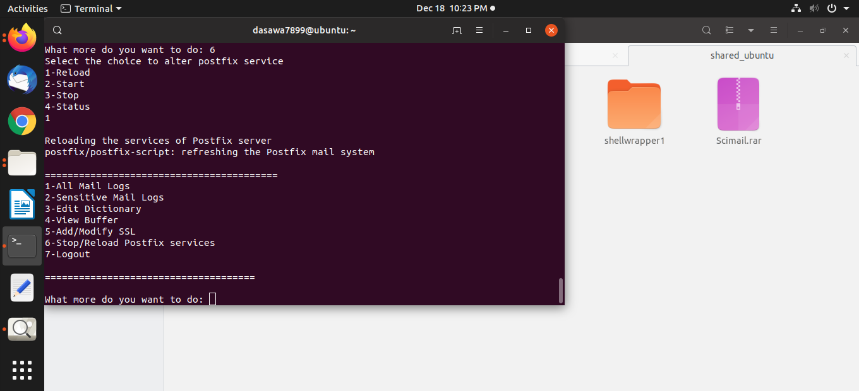

**Fig 8: If the admin wishes to ‘Reload’ the postfix services and selects the option ‘1’,**

**After selecting the option ‘6’ in the main panel.**

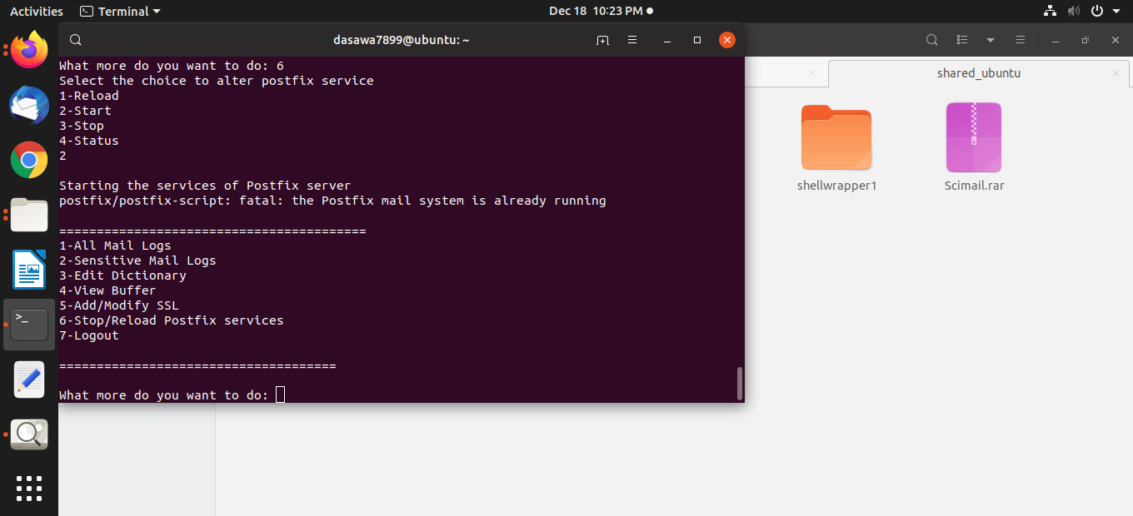

**Fig 9: If the admin wishes to ‘Start’ the postfix services and selects the option ‘2’,**

**After selecting the option ‘6’ in the main panel.**

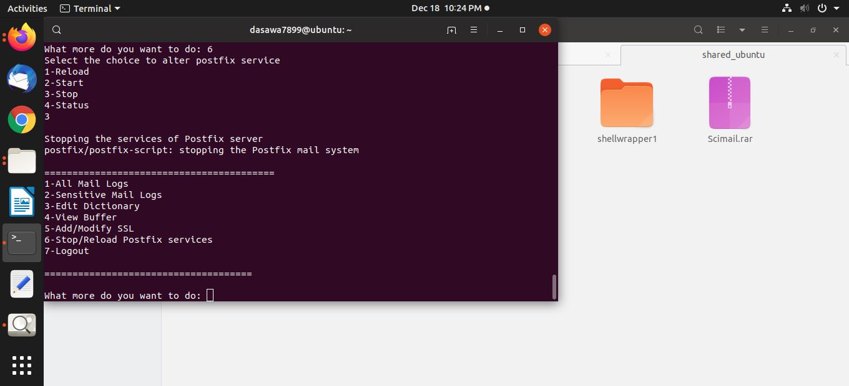

**Fig 10: If the admin wishes to ‘Stop’ the postfix services and selects the option ‘3’,**

**After selecting the option ‘6’ in the main panel.**

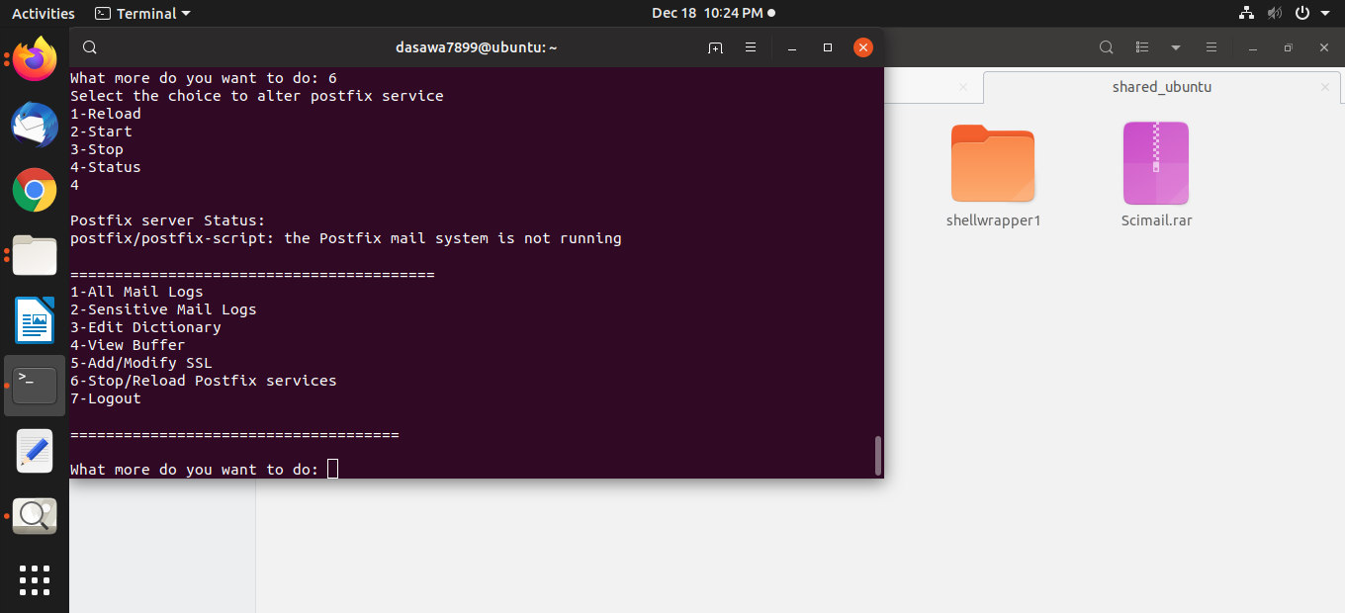

**Fig 11: If the admin wishes to check ‘Status’ of the postfix server then**

**admin selects the option ‘3’,**

**After selecting the option ‘6’ in the main panel.**

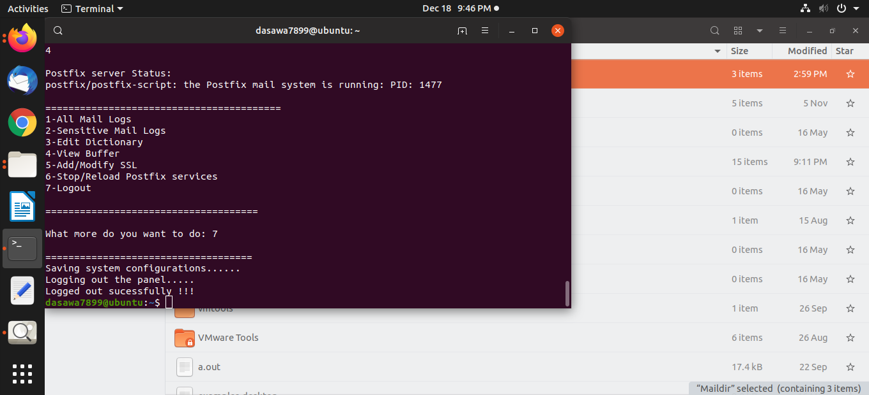

**Fig 12: After the work is complete, Admin can simple select the option ‘7’**

**To logout from the panel and all the respective configuration will be saved.**

**9.4 SCIMAIL-INSTALL**

Scimail-install is an alias to execute install.sh script. Install.sh is a simple script which provides quick way to install the postfix over any Linux-based system.

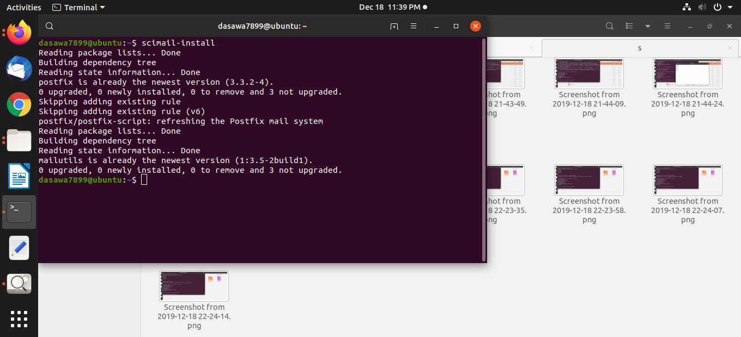

**Fig 1: Scimail-install execution when postfix is already installed and running.**

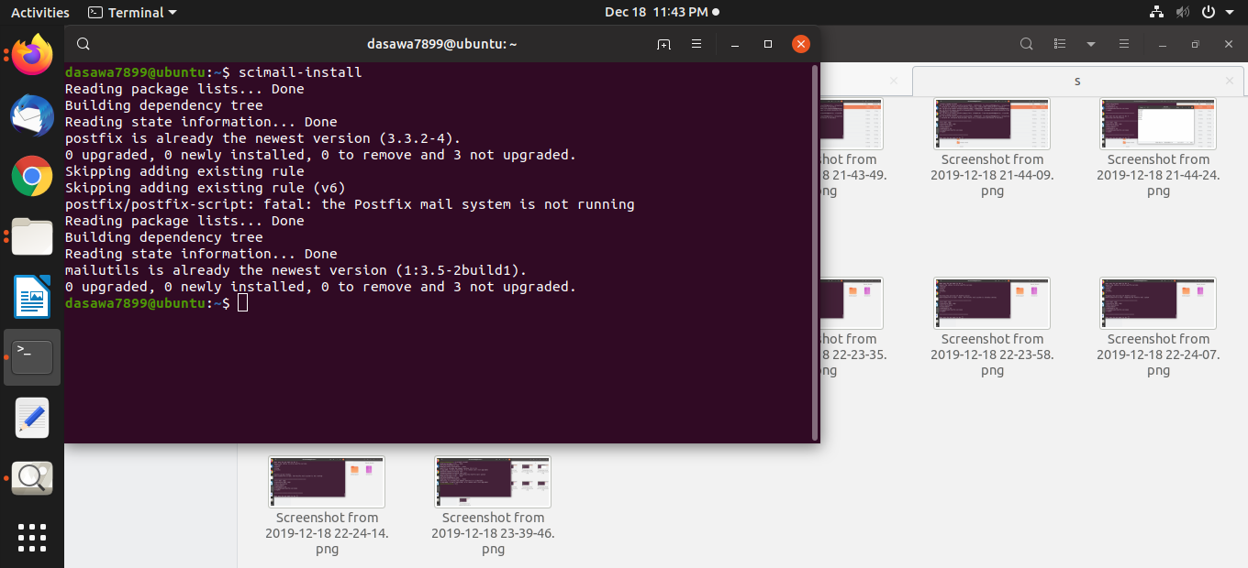

**Fig 2: Scimail-install execution when postfix is already installed and not running.**

**9.5 Cron**

The software utility cron is a time-based job scheduler in Unix-like computer operating systems. Users that set up and maintain software environments use cron to schedule jobs to run periodically at fixed times, dates, or intervals.

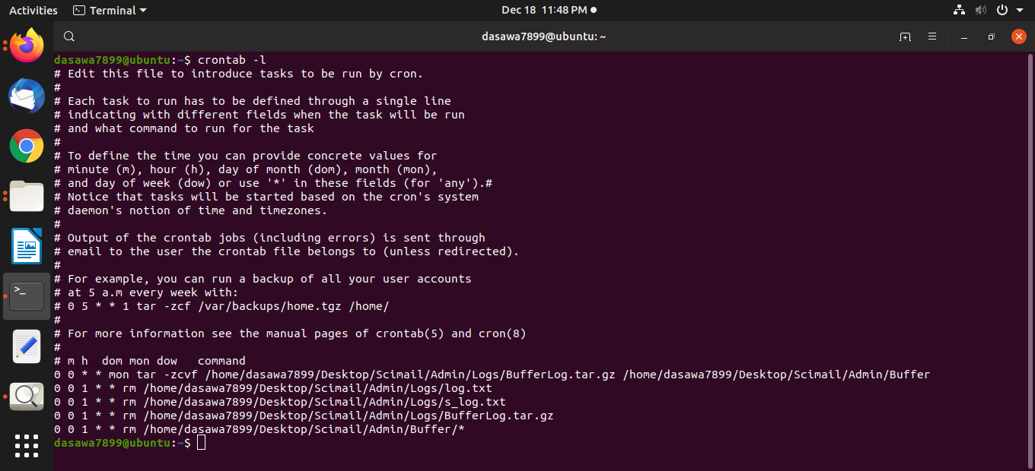

**Fig 1: Crontab –l shows all the cron jobs for the Linux-system.**

**The cron jobs specified are:**

**0 0 * * mon tar -zcvf /home/dasawa7899/Desktop/Scimail/Admin/Logs/BufferLog.tar.gz /home/dasawa7899/Desktop/Scimail/Admin/Buffer:** This Cron job will automatically make tape archive files (Compressed file) for all the filtered flagged email files present in the buffer directory on every Monday at time 00:00.

**0 0 1 * * rm /home/dasawa7899/Desktop/Scimail/Admin/Logs/log.txt:** This Cron job automatically removes the log.txt file on 1st of every month.

**0 0 1 * * rm /home/dasawa7899/Desktop/Scimail/Admin/Logs/s_log.txt:** This Cron job automatically removes the sensitive log file i.e. s_log.txt on 1st of every month.

**0 0 1 * * rm /home/dasawa7899/Desktop/Scimail/Admin/Logs/BufferLog.tar.gz:** This Cron job automatically removes the tar files that were made for the buffer directory on 1st of every month.

**0 0 1 * * rm /home/dasawa7899/Desktop/Scimail/Admin/Buffer/*:** This Cron job automatically removes the files present in buffer directory on 1st of every month.

# **10. DIAGRAMS:**

## **10.1 Activity diagram:**

### **10.1.1 Scimail:**

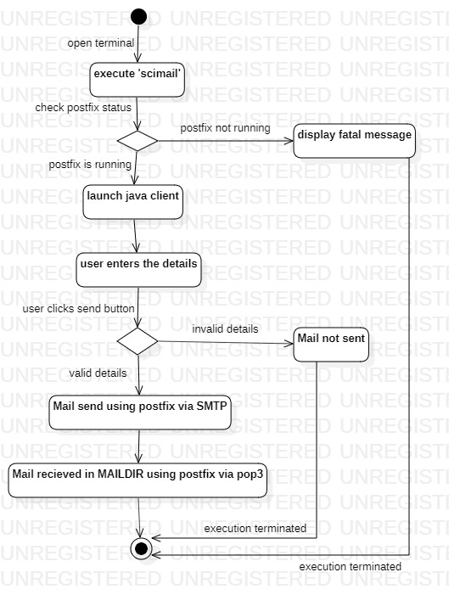

**Fig 10.1.1: Scimail activity diagram**

### **10.1.2 Scimail-admin**:

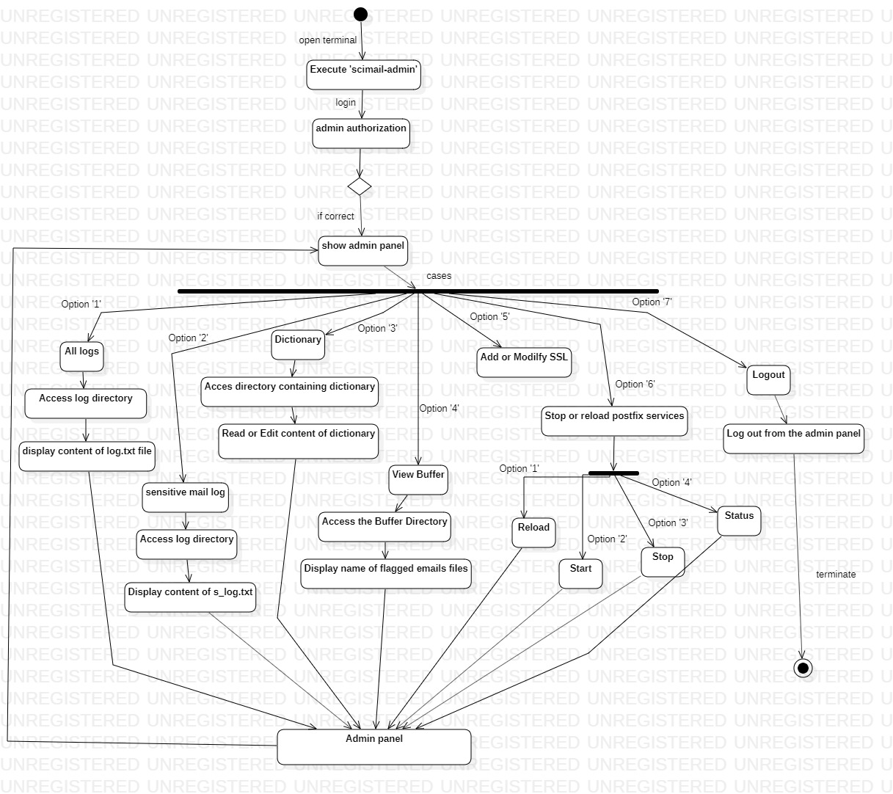

**Fig 10.1.2: scimail-admin activity diagram**

## **10.2 Use Case Diagram:**

**Scimail:**

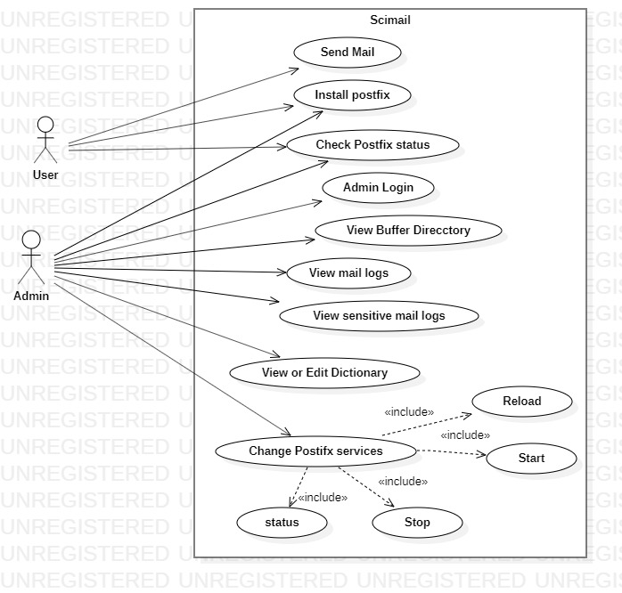

**Fig 10.2: Use case diagram for SCIMAIL**

# **FUTURE SCOPE**

* 1. Hashing and indexing algorithm can be applied on Content Filtering of emails.
  2. User interface of sending mail and interface for admin panel both can be made much more interactive.
  3. Dictionary containing sensitive content can be enlarged to be used at large scale.
  4. Machine learning can be applied to make email filtering much faster and more enhanced and secured.
  5. Since this email system is set to local only, the whole configuration and customization can be taken over to a local server or Internet.
  6. This project is limited to Linux-based system; the configuration part can be taken to other operating platform such as Windows and MacOS by using some other email server configuration.

# **REFRENCES**

[1] SMTP Available at https://www.geeksforgeeks.org/simple-mail-transfer-protocol-smtp/

[2] Available at <https://www.javatpoint.com/simple-mail-transfer-protocol>

[3] Available at <https://www.globalsign.com/en-in/blog/what-is-a-certificate-signing-request-csr/>

[4] VONBEHREN, J., CZERWINSKI, S et al “Ageability, availability, and performance in Postfix: a highly scalable, cluster-based mail service.” ACM transactions on Computer Systems 18-3-2000, pp 298–298.

[5] J. J. Davis and A. J. Clark, "Content security in postfix" Mailing & Security, vol. 30, pp. 353-375, 2011.

[6] Available at <https://blogs.ntu.edu.sg/lib-scholarlycomm/?page_id=18004>

[7] Available at <https://www.quora.com/What-is-the-difference-between-Waterfall-and-Incremental-Model>

[8] Available at <https://www.researchgate.net/figure/Architecture-of-email-system-13_fig1_319182999/>

[9] Available at <https://www.studytonight.com/data-structures/linear-search-algorithm/>