**Minor Project**

**Synopsis**

**On**

**E-Mail Server Customization and Configuration**

**Submitted by:**

|  |  |  |
| --- | --- | --- |
| **Name** | **Roll No** | **Branch** |
| Anirudh Chaudhary | R171217008 | CSE-DevOps |
| Darsh Asawa | R171217016 | CSE-DevOps |
| Saurabh Dimri | R171217052 | CSE-DevOps |
| Shivam Pandey | R171217053 | CSE-DevOps |

**Under the guidance of**

Dr. Monit Kapoor

Associate Professor

HOD - Department of Cybernetics



**School of Computer Science and Engineering**

**University of Petroleum & Energy Studies**

**Dehradun - 248001**

**2019**

**INDEX**

|  |  |  |
| --- | --- | --- |
| **S.NO** | **TITLE** | **PAGE NO.** |
| 1 | Project Title and Abstract | 3 |
| 2 | Introduction   * Mail Server * MTA Agents and Architecture * SMTP * POP3 * SSL | 4-5  4  4  5  5  5 |
| 3 | Problem Statement and Objective | 6 |
| 4 | Literature Review | 7 |
| 5 | Methodology   * Model used * Architecture | 8-9  8  9 |
| 6 | System Requirements | 9 |
| 7 | Pert Chart | 10 |
| 8 | References | 11 |



**School of Computer Science and Engineering**

**University of Petroleum & Energy Studies, Dehradun**

**Project Proposal Approval Form (2019)**

**PROJECT TITLE:**

**E-Mail Server Customization and Configuration**

**ABSTRACT:**

Emails have become a greater part of our lives. The Email, one organized well, is the most effective means of communication for business. A lot of companies nowadays have their own privacy factors, in which they prefer to keep their delicate data inside their organizations. Thus, data can be shared with trust and under supervision by the organization. More versatile than anything it can be used to communicate people in different parts of the world, but for different organization different types of configurations are required. The customization done in the project are on the requirements that are generally required by the company to establish a smooth and reliable medium of communication with restriction of messages like maintaining the buffer log, automating the mail server to generate automatic backups, providing special restriction to unaccepted contents and to make the data searchable and easily accessible.

**Keywords**: Logs, Buffer, Backups, Algorithms (Searching and Sorting), Security and SSL Certifications.

**INTRODUCTION:**

The use of the latest e-mail (electronic mail) as a means of communication in the virtual world is increasing rapidly. The basis on statistics report on e-mail account in 2014, totaled 4.1 billion email accounts were actively used. And this number kept increasing and till 2018, the number increased to 5.2 billion and still counting as of 2019.

An **email server** or a **mail server** is a computer that serves the functionality of a mail transfer agent (MTA). In Laymen language, email servers are nothing but an alternative computerized equivalent of neighbourhood mailman. Mail that is sent passes through various mail servers which are running special software. These mail servers are built over a list of standardized protocols for handling messaged and the multimedia content in it.

Most of the internet system uses **SMTP (Simple Mail Transfer Protocol) for** transfer of mail from one user to another. It is a push protocol i.e. it is used to send the mail. It is an application layer protocol w.r.t TCP/IP Model of networking. The default port used by SMTP is port (25).It is always on listening mode so that it actively initiates a connection process as soon as it listens for a TCP connection from a client.

After the successful establishment of the TCP connection, the client sends the mail instantly.

SMTP is of two types:

1. End-to-end method: It is the model which defines communication between different organizations.
2. Store-and-forward method: It is the model which defines communication within the organization.

[1]

In **SMTP**, there is a direct link between the sender's client SMTP (who wants to send the mail) and the destinations host SMTP. The client SMTP is the one which initiates the session, and the receiver-SMTP is the one which responds to the session.

The SMTP server keeps the mail until and unless it is successfully copied to the receiver's SMTP.

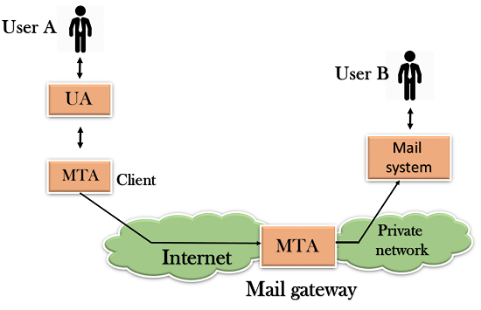

**Components of SMTP [2]**

Working of SMTP:

1. Composition of Mail.
2. Submission of Mail.
3. Delivery of Mail.
4. Receipt and Processing of Mail.
5. Access and Retrieval of Mail.

**POSTFIX:** It is a free and open mail transfer agent (MTA) that relays mail between different mail servers and the internet. It routes and delivers the email. It is released under the IBM Public License 1.0 which is a free software license.

It is a fast, easy to administer and secure way.

Estimation says that around 25% of public mail servers use postfix on the internet.

**POP3:**  It stands for Post Office Protocol 3. It is the most recent version of a standard protocol used for receiving an email. It is a client-server protocol which helps in handling of received email that is held by your internet server. Also built into the Netscape and Microsoft Internet Explorer browsers.

The mail on the server is deleted by POP3 as soon as the user downloads it. The users or the administrator have the ability to save the mail for a while.

POP can be thought of as a "store-and-forward” service.

The receiving port of POP3 is 995.

**SSL** stands for **Secure Socket Layer.**

It is a standard technology for securing the internet connection and also safeguarding any kind of sensitive data that is sent between two systems.

It helps prevent criminals from reading and modifying any information transferred. SSL uses encryption algorithms to scramble data in transit, which helps in making sure that the transfer of data between users and sites is impossible to be read and also preventing hackers from reading it as it is sent over a connection.

SSL works over port number 465.

The information equipped with SSL is:

1. Common Name (CN)
2. organization (O)
3. Organization Unit (OU)
4. City/Locality (L)
5. State/Country/Region (S)
6. Country (C)
7. Email Address

SSL uses public-key, or asymmetric, cryptography to encrypt transmitted data during an SSL session. [3]

**TLS or Transport Layer Security** is an updated and more secure version of SSL. But till now, SSL is preferred as the security certificate.

TLS works over port number 587.

**CSR** stands for **Certificate Signing Request** is the first step towards getting your SSL certificate. This is generated on the same server on which you plan to install the certificate. The CSR contains information which is useful to create your certificate by Certificate Authority (CA). The certificate is signed with a corresponding private key, and there is a public key for your certificate and both of these keys are present in CSR.

**PROBLEM STATEMENT:**

A lot of companies nowadays have their own privacy factors, in which they prefer to keep their delicate data inside their organizations. The Proposed work attempts to provide an improvement over basic email servers to add functionalities like log maintenance (Back up/ Deletion), algorithm to inspect incoming traffic and provide ease of access to the flagged emails.

**OBJECTIVE:**

* The Perform Customization of an email server to serve as per the constraints identified for an organization
* Maintain a log of all emails (sent/ received) from the server.
* To automate the process of Backup and deletion of logs.
* To inspect sensitive content in the mail and add constraints respective to it.
* Applying searching and sorting algorithm to buffer list for easy access.
* Filtering the content and providing the security to the process by signing SSL, TSL Certifications.

**LITERATURE REVIEW:**

* **POSTFIX SERVER**
* **Saito, Y., Bershad, B. N., Andlevy, H. Mamge**

Behrend et al. described a working-in-progress project called PostFix, a high-performance clustered, distributed e-mail system [4]. It used a collection of clusters distributed through a wide area to provide users with highly available and scalable services. Saito et al. described the motivation, design, and performance of PostFix, a scalable mail server [5]. The goal of PostFix was to provide a highly available and scalable electronic mail service using a large cluster of commodity PCs. Their focus was on dynamic load balancing, automatic-configuration, and graceful degradation in the presence of failures.

* **DEVELOPMENT OF SERVER [6]**

**- O. De Vel, A. Anderson, M. Corney, and G. Mohay**

In its development, email standardization in communicating the message exchange, the shipping documents (text, images, files, audio, video), which was validated by the service either by companies, individuals and government [6]. Legality email can check from the header, the sender mail domain with a mail relay must match. Moreover, the validity of the email account must register in the system Mail Server.

* **EMAIL ARCHIVING STANDARDS [7]**
* **J., Czerwinski, S., Joseph, A. D., Brewer**

It would be useful to refer to standards as approved practices especially at the initial stage of developing an email archiving program. General guidelines for establishing email archiving standards and procedures can be found in the following standards:

* ANSI/ARMA 9-2004[7], Requirements for Managing Electronic Messages as Records
* ANSI/ARMA TR2-2007[7], Procedures and Issues for Managing Electronic Messages as Records
* ANSI/AIIM/ARMA TR48-2006[7], Revised Framework for the Integration of Electronic Document Management Systems and Electronic Records Management Systems

**METHODOLOGY:**

The project follows the **Iterative model.**

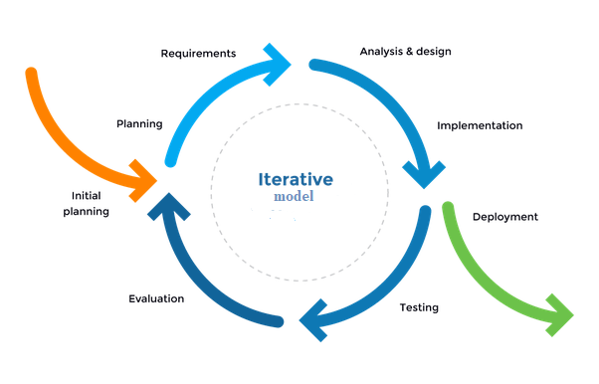

**Iterative Model [8]**

* **Study Period and Requirement Gathering**

Studying and gathering information for a basic E-Mail server configuration and specifications

required by an organization.

* **Designing Algorithm**

Designing and implementing the algorithm in C language (searching and sorting) and to filter the content.

* **Coding and Implementation**

Using the existing E-Mail server (POSTFIX) source code and to configure the code as per the requirements gathered.

* **Testing and Debugging**

Examining and testing the result by applying algorithms.

Making suitable changes if required.

Collecting the result after applying complete algorithms.

* **Review Phase**

Documentation of the implemented code.

Completion of the project.

**Email Architecture**

The e-mail system is an integration of several components such as hardware and software, services and protocol that support the communication between user and server, or vice versa. Based on working mail server can classify into two components: Outgoing Server (Sending Mail) used to send the email via SMTP port 25; Incoming Server (Receiving Mail) is useful to handle the process of accessing the mail on the server using the POP3 protocol.

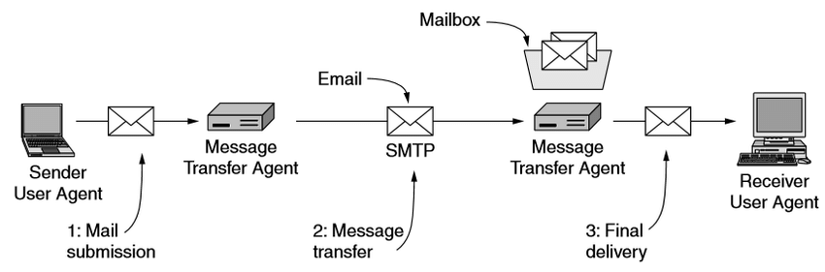

**Architecture of Email System [9]**

**SYSTEM REQUIREMENTS:**

* Hardware Requirements
* Computer system
* Minimum 1GB Ram
* Minimum 40GB Hard disk
* Software Requirements
* Linux OS (Ubuntu Distribution)
* GCC
* Postfix/SMTP/POP3
* SSL

**SCHEDULE (Pert Chart):**

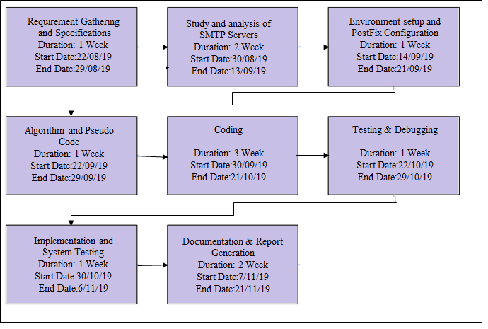

**REFRENCES**

[1] https://www.geeksforgeeks.org/simple-mail-transfer-protocol-smtp/

[2] <https://www.javatpoint.com/simple-mail-transfer-protocol>

[3] <https://www.globalsign.com/en-in/blog/what-is-a-certificate-signing-request-csr/>

[4] VONBEHREN, J., CZERWINSKI, S., JOSEPH, A. D., BREWER, E. A., AND KUBIATOWICZ, J.

[5] SAITO, Y., BERSHAD, B. N., ANDLEVY, H. M. Man-ageability, availability, and performance in Postfix: a highly scalable, cluster-based mail service. ACM transactions on Computer Systems 18, 3 (2000),298–298.

[6] O. De Vel, A. Anderson, M. Corney, and G. Mohay, “*Mining E-mail Content for Author Identification Forensics*.”

[7] <https://blogs.ntu.edu.sg/lib-scholarlycomm/?page_id=18004>

[8] <https://www.quora.com/What-is-the-difference-between-Waterfall-and-Incremental-Model>

[9] https://www.researchgate.net/figure/Architecture-of-email-system-13_fig1_319182999/

**Approved By:**

(Name & Signature)(Name & Signature)

**Project Guide Program Head**

**DR. MONIT KAPOOR DR. MONIT KAPOOR**