1. Install jenkins and run jenkins on port number 8081.

Created one instance and I have installed a java prerequisite and installed jenkins

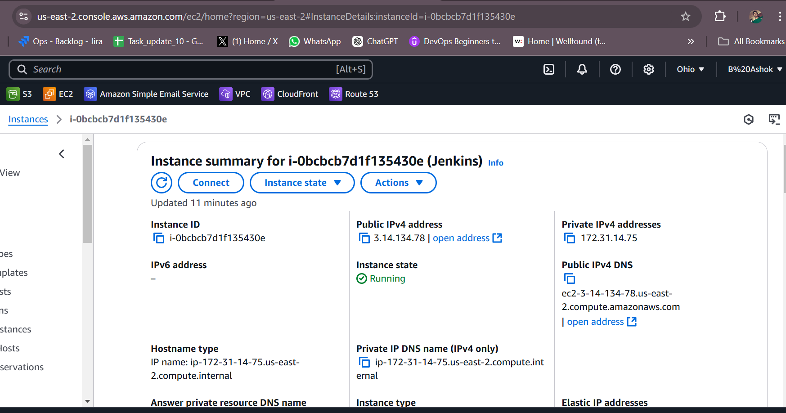

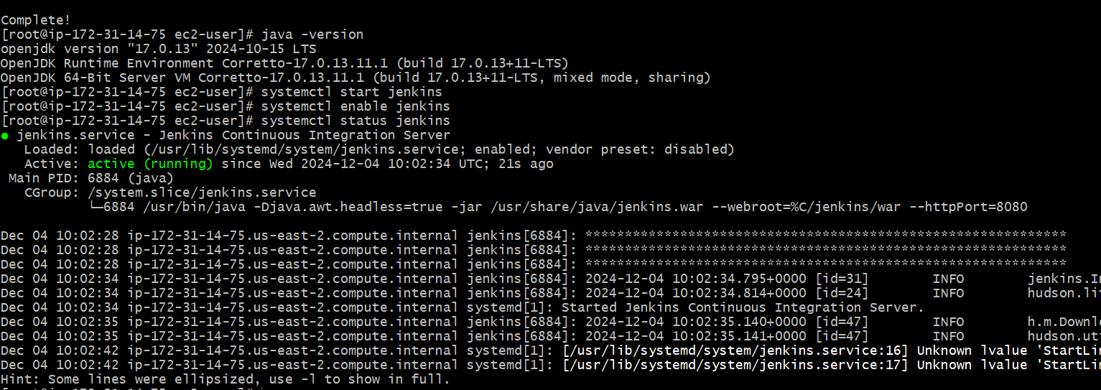

Running on port number 8081

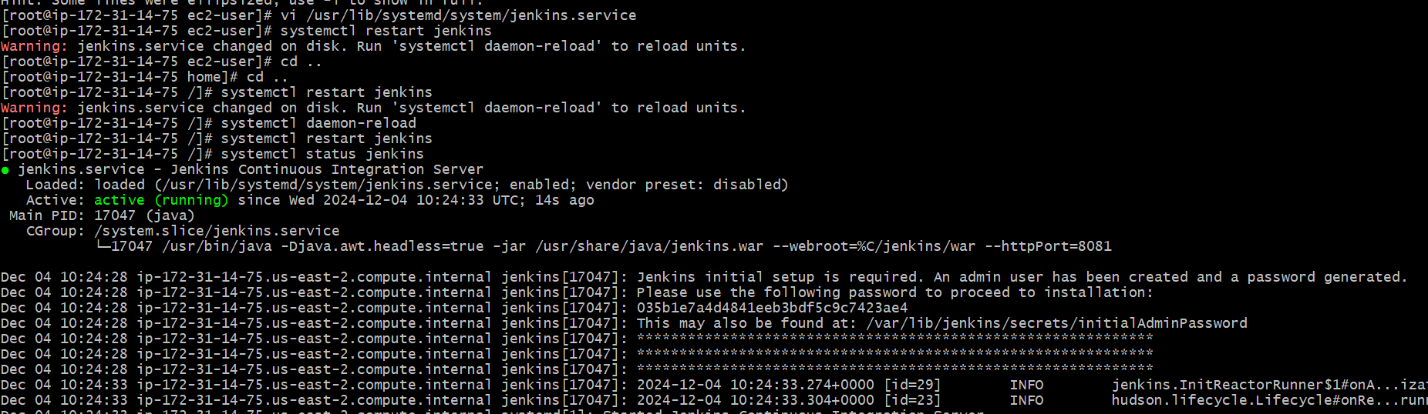

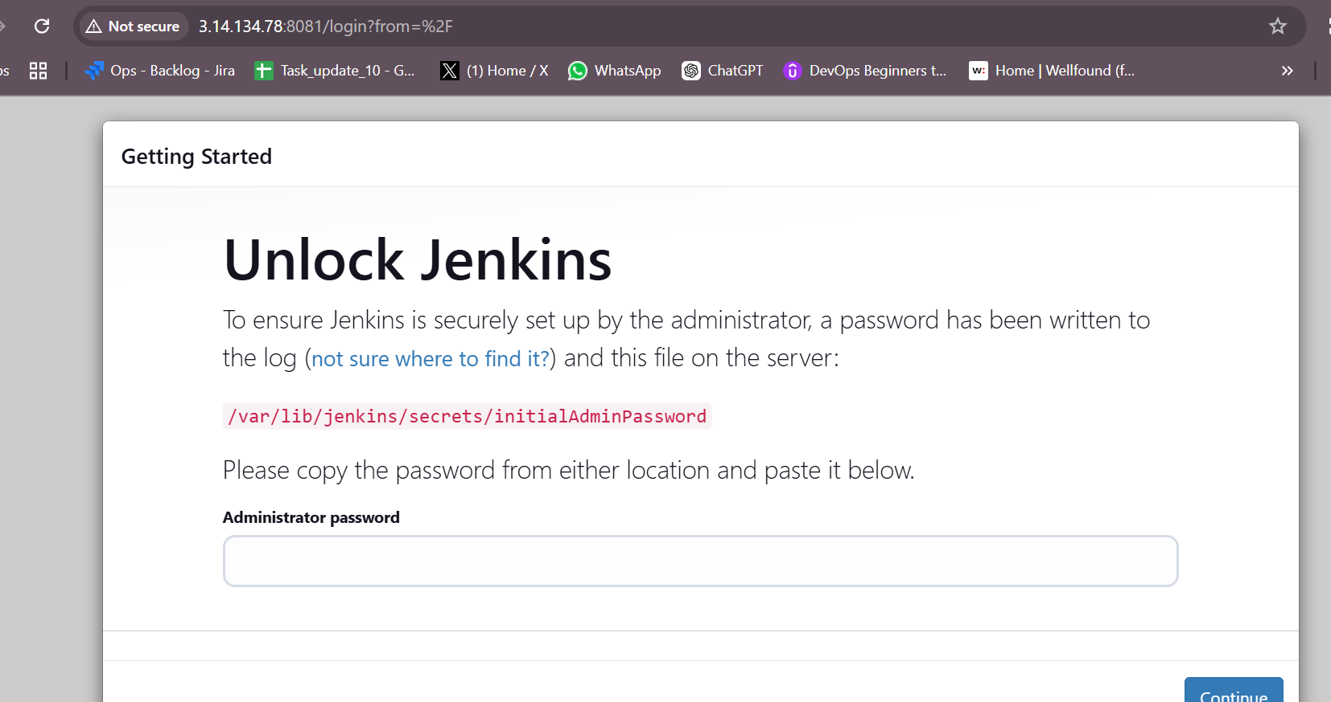

1. Secure Jenkins server

Chenged the password and delited the initial admin password

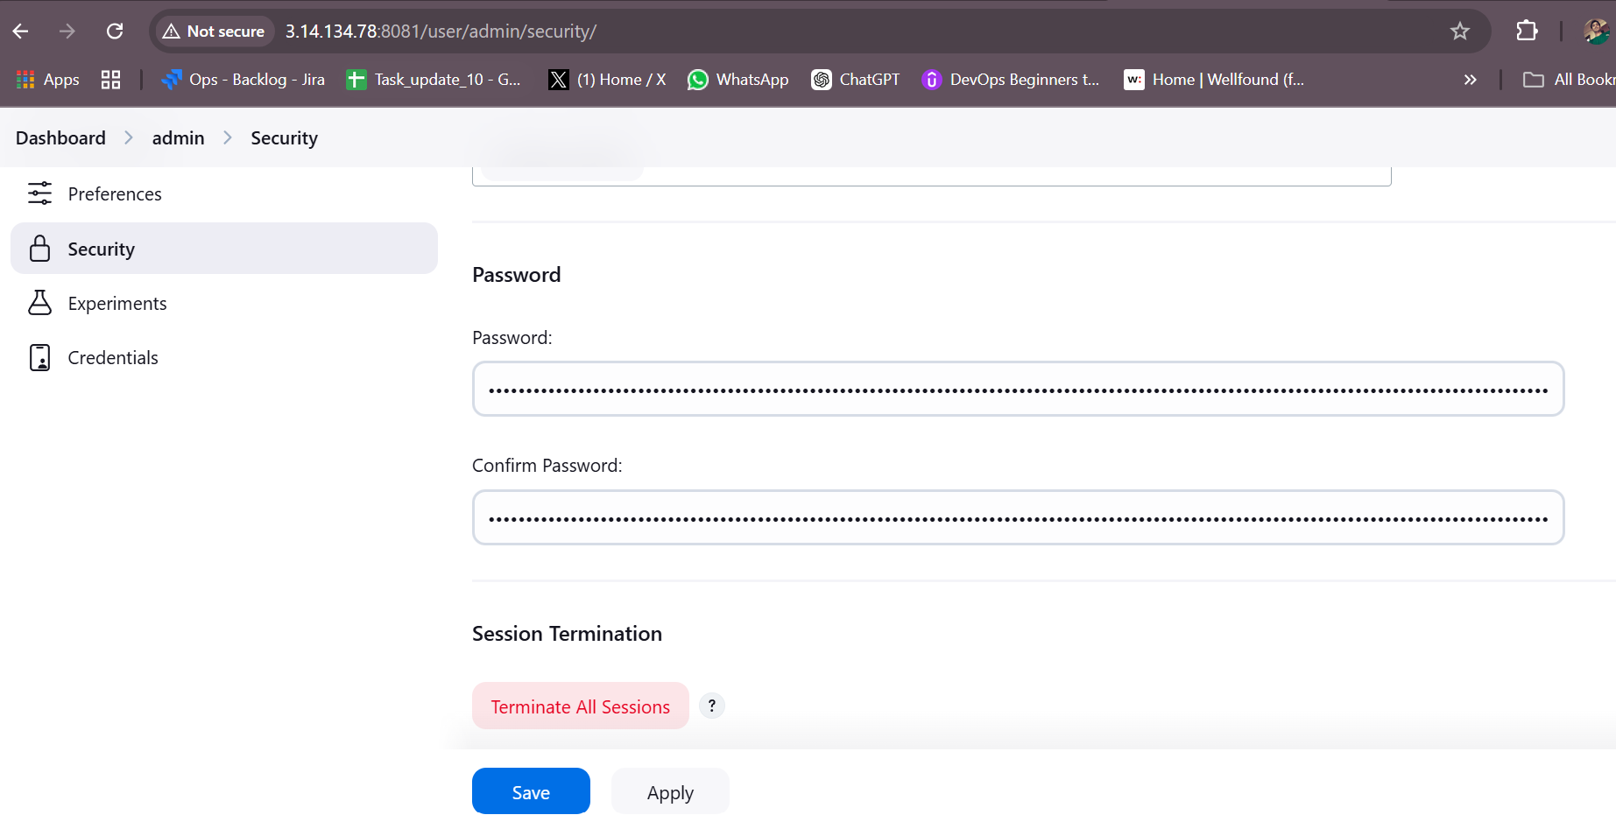

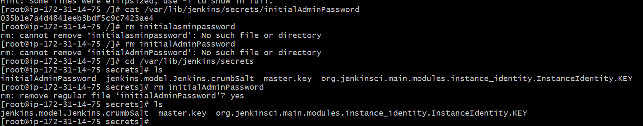

1. Create users called Devops, Testing in Jenkins with Limited access.

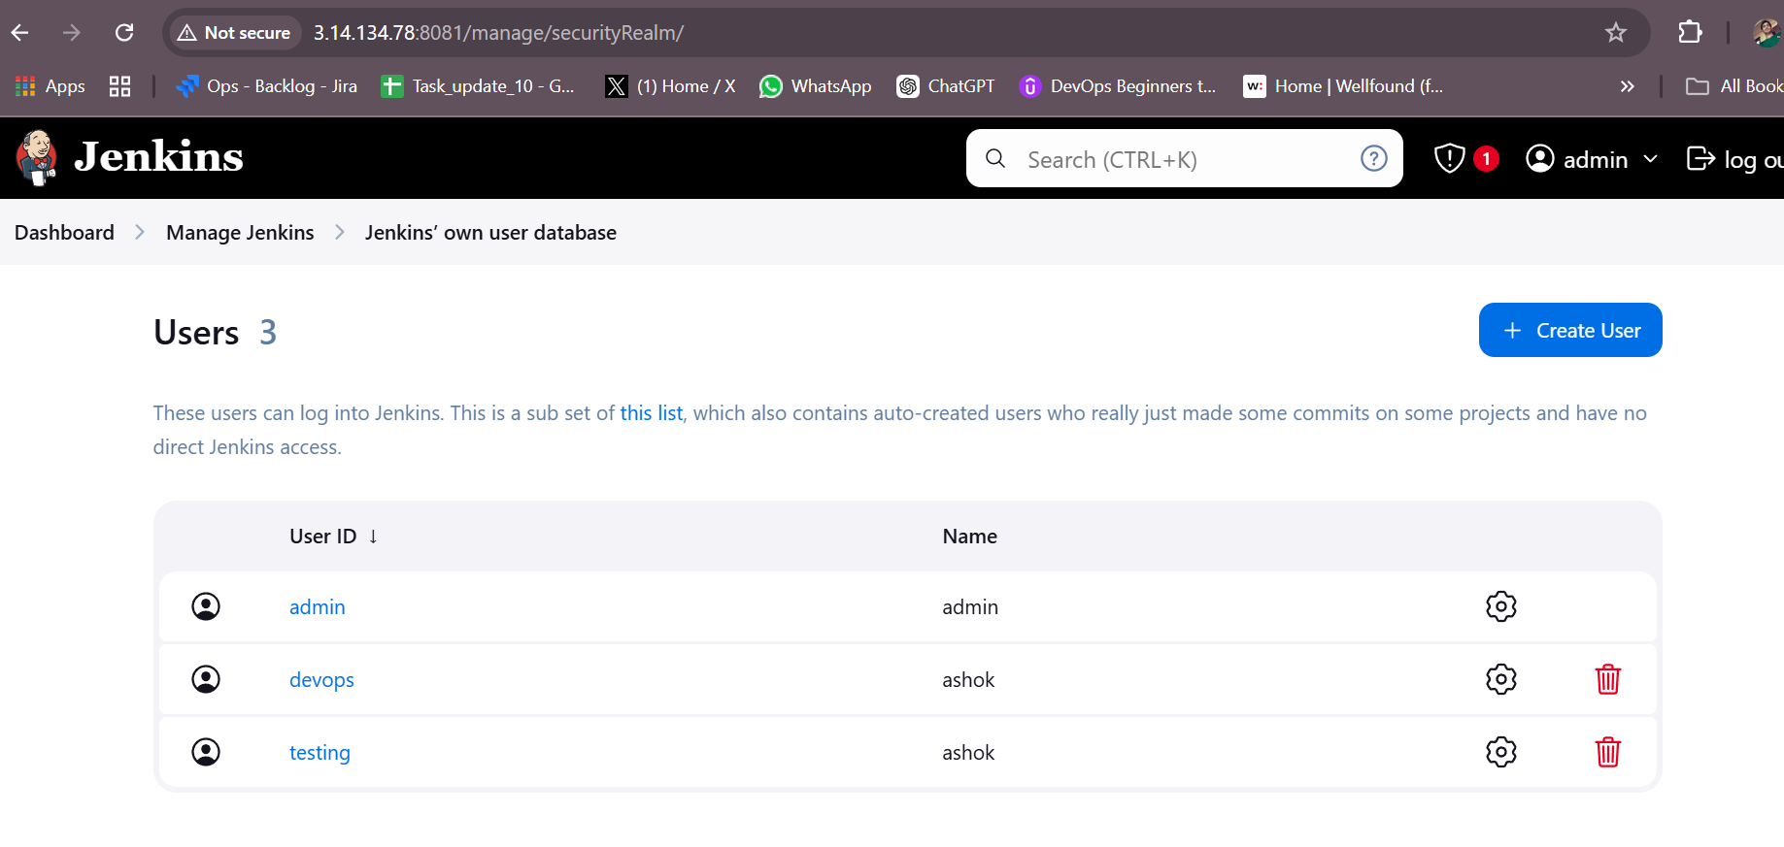

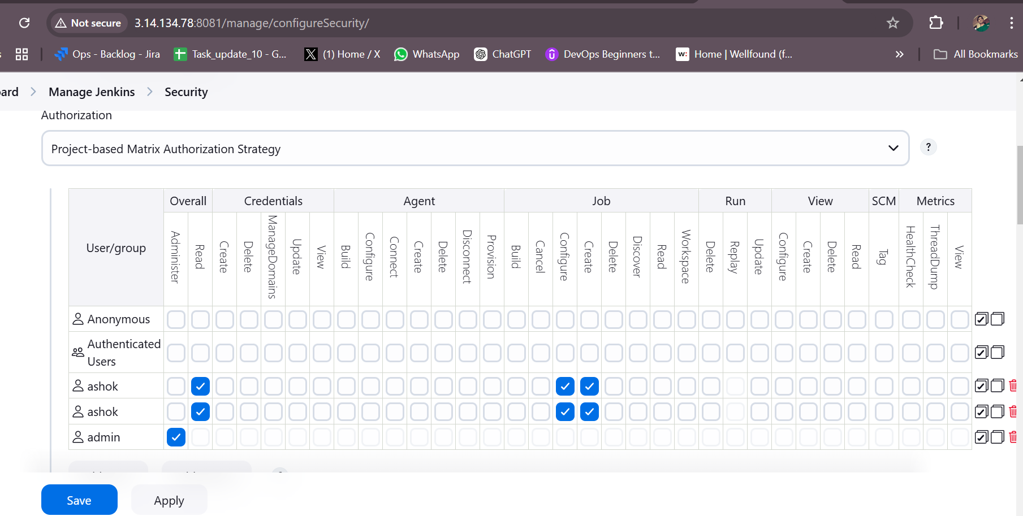

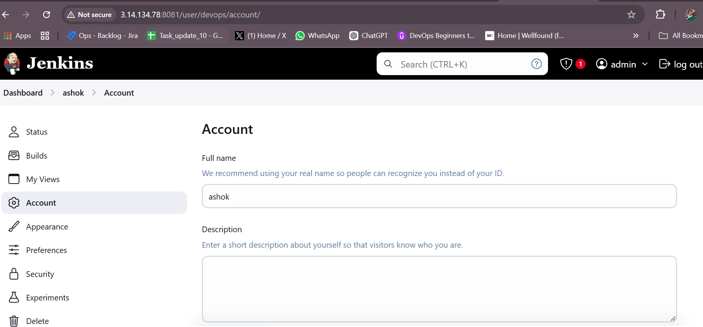

1. Configure labels and restrict the jobs to execute based on label only.

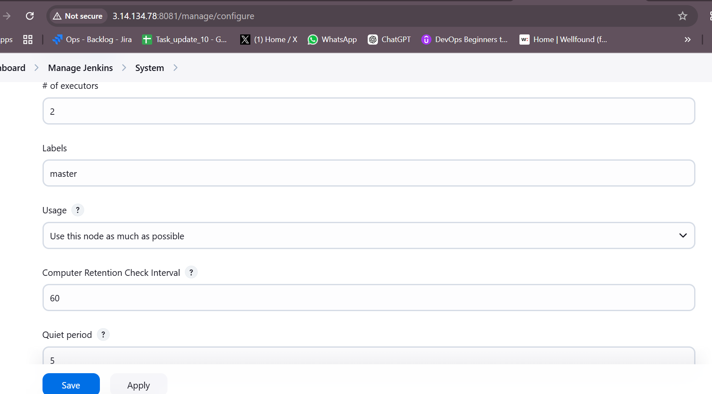

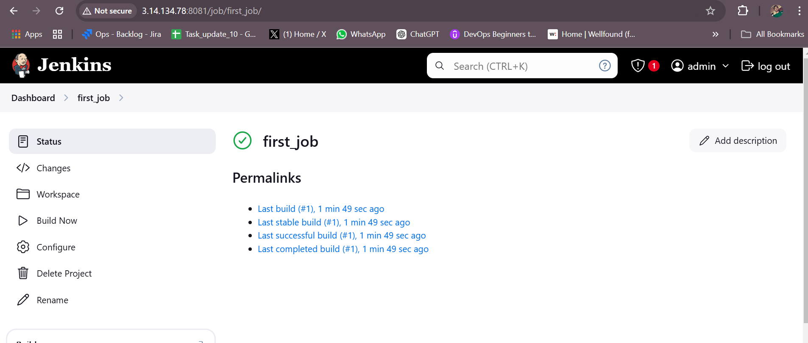

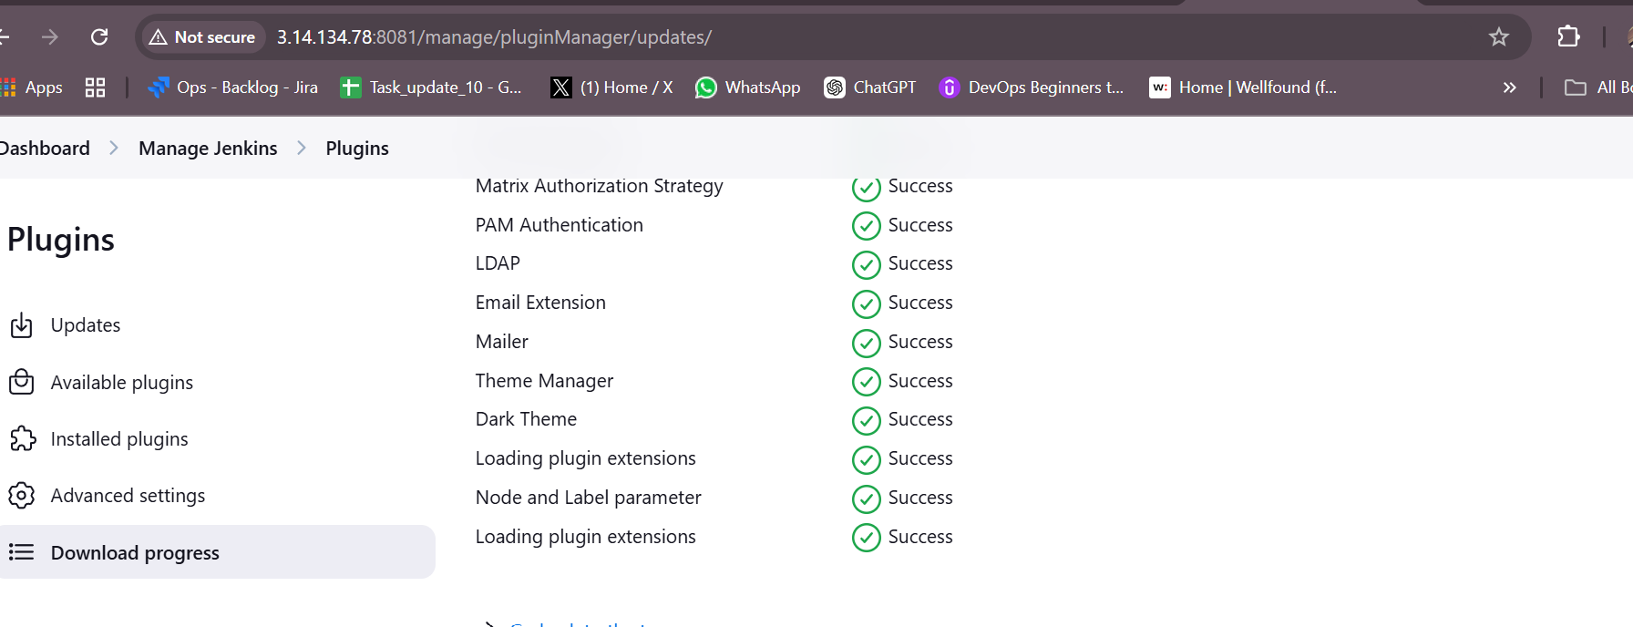

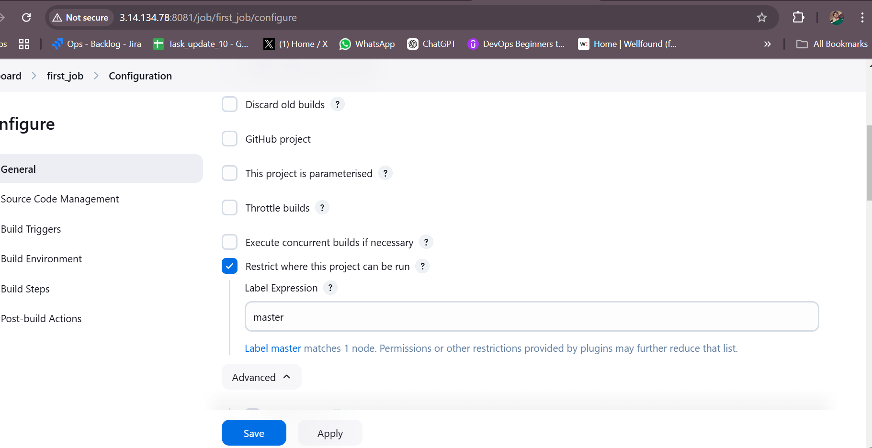

1. Create Three sample jobs using the below URL. [https://github.com/betawins/Techie_horizon_Login_app.git](https://github.com/betawins/Techie_horizon_Login_app.git" \t "https://app.slack.com/client/T03TRQ064Q0/_blank)

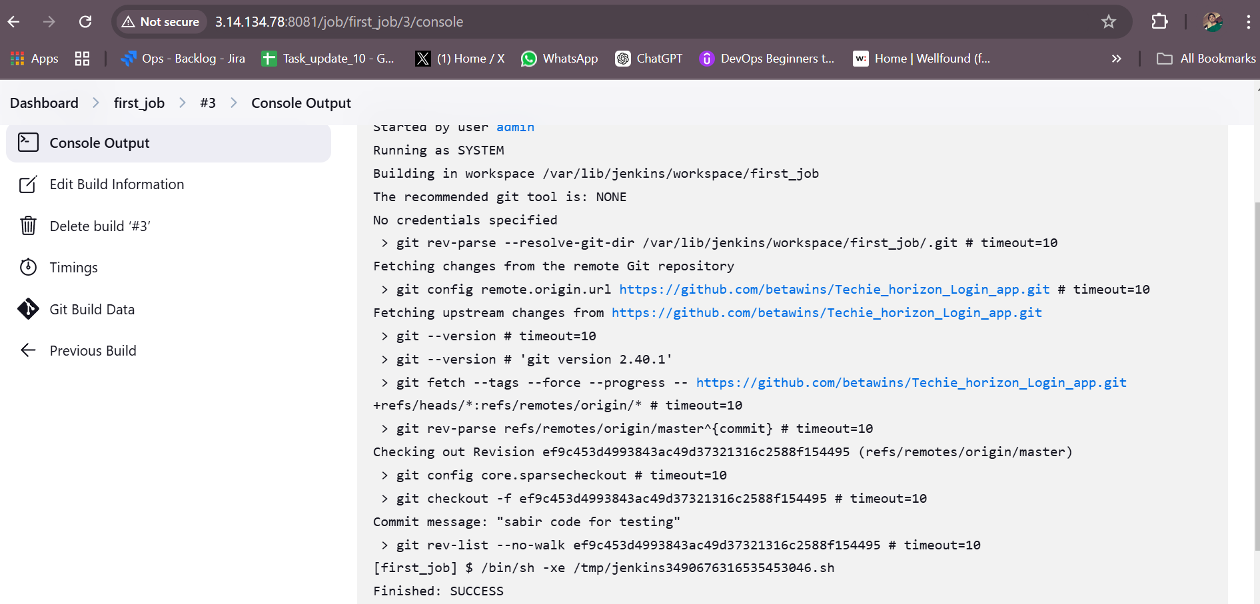

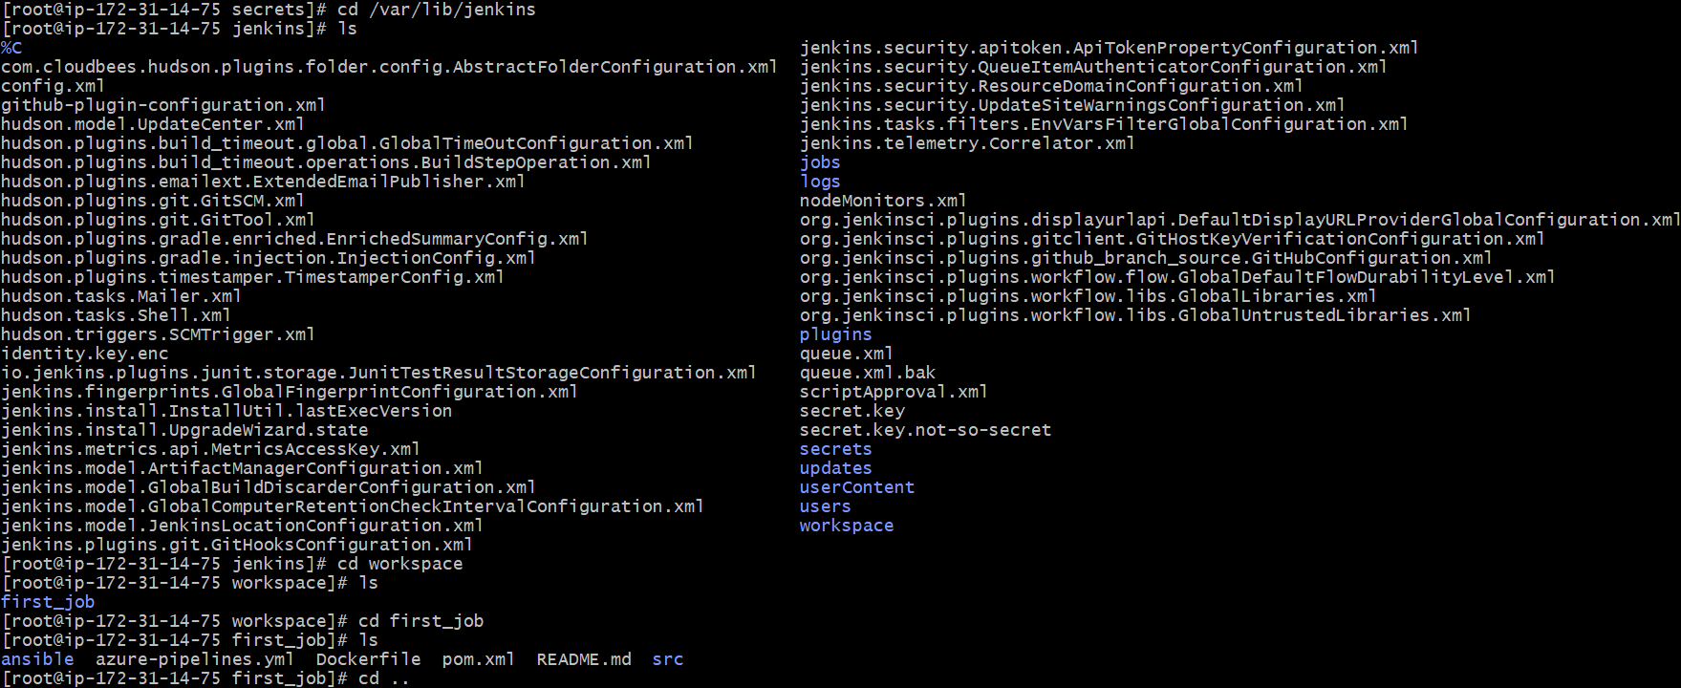

1. Create one jenkins job using git hub Private repository.

