1. Create one jenkins job using the below code and create three stages. stage1: Git clone to download the source code.

Have colne the source code

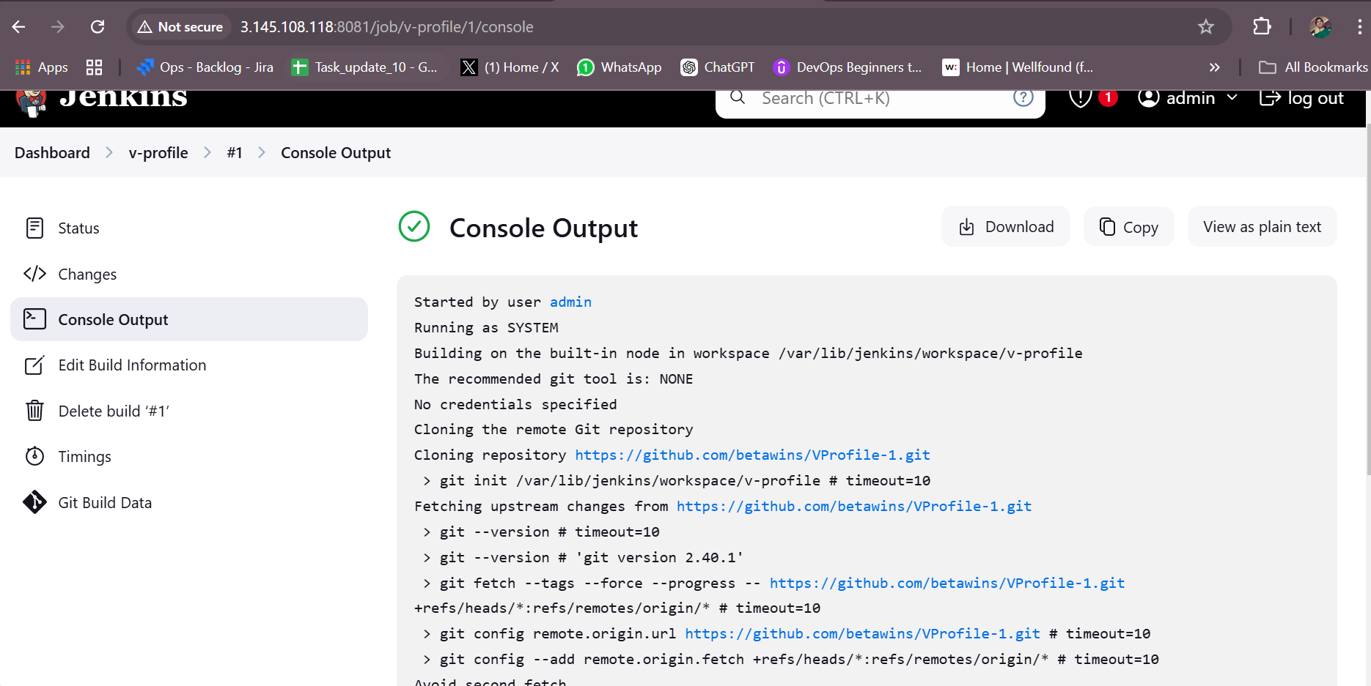

stage2: Sonarqube Integration to check the quality of code stage

Installed one sonarqube instance and installed pre-requisite java

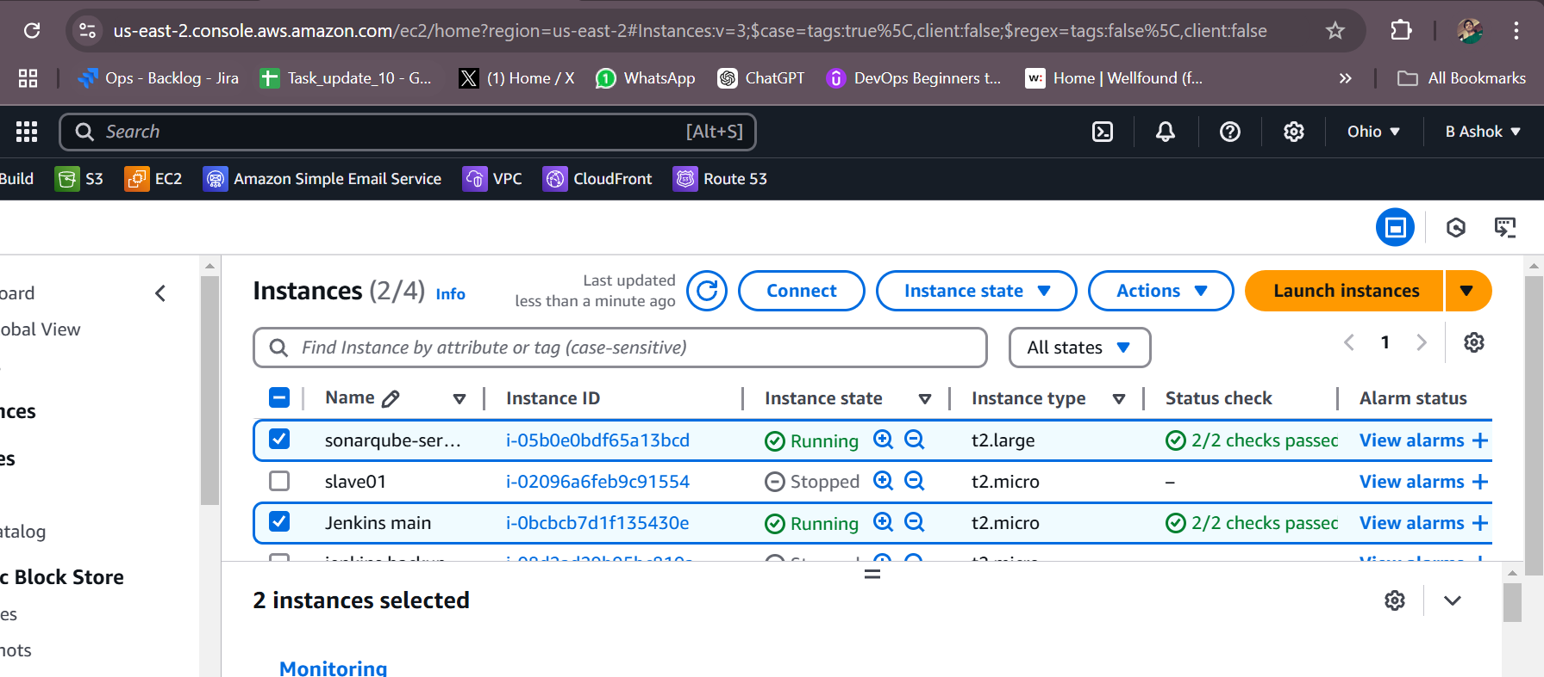

Installed java

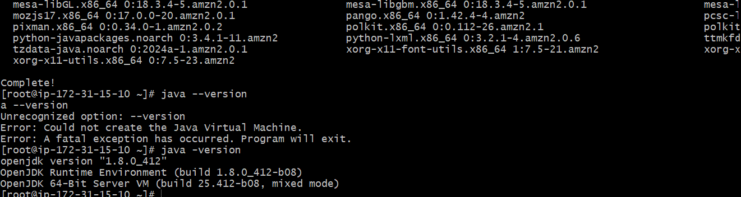

Added mysql rpm repository and installed mysql

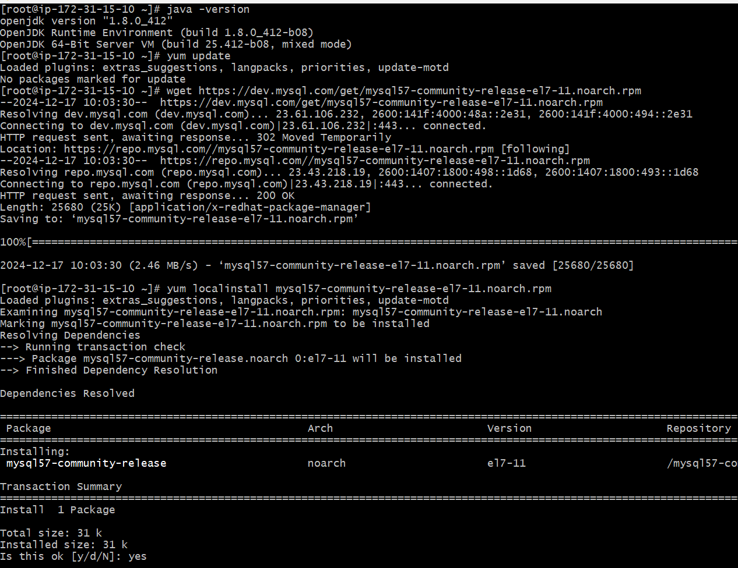

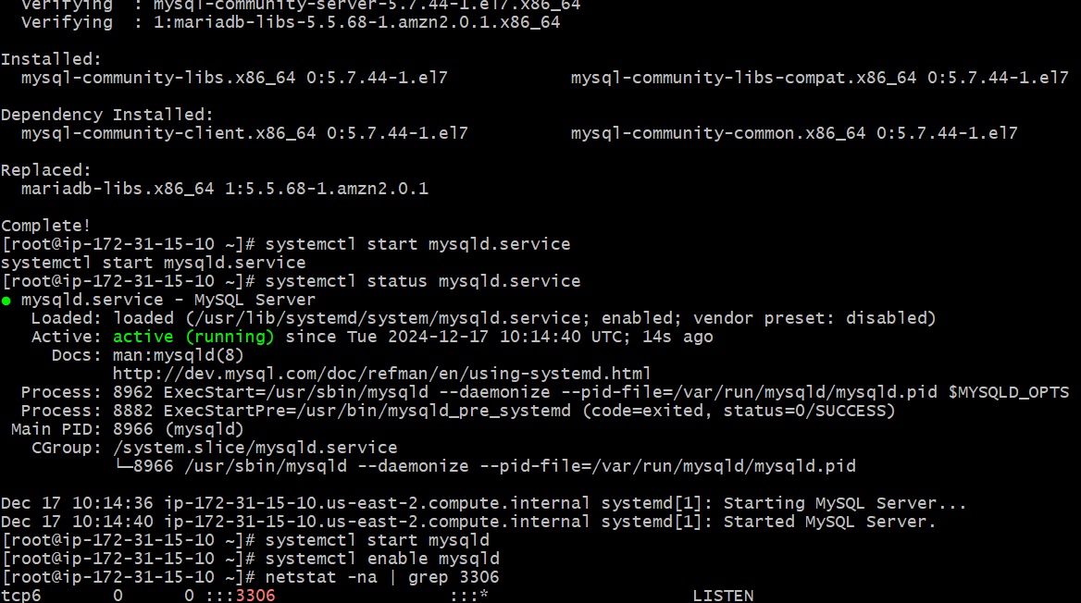

Connected to myaql and changed the password

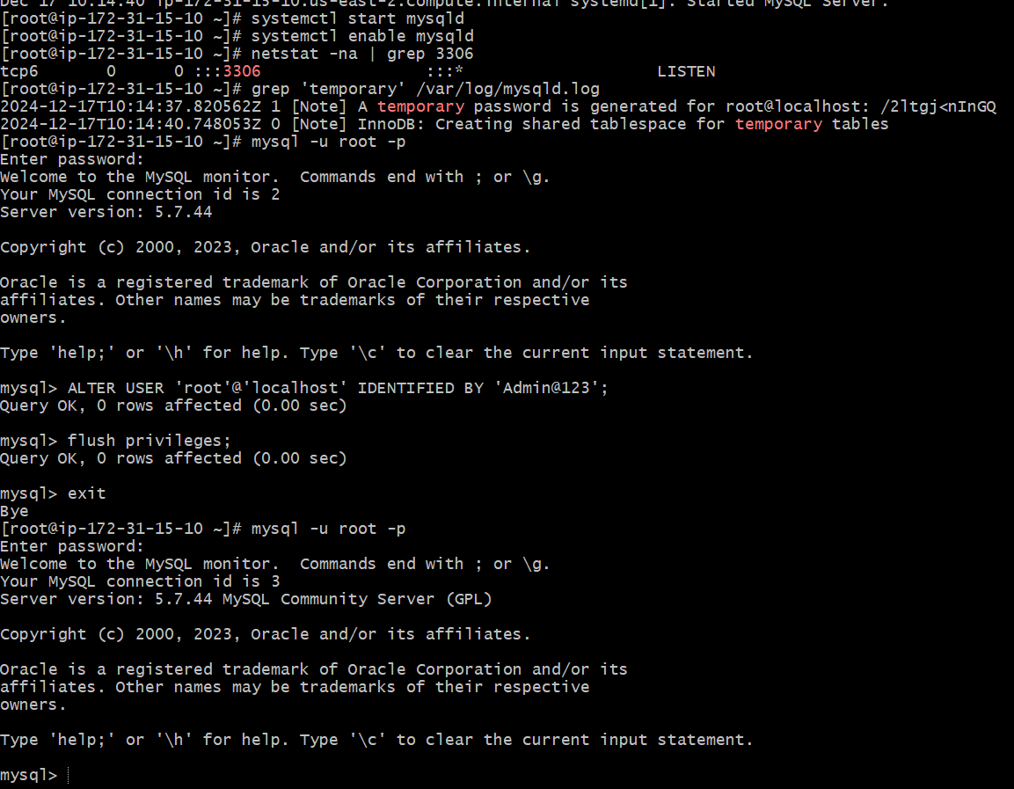

Installed sonarqube and unzipped and renamed

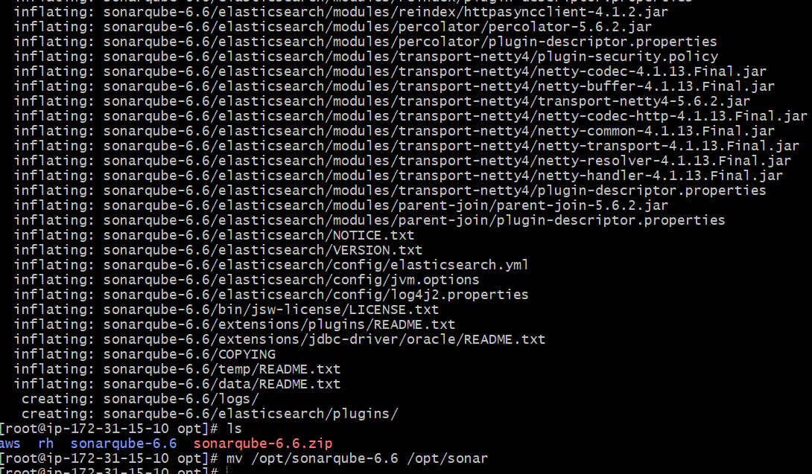

Login to mysql and and created new database and remote and local users and grant permissions

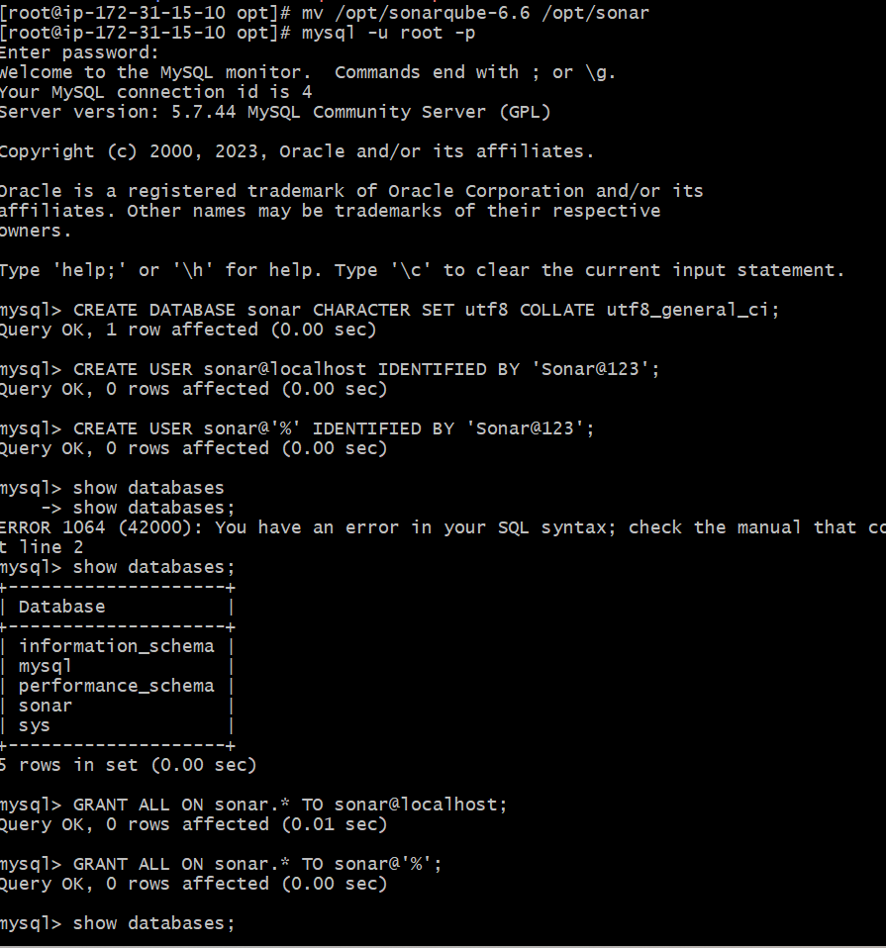

And I have edited the sonar properties

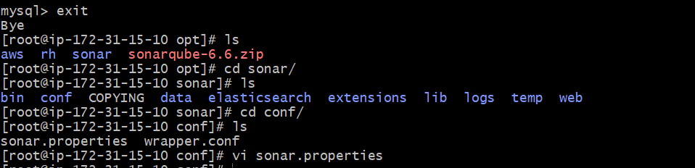

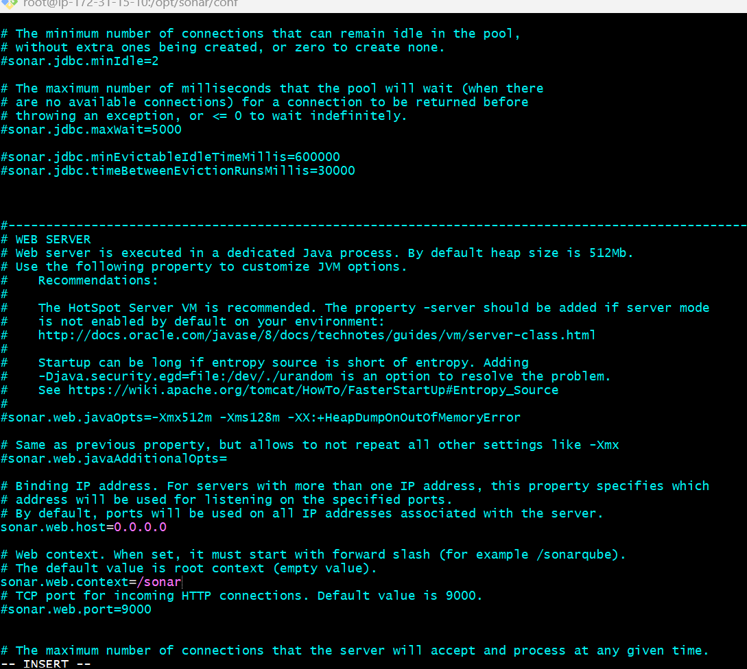

And login via ec2-user y becox of sonar will not accept root user and started the sonarqube

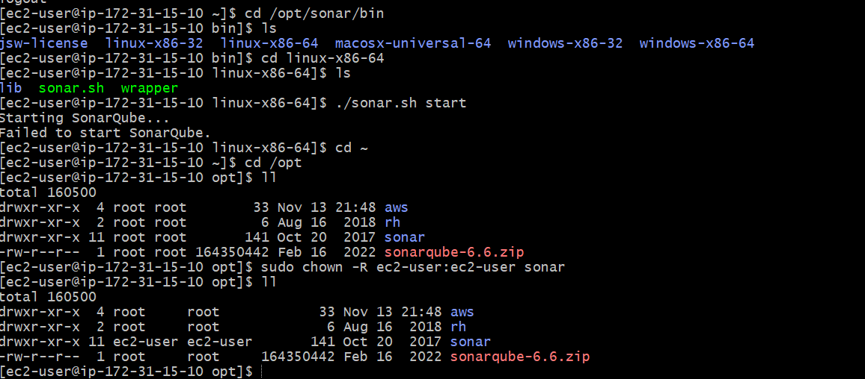

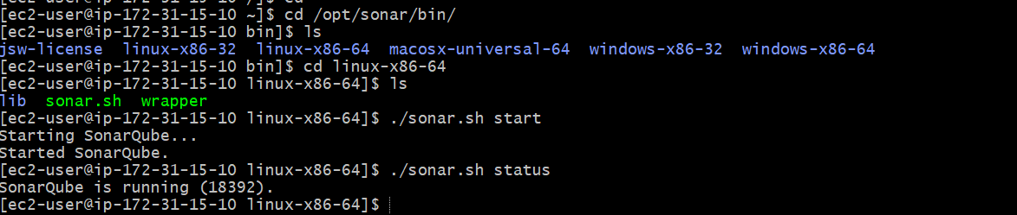

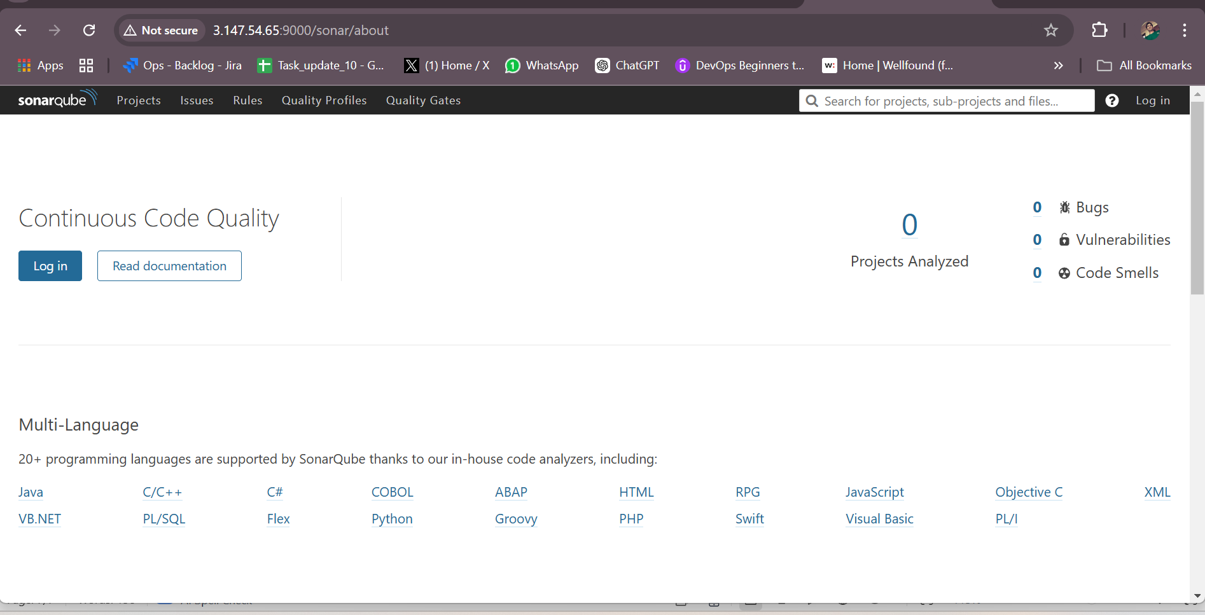

Integreating jenkins with sonarqube

Installed sonarqube scanner

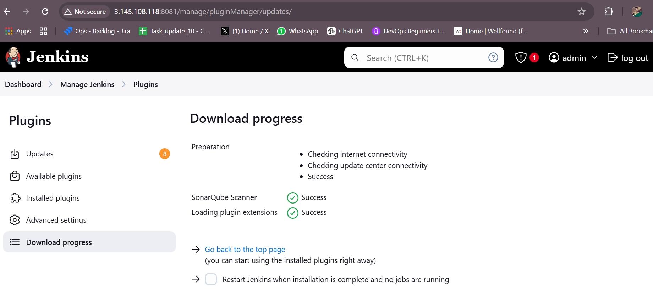

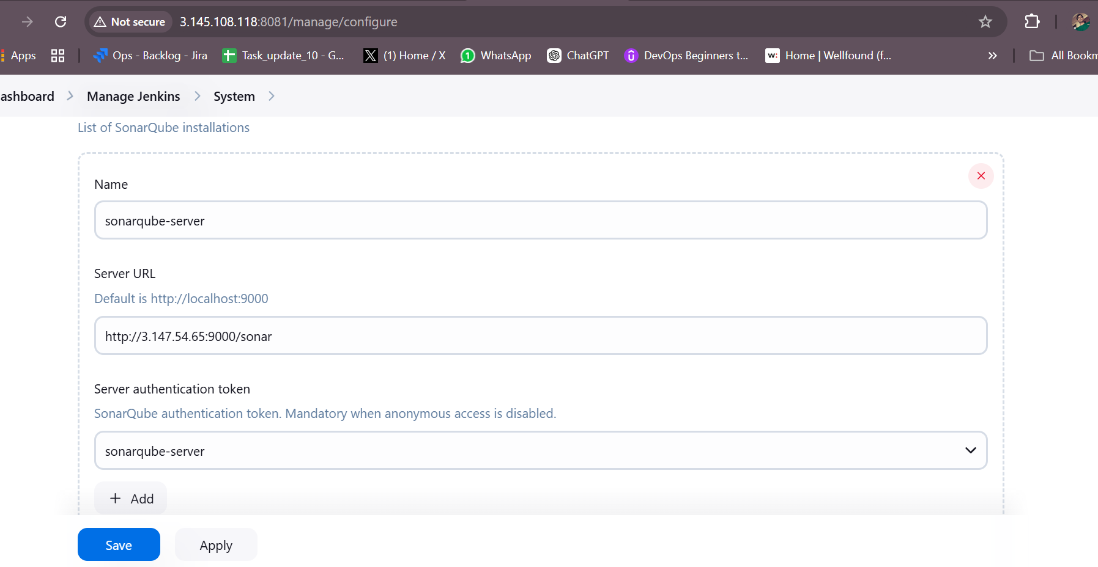

Now install sonar-scanner in jenkin main server to push the code to sonarqube

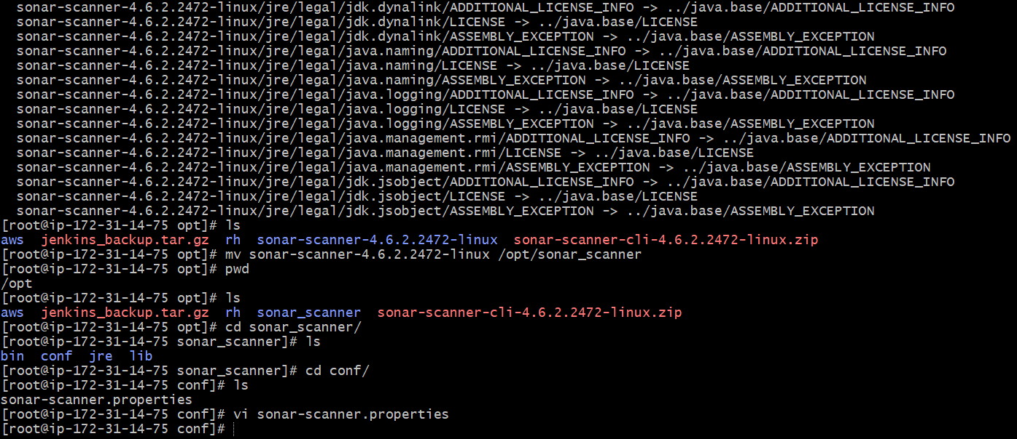

And changed the sonar-scanner properties to link to sonarqube

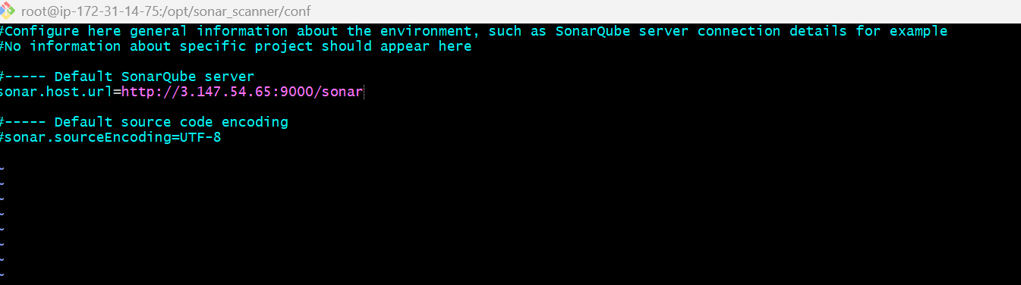

And executed sonarqube scanner in build steps

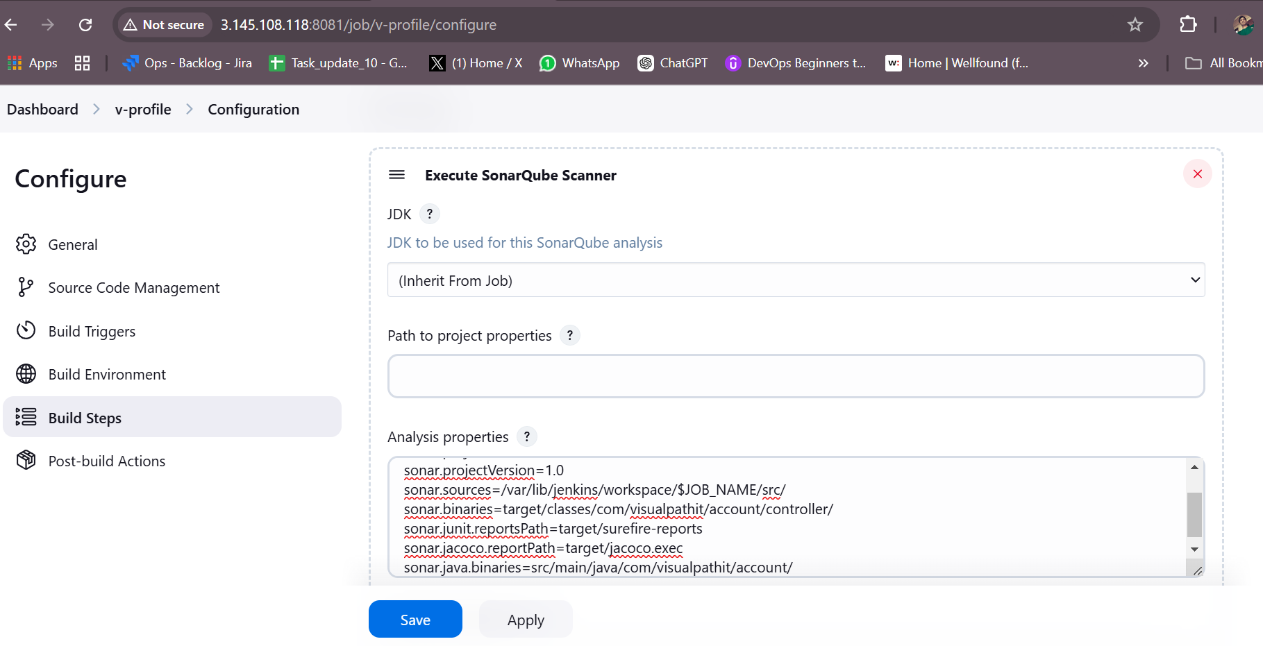

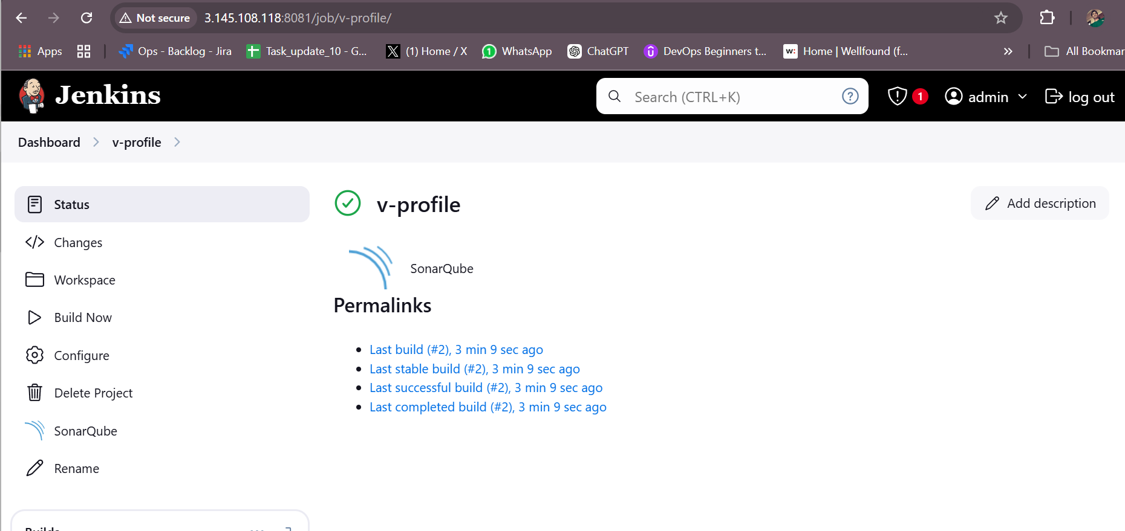

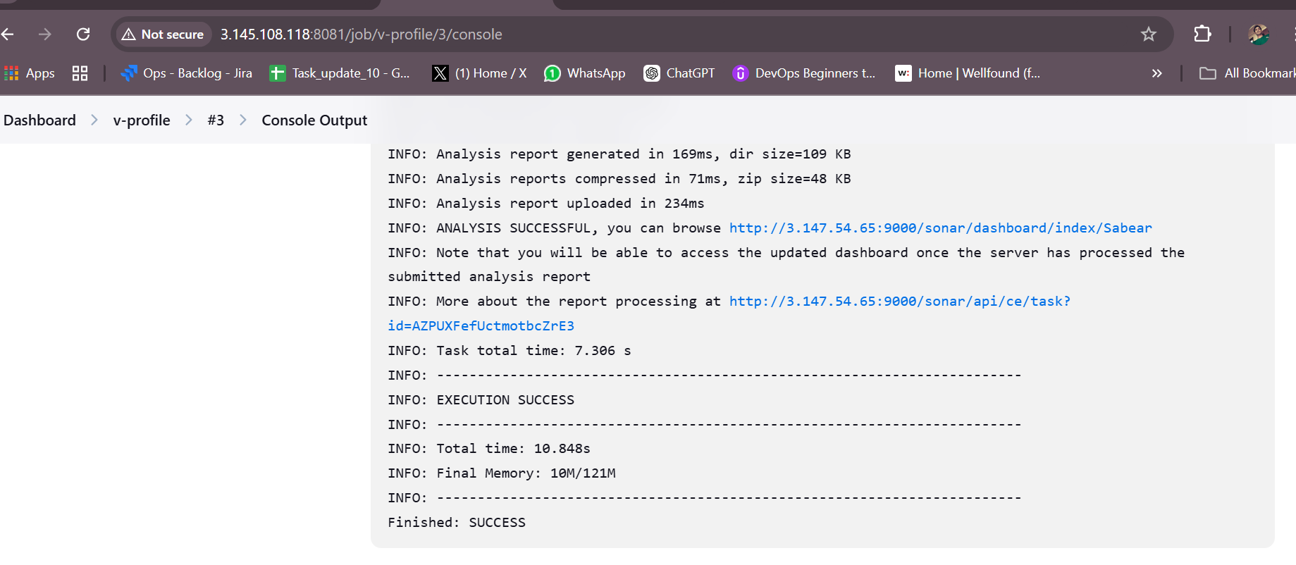

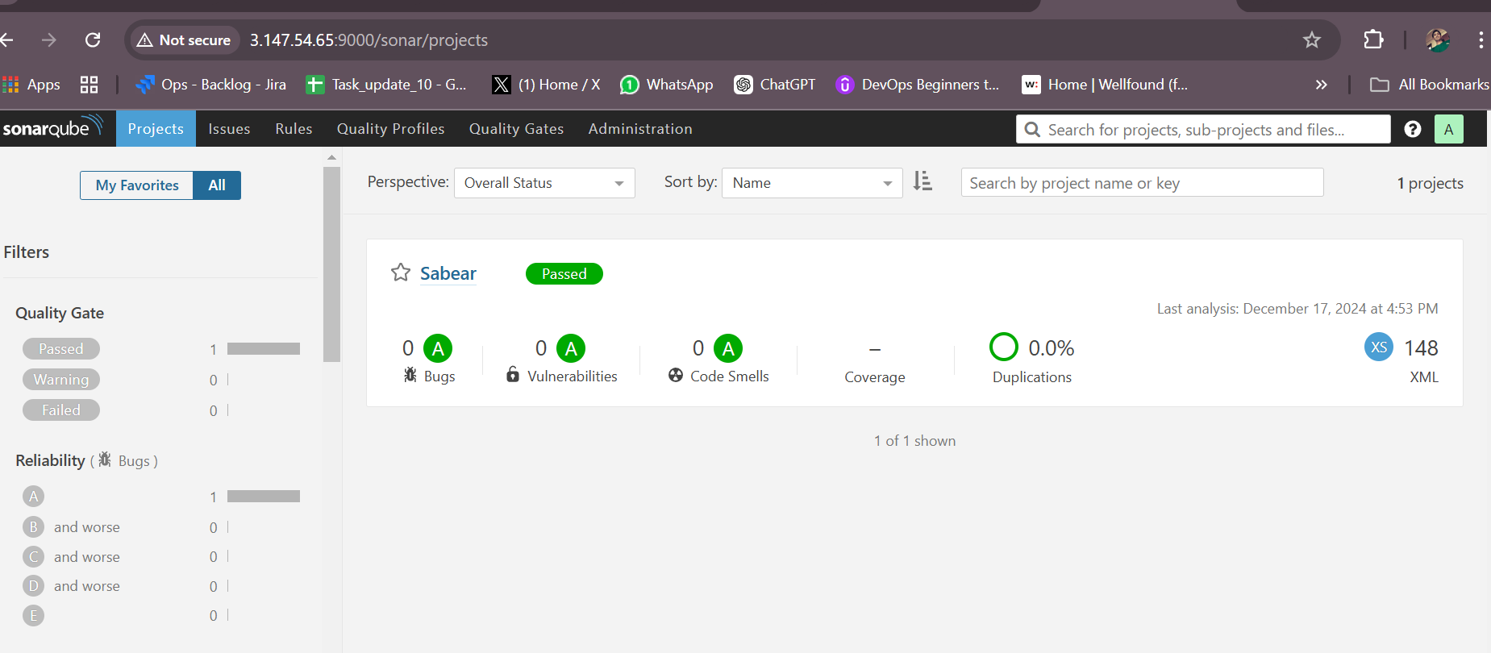

3: Slack Integration to send the alerts to slack. URL: [https://github.com/betawins/VProfile-1.git](https://github.com/betawins/VProfile-1.git" \t "https://app.slack.com/client/T03TRQ064Q0/_blank)

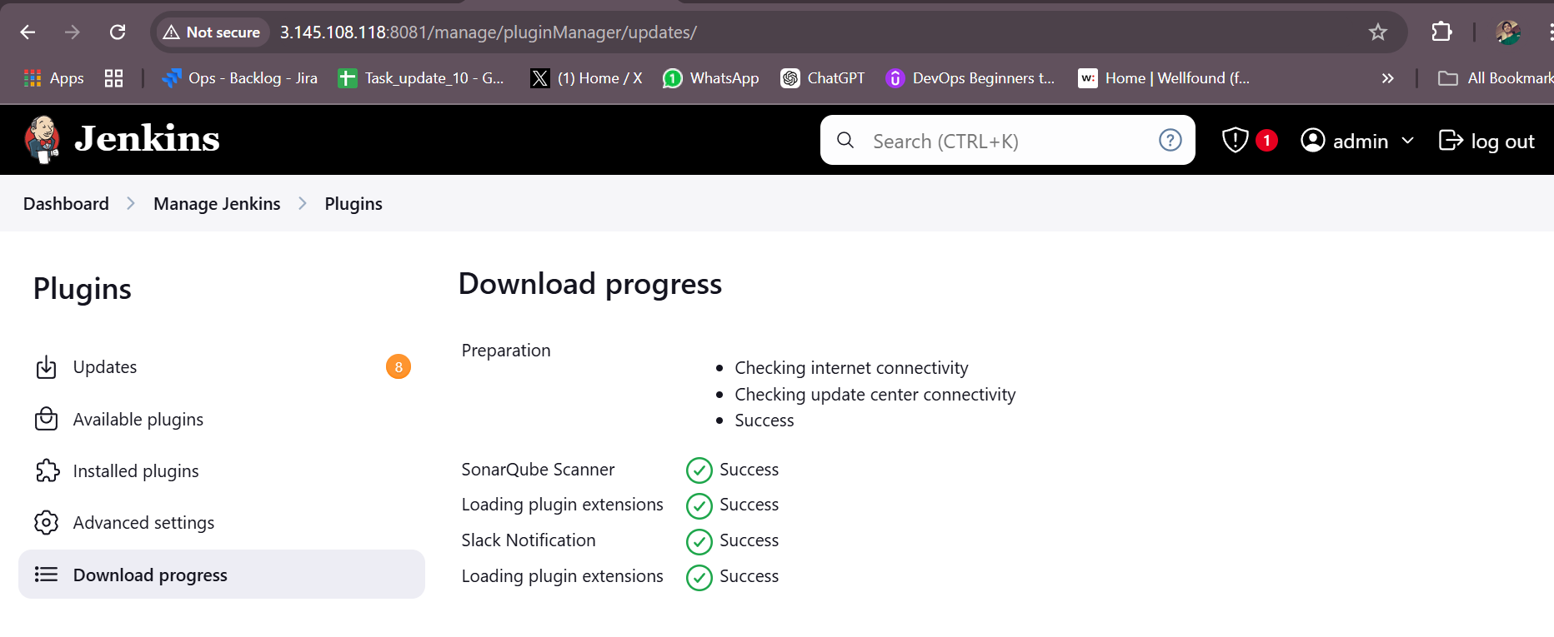

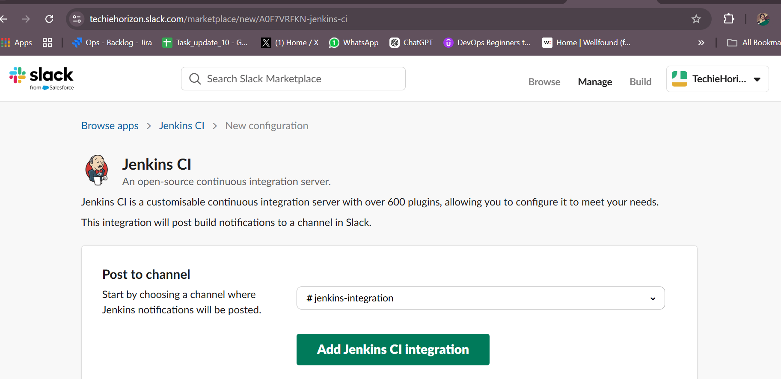

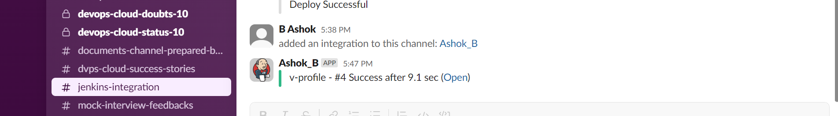

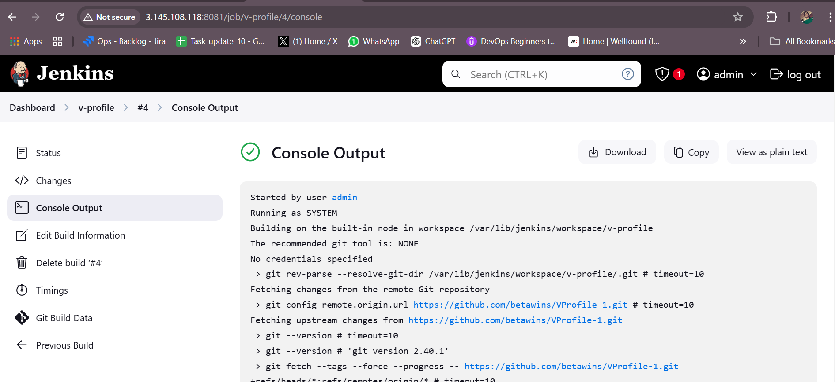

1. 1) Create one jenkins job using the below code and create three stages. stage1: Git clone to download the source code.

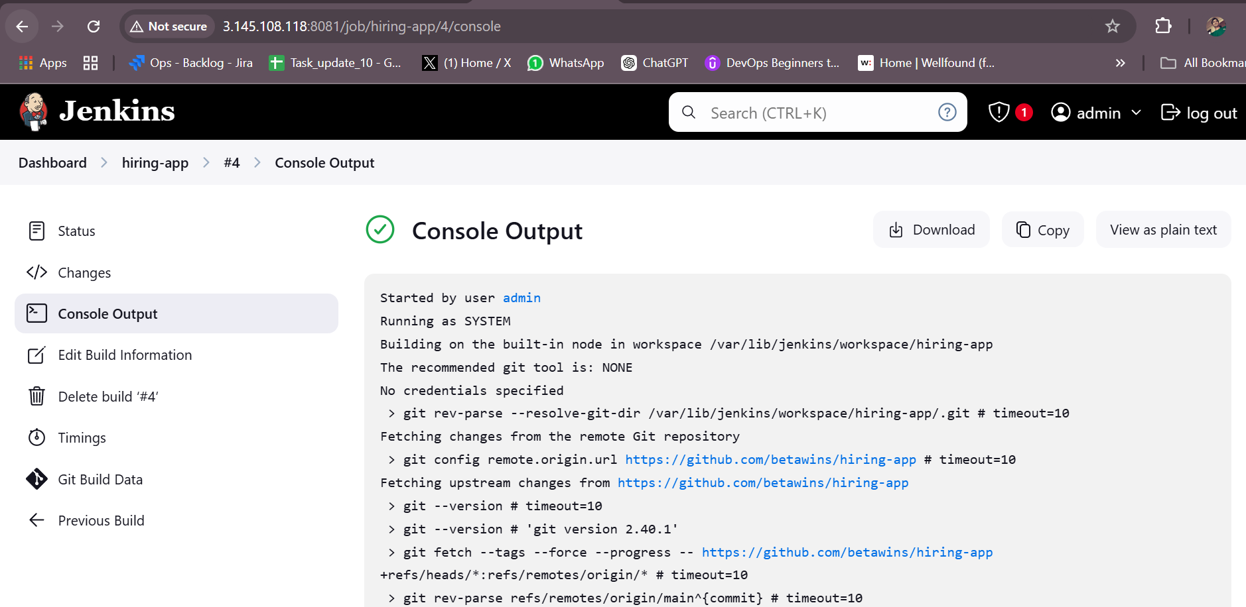

1. stage2: Sonarqube Integration to check the quality of code stage

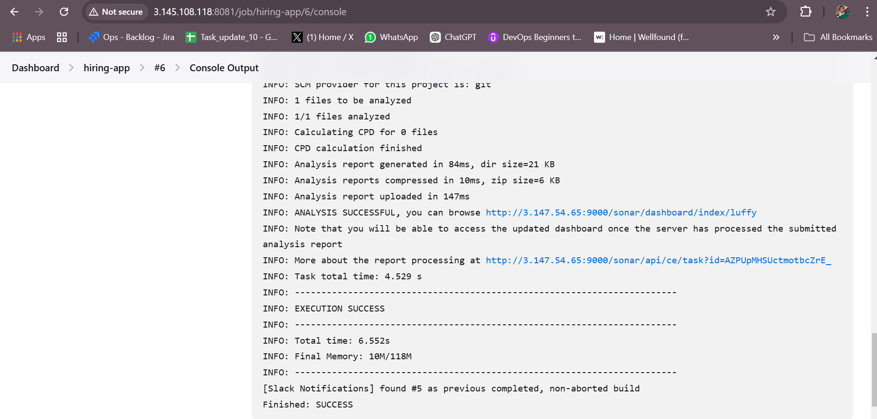

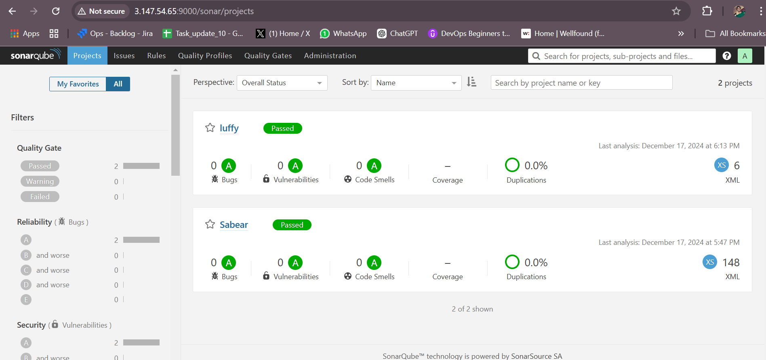

3: Slack Integration to send the alerts to slack. URL: [https://github.com/betawins/hiring-app.git](https://github.com/betawins/hiring-app.git" \t "https://app.slack.com/client/T03TRQ064Q0/_blank)

