1. Setup jenkins CICD pipeline using freestyle job using Docker containers using below code. [https://github.com/betawins/hiring-app.git](https://github.com/betawins/hiring-app.git" \t "https://app.slack.com/client/T03TRQ064Q0/_blank) Stages: 1) Git Clone 2) Sonarqube Integration 3) Maven Compilation 4) Nexus Artifactory 5) Slack Notification 6) Deploy On tomcat

Installed docker on sonarqube server

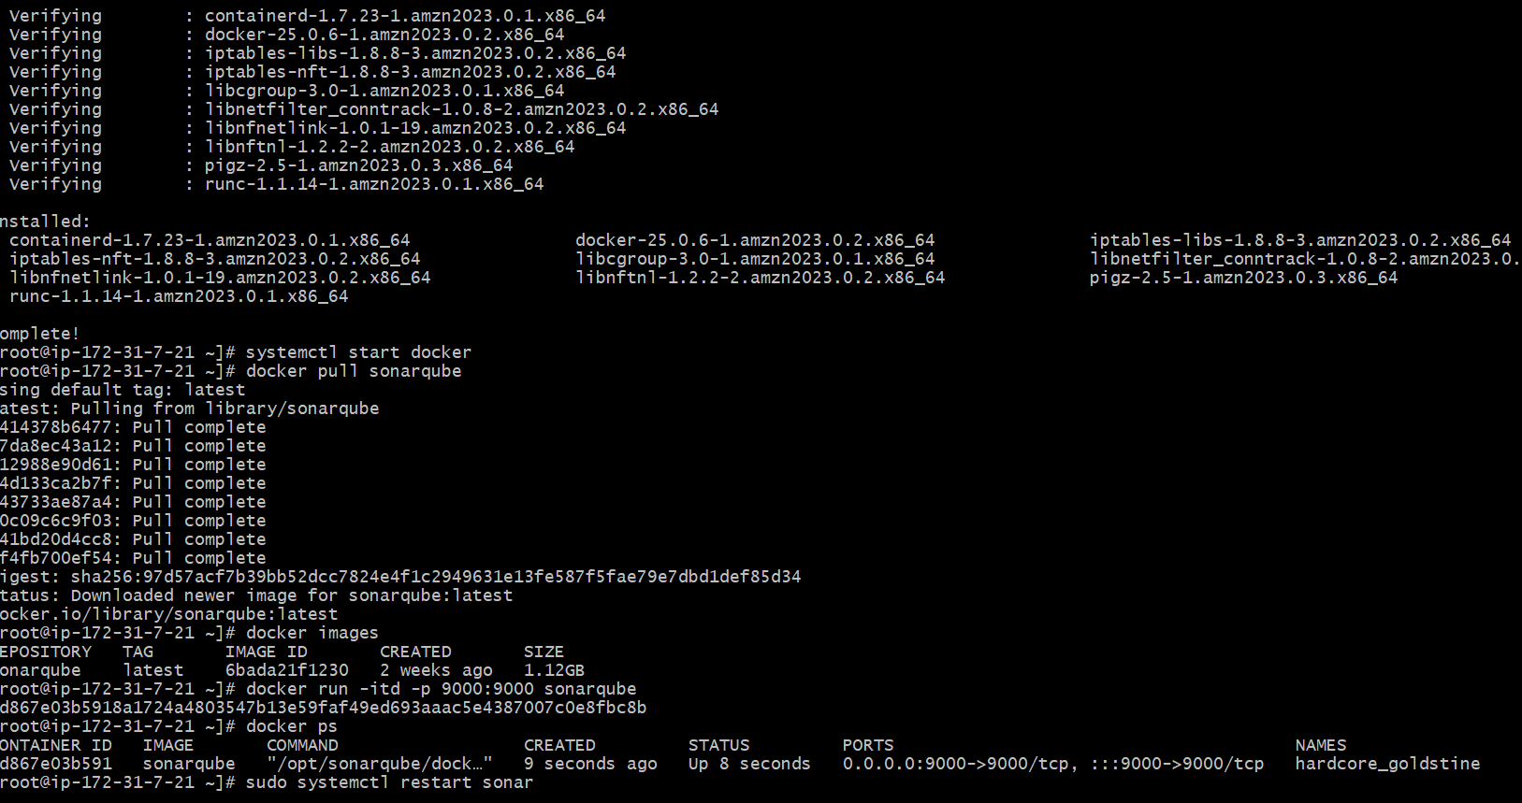

Cloned git:

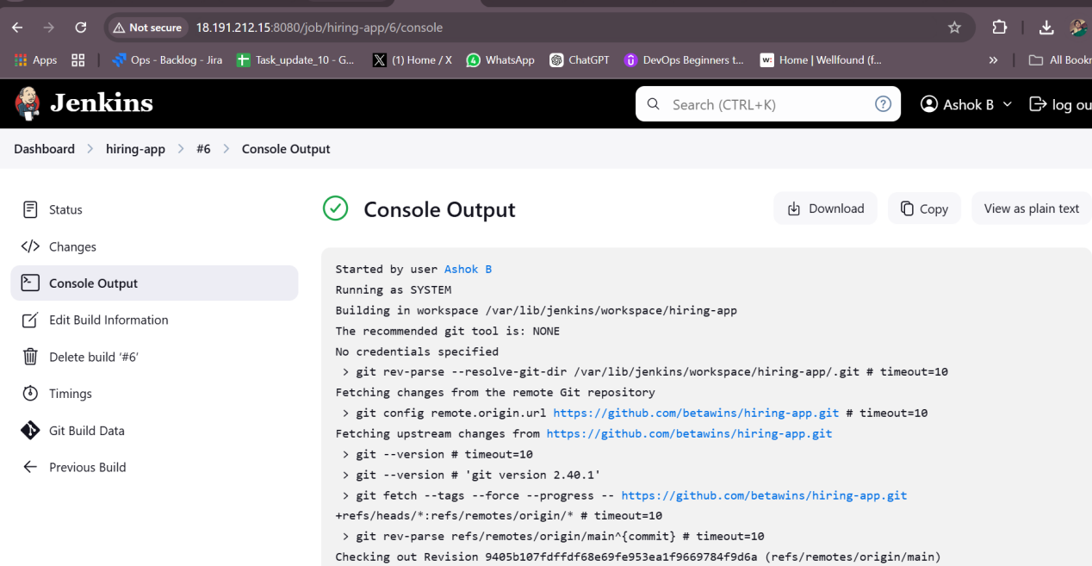

Sonarqube qualiy checks

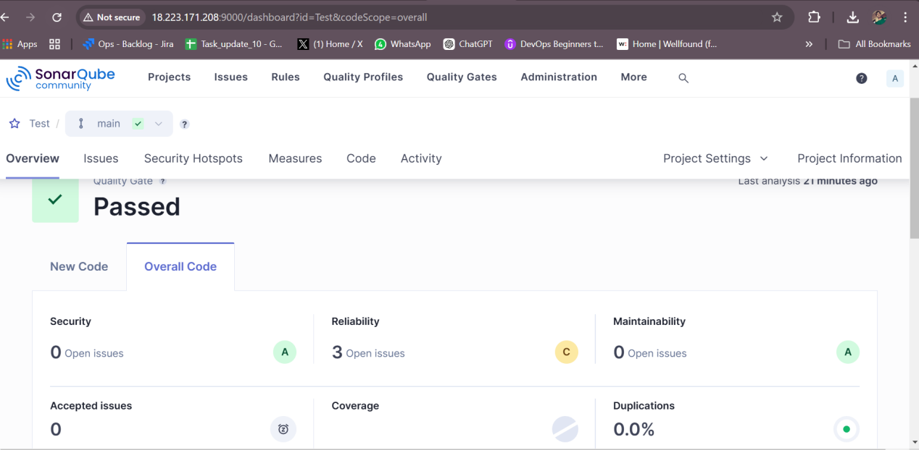

Installed maven in jenkin main server

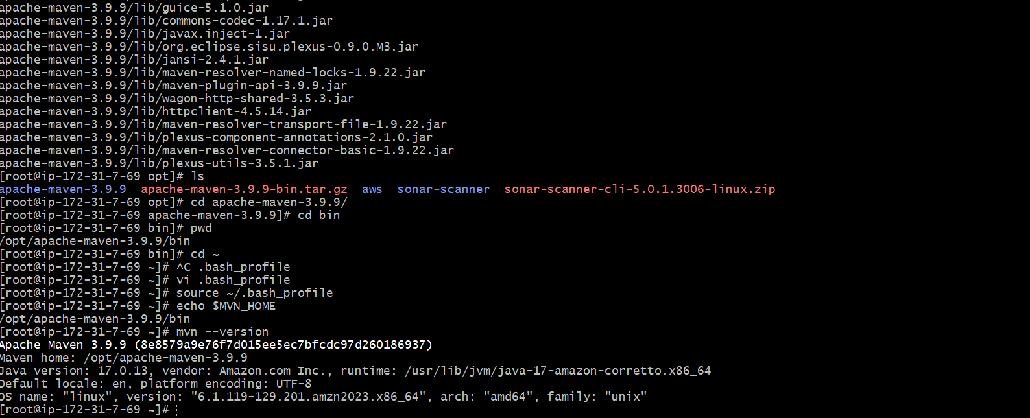

Created a war file using maven compiler

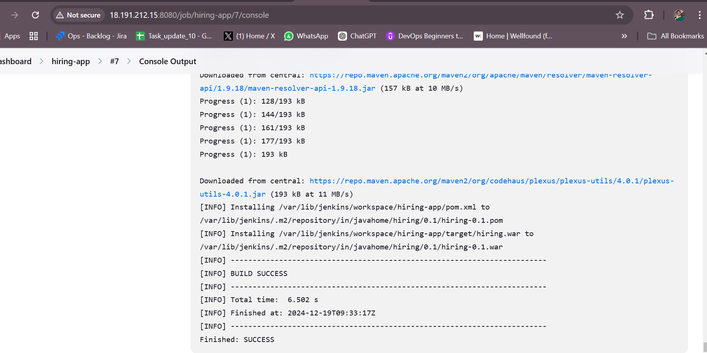

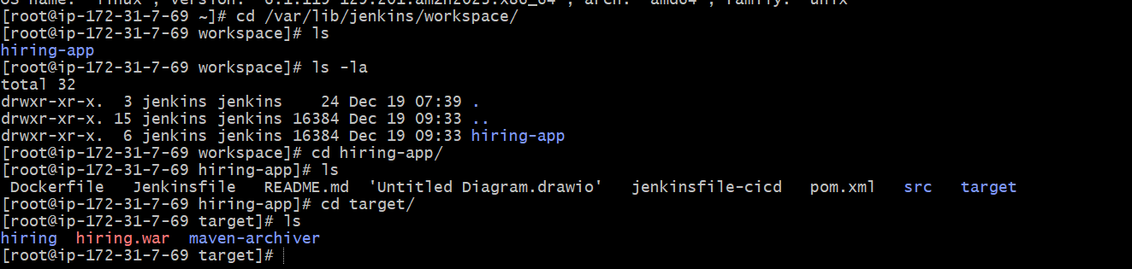

Installed nexus artifactory

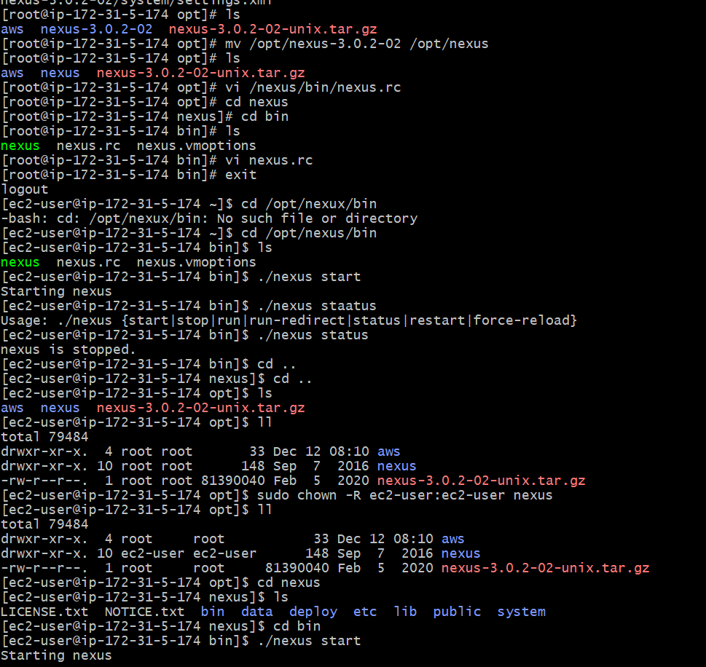

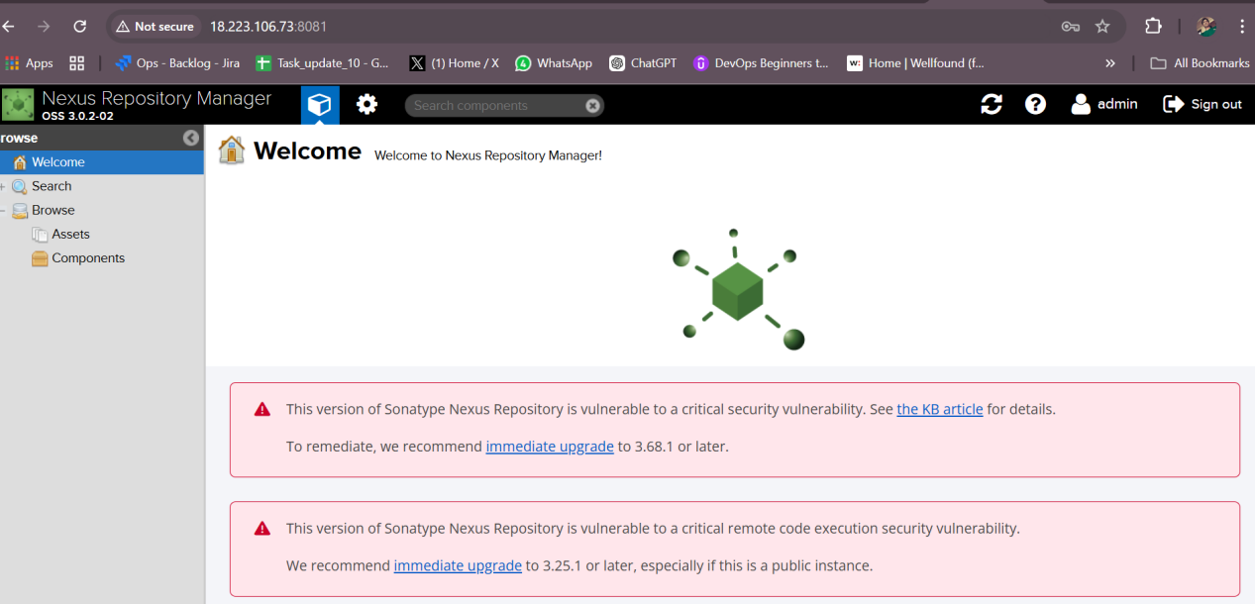

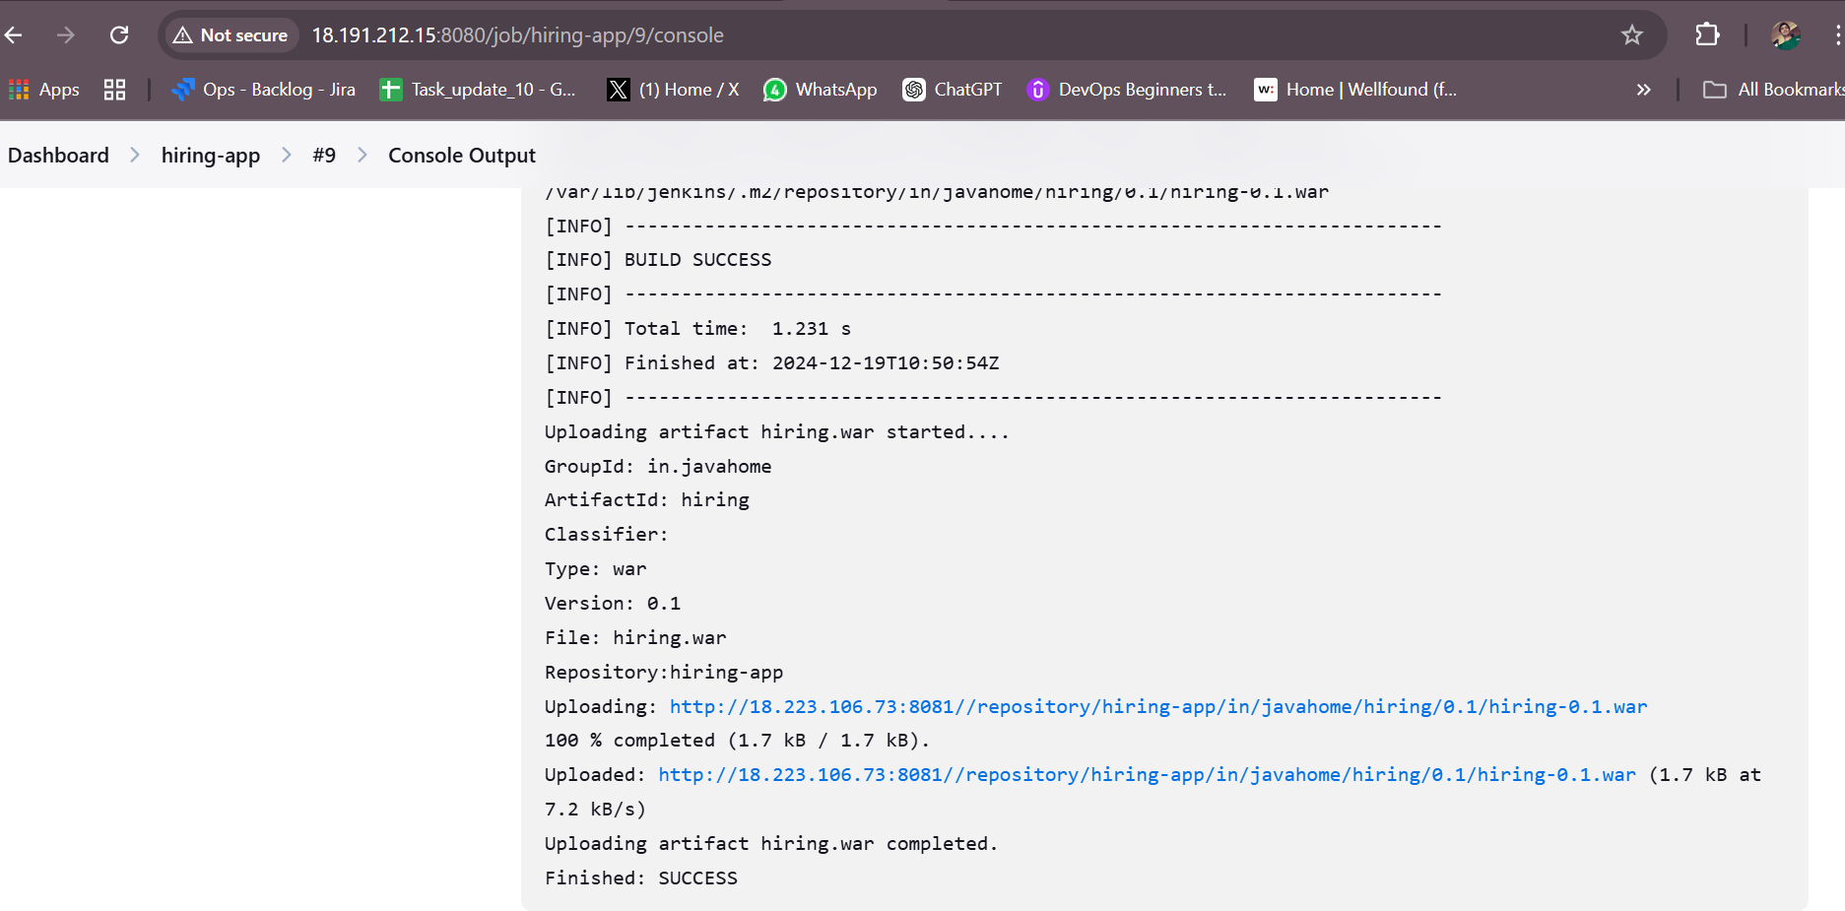

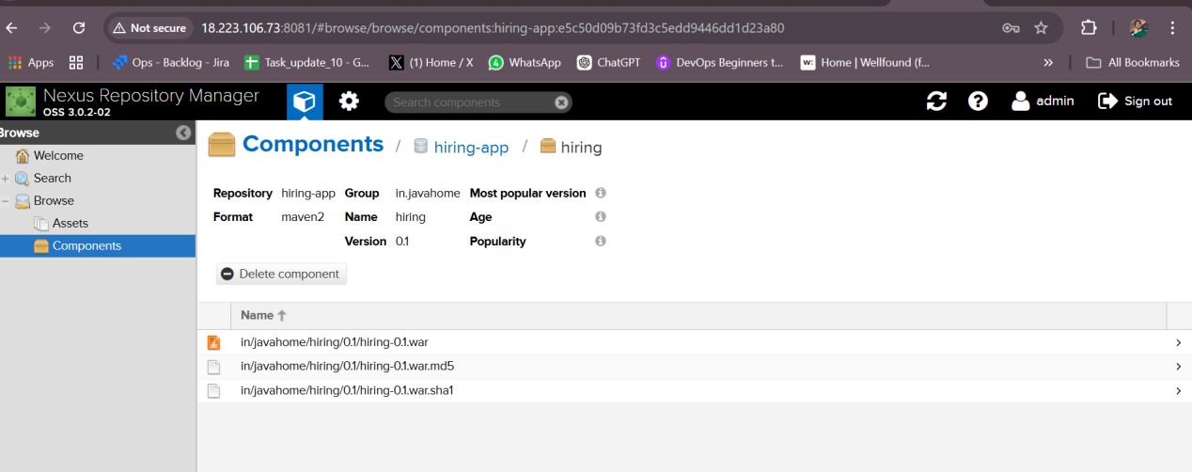

sent the slack notification

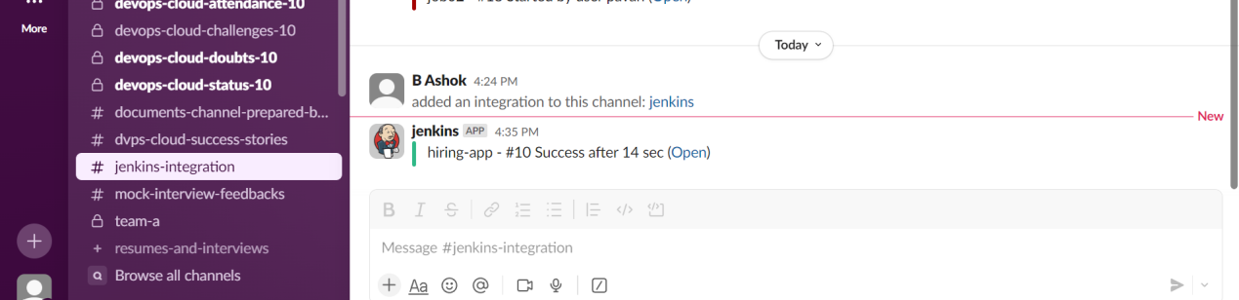

Tomcat deploymet

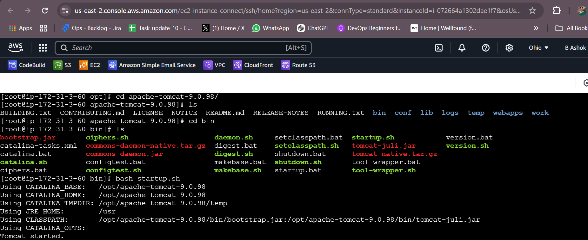

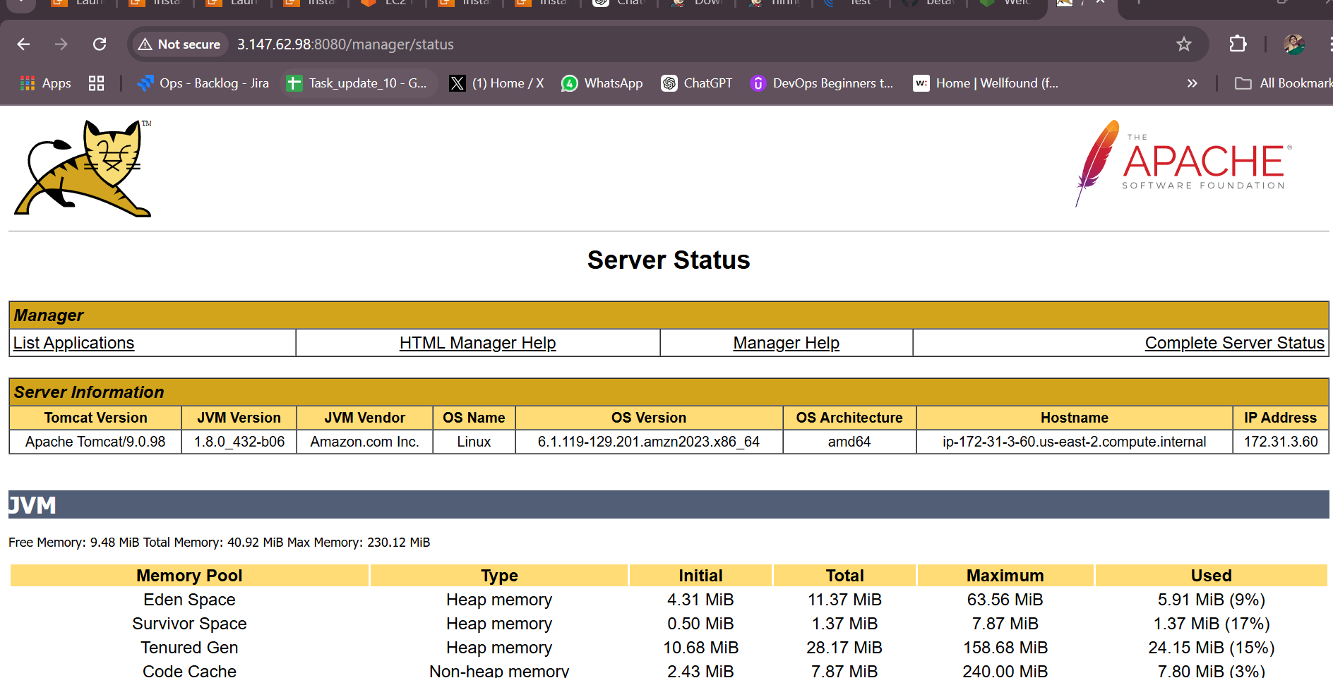

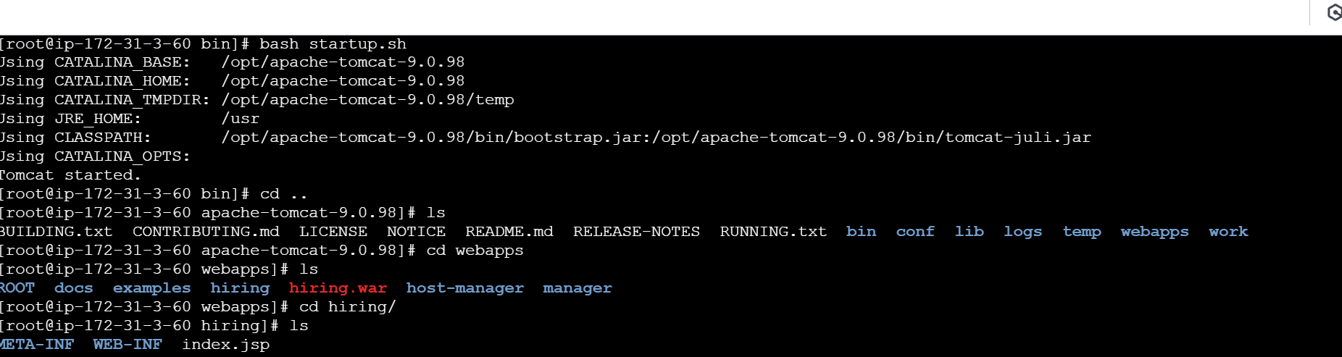

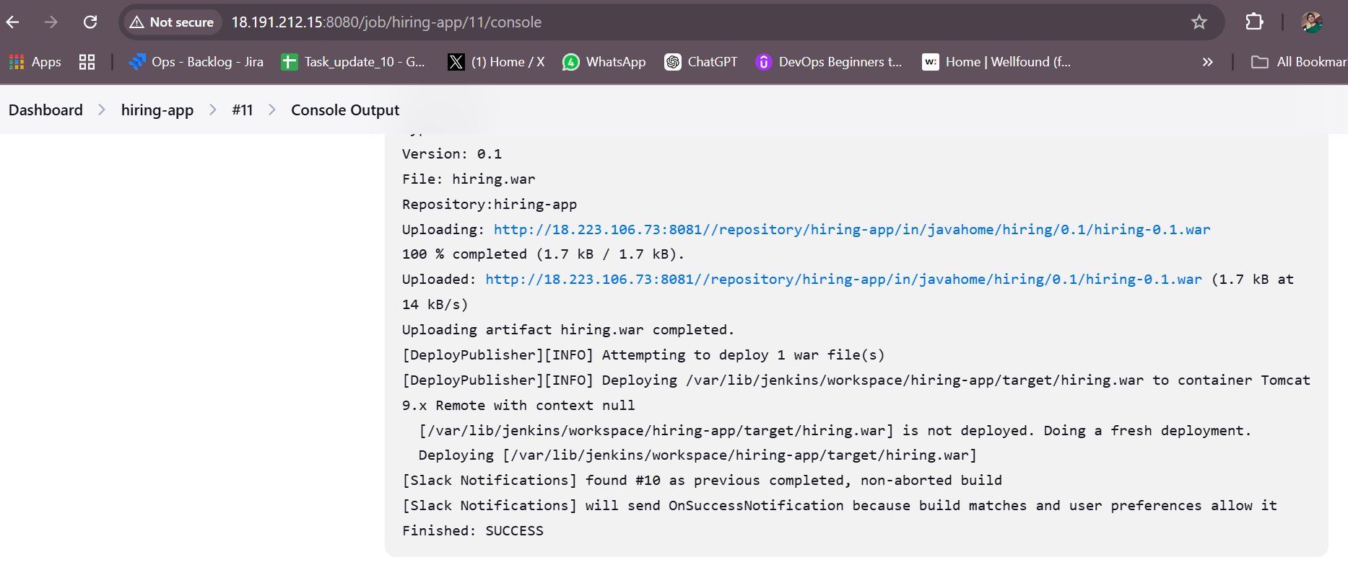

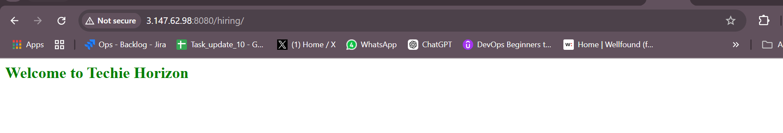

1. Setup a jenkins CICD pipeline using Declarative pipeline using feature-1.1 branch. [https://github.com/betawins/sabear_simplecutomerapp/tree/feature-1.1](https://github.com/betawins/sabear_simplecutomerapp/tree/feature-1.1" \t "https://app.slack.com/client/T03TRQ064Q0/_blank) stages: 1) Git Clone 2) Sonarqube Integration 3) Maven Compilation 4) Nexus Artifactory 5) Slack Notification 6) Deploy On tomcat

3) Setup a jenkins CICD pipeline using Scripted pipeline using feature-1.1 branch. [https://github.com/betawins/sabear_simplecutomerapp/tree/feature-1.1](https://github.com/betawins/sabear_simplecutomerapp/tree/feature-1.1" \t "https://app.slack.com/client/T03TRQ064Q0/_blank) stages: 1) Git Clone 2) Sonarqube Integration 3) Maven Compilation 4) Nexus Artifactory 5) Slack Notification 6) Deploy On tomcat 4) Write sample skeleton of pipelines. 5) Create a parametirized job in jenkins. [https://github.com/betawins/spring3-mvc-maven-xml-hello-world-1.git](https://github.com/betawins/spring3-mvc-maven-xml-hello-world-1.git" \t "https://app.slack.com/client/T03TRQ064Q0/_blank) 6) Setup one slave machine for jenkins.