Sr No. | Name.
1 | System Architecture
2 | User Roles and Capabilities
3 | Core Features Overview
4 | Technology Stack
5 | Backend Route Architecture
6 | Frontend Component Architecture
7 | Key Data Flow: Record Creation with AI Analysis
8 | Authentication and Authorization Flow
9 | Project Structure Overview
10 | Feature Architecture Overview
11 | Feature Integration Flow
12 | Feature Interaction Matrix
13 | Role-Based Feature Access
14 | Core Features Summary
15 | Feature Activation Sequence
16 | Health Records Management
17 | Access Control
18 | CRUD Operations
19 | Patient Records Interface
20 | Doctor Records Management Interface
21 | Automated PDF and Email Workflow
22 | AI Integration
23 | Health Record Analysis System
24 | Clinical Communication Assistant
25 | Strict Context Limitation
26 | AI Model Configuration

1.System Architecture
Meditrack follows a three-tier architecture with a React frontend, Express.js backend API server, and MongoDB database. The system integrates with Google Generative AI for intelligent health analysis and uses SMTP services for email notifications.
High-Level Architecture Diagram
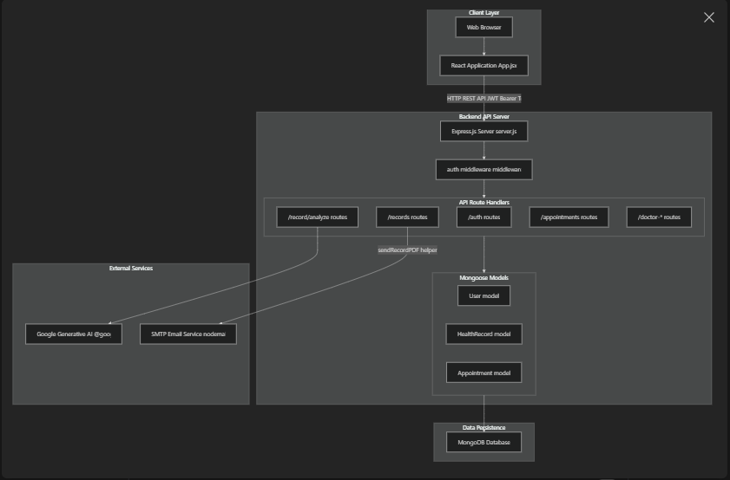

2.User Roles and Capabilities
Meditrack implements role-based access control with two primary user types stored in the User model:
Role | Capabilities | Access Level
Doctor | Create, read, update, delete health records  View all patients and their records  Approve/reject appointments  Send emails to patients  Access doctor-specific dashboard | Full CRUD on health records  Protected routes require role === "doctor"
Patient | View own health records (read-only)  Request AI analysis of records  Chat with AI about health records  Request appointments  Receive email notifications | Read-only access to own records  Protected by user ID matching

The auth middleware verifies JWT tokens and attaches user information (including role field) to req.user for all protected routes. Role checks are enforced at the route handler level.

3.Core Features Overview
3.1.Health Records Management
The records system centers around the HealthRecord model, which stores:
Patient notes and observations
Prescriptions (array of strings)
Vital signs (blood pressure, pulse, temperature)
Doctor and patient references
Key Routes:
POST /records - Create new record (doctor only)
GET /records/patient/:id - Retrieve patient records
PUT /records/:id - Update existing record (doctor only)
DELETE /records/:id - Delete record (doctor only)
Each record creation or update triggers asynchronous PDF generation via the sendRecordPDF helper function.

3.2.AI-Powered Analysis
The system integrates Google's Gemini AI (gemini-2.5-flash model) through the @google/generative-ai package. The /record/analyze endpoint implements safety constraints:
Analyze this health record safely.
Do not diagnose diseases.
Give general safe advice.
The frontend provides two AI interaction modes:
One-shot analysis - Single AI analysis of a complete record
Conversational chat - Multi-turn dialogue where questions are appended to record context
The formatAIText() function in HealthTipsPage.jsx parses raw AI output into structured HTML with headings, lists, and warning styles.

3.3.Appointment Scheduling
Appointments track doctor-patient scheduling with status transitions:
requested - Initial patient request
accepted - Doctor approval
rejected - Doctor denial
completed - Post-appointment

3.4.PDF & Email Notifications
The sendRecordPDF helper (called from the records routes) implements asynchronous PDF generation:
- Fetches record from database
- Generates PDF using PDFKit
- Sends email via Nodemailer to patient's email address
This is a "fire-and-forget" pattern where API responses don't wait for email delivery.

4.Technology Stack
4.1.Backend Dependencies
Package | Version | Purpose
Express | ^4.18.2 | Web server framework
Mongoose | ^7.0.0 | MongoDB ODM
Jsonwebtoken | ^9.0.0 | JWT authentication
Bcryptjs | ^2.4.3 | Password hashing
@google/generative-ai | ^0.24.1 | Gemini AI integration
Nodemailer | ^6.9.1 | Email delivery
Pdfkit | ^0.17.2 | PDF generation
Cors | ^2.8.5 | Cross-origin requests
Dotenv | ^16.0.0 | Environment configuration

Frontend Stack
- React - Component-based UI framework
- axios - HTTP client wrapped in custom API module
- localStorage - Client-side token and user data persistence

5.Backend Route Architecture
The backend organizes API endpoints by functional domain, with authentication middleware protecting most routes:
5.1.Route-to-Code Mapping
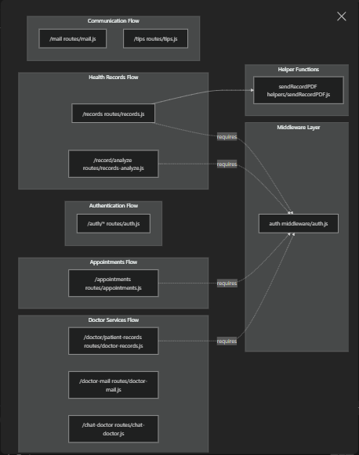
Key Implementation Details:
- auth middleware verifies JWT from Authorization: Bearer <token> header
- req.user object contains _id, role, and other user fields after authentication
- Role checks like req.user.role !== "doctor" enforce authorization
- Most routes return JSON responses with res.json()

6.Frontend Component Architecture
The React frontend implements role-based interfaces with distinct components for doctors and patients:
Component-to-File Mapping
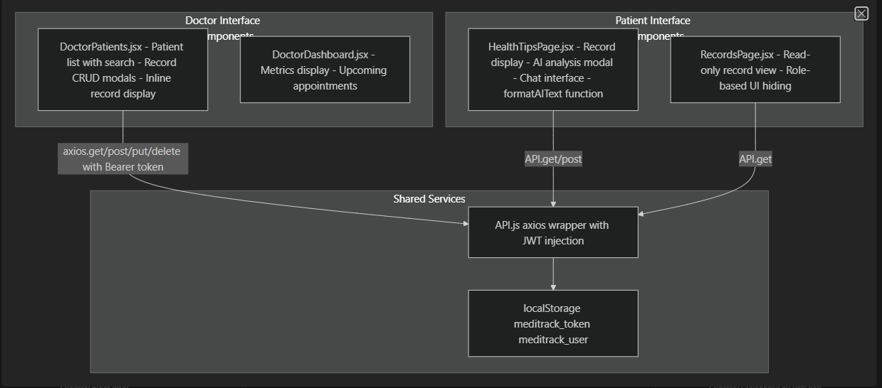
Key Implementation Patterns:
- Components check user.role === "patient" to conditionally render UI elements
- The API module automatically injects JWT token from localStorage
- Doctor components use direct axios calls with manual token headers
- Patient components use the centralized API wrapper
- State management via React hooks (useState, useEffect)
7.Key Data Flow: Record Creation with AI Analysis
The following sequence demonstrates the complete lifecycle of a health record from creation through AI analysis:
7.1.Record Creation and PDF Generation Flow
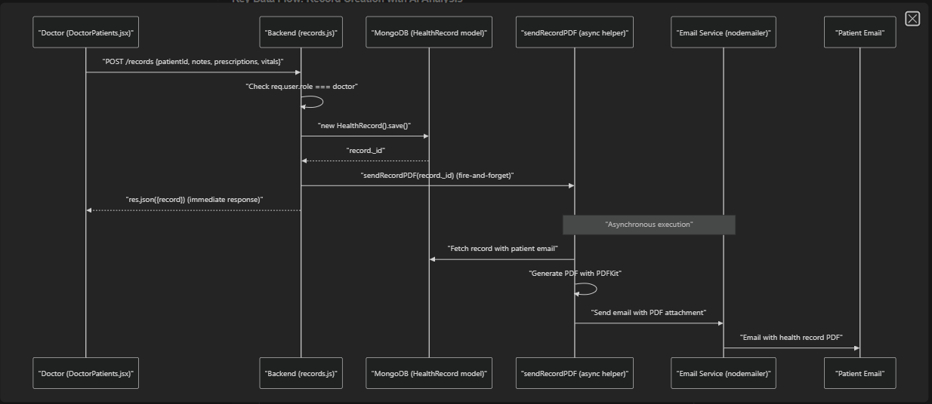

7.2.AI Analysis Request Flow
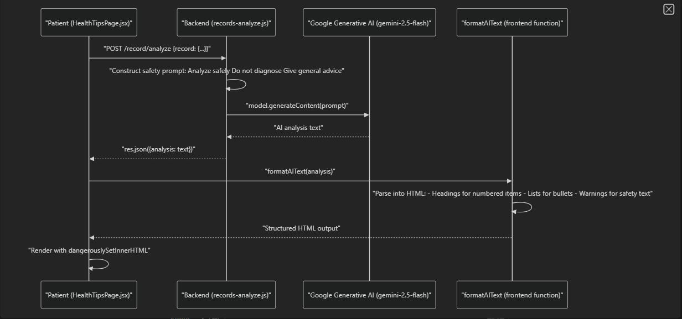

8.Authentication and Authorization Flow
The system implements JWT-based authentication with role-based access control:
8.1.Authentication Architecture
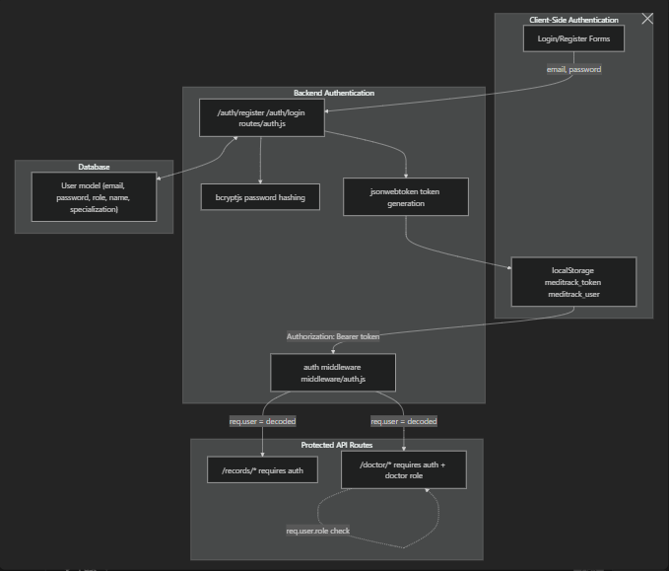
Authorization Checks:
- Line-level role verification: if (req.user.role !== "doctor") return res.status(403)
- Patient ID matching: if (req.user.role === "patient" && req.user._id.toString() !== id) return res.status(403)
- Frontend conditional rendering: {!isPatient && <button>...</button>}

9.Project Structure Overview
Meditrack-React/
├── backend/
│ ├── server.js # Express app entry point
│ ├── models/ # Mongoose schemas
│ │ ├── User.js # User model (role, email, password)
│ │ ├── HealthRecord.js # Health record model
│ │ └── Appointment.js # Appointment model
│ ├── routes/ # API route handlers
│ │ ├── auth.js # Authentication endpoints
│ │ ├── records.js # Health records CRUD
│ │ ├── records-analyze.js # AI analysis endpoint
│ │ ├── appointments.js # Appointment scheduling
│ │ └── doctor-*.js # Doctor-specific routes
│ ├── middleware/
│ │ └── auth.js # JWT verification middleware
│ ├── helpers/
│ │ └── sendRecordPDF.js # PDF generation and email
│ └── package.json # Backend dependencies
│
└── frontend/
└── src/
├── App.jsx # React app root
├── api.js # Axios wrapper with auth
├── doctor/
│ └── DoctorPatients.jsx # Doctor interface
└── patient/
├── RecordsPage.jsx # Patient record view
└── HealthTipsPage.jsx # AI analysis interface
10.Feature Architecture Overview
Meditrack implements five core functional areas that work together to provide a complete healthcare records management platform. The system enforces role-based access control throughout, with doctors having administrative capabilities and patients having read/view access with AI-enhanced insights.
Core Feature Map
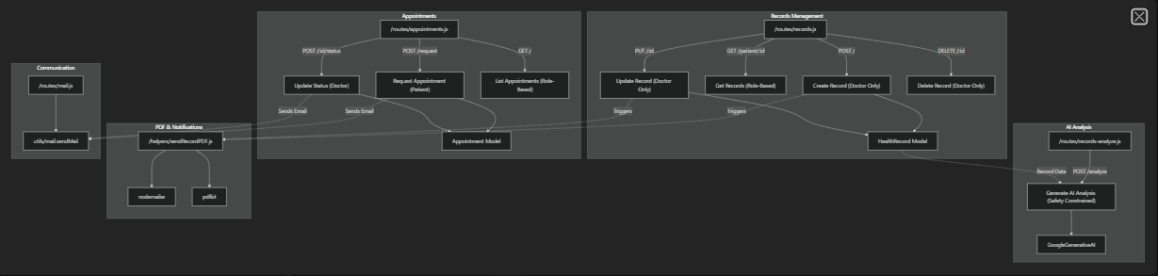

11.Feature Integration Flow
The core features integrate through shared data models and event-driven triggers. The primary integration pattern is the health record lifecycle, where record creation/updates automatically trigger downstream notifications while AI analysis and appointments operate on existing record data.
Health Record Lifecycle with Feature Interactions
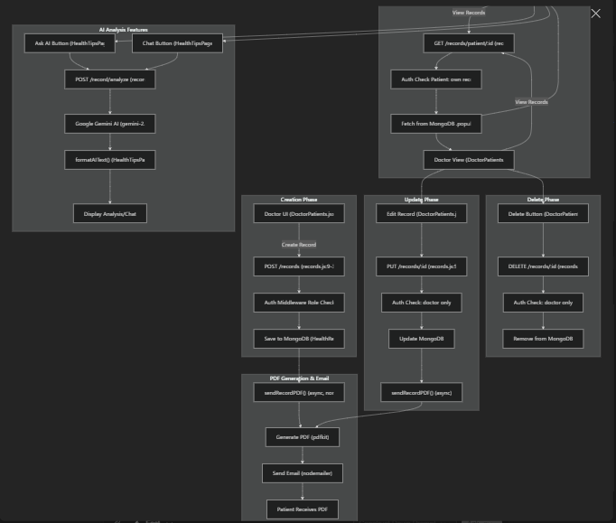

12.Feature Interaction Matrix
The following table shows how each feature interacts with others and what triggers these interactions:
Source Feature | Target Feature | Interaction Type | Trigger | Implementation
Health Records | PDF/Email | Event-driven | Record create/update | records.js27 records.js68 call sendRecordPDF()
Health Records | AI Analysis | On-demand | Patient request | Patient sends record data to records-analyze.js8
Appointments | Email | Event-driven | Status change | appointments.js60-69 appointments.js111-123
AI Analysis | Health Records | Read-only | Analysis request | AI receives record via request body records-analyze.js10
Doctor-Patient Comm | Email | On-demand | User action | Mail routes call sendMail() utility

13.Role-Based Feature Access
Meditrack enforces role-based access control at both the route handler level and through the auth middleware. The following diagram shows which features are accessible to each role:
Role Enforcement Patterns
The system uses consistent patterns to enforce role-based access:
- Explicit Role Checks: Route handlers check req.user.role before allowing operations
  - Example: backend/routes/records.js11-12 - if (req.user.role !== "doctor") return res.status(403)
- Data Ownership Checks: Patients can only access their own data
  - Example: backend/routes/records.js41-42 - if (req.user.role === "patient" && req.user._id.toString() !== id)
- Automatic Filtering: List endpoints automatically filter by role
  - Example: backend/routes/appointments.js140-146 - Appointments filtered by patient or doctor field based on role
14.Core Features Summary
14.1. Health Records Management
The primary feature of Meditrack, providing CRUD operations for patient health records. Doctors create, update, and delete records containing notes, prescriptions, and vitals. Patients view their records in read-only mode.
Key Implementation:
- Route: backend/routes/records.js
- Model: HealthRecord with fields patient, doctor, notes, prescriptions, vitals
- Access Control: Doctor-only for CUD operations, role-based for read
- Auto-triggers: PDF generation on create/update
14.2. AI-Powered Analysis & Chat
Integration with Google Gemini AI to provide health insights and conversational assistance. The system enforces safety constraints to prevent diagnosis and ensure responsible AI use.
Key Implementation:
- Route: backend/routes/records-analyze.js8-34
- API: GoogleGenerativeAI with model gemini-2.5-flash
- Safety Prompt: records-analyze.js16-23 includes "Do not diagnose diseases" and "Give general safe advice"
- Input: Health record JSON structure
- Output: Formatted AI analysis text

14.3. Appointment Scheduling
Workflow for patients to request appointments with doctors and doctors to approve/reject them. Includes conflict detection to prevent double-booking and automatic email notifications.
Key Implementation:
- Route: backend/routes/appointments.js
- Model: Appointment with fields patient, doctor, date, reason, status
- Statuses: requested, accepted, rejected, completed
- Conflict Detection: appointments.js37-47 checks for existing appointments at same time
- Date Validation: appointments.js28-32 blocks past dates
14.4. PDF Generation & Email Notifications
Automatic generation of PDF documents from health records and email delivery to patients. Operates asynchronously using a fire-and-forget pattern to avoid blocking API responses.
Key Implementation:
- Helper: backend/helpers/sendRecordPDF.js6-73
- Libraries: pdfkit for PDF generation, nodemailer for email
- Trigger Points: records.js27 (create), records.js68 (update)
- Email Service: Gmail SMTP configured via process.env.SMTP_USER and SMTP_PASS
- PDF Content: Patient name, doctor name, date, notes, prescriptions, vitals

14.5. Doctor-Patient Communication
Email messaging system enabling bidirectional communication between doctors and patients through the platform.
Key Implementation:
- Routes: /mail and /doctor-mail endpoints
- Utility: utils/mail.sendMail function
- Used by: Appointment notifications, record updates, direct messaging

15.Feature Activation Sequence
When a doctor creates a health record, multiple features activate in sequence:
Step | Feature | Action | Code Reference
1 | Records Management | Validate doctor role | records.js11-12
2 | Records Management | Create HealthRecord document | records.js16-24
3 | Records Management | Call sendRecordPDF(record._id) | records.js27
4 | PDF Generation | Fetch record with populated patient/doctor | sendRecordPDF.js7-9
5 | PDF Generation | Generate PDF using pdfkit | sendRecordPDF.js16-70
6 | Email Notifications | Send via nodemailer | sendRecordPDF.js32-43
7 | Records Management | Return response to client | records.js29
Note that steps 4-6 execute asynchronously after step 3 returns, ensuring API response speed is not blocked by PDF/email operations.

16. Health Records Management
16.1.System Overview
The health records system follows a strict role-based access model where doctors have full CRUD privileges and patients have read-only access to their own records. All record modifications trigger automated PDF generation and email delivery to the patient.
Health Records Architecture
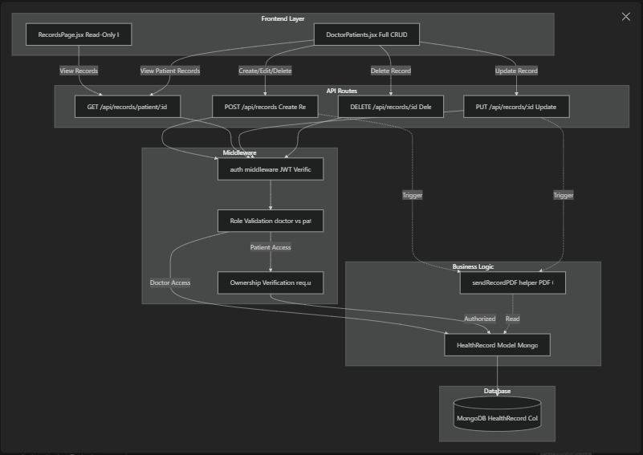

16.2.Data Model
The HealthRecord model stores medical information with references to both the patient and the attending doctor. Each record contains clinical notes, prescriptions, and vital signs.
HealthRecord Schema
Field | Type | Description | Required
patient | ObjectId (ref: User) | Reference to patient user | Yes
doctor | ObjectId (ref: User) | Reference to doctor who created record | No
notes | String | Clinical notes and observations | No
prescriptions | Array of Strings | List of prescribed medications | No
vitals | Object | Patient vital signs (bp, pulse, temp) | No
vitals.bp | String | Blood pressure reading | No
vitals.pulse | String | Pulse rate | No
vitals.temp | String | Body temperature | No
createdAt | Date | Timestamp of record creation | Auto-generated

The schema enforces referential integrity through Mongoose's ref field, enabling population of doctor details when querying records.

17.Access Control
The system implements two-layer authorization: role-based access control (RBAC) and ownership verification.
17.1.Role-Based Permissions
Operation | Patient | Doctor
Create Record | ❌ | ✅
View Own Records | ✅ | ✅
View Other Patient Records | ❌ | ✅ (via appointments)
Update Record | ❌ | ✅
Delete Record | ❌ | ✅
Patient Access Rules:
- Can only access records where patient field matches their user ID
- Enforced at backend/routes/records.js41-42
- Returns 403 error if attempting to access other patients' records
Doctor Access Rules:
- Can create records for any patient
- Can update any record (no ownership check)
- Can delete any record (no ownership check)

18.CRUD Operations
18.1.Create Record
Endpoint: POST /api/records
Authorization: Doctor only
Request Body:
{
"patientId": "objectId",
"notes": "Clinical observations",
"prescriptions": ["Medication A", "Medication B"],
"vitals": {
"bp": "120/80",
"pulse": "72",
"temp": "98.6"
}
}
Process:
- Verify user has doctor role at backend/routes/records.js11-12
- Create new HealthRecord with doctor field set to req.user._id at backend/routes/records.js16-22
- Save to database at backend/routes/records.js24
- Trigger PDF generation and email via sendRecordPDF(record._id) at backend/routes/records.js27
- Return created record

18.2.Read Records
Endpoint: GET /api/records/patient/:id
Authorization:
- Patients: Can only access their own ID
- Doctors: Can access any patient's records
Response:
{
"records": [
{
"_id": "recordId",
"patient": "patientId",
"doctor": {
"_id": "doctorId",
"name": "Dr. Smith",
"email": "doctor@example.com"
},
"notes": "Clinical notes",
"prescriptions": ["Med 1", "Med 2"],
"vitals": {
"bp": "120/80",
"pulse": "72",
"temp": "98.6"
},
"createdAt": "2024-01-15T10:30:00.000Z"
}
]
}

Process:
- Extract patient ID from URL parameters at backend/routes/records.js39
- If user is patient, verify req.user._id matches :id at backend/routes/records.js41-42
- Query records with .populate("doctor") to include doctor details at backend/routes/records.js44
- Return records array

18.3.Update Record
Endpoint: PUT /api/records/:id
Authorization: Doctor only
Request Body:
{
"notes": "Updated clinical notes",
"prescriptions": ["Updated medication list"],
"vitals": {
"bp": "118/78",
"pulse": "70",
"temp": "98.4"
}
}
Process:
- Verify user has doctor role at backend/routes/records.js56-57
- Update record using findByIdAndUpdate with {new: true} option at backend/routes/records.js61-65
- Trigger PDF generation and email at backend/routes/records.js68
- Return updated record
Note: No ownership verification - any doctor can update any record.

18.4.Delete Record
Endpoint: DELETE /api/records/:id
Authorization: Doctor only
Process:
- Verify user has doctor role at backend/routes/records.js81-82
- Delete record using findByIdAndDelete at backend/routes/records.js84
- Return success message
Note: Deletion does not trigger email notification. The record is permanently removed from the database.

19.Patient Records Interface
The patient-facing interface (RecordsPage.jsx) provides a read-only view of health records with minimal interaction capabilities.
19.1.UI Component Structure
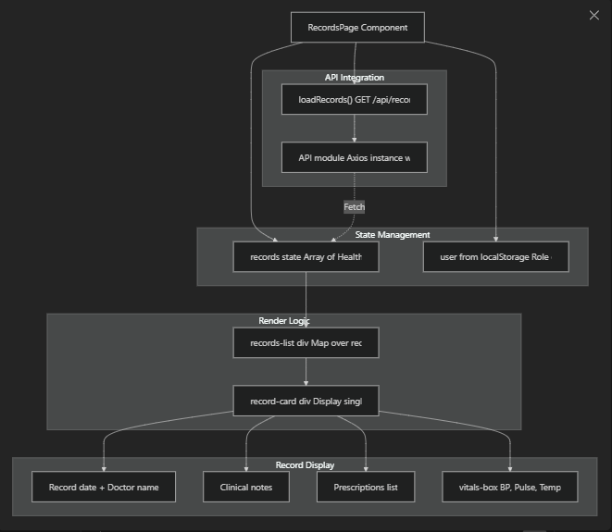

19.2.Key Features
Read-Only Access:
- UI conditionally hides create/edit/delete buttons if user.role === "patient" at frontend/src/patient/RecordsPage.jsx12
- Functions openCreate(), openEdit(), saveRecord(), and deleteRecord() include early returns for patients at frontend/src/patient/RecordsPage.jsx32 frontend/src/patient/RecordsPage.jsx40 frontend/src/patient/RecordsPage.jsx62 frontend/src/patient/RecordsPage.jsx84
Data Loading:
- Records loaded on component mount via useEffect at frontend/src/patient/RecordsPage.jsx22-24
- API call uses patient's ID from localStorage at frontend/src/patient/RecordsPage.jsx27
Record Display: Each record card shows:
- Creation date at frontend/src/patient/RecordsPage.jsx108
- Doctor's name (or "Self / Patient" if no doctor) at frontend/src/patient/RecordsPage.jsx118
- Clinical notes at frontend/src/patient/RecordsPage.jsx119
- Prescriptions as comma-separated list at frontend/src/patient/RecordsPage.jsx121-123
- Vitals in a dedicated box at frontend/src/patient/RecordsPage.jsx125-131

20.Doctor Records Management Interface
The doctor interface (DoctorPatients.jsx) provides full CRUD capabilities with a patient-centric workflow.
20.1.Component Architecture
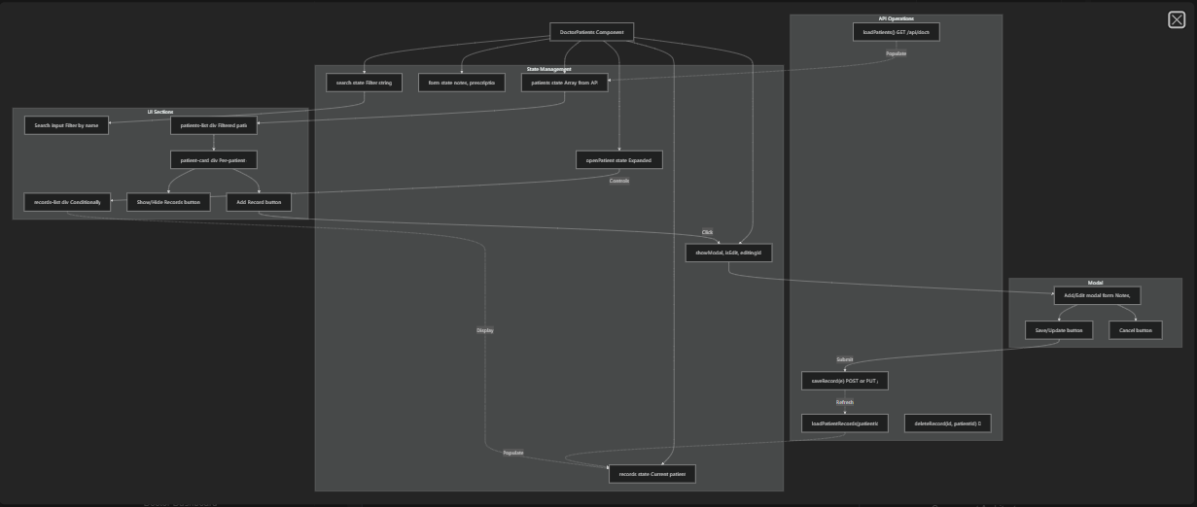

20.2.Key Workflows
Patient List Management:
- Load patients on mount at frontend/src/doctor/DoctorPatients.jsx157-159
- Search filter applied at frontend/src/doctor/DoctorPatients.jsx162-164
- Each patient rendered as expandable card at frontend/src/doctor/DoctorPatients.jsx179-252
Record Creation:
- Click "Add Record" button triggers openAddRecord(patientId) at frontend/src/doctor/DoctorPatients.jsx57-71
- Modal opens with empty form
- Form submission calls saveRecord(e) at frontend/src/doctor/DoctorPatients.jsx91-127
- Data formatted: prescriptions split by comma at frontend/src/doctor/DoctorPatients.jsx97
- POST request to /api/records at frontend/src/doctor/DoctorPatients.jsx113-117
- Records list refreshed at frontend/src/doctor/DoctorPatients.jsx121
Record Editing:
- Click "Edit" button triggers openEditRecord(rec, patientId) at frontend/src/doctor/DoctorPatients.jsx74-88
- Form pre-populated with record data at frontend/src/doctor/DoctorPatients.jsx79-85
- Prescriptions array joined to comma-separated string at frontend/src/doctor/DoctorPatients.jsx81
- PUT request to /api/records/:id at frontend/src/doctor/DoctorPatients.jsx107-111

Record Deletion:
- Click "Delete" button triggers deleteRecord(id, patientId) at frontend/src/doctor/DoctorPatients.jsx130-144
- Confirmation dialog at frontend/src/doctor/DoctorPatients.jsx131
- DELETE request to /api/records/:id at frontend/src/doctor/DoctorPatients.jsx134-137
- Records list refreshed at frontend/src/doctor/DoctorPatients.jsx139
Toggle Records View:
- Click "Show/Hide Records" toggles openPatient state at frontend/src/doctor/DoctorPatients.jsx147-155
- When opening, loads patient records via loadPatientRecords(p._id) at frontend/src/doctor/DoctorPatients.jsx153
- Records list conditionally rendered based on openPatient === p._id at frontend/src/doctor/DoctorPatients.jsx207-249

21.Automated PDF and Email Workflow
All record creation and update operations automatically trigger PDF generation and email delivery to the patient.
Workflow Trigger Points
Operation | Trigger Location | Function Called
Create Record | backend/routes/records.js27 | sendRecordPDF(record._id)
Update Record | backend/routes/records.js68 | sendRecordPDF(updated._id)
Delete Record | None | No email sent on deletion
Process Flow
The sendRecordPDF helper function orchestrates:
- Loading the complete health record from database
- Generating a PDF document with patient and doctor information
- Sending the PDF as an email attachment to the patient

22.AI Integration
System Architecture
The AI integration consists of two independent API endpoints that share a common architecture pattern: prompt engineering with safety constraints, API calls to Google Generative AI, and response formatting.
AI Integration Points
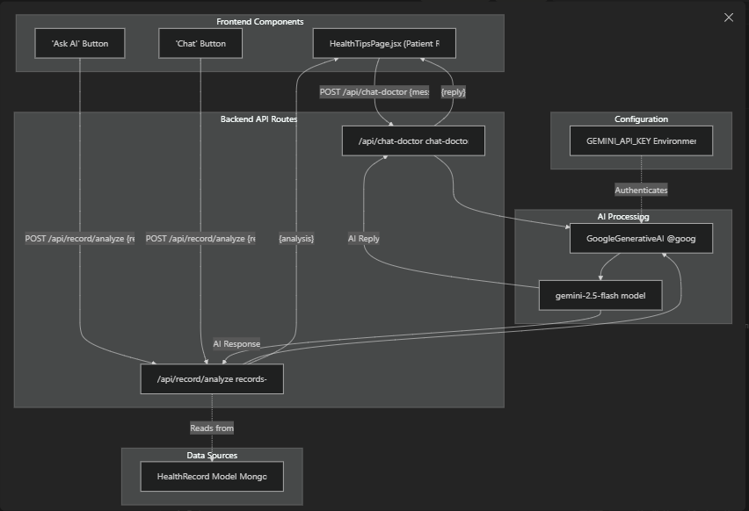

23.Health Record Analysis System
The health record analysis system provides AI-powered insights into patient health records through two interaction modes: one-shot analysis and conversational chat.
23.1.Backend Implementation
The /api/record/analyze endpoint in backend/routes/records-analyze.js handles both analysis modes using a single POST endpoint:
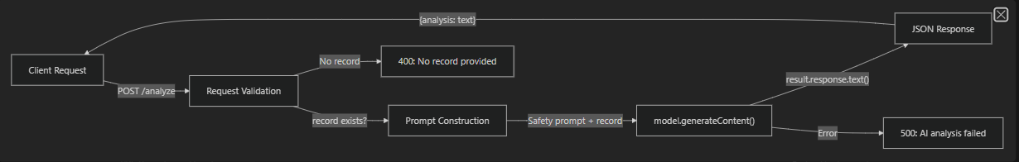
The endpoint accepts two request patterns:
Request Type | Body Schema | Use Case
Single Analysis | {record: Object} | One-time analysis via "Ask AI" button
Conversational Chat | {record: Object, question: String} | Multi-turn dialogue via "Chat" interface

The implementation at backend/routes/records-analyze.js8-34 instantiates the AI model at module load time:
const genAI = new GoogleGenerativeAI(process.env.GEMINI_API_KEY);
const model = genAI.getGenerativeModel({ model: "gemini-2.5-flash" });
23.2.Safety Prompt Engineering
The system constructs a safety-first prompt that appears at backend/routes/records-analyze.js16-23:
Analyze this health record safely.
Do not diagnose diseases.
Give general safe advice.
Record:
${JSON.stringify(record, null, 2)}
This prompt engineering enforces three critical constraints:
- No Diagnosis: The AI explicitly cannot diagnose medical conditions
- General Advice Only: Responses are limited to safe, general health guidance
- Contextual Analysis: The full record object (including notes, prescriptions, vitals) is provided as JSON
The JSON.stringify() with formatting provides the AI with structured data that includes all fields from the HealthRecord schema.

23.3.Frontend Integration
The patient interface at frontend/src/patient/HealthTipsPage.jsx implements two distinct AI interaction patterns:
One-Shot Analysis ("Ask AI")
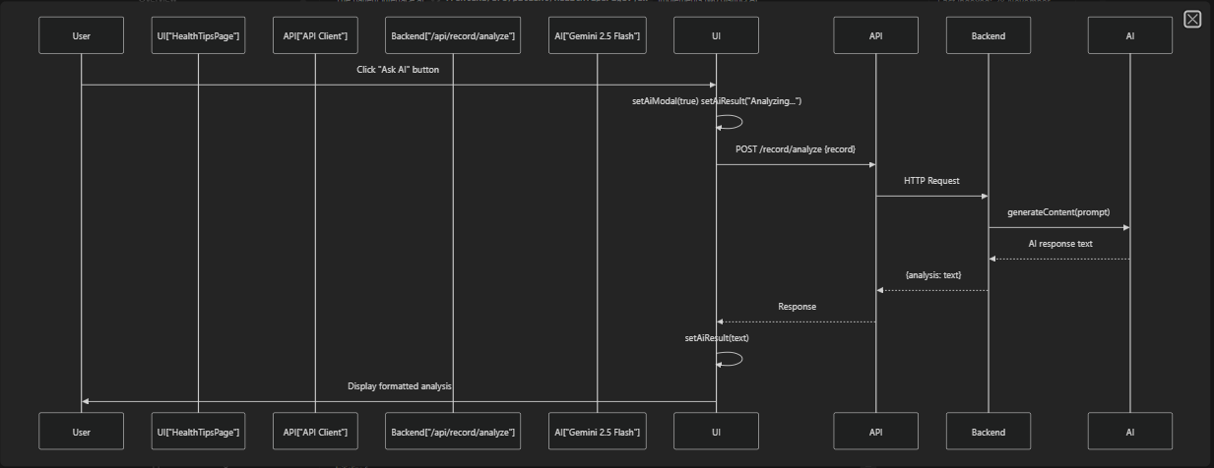
The implementation at frontend/src/patient/HealthTipsPage.jsx88-99 opens a modal and displays results:
- Immediate UI feedback: "Analyzing with AI..."
- Single API call to /record/analyze with the record object
- Error handling with fallback message: "AI analysis failed."

23.4.Conversational Chat
The chat interface at frontend/src/patient/HealthTipsPage.jsx104-127 enables multi-turn conversations about a specific health record:
Step | Function | Location
Initialize Chat | User clicks "Chat" button | frontend/src/patient/HealthTipsPage.jsx213-223
Display Chat Modal | setChatModal(true) with initial AI greeting | frontend/src/patient/HealthTipsPage.jsx216-219
Send Message | sendChatMessage() appends user message | frontend/src/patient/HealthTipsPage.jsx104-127
Format Response | formatAIText() converts plain text to HTML | frontend/src/patient/HealthTipsPage.jsx48-83
Each message in the chat calls the same /record/analyze endpoint with both the original record and the user's question, maintaining conversation context through the full record object.

23.5.Response Formatting
The formatAIText() function at frontend/src/patient/HealthTipsPage.jsx48-83 transforms AI text into structured HTML with semantic styling:
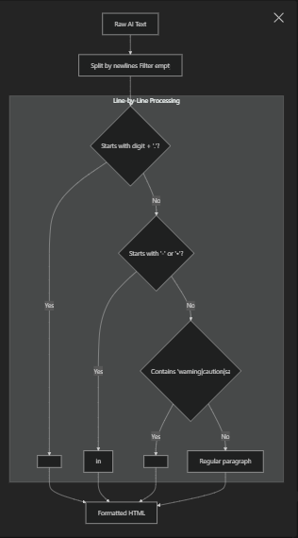

The formatter implements stateful list handling (inList flag) to properly open and close <ul> tags, ensuring valid HTML structure.
Text Pattern Matching:
- Numbered headings: /^\d+\./ → <h3 class="chat-heading">
- Bullet points: /^[-•]/ → <li> within <ul class='chat-list'>
- Safety warnings: /warning|caution|safety/i → <p class="chat-warning">
- Default text: <p>

24.Clinical Communication Assistant
The /api/chat-doctor endpoint provides a separate AI assistant focused on clinical communication and health-related queries.

24.1.Backend Implementation
The implementation at backend/routes/chat-doctor.js1-55 follows the same architectural pattern as record analysis but with stricter context limitations:
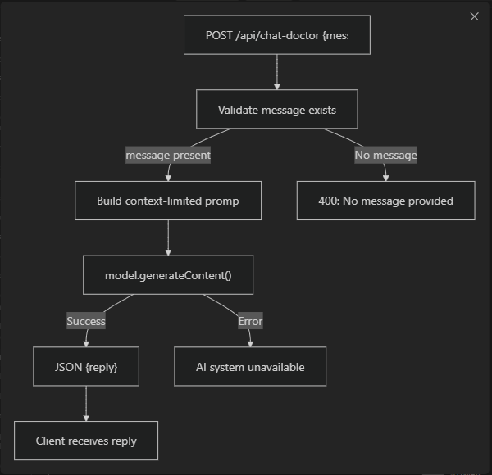

The model initialization at backend/routes/chat-doctor.js5-6 uses the same Gemini 2.5 Flash model:
const genAI = new GoogleGenerativeAI(process.env.GEMINI_API_KEY)
const model = genAI.getGenerativeModel({ model: "gemini-2.5-flash" })

25.Strict Context Limitation
The prompt at backend/routes/chat-doctor.js17-41 implements a whitelist-based context restriction:
Allowed Topics:
- Doctor communication
- Appointments
- Symptoms
- Vitals (BP, pulse, fever, etc.)
- Basic health guidance
- Medications/prescriptions
- Medical reports
- Patient-doctor messages
Refusal Protocol: If the user asks about unrelated topics (jokes, politics, math, stories, coding, movies, random topics), the AI must respond:
"I can only help with health-related communication and doctor assistance."
Additional Constraints:
- DO NOT diagnose
- Keep responses short, medical, helpful, and professional
This differs from the record analysis endpoint in that it actively refuses off-topic queries rather than passively ignoring them.

26.AI Model Configuration
Both AI endpoints share a common configuration pattern:
Model Instantiation
Configuration Parameters
Parameter | Value | Location | Purpose
GEMINI_API_KEY | Environment variable | .env file | Authenticates with Google AI
Model name | "gemini-2.5-flash" | backend/routes/records-analyze.js6 backend/routes/chat-doctor.js6 | Specifies Gemini model version
The model is instantiated once at module load time (not per-request), allowing Node.js to reuse the same AI client instance across multiple requests.

