# 第一章

## 1.1什么是面向过程的程序设计的特点?

**采用自顶向下的功能分解方法,即一个要解决的问题被划分成成若干个子问题.直至子问题足够简单,可以在相应的子问题中解决.而程序结构也按照功能划分为若干个模块,每个模块用以过程或函数实现.**

## 1.2什么是面向对象的程序设计特点?

**程序模块间关系简单,程序的独立性高,数据安全;显著特性有:封装性,抽象性,继承性,多态性,使软件具有可重用性,开发和维护成本低.**

## 1.3什么是类和对象?

**类:对于相同类型的对象进行分类,得出具有相同的特性而形成类;  
对象:将数据与对数据的操作行为放在一起,作为一个不可分割,相互依存的整体;**

## 1.4什么叫引用变量?

**具有类类型的变量叫引用变量;**

## 1.5什么叫OOP的封装性,继承性,抽象性,多态性?

**封装:就是把对象的属性与操作结合为一个独立的整体,并尽可能的隐藏内部实现细节  
继承性:可以在已有类的基础上派生出新的类,新的来可以吸收已有类的属性与行为,并扩展新能力  
抽象性:类是对于相同类型的对象进行分类抽象,得出具有相同的特性而形成类 多态性:超类中定义的属性与行为,被子类继承后,可以具有不同的数据类型或表现出不同的行为**

# 第二章

## 2.1什么是Java语言的基本特点?

面向对象,平台无关性,可靠性,安全性,多线程,分布式

## 2.2什么是Java程序的基本类型,各有何特点?

应用小程序,应用程序,servlet,bean

## 2.3执行如下代码会打印什么?

System.out.print("*/n**\n***\n***/n****");

*/n**  
***  
***/n****

class Test3{

public static void main(String[] args)

{

System.out.print("*/n**\n***\n***/n****");

}

}

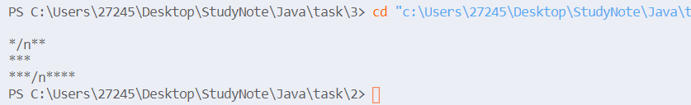

## 2.4执行如下代码会打印什么?请编制一个完整程序验证其结果;

int a,b;a=20;b=10;

System.out.printf("a=%d,b=%d",a,b);

System.out.println("*\n***");

System.out.printf("%s%s","string1","string2");

a=20,b=10*  
***  
string1string2

class Test4{

public static void main(String[] args)

{

int a,b;a=20;b=10;

System.out.printf("a=%d,b=%d",a,b);

System.out.println("*\n***");

System.out.printf("%s%s","string1","string2");

}

}

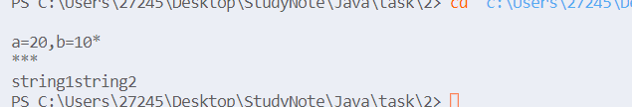

## 2.5编写一个程序,输入用户的姓名和性别,输出姓名和性别,并且在他们之间加一个空格.

import java.util.Scanner;

class Test5{

public static void main(String[] args)

{

String s1,s2;

Scanner input=new Scanner(System.in);

s1=input.next();

s2=input.next();

System.out.println(s1+" "+s2);

}

}

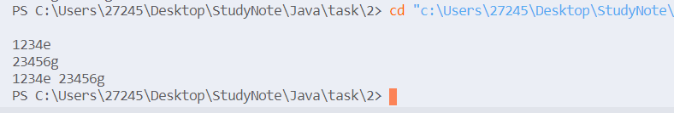

## 2.6编写一个程序,要求输入俩个整数,并显示这俩个数的和,差;

import java.util.Scanner;

class Test6{

public static void main(String[] args){

Scanner input=new Scanner(System.in);

int a,b;

a=input.nextInt();

b=input.nextInt();

System.out.println("a+b="+(a+b)+" a-b="+(a-b));

}

}

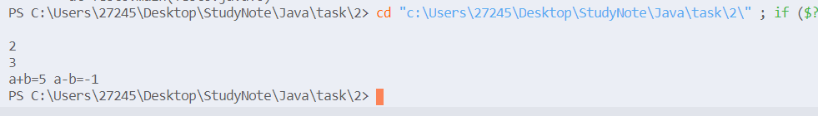

## 2.7编写一个applet,要求画一个矩形,并在矩形的上方显示"这是一个矩形"的字符;

**import** java.awt.*;

**import** javax.swing.*;

**public** **class** **DrawRectangle** **extends** **JApplet**{

**public** void **paint**(Graphics g)

    {

        super**.paint**(g);

        g**.drawRect**(40,40,100,100);

        g**.drawString**("这是一个矩形",45,20);

    }

}

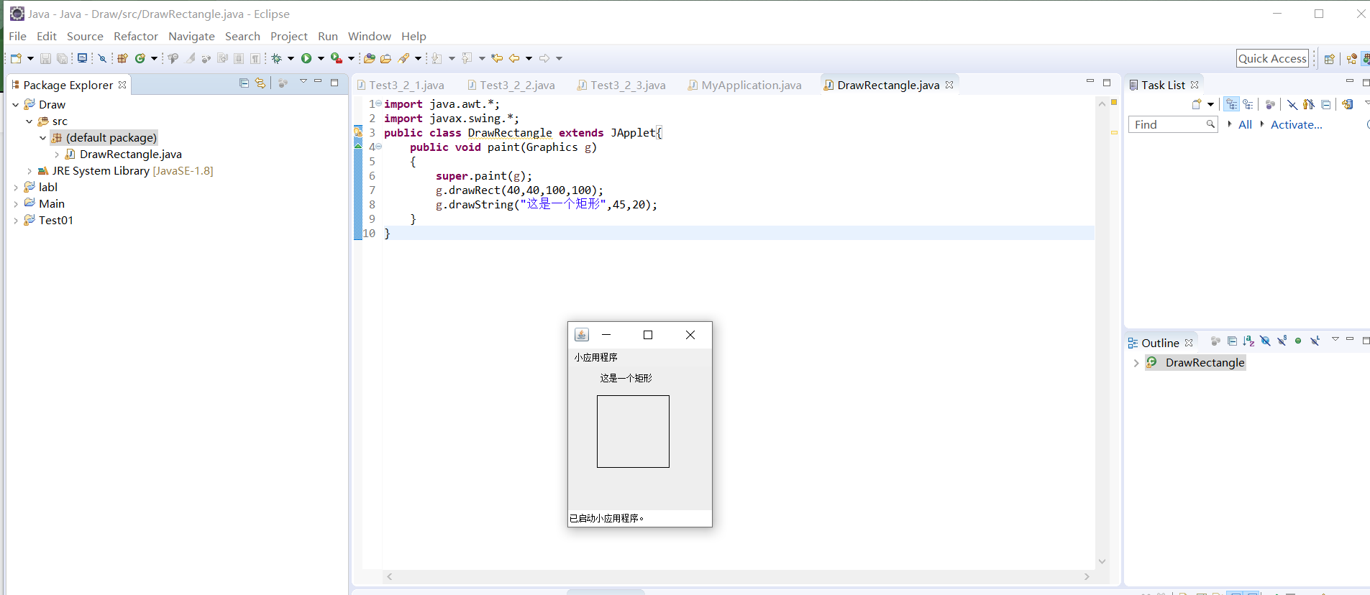

# 第三章

## 题目截图

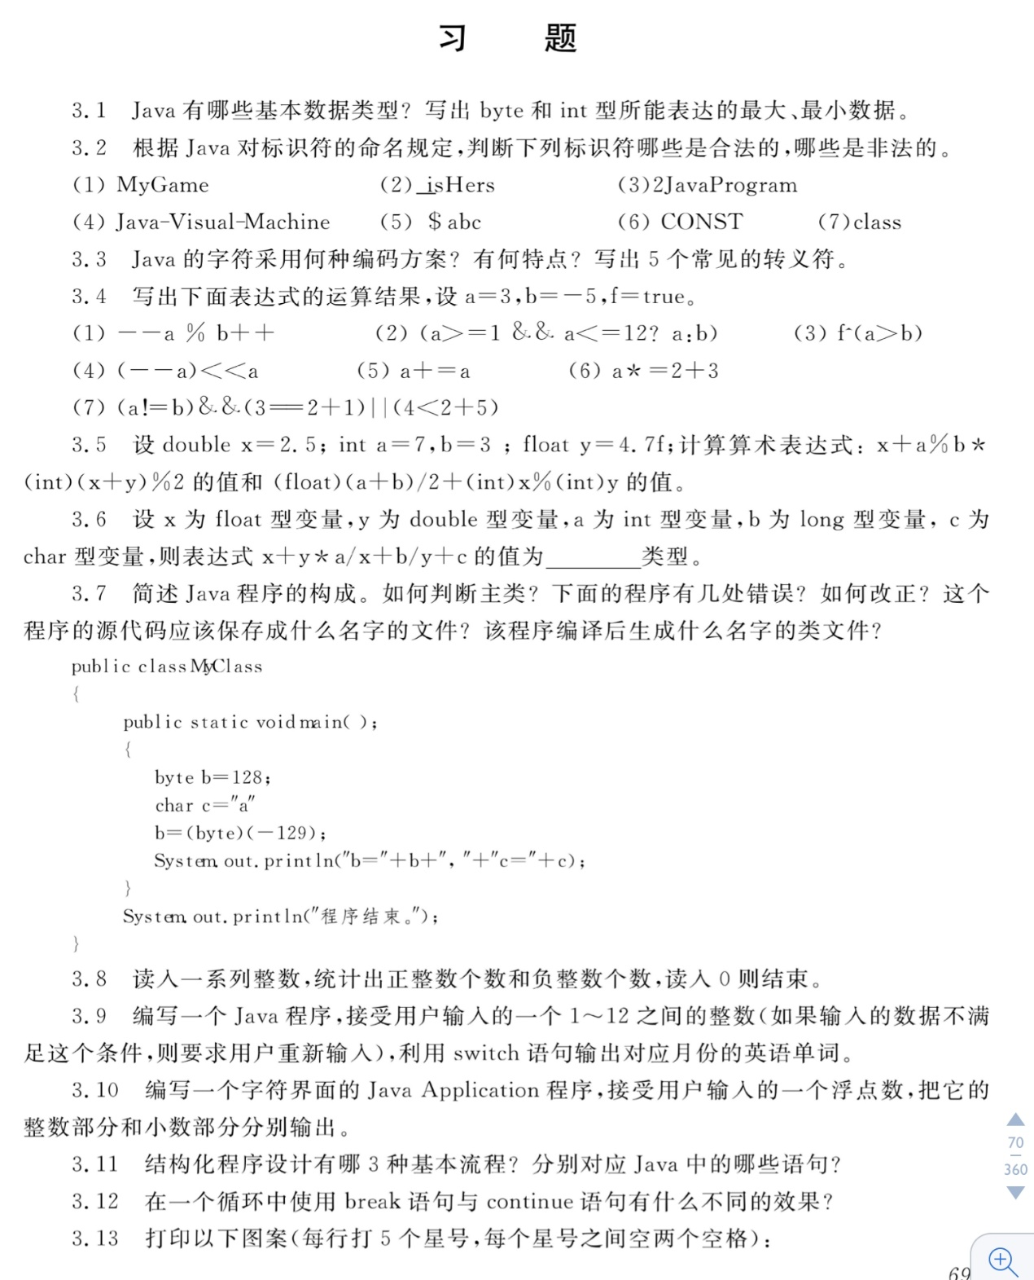

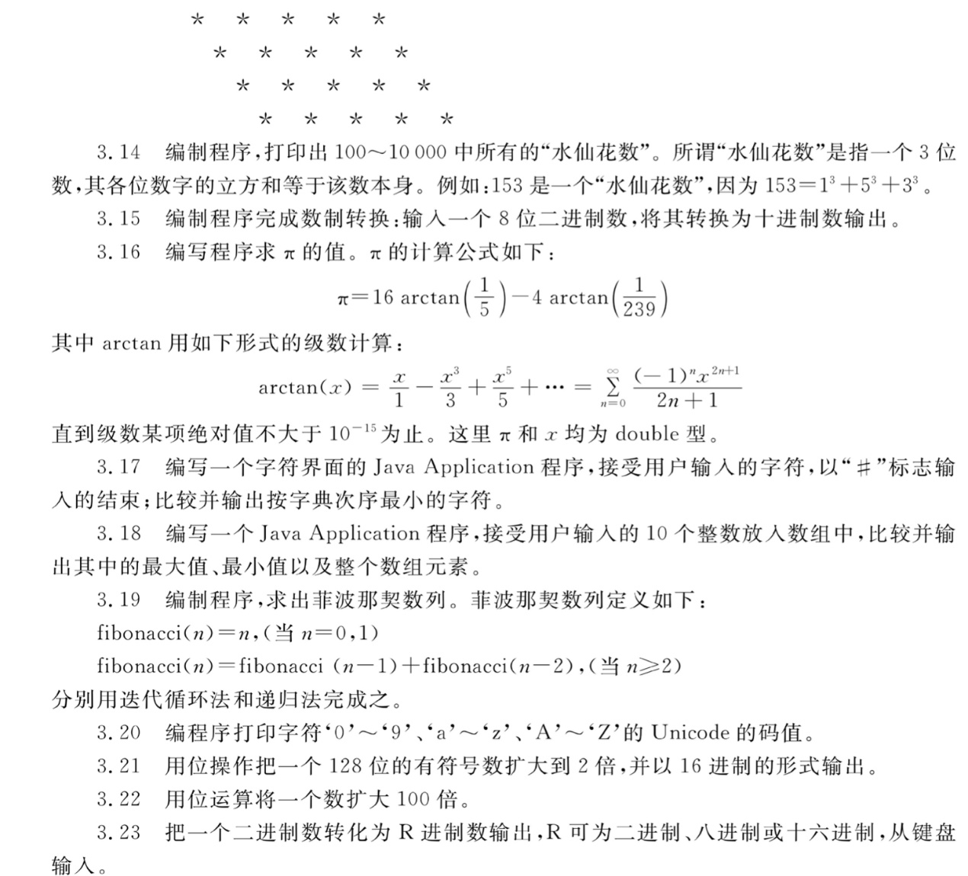

## 解答

### 3.1

**boolean  
int[2^31-1,-2^31]  
long  
float  
char  
double  
short  
byte[127,-128]**

### 3.2

**合法**:(1)(2)(6) **非法**:(3)(4)(5)

### 3.3

Unicode编码;每个Unicode码占用16bit;  
**'\n'  
'\t'  
'\" '  
'\''  
'\\'**

### 3.4

--a%b++=2 (a>=1&&a<=12?a:b)=2 f^(a>b)=false (--a)<<a=2 (a+=a),a=1 a*=2+3,a=3 (a!=b)&&(3==2+1)||(4<2+5)=true

class Test4{

public static void main(String[] args){

int a=3,b=-5;

boolean f=true;

System.out.println("--a%b++="+(--a%b++));

System.out.println("(a>=1&&a<=12?a:b)="+(a>=1&&a<=12?a:b));

System.out.println("f^(a>b)="+(f^(a>b)));

System.out.println("(--a)<<a="+((--a)<<a));

System.out.println("(a+=a),a="+a);

a=3;

System.out.println("a*=2+3,a="+a);

a=3;

System.out.println("(a!=b)&&(3==2+1)||(4<2+5)="+((a!=b)&&(3==2+1)||(4<2+5)));

}

}

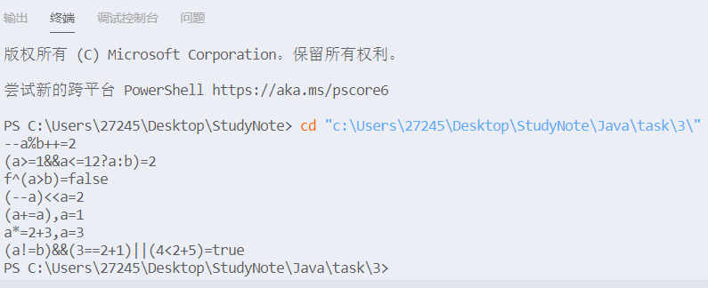

### 3.5

x+a%b*(int)(x+y)%2=3.5 (float)(a+b)/2+(int)x%(int)y=7.0

class Test5{

public static void main(String[] args){

double x=2.5;

int a=7,b=3;

float y=4.7f;

System.out.println("x+a%b*(int)(x+y)%2="+(x+a%b*(int)(x+y)%2));

System.out.println("(float)(a+b)/2+(int)x%(int)y="+((float)(a+b)/2+(int)x%(int)y));

}

}



### 3.6

double类型

### 3.7

class MyClass{

public static void main(String[] args)

{

int b=128;

char c='a';

b=(int)(-129);

System.out.println("b="+b+","+"c="+c);

System.out.println("程序结束");

}

}



主类具有main方法; 有五处错误;改正如上; MyClass.java; MyClass.class;

### 3.8

import java.util.Scanner;

class Test8{

public static void main(String[] args)

{

Scanner input = new Scanner(System.in);

int x,sum1=0,sum2=0;

x=input.nextInt();

while(x!=0)

{

if(x>0)

sum1++;

else sum2++;

x=input.nextInt();

}

System.out.println("sum1="+sum1+" sum2="+sum2);

}

}

1 -1 2 -3 5 0  
sum1=3 sum2=2

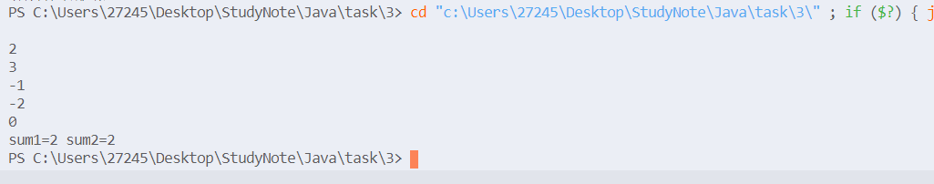

### 3.9

13 Error! 12 December

import java.util.Scanner;

class Test9{

public static void main(String[] args)

{

int x;

Scanner input=new Scanner(System.in);

x=input.nextInt();

while(x<=0||x>12)

{

System.out.println("Error!");

x=input.nextInt();

}

switch(x)

{

case 1:{

System.out.println("January");

break;

}

case 2:{

System.out.println("February");

break;

}

case 3:{

System.out.println("March");

break;

}

case 4:{

System.out.println("April");

break;

}

case 5:{

System.out.println("May");

break;

}

case 6:{

System.out.println("June");

break;

}

case 7:{

System.out.println("July");

break;

}

case 8:{

System.out.println("August");

break;

}

case 9:{

System.out.println("September");

break;

}

case 10:{

System.out.println("October");

break;

}

case 11:{

System.out.println("November");

break;

}

case 12:{

System.out.println("December");

break;

}

default:

break;

}

}

}

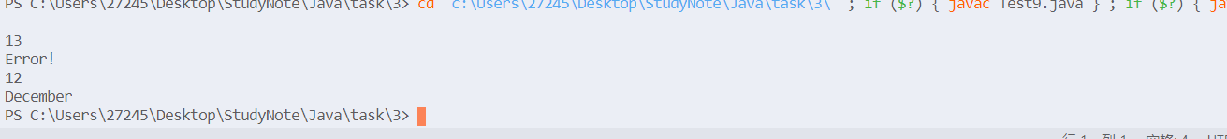

### 3.10

**import** java.text.DecimalFormat;

**import** javax.swing.JOptionPane;

**public** **class** Test10 {

**public** **static** **void** main(String[] args) {

String number;

**double** number1=0;

number=JOptionPane.*showInputDialog*(" 输入第一个浮点数");

number1=Double.*parseDouble*(number);

**int** int1=(**int**)(number1);

**double** double1=number1-int1;

JOptionPane.*showMessageDialog*(**null**, "整数部分是:"+int1+"\n小数部分是:"+double1,"结果",JOptionPane.***PLAIN_MESSAGE***);

System.*exit*(0);

}

}

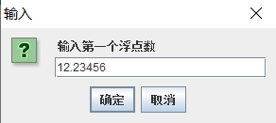

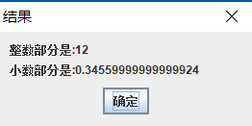

### 3.11

顺序结构:声明语句,赋值语句,方法调用语句;  
选择结构:if语句,switch语句;  
循环结构:while语句,do-while语句,for语句;

### 3.12

break:直接从该循环中跳出; continue:跳过本次循环,判断是否进入下次循环;

### 3.13

class Test13{

public static void main(String[] args){

for(int i=0;i<4;i++)

{

for(int j=0;j<i;j++)

System.out.print(" ");

System.out.println("* * * * *");

}

}

}

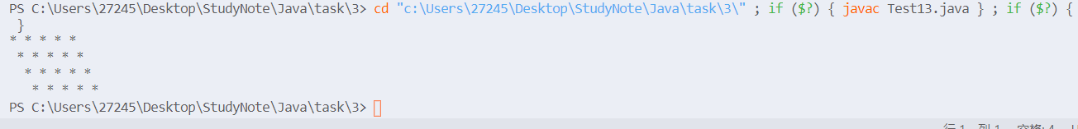

### 3.14

153 370 371 407

class Test14{

public static void main(String[] args)

{

int a,b,c;

for(int i=100;i<1000;i++)

{

a=i/100;

b=(i/10)%10;

c=i%10;

if(a*a*a+b*b*b+c*c*c==i)

System.out.println(i);

}

}

}

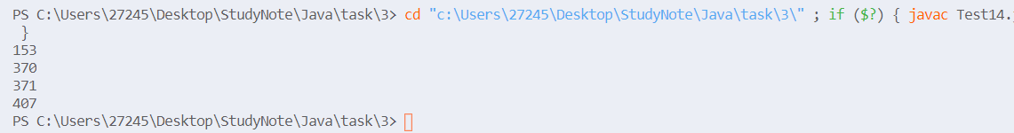

### 3.15

import java.util.Scanner;

class Test15{

public static void main(String[] args)

{

Scanner input=new Scanner(System.in);

String s=input.next();

int x=128,sum=0;

for(int i=0;i<8;i++)

{

sum+=(s.charAt(i)-'0')*x;

x/=2;

}

System.out.println("sum="+sum);

}

}

11111111

sum=255

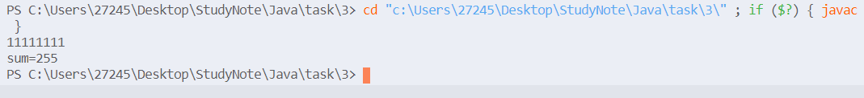

### 3.16

class Test16{

public static void main(String[] args){

double a=16*arctan(1/5.0),b=4*arctan(1/239.0);

System.out.println("pi="+(a-b));

}

static double arctan(double x)

{

double sum=0;

double v=x;

int t=1;

double s=t*v/1;

for(int i=1;Math.abs(s)>1e-15;i++)

{

sum+=s;

v*=x*x;

t*=-1;

s=(t*v)/(2*i+1);

}

return sum;

}

}

pi=3.1415926535897922



### 3.17

**import** java.util.Scanner;

**class** **Test17**{

**public** **static** void **main**(String[] args)

    {

        Scanner input=**new** **Scanner**(System**.**in);

        String s;

        int i=0;

        char t,c;

        s=input**.next**();

        t=s**.charAt**(0);

        c=s**.charAt**(i++);

**while**(c**!=**'#')

        {

**if**(c**>=**'a'**&&**c**<=**'z')

            c+='A'-'a';

**if**(c**<**t)

            t=c;

            c=s**.charAt**(i++);

        }

        System**.**out**.println**(t);

    }

}

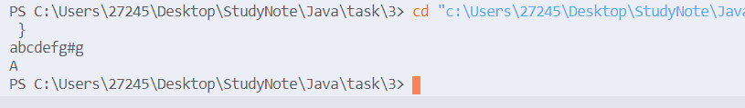

### 3.19

import java.util.Scanner;

class Test19{

public static void main(String[] args)

{

Scanner input=new Scanner(System.in);

int n;

n=input.nextInt();

int f[]=new int[n+2];

f[0]=1;

f[1]=1;

for(int i=2;i<=n;i++)

f[i]=f[i-1]+f[i-2];

System.out.println("fibonacci("+n+")="+f[n]);

}

}

5 fibonacci(5)=8

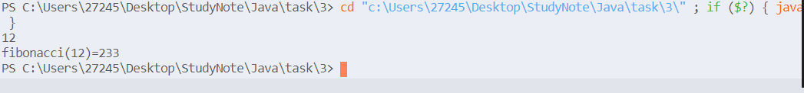

import java.util.Scanner;

class Test19_1{

public static void main(String[] args)

{

Scanner input=new Scanner(System.in);

int n;

n=input.nextInt();

System.out.println("fibonacci("+n+")="+f(n));

}

static int f(int n)

{

if(n==0||n==1)

return 1;

else {

return f(n-1)+f(n-2);

}

}

}

4 fibonacci(4)=5 6 fibonacci(6)=13



### 3.20

class Test20{

public static void main(String[] args)

{

for(char c='0';c<='9';c++)

System.out.print((int)c+" ");

System.out.println();

for(char c='a';c<='z';c++)

System.out.print((int)c+" ");

System.out.println();

for(char c='A';c<='Z';c++)

System.out.print((int)c+" ");

System.out.println();

}

}

48 49 50 51 52 53 54 55 56 57 97 98 99 100 101 102 103 104 105 106 107 108 109 110 111 112 113 114 115 116 117 118 119 120 121 122 65 66 67 68 69 70 71 72 73 74 75 76 77 78 79 80 81 82 83 84 85 86 87 88 89 90

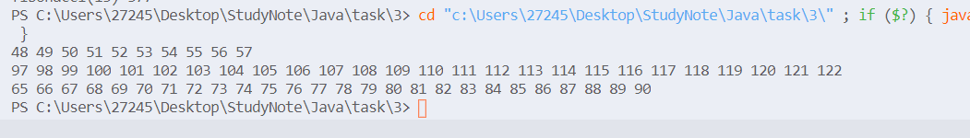

### 3.21

public class Test21{

public static void main(String[] args)

{

long a,b,s;

a=1;

b=-1;

System.out.printf("128位的原数: %016x%016x\n",a,b);

s=(b>>>63)&1;

a=(a<<1)+b;

b=b<<1;

System.out.prinf("扩大2倍后的结果:%016x%016x",a,b);

}

}

### 3.22

**import** javax.swing.JOptionPane;

**public** **class** Tested2 {

**public** **static** **void** main(String[] args){

String input =JOptionPane.*showInputDialog*(**null**,"Enter an input:","Mutiply 100",JOptionPane.***QUESTION_MESSAGE***);

**int** a=Integer.*parseInt*(input),b;

b=(a<<5)+(a<<6)+(a<<2);

JOptionPane.*showMessageDialog*(**null**, a+"*100="+b);

}

}

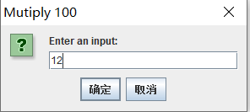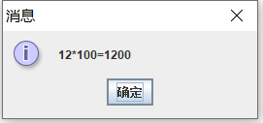

### 3.23

**import** javax.swing.JOptionPane;

**public** **class** Test23 {

**public** **static** **void** main(String[] args){

**int** R,number=0;

String s=JOptionPane.*showInputDialog*(**null**,"Enter an input","please enter a binary number",javax.swing.JOptionPane.***QUESTION_MESSAGE***);

R=Integer.*valueOf*(JOptionPane.*showInputDialog*(**null**,"Enter an input","转换成的目标进制数",JOptionPane.***QUESTION_MESSAGE***));

**int** len=s.trim().length();

**for**(**int** i=0;i<len;i++)

{

number =number*2+(s.charAt(i)-'0');

}

JOptionPane.*showConfirmDialog*(**null**, "二进制数:"+s+"\n对应"+R+"进制数:"+*convert*(number,R),"结果",JOptionPane.***PLAIN_MESSAGE***);

}

**public** **static** String convert(**int** number,**int** R)

{

String s="";

**int** c;

**char** s1[]={'0','1','2','3','4','5','6','7','8','9','A','B','C','D','E','F','G','H','I','J','K','L','M','N'};

**while**(number>0)

{

s=s1[number%R]+s;

number=number/R;

}

**return** s;

}

}

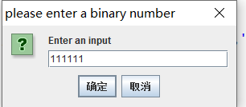

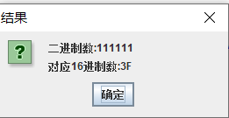

## 附加题

### 一、输入正整数n、实数x，求S。

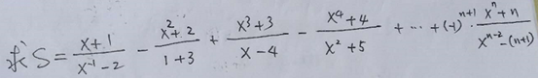

**package** Test3_2;

**import** java.util.Scanner;

**public** **class** Test3_2_1{

**public** **static** **void** main(String[] args){

**int** n;

**double** x,s=0,t1,t2;

**int** p=1;

Scanner input = **new** Scanner(System.***in***);

n=input.nextInt();

x=input.nextDouble();

t1=1;

t2=1/x/x;

**for**(**int** i=1;i<=n;i++)

{

t1*=x;

t2*=x;

s+=(t1+i)/(t2-(i+1)*p)*p;

p*=(-1);

}

System.***out***.println(s);

}

}

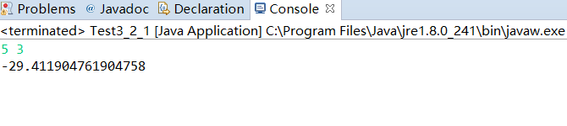

### 二、输入正整数N，显示出下列形状的杨辉三角形。(N<=20,注：一定要是下列形状)

**1**

**1 1**

**1 2 1**

**1 3 3 1**

**1 4 6 4 1**

**1 5 10 10 5 1**

**......**

**1 ...... 1**

**package** Test3_2;

**import** java.util.Scanner;

**public** **class** Test3_2_2 {

**public** **static** **void** main(String[] args){

**int** N;

Scanner input=**new** Scanner(System.***in***);

N=input.nextInt();

**int** s[][]=**new** **int**[N+5][N+5];

System.***out***.println(1);

s[1][1]=1;

s[2][1]=1;

s[2][2]=1;

System.***out***.println(1+" "+1);

**for**(**int** i=3;i<=N;i++)

{

s[i][1]=1;

System.***out***.print(1+" ");

**for**(**int** j=2;j<=i-1;j++)

{

s[i][j]=s[i-1][j-1]+s[i-1][j];

System.***out***.print(s[i][j]+" ");

}

s[i][i]=1;

System.***out***.println(1+" ");

}

}

}

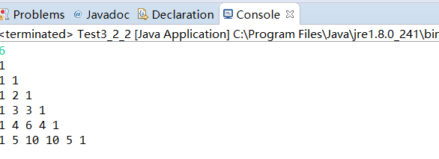

### 三、将3.8题改为：输入一系列整数，统计出其中（1）正整数、负整数的个数；（2）正整数的最大值、最小值；（3）负整数的最大值、最小值；（4）所有数的均方差S,S=(Xi-△x)2,其中△x为平均数，Xi为第i个整数；（5）如输入的是0，则停止输入，然后显示出上述求解的结果。

**package** Test3_2;

**import** java.util.Scanner;

**class** Test3_2_3{

**public** **static** **void** main(String[] args)

{

Scanner input = **new** Scanner(System.***in***);

**int** x,sum1=0,sum2=0;

**int** sum[]=**new** **int**[10000];

**int** i=0,t=0;

**int** max1=0,max2=0,min1=0,min2=0;

x=input.nextInt();

**while**(x!=0)

{

**if**(x>0)

{

sum[i++]=x;

sum1++;

t+=x;

**if**(sum1==1)

{

max1=x;

min1=x;

}

**else**{

**if**(max1<x)max1=x;

**if**(min1>x)min1=x;

}

}

**else**{

sum2++;

sum[i++]=x;

t+=x;

**if**(sum2==1)

{

max2=x;

min2=x;

}

**else**{

**if**(max2<x)max2=x;

**if**(min2>x)min2=x;

}

}

x=input.nextInt();

}

**double** f=0;

**for**(i-=1;i>=0;i--)

{

f+=(sum[i]-t/(sum1+sum2))*(sum[i]-t/(sum1+sum2));

}

System.***out***.println("sum1="+sum1+" sum2="+sum2);

System.***out***.println("max1="+max1+"max2="+max2+"min1="+min1+"min2="+min2);

System.***out***.println("平方差="+f);

}

}

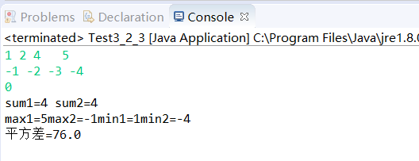

### 四、将3.13题改为：显示出下列图案

**AB**

**ABCD**

**ABCDEF**

**ABCDEFGH**

**654321**

**4321**

**21**

**package** Test3_2;

**public** **class** Test3_2_4 {

**public** **static** **void** main(String[] args)

{

System.***out***.printf(" AB\n ABCD\n ABCDEF\n ABCDEFGH\n 654321\n 4321\n 21");

}

}

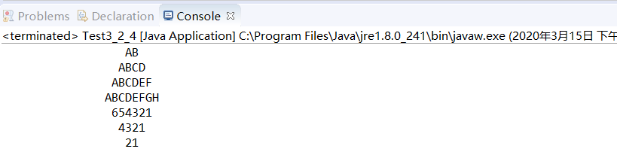

### 五、请写出完成下面功能的程序。假定某班有10个学生，本学期上了3门课，请依次输入 姓名、第1门课成绩、第2门课成绩、第3门课成绩。 即首先输入第一个同学的姓名、第1门课成绩、第2门课成绩、第3门课成绩； 再输入第二个同学的姓名、第1门课成绩、第2门课成绩、第3门课成绩； 再输入第三个同学的姓名、第1门课成绩、第2门课成绩、第3门课成绩；......， 直至输入第10个同学的姓名、第1门课成绩、第2门课成绩、第3门课成绩。 然后求出每个同学的3门课的总分，再按总分对数组排序，最后按总分由高到低的顺序输出排序后的信息：    名次   姓名  第一门   第二门    第三门    总分

**package** Test3_2;

**import** java.util.Scanner;

**public** **class** Test3_2_5 {

**public** **static** **void** main(String[] args)

{

Student p[]=**new** Student[10];

Scanner input=**new** Scanner(System.***in***);

**for**(**int** i=0;i<10;i++){

String name=input.next();

**double** a=input.nextDouble();

**double** b=input.nextDouble();

**double** c=input.nextDouble();

p[i]=**new** Student(name,a,b,c);

p[i].sum();

}

java.util.Arrays.*sort*(p);

**for**(Student a:p){

System.***out***.print(a);

}

}

}

**class** Student{

String name;

**double** a,b,c;

**double** total;

**public** Student(String name,**double** a,**double** b,**double** c)

{

**this**.name=name;

**this**.a=a;

**this**.b=b;

**this**.c=c;

}

**public** **void** sum()

{

**this**.total=**this**.a+**this**.b+**this**.c;

}

**public** **int** compareTo(Student o){

**if**(**this**.total>o.total)

**return** -1;

**else** **return** 1;

}

}

第四章作业

4-1.修饰类的访问控制有哪些?修饰类中成员的访问控制符有哪些?各有什么含义作用?请举例说明.

修饰类的访问控制:public,protected;

修饰类中成员的访问控制符:private,package protected ,public;

4-2.构造方法特殊在哪里?构造方法什么时候执行?被谁调用?

1.这能在创建对象用new命令调用;  
2.构造方法是在创建对象时被自动调用的;  
3.构造方法名必须与类名相同,没有返回值,可以有参量,并且可以被重载;

4-3.关键字static可以修饰类的那些组成部分?实例变量和类变量的区别是什么?

1.类的属性和方法;  
2.实例变量是非static的成员变量,而类变量是所有对象共有的变量;

4-4静态属性有什么特点?类的对象可以访问或修改静态属性吗?

1.是类的属性,不属于某个对象;

2.可以访问或修改;

4-5构造方法重载的特点是什么?有什么作用?

1.方法名不变,形式参数会有区别;  
2.用于创建对象传递给对象的参数可以多样化

4-6.什么是包?如何创建包?包物理上对应什么操作系统中的实体?

1.包是相关一组类的集合;

2.package语句;

3.文件夹;

4-7.试写出创建一个名为MyPackage包的语句,这个语句应该放在程序的什么位置?

1.package MyPackage;

2.第一行;

4-8.试写出引用MyPackage包中所有类的语句,而引用MyPackage包中的一个MyClass1的语句;

1.import MyPackage.*;

2.import Mypackage.MyClass1;

4-9阅读下面的程序,说明他们的输出.

class MyClass{

int data;

MyClass(int d)

{

data=d;

}

int getData()

{

return data;

}

void setData(int d)

{

data=d;

}

}

public class Test9{

public static void main(String[] args)

{

MyClass myobj,myref;

myobj = new MyClass(-1);

myref = myobj;

System.out.println("the original data is:"+myobj.getData());

myref.setData(10);

System.out.println("now the data is:"+myobj.getData());

}

}

the original data is:-1 now the data is:10

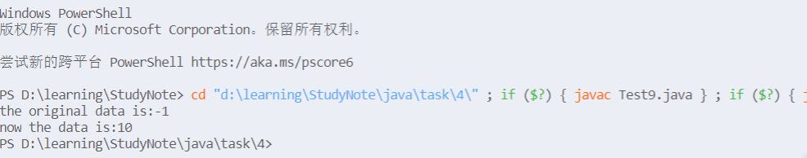

4-10.编写一个类实现秒表的功能.要求实现开始计时,停止计时,分针秒针归零,获得分针示数,获得秒针示数,获得总时间的毫秒数等功能.

public class Test10{

int minute;//分针示数

double seconds;//秒针示数

void start();//开始计时

void stop();//停止计时

void reZero();//分针秒针归零

int getMinute();//获得分针示数

double getSeconds();//获得秒针示数

int getToatal();//获得总时间的毫秒数

}

4-11.编写一个类实现复数的运算,要求至少实现复数相加,复数相减,复数相乘等功能;

import java.util.Scanner;

public class Test11{

static void add(double a,double b,double c,double d)

{

System.out.println((a+c)+"i+"+(b+d));

}

static void subtract(double a,double b,double c,double d)

{

System.out.println((a-c)+"i+"+(b-d));

}

static void mutiply(double a,double b,double c,double d)

{

System.out.println((a*d+b*c)+"i+"+(b*d-a*c));

}

public static void main(String args[])

{

double a,b,c,d;

Scanner input =new Scanner(System.in);

a=input.nextDouble();

b=input.nextDouble();

c=input.nextDouble();

d=input.nextDouble();

add(a,b,c,d);

subtract(a,b,c,d);

mutiply(a,b,c,d);

}

}



4-12.编程创建一个Box类.要求:定义三个实例变量分别表示立方体的长宽高,定义一个构造方法对这三个变量进行初始化,然后定义一个方法求立方体的体积;创建一个对象,求给定尺寸的立方体的体积;

public class Test12{

public static void main(String[] args)

{

Box a= new Box(1,2,3);

System.out.println(a.getSize());

}

}

class Box{

double length,width,height;

public Box(double l,double w,double h)

{

length = l;

width = w;

height = h;

}

public double getSize()

{

double s=length*(width*height);

return s;

}

}



4-13.学生类的创建与使用.

**1.创建一个student类,包括的域有学号,班号,姓名,性别,年龄等,都是private类型;  
2.声明一个构造方法,以初始化对象的所有的域;  
3.声明分别获得个属性的各个Public方法;  
4.声明修改个属性的各个public方法;  
5.声明一个public型的toString()方法,把该类的所有域信息组合成一个字符串;  
6.在类中声明统计班级总人数的私有域count得到班级总人数的public方法(可在构造方法中进行Student对象个数的增加);  
7.将类student放在子包Student中;  
8.在子 包student外,创建测试类student的主类;在主类中,使用student类创建两个student对象,输出对象的所有域信息;修改对象的姓名与年龄,修改后显示各对象的姓名和年龄;你叫两个student对象的年龄大小,输出年龄较大的Student对象;**

import student.Student;

class Test13{

public static void main(String args[]){

Student a=new Student(1,3,"Lucre","boy",20);

Student b=new Student(23,5,"Kiwis","boy",20);

Student c=new Student(24,5,"XiaoWu","boy",20);

System.out.println(a.getId()+",”+a.getClassId()+','+a.getName()+','+a.getSex()+','+a.getAge());

a.setAge(19);

a.setName("Panda");

a.setSex("girl");

System.out.println(a.toString());

if(a.getAge()>b.getAge())

System.out.println(a);

else System.out.println(b);

}

}

package student;

public class Student{

private int id;

private int classId;

private String name;

private String sex;

private int age;

private static int count=0;

public Student(int id,int classId,String name,String sex,int age)

{

this.id=id;

this.classId=classId;

this.name=name;

this.sex=sex;

this.age=age;

count++;

}

public int getId()

{

return id;

}

public int getClassId(){

return classId;

}

public String getName()

{

return name;

}

public String getSex()

{

return sex;

}

public int getAge()

{

return age;

}

public void setId(int x)

{

this.id=x;

}

public void setClassId(int x)

{

this.classId=x;

}

public void setName(String x)

{

this.name=x;

}

public void setSex(String x)

{

this.sex=x;

}

public void setAge(int x)

{

this.age=x;

}

public String toString()

{

return "id="+id+",classId="+classId+",name="+name+",sex="+sex+",age="+age;

}

public int getCount()

{

return count;

}

}

1,3,Lucre,boy,20  
id=1,classId=3,name=Panda,sex=girl,age=19  
id=23,classId=5,name=Kiwis,sex=boy,age=20



4-14 定义一个学生类和一个课程类,要求能够表示现实生活中一个学生可以选择多门课程的情况.编写程序进行测试;

class Test14{

public static void main(String args[])

{

Student a=new Student("Chengfen");

a.select("math");

a.select("English");

}

}

public class Student{

Curriculumn t[]=new Curriculumn[20];

String name;

int num;

public Student(String s)

{

name=s;

num=0;

}

public void select(String s)

{

t[num++]=new Curriculumn(s);

}

}

public class Curriculumn{

String name;

public Curriculumn(String s)

{

name=s;

}

}

4-15 定义一个方程类,一求方程的两个实根;请将测试主类和方程定义在不同的包中;

import equation.*;

class Test15{

public static void main(String args[])

{

Equation a= new Equation(4,5,1);

System.out.println("two results are:"+a.solve1()+" "+a.solve2());

}

}

package equation;

import java.lang.Math;

public class Equation{

private int a,b,c;

public Equation(int a,int b,int c)

{

this.a=a;

this.b=b;

this.c=c;

}

public double solve1()

{

return (-b+Math.sqrt(b*b-4*a*c))/2*a;

}

public double solve2()

{

return (-b-Math.sqrt(b*b-4*a*c))/2*a;

}

}



第五章

## 5-1 试描述继承下的父类和子类的概念;父类和子类有何关系?

1.父类是子类的一般化,而子类是父类的特殊化;  
2.子类是父类的公共性基础上的延伸与扩展;

## 5-2 什么是单重继承?什么是多重继承?Java采用什么继承

1.一个父类只有一个子类是单继承;  
2.一个父类可以有多个子类是多继承;  
3.多继承;

## 5-3 Java中如何定义继承关系?写出定义类库中的类java.awt.Frame的子类MyFrame的类头的语句.

1.extend是语句  
2.import java.awt.Frame;  
class MyFrame extends Frame

## 5-4 关键字protected的作用是什么?什么情况下比较好?

1.父类定义的proteceted成员在子类和同一包内可以直接使用;  
2.如果确实需要在子类中修改超类的成员;

## 5-5 什么叫方法的重新定义?

在子类中重新定义父类的同名方法;如果子类重新定义了同名方法,我们则可以:  
super.function();调用父类的同名方法;

## 5-6 试解释构造方法重载作用.一个构造方法如何调用同类的其他方法函数?如何调用父类的构造方法?

1.构造方法的重载,针对不同的参数个数或类型创建类的对象;  
2.this(); 3.super();

## 5-7 阅读下面的程序并写出程序的执行结果,并说明为什么.

class S1{

public static void main(String args[])

{

new S2();

}

S1()

{

System.out.println("S1");

}

}

class S2 extends S1{

S2()

{

System.out.println("S2");

}

}

S1 S2

## 5-8 定义一个类MyRectangle代表矩形,为矩形定义getLength方法(获得矩形的长度),getWidth方法(获得矩形的宽度),setLength(设置长度),setWidth方法(设置宽度),getArea方法(求矩形的面积),toString方法(显示矩形的格式),为矩形派生出一个子类MySquare代表正方形,并对getArea和toString进行重写.并测试;

class Test8{

public static void main(String args[])

{

MySquare a =new MySquare(3.5);

System.out.println("Area is :"+a.getArea());

System.out.println(a);

MyRectangle b = new MyRectangle(12,3);

System.out.println("Area is :"+b.getArea());

System.out.println(b);

b.setWidth(5);

System.out.println(b);

}

}

class MySquare extends MyRectangle{

public MySquare(double s)

{

super(s,s);

}

public double getArea()

{

return super.getArea();

}

public String toString()

{

return "边长是:"+super.getWidth();

}

}

public class MyRectangle{

private double width;

private double length;

public MyRectangle(double a,double b)

{

width=a;

length=b;

}

public double getLength()

{

return length;

}

public double getWidth()

{

return width;

}

public void setLength(double a)

{

length=a;

}

public void setWidth(double b)

{

width=b;

}

public double getArea()

{

return width*length;

}

public String toString()

{

return "常为:"+length+",宽为:"+width;

}

} 

## 5-9 编写一个类,以实现地址的概念,包阔的属性有"国家","省份","市县","街道","门牌","单位","邮编",定义构造方法设置这些属性,并定义一个方法返回一个寄给该地址的信封的字符串.请从地址类派生出国内,国际两种模式,要求在子类中通过方法重载,返回国际或国内的地址字符串.

class Test9

{

public static void main(String args[])

{

NativeAddress a =new NativeAddress("China","Anhui","shucheng","Walk","520","PostOffice","0520");

AbroadAddress b =new AbroadAddress("America","Dex","Geroge","Upon","345","bank","5432");

System.out.println(a);

System.out.println(b);

}

}

class Address{

String country;

String province;

String city;

String street;

String doorpalte;

String unit;

String postnumber;

public Address(String a,String b,String c,String d,String e,String f,String h)

{

country=a;

province=b;

city=c;

street=d;

doorpalte=e;

unit=f;

postnumber=h;

}

public String toString()

{

return postnumber+'\n'+country+province+city+street+doorpalte+unit+'\n';

}

}

class AbroadAddress extends Address{

public AbroadAddress(String a,String b,String c,String d,String e,String f,String h)

{

super(a,b,c,d,e,f,h);

}

public String toString()

{

return super.country+'\n'+super.province+'\n'+super.city+'\n'+super.street+'\n'+super.doorpalte+'\n'+super.unit+'\n'+super.postnumber;

}

}

class NativeAddress extends Address{

public NativeAddress(String a,String b,String c,String d,String e,String f,String h)

{

super(a,b,c,d,e,f,h);

}

public String toString()

{

return super.toString();

}

}

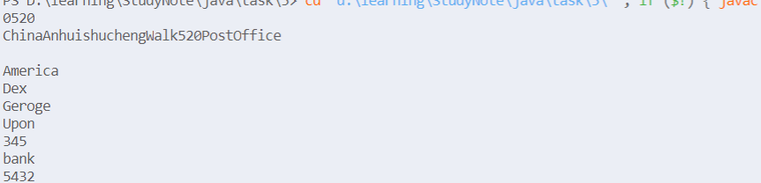

# 第六章

## 6-8.

### 1.

Person.java

abstract class Person{

    protected String name;

    public Person(String name)

    {

        this**.**name = name ;

    }

    abstract public double pay();

    public String toString()

    {

        return name+"的工资支出:"+this**.**pay()+'\n';

    }

}

Teacher.java

class Teacher extends Person{

    private double baseWage ;

    private  double teachingHours;

    public Teacher(String name,double baseWage,double teachingHours)

    {

        super(name);

        this**.**baseWage = baseWage;

        this**.**teachingHours = teachingHours ;

    }

    public double pay()

    {

        return baseWage + teachingHours * 30;

    }

}

Student.java

class Student extends Person{

    private double scholarship ;

    public Student(String name,double scholarship)

    {

        super(name);

        this**.**scholarship = scholarship;

    }

    public double pay()

    {

        return scholarship ;

    }

}

Test.java

class Test{

    public static void main(String[] args)

    {

        Teacher a = new Teacher("Andriod",5000,30);

        Student b = new Student("Windows",1600);

        System**.**out**.**println(a);

        System**.**out**.**println(b);

    }

}



### 2.

PersonPay.java

public interface PersonPay

{

    public double pay();

}

Person.java

abstract class Person implements PersonPay{

    protected String name;

    public Person(String name)

    {

        this**.**name = name ;

    }

    public String toString()

    {

        return name+"的工资支出:"+this**.**pay()+'\n';

    }

}

其余与第一种方法无异;

## 6-9

import java.awt.*;

import javax.swing.*;

import java.awt.event.*;

public class Test extends JFrame{

    private String name;

    private JLabel nameLabel;

    private JTextField nameField , displayField ;

    private JButton exitButton ;

    public Test()

    {

        super("Inner Class Demonstration");

        Container container = getContentPane();

        container**.**setLayout( new FlowLayout());

        nameLabel = new JLabel("姓名");

        nameField = new JTextField(20);

        container**.**add(nameLabel);

        container**.**add(nameField);

        displayField = new JTextField(30);

        displayField**.**setEditable(false);

        container**.**add(exitButton);

        ActionEventhandler handler =  new ActionEventhandler();

        nameField**.**addActionListener(handler);

        exitButton**.**addActionListener(handler);

    }

    public void displayName()

    {

        displayField**.**setText("姓名是:"+name);

    }

    public static void main(String[] args)

    {

        Test window = new Test();

        window**.**setSize(400,150);

        window**.**setVisible(true);

    }

    private class ActionEventhandler implements ActionListener{

        public void actionPerformed(ActionEvent event)

        {

            if(event**.**getSource()==exitButton)

            System**.**exit(0);

            else if(event**.**getSource()==nameField)

            {

                name = event**.**getActionCommand();

                nameField**.**setText("");

            }

            displayName();

        }

    }

}

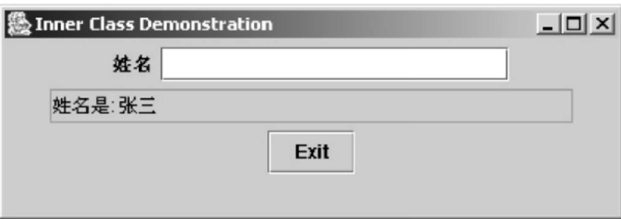

## 6-10

Time.java

import java.text.DecimalFormat;

public class Time{

    private int hour;

    private int minute;

    private int second;

    private static DecimalFormat twoDigits = new DecimalFormat("00");

    public Time()

    {

        this(0,0,0);

    }

    public Time(int h)

    {

        this(h,0,0);

    }

    public Time(int h,int m)

    {

        this(h,m,0);

    }

    public Time(int h,int m,int s)

    {

        setTime(h,m,s);

    }

    public Time(Time time)

    {

        this(time**.**getHour(),time**.**getMinute(),time**.**getSecond());

    }

    public void setTime(int h,int m,int s)

    {

        setHour(h);

        setMinute(m);

        setSecond(s);

    }

    public void setHour(int h)

    {

        hour = h;

    }

    public void setMinute(int m)

    {

        minute = m;

    }

    public void setSecond(int s)

    {

        second = s;

    }

    public int getHour()

    {

        return hour;

    }

    public int getMinute()

    {

        return minute;

    }

    public int getSecond()

    {

        return second;

    }

    public String toString()

    {

        String s;

        s=getSecond()+":"+twoDigits**.**format(getMinute())+":"+twoDigits**.**format(getSecond())+(getHour()<12?"AM":"PM");

        return s;

    }

}

Test.java

import java.awt.*;

import javax.swing.*;

import java.awt.event.*;

public class TimeTestWindow extends JFrame{

    private Time time;

    private JLabel hourLabel,minuteLabel,secondLabel ;

    private JTextField hourField,minuteField,secondField,displayField;

    public TimeTestWindow()

    {

        super("嵌套内部类使用例子");

        time= new Time();

        createGUI();

        registerEventHandlers();

    }

    private void createGUI()

    {

        Container container = getContentPane();

        container**.**setLayout(new FlowLayout());

        hourLabel = new JLabel("设置时间:");

        hourField = new JTextField(10);

        container**.**add(hourLabel);

        container**.**add(hourField);

        minuteField = new JLabel("设置分:");

        minuteField = new JTextField(10);

        container**.**add(minuteLabel);

        container**.**add(minuteField);

        secondLabel = new JLabel("设置秒:");

        secondField = new JTextField(10);

        container**.**add(secondLabel);

        containeradd(secondField);

        displayField = new JTextField(30);

        displayField**.**setEditable(false);

        container**.**add(displayField);

    }

    private void registerEventHandlers()

    {

        ActionEventHandler handler = new ActionEventHandler();

        hourField**.**addActionListener(handler);

        minuteField**.**addActionListener(handler);

        secondField**.**addActionListener(handler);

    }

    private class ActionEventHandler implements ActionListener{

        public void actionPerformed(ActionEvent event)

        {

            if(event**.**getSource()==hourField)

            {

                time**.**setHour(Integer**.**parseInt(event**.**getActionCommand()));

            }

            else if(event**.**getSource()==minuteField)

            {

                time**.**setMinute(Integer**.**parseInt(event**.**getActionCommand()));

            }

            else if(event**.**getSource()==secondField)

            {

                time**.**setSecond(Integer**.**parseInt(event**.**getActionCommand()));

            }

            displayTime();

        }

    }

    public void displayTime()

    {

        displayField**.**setText("时间是:"+time);

    }

    public static void main(String[] args)

    {

        TimeTestWindow window = new TimeTestWindow();

        window**.**addWindowListener(

            newWindowAdapter(){

                public void windowClosing(WindowEvent event)

                {

                    System**.**exit(0);

                }

            }

        );

        window**.**setSize(550,150);

        window**.**setVisible(true);

    }

}

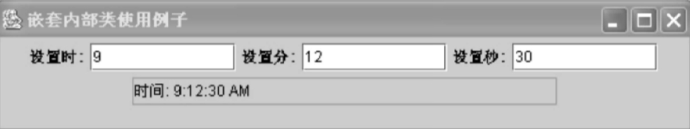

# 第七章

## 7.4

可以将字符串分解为组成它的单词符号.

## 7.5

public class Test5{

public static void main(String[] args)

{

String str1 = new String("Good luck!");

String str2 = new String("Andry");

String str3 = new String(str1.concat(str2));

System.out.println(str3);

}

}



## 7.6

public class Test6{

public static void main(String args[])

{

String str = new String("Good luck!Boys.");

System.out.println(str+'\n'+"第一个字符为:"+str.charAt(0)+'\n'+"最后一个字符为:"+str.charAt(str.length()-1));

}

}

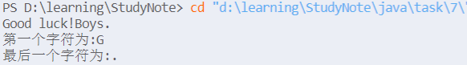

## 7.7

import java.util.*;//导入vector

class Test7{

public static void main(String args[])

{

Vector vec = new Vector();

vec.add("数学");

vec.add("语文");

vec.add("英语");

vec.add("政治");

vec.add("物理");

vec.add("化学");

System.out.println("课程有:");

Enumeration items = vec.elements();

while(items.hasMoreElements())

System.out.println(items.nextElement());

System.out.println("物理所放的位置在:"+vec.indexOf("物理"));

}

}

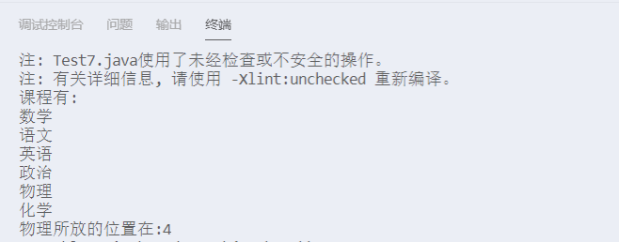

## 7.8

import java.util.*;

class Test8{

public static void main(String args[])

{

List<Student> list =new ArrayList<Student>();

list.add(new Student("Lucre",20));

list.add(new Student("Amy",21));

Iterator iter = list.iterator();

while(iter.hasNext())

{

Student s = (Student) iter. next();

s.showMessage();

}

}

}

class Student{

private String name;

private int age;

public Student(String s,int a)

{

name = s;

age = a;

}

public void showMessage()

{

System.out.println("name:"+name+",age:"+age);

}

}



## 7.9

import java.util.*;

class Test9{

    public static void count(String str){

    //*创建26个空间大小的数组，存放26个字母*

        int[] nums = new int[26];

        String loc[] = new String[26];

        for(int i=0;i<26;i++)

        loc[i] = "";

        int count=0;

        for(char i: str**.**toCharArray()){

        //*自动将char i转化成ascall码*

            if(i>=97 && i<= 122){

            //*利用数组的索引进行存储*

                nums[i-97]++;

                loc[i-97]+=count+" ";

            }

            count++;

        }

        for(int i = 0; i< nums**.**length; i++){

            if(nums[i] != 0){

                //*i加上97并且再转化为char类型就可以显示相应的字符*

                char j = (char)(i+97);

                System**.**out**.**println( j + "====" + nums[i]+",location:"+loc[i]);

            }

        }

    }

    public static void main(String[] args)

    {

        Scanner input = new Scanner(System**.**in);

        String s = input**.**nextLine();

        count(s);

        MyStringTokenizer test = new MyStringTokenizer(s);

        System**.**out**.**println("这句话总共有"+test**.**counts()+"单词,依次是:");

        while(test**.**hasMoreWords())

        {

            System**.**out**.**println(test**.**nextWord());

        }

        test**.**nextWord1();

    }

}

class MyStringTokenizer{

    String s;

    String[] words ;

    int index = 0;

    public MyStringTokenizer(String s)

    {

        this**.**s = s;

        this**.**words = s**.**split("\\n|\\t|\\r| ");//*分割单词*

    }

    public int counts()

    {

        return words**.**length;//*返回单词数*

    }

    public boolean hasMoreWords()

    {

        if(index<words**.**length)

        {

            return true;

        }

        else return false;

    }

    public String nextWord(){

        index++;

        return words[index-1];

    }

    public void nextWord1(){

        index = words**.**length-1;

        while(index>=0)

        {

            System**.**out**.**println(words[index]);

            index--;

        }

    }

}

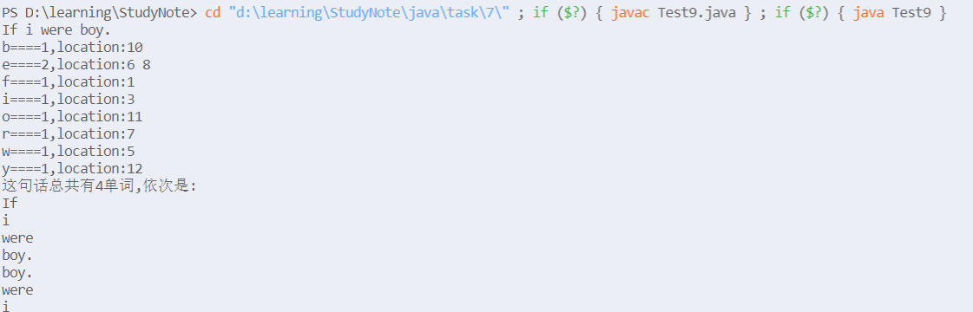

## 7.10

import java.util.*;

class Test10{

public static void main(String[] args)

{

Scanner input = new Scanner(System.in);

String s = input.nextLine();

MyStringTokenizer test = new MyStringTokenizer(s);

System.out.println("这句话总共有"+test.counts()+"单词,依次是:");

while(test.hasMoreWords())

{

System.out.println(test.nextWord());

}

}

}

class MyStringTokenizer{

String s;

String[] words ;

int index = 0;

public MyStringTokenizer(String s)

{

this.s = s;

this.words = s.split("\\n|\\t|\\r| ");//分割单词

}

public int counts()

{

return words.length;//返回单词数

}

public boolean hasMoreWords()

{

if(index<this.counts())

{

return true;

}

else return false;

}

public String nextWord(){

index++;

return words[index-1];

}

}

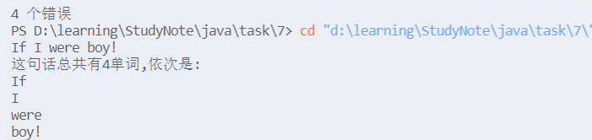

## 附加题

import java.util.Scanner;

public class Extra{

        public static void main(String[] args)

        {

            Scanner input = new Scanner(System**.**in);

            String s ="";

            int a=0,b=0;

            for(int i=0;i<5;i++)

            {

                s = input**.**nextLine();

                MyStringTokenizer test = new MyStringTokenizer(s);

                a+=test**.**countWords();

                b+=test**.**countSentences()+1;

            }

            System**.**out**.**println("这句话总共有"+a+"单词,共有"+b+"个句子");

        }

}

class MyStringTokenizer{

    String s;

    String[] words ;

    String[] sentences;

    int index = 0;

    public MyStringTokenizer(String s)

    {

        this**.**s = s;

        this**.**words = s**.**split("\\n|\\t|\\r| ");//*分割单词*

        this**.**sentences = s**.**split(".|");

    }

    public int countWords()

    {

        return words**.**length;//*返回单词数*

    }

    public int countSentences()

    {

        return sentences**.**length;//*返回单词数*

    }

}

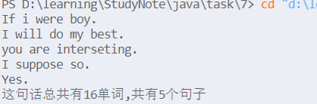

# 第八章

## 8.2

import java.awt.*;

import javax.swing.*;

import java.util.Date;

class Test2 extends JFrame{

public void paint(Graphics g)

{

int x1,y1,x2,y2;

x1 = (int) (Math.random() * 500);

y1 = (int) (Math.random() * 500);

x2 = (int) (Math.random() * 500);

y2 = (int) (Math.random() * 500);//随机生成两个端点

g.setColor(new Color((int)(Math.random()*256),(int)(Math.random()*256),(int)(Math.random()*256)));//随机生成颜色

g.drawLine(x1,y1,x2,y2);

}

public static void main(String[] args){

Test2 win = new Test2();

win.setSize(500,500);

win.setVisible(true);

win.setDefaultCloseOperation(JFrame.EXIT_ON_CLOSE);

}

}

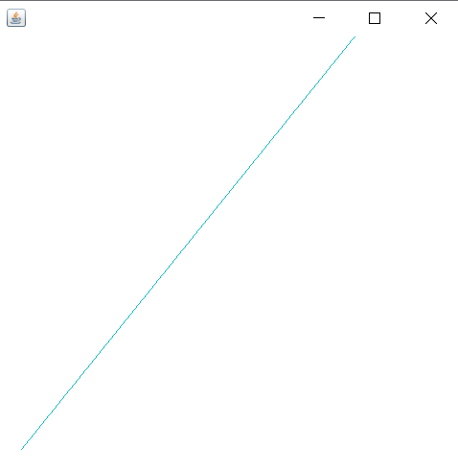

## 8.3

import java.awt.*;

import javax.swing.*;

import java.util.Date;

class Test3 extends JFrame{

public void paint(Graphics g)

{

for(int i=1;i<=8;i++)

{

g.setColor(new Color((int)(Math.random()*256),(int)(Math.random()*256),(int)(Math.random()*256)));//随机生成颜色

g.drawOval(200-i*10,200-i*10,i*20,i*20);//前两个坐标并非圆心

}

}

public static void main(String[] args){

Test3 win = new Test3();

win.setSize(500,500);

win.setVisible(true);

win.setDefaultCloseOperation(JFrame.EXIT_ON_CLOSE);

}

}

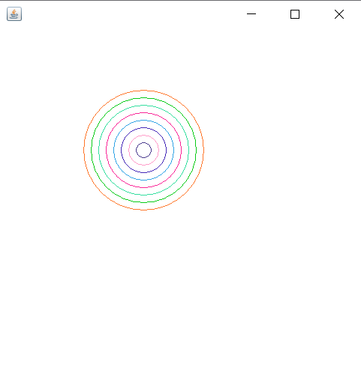

## 8.4

import java.awt.*;

import javax.swing.*;

import java.util.Date;

class Test4 extends JFrame{

public void paint(Graphics g)

{

for(int i=1;i<=8;i++)

{

g.setColor(new Color((int)(Math.random()*256),(int)(Math.random()*256),(int)(Math.random()*256)));//随机生成颜色

g.drawArc(200-i*10,200-i*10,i*20,i*20,0,360);

}

}

public static void main(String[] args){

Test4 win = new Test4();

win.setSize(500,500);

win.setVisible(true);

win.setDefaultCloseOperation(JFrame.EXIT_ON_CLOSE);

}

}



## 8.5

import java.awt.*;

import java.awt.geom.GeneralPath;

import javax.swing.*;

public class Test5 extends JFrame{

public Test5()

{

super("Draw 2D Shapes");

getContentPane().setBackground(Color.WHITE);

setSize(200,200);

setVisible(true);

}

public void paint(Graphics g){

super.paint(g);

int x[] = {60,72,114,78,88,60,32,42,6,48};//把五角星的点坐标顺时针列出来

int y[] = {60,96,96,114,156,122,156,114,96,96};

Graphics2D g2 = (Graphics2D) g ;//转换

GeneralPath star = new GeneralPath();

star.moveTo(x[0],y[0]);

for(int count = 1;count < x.length;count++)

{

star.lineTo(x[count],y[count]);//连线

}

star.closePath();

g2.setColor(Color.RED);

g2.fill(star);

}

public static void main(String[] args)

{

Test5 win = new Test5();

win.setDefaultCloseOperation(JFrame.EXIT_ON_CLOSE);

}

}

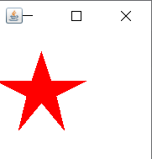

## 8.6

import java.awt.*;

import java.awt.geom.GeneralPath;

import javax.swing.*;

public class Test6 extends JFrame{

    public Test6()

    {

        super("Draw 2D Shapes");

        getContentPane()**.**setBackground(Color**.**WHITE);

        setSize(300,300);

        setVisible(true);

    }

    public void paint(Graphics g){

        super**.**paint(g);

        g**.**drawRect(40, 40, 100, 100);

        g**.**drawLine(40, 40, 60, 20);

        g**.**drawLine(60, 20, 160, 20);

        g**.**drawLine(140, 40, 160, 20);

        g**.**drawLine(160, 120, 160, 20);

        g**.**drawLine(160, 120, 140, 140);

        Graphics2D g2 = (Graphics2D) g ;//*转换*

        Stroke dashed = new BasicStroke(3, BasicStroke**.**CAP_BUTT, BasicStroke**.**JOIN_BEVEL, 0, new float[]{9}, 0);

        g2**.**setStroke(dashed);

        g2**.**drawLine(60,120,40,140);

        g2**.**drawLine(60,120,160,120);

        g2**.**drawLine(60,20,60,120);

    }

    public static void main(String[] args)

    {

        Test6 win = new Test6();

        win**.**setDefaultCloseOperation(JFrame**.**EXIT_ON_CLOSE);

    }

}

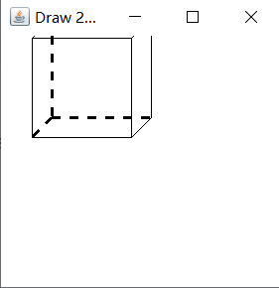

## 8.7

import java.awt.Color;

import java.awt.GradientPaint;

import java.awt.Graphics;

import java.awt.Graphics2D;

import java.awt.geom.Rectangle2D;

import javax.swing.JFrame;

import javax.swing.JPanel;

public class Test7 extends JFrame {

FillGradientPanel fillGradientPanel = new FillGradientPanel(); // 创建面板类的实例

public static void main(String args[]) { // 主方法

Test7 frame = new Test7(); // 创建窗体类的实例

frame.setVisible(true); // 显示窗体

}

public Test7() {

super(); // 调用超类的构造方法

setTitle("为图形填充渐变色"); // 窗体标题

setBounds(100, 100, 340, 360); // 窗体的显示位置和大小

setDefaultCloseOperation(JFrame.EXIT_ON_CLOSE); // 窗体关闭方式

add(fillGradientPanel); // 将面板类的实例添加到窗体容器中

}

class FillGradientPanel extends JPanel { // 创建内部面板类

public void paint(Graphics g) { // 重写paint()方法

Graphics2D g2 = (Graphics2D) g; // 获得Graphics2D对象

Rectangle2D.Float rect = new Rectangle2D.Float(20, 20, 280, 280);// 创建矩形对象

// 创建循环渐变的GraphientPaint对象

GradientPaint paint = new GradientPaint(5,40,Color.RED,15,50,Color.YELLOW,true);

g2.setPaint(paint);// 设置渐变

g2.fill(rect);// 绘制矩形

}

}

}

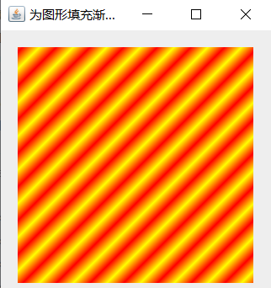

## 8.8

import java.awt.BorderLayout;

import java.awt.Color;

import java.awt.Graphics;

import javax.swing.JFrame;

import javax.swing.JPanel;

import javax.swing.JSlider;

import javax.swing.event.ChangeEvent;

import javax.swing.event.ChangeListener;

class SineDraw extends JPanel {

private static final int SCALEFACTOR = 200;

private int cycles;

private int points;

private double[] sines;

private int[] pts;

public SineDraw() {

setCycles(5);

}

public void setCycles(int newCycles) {

cycles = newCycles;

points = SCALEFACTOR * cycles * 2;

sines = new double[points];

for (int i = 0; i < points; i++) {

double radians = (Math.PI / SCALEFACTOR) * i;

sines[i] = Math.sin(radians);

}

repaint();

}

public void paintComponent(Graphics g) {

super.paintComponent(g);

int maxWidth = getWidth();

double hstep = (double) maxWidth / (double) points;

int maxHeight = getHeight();

pts = new int[points];

for (int i = 0; i < points; i++)

pts[i] = (int) (sines[i] * maxHeight / 2 * .95 + maxHeight / 2);

g.setColor(Color.RED);

for (int i = 1; i < points; i++) {

int x1 = (int) ((i - 1) * hstep);

int x2 = (int) (i * hstep);

int y1 = pts[i - 1];

int y2 = pts[i];

g.drawLine(x1, y1, x2, y2);

}

}

}

public class Test8 extends JPanel {

private SineDraw sines = new SineDraw();

private JSlider adjustCycles = new JSlider(1, 30, 5);

public Test8() {

super(new BorderLayout());

add(BorderLayout.CENTER,sines);

adjustCycles.addChangeListener(new ChangeListener() {

public void stateChanged(ChangeEvent e) {

sines.setCycles(((JSlider) e.getSource()).getValue());

}

});

add(BorderLayout.SOUTH, adjustCycles);

}

public static void main(String[] args) {

JPanel p = new Test8();

JFrame frame = new JFrame();

frame.setDefaultCloseOperation(JFrame.EXIT_ON_CLOSE);

frame.add(p);

frame.setSize(500,500 );

frame.setVisible(true);

}

}

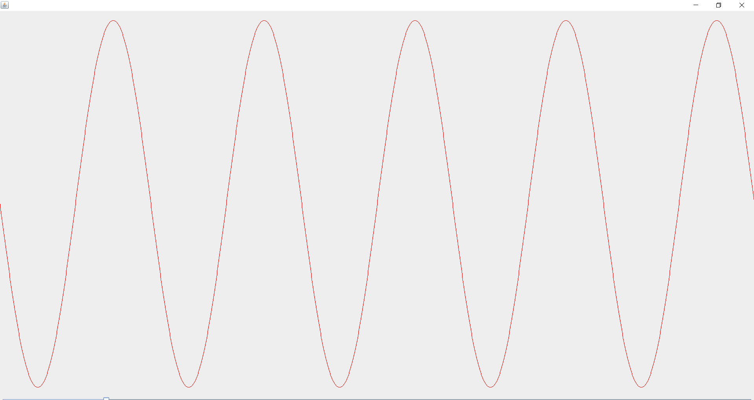

## 附加题

import java.awt.*;

import java.awt.geom.QuadCurve2D;

import javax.swing.JFrame;

import javax.swing.JPanel;

public class Extra extends JFrame{

    public static void main(String args[]) {

        new Extra();

    }

    public Extra() {

        Toolkit kit = Toolkit**.**getDefaultToolkit();

        Dimension screen = kit**.**getScreenSize();

        int wight = screen**.**width;

        int hight = screen**.**height;

        this**.**add(new DrawQuadCurve());

        this**.**setBounds(wight/4, hight/4, 400, 300);

        this**.**setDefaultCloseOperation(3);

        this**.**setVisible(true);

    }

}

class DrawQuadCurve extends JPanel{

    public void paint(Graphics g) {

        Graphics2D g2 = (Graphics2D)g;

        QuadCurve2D**.**Double quadCurve1 = new QuadCurve2D**.**Double(10,20,100,32,200,200);

        g2**.**setColor(Color**.**RED);

        g2**.**draw(quadCurve1);

        QuadCurve2D**.**Double quadCurve2 = new QuadCurve2D**.**Double(10,25,100,123,200,156);

        g2**.**setColor(Color**.**BLUE);

        g2**.**draw(quadCurve2);

        QuadCurve2D**.**Double quadCurve3 = new QuadCurve2D**.**Double(10,25,100,33,200,43);

        g2**.**setColor(Color**.**YELLOW);

        g2**.**draw(quadCurve3);

    }

}

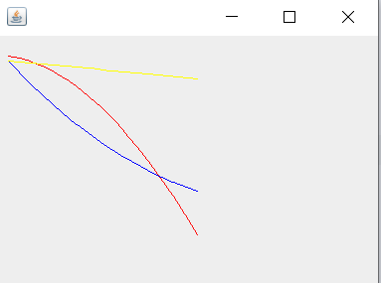

# 实验

## 实验一

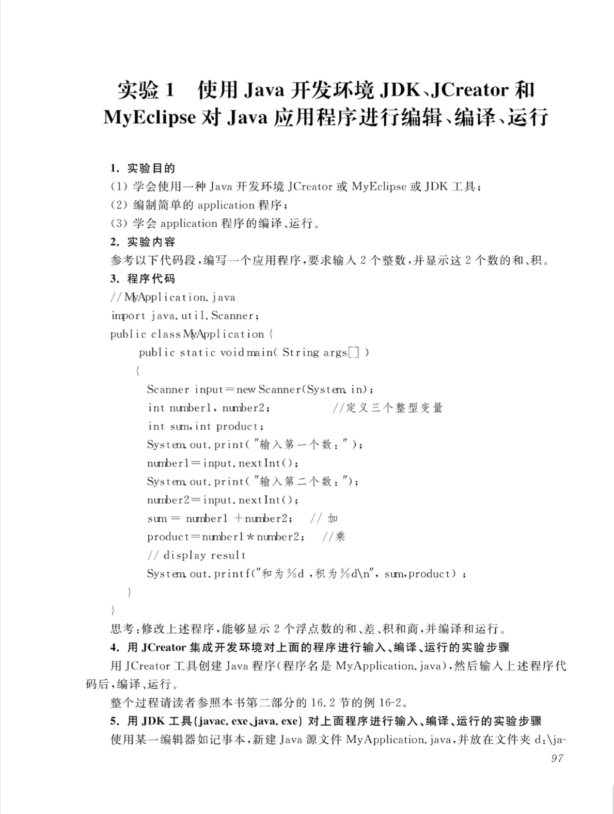

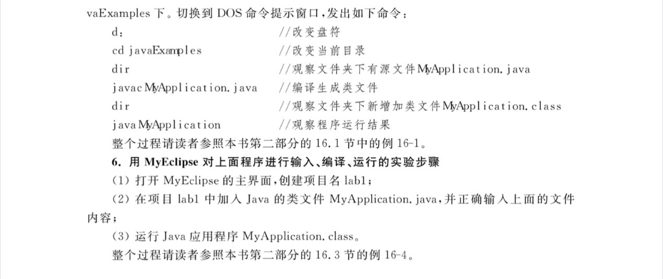可执行代码

**package** labl;

**import** java.util.Scanner;

**public** **class** MyApplication{

**public** **static** **void** main(String[] args)

{

Scanner input=**new** Scanner(System.***in***);

**double** number1,number2;

**double** sum=0;

**double** product=0;

System.***out***.print("输入第一个数:");

number1=input.nextDouble();

System.***out***.print("输入第二个数:");

number2=input.nextDouble();

sum=number1+number2;

product+=number1*number2;

System.***out***.printf("和为%f,积为%f的\n",sum,product);

System.***out***.printf("差为%f,商为%f的\n",number1-number2,number1/number2);

}

}

### Eclipse上运行:

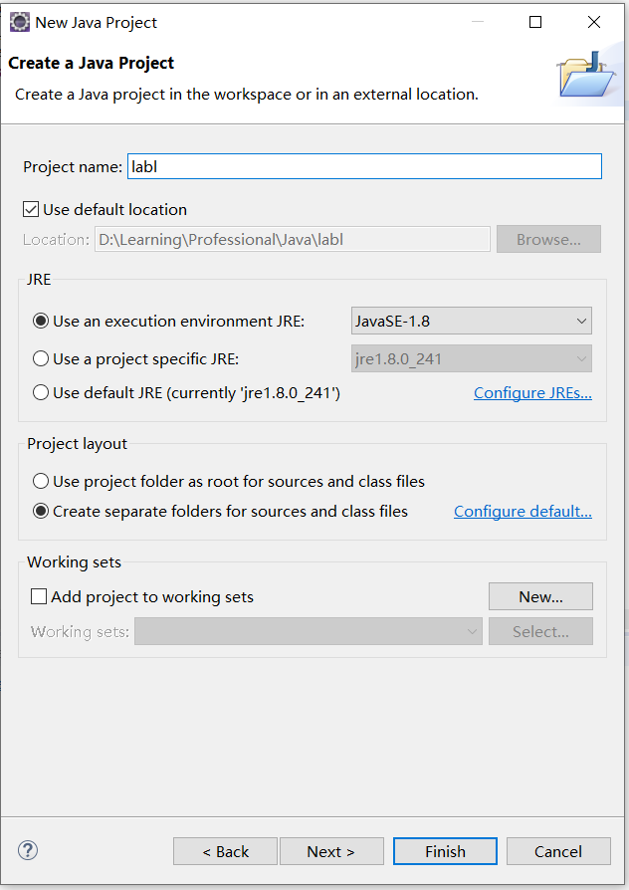

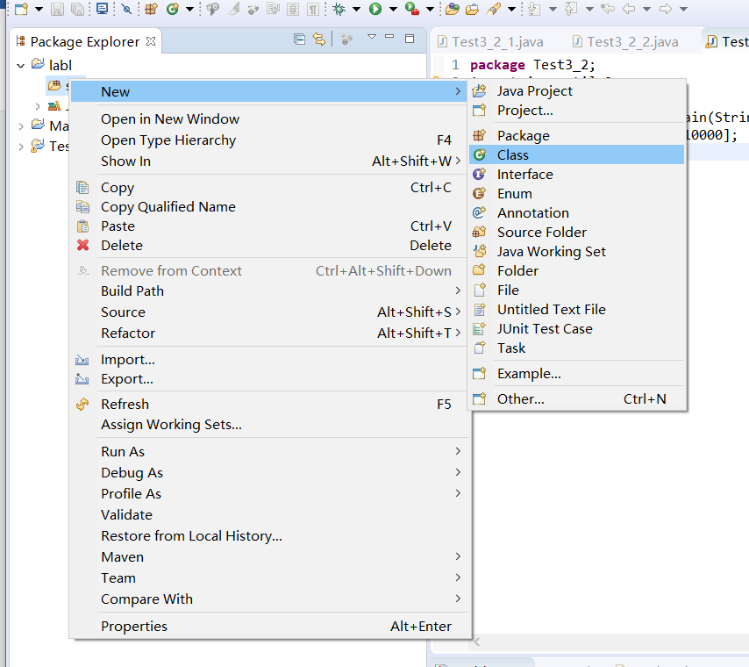

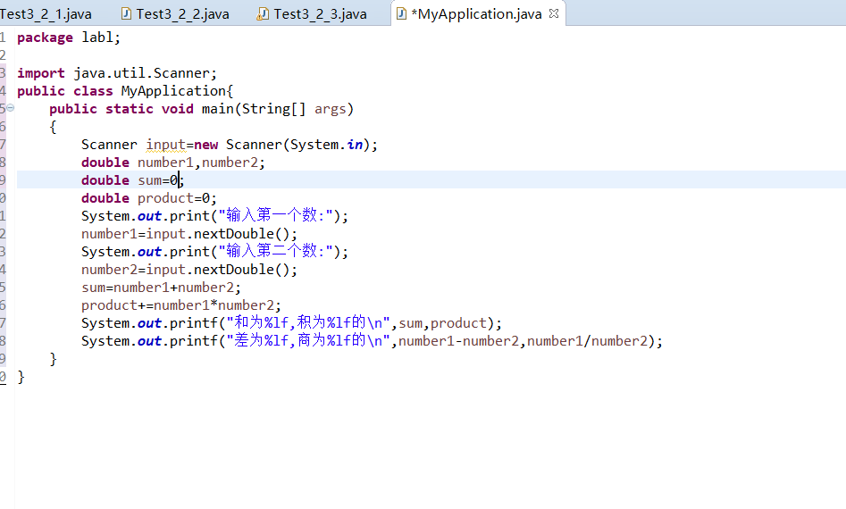

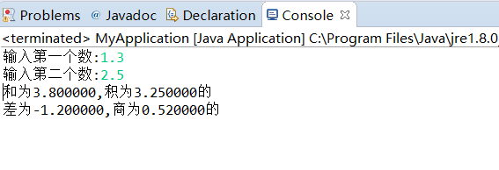

### CMD上运行:

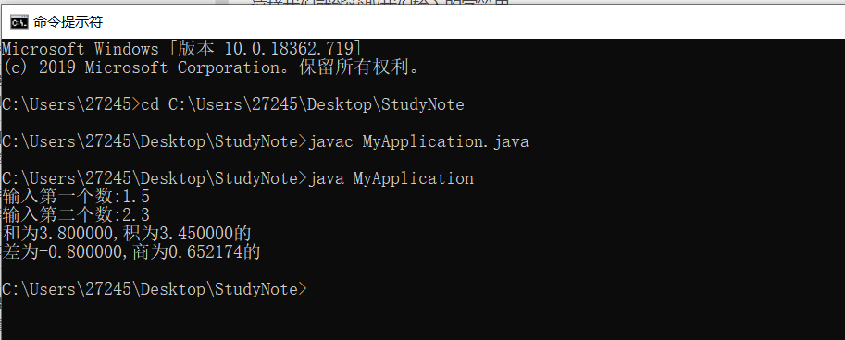

## 实验二

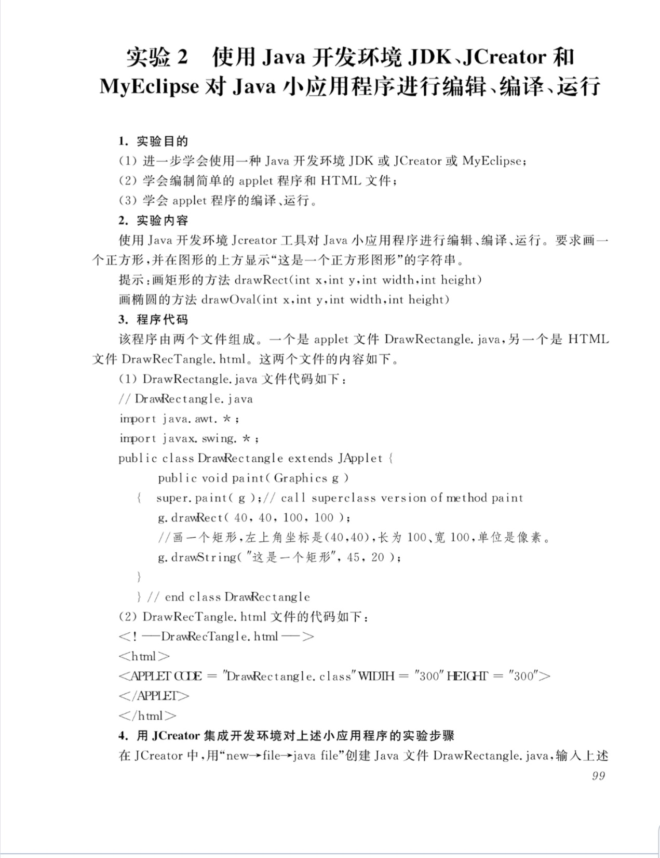

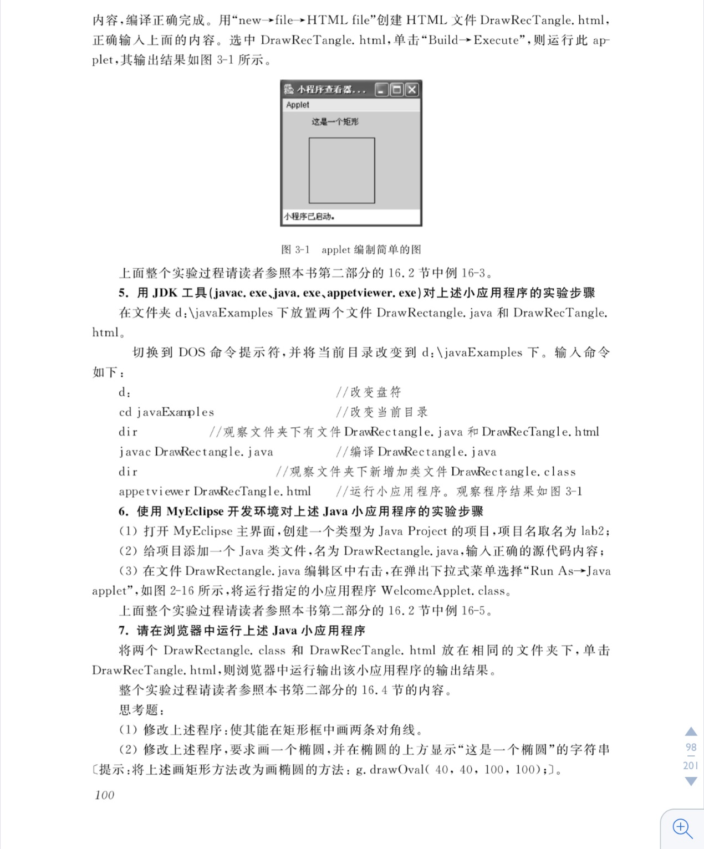

### CMD运行:

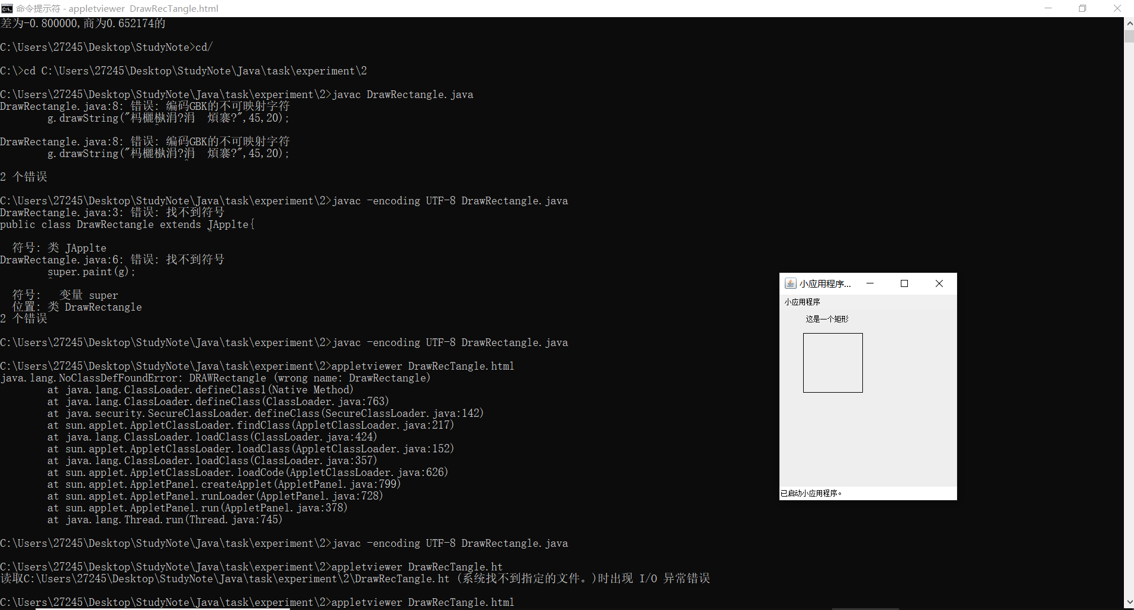

### Eclipse运行:

