**Feature #4: Animation**

Document Established: 04.12.17

1. **INTRODUCTION**
   1. **Purpose**

Makes the graphical front end of the game more visually appealing. By adding animation the player will appear to move between cells rather than simply appearing at a location.

* 1. **Reference Material**

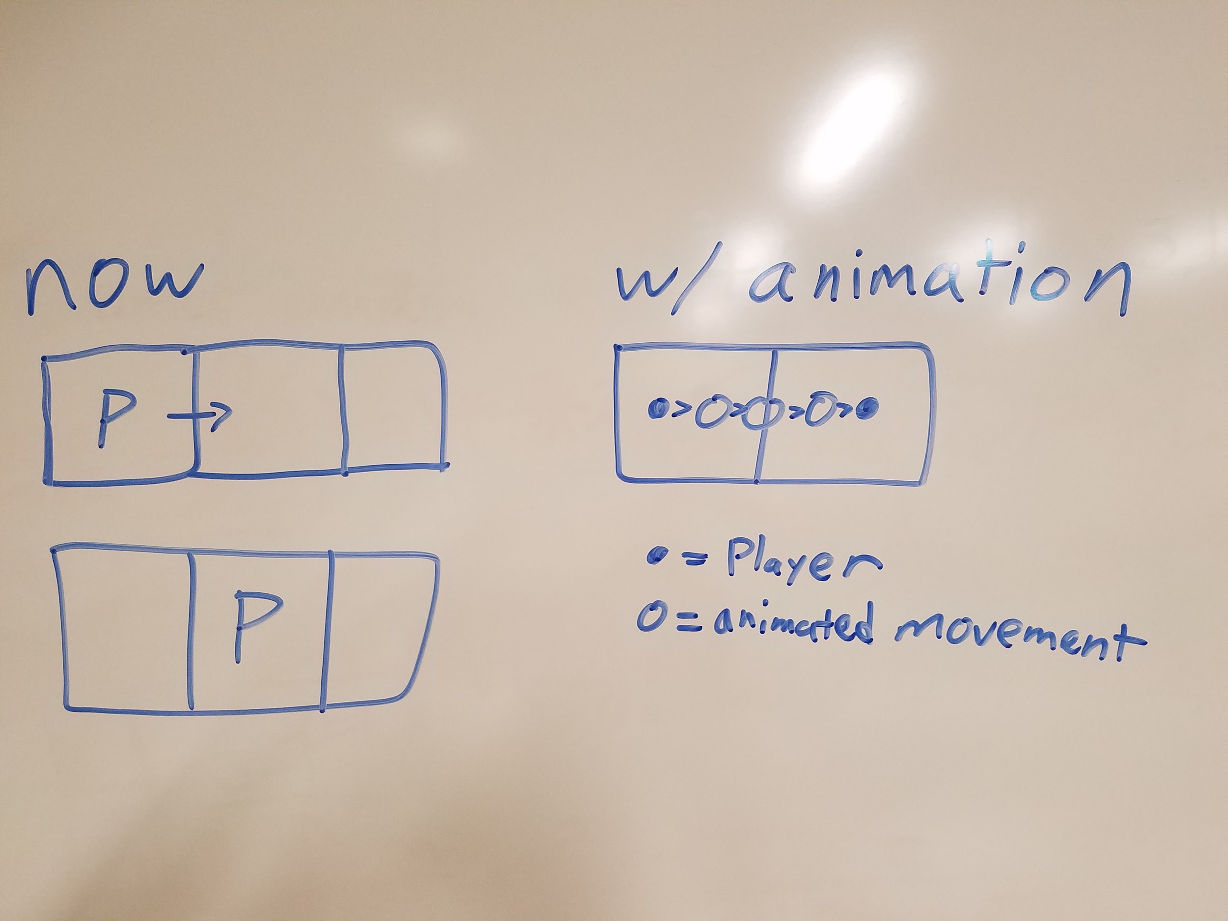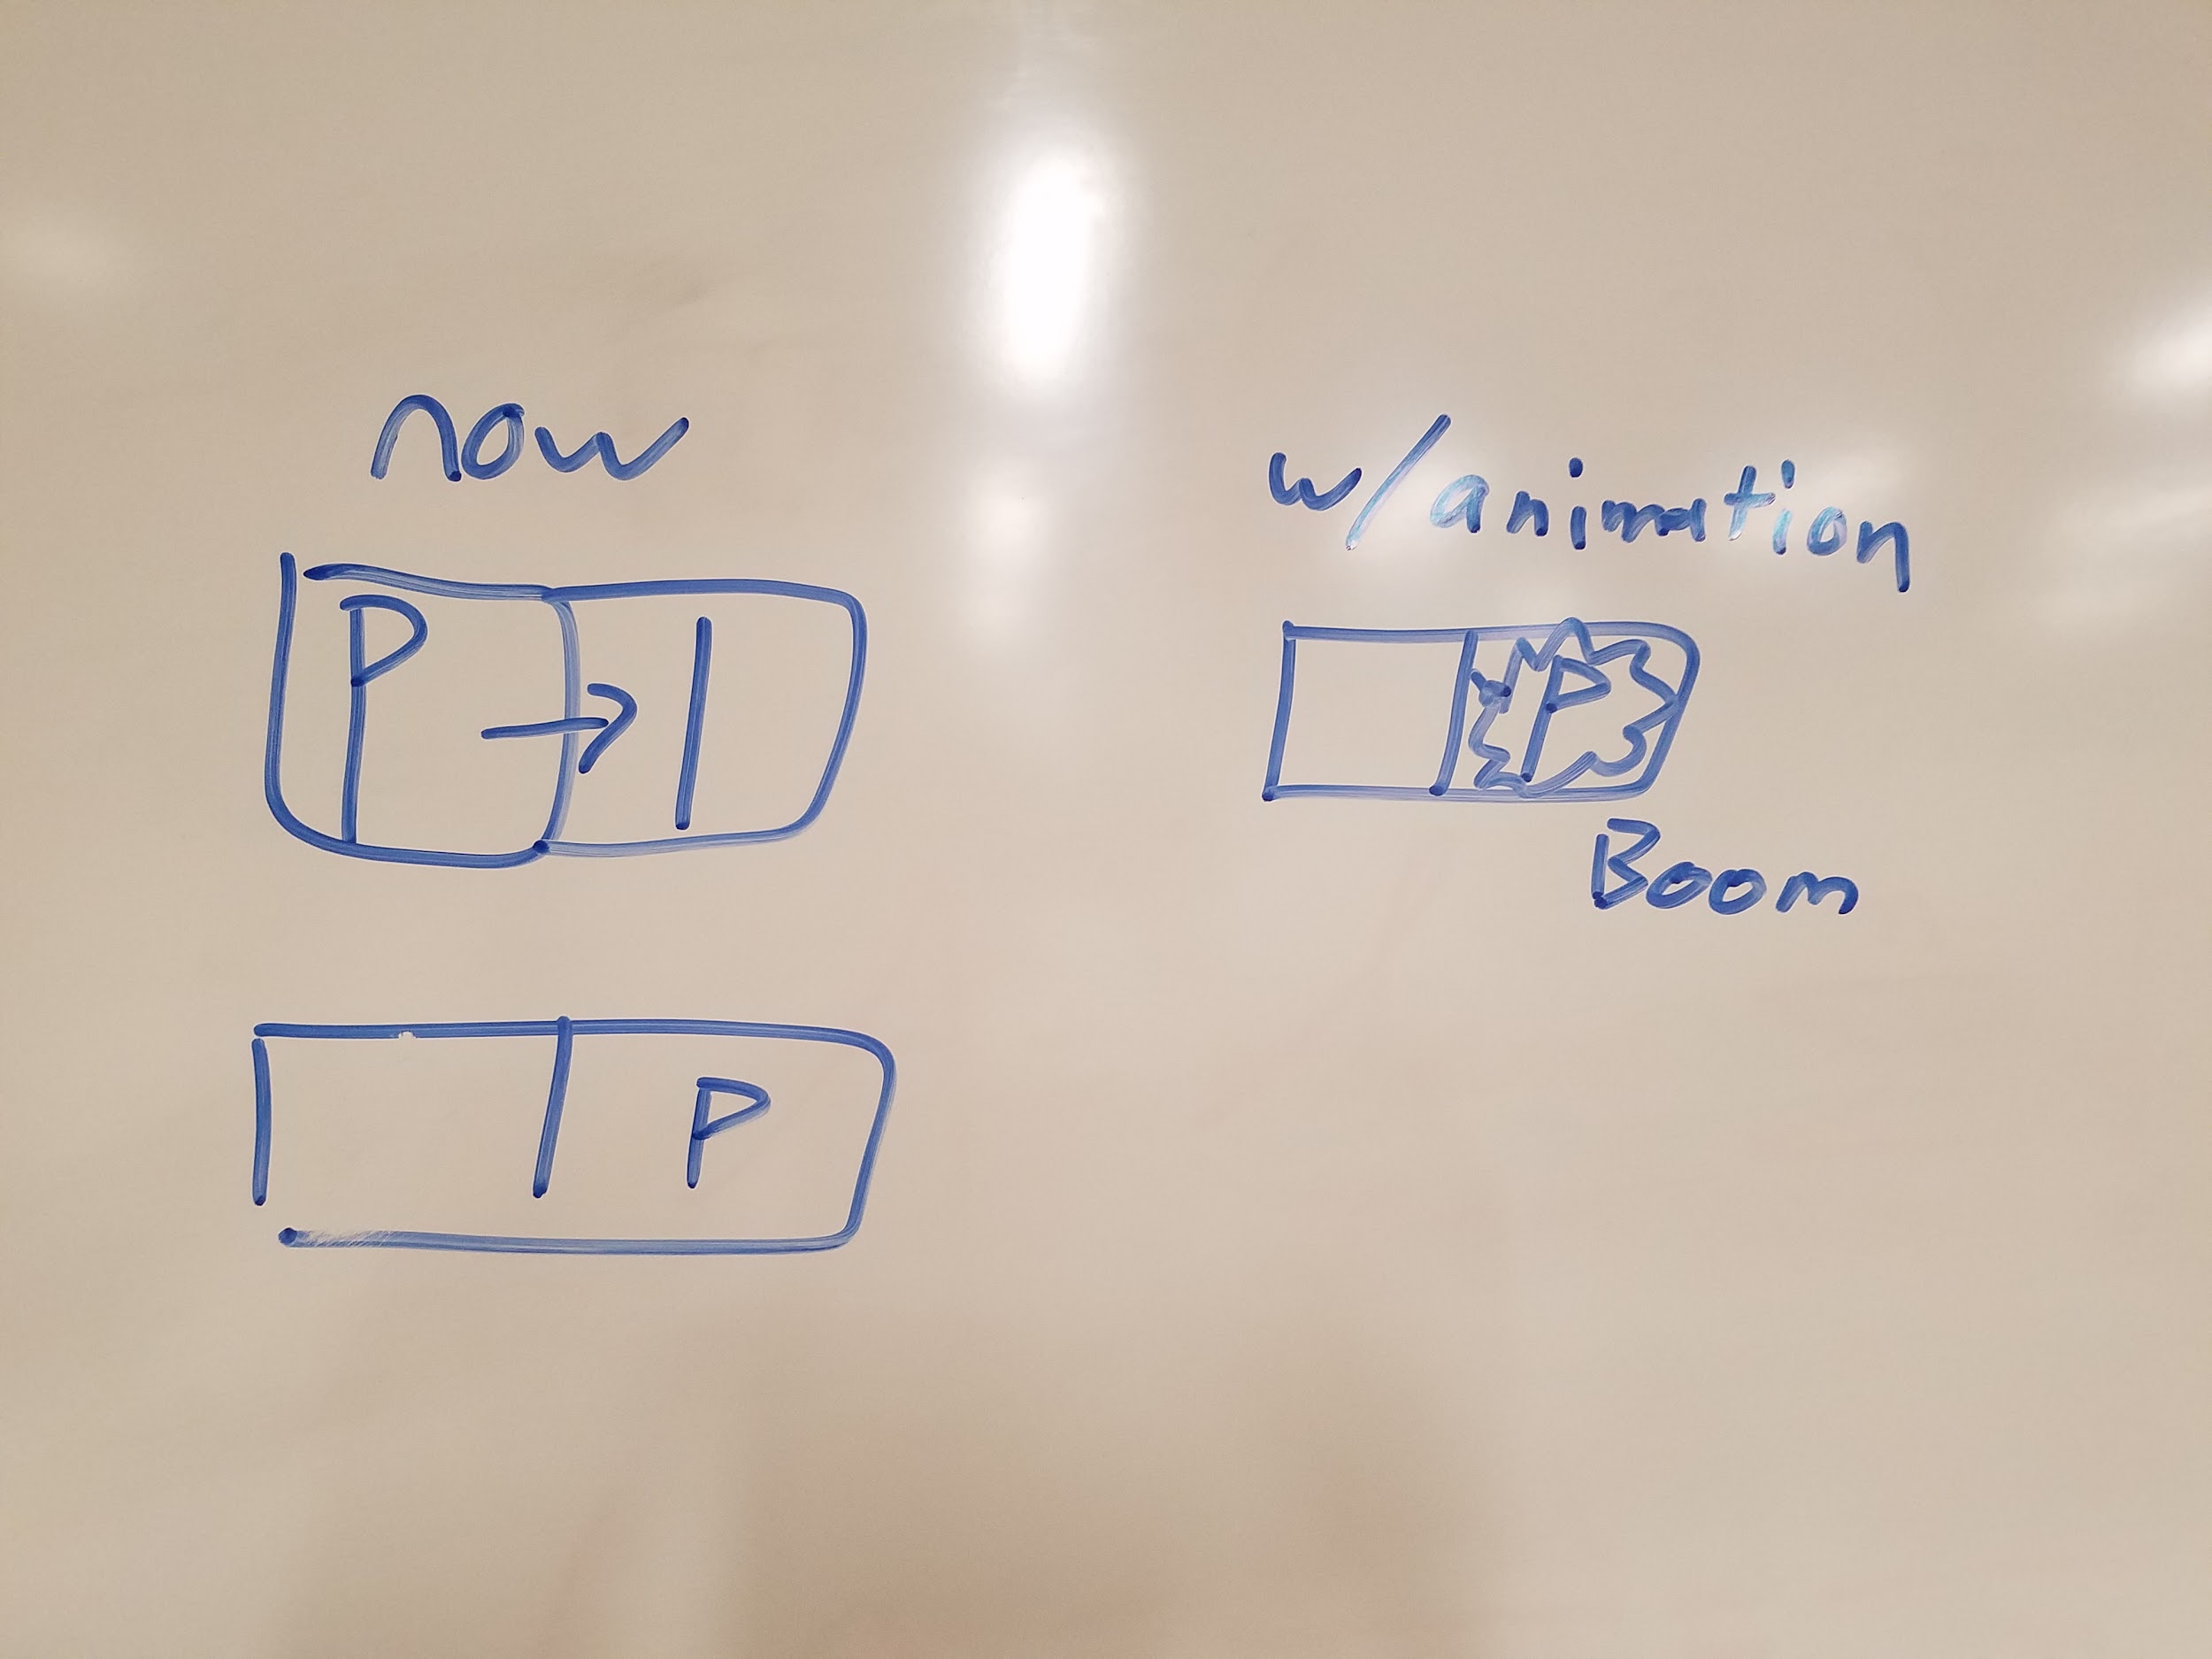

1. **DECISIONS**
2. **Player Animation**

Player can move between tiles and have frames where the player appears to be moving towards a new tile rather than simply appearing.

1. **Rope Animation**

When a rope is deleted, it makes a mini explosion animation which could be an image.

1. **TESTING**

Currently unavailable and not implemented.

1. **ERRORS FOUND WHILE WORKING**