Feature #7: Assembly Integration

Document Established: 04.12.17

1. **INTRODUCTION**
   1. **Purpose**

This feature shows the user what ports are represented and how to go about controlling the robot.

* 1. **Reference Material**

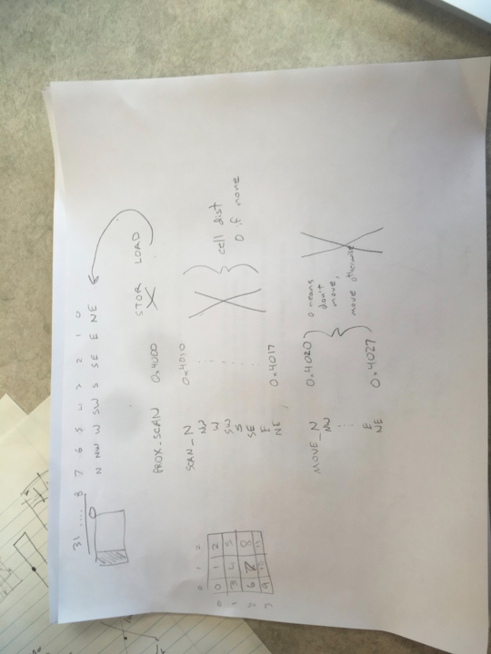

1. **DECISIONS**
2. **TESTING**
   1. Reading in the .bin file
3. **ERRORS FOUND WHILE WORKING**