Feature #8: Color Selection

Document Established: 04.12.17

1. **INTRODUCTION**
   1. **Purpose**

This feature enables the player color to be changed. It is an aesthetic feature.

* 1. **Reference Material**

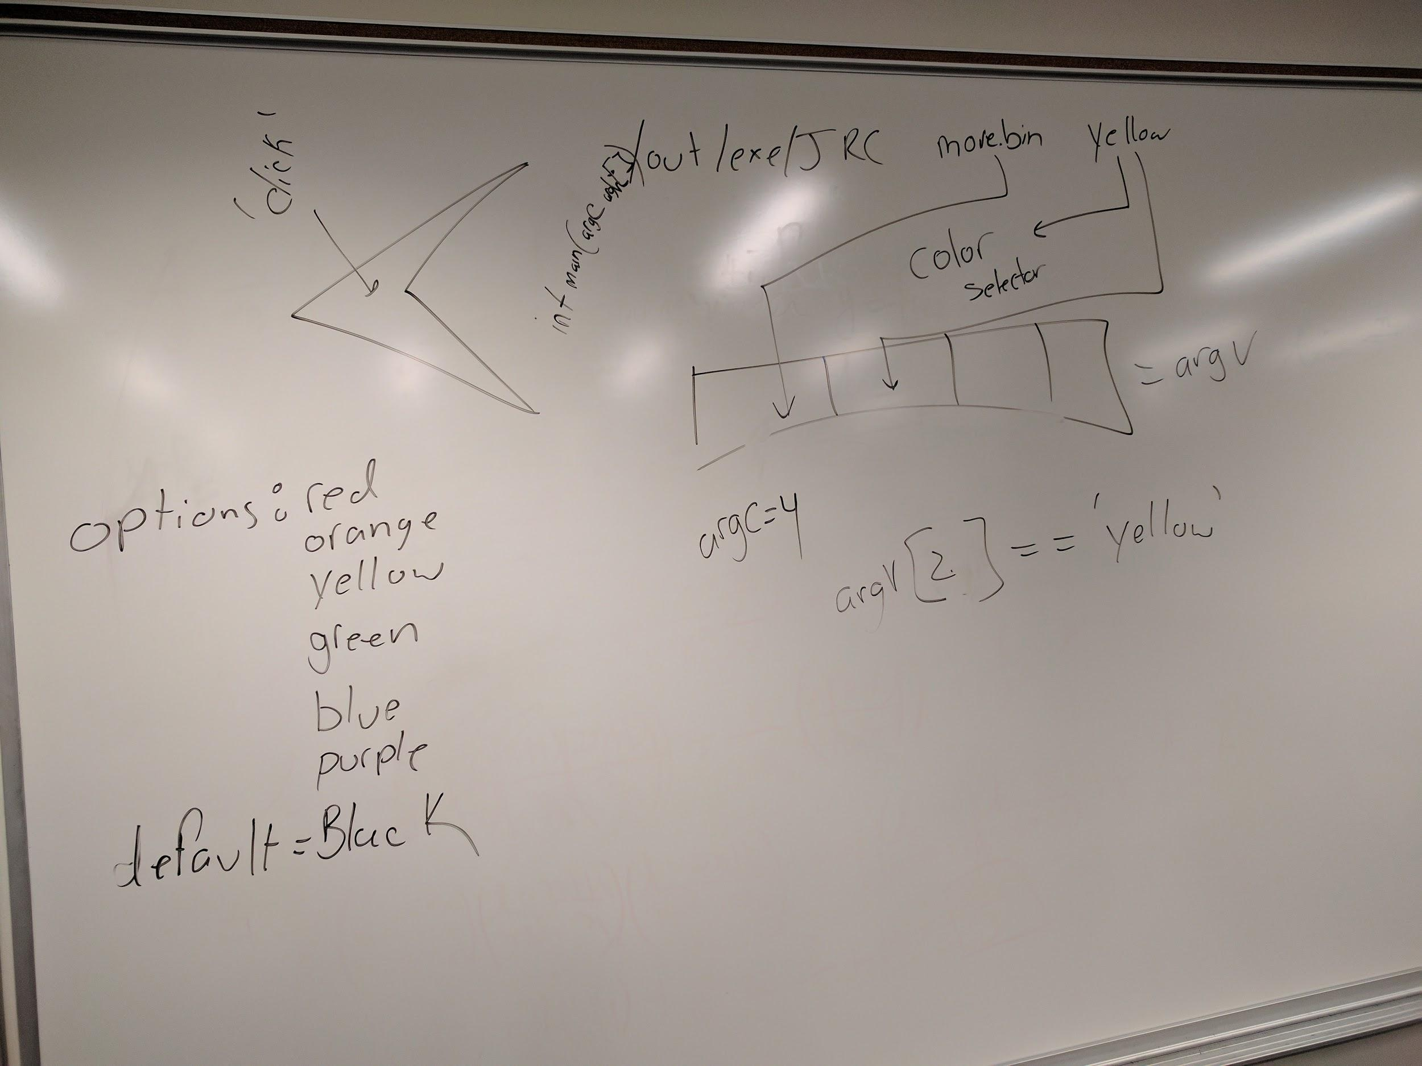

1. **DECISIONS**

1. **TESTING**
2. **ERRORS FOUND WHILE WORKING**