Feature #6: Score

Document Established: 04.12.17

1. **INTRODUCTION**
   1. **Purpose**

This feature involves calculating how many ropes are successfully conquered.

* 1. **Reference Material**

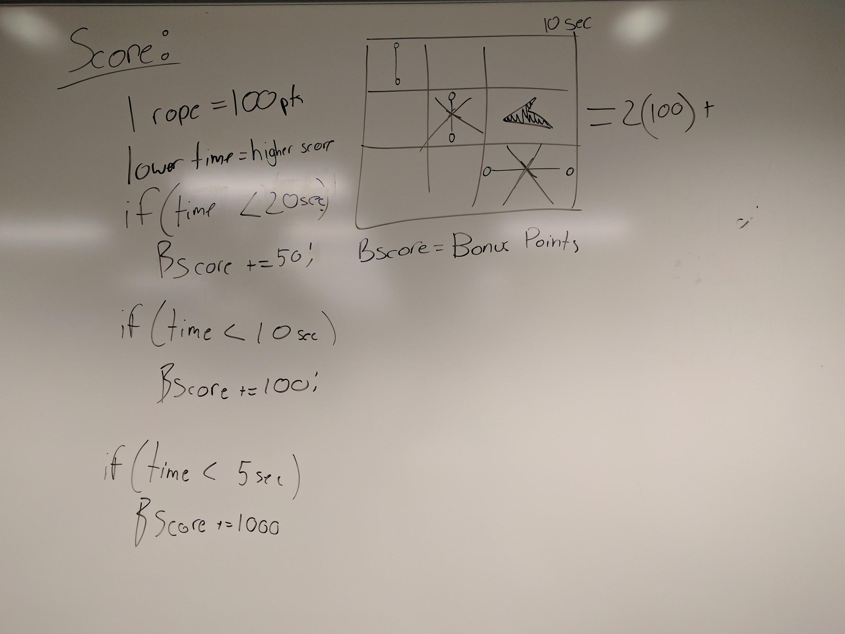

1. **DECISIONS**

1. **TESTING**
2. **ERRORS FOUND WHILE WORKING**