Feature #3: User Generated Mapping

Document Established: 04.12.17

1. **INTRODUCTION**
   1. Purpose
      1. This feature allows ropes to be spawned on the map by the user.
   2. Reference Material
      1. 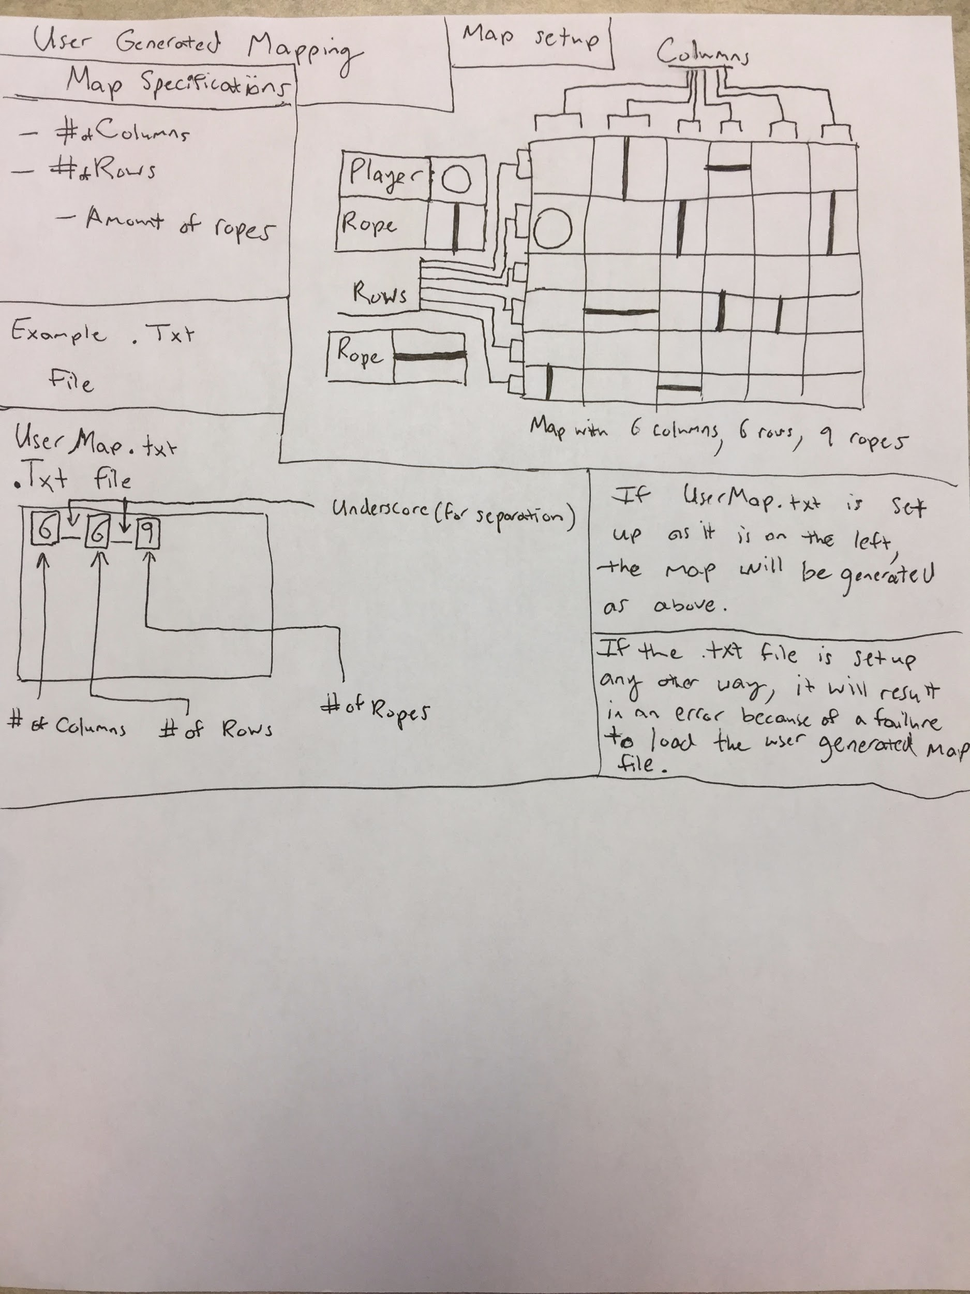
2. **DECISIONS**
   1. The player will be able to choose the specifications for their map through a .txt file.
   2. After saved, the file will be read in by the code, and the map’s settings will be changed to that of the .txt file.
3. **TESTING**
   1. Successful loading of the map

* If the user chooses to create a user generated map, a map should be generated and the map generated should correspond with the specifications that the user set in the .txt file.
* If this fails for the reason of invalid values being entered into the .txt file, an error message should be output to the user stating that the values entered into the .txt file were invalid.

1. **ERRORS FOUND WHILE WORKING**