Feature #5: Multiplayer

Document Established: 04.12.17

1. **INTRODUCTION**
   1. **Purpose**

This features allows multiple users to be spawned onto the same map.

* 1. **Reference Material**

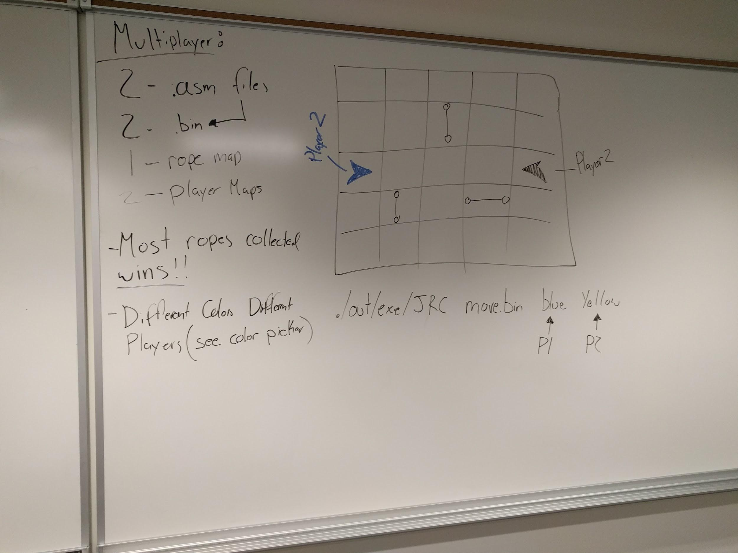

1. **DECISIONS**

1. **TESTING**
2. **ERRORS FOUND WHILE WORKING**