Feature #2: Rope Collection and Deletion

Document Established: 04.12.17

1. **INTRODUCTION**
   1. **Purpose**

This feature grants the ability to remove ropes from the map as well as adding onto an overall score.

* 1. **Reference Material**

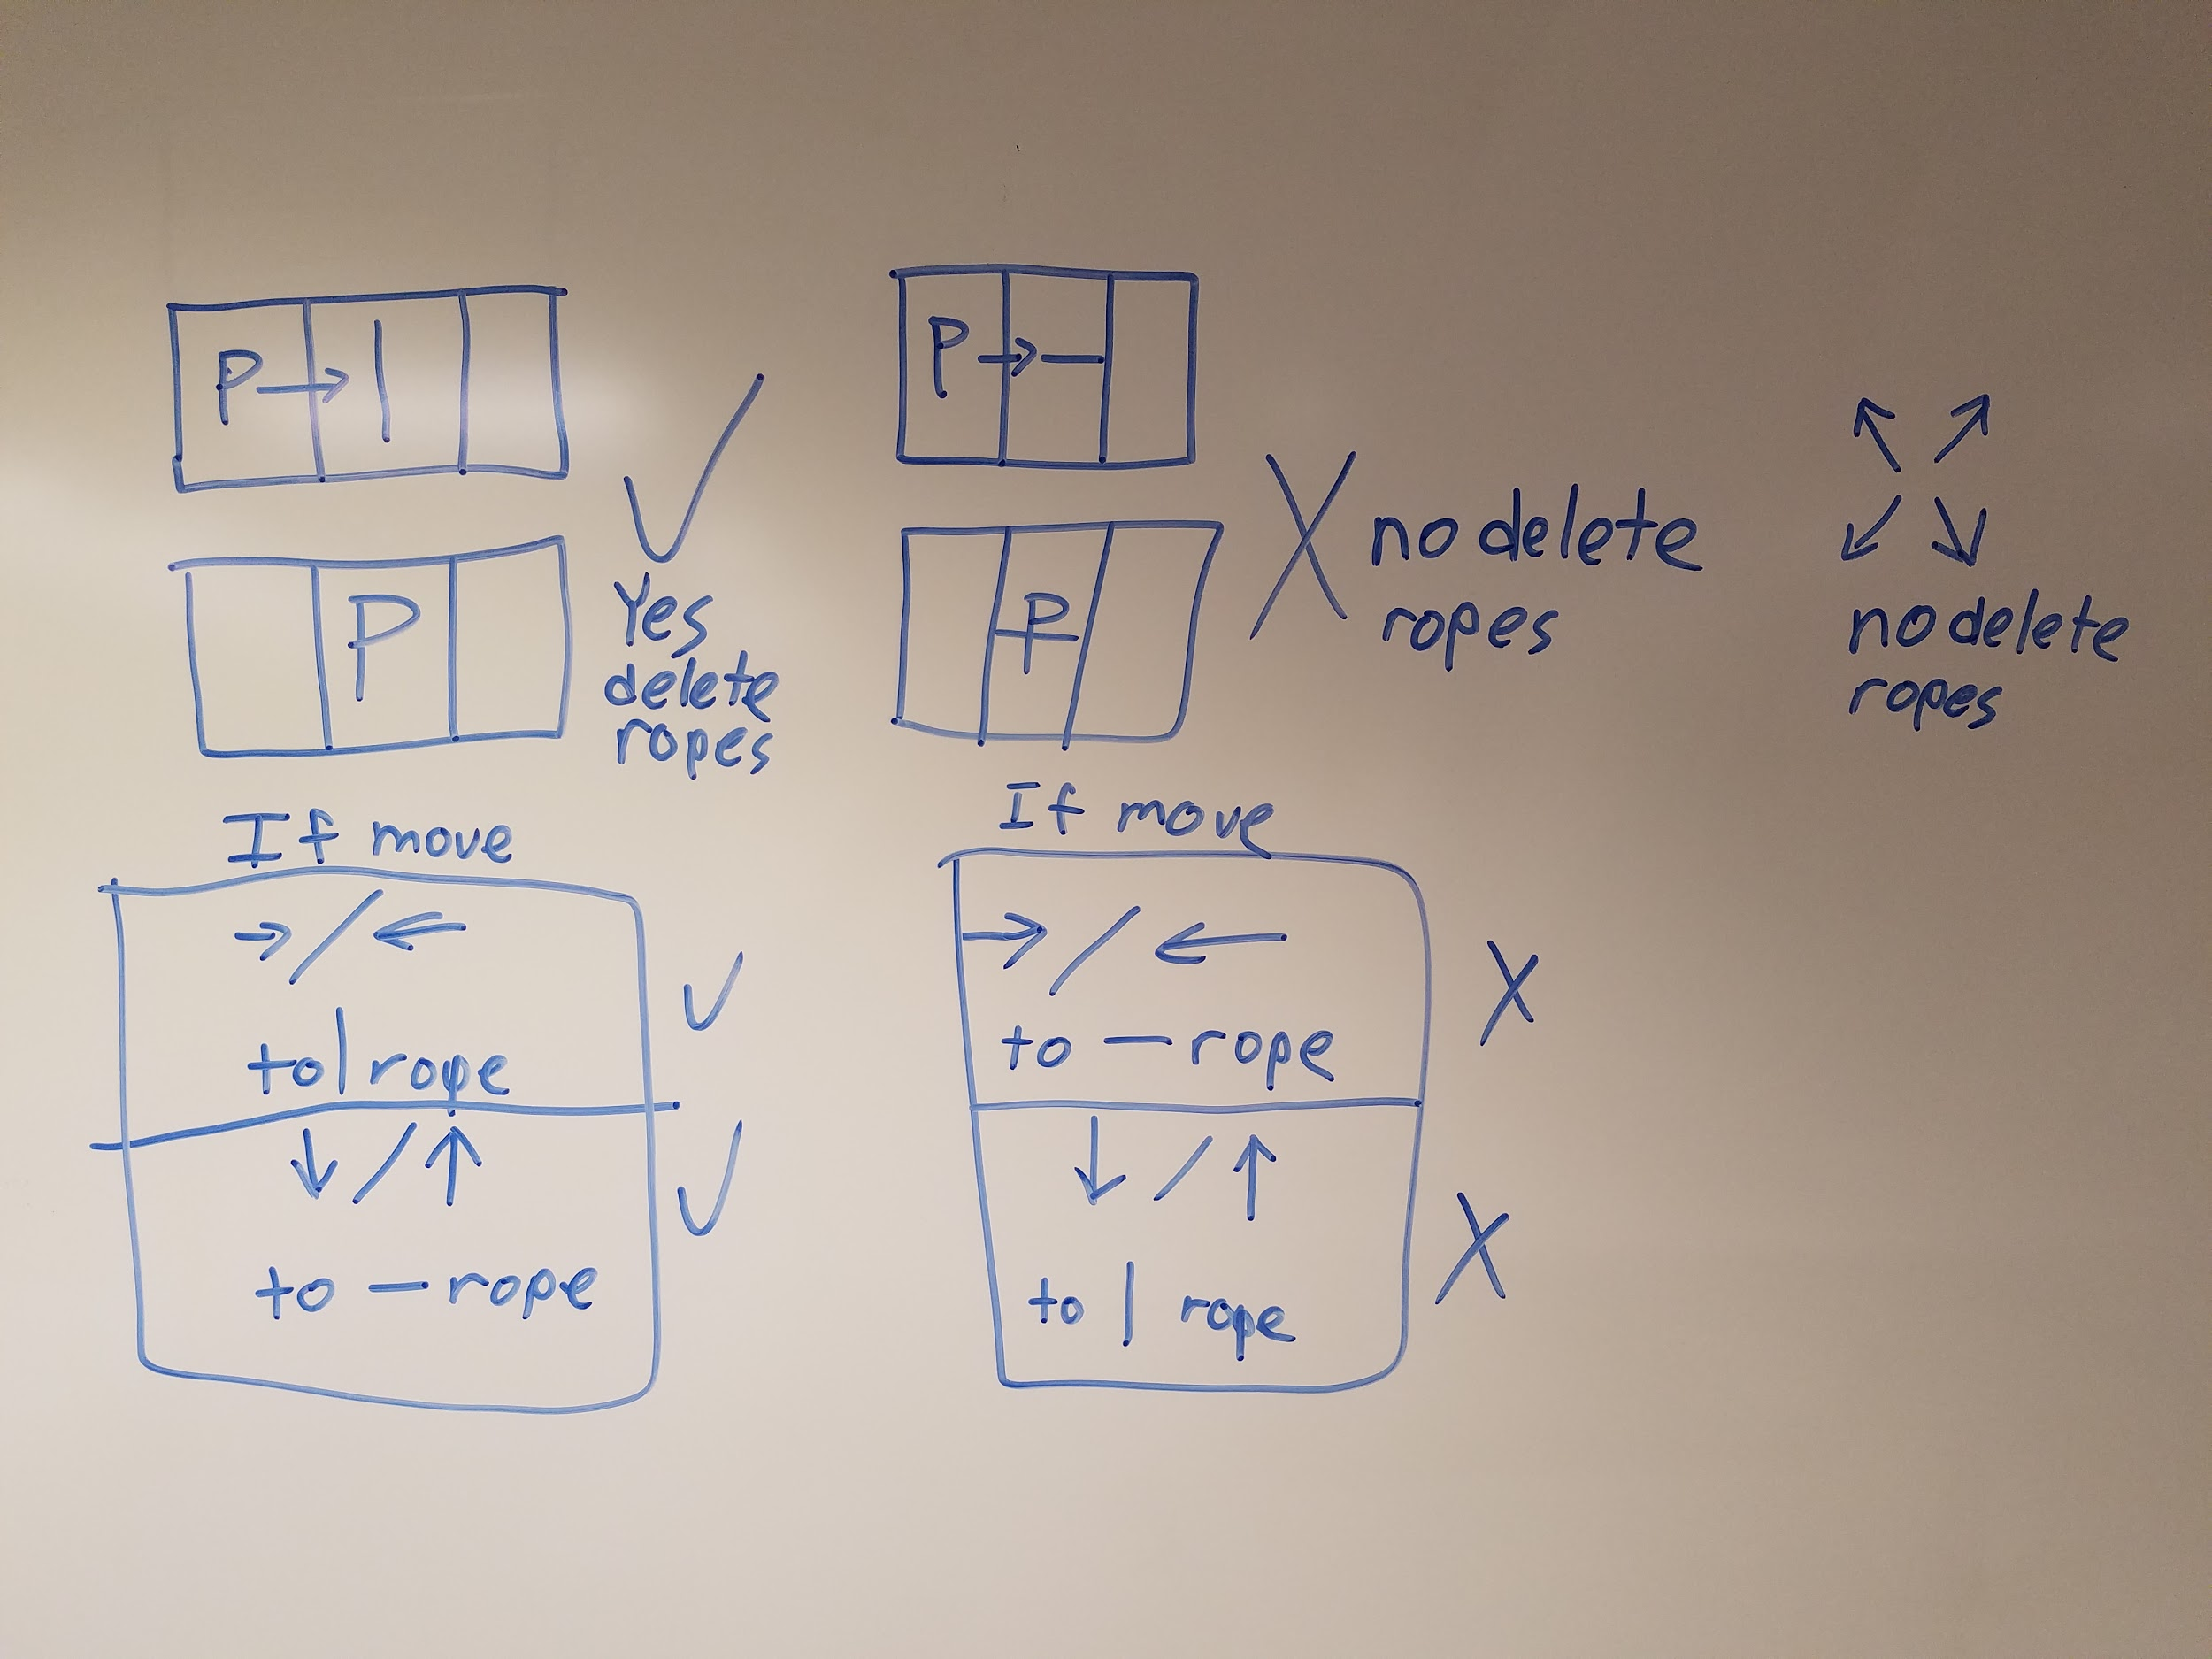

1. **DECISIONS**
2. **Removal**

The Rope class has a removal function that frees the texture and sets all the values to 0.

1. **Conditions**

The movement (up, down, left, right) will determine if a rope (horizontal or vertical) is deleted. When the player moves onto a rope perpendicular to the rope’s angle, the rope is deleted. Diagonal movement does not remove ropes.

1. **TESTING**
   1. **Successful/Unsuccessful Rope Collection**

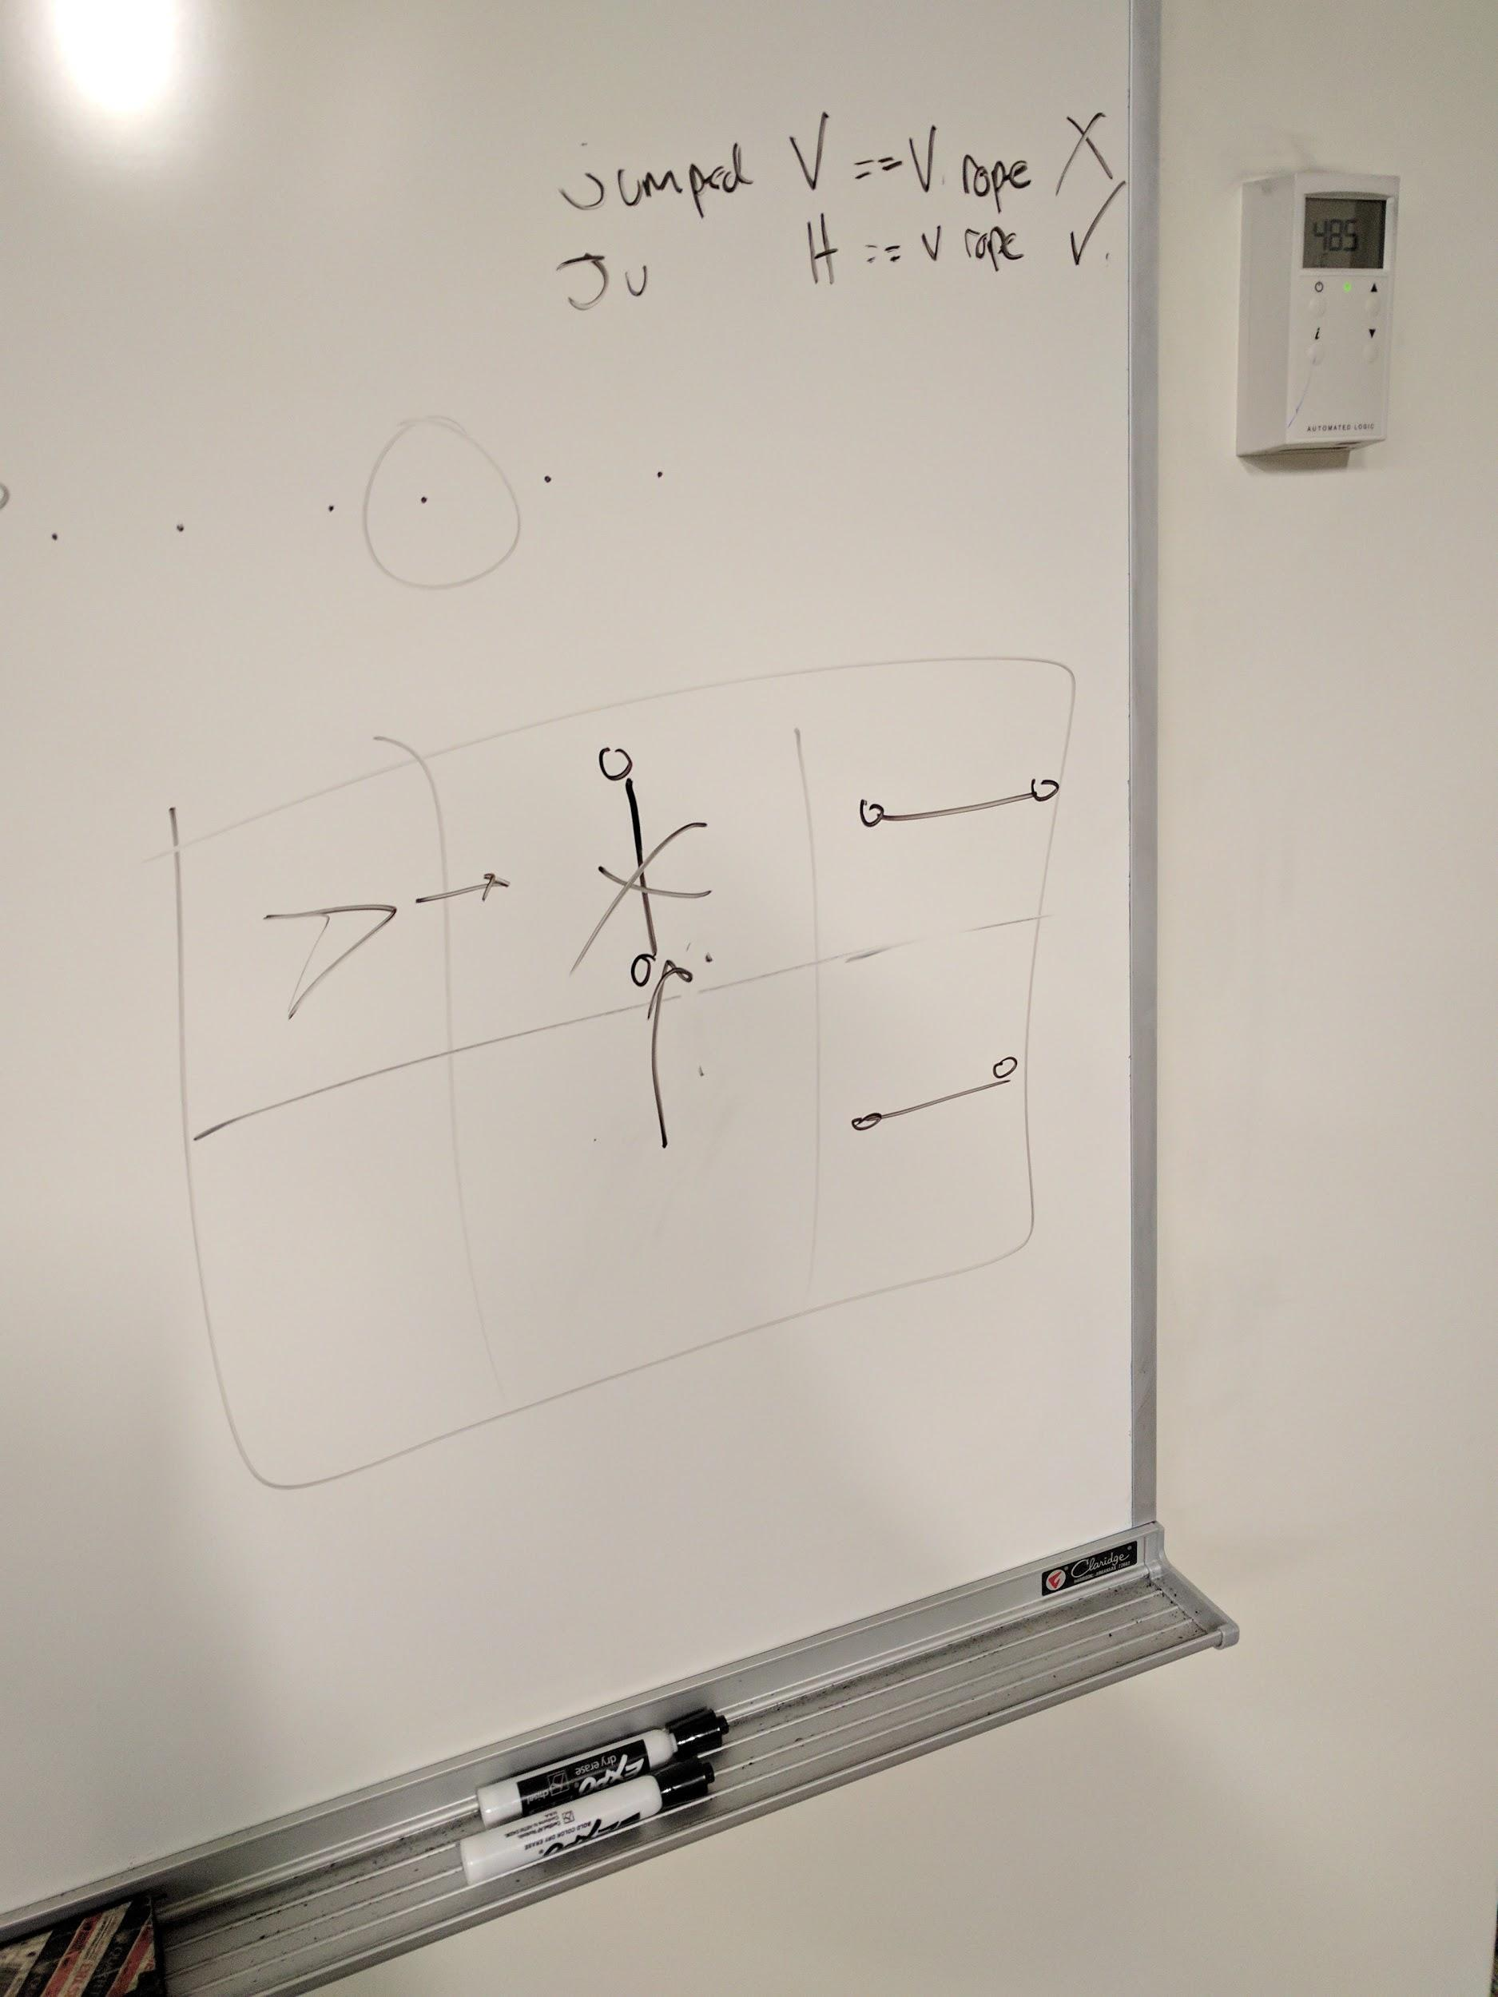

Provides feedback on if the player is conquering ropes. If the player attempts to jump an unconquerable rope, such as a vertical rope, they will receive feedback in the form of an X. If the player attempts to jump a conquerable rope, such as a horizontal or vertical rope, they will receive feedback in the form of a check mark.

1. **ERRORS FOUND WHILE WORKING**