Feature #1: User Movement

Document Established: 04.10.17

1. **INTRODUCTION**
   1. **Purpose**

This feature involves moving the player around the map.

* 1. **Reference Material**

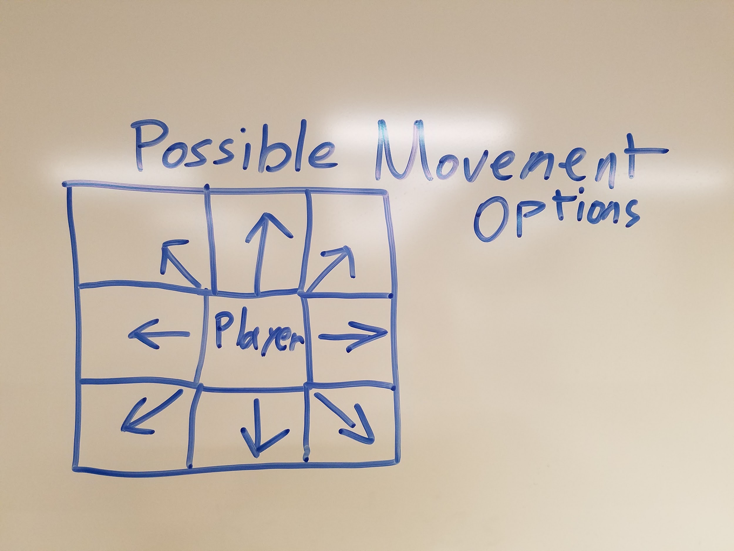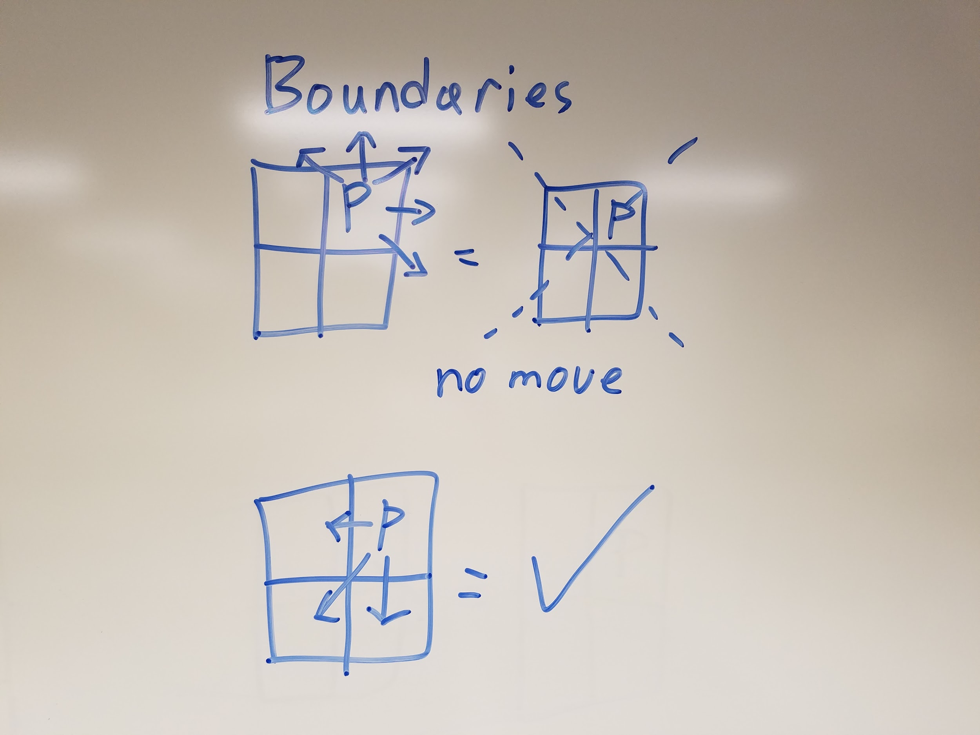

1. **DECISIONS**
2. **Movement**

The player can move around the map in basic cardinal directions (up, down, left, right, and diagonally). When moving diagonally, the player moves vertically then horizontally (this counts as a single movement). The player stays in place if attempting to move off the map. When attempting to move off the bounds of the map, the player will be moved back into the map.

Example: Being to the left most side of the map and attempting to move left again will result in the player’s address re-assigned to the same location.

1. **TESTING**
   1. Keyboard inputs allows movement

UP = (x, -y) -125Y

DOWN = (x, +y) +125Y

LEFT = (-x, y) -125X

RIGHT = (+x, y) +125X

Cannot move outside of array bounds

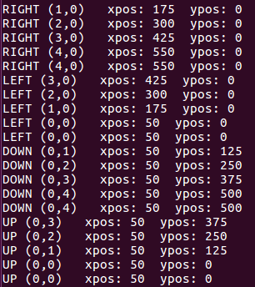

* 1. MiniAT Movement

1. **ERRORS FOUND WHILE WORKING**
   1. n/a