Feature #1: User Movement

1. Testing Logic
   1. What if the player would to try to leave the specified playing field?
   2. Could the player move past 0 in the negative directions? And or could they move past 5 in the positive direction.
2. Testing Parameters
   1. In order to test this we decided to create an assembly file that moves the player 20 steps in every direction. It starts moving in one direction 20 places changes direction and begins to move again. This tests all possible edges. You can see the assembly bellow:

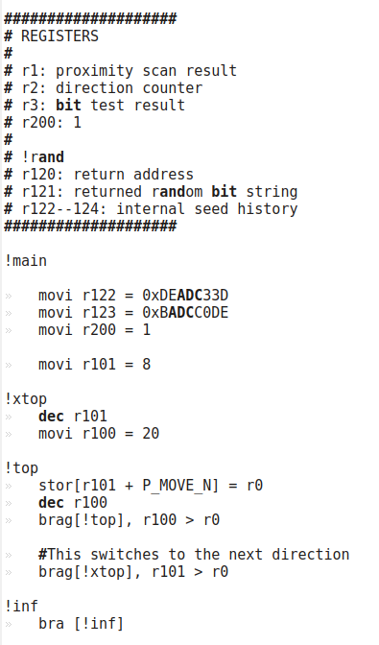

* 1. From here we had our c++ movement system output the x and y coordinates of the player for every change in movement. These x y coordinates were placed in the JumpRopeCity/Testing/Log folder under the name playerMovement.log.
  2. There was also a little python script that was written, this resides in JumpRopeCIty/Testing/Programs tis called BoundsChecking.py. You can see a screenshot bellow. This python script will parse the playerMovement.log file and determine if there was any errors. Producing a different response for correct movement and incorrect movement. You can see the script here:

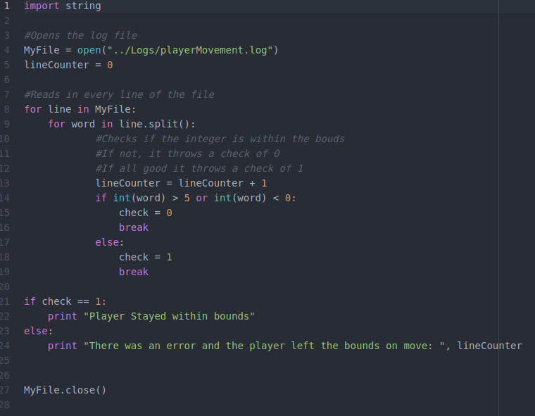

1. Testing Results
   1. From these tests we were able to conclude that the player does in fact stay within the bounds of the player grid. No more testing for this was needed at this point.