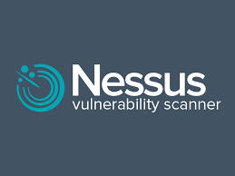











































































































A Quick Intro
To Nessus Scanner
www.linkedin.com/in/alwaysroot

WHAT IS NESSUS VULNERABILITY SCANNER?
Nessus is a vulnerability scanner developed by Tenable that helps identify security weaknesses in computer systems and networks. It detects thousands of known vulnerabilities including software flaws, missing patches, misconfigurations, and malware. Which scans a computer and raises an alert if it discovers any vulnerabilities that malicious hackers could use to gain access to any computer, that you have connected with any network. It does this by running over 1200 checks on a given computer, to see if any of these attacks could be used to break into the computer.

Limitations of the Free Version (Nessus Essentials)
- 16 IP address limit - You can only scan up to 16 hosts.
- Security measures may interrupt Nessus scans, leading to incomplete results.
- Nessus may produce false positives, incorrectly identifying a vulnerability that doesn't exist or false negatives, missing actual vulnerabilities.
- Missing some enterprise level detection capabilities.
- Slower plugin updates compared to paid versions.
- Reports lack some detailed risk ratings and remediation steps.

Nessus installation, setup and scanning a target.
Step 1: Download Nessus Essentials
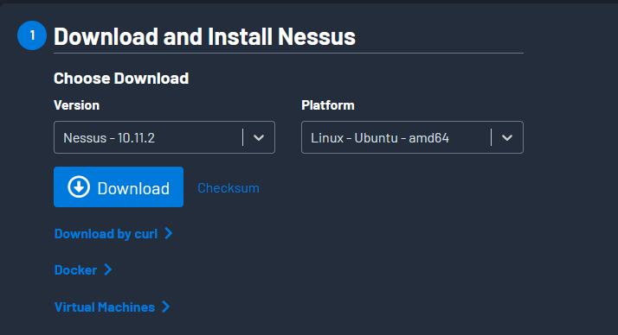
- Go to and choose the OS: https://www.tenable.com/downloads/nessus?loginAttempted=true

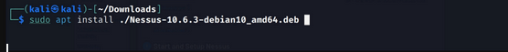
- Install by executing “sudo apt install ./Nessus-xxx.deb” command

- To start the Nessues service execute “sudo systemctl start/status/ nessusd”

- Now open your browser and type “https://localhost:8834”

Step 2: Register for an Activation Code
https://linkedin.com/in/ibrahimkhan-ghalib/

- Go to the following website and fill the form to get a key:
https://www.tenable.com/products/nessus/nessus-essentials
- Copy the challenge code from your Nessus initial setup page
- Copy your activation code as well from your registered email
- Go to “https://plugins.nessus.org/offline.php” and paste both your keys here to generate a license and copy that license and paste that license in Nessus installation page
- Setup USER and PASS for Nessus dashboard
- When activation took place, Goto Setting Update ALL COMPONENTS and PLUGINS manually to make SCAN button active.

Step 3: Create a new scan for a target
- Click "New Scan" in the web interface and select "Basic Network Scan"
- Give your scan a name and targets IP addresses and launch the scan
- When a scan completes all the vulnerabilities are categorized by severity: Critical, High, Medium, Low, Informational and each finding includes descriptions
