Implementation of MergeSort using arrays

Program:

#include <stdio.h>

void merge(int arr[], int left, int middle, int right) {
int i, j, k;
int n1 = middle - left + 1;
int n2 = right - middle;
int L[n1], R[n2];
for (i = 0; i < n1; i++)
L[i] = arr[left + i];
for (j = 0; j < n2; j++)
R[j] = arr[middle + 1 + j];
i = 0;
j = 0;
k = left;
while (i < n1 && j < n2) {
if (L[i] <= R[j]) {
arr[k] = L[i];
i++;
} else {
arr[k] = R[j];
j++;
}
k++;
}
while (i < n1) {
arr[k] = L[i];
i++;
k++;
}
while (j < n2) {
arr[k] = R[j];
j++;
k++;
}
}

void mergeSort(int arr[], int left, int right) {
if (left < right) {
int middle = left + (right - left) / 2;
mergeSort(arr, left, middle);
mergeSort(arr, middle + 1, right);
merge(arr, left, middle, right);
}
}
int main() {
int n;
printf("Enter the number of elements: ");
scanf("%d", &n);
int arr[n];
printf("Enter the array elements:\n ");
for (int i = 0; i < n; i++) {
scanf("%d", &arr[i]);
}

printf("Given array is \n");
for (int i = 0; i < n; i++)
printf("%d ", arr[i]);
printf("\n");
mergeSort(arr, 0, n - 1);
printf("Sorted array is \n");
for (int i = 0; i < n; i++)
printf("%d ", arr[i]);
printf("\n");

return 0;
}

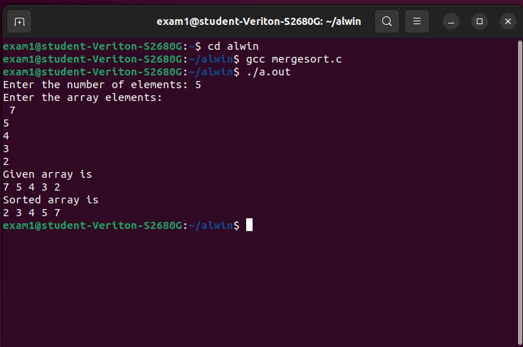
Output:

