Student
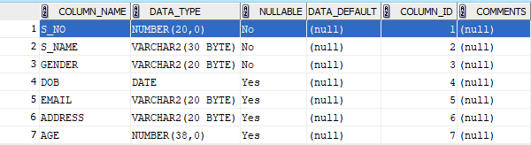

COURSE
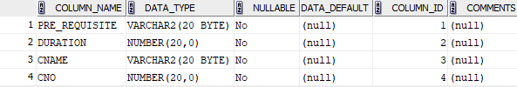

Department
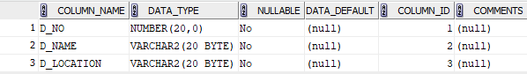

Instructor
