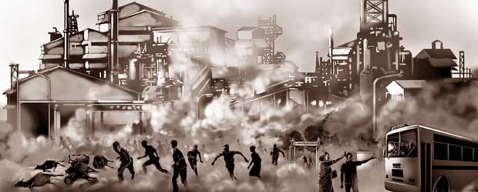

Bhopal Gas Tragedy

Submitted by:
Class: S3 CSE A
Date:

Table of Contents

1.Where and What Happened ? .
2.How it unfolded ?.
3.After effects.
4.KeyIssues
5. Ethical failures
6 learnings.
1.Where and What Happened
The Bhopal Gas Tragedy took place in Bhopal, Madhya Pradesh, India, on the night of December 2nd to 3rd, 1984. It is considered the world’s worst industrial disaster. A toxic gas called methyl isocyanate (MIC) leaked from the pesticide manufacturing plant owned by Union Carbide India Limited (UCIL), a subsidiary of the American company Union Carbide Corporation (UCC). The gas spread quickly across nearby slums and residential areas, exposing hundreds of thousands of people.

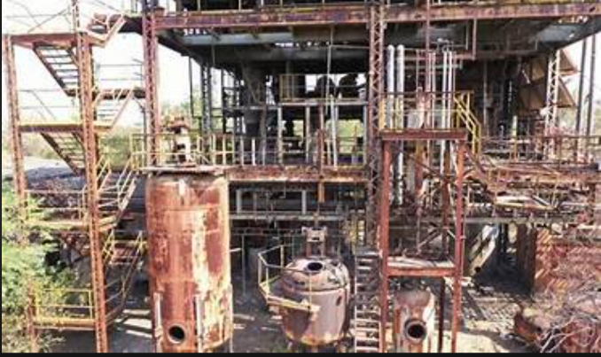
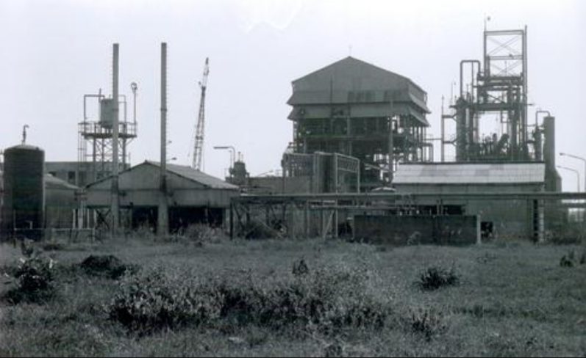
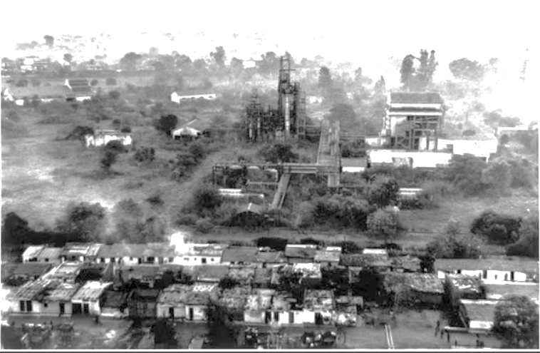

2.How It Unfolded

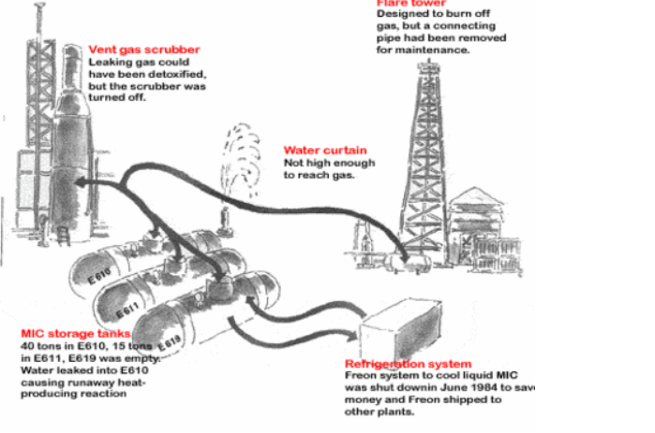
The pesticide plant was used to manufacture a chemical called Sevin, with MIC (Methyl isocynate) as one of the key ingredients. On the night of the disaster, water accidentally entered a tank (Tank 610) containing MIC, triggering a chemical reaction that caused the tank to heat up and build pressure. Due to cost-cutting measures, critical safety systems such as the refrigeration unit, gas scrubber, and flare tower were either turned off or malfunctioning.
As a result, over 40 tonnes of MIC gas escaped into the atmosphere and drifted into nearby neighborhoods. The residents, mostly unaware of what was happening, woke up coughing, choking, and in panic, many dying in their sleep or while fleeing.

After Effects of the Tragedy
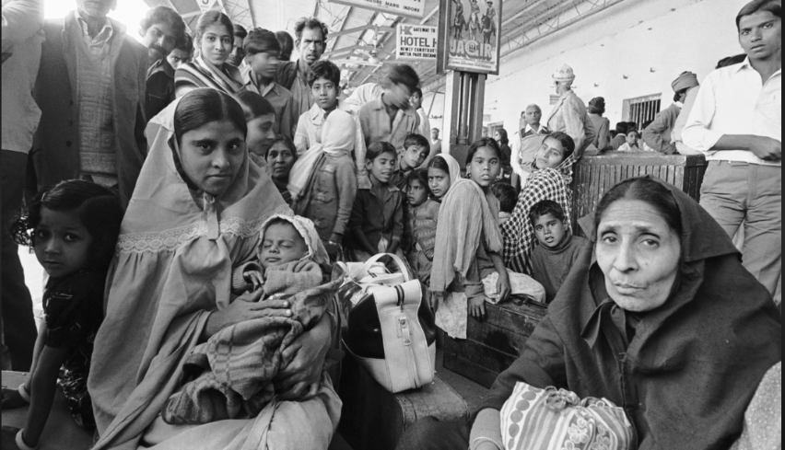
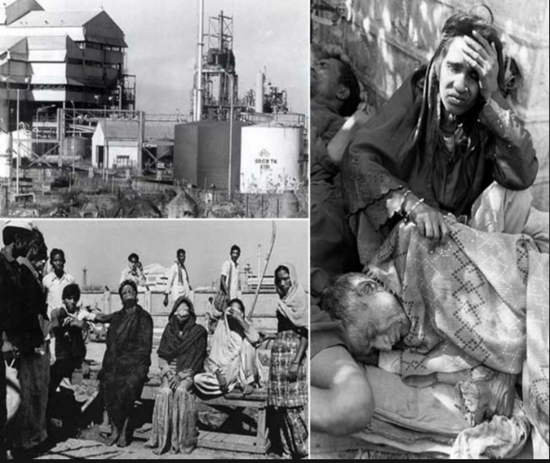

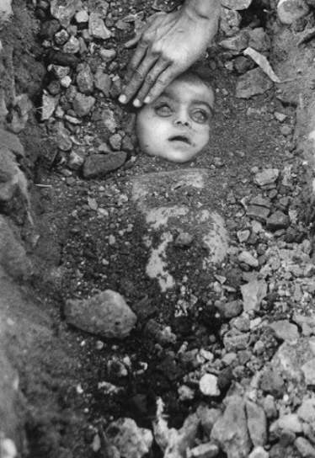
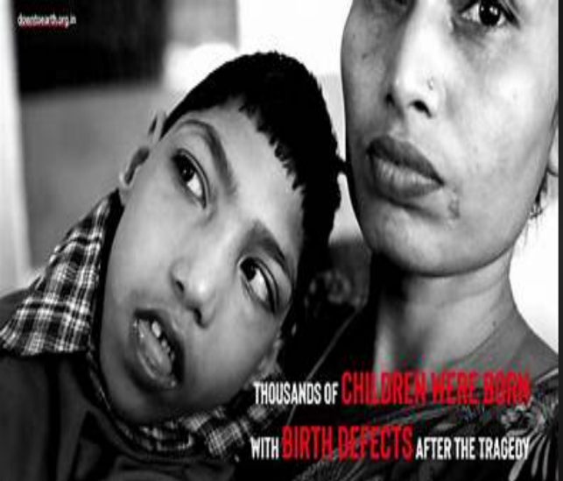
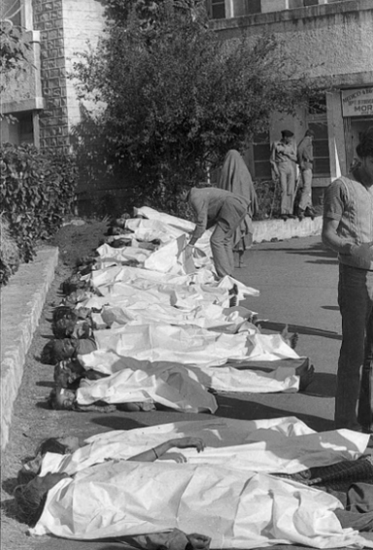
The immediate effects were catastrophic. Thousands of people died within hours, many suffocating due to the poisonous gas. The official death toll was around 3,000, but later estimates suggest that between 15,000 and 25,000 people may have died in total over the years. Over 500,000 people were affected, suffering from severe injuries including blindness, lung damage, and neurological disorders.
Hospitals were overwhelmed. Medical personnel were not trained to deal with chemical exposure on such a large scale, and there was no protocol in place for emergency response

The tragedy had long-lasting impacts. Many survivors continue to suffer from chronic respiratory, gastrointestinal, and reproductive health issues. There were also increased cases of birth defects among children born to affected families.

The site of the disaster remains contaminated even decades later. Toxic waste buried at the site continues to pollute the soil and groundwater, affecting the local population’s health and access to clean water
Ethical Failures

- Corporate Irresponsibility: Union Carbide did not implement global safety standards in its Indian operations.

- Failure to Warn: Local employees and nearby residents were not informed of potential risks or trained for emergencies.

- Lack of Accountability: Union Carbide’s CEO Warren Anderson was arrested but quickly released and never faced trial in India.

- Government Negligence: Indian regulatory bodies failed to monitor and ensure safety compliance.

Learnings and Lessons

The Bhopal Gas Tragedy taught the world the importance of corporate responsibility, safety enforcement, and government oversight. Multinational companies must ensure that their safety protocols are consistent across all countries, regardless of local regulations.

Governments must implement stronger environmental and industrial laws, and cities must keep hazardous industries away from residential zones. There’s also a need to educate and train communities on disaster response and ensure medical systems are prepared for such crises

