MATCH EXPLAINER
System Architecture and Design
Components, data schemas, algorithms, xG model, explanation layer and repository layout
Field | Value
Document ID | MX-03
Project | Match Explainer (working title)
Version | 1.0 (baseline)
Date | 25 October 2026
Status | Draft for feasibility review
Audience | Project owner, evaluators, AI coding agents (Claude Code / Codex)

Contents
1. Architectural principles
2. System context and structure
3. Technology stack
4. Pipeline components
5. Data design and JSON schemas
6. Algorithms and formulas
7. xG model design
8. Explanation layer (LLM and templates)
9. Web application design
10. Repository layout and configuration
11. Build, run and deployment
12. Error handling and fallbacks
13. Security, privacy and licensing
14. Design decisions and alternatives

1. Architectural principles
Principle | Meaning | Why
Static-first | All heavy work happens offline; the website only reads JSON | Demo cannot fail from network or server problems
Files as interfaces | Every pipeline stage reads and writes plain files | Easy to test, cache, inspect and hand to an AI agent
Facts before words | Text is generated only from structured facts and validated | Prevents hallucinated football claims
Honest ML | No leakage; benchmarks and limits published | Credibility in evaluation
Coordinate-agnostic UI | Pitch and replay components take lists of (x, y) points | Reusable for the future video pipeline
Small and boring | Plain Python and vanilla JS; no frameworks needed | Fewer failure points in one day

2. System context and structure
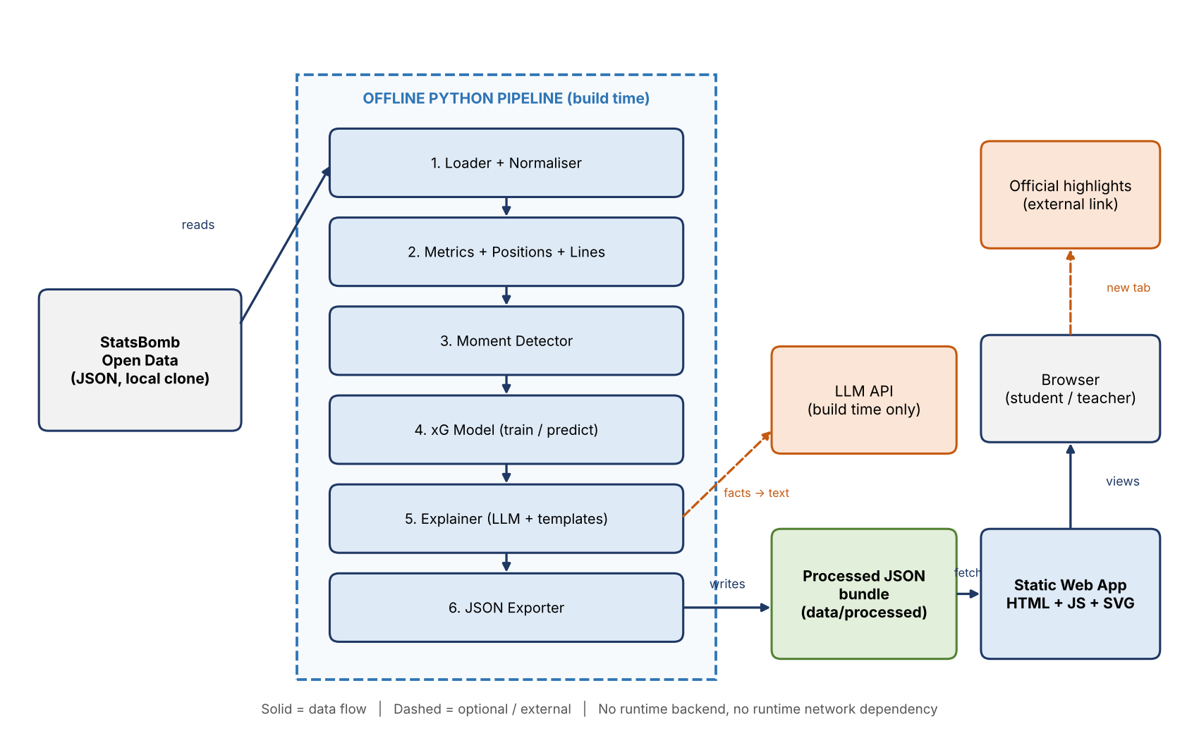
Figure 1. Logical architecture. The offline pipeline consumes StatsBomb JSON and writes a processed bundle. The static web app fetches the bundle. The LLM is used only at build time. The external highlights link is optional.
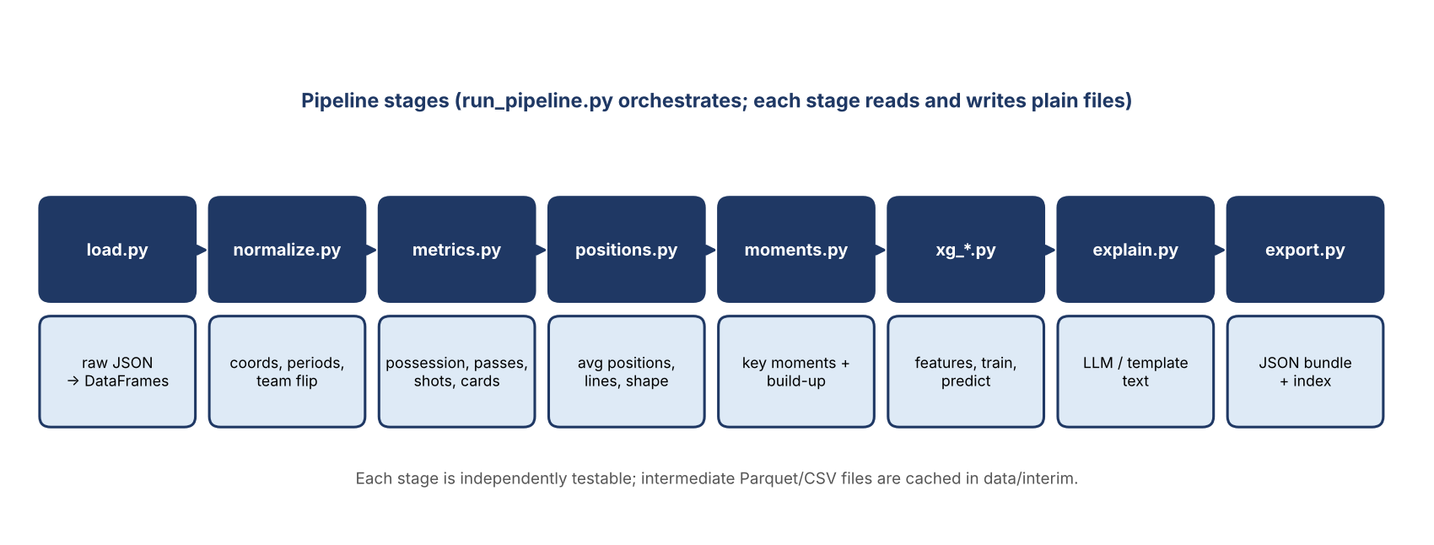
Figure 2. Pipeline stages and module names. Orchestrated by run_pipeline.py.

3. Technology stack
Layer | Choice | Reason
Language (pipeline) | Python 3.10+ | Data and ML ecosystem
Data handling | pandas, numpy; read raw JSON directly with json | No network or API wrapper needed
ML | scikit-learn (LogisticRegression, HistGradientBoostingClassifier); optional xgboost | Stable, fast, calibration tools included
Persistence | joblib for model; JSON for outputs; Parquet or CSV for interim tables | Simple and portable
Plots (offline) | matplotlib (calibration plot, optional figures) | Standard
LLM (optional) | Anthropic SDK via environment key; model name read from config | Build-time only; swappable
Tests | pytest | Standard
Web app | HTML5, CSS, vanilla JavaScript (ES modules), SVG | No build step; works from any static host
Dev server | python -m http.server | Needed because fetch is blocked on file://
Hosting | GitHub Pages (or Netlify, Vercel static) | Free, matches portfolio goal
Automation | Makefile (or tasks.py on Windows) | One-command rebuild

4. Pipeline components
Module | Responsibility | Input | Output
config.py | Paths, thresholds, competition list, match id, LLM settings (from config/*.json and env) | config files | Config object
load.py | Read competitions, matches, lineups, events, 360 for a match; validate | raw JSON | DataFrames in memory
normalize.py | Flatten nested fields, add period/time columns, coordinate helpers, mirror, exclude period 5 | DataFrames | Clean events table
metrics.py | Possession, passes, shots, cards, fouls, corners; team stats | Clean events | summary.json part
positions.py | Average positions, lines, shape metrics per window | Events, lineups | positions.json
moments.py | Detect key moments, extract build-up, attach 360 snapshots | Events, 360, xG | moments.json part
xg_features.py | Feature engineering for shots (training and prediction) | Shot rows (+ freeze frame) | Feature matrix
xg_train.py | Train, validate, evaluate, save model and metrics | Many matches' shots | models/*
xg_predict.py | Predict xG for the demo match; penalties fixed rate | Model, shots | shots.json
network.py, momentum.py | Optional pass network and rolling xG | Events, xG | network.json, momentum.json
explain.py | Build prompts from facts, call LLM, validate, cache; or use templates | Facts | Text fields in JSON
validate.py | Text validation and JSON Schema validation of outputs | Outputs | Pass or error
export.py | Assemble the final bundle and index.json | All parts | data/processed/<match_id>/*
run_pipeline.py | CLI orchestration, logging, flags (--no-llm, --skip-train) | CLI args | Complete bundle

5. Data design and JSON schemas

5.1 Pitch coordinate frame
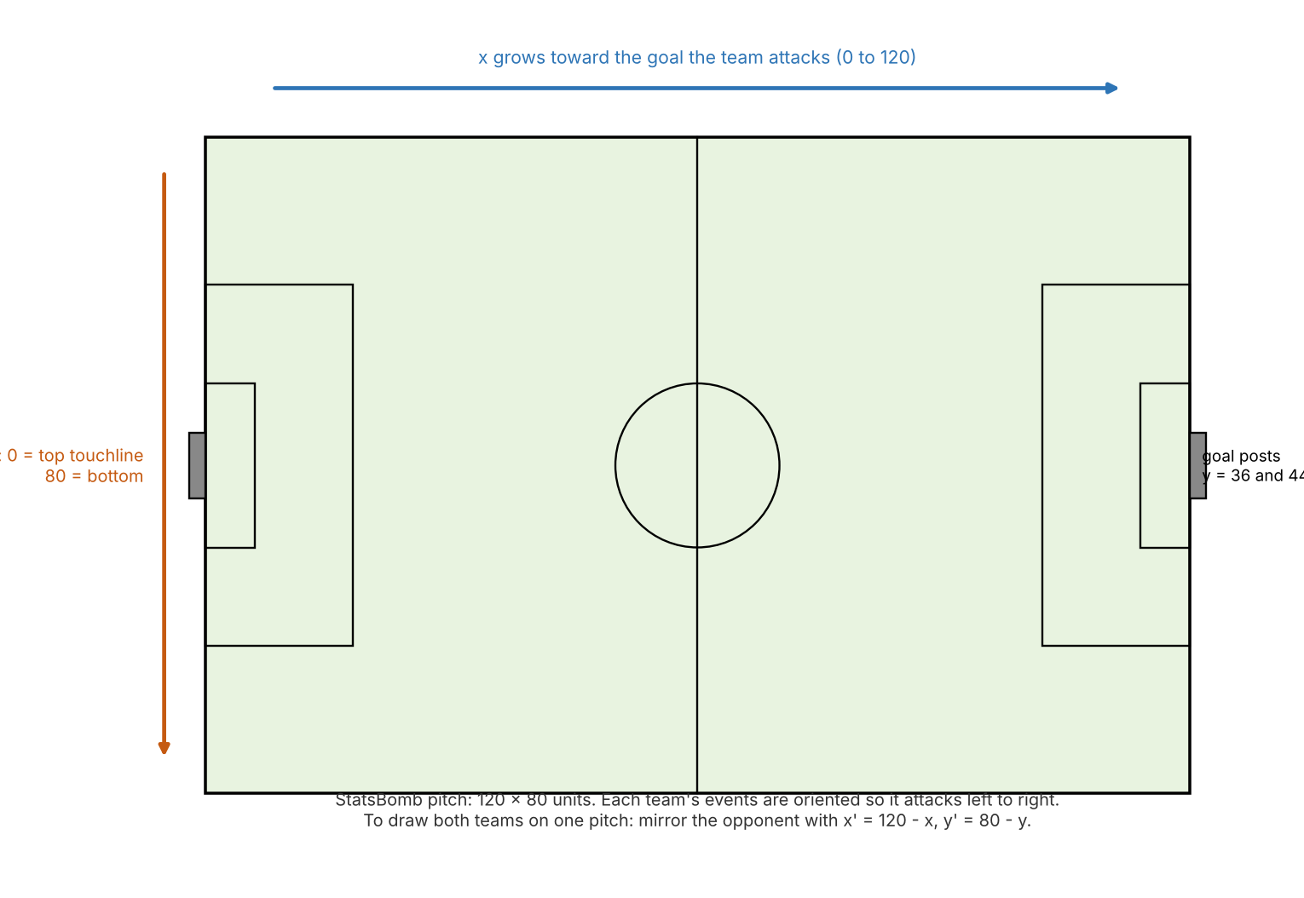
Figure 3. StatsBomb coordinate frame. All stored coordinates keep this frame. The web app draws the pitch in a 120 x 80 SVG viewBox so no scaling math is needed. The opponent is mirrored at export time for the two-team pitch view.

5.2 Key event fields and how they are used
Field | Use
period, minute, second, timestamp | Ordering, minute slider, moment time. Period 1 and 2 regulation, 3 and 4 extra time, 5 shootout (excluded).
type.name | Pass, Carry, Shot, Ball Receipt*, Dribble, Duel, Foul Committed, Bad Behaviour, Substitution
possession, possession_team | Group events into possession sequences; possession time; build-up extraction
location [x, y] | Positions, shot features, replay start points
pass.end_location, carry.end_location | Replay arrows
shot.* | xG features and labels (outcome.name == "Goal"); statsbomb_xg for benchmark only
shot.freeze_frame | Shot-time defender and goalkeeper features (when present)
foul_committed.card, bad_behaviour.card | Red card and second-yellow detection

5.3 Output schemas (informal; formal JSON Schema files live in `schemas/`)

summary.json
{
"match_id": 3869685,
"competition": "FIFA World Cup", "season": "2022", "date": "2022-12-18",
"teams": {"home": {"id": "<team_id>", "name": "Argentina", "color": "#2E75B6"},
"away": {"id": "<team_id>", "name": "France", "color": "#C55A11"}},
"score": {"home": 3, "away": 3, "shootout": {"home": 4, "away": 2}},
"possession": {"method": "sum of possession-sequence duration", "home": 0.0, "away": 0.0},
"stats": {"home": {"shots": 0, "on_target": 0, "passes": 0, "passes_completed": 0,
"xg_model": 0.0, "xg_statsbomb": 0.0, "fouls": 0, "corners": 0,
"yellow": 0, "red": 0}, "away": {}},
"story": {"text": "...", "label": "Automated analysis"}
}

positions.json
{
"windows": [{"id": "full", "label": "Full match", "start": 0, "end": 120},
{"id": "p1", "label": "First half", "start": 0, "end": 45},
{"id": "m15_30", "label": "15-30 min", "start": 15, "end": 30}],
"data": {"full": {"home": {"players": [{"id": 5503, "name": "...", "role": "DEF", "x": 41.2, "y": 22.0, "n": 38}],
"lines": {"def": 38.5, "mid": 61.0, "att": 82.4},
"shape": {"length": 43.9, "width": 52.1, "compact": 0.66, "label": "mid block"}},
"away": {}}}
}

Away-team coordinates are stored already mirrored (drawing frame) with a field frame: "mirrored". Line values are measured from the team's own goal line along its attacking direction, in pitch units.

moments.json
{
"moments": [{
"id": "m01", "type": "goal", "period": 1, "minute": 23, "second": 4,
"team": "home", "player": "...", "xg_model": 0.78, "xg_statsbomb": 0.78,
"sequence": [{"kind": "pass", "from": [x, y], "to": [x, y], "player": "...", "recipient": "...", "t": 0.0, "outcome": "Complete"},
{"kind": "carry", "from": [x, y], "to": [x, y], "player": "...", "t": 2.1},
{"kind": "shot", "from": [x, y], "to": [120, 41.2], "player": "...", "t": 4.0}],
"snapshots": {"key_pass": {"players": [{"x": 0, "y": 0, "role": "attacker|defender|keeper"}], "offside_line_x": 96.5},
"shot": {"players": [], "offside_line_x": null}},
"facts": {"sequence_len": 5, "duration_s": 9.2, "defensive_line_height": 41.0, "gap_to_line": 6.5, "play_pattern": "Regular Play"},
"explanation": {"text": "...", "why": "...", "source": "llm|template", "label": "Automated analysis"},
"highlights_url": null
}]
}

shots.json
{"shots": [{"id": "uuid", "minute": 12, "team": "home", "player": "...", "x": 108.0, "y": 36.0,
"xg_model": 0.12, "xg_statsbomb": 0.10, "outcome": "Saved", "body_part": "Right Foot", "is_penalty": false}]}

6. Algorithms and formulas

6.1 Possession percent
For each possession id, duration = timestamp of last event minus timestamp of first event in that possession (same period). Team possession = sum of durations of possessions owned by the team divided by the sum for both teams. Shootout excluded. The method string is stored and displayed (FR-M4).

6.2 Average positions
- Filter events in the window with a location, an actor player and event types that represent the player on the ball (Pass, Carry, Shot, Ball Receipt*, Dribble, Duel, Interception, Clearance).
- Per player: mean x and mean y; keep n (sample count). Drop players with n below 5 in short windows.
- Assign role group from lineup position name: GK (Goalkeeper), DEF (Centre/Left/Right Back, Wing Back), MID (Defensive, Central, Attacking, Left/Right Midfield), ATT (Wing, Centre Forward, Second Striker). For a player with several positions use the most frequent within the window.
- Mirror the away team for drawing (x' = 120 - x, y' = 80 - y).

6.3 Lines and shape
- Line height per group = mean x of that group's outfield players, measured from the team's own goal (x as stored for the team).
- Team length = line height of ATT minus line height of DEF. Width = (maximum minus minimum y) of outfield average positions.
- Compactness = 1 minus team length divided by 80, clipped to [0, 1] (higher is more compact).
- Block label from DEF line height: below 35 "low block", 35 to 48 "mid block", above 48 "high line". Thresholds live in config and are tuned on the demo match.
- Cross-check: 1-D k-means with k = 3 on outfield average x should agree with role-based grouping for at least 80 percent of players; disagreements are logged, not shown.

6.4 Key moment detection
- Candidates: shots with outcome Goal; shots with xG at or above moment_xg_threshold (default 0.15); penalties; red cards (card name "Red Card" or "Second Yellow"); optional substitutions.
- Remove shootout shots. Score = goal 100, penalty 80, red card 70, xG times 100 for other shots.
- Sort by score, greedily keep moments so that any two are at least min_gap_s apart (default 60 s), up to max_moments (default 10); always keep all goals.
- Re-sort chronologically.

6.5 Build-up extraction
- Take events with the same possession id as the shot and index below the shot.
- Keep types Pass, Carry, Dribble, Ball Receipt* (receipts used only to confirm recipients, not drawn).
- Keep the last 12 actions or those within 20 s of the shot, whichever is fewer. The last Pass before the shot is the key pass.
- Convert to steps: pass = (location to pass.end_location); carry = (location to carry.end_location); shot = (location to shot.end_location x, y, clamp to goal mouth when missing).
- Step timing t = event timestamp minus first step timestamp (seconds).

6.6 360 snapshots and offside line
- Look up the 360 record by event_uuid equal to the event id for the key pass and for the shot.
- Colour: actor or teammate true = attackers (the event's team); teammate false and not keeper = defenders; keeper flagged.
- Offside line x = maximum x among defending outfield players visible (attackers move toward x = 120). Gap = line x minus the receiver's x when known.
- The UI states "visible players only" because broadcast framing hides some players.

6.7 Replay animation model
- Each step gets a display duration = clamp(real duration x compression, 0.6 s, 2.0 s); default compression 0.35.
- The ball marker moves linearly along each step (ease-in-out optional). Arrows are added to the SVG as steps complete; carries are dashed; the shot arrow uses the accent colour.
- Controls: play, pause, restart, speed 0.5x and 1x, scrubber maps progress 0 to 1 to the step timeline.
- Implementation uses requestAnimationFrame; reduced-motion mode renders all steps statically with numbers.

6.8 Pass network and momentum (optional)
- Nodes: starting XI average positions until the first substitution; size proportional to completed passes made. Edges: pairs with at least 3 completed passes in either direction; width proportional to count.
- Momentum: for each minute, sum xG per team over the trailing 5 minutes; plot difference as a two-sided area.

7. xG model design

7.1 Problem statement
Binary classification: given information available at the moment of a non-penalty shot, predict P(goal). Output is a probability in [0, 1].

7.2 Data
- Source: StatsBomb events for the competitions in config/train_competitions.json (suggested: several league seasons, European and women's competitions, World Cup 2018, Euro 2020) excluding FIFA World Cup 2022.
- Exclusions: penalties (shot.type.name == "Penalty"), own goals, shootout (period 5), shots with missing location.
- Label: shot.outcome.name == "Goal".
- Expected size: tens of thousands of shots with a class imbalance of roughly 10 percent goals; exact counts are logged and written to the metrics file.

7.3 Features (pre-shot only)
Feature | Definition
dist | Euclidean distance from (x, y) to goal centre (120, 40)
angle | Angle subtended by the posts: atan2(8 x dx, dx² + dy² - 16) where dx = 120 - x, dy = y - 40 (8 = goal width, 16 = (8/2)²); clipped to [0, pi]
x, y_abs | Distance from goal line and absolute lateral offset from the centre line
body_part | One-hot: right foot, left foot, head, other
technique | One-hot: normal, volley, half volley, lob, overhead, backheel, etc.
play_pattern | Regular play, from corner, from free kick, from throw-in, counter, etc.
under_pressure, first_time | Booleans from the event (missing treated as false)
is_open_goal | Derived from freeze-frame when present
gk_dist, gk_off_centre | Goalkeeper distance to shooter and lateral offset (freeze-frame only; imputed with indicator when absent)
n_def_in_cone, nearest_def_dist | Defenders inside the triangle shooter-to-posts and distance to nearest defender (freeze-frame only; imputed with indicator when absent)
has_ff | Indicator that a freeze-frame was available

Leakage guard: forbidden features are shot.outcome, shot.end_location, shot.statsbomb_xg, shot.key_pass_id outcome fields, and any column derived from them. A unit test fails the build if any forbidden name appears in the feature list.

7.4 Training and validation
- Split by competition-season: hold out one or two competition-seasons as the test set; use group k-fold (by match) on the rest for tuning. Random shot-level splits are forbidden because shots in one match are correlated.
- Baselines: (a) constant mean rate; (b) logistic regression on dist and angle only.
- Models: logistic regression with all features (standardised numerics); HistGradientBoostingClassifier with small depth and early stopping. Optional isotonic or sigmoid calibration fitted on validation folds.
- Selection metric: validation log loss. Seeds fixed.

7.5 Evaluation outputs
Metric | Purpose
Log loss and Brier score | Quality of probabilities (lower better)
ROC AUC | Ranking quality
Calibration curve (10 bins) and expected calibration error | Does 0.3 mean 30 percent?
Comparison with StatsBomb xG on the same test shots | Benchmark: aim to be close, not to beat a richer proprietary model
Feature importance (permutation) or SHAP for the best model | Explainability on the model card
Total xG versus actual goals on the test set | Sanity check on bias

Expected honest outcome: the full-feature model clearly beats the distance-angle baseline on log loss and lands somewhat behind StatsBomb's own xG. Report whatever the numbers are.

7.6 Penalties and edge cases
- Penalty xG = penalty conversion rate in the training data (about 0.75 to 0.80), stored with its count.
- Missing freeze-frame: use has_ff = 0 and imputed values; model card reports performance by has_ff group.

7.7 Artefacts
- models/xg_model.joblib (pipeline including preprocessing).
- models/xg_metrics.json (counts, splits, all metrics, feature list, seeds, library versions, date).
- models/xg_calibration.png.
- The web model card page renders from the metrics file.

8. Explanation layer (LLM and templates)

8.1 Flow
- Build a facts object per moment (numbers, names, minutes, line heights, gap, sequence length, xG, play pattern).
- Render a prompt from prompts/moment.txt with the facts as JSON.
- Call the LLM (temperature low). Parse a JSON reply: text (2 to 3 sentences) and why (1 sentence).
- Validate with validate.py: every capitalised name must be in the facts; every minute or number mentioned must equal a fact value; length limits; banned phrases (certainty about intent, claims about marking).
- On failure retry once with a stricter reminder, then use the template.
- Write result with source = llm or template and cache by a hash of facts plus prompt version.

8.2 Prompt contract (moment)
SYSTEM: You explain football to complete beginners. Use only the facts provided.
Never invent names, minutes, numbers or tactics not supported by the facts.
Avoid jargon; if you use a term (xG, high line, build-up), explain it in a few words.
Return JSON: {"text": "<2-3 sentences>", "why": "<1 sentence on why it worked>"}.

USER: facts = {{facts_json}}

8.3 Templates (fallback)
Deterministic sentences with slots, chosen by moment type and thresholds, for example: "In minute {minute}, {player} scored for {team} after a {sequence_len}-pass move. The chance was worth {xg:.2f} xG, which means roughly {xg_in_ten} in 10 shots like this are goals." The "why" line is picked from rules: gap to defensive line above 5 units gives "the defence was stretched, leaving space behind the line"; play pattern counter gives "the attack started from a quick counter".

8.4 Settings
- ANTHROPIC_API_KEY from environment; LLM_MODEL from config (not hard-coded in code); --no-llm flag forces templates.
- Cache file data/interim/llm_cache.json is committed only for the demo match so the project rebuilds without a key.

9. Web application design

9.1 Structure
web/
index.html single page, hash routing (#summary, #pitch, #moments, #shots, #model, #glossary)
css/style.css tokens (colours, spacing), layout, focus styles
js/app.js bootstrap, router, state, data loader
js/summary.js stat cards, tooltips, story
js/pitch.js SVG pitch factory, positions, lines, slider
js/replay.js replay engine (steps, timeline, controls, snapshots)
js/shots.js shot map, momentum graph
js/network.js pass network (optional)
js/model.js model card renderer
js/glossary.js glossary data and tooltip helper
data/ copy or symlink of data/processed
assets/ logo, favicon, fonts (local only)

9.2 State and data flow
- Single state object: matchId, window, team, momentId, playing, speed, progress.
- Loader fetches index.json, then the five match files lazily per tab; results cached in memory.
- Pure render functions take data and state and return SVG or DOM; no framework.

9.3 Visual design
- Colour tokens: navy #1F3864 for text and headers, team colours blue #2E75B6 and orange #C55A11 (colour-blind safe pair), pitch green #E8F3E0 with dark lines.
- Always pair colour with shape or label (home circles, away squares).
- Layout: top nav; Moments uses two columns (list 30 percent, replay 70 percent); mobile stacks.
- Every statistic label has a dotted underline and tooltip on hover or focus.

9.4 Accessibility
- Controls are <button> elements with aria-label; scrubber is <input type="range">.
- SVG has role="img" with a text alternative describing the moment; the step list is also available as plain text.
- Visible focus ring; no keyboard traps; honour prefers-reduced-motion.

10. Repository layout and configuration
match-explainer/
README.md CLAUDE.md AGENTS.md LICENSE Makefile requirements.txt .gitignore
docs/ MX-01 to MX-04 (.docx) and exported figures
config/
default.json thresholds, window sizes, caps, paths
train_competitions.json list of {competition_id, season_id} used for training
schemas/ JSON Schema files for each output
prompts/ moment.txt, story.txt, team.txt
pipeline/ modules listed in Section 4
models/ xg_model.joblib, xg_metrics.json, xg_calibration.png
data/
raw/ NOT committed (StatsBomb clone or subset)
interim/ NOT committed except llm_cache.json for the demo match
processed/<match_id>/ committed for the demo match only
web/ static site (Section 9)
tests/ pytest files and small fixtures (first 200 events of one match)
scripts/ fetch_data.sh/.ps1, verify_ids.py

10.1 Configuration keys (config/default.json)
Key | Default | Meaning
raw_dir | data/raw/open-data/data | Location of StatsBomb data folder
match_id | 3869685 | Demo match
window_minutes | 15 | Default slider window
moment_xg_threshold | 0.15 | Minimum xG for non-goal shot moments
max_moments, min_gap_s | 10, 60 | Moment cap and spacing
block_thresholds | [35, 48] | Low / mid / high line boundaries
replay_compression | 0.35 | Real time to animation time ratio
llm_model | set by owner | Model name for explanations
seed | 42 | Random seed

11. Build, run and deployment
# one-time setup
git clone --depth 1 https://github.com/statsbomb/open-data data/raw/open-data
python -m venv .venv && . .venv/bin/activate # Windows: .venv\Scripts\activate
pip install -r requirements.txt
python scripts/verify_ids.py # asserts ids, files, 360 availability

# build
python -m pipeline.xg_train # trains and writes models/
python -m pipeline.run_pipeline --match-id 3869685 # writes data/processed/3869685/
pytest -q

# run
python -m http.server -d web 8000 # open http://localhost:8000

Deployment: publish the web/ folder (with data/ copied inside) to GitHub Pages. The processed demo bundle is small enough to commit. Raw data and interim files stay out of the repository.

12. Error handling and fallbacks
Failure | Behaviour
Raw data path missing | Pipeline stops with instructions to run scripts/fetch_data.sh
360 file missing for a match | Pipeline continues; snapshots empty; UI hides snapshot panel
Unexpected null in a field | Row skipped with a counted warning; totals reported at end of run
LLM error, timeout or validation failure | Template text used; source: "template" stored
Model file missing | Pipeline falls back to shot.statsbomb_xg for display only and flags it in the UI
JSON fetch fails in browser | Friendly message naming the file; suggests running the dev server
Animation error | Static step list shown

13. Security, privacy and licensing
- No secrets committed; .env ignored; the API key is read only by the pipeline.
- The site is static and collects no personal data, sets no cookies and loads no third-party scripts or fonts.
- StatsBomb: keep the attribution line "Data provided by StatsBomb" with a link in the footer and README; follow the licence file in the data repository.
- No broadcast video is stored, embedded or re-hosted; highlight links open the official source in a new tab.
- Generated text is labelled "Automated analysis" and the model card lists limitations.

14. Design decisions and alternatives
Decision | Alternative | Why this choice
Offline pipeline plus static site | Flask or FastAPI backend | No server to fail on demo day; free hosting
Vanilla JS and SVG | React, D3 | No build tooling; faster for a one-day build; easy for agents to edit
Read raw JSON directly | statsbombpy | Offline, no API surprises, full control of fields
Role-based lines with k-means cross-check | Pure clustering | Stable and explainable; clustering alone is noisy with sparse positions
Competition-level split for xG | Random shot split | Avoids optimistic metrics from correlated shots
Cached LLM text with template fallback | Live LLM calls | Deterministic demo, no key needed to run
Animation from events and snapshots | Tracking-style full-player animation | Event data has no continuous tracking; avoid false precision

