NETFLIX EDA
Exploratory Data Analysis Report
A Data-Driven Study of Netflix's Global Content Catalogue

Prepared by: [Name]
Date: July 2026
Table of Contents

Contents
1. Introduction 3
1.1 Exploratory Data Analysis 3
1.2 Objectives 3
1.3 Business Problem 3
1.4 Importance of Netflix Content Analysis 3
2. Dataset Overview 3
2.1 Dataset Description 3
2.2 Dataset Dimensions 3
2.3 Column Description 4
3. Data Quality Assessment 4
4. Data Cleaning 5
5. Univariate Analysis 5
5.1 Content Type Distribution 5
5.2 Genre Distribution 6
5.3 Content-Producing Countries 7
5.4 Release Trend Over Time 7
6. Bivariate Analysis 8
6.1 Content Rating vs Genre 8
6.2 Genre vs Country 10
7. Multivariate Analysis 11
7.1 Genre Popularity Trends Over Time 11
7.2 Genre Availability Across Release Years 12
7.3 Genre Distribution Across Top Content-Producing Countries 13
8. Overall Findings 14
9. Business Recommendations 14
10. Conclusion 15

1. Introduction

1.1 Exploratory Data Analysis
Exploratory Data Analysis (EDA) is the process of examining a dataset through summary statistics and visualizations in order to understand its underlying structure, identify patterns, detect anomalies, and generate hypotheses before any formal modelling is undertaken. Rather than testing a predefined theory, EDA lets the data itself reveal the relationships that matter, which is particularly valuable for a large, multi-label, cross-market catalogue such as Netflix's content library.

1.2 Objectives
This report analyses the composition and evolution of Netflix's content catalogue to answer four core questions: (1) how is content distributed between movies and TV shows; (2) which genres, countries, and content ratings dominate the platform; (3) how do genre, country, and rating interact with one another; and (4) how has the catalogue's genre composition evolved over time. The analysis is structured to move from single-variable summaries through paired relationships to multi-factor patterns, culminating in a set of business recommendations.

1.3 Business Problem
Streaming platforms compete primarily on the breadth, relevance, and freshness of their content catalogue. Content acquisition and production budgets are finite, so decisions about which genres, regions, and audience segments to prioritise materially affect subscriber acquisition and retention. Without a clear, data-backed view of how the existing catalogue is structured, content strategy risks being driven by intuition rather than evidence. This analysis is intended to surface the structural patterns in Netflix's catalogue that can inform more targeted content investment.

1.4 Importance of Netflix Content Analysis
Understanding catalogue composition matters because it shapes audience discovery, regional relevance, and competitive positioning. A platform that under-represents a fast-growing region or genre risks losing subscribers to competitors who serve that demand more directly, while over-concentration in a single content type increases exposure if audience tastes shift. The findings in this report are framed throughout in terms of their implications for content acquisition, audience targeting, regional diversification, and recommendation-system design.

2. Dataset Overview

2.1 Dataset Description
The dataset underlying this analysis is a title-level catalogue of Netflix content, in which each record represents a single movie or TV show together with descriptive attributes including its content type, genre classification, content rating, country of production, and release year. Genre is recorded as a multi-label field: a large majority of titles are tagged with more than one genre, which is why aggregate genre counts across the catalogue exceed the total number of titles.

2.2 Dataset Dimensions
Summing the yearly release counts across the full observation window (2008–2021) indicates a catalogue of approximately 7,805 titles. Table 1 summarises the dataset's key characteristics as established from the uploaded visual analyses.
Table 1: Dataset overview
Attribute | Value
Dataset | Netflix
Approximate number of titles | 7,789
Content types | Movie, TV Show
Time period covered | 2008 – 2021
Key categorical fields | Type, Genre (listed in), Rating, Country, Release Year
Genre field structure | Multi-label (titles typically carry more than one genre tag)
Distinct genre tags observed | 35+ (see Section 5.2)
Distinct countries observed | 60+ (top 15 profiled in Section 5.3)

2.3 Column Description
- Type — whether the title is a Movie or a TV Show.
- Genre (listed in) — one or more descriptive genre tags per title, e.g. Dramas, Comedies, International Movies.
- Rating — the content/maturity rating assigned to the title (e.g. TV-MA, TV-14, PG-13, TV-Y).
- Country — the country or countries associated with the title's production.
- Release Year — the calendar year in which the title was originally released.

3. Data Quality Assessment
Before analysis, the categorical fields were reviewed for completeness and consistency. Two fields show evidence of intentional handling of missing or unspecified values rather than removal of records. The Country field includes an explicit “Unknown” category, which is the fourth most frequent value overall, accounting for 506 titles (Section 5.3). The Rating field includes “NR” (Not Rated) and “UR” (Unrated) categories, both of which appear at very low but non-zero frequency across genres (Section 6.1). In both cases, missing or unspecified source values were evidently preserved as distinct labelled categories rather than dropped, which keeps the full record count available for volume-based analyses while still flagging incompleteness at the field level.
The Release Year field spans a continuous, plausible range (2008–2021) with no evidence of anomalous or out-of-range values, and the sharp rise in title counts from 2015 onward is consistent with Netflix's well-documented expansion into original content and international markets rather than a data artefact. The final year, 2021, shows a marked drop-off relative to the peak years, which most plausibly reflects a partial-year data extraction rather than an actual collapse in output; this is treated as a data boundary effect in Section 5.4 and Section 7 rather than a genuine business trend.
Table 2: Data quality summary
Field | Observation | Handling in this analysis
Country | “Unknown” present as an explicit category (506 titles) | Retained as a distinct category; excluded from country-specific strategic conclusions
Rating | “NR” and “UR” present at low frequency | Retained as distinct categories; treated as unspecified rather than a missing-data error
Release Year | Continuous range, no invalid values; 2021 substantially lower than 2019–2020 | 2021 treated as a partial-year boundary effect, not a genuine decline
Genre | Multi-label field; genre-level totals exceed title count | Analysed at the individual-genre level rather than by unique genre combination

4. Data Cleaning
The preprocessing applied ahead of the exploratory analysis was limited to the transformations required to make the categorical and temporal fields analysable, consistent with the data quality findings above. The multi-label Genre field was decomposed so that each genre tag associated with a title could be counted and cross-tabulated individually, which is what enables genre-level aggregation in Sections 5 through 7. Missing or unspecified Country and Rating values were left as their existing “Unknown”, “NR”, and “UR” labels rather than being imputed or removed, preserving the original record count for all volume-based charts. Release Year was treated as a numeric field to support the yearly and trend-based aggregations used throughout the univariate and multivariate analysis. No records were removed and no values were artificially imputed, so all figures in this report reflect the catalogue as recorded.

5. Univariate Analysis
This section examines each core variable in isolation — content type, genre, country, and release year — to establish baseline patterns before considering how these variables interact with one another in later sections.

5.1 Content Type Distribution
Movies account for 69.1% of the catalogue against 30.9% for TV shows (Figure 5.1), a ratio of roughly 2.2 movies for every TV show. Movies are cheaper and faster to license or produce at scale than multi-season television, and this imbalance likely reflects a historical acquisition strategy built around breadth of film licensing. It also has direct engagement implications: TV shows generate materially more repeat viewing sessions per title once a subscriber is hooked, so the comparatively small TV share represents a lever Netflix has increasingly pulled through original series investment in more recent years, a pattern visible in the accelerating TV-oriented genre growth discussed in Section 7.
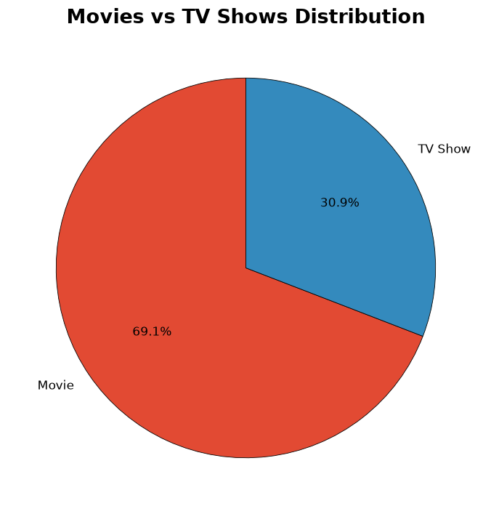
Figure 5.1: Movies vs TV Shows distribution

5.2 Genre Distribution
International Movies (2,437 titles) and Dramas (2,106 titles) are by a wide margin the two largest genre tags on the platform, followed by Comedies (1,471) and International TV Shows (1,198) (Figure 5.2). The next tier — Documentaries, Action & Adventure, TV Dramas, Independent Movies — each fall between roughly 670 and 790 titles. The dominance of “International” labelled genres signals that a substantial share of the catalogue is sourced from, or licensed for, markets outside the United States, which is consistent with Netflix's global subscriber base and supports a content strategy built around broad international licensing rather than a purely domestic content core.
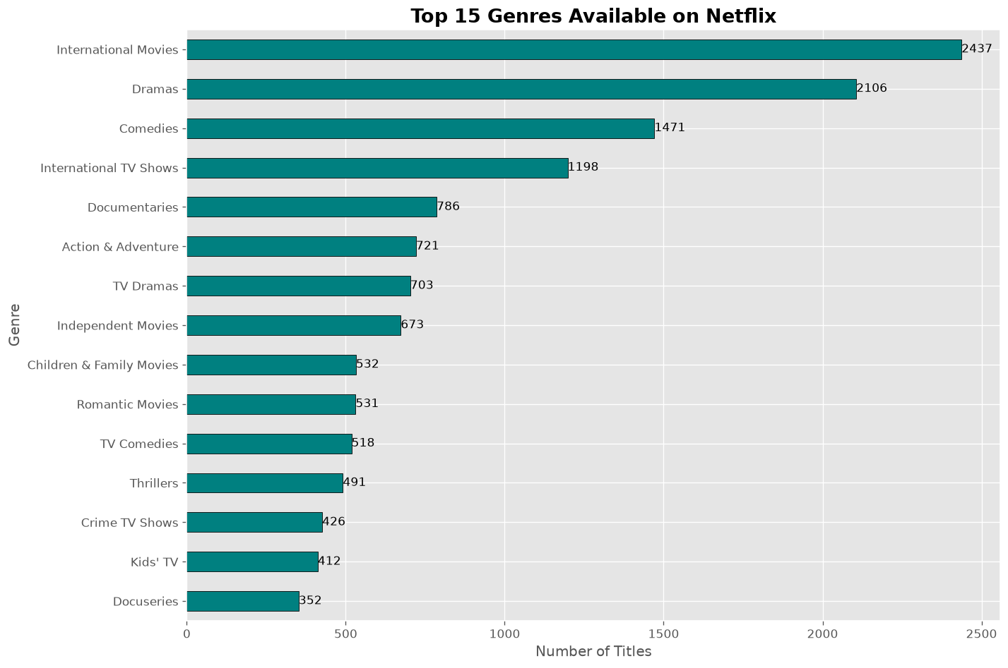
Figure 5.2: Top 15 genres available on Netflix, by title count

5.3 Content-Producing Countries
The United States is the single largest content-producing country by a substantial margin, with 3,291 titles — more than three times the next-largest contributor, India, at 990 titles (Figure 5.3). The United Kingdom follows at 722 titles, and the “Unknown” category, at 506 titles, is large enough to rank fourth overall, ahead of Canada (412) and France (349). The steep drop-off after the top three countries indicates that despite Netflix's global footprint, content production remains heavily concentrated in a small number of established media markets, leaving considerable room for further regional diversification, particularly in high-population markets that are comparatively under-represented relative to their subscriber potential.
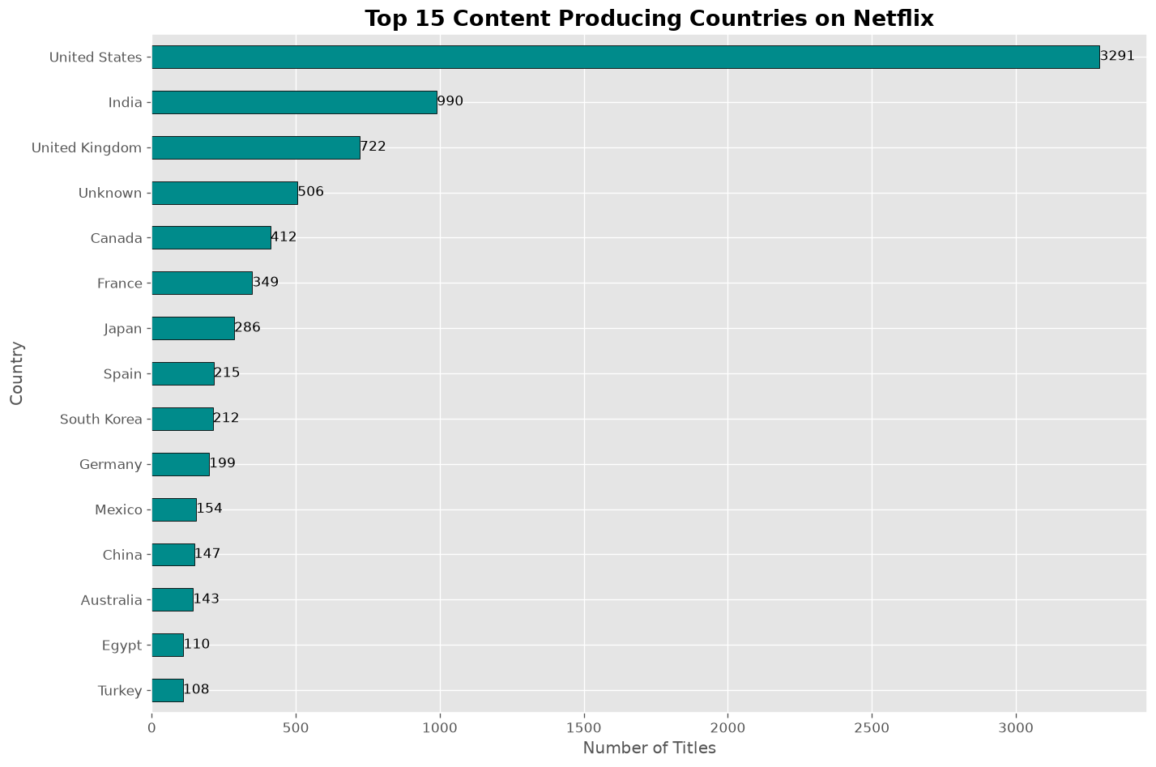
Figure 5.3: Top 15 content-producing countries on Netflix, by title count

5.4 Release Trend Over Time
Title counts by release year show negligible output before 2015 (fewer than 90 titles per year), followed by an inflection point in 2016 (443 titles) and rapid acceleration through 2017 (1,225), 2018 (1,685), and a peak in 2019 (2,153) (Figure 5.4). Output remained high in 2020 (2,009) before falling sharply to 117 in 2021. Given that the 2021 figure breaks a clear multi-year growth trend with no comparable precedent, it is most consistent with the dataset having been extracted partway through 2021 rather than a genuine contraction in output. The 2016–2020 growth phase corresponds to Netflix's well-known scaling of original and licensed content during its period of rapid international subscriber growth, and the sheer scale of the increase — from under 100 titles a year to over 2,000 — underscores how much of the current catalogue is comparatively recent.
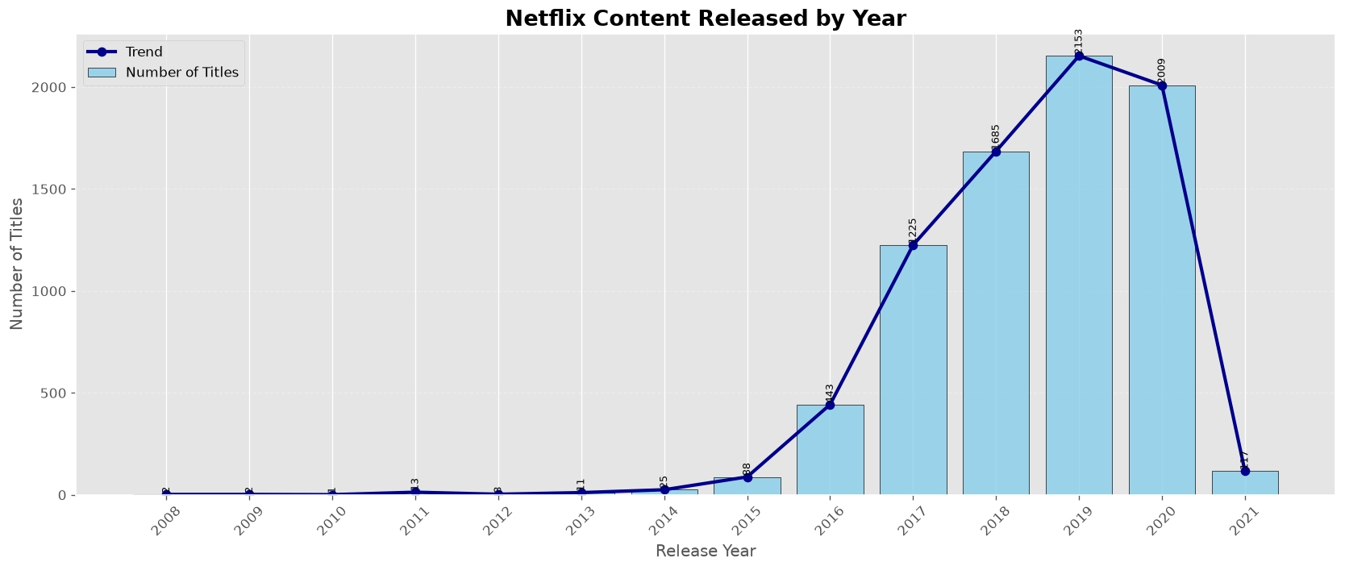
Figure 5.4: Netflix content released by year (2021 reflects a partial data-collection year)

6. Bivariate Analysis
This section considers how pairs of variables relate to one another: content rating against genre, and genre against country. These relationships reveal targeting and localisation patterns that are invisible when each variable is examined alone.

6.1 Content Rating vs Genre
Among the ten largest genres, TV-MA (mature audience) and TV-14 are consistently the two most common ratings, together accounting for the large majority of titles in every major genre (Figure 6.1). TV Dramas are the most heavily skewed toward mature content, at 56.4% TV-MA, followed by International TV Shows (51.8% TV-MA) and Independent Movies (46.2% TV-MA). By contrast, Children & Family Movies is the clear outlier, dominated by PG (31.2%), TV-Y (18.4%), and TV-Y7 (15.8%), with almost no TV-MA content — confirming that this genre functions as Netflix's dedicated family-safe content bucket rather than overlapping meaningfully with the mature-skewed genres around it.
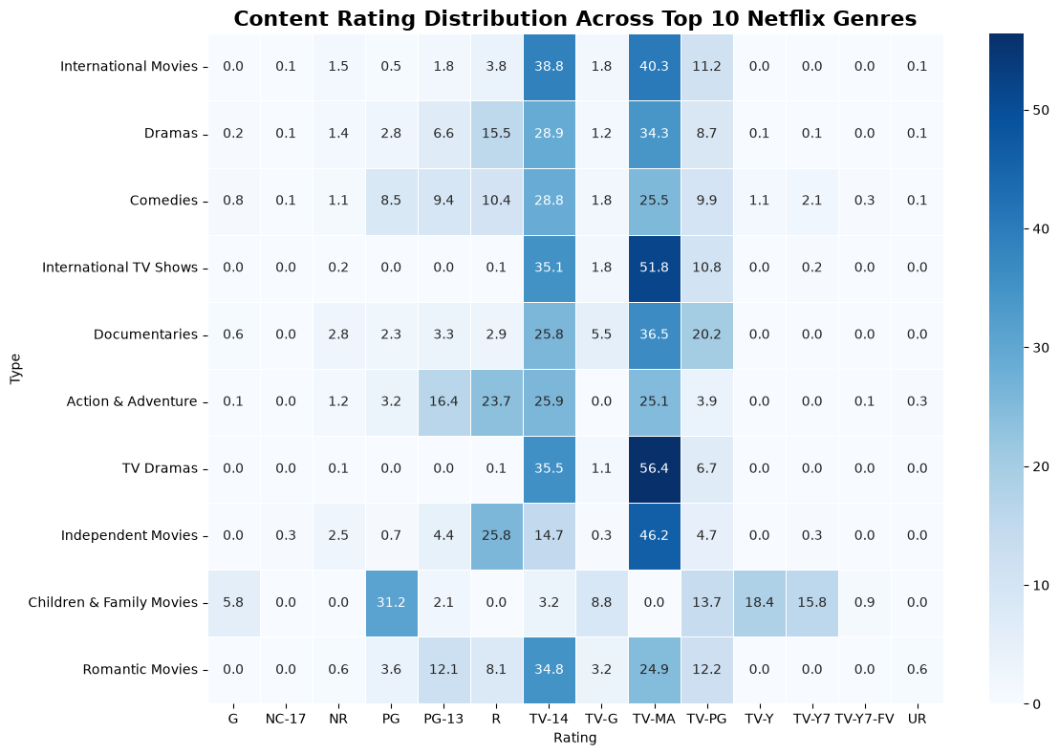
Figure 6.1: Content rating distribution across the top 10 Netflix genres (%)
Extending the view to the full genre list confirms that this mature-content skew is even more pronounced in several niche genres: Stand-Up Comedy is 85.4% TV-MA, TV Horror 76.8% TV-MA, and Spanish-Language TV Shows 71.4% TV-MA (Figure 6.2). Kids' TV, by contrast, splits almost entirely between TV-Y (39.5%) and TV-Y7 (41.6%), reinforcing the same family-content segregation seen in Figure 6.1. In absolute terms, the raw count matrix (Figure 6.3) shows that International Movies alone contributes 983 TV-MA-rated and 946 TV-14-rated titles — more mature-and-teen-rated volume than any other single genre — which means that content-rating strategy and international-licensing strategy are, in practice, closely intertwined rather than independent levers.
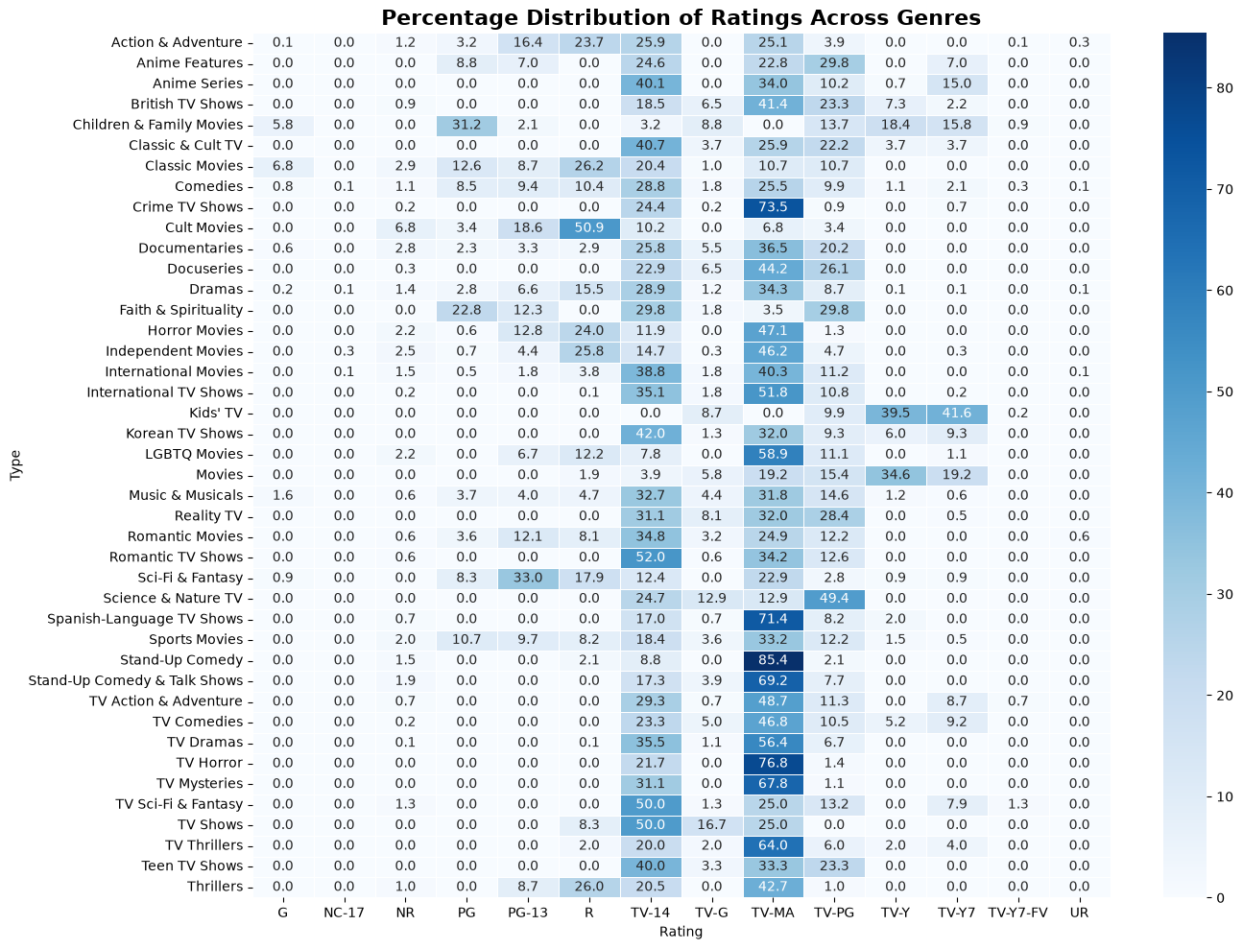
Figure 6.2: Percentage distribution of ratings across all genres
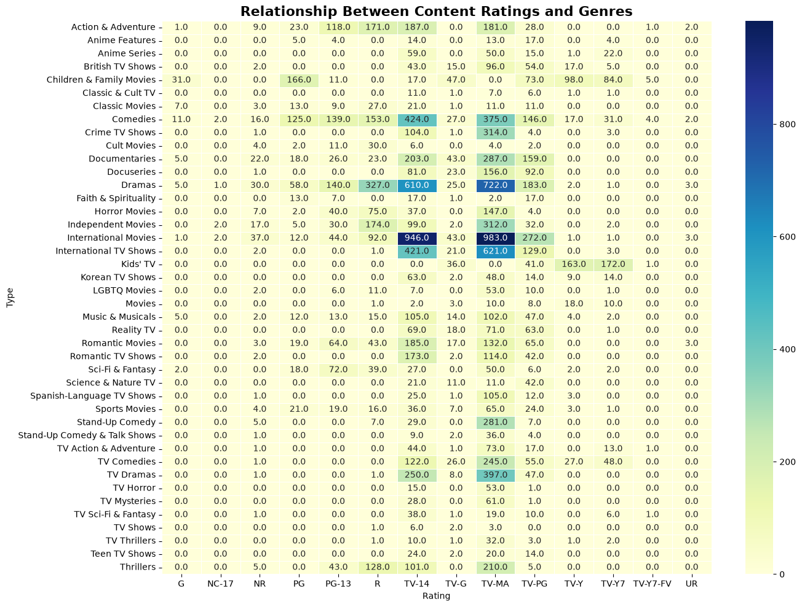
Figure 6.3: Relationship between content ratings and genres (absolute title counts)
From a business standpoint, the near-total absence of TV-MA content in family genres and its near-total dominance elsewhere suggests Netflix already operates two largely separate content pipelines — a mature/general-audience pipeline built on Dramas, Comedies, and International content, and a distinct family-safe pipeline. This separation supports targeted recommendation-system tuning by household profile and reduces the risk of inappropriate content surfacing for younger viewers.

6.2 Genre vs Country
Cross-tabulating genre against country shows that International Movies, Dramas, and Documentaries form a broad, high-percentage band across the majority of smaller-catalogue countries, while a long tail of countries shows sharp, near-100% spikes concentrated in a single genre column (Figure 6.4). This spike pattern is characteristic of countries with only a handful of titles in the catalogue, where one or two productions can dominate that country's entire genre profile; it should therefore be read as a reflection of catalogue depth rather than a genuine national content preference. The more reliable signal is the consistent breadth of International Movies, Dramas, and Documentaries across dozens of countries, which indicates these three genres act as Netflix's default cross-market content categories — the ones most likely to be licensed regardless of the producing country.
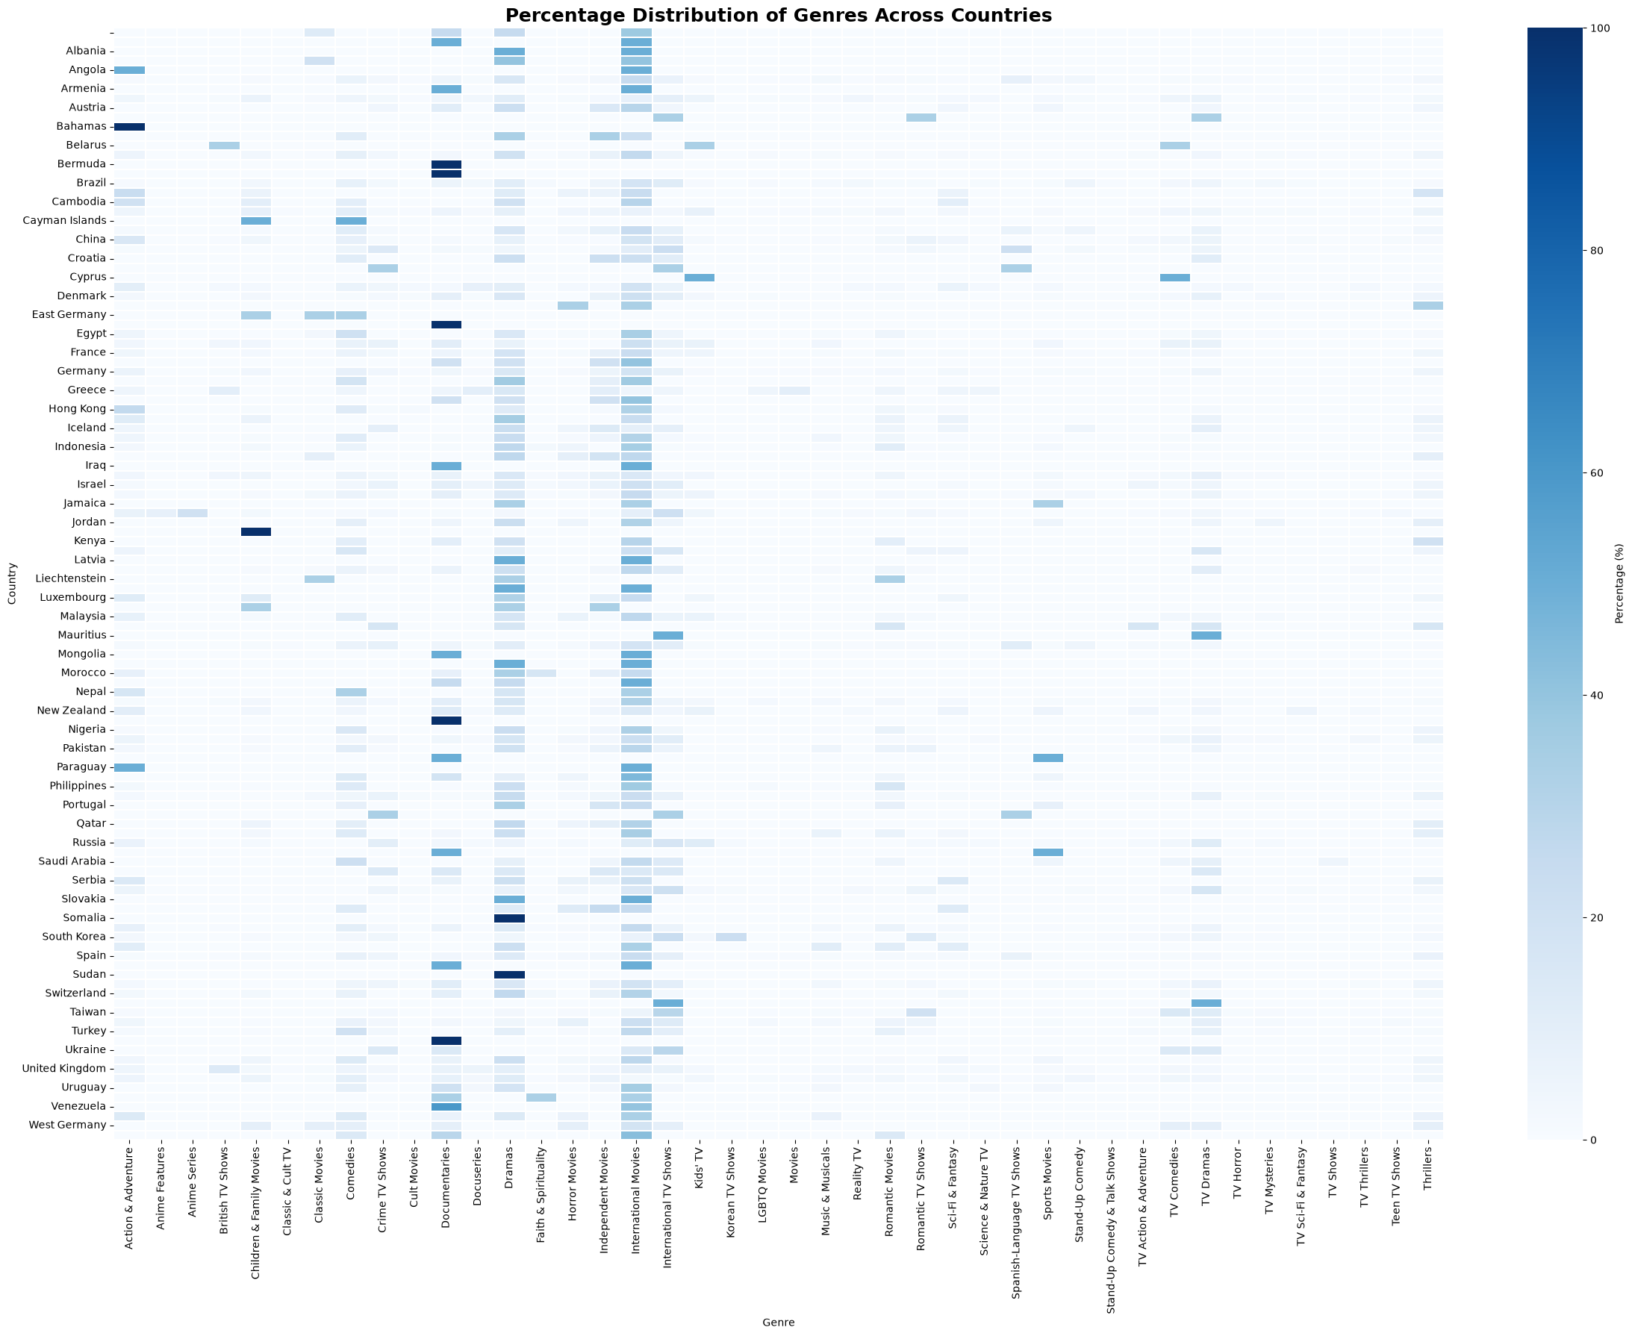
Figure 6.4: Percentage distribution of genres across countries
The practical implication is that country-level genre strategy should be evaluated separately for high-catalogue-depth markets, where genre shares are statistically meaningful, and low-catalogue-depth markets, where a single new acquisition can shift the entire genre profile and where genre diversification is primarily a function of catalogue growth rather than existing preference.

7. Multivariate Analysis
This section brings genre, release year, and country together to examine how catalogue composition has evolved and how it varies across Netflix's largest production markets, extending the two-variable relationships from Section 6 into a fuller picture of catalogue strategy.

7.1 Genre Popularity Trends Over Time
Tracking the ten largest genres by release year shows that all major genres follow the same broad growth-then-decline shape identified in Section 5.4, but they do not peak simultaneously (Figure 7.1). International Movies peaks earliest and highest, at 677 titles in 2018, before easing to 641 (2019) and 578 (2020). Dramas peaks a year later, reaching 597 titles in 2019, and Comedies and International TV Shows follow the same one-year-lagged pattern, peaking in 2019 at 452 and 359 titles respectively. Documentaries is the exception, peaking earlier, at 206 titles in 2017, and declining steadily thereafter even while other genres continued climbing. This staggered sequencing suggests a phased content strategy in which broad international film licensing was scaled first, with drama and comedy series investment following roughly a year behind — consistent with the additional lead time required to produce or license multi-season television relative to film.
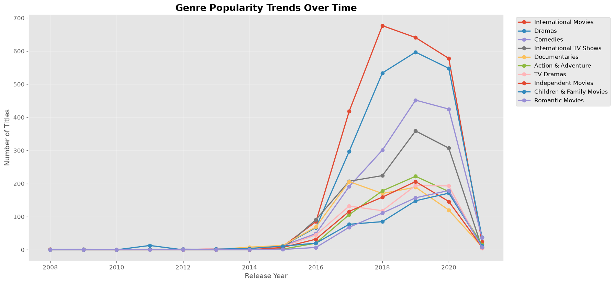
Figure 7.1: Genre popularity trends over time, top 10 genres by release year

7.2 Genre Availability Across Release Years
Viewed across the full genre list rather than just the top 10, the year-by-genre heatmap confirms that almost every genre — not only the largest ones — was negligible before 2016 and expanded sharply from 2017 onward (Figure 7.2). Several niche genres, including Anime Series, Korean TV Shows, and Kids' TV, show visible presence only from 2017 or 2018 onward, indicating these categories were introduced or meaningfully scaled later than the platform's original Drama- and Movie-led growth phase. This later arrival is consistent with genre-specific expansion decisions — for example, growth in Korean TV Shows and Anime tracking Netflix's increased investment in East Asian content production and licensing during its most recent growth years — rather than these genres simply being smaller from the outset.
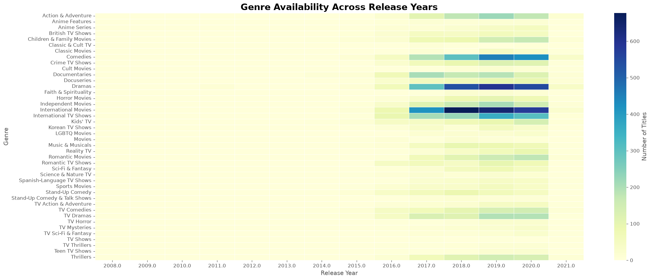
Figure 7.2: Genre availability across release years, full genre list
The equivalent view restricted to the top 10 genres (Figure 7.3) makes the magnitude of the 2018–2020 peak explicit in absolute numbers: International Movies alone contributed 677, 641, and 578 titles in 2018, 2019, and 2020 respectively, while Dramas contributed 534, 597, and 548 in the same three years. Together these two genres alone account for well over 2,000 titles released in this three-year window, underscoring how concentrated Netflix's most intensive catalogue growth was in both time and genre.
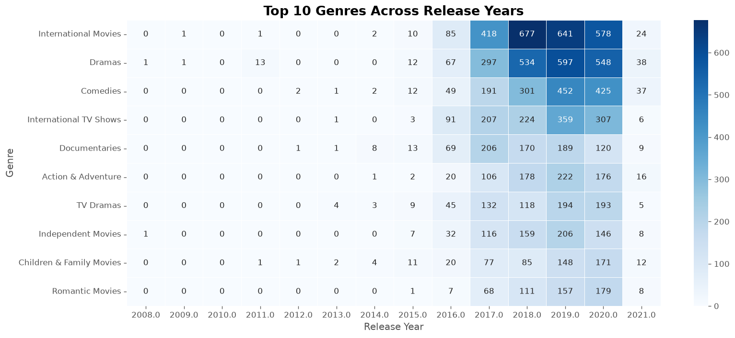
Figure 7.3: Top 10 genres across release years, absolute title counts

7.3 Genre Distribution Across Top Content-Producing Countries
Comparing genre share within each of the ten largest producing countries reveals meaningfully different content profiles rather than a single global pattern (Figure 7.4). India is the most genre-concentrated of the major markets: International Movies and Dramas together account for 54.6% of its catalogue (31.1% and 23.5% respectively), far above the equivalent combined share for the United States (14.3%). The United States, by contrast, shows the flattest, most evenly distributed genre profile of any top-10 country, with no single genre exceeding 12% — consistent with its role as the platform's largest and most diversified content base rather than a genre-specialist market. Japan and South Korea stand out for a different reason: both show a pronounced skew toward International TV Shows (21.1% and 23.8% respectively), reflecting their series-led production traditions, in contrast to the film-led profiles of India, France, and Spain, all of which show International Movies as their leading genre.
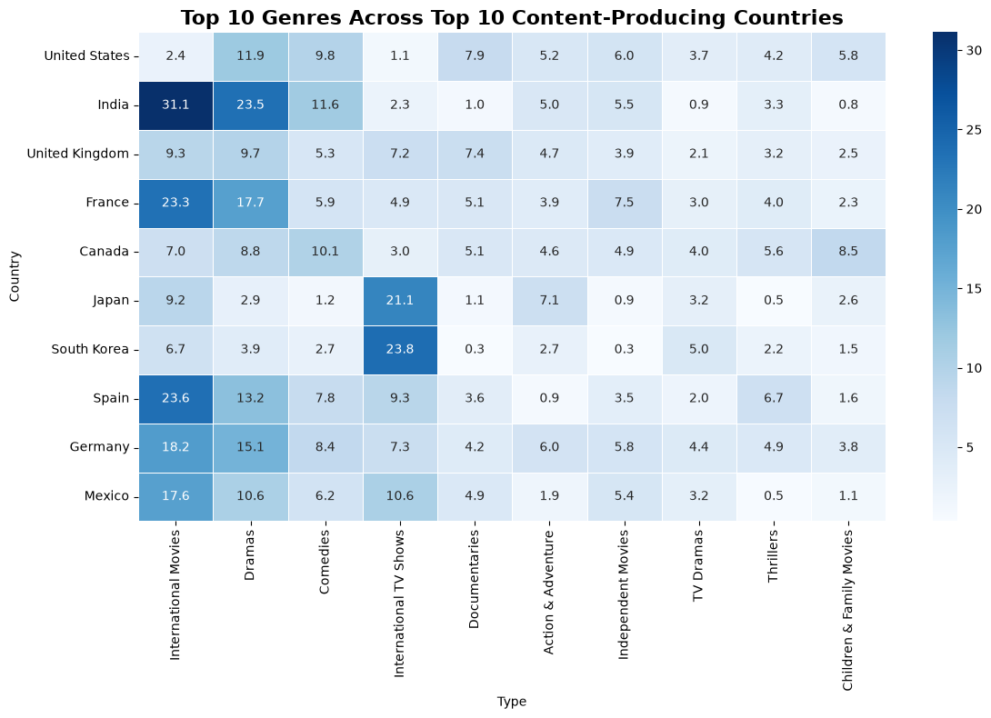
Figure 7.4: Top 10 genres across the top 10 content-producing countries (%)
From a content-strategy perspective, this means genre investment cannot be treated as a single global allocation: markets like Japan and South Korea justify continued investment in episodic television, while India, France, and Spain reward continued film licensing, and the United States' flat profile suggests its role is to sustain breadth across genres rather than lead growth in any one of them.

8. Overall Findings
Synthesising the univariate, bivariate, and multivariate results, several patterns stand out as most relevant to Netflix's content strategy:
- Movies outnumber TV shows by roughly 2.2 to 1 (69.1% vs 30.9%), indicating a catalogue still weighted toward film licensing despite the platform's increasing investment in original series.
- International Movies and Dramas are the two dominant genres by a wide margin (2,437 and 2,106 titles respectively), and together with Comedies and International TV Shows form the backbone of the catalogue.
- Content production is heavily concentrated in a small number of countries: the United States alone accounts for more titles than the next several countries combined, with India and the United Kingdom the only other markets producing more than 700 titles.
- TV-MA and TV-14 dominate mature-audience genres, while Children & Family Movies and Kids' TV form a distinct, almost entirely separate family-safe content segment.
- Catalogue growth was extremely rapid and recent: fewer than 90 titles were released per year before 2015, rising to a peak of 2,153 in 2019 — a roughly 24-fold increase in four years.
- Genre growth was staggered rather than simultaneous: International Movies peaked in 2018, while Dramas, Comedies, and International TV Shows peaked a year later in 2019, and Documentaries peaked earlier, in 2017.
- Country-level genre profiles differ substantially: India is genre-concentrated around International Movies and Dramas, the United States is the flattest and most diversified market, and Japan and South Korea are distinctively series-led through International TV Shows.
- Country-level genre spikes in smaller markets are frequently driven by catalogue depth (a handful of titles) rather than a genuine content preference, and should be interpreted cautiously.

9. Business Recommendations
The following recommendations translate the findings above into concrete actions for content strategy, broadly ordered by expected impact.
- Continue rebalancing toward TV series investment. With movies still outnumbering TV shows 2.2 to 1, and TV content typically driving stronger repeat engagement, further growth in original and licensed series — building on the momentum already visible in the 2018–2020 series-genre growth — is likely to improve retention more than continued film-led growth.
- Deepen investment in under-represented high-potential markets. The steep drop-off after the United States, India, and the United Kingdom suggests markets such as Germany, Mexico, and China — populous markets currently producing under 200 titles each — are candidates for expanded local content investment relative to their subscriber potential.
- Tailor genre strategy by market rather than applying a global template. Given that Japan and South Korea reward series-led investment while India, France, and Spain reward film licensing, content budgets should be allocated by market-specific genre profile rather than a single worldwide genre mix.
- Preserve and expand the family-safe content segment as a distinct pipeline. Because Children & Family Movies and Kids' TV are almost entirely separate from the TV-MA/TV-14-dominated core catalogue, this segment can be grown and marketed independently without diluting the platform's broader mature-audience positioning.
- Treat the “Unknown” country category as a data-governance priority. At 506 titles, unresolved country metadata is large enough to distort regional strategy decisions if left unaddressed, and closing this gap would improve the reliability of future country-level analysis.
- Use the staggered genre growth pattern for production-pipeline planning. Because film-led genres (International Movies) scale faster than series-led genres (Dramas, Comedies), forward content calendars should anticipate this roughly one-year lag when sequencing licensing versus original-production investment.

10. Conclusion
This analysis of Netflix's content catalogue shows a platform built predominantly on film content and concentrated production markets, but one that has diversified rapidly and recently. The catalogue nearly doubled in scale between 2017 and 2019 alone, and while the United States, India, and the United Kingdom remain the dominant production bases, distinct genre profiles across countries — from India's film-and-drama concentration to Japan and South Korea's series-led catalogues — show that Netflix's global content strategy is already market-differentiated rather than uniform. Content rating patterns confirm a clear operational separation between mature-audience and family-safe content, which supports targeted audience segmentation and recommendation-system design. Taken together, the evidence points toward a maturing catalogue whose next phase of growth is more likely to come from deepening series investment, closing regional production gaps, and applying market-specific genre strategy than from simply continuing to add film volume at the pace of 2017–2019.

