**README – Project Setup**

**Dependencies – WAMP, MySQL, JDK (Java with PATH set), Node.JS,**

1. Change Credentials:  
     
   **Turn on WAMP server, and based on your PHPMYADMIN Credentials:**  
     
   Go to Application properties file which can be found in the following directory: ***app/backend/config/application.properties***

Update the following properties in the application.properties file:

Properties:

• spring.datasource.username -> username in WAMP SQL server

• spring.datasource.password -> password in WAMP SQL server

1. Starting up the servers  
     
   Go to ***/app directory***, click on run.bat, and you will see 2 consoles that will pop up! One is for react frontend, and another is for spring boot backend.   
     
   Wait for awhile until both are successfully up

*If you get the error as seen below in your backend console, please upgrade your JDK version to 14 and try running the run.bat again.  
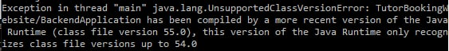

1. Before visiting the tutor site, we need to populate up the database  
     
   Login into WAMP phpMyAdmin, and you can see a newly generated DB called “tutorbooking”. This is generated from backend.  
     
   Go to ***/app directory,*** and you should see a script called tutorbooking.sql. Import this script into the “tutorbooking” Database in phpMyAdmin. Now our database have been populated with sample data for testing!
2. Refresh the tutor site and test the environment @ **http://localhost:3000/**