North-West University |

Class Diagram Assignment

CMPG 223

Bongani Tabu - 32234147

Tebogo Setona - 28910273

Renier Smith - 35024968

Alwyn Barnard - 32033303

Mecaylla Beukes - 28331869

Thabo Khoza TN - 35639407

Problem statement

The National Park is using a manual registration to book guests into different accommodations by using a register book. The system experienced a loss of valuable data containing the guest’s information and activities are being left out that guests booked. The system usually experience theft because of the lack of security, and anyone can access the register at any time.

Goal

Our team was called upon to design a system which reduces the number of problems they were facing by improving:

* Upgrading the system to computers.
* Saving data to a database.
* Improving information security.
* Improving parks functionality.
* Improving data consistency.
* Creating less time-consuming booking processes.
* Creating a more user-friendly system.

Mission of the system

The system must include functionality for the following:

* Maintenance of Activities (Booked and Cancelled).
* Maintenance of guests.
* Make a booking,
* Cancel a booking.
* Change a booking.
* Change an Activity Type.
* Detailed reporting such as: Monthly expenses and income report, Client report, Past transactions report, Activity income. Reports income per period.

Use-Case Model for National Park

National Park System

Log into System

Maintain Animals

**Administrator**

Data Model for National Park

|  |  |
| --- | --- |
| GUESTS | |
| PK | Guest_ID |
|  | Guest_Name |
|  | Guest_Surname |
|  | isChecked_in |
|  | Email_Address |

|  |  |
| --- | --- |
| Activity | |
| PK | Activity_ID |
|  | Activity_Duration |
|  | Activity_Price |
|  | Activity_Capacity |
|  | Activity_Area |
| FK | Activity _Type |

|  |  |
| --- | --- |
| BOOKING | |
| PK | Booking_ID |
|  | Booking_Date |
|  | Booking_Payment |
|  | Guest_Arrival |
|  | Guest_Departure |
| FK1 | House_Number |
| FK2 | Guest_ID |
| FK3 | Activity_ID |

|  |  |
| --- | --- |
| GUEST_HOUSE | |
| PK | House_Number |
|  | House_Type |
|  | House_Area |

Process Model for Maintain Bookings

System User

Booking_Date

Guests’ Requested Booking

Maintain Bookings

**New Booking:**

**Cancel Booking:**

**Change Booking: (Read)**

1{Booking_Date + Cancelled_Booking + Changed_Booking + Booking_Payment + Guest_Arrival + Guest_Departure + House_Number + Guest_ID }N

1{ House_Number + House_Price + House_Type +

House_Area }N

1{ Booking_ID + Booking_Date + Cancelled_Booking + Changed_Booking + Booking_Payment + Guest_Arrival + Guest_Departure + House_Number + Guest_ID }N

1{Booking_ID}N

|  |  |
| --- | --- |
| D3 | Guest House |

|  |  |
| --- | --- |
| D2 | Guests |

1{ Guest_ID + Guest_Name + Guest_Surname }N

|  |  |
| --- | --- |
| D1 | Booking |

**Change Booking: (Write)**

1{Booking_ID + Booking_Date + Cancelled_Booking + Changed_Booking + Booking_Payment + Guest_Arrival + House_Number + Guest_ID }N

Process Model for Maintain Activities

System User

Activity_Type, Activity_Area

Maintain Activities

**Add Activity: (Booked)**

1{ Activity_Type + Activity_Area + Activity_Duration + Activity_Capacity}N

**Remove Activity: (Cancelled)**

1{ Activity_ID}N

|  |  |
| --- | --- |
| D4 | Activities |

Process Model for Maintain Guests

System User

1{ Guest_Name + Guest_Surname }N

Request to Maintain Guests’ Details

Maintain Guests

1{ Guest_ID + Guest_Arrival + Guest_Departure}N

**New Guest:**

**Delete Guest:**

1{Guest_Name + Guest_Surname }N

1{Guest_ID}N

|  |  |
| --- | --- |
| D1 | Booking |

|  |  |
| --- | --- |
| D2 | Guests |

ER Diagram

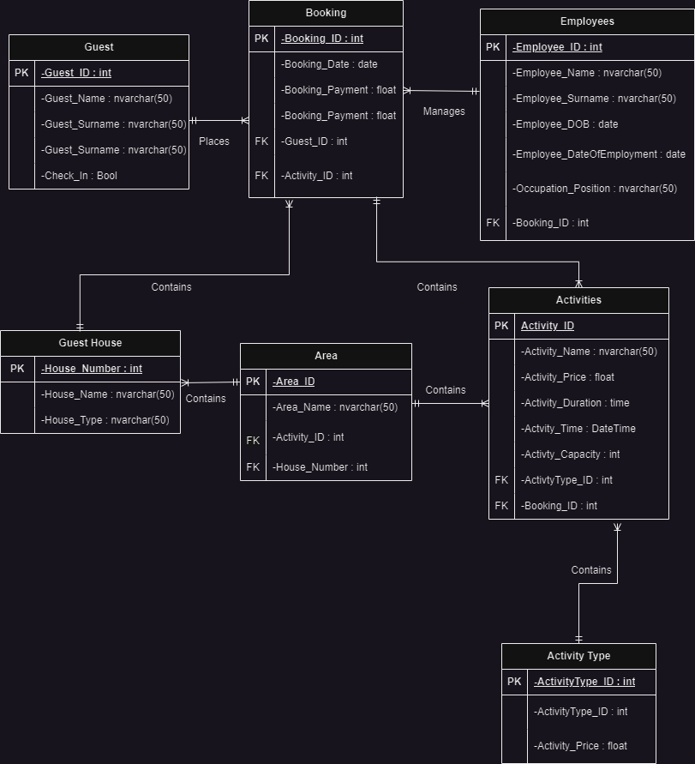

Class Diagram

