Laboratory No. 4: Testing Report
Advanced Laravel Features: Authorization, Form Validation, and File Uploads
Item | Details
Course | Application Development and Emerging Technologies
Project | laravel-crud-application (product inventory CRUD)
Student | Alwyn Reuyan
Date | 29 October 2026
Technology | Laravel 12, PHP 8.2+, Blade, Laravel Breeze, SQLite / MySQL
Test runner | PHPUnit 11 via php artisan test

1. Required Test Cases
# | Test case | Expected result | Actual result | Status
1 | Submit an empty product form | Validation errors appear | Form redisplayed with errors for name, quantity and price; no row saved. | PASS
2 | Enter a negative price (-500) | Submission is rejected | Error: "The price cannot be negative." No product saved. | PASS
3 | Upload an unsupported file (.gif, .php.jpg) | Upload is rejected | Error: only JPEG, PNG and WebP are accepted; nothing stored. | PASS
4 | Upload a valid product image (PNG) | Image is stored and displayed | Saved as products/<hash>.png; thumbnail in listing and image on detail page. | PASS
5 | Log in as a regular user | Management actions are restricted | Add, Edit and Delete are absent; dashboard shows a read-only notice. | PASS
6 | Log in as an admin | Authorized CRUD is available | Create, update and delete all succeed. | PASS
7 | Search for an existing product ("monitor") | Matching results appear | One product listed; the keyword is kept on the next page. | PASS
8 | Delete a product with an image | Product and image are removed | Row deleted, then the file removed from storage/app/public/products. | PASS
9 | Open /product/create as a regular user | Access is denied | HTTP 403 with the custom error page; no product form shown. | PASS

2. Automated Tests
The same behaviour is covered by PHPUnit feature tests that run the full HTTP stack against an in-memory database:
Test file | Covers | Tests
ProductValidationTest | Required fields, ranges, formats, old input | 10
ProductAuthorizationTest | Guest redirect, role gates, hidden buttons | 9
ProductImageTest | Upload, MIME sniffing, size limit, replace, delete | 9
ProductSearchTest | Filtering, pagination, preserved keyword | 6
Breeze auth/profile suites | Regression check on authentication | 26
Total | 60 passed, 0 failed | 60

Result: 60 tests, 183 assertions, all passing (php artisan test, about three seconds). The suite uses a fake public disk and a refreshed database, so it can be re-run at any time without affecting the demonstration data.

3. Interface Verification
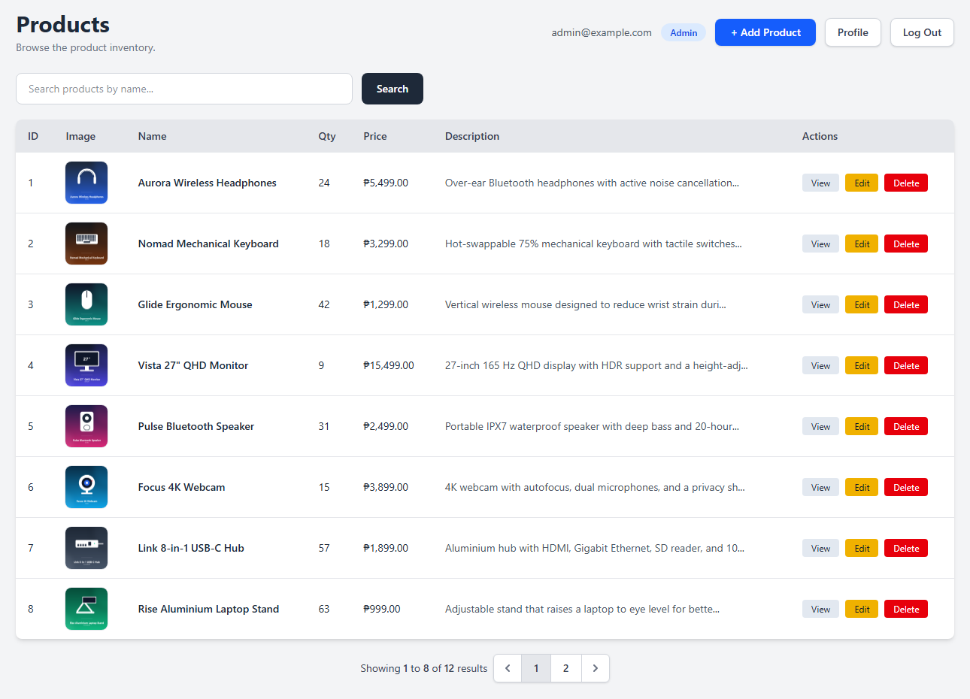
Figure 1. Administrator listing: signed-in account, role badge, Profile and Log Out, search field, thumbnails, pagination and management actions.
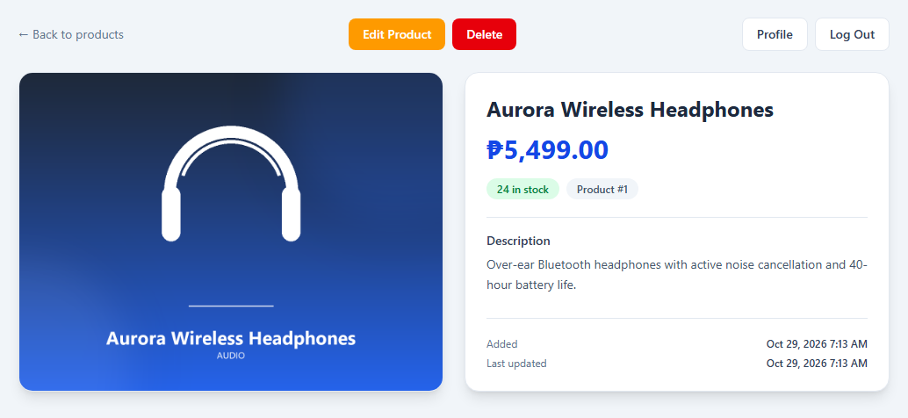
Figure 2. Product detail page showing the uploaded image, price, stock and timestamps.
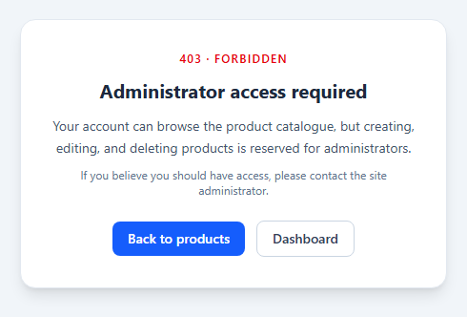
Figure 3. A regular user opening /product/create directly receives HTTP 403.
4. Conclusion
All nine required test cases pass, along with eleven additional cases covering negative and fractional values, oversized names, malicious uploads, image replacement failure, privilege escalation and pagination. The automated suite passes in full on a clean database, and the browser checks match the laboratory sheet, so the application is ready for the face-to-face demonstration.

