CS 501 Mobile Application Development

**Worksheet 1: Brainstorming Android Apps.**

**Date:** 9/13/2022

**Team Members:** Alex Wang, Jinpeng Lyu, Lesley Chen, Tiffany Chen

The purpose of this worksheet is to initiate some collaboration that will get you thinking creatively about the functions and features of your mobile device. Please try to get to know the people you are collaborating with. They may become your team members for the final project.

Assignment is due **via Blackboard** by next class. Do not email homework. Please submit via Blackboard.

Please write your answers clearly, or type and print them.

Although we are working with Android, the concepts apply for any device.

1. **List the various sensors and devices on typical Mobile Phones.**

Accelerometer – checks direction/orientation of device

Biometric Sensors – fingerprint, facial recognition for security

GPS - location

Gyroscope Sensor – angles and direction

Magnetometer – strength and direction of magnetic field, helps with positioning (compass)

Pedometer Sensor - records steps

Ambient Light Sensor – surrounding lights/ controls brightness of device

Proximity Sensor – when sensing an object close by, device screen turns off

1. **List 5 of your favorite Apps. Briefly describe what they do and what makes them so great.**

UberEATS: Allows users to order food and groceries online with delivery or pickup options which is really convenient

Google Drive: Provides users with free cloud storage and the ability to share files with others which is useful for collaboration

Zoom: Allows users to hold video conferences with screenshare and drawing capabilities which is convenient for communication

Discord: is a platform for communication; has a wide variety of features that are highly customizable and fun/useful.

Google Chrome: Allows users to browse the internet, sync across all devices when signed in, can translate websites

1. **With your team, generate 3 ideas for apps. Briefly describe what they would do if they existed. You will share these with the class.**

Go Home Monitor – contains all possible routes to home/an address: bus from google maps, cars from Uber/Lyft, Bluebike, walking

Android Shortcuts – similar to iPhone’s; allows users to create personal automation

Pet Garden – list all the available/upcoming pets from all categories (dog, cat, bird, etc.), allows adopters and sellers/shelters to directly communicate, sellers can list their pet information, includes the locations close to you, can post missing pet notices, record personal pet information (weight, health, etc.)

**Could you do it better?:**

Identify an App you use often, but you wish were better, (*e.g.,* - Uber, Lyft, Venmo, Indeed, FishBrain, etc.) Identify the pros and cons of each, and what features are great, but could be improved, what features are missing. For the latter two items, describe with some detail how you would implement these features and what technology might be used to implement these missing features. Be ready to present to the class.

eBay:

**Pros:**

easy management, deliver packages to buyer,

buyers can return packages at no cost via shipping service with USPS

allows buyer and seller to bargain/make offers/ communicate

**Cons:**

Redundant listing recommendation

Notifications are not organized according to different categories

**Improve: via Android UI design, Android Studio, xml, java**

Notifications: have different tabs (like Gmail) for messages; ex: notifs from sellers, eBay, general

Remove offer deals from Inbox and just include it with notifications

Improve the direct messaging interface, make it like a chat app

**Missing:**

Missing product listing from sellers in the saved sellers tab; the products tab lists the products but not seller information, so combine the two by showing the products that are newly added to the store/seller. Utilize big data recommendation on this page so that the buyers would be able to review the newly added items which may be their preferred offers.

**App Design Challenge(s):**

For each of the scenarios below, design an app that might be helpful. Consider all of the resources and tools available to you (or that you might implement or get from a 3rd party) on a typical Android cellular phone. E.g., voice recorder, call blocker, databases, crowdsourcing, caller ID, SMS, Camera, gyroscope, GPS, etc. Storyboard your idea on a separate sheet of paper, that is describe the application and sketch what the app might look like.

You will work in teams on this, be prepared to present your designs to the class.

**1. Emergency Response App.**

Every year at BU incoming freshman are overwhelmed by the city and occasionally get themselves into dangerous situations. What are some of your ideas for an App that would enable someone to know where it is safe to go and, if in trouble, quickly and easily notify others.

* Consider the different sensors on an Android Handset.
* Also consider the possibility of crowdsourcing real-time and archived data

Dangerous Situations:

Lost: Using the GPS function, the app will locate and show service stations such nearby police stations, school offices, libraries, hospitals on a map; option of sharing location with a friend/emergency contact so they are aware of user’s location

Alone at night: Using the GPS function, the app will also show locations of BU Emergency Call Boxes nearby; can also access Scarlet Safe Walk number saved in the app

Robbery, Assault: Emergency SOS feature- if this is triggered, will automatically contact emergency contacts that are saved in the app

Car crash/accidents: Using the accelerometer, gyroscope, and biometrics sensors, will prompt the user to respond if any abnormal signals are sensed; if the user doesn’t respond in a timed manner, device will automatically contact emergency

Fall/Collapsed/Critical Health Issues: Using biometrics, if device senses anything unusual about User’s vital signs, will contact emergency (911, ambulance, family)

Wild animal encounter: Using GPS and crowdsourcing information, users can see on the map locations where there are sighting of wild animals e.g., turkeys or geese. Users can upload and update information about wild animal sightings

Severe Weather: collects data from weather.com and sends reminder to user about any weather warnings, where the weather warning is centered around (on map), and the times during which the warning is active

Fire: Relying on data from BU/Boston fire department, lets the user know the location of fires. Data from Smart Homes’ Smart Thermometer will be sent to the user’s device and if the app finds abnormal temperature increase, it will notify the user, and if the user is in the same location as the home (using GPS), the app will set off an alarm

Shooting Event: Collecting information from police department and crowdsourcing to make note of shooting events near current location

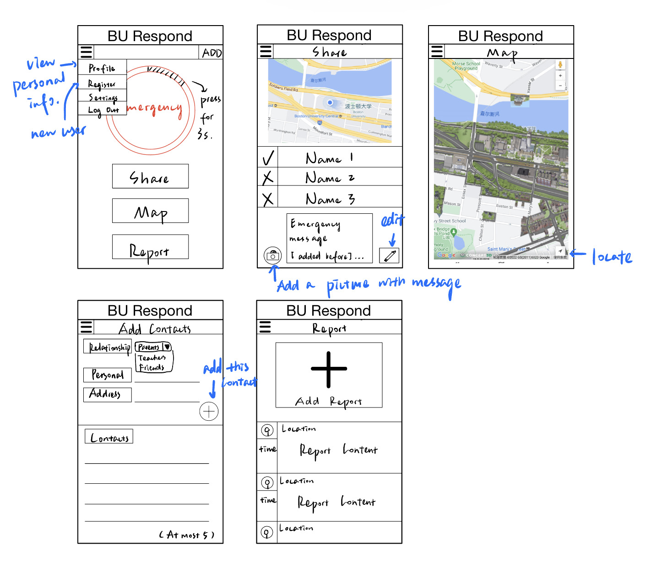

**2. Contractor for You:**

“Contractor For You” is an App connecting Professional Contractors with individuals interested in having work done on their home.

**If someone were to pay you to design this App, what are some things you would need to consider? What would some of the requirements be in terms of device hardware/software/back-end storage/etc.?**

Some things we would need to consider is how Professional Contractors and Homeowners would use the app, privacy (due to home addresses) and scam prevention. Professional Contractors and Homeowners would have their own UIs and be able to do different things on the app. When the user registers an account, they must be verified through uploading files to certify identity/home ownership/Contractor certification.

Some requirements: The software should be intuitive to use and contains all necessary information regarding jobs/requests/pricing. Users can transfer money (pay) via the app.

Frontend: Basic communication interface, Contractor Listing interface, Ability to list job requests as a Homeowner, payment management, order management, feedback/ratings, upload photos

Backend: store information about Contractors, Homeowners, Jobs

Like eBay, use big data to show related services/ recommended services for homeowners, and related/recommended job listings for Professional Contractors

App should be usable across multiple operating systems and take minimal space (~500 – 800 mb)

Use electron.js to build cross-platform app

Storyboard on the next page 🡪

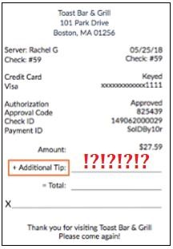_________________________________________________________________________________ **Scenario 2:** **“Don't Fleece Me Dude”** - Quite a few users of credit cards do not regularly check their statements. Or, when they do, they check them long after making a charge. Unscrupulous vendors might take advantage of this laxness. Let's focus on one specific area, tipping at restaurants.

Design an app that would enable a restaurant patron to validate that the tip they left is the same as the tip that was charged. For example, when you go to a restaurant, a hold is placed on your credit card and a tip is added after you leave. What if an unscrupulous waiter charged you a different amount then you had written in? How could you automatically be notified that this occurred?

**App Description (detailed)**:

We assume that the message that sent by bank will contain the full store name, price, date.

When registering for an account, the user will give the app permission to access text messages that contain spending information, which the app will read to find discrepancies. The message for tip spent is sent separately from the message containing the amount spent before tip. This automated text message usually includes the restaurant name, date, last four digits of credit card number, and amount charged.

Using the app, the user will take a picture of the receipt and the tip amount will be extracted via open- sourced **OCR** (Optical Character Recognition).

The tip amount will be compared to the user’s charged amount from the credit card using the restaurant’s name. The app will compare the amount of money spent with the same restaurant name and date. If the amount of tip charged is different from the receipt, the app will notify the user.

You can also login with your Yelp account to sync your review to the correspond Yelp store review page.

This app use location service to locate the restaurant to ensure the info is correct.

Currency: USD

To ensure the app is looking at the right information, the app will look at the date, restaurant name, meal price, and credit card number.

1. Compare date charged in text message with date on receipt picture. Check for same date or dates within 24 hours of each other.
2. Compare price amounts of food (excl tip).
3. Compare last 4 digits of credit card.

