
Received 21 January 2025, accepted 22 February 2025, date of publication 26 February 2025, date of current version 13 March 2025.
Digital Object Identifier 10.1109/ACCESS.2025.3546099

A Novel RMS-Driven Deep Reinforcement
Learning for Optimized Portfolio Management
in Stock Trading
ASMA SATTAR
1AMNA SARWAR2, SAIRA GIANI3, MARYAM BUKHARI4, SEUNGMIN RHO5, AND MUHAMMAD FASEEH6
1College of Computer and Information Sciences (CCIS), Prince Sultan University, Riyadh 11586, Saudi Arabia 2Department of Computer Science, University of Wah, Wah Cantt 47040, Pakistan
3Department of Information Technology and Computer Science, University of Central Punjab, Lahore 54000, Pakistan 4Department of Computer Science, COMSATS University Islamabad, Attock Campus, Attock 43600, Pakistan 5Department of Industrial Security, Chung-Ang University, Seoul 06974, South Korea
6Department of Electronic Engineering, Jeju National University, Jeju-si 63243, Republic of Korea
Corresponding authors: Seungmin Rho (smrho@cau.ac.kr) and Maryam Bukhari (maryambukhari09@gmail.com)
This work was supported by the MSIT (Ministry of Science and ICT), Korea, under the Convergence security core talent training business support program (IITP-2025-RS-2023-00266605) supervised by the IITP (Institute for Information & Communications Technology Planning & Evaluation).
ABSTRACTAlgorithmicstocktradinghasimprovedtremendously,withReinforcementLearning(RL) algorithmsbeingmoreadaptablethanclassicapproacheslikemeanreversionandmomentum.However, challengesremaininadequatelydepictingmarketeventsandgeneratingsuitablerewardstoinfluence thetradingdecisionsofanagentinadynamicenvironment.Thisstudyproposedanimprovedstock market trading framework termed the RMS-Driven Deep Reinforcement Learning (DRL) model for optimal portfoliomanagement.Theresearchattemptstogiveamorecomprehensiveviewofthemarketand,asa result,enhancetradingdecisionsbyincludingconsumerinformationandincorporatingnewssentiments intothemodel,inadditiontodatafromtypicalearningsreports.Morespecifically,threekindsofDRL modelsarepresented,combinedwithdatafromstockearningsreports,MaxDrawdownrewards,and sentiment indicators (RMS), known as PPO_RMS, A2C_RMS, and DDPG_RMS, respectively. The findings ofthisresearchindicatethattheintegratedmodel,mainlytheDDPG_RMSeffectivelyoutperformsthe baseline ^DJI index in many risk-return analyses in ratios showing better risk management, and profitability. Theproposedstocktradingmodelgeneratesamaximumcumulativereturnof27%withaSharperatio of0.66,showinganappropriatetrade-offbetweenriskandreturn.Thisapproach,whichincorporates sentiment analysis and Max Drawdown rewards, significantly enhances the model’s performance in adapting to changing market conditions. Therefore, the results emphasize the appropriateness of integrating sentiment indiceswithtraditionalfinancialdatatoenhanceatrader’sperformancewhilealsoofferingessential information to aid in the development of improved trading tactics in continuously changing financial markets.
INDEXTERMSDeepreinforcementlearning(DRL),stockmarkettrading,portfoliomanagement,max drawdownrewards,advantageactor-critic(A2C),deepdeterministicpolicygradient(DDPG),proximal policy optimization (PPO).
I.INTRODUCTION
Stocktradingistheactofbuyingandsellingacompany’s
sharesonthestockmarket.Theprimarygoaloffrequent

Theassociateeditorcoordinatingthereviewofthismanuscriptand approving it for publication was Wei Ni.

purchases and sales is to maximize capital returns by exploit-ingtheadvantagesofmarketvolatility[1].However,an

2025 The Authors. This work is licensed under a Creative Commons Attribution-NonCommercial-NoDerivatives 4.0 License.
VOLUME 13, 2025 | For more information, see https://creativecommons.org/licenses/by-nc-nd/4.0/ | 42813

 | A. Sattar et al.: Novel RMS-Driven DRL for Optimized Portfolio Management in Stock Trading

organization’sfinancialcondition,internalandexternalsit-uations,trendsintheglobalmarket,andotherrelevant factorsallhaveanimpactonstockprices,thusaffecting stocktradedecisions[2].Stockmarkettradinginvolvesthe useofanalysis,knowledge,andmanagementofrisksin aneffectivelyconductedmarket.Thereareseveralmethods throughwhichtraderscanassesstheperformanceofstocks withthemainonesbeingfundamentalanalysisandtechni-cal analysis [3]. Fundamental analysis involves checking the general operational capability of a specific firm, its position in the industry as well as the overall economic conditions to establishthevalueofthesecurity.Ontheotherhand,tech-nicalanalysisinvolvestheanalysisofthepriceandvolume datawiththeviewoftryingtoestablishsomeindications offutureprices[4].Theseanalysesthusassisttraderson howtoproceduresforpurchasingatthecheapandselling attheexpensive.Thetradersneedtobemorecarefuland flexibletolookatmarketparametersdayandnightand shouldtweaktheirpolicies[5].Theprimaryobjectivethat any investor seeks to achieve their capacity within the finan-cialmarketistomaximizereturnswhileminimizingrisks. To achieve this objective, it is required to estimate the correct pricesorvaluechangeratesforvariousmarketassetsand correctlydistributeinvestmentamongthechosenones[6]. Thisprocedureischallengingforhumanssincenumerous aspectsmustbeexaminedwithinaparticularcontextand arealwayschanging.Existingresearchshowsthathuman trader’s decision-making is typically influenced by emotions, resultinginlesserrevenuesthanestimated[7].Stockprices fluctuate often, which makes it challenging for human traders toadaptappropriately.Thus,thefocusoftheresearchhas been to develop optimal adaptive automated trading systems thataddressinvestor’srequirementsandprovideadditional active capital to the global market.
Intheexistingstudies,severaltradingtechniqueshave been designed but they are unable to perform and yield good resultsoverdifferentmarketconditions[8].Sincetheearly 1990s,researchershaveusedartificialintelligence(AI)to analyzeinvestmentsinthestockmarket[9].Fromthecon-textofAI,theconceptofAlgorithmicTrading(AT)isused byresearcherstoimprovethesestrategies.Dependingupon instructions and rules defined by the programmer, the AT is simply a computer program. It is observed that in comparison with human traders, these automated computer programs take less time to assist with trading decisions. Several traditional techniquesincludemeanreversion[10],momentum-based methods [11], and rule-discovery techniques [12]. Moreover,

connected with it e.g., disparities among the forecasted prices andtradingdecisions[14].Theysometimesfailtocapture the external conditions of the marketplace, for instance, lack ofcashandtransactioncostswhich,inturn,narrowstheir applicability.Therefore,althoughSLtechniqueshavebeen implemented extensively, such limitations as the inability to solveboththepredictionandcapitalallocationproblemsat thesametime,aswellastheneglectoftheconstraintsof themarketenvironment,havebecomeapparent[15].Many forecastingsystemsestimatefuturestockpricesandcreate trading rules [16]. Furthermore, translating predicted signals to trading positions is not straightforward; for example, fore-castinghorizonstypicallyrangefromonetoseveraldays, depending on daily data [17].
Tohandleriskmanagementandportfolios,sophisticated technologieslikeReinforcementLearning(RL)areutilized incomparisonwithsupervisedlearning.RLisasubfieldof machine learning where an agent has to observe the feedback itgetsfromtheenvironmentinwhichitperformsactions toachieveamaximumsumofrewards.Whileinsuper-visedlearningthetrainingdataislabeled,inRLtheagent isactiveandisfreetoroamwithintheenvironmentand learnsthrough‘reinforcement’whichcouldbeintermsof rewardsforthecorrectactionorpenaltiesforthewrong action[18].InthecontextofQuantitativeTrading(QT), firstly, supervised learning does not suffice for the issues that relate to long-term and delayed time rewards including trades inthefinancialmarkets[19].Intrading,futuredecisions aremadebasedontherewardsthatthetradingagentgains inacertainperiod.Basedonthefindingsoftheresearch, itcanbestatedthattheRLapproachismoresuitablefor solvingdecision-makingproblemsintheuncertaincontext ofthefinancialmarkets[20].UtilizingRLforalgorithmic trading requires a continuous perception of the stock market in order to make optimal trading decisions. These algorithms canself-learnandimprovetheirpoliciesovertime,making themappropriatefortheadaptableenvironmentofstock trading. Moreover, RL works to overcome the problems that are associated with the SL approaches when trading financial marketsbycombiningthetwosteps,whicharetheprice‘‘prediction’’ step of the financial assets and the ‘‘allocation’’step of the portfolio to maximize the investor’s goal [21]. The stocktradingagentisinvolvedintheprocessofinteracting withtheenvironmentwhichinthiscaseisthemodelto make appropriate decisions. Financial data are usually highly time-dependent, which makes the Markov Decision Process (MDP),whichisaprimaryobjectinsolvingRLproblems,

numerousattemptshavebeenmadetowardsthedevelop- an ideal fit.

mentofsuchsystemswiththeuseofsupervisedlearning methodologiesdominating.Thesestrategiesmakemodels tolearnpredictedmarketpatternsusingpredictivemodels such as neural networks and random forests [13]. Moreover, mostofthemethodsthatareappliedundertheassumption ofusingsupervisedlearningprincipallyconsiderreduced prediction error risk as a target while leaving aside the threats

Therefore,inrecentstudies,severalresearchershave designedstocktradingstrategieswiththeuseofRLalgo-rithms.However,themajorchallengesinframingproblems withRLtechniquesarethestaterepresentationfromthe environmentandsuitablerewards[1].Sincetheseelements arethemajorcriteriatoimprovetheperformanceofRL agents,forinstance,aholisticviewofthestockmarketin

42814 VOLUME 13, 2025

A. Sattar et al.: Novel RMS-Driven DRL for Optimized Portfolio Management in Stock Trading
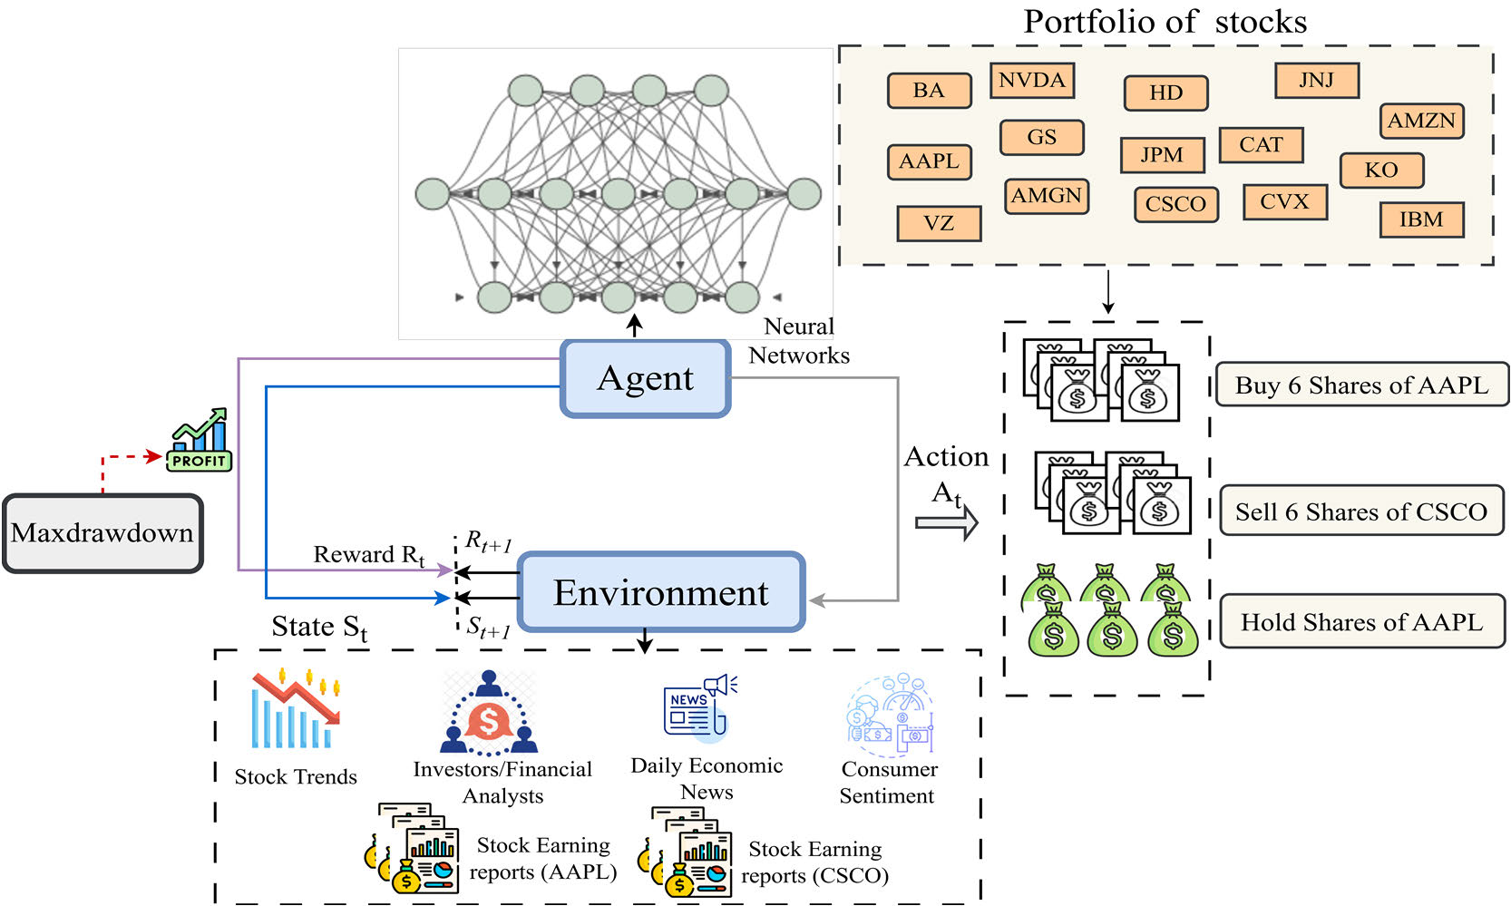
FIGURE 1.Generic overview reinforcement learning framework for stock market trading.

state representation makes the agent more aware of different environmentalvariables.Toaddresssuchchallenges,some studies employed daily historical records, [22] and additional variables such as news sentiments [23], as well as data fusion methodssuchasacombinationofcandlestickchartsand technicalindicators[24]orcombinationofsentimentsand macro-economicfactors[25].Thekeychallengeforallof thesealgorithmsisexactcomprehensionofthestockenvi-ronment; the better informed an agent is regarding the stock market, the better choices it can draw.
Although,severaleffortshavebeenmadetoenrichdata representation,however,therearestillsomeresearchgaps orexternalelementsthatneedtobemodeledinthestock tradingagent.Likewise,differentsuitabletradingrewards forRLhavealsobeendesigned,butarewardfunctionthat ensuresatradeoffbetweenbothprofitabilityandlowrisks andfinanciallossesisamajorresearchgaptobefulfilled. Hence, in this research study, the RMS variables namely data from earning reports as well as sentiment indices containing dailynewssentimentsandconsumersentimentsinaddi-tiontoMaxdrawdown-basedrewardshavebeenmodeled. Inadditiontodailyhistoricaldata,theproposedframework alsomodelsavarietyoftechnicalindicators.Theagentcan betrainedbyuseofDeepDeterministicPolicyGradient (DDPG), Asynchronous Advantage Actor-Critic (A2C), and ProximalPolicyOptimization(PPO)algorithmsareusedin addition to proposed RMS factors referred to as A2C_RMS, DDPG_RMS,andPPO_RMS.Altogether,thesealgorithms guarantee potential sustainable future benefits, together with potentialshort-termprofits,whichallowsthedevelopment ofstrategiesintheformoflong-termsustainableplans. The benefits of including RMS factors include, for instance,

consumersentimentisofmuchimportance,especiallyto stock traders since it has an impact on spending, which has an impact on the revenues of corporations and economic growth [26].Likewise,earningreportsalsocontainprojectionsor outlooksatthecompany’sfutureoperationsandpossible difficulties that may be encountered. Similarly, the proposed variations of RL agents that use Max Drawdown as a reward function offer a substantial benefit since the proposed reward is combined with risk management. By combining these RMS factors with the advantages of DDPG, A2C, and PPO, these algorithmsprioritizelong-termgainswhilestillachieving potential short-term profits, allowing for the development of strategiesthatguaranteesustainabilityinthelongrun.This studyaimstoincreasetheeffectivenessoftradingsystems and decision-making in the stock market. The main contribu-tions of this study are as follows:
•This study proposed three variants of RL agents namely A2C, DDPG, and PPO with RMS factors modeling•Theproposedvariantsintegratebothconsumersenti- ment as well as news sentiment indexes into its modeling approach, providing a more complete view of the stock market in addition to technical indicators and historical data
•Data from stock earnings releases is also exploited in the modelingprocesstocreatemorecomprehensiverepre- sentations of states in RL
•AnovelMaxdrawdown-basedrewardfunctionisalso proposed guaranteeing that the trading strategy not only seeks high profitability but also mitigates risks
Theremainderofthearticlehasbeendividedintodiffer-entsections:SectionIIpresentsrelatedwork,SectionIII

VOLUME 13, 2025 42815

A. Sattar et al.: Novel RMS-Driven DRL for Optimized Portfolio Management in Stock Trading

highlightstheproposedwork,andSectionIVgivesresults and discussion Section V presents comparative analysis, lim-itations,futurework,andconclusion.Figure1showsthe generic overview of stock market trading using RL.
II.LITERATURE REVIEW
Financialmarketsareamongthecaptivatingadvancements ofrecentyearsthathaveimpactedseveralsectorsinclud-ingcommerce,education,employment,technology,andthe overalleconomy[27].Theinherenttaskofdetectingtrends andpricesinthestockmarketsisverycomplexmainly becauseofthedynamic,non-linear,non-stationary,non-parametric, noisy, and chaotic nature of the markets. Mainly, AI-based systems for stock analysis involve stock price fore-castingmodels,stockmovementpredictions,stocktrading systemsorportfoliooptimizationtechniques[1],[28],[29]. Fromallthese,thetaskofstockalgorithmictradingwas initially approached and developed by economists and math-ematicianswithouttheuseofAI.Inthisregard,several methodshavebeendevelopedsuchasmeanreversion[10], momentum-basedmethods[11],andrule-discoverytech-niques[12].However,insuchmethods,expertknowledge requiredfromthedomainoffinanceiscrucialtodetermine underlyingtrendsinthefinancialsector.Similarly,some TTR(TechnicalTradingrule)relianttechniqueshavealso employed.Forinstance,fiveTTRruleshavebeendesigned suchasmovingaverage,relativestrengthindex,momen-tum,etc.,andfindingshavebeenreportedontheTurkish stock market [30]. Likewise, some researchers employ fuzzy-rules-basedtechniquestopredicttradingsignals[31],[32]. A hybrid strategy for stock trading that combines rough sets aswellasgeneticalgorithmsisalsoproposedin[33].Data from the Korea Composite Stock Market Index 200 (KOSPI 200)isemployedtoperformexperimentationtoreportthe findings.Theserules-basedmethodsalthoughexhibitgood performancebuttheireffectivenessislimitedtogeneralize across a variety of situations of stock markets.
Following the aforementioned traditional trading methods, severalresearchhasusedmethodologiescenteredaround supervisedmachinelearninganddeeplearningalgorithms. These are algorithms that are trained on labeled datasets, that is the feature or independent variables and their correspond-ingdependentvariablesanddemonstrategoodresultsnot only in finance-related applications but also in other use-cases [34],[35].Moreexplicitly,severalkindsofstrategiesbased onstockpriceforecastingandstocktrendpredictionshave been designed. For example, in [36] and [37], the stock price prediction model is designed using LSTM (Long Short-Term MemoryNetworks).Thismodelalsofusedupadditional informationintheformoftechnicalindicatorsincluding MFI,relativeRSI,MACD,etc.Inthenextstep,traders utilizeaninvestmentsuccessscorecalculatedfromthepre-dictionoutcomesofthemodelinmakingtradingdecisions. Similarly,ahybridapproachofCNNandLSTMhasbeen proposed [37], [38]. In this, the time series has been framed

to predict future prices with 20 days ahead. By employing a weighted multicategory generalized eigenvalue support vec-tor machine (WMGEPSVM) model is proposed in which the input of the algorithm is the stock’s historical price data and technicalindicators[38].Theirproposedmodelexhibitsa minimal MDD value in contrast to baseline techniques.
Furthermore, RL approaches are one of the latest and third categoryofMLalgorithmsforstockmarkettrading.For instance,twoimprovedtradingstrategiesthataredesigned toworkforstatesandactionsoffinancialmarkets:GDQN (GatedDeepQ-learning)andGDPG(GatedDeterministic Policy Gradient) have been proposed [8]. These strategies tie in a new hedonic reward function that fundamentally should provide steady returns, including in a situation where market conditionsarefluctuatingsignificantly.Theanalysisofthe signalsusingtechniquesfrommathematicsandcomputer scienceshowsthatthemodelsofGDQNandGDPGare more effective than the Turtle trading strategy having higher predictedprofitabilityandmorestablereturnratesthanthe currentleadersbasedontheDRLmechanisms.Similarly, a new trading system based on the improved Deep SARSA for algorithmic trading in volatile markets is proposed [39]. This studyimprovestheperformancestabilityandconvergence of the SARSA algorithm which is of special importance for risk control and daily trading portfolio management. A novel approachnamelyDRL-UTransthatisadeepreinforcement learning with the transformer and U-net for the stock trading isproposedin[40].Thetransformerlayersinthismodel learnaboutdynamicpatternsofthemarket,whereasU-net architectureintegratesbothlongandshortfeaturesthrough skipconnections.Similarly,in[41],theauthorsproposea newtradingapproachbasedontheDRLprocedurethrough theapplicationoftheMADDQNmechanism.Theresearch alsohighlightsthedrawbacksofsingle-agentmodelsin simulatingintricatefinancialrelationsandsuggeststheuse ofamulti-agentsystemtosimulatevarioustradingpat-terns. An attention mechanism with the RL approach is also designed for stock market trading to boost up the results fol-lowed by validating results on stocks of S&P500 [42]. Their proposed method exhibits good results in terms of the Sharpe ratio. Likewise, to acquire more abstract representations and informationfromstockprices,amoduleofCascadedLong Short-Term Memory (CLSTM-PPO Model) is also incorpo-rated into DRL for robust feature learning [43]. The input of this method is the fusion of daily historical records as well as common technical indicators. Subsequently, to combine con-ventional techniques with the latest methods, a hybrid model integrating concepts of rule-based expert systems along with the DRL model is proposed in [44]. This rule-based method makes DRL agents to learn more good trading opportunities and demonstrates superior performance.
A number of studies have been conducted on how DRL can beappliedtostockmarkettrading,butsomeresearchgaps exist. Also, most of the current literature focuses on historical pricesandtechnicalfactorsbutdoesnotconsidersentiment data,especiallyconsumersentimentsandearningreports

42816 VOLUME 13, 2025

A. Sattar et al.: Novel RMS-Driven DRL for Optimized Portfolio Management in Stock Trading
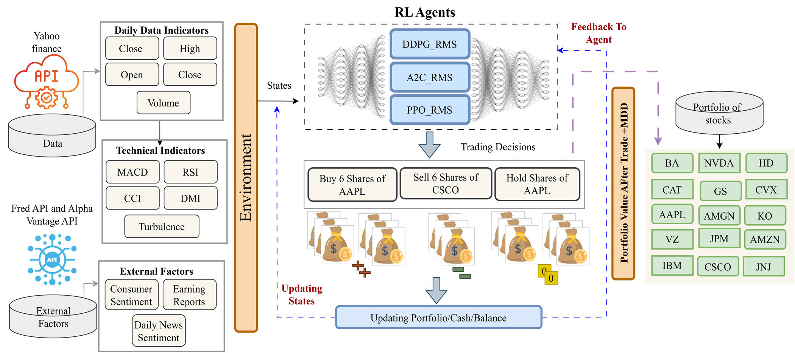
FIGURE 2.A pictorial representation of proposed RL framework for optimizing portfolios to assist investors.

ofstocksorcompanies.Thisoversightmeansthattrading strategiescannotbeeasilyadjustedinresponsetochanging conditions,especiallyinunpredictableenvironments.Fur-thermore,somemodelsreceivehightheoreticalscores,but whenemployingtheminliveaccounts,significantissues arerevealed,whichmakestheinvestigationofthepractical applicability of the models important. Therefore, the research intendedtoaddresscertainchallenges,includingevaluating theperformanceofDDPG,A2C,andPPOalgorithmsin different market environments.
To integrate dynamic elements into the model, aspects like stock price information are incorporated in our methodology, as consumer sentiment and daily new sentiments, in addition, datafromearningreportsandMaxdrawdownisidentified ashavingamajorinfluenceonmarketdirectionthatcould nothavebeenmadeaspartofastaticmodel.Thiswill helpustomakebettermodelsthatwouldbettersuitboth historicalconditionsandpresenttendenciesinthemarket, thus improving their efficiency. Last but not least the research aspectofthestudyisconductedwithadequatebacktesting andcross-validationforvariousmarketsituationstoassess the efficiency of the proposed strategies.
III.PROPOSED METHODOLOGY
Inthissection,adetaileddescriptionofthefunctionalityof the proposed RL agent is provided step by step. A conceptual framework that illustrates the proposed work is illustrated in Figure 2.
A.BACKGROUND OF RL
Reinforcement learning (RL), which is a subfield of machine learning,hasstronglearningagentsthataimtoacquireas muchcumulativerewardaspossiblefromanenvironment.

For instance, In 2015, Alpha Go proved to be much superior to the Human professional players [45]. As for RL, it provides foreffectivelearningintermsofobjectivessetalongwith rationalchoice-making.Inotherwords,RLisaprocessin whichagentsadjusttheirpoliciesthroughtrialanderrorin anenvironment.Theenvironmentisgenerallydescribedas theMarkovDecisionProcess(MDP),definedasS, A, T, R andγwhereSstandsforthestate,Aistheactions,Tfor state transition, R for award and γas the discount factor. The return refers to the aggregate of the number of future rewards overthediscountfactorγwherebyγ ∈(0, 1].Theagent improves actions that produce favorable outcomes and avoids thosethatresultinundesiredoutcomesthroughtheprocess of trial and error with a view to achieving the best outcomes. In RL, the common classification of methods involves value-based,policy-basedandtheactor-critic.Whilevalue-based techniquesinvolveestimatingthevalueofactions,policy-based techniques directly aim for the optimization of policies. Actor-criticmethodsareacombinationofvalue-basedand policy-basedmethods.InRL,tosolveanyproblem,itis mandatory to define states, rewards, actions, and environment according to the design and for achieving certain objectives. Inalgorithmictrading,statesarenotdirectlygivenbutare derivedfromaseriesofobservations.Tohandlethisprob-lem,themodelisextendedandanobservationprobability P(ob|s, a)isincorporatedtomakewhatweknowasthe Partially Observable MDP model.
B.MARKOV DECISION PROCESS (MDP) FORMULATION
The Markov Decision Process (MDP) is a model of stochastic processes and random variables that dictate the transition of statetostatewithregardtocertainassumptionsandprob-abilisticlaws.ItisnecessarytodefineRLandMDPsas

VOLUME 13, 2025 42817

 | A. Sattar et al.: Novel RMS-Driven DRL for Optimized Portfolio Management in Stock Trading
perfect for it since the latter is mathematically well grounded. |  | equation (1):
By so doing, the agent corresponds to the decision maker or
learner while the environment is the world the agent exists in. | MACD = N.Period_EMA −MPeriod_EMA | (1)
Intheparticulartimestept∈{1, 2, 3, . . . , T},thelearning | MACD = N.Period_EMA −MPeriod_EMA | (1)
agent comes across the environment. In this work, the MDP

framework has been used in stock market trading to emulate a real-life trading environment.
1)STATES MODELING
Theabilitytodepictthestateoftheenvironmentiscritical toagents’learningofthebestpolicies.Inthestockmarket, theagent’senvironmentisdeterminedbythecurrentstock market environment. The choice of the right inputs is critical inhelpingtradersgaininsightintothemarketaswellas formulatingtradingrules.Similartothetradingdecisions where investors may consider more factors, the proposed RL agentalsoincludesmultiplefactorswithinitsobservation

In the above equation (1), the MACD is determined by sub-tracting the long-term EMA i.e.Nfrom that of the short-term EMA, M. An EMA is a moving average (MA) i.e. that gives greater importance and relevance to more recent data values.
2. Relative Strength Index (RSI)
Anothertechnicaltoolthatinvestorsuseinthefinancial markets is the Relative Strength Index commonly referred to asRSI[46].Inrecap,itisdesignedtoshowthepastand presenttrendsorhealthofastockormarketbasedonthe lasttradedpricesofthecurrenttradingsession.Thisalso indicates how much the current prices have recently changed. Thus, if the variations in price occur within the support line makingapatternwithRSI,thenitmeansthatthestockhas

space. beenoversold.Fromthis,itmeansthathumansareableto

The states of the proposed RL agent involve the daily his-toricalstockinformationincludingtheopeningprice(opt), the highest price within the day (hit), the lowest price within the day (lot) and closing price (clt) as well as the trade vol-umes (tvt) all of which are denoted as opt, hit, lot, clt, tvt∈Rn +. In particular, optstands for the initial stock’s price in the certaintime,hitandlotdefinethemaximumandminimum price inthe time t, cltis theprice beforethe market closes,

make judgement as to purchases. Likewise, if the price moves aroundtheresistancelevel,itmeansitisoverboughtanda sale ought to be made. We have determined the RSI for every stock in a portfolio represented as Rp∈Rt +where t is the total number of stocks. For all collections of stocks in a portfolio representedasRp∈Rt +,initially,averagegainandlossis computed:

whiletvtisthetotalnumberofsharestradedwithinthe | RSI= 100 − | " | 100 | # | (2
∈
particular session. Also, using ‘t’ to refer to the time step, bt R+represents the balance at any time stepand the available |  |  | 1 +MeanGain MeanLoss

number of shares for each stock in the portfolio is represented bythevectorht∈Zn +.Inadditiontothese,sometechnical indicators(describedbelowincludingMACD,CCI,DMI, RSI,andTurbulence),anddatafromearningreports,con-sumer sentiment indices, and daily news sentiment (described below) have also been modeled into the states of RL. All these indicatorsarecombinedthroughconcatenationalongwith timestepsofdaysandprovidedasinputtothestatesofall three variants of proposed DRL models namely A2C_RMS, DDPG_RMS,andPPO_RMSrespectively.Figure3shows the training and testing setup.
a:TECHNICAL INDICATORS
Whenmakingtradingdecisions,investorsfrequentlyuse

In the above equation (2), the formula uses the mean percent-age gain or loss throughout a given look-back time.
3. Commodity Channel Index (CCI)
This measure is derived from functions that involve high, low,andclosingpricesandmoveswithanoscillatorthat incorporatesmomentum[47].Thismeasureillustratesthe current price in relation to the mean of the prices of a given windowsizeofthepurchasingandsellingoptions.Italso meansthatwhenthismeasureiszerothenthecurrentprice is higher than the mean of the previous prices. We calculated CCIforeachstockinaportfolio,representedasCp∈Rt +, where t represents the number of stocks higher than the mean of the previous prices. We calculated CCI for each stock in a portfolio,representedasCp∈Rt +,wheretrepresentsthe

technicalfactorsTi,whichareheuristicandmathematical number of stocks.

computations based on past stock data. Some of the technical indicators that this study computed are as follows:
1. Moving Average Convergence Divergence (MACD) In technical analysis, it is one of the most used indicators enabling to use of changes in intensity, direction, and duration ofstockpricepatterns[46].Itissometimesreferredtoas a‘‘movingaveragesindicator’’orcommonlyknownasa‘‘momentum indicator’’. We have determined the MACD for everystockinaportfoliorepresentedasMp∈Rt +wheret isthetotalnumberofstocks.Itcanbecomputedusingan

4. Directional Movement Index (DMI)
This measure is employed to determine the trend of an asset price.Itmaybeestimatedusingthehigh,low,andclosing prices anddescribes the directionas well as the intensity of trading prices [48]. These are the directional movement lines (−DI)and(+DI),theaveragedirectionalindex(ADX),the directional index (DX), and the EMA of ADX, among others. Inthisresearch,DXhasbeencalculatedforeverystockin aportfoliorepresentedasCp∈Rt +,wheretisthetotal number of stocks. The following equations(3-5) are showing

42818 VOLUME 13, 2025

A. Sattar et al.: Novel RMS-Driven DRL for Optimized Portfolio Management in Stock Trading

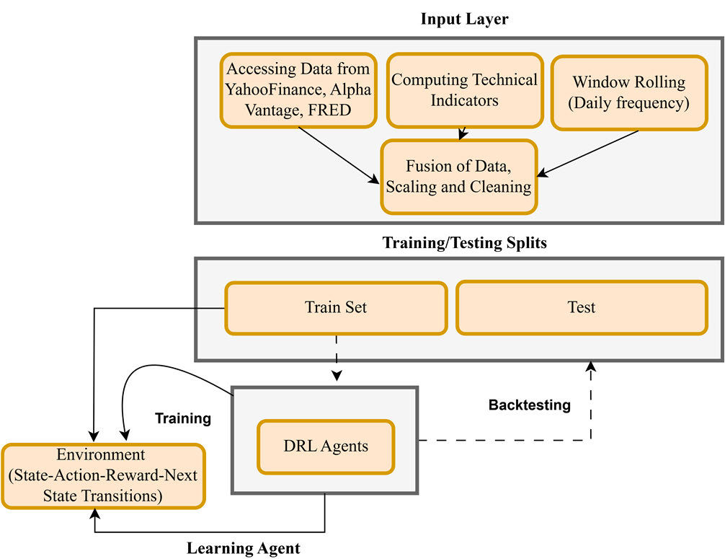
FIGURE 3.A pictorial representation of training and testing setup.

1. Daily news Sentiment
Dailynewssentimentisveryusefulfortradingbecause itgivesanopportunitytoinvestbasedonthecurrentglobal mood of the market. Markets are not only determined by the supply and demand factors but also depend on the sentiments of the investor, which are in most cases, swayed by the news. When the news sentiment is positive the investor gains confi-dence to invest, and the volume of buying increases the stock prices of the share [50]. On the other hand, negative sentiment oftenleadstoaselloffduetoinvestorswantingtoreduce the amount of money they are likely to lose. In this research, we have collected the daily news sentiment to combine with daily stock data as an additional indicator as follows:
Xt= concat (opt, hit, lot, clt, tvt∈Rn +), (Ti∈Rn +), (Snews∈Rn +) (7)
In the above equation (7), (Snews) feature is fused with daily historical stock as well as technical indicators. The daily news

the mathematical formulation of DX computation: |  |  |  |  |  |  | sentiment is extracted from the Federal Reserve Bank of San
 |  |  |  |  |  |  | Francisco [51].
+DI= |  | nP | DM−(PN I=1 |  | DM  14) + CurrentDM |  | 2. Consumer Sentiment
+DI= |  | nP |  |  | DM  14) + CurrentDM | × 100 | Consumersentimentisdefinedastheoutlookthatcon-
+DI= |  | i=1
+DI= |  | i=1 | ATR |  |  |  | sumers have about the current and future state of the economy
 |  |  |  |  |  |  | withpersonalfinancialprospects.Itismainlyassessedby
−DI= |  | nP | DM−(PN I=1 |  | DM  14) −CurrentDM | (3) | theconsumerexpectationsconcerningfuturechanges,their
 |  |  |  |  |  |  | expenditure pattern, and their view on economic conditions.
 |  |  |  |  |  |  | expenditure pattern, and their view on economic conditions.
 |  |  |  |  |  |  | Highconsumersentimentalsogivesanindicationthatthe
−DI= |  | i=1 |  |  | DM  14) −CurrentDM | × 100 | consumers are optimistic about the economic status thus they
−DI= |  | i=1 | ATR |  |  |  | willspendmoreonaspectsthatassistineconomicgrowth.
 |  |  |  |  |  |  | On the other hand, low consumer confidence can be attributed
 |  |  |  |  |  | (4) | On the other hand, low consumer confidence can be attributed
 |  |  |  |  |  |  | toaconsumerbeingconservativewhichtranslatesintoless
DX= |  | | + DI−−DI| |  | × 100 |  | (4) | toaconsumerbeingconservativewhichtranslatesintoless
 |  |  |  |  |  |  | spendingandpossiblyslowereconomicgrowth.Consumer
 |  |  |  |  |  | (5
 |  | | + DI± DI| |  |  |  | (5 | sentiment is of much importance, especially to stock traders
 |  |  |  |  |  |  | since it has an impact on spending, which has an impact on the
5. Turbulence |  |  |  |  |  | (5 | revenuesofcorporationsandeconomicgrowth[26].Inthis

Thismeasureisreferredtoasperiodscharacterizedby high volatility, unpredictability, and conflicts in the financial

research, we have collected consumer sentiment to combine withdaily,technical,aswellasnewssentiment.Theabove

markets.  Inthisresearch,wehavecalculatedtheturbulencefor |  |  |  | equation is revised to include the consumer sentiment:
 |  |  |  | Xt= concat |  | opt, hit, lot, clt, tvt∈Rn + |  |  | , (Ti
everystockinaportfoliorepresentedasTp |  | ∈ | Rt +, |  |  |  |  |  | , (Ti
wheretisthetotalnumberofstocks.Mathematically,itis defined as |  |  |  | ∈Rn + | , | Snews∈Rn + | ( | Sconsumer∈Rn + | (8)
 |  |  |  | Intheaboveequation(8),(Sconsumer)featureisfusedwith dailyhistoricalstock,technicalindicators,aswellasnews sentiment.Thisdataofconsumersentimentisextracted
dt= (yt−µ) | X−1(yt−µ)′ | (6)

Intheaboveequation(6),dtistheturbulenceovera specific time period t, where ytsymbolizes the vector of asset returns, µ shows the mean value of historical returns, whereas shows the covariance matrix of returns.
b:SENTIMENT INDICES
SentimentIndicesareindicatorsthatquantifythesentiment of news and other textual information associated with finan-cial markets [49]. These indices are frequently extracted from articlesorpostsfromnewssourcesorsocialnetworksthat shape people’s perceptions of the market.

through FredAPI [52].
3. Stock Earning Reports
Stockearningreportsarereportsthatareissuedbymost companies as they adopt the public company model of oper-ationandcontainthebalancesheetsofthecompanyfora givenperiodoftime.Commononesaretherevenuesand net income, earnings per share, and the operating expenses to mention but a few. They contain a summary of a company’s financialperformanceandareofvitalinteresttoinvestors, analysts, and traders. Earning reports also contain projections or outlooks for the company’s future operations and possible

VOLUME 13, 2025 42819

A. Sattar et al.: Novel RMS-Driven DRL for Optimized Portfolio Management in Stock Trading

difficulties that may be encountered [53]. Earning reports are particularlysignificantinstocktradingbecausetheyoffer first-handinformationonhowacompanyisperformingin termsofstock.Inthisresearch,wehavecollectedthecon-sumer sentiment to combine with daily, technical, as well as news sentiment. The above equation is revised to include the consumer sentiment:

(e.g.,buyingorsellingaspecifiedquantityofasset).For instance, before the agent purchases 100 shares in a company thefinancialstatusofthecompanyaswellastheagent’s portfolioisalteredthroughamarketaction.Consequently, after the action, the RL states for the next day include shares, dollar amount of shares, balance, and trading shares. That is, iftheagentinvestsinstocks,thecurrentbalanceisreduced

Xt= concat |  | opt, hit, lot, clt, tvt∈Rn + |  |  | , (Ti | bytheamountinvestedtomakesuchanacquisition,while the dollar value of stocks owned in the given asset increases. Aftertradingshares,andrebalancingtheportfolio,theRL agent goes to the next state in the state space. The state also enables the agent to have a real-time view of the environment andone’spositioninitonceaparticularactivityhasbeen accomplished.
∈Rn + | , | Snews∈Rn + | ( | Sconsumer∈Rn + | EReports∈Rn +
(9)
Intheaboveequation(9),(EReports)featureisfusedwith dailyhistoricalstock,technicalindicators,dailynews,and
consumer sentiment to generate a combined feature represen-

tation denotes as Xt. The data of earning reports of stocks is extracted from AlphaVantage API [54].
2)TRADING ACTIONS
The behavior that is exhibited by the agent when interacting withthetradingenvironmentcanbeexpressedinaction. Inthis,theagentseesthefundamental,technical,andthe dailydataofthestockmarketthendecidestoeitherbuy, sellorhold.Theseactionsa∈Aarerepresentedasa∈{−1, 0, 1},where0representspurchase,1showshold,and

C.DRL STOCK AGENTS
Thisstudyemploysthreereinforcementlearningmodels namely:AdvantageActorCritic(A2C),DeepDeterminis-tic Policy Gradient (DDPG), and Proximal Policy Gradients (PPO).TheweightsoftheseDRLagentsinvolvingneural networks are optimized through Adam optimizer. The states are comprised of technical indicators, sentiment indices, con-sumerindicesanddailyindicatorsandthesefeaturesare providedasinputtoDRL-agents.Figure4showsthedetail internalworkingofarchitectureandfollowingisadetailed

−1 shows sell. Since the actions are taken over several shares, description of them:

theactionspaceinthiscaseis{−q, . . . , −1, 0, 1, . . . , q}, wheresymbolqdenotesthetotalshares.Forthisstudy,q

1. Deep Deterministic Policy Gradient (DDPG)
DeepDeterministicPolicyGradient(DDPG)isusedto

equals 100. optimizeinvestmentreturns.DDPGisdevelopedfromthe

1. Proposed MDD Reward
A reward in the case of stock trading most often means the yield or profit on capital. This desirable outcome is actively achievedbytradersduetotheintentionalacquirementand divestitureofequities.Sincetheprincipalmotivationofthe traders is to ensure that they earn higher profits with minimal risks,theconceptofrewardisveryrelevanttothetrader. Inthisstudy,wehaveemployedthemaxdrawdownasan additional variable with portfolio values in the reward func-tion.Themaxdrawdownisthesinglebiggestlossthata portfoliocanendurefrom,ahighpointtoalowpointand thenbacktoahighbeforeanewlowpoint.Itmeasures

DeterministicPolicyGradient(DPG)algorithm[56],which isacombinationofQ-learning[57]andpolicygradient framework[58].However,DDPGappliesneuralnetworks asthefunctionapproximators.TheDDPGalgorithmis intendedfortheMarkovDecisionProcess(MDP)model ofthestocktradingmarket.Q-learningisfundamentally amethodforlearningabouttheenvironment.Insteadof
updatingQ | sy, ay | usingtheexpectedvalueof(sy+1ay+1),
Q-learningemploysagreedyactionay+1thatmaximizes Q(sy+1ay+1) for the next state sy+1 i.e.,
Qπ | sy, ay | = Esy+1[ω(sy, ay, sy+1) + γmax ay+1Q(sy+1ay+1)]

themaximumpercentagelossfromthehighestvalueof aninvestmentandgivestheinvestoraworst-caseviewof their portfolio [55]. The max drawdown is defined below in equation (10): |  | (11) Equation(11)representstheQ-functioninreinforcement learning is the expected return of taking an action ayin state syunderpolicyπ.Itiscalculatedbytakingtheexpected value of the immediate reward ω(sy, ay, sy+1)+ plus the dis-countedmaximumfuturereward,whereγisthediscount
MDD =Trough value −Peakvalue Peakvalue | (10)

In stock trading, max drawdown is very handy since it lets a trader measure the risk that is attached to it in various invest-mentsandstrategies.Possibledrawdowncanbeusefulfor traders to have some understanding to improve their portfolio, that is to avoid risking more than is needed.
4. State Transitions
TheRLagentchoosesanactionfromthepolicygiven itscurrentstateanditexecutesthisactioninthemarket

factor and γmax ay+1Q (sy+1ay+1)] represents the highest expected return from the next state sy+1 considering all possible future actions ay+1. As for the Deep Q-network (DQN) architecture, functions are approximated using neural networks, and states areencodedintovaluefunctions.However,DQNcannot beappliedtothisproblembecauseofthescaleofaction spaceandhowithasbeenreducedfromthepreviousprob-lem.Severaltradingactionsarefeasibleforeachstock, and

42820 VOLUME 13, 2025

A. Sattar et al.: Novel RMS-Driven DRL for Optimized Portfolio Management in Stock Trading
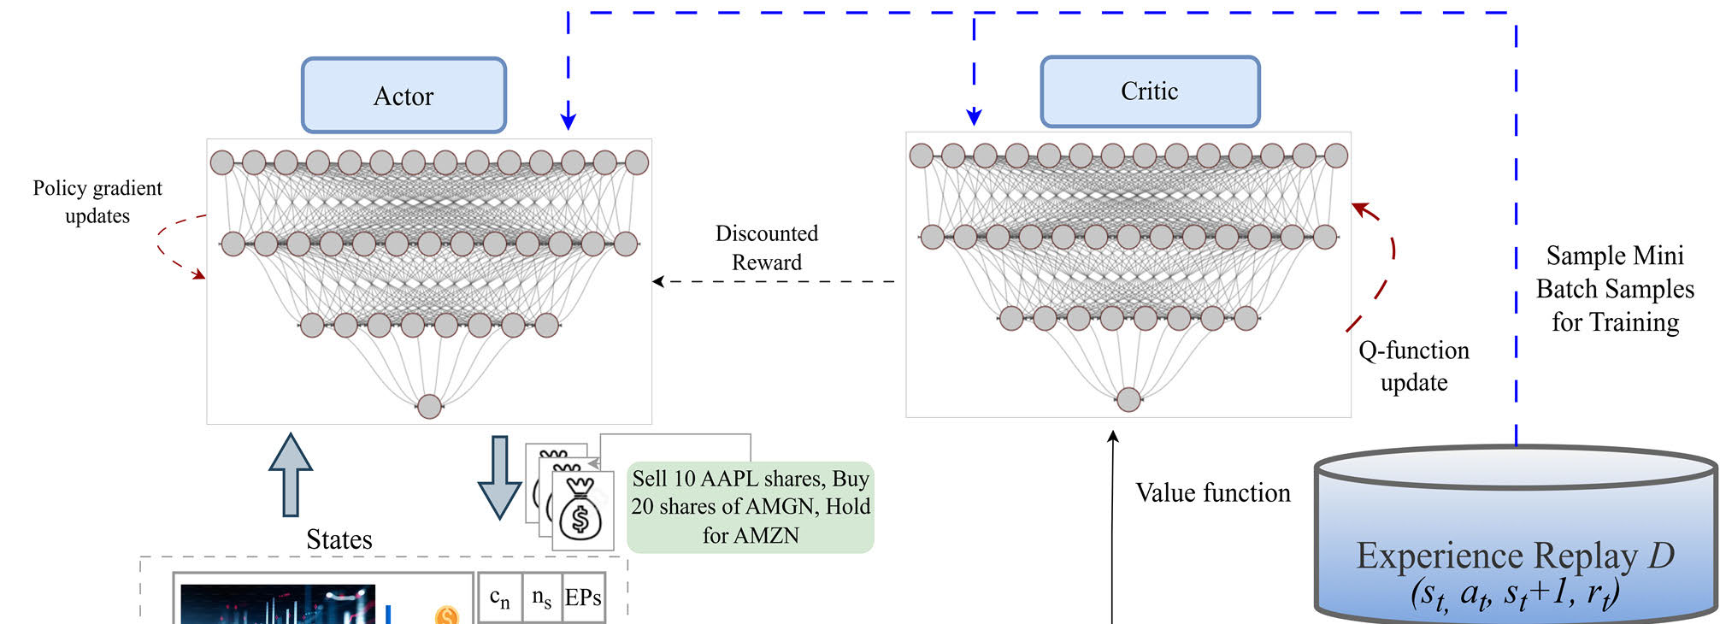
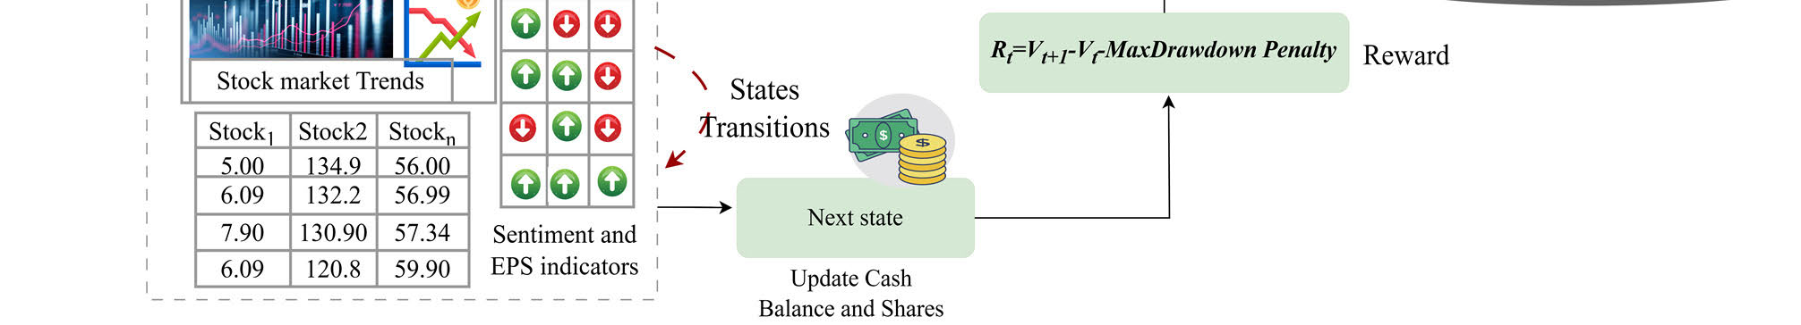
FIGURE 4.Detailed internal working of rl framework for stock market trading.

withrespecttothetotalnumberofstocks,thesizesofthe actionspacesincreaseexponentiallywhichleadstoacurse of dimensionality [15]. To deal with this problem, there needs

Following the updates to the critic and actor networks using transitionsfromtheexperiencebuffer,thetargetactorand target critic networks are updated in the following manner:

to be an algorithm that can map states to action deterministi- | θQ′←τθQ+ (1 −τ)θQ′ | (14)
cally, and this is where the DDPG algorithm comes in. | θQ′←τθQ+ (1 −τ)θQ′ | (14)
cally, and this is where the DDPG algorithm comes in. | θσ ′←τθσ+ (1 −τ)θσ ′ | (15)
ThetargetnetworksQ′andσ′arecreatedbyduplicating | θσ ′←τθσ+ (1 −τ)θσ ′ | (15)

the actor and critic networks, ensuring stable temporal differ-ence updates. These networks are updated iteratively. At each timestep, the DDPG agent performs an action ay based on the state sy, and subsequently receives a reward corresponding to the new state sy+1. The transition (sy, ay, sy+1γy) is stored in the replay buffer R. A minibatch of N sample transitions are then drawn from R and yi= ri+γ Q′(sy+1, σ′(si+1|θσ ′)| θQ′) iscomputedfori=1, . . . .N.Thecriticnetworkissubse-quently updated by minimizing the expected difference L(θQ) betweentheoutputsofthetargetcriticnetworkQ′andthe critic network Q, specifically:

where τis the learning rate.
2. Policy Gradient Methods
Policygradientmethodsareasubclassofthealgorithms used in learning reinforcement that intend to find the policy that optimizes the given function by calculating the estimator of the gradient of the policy. The policy gradient estimator is represented asˆg = Ey[∇θlogπθ(ay|sy)ˆAy], where πθdenotes the stochastic policy andˆAyis an estimator of the advantage function at a given timestep y. Proximal Policy Optimization (PPO) with Actor-Critic is one of the policy gradient methods which involves optimizing the policy by combining multiple

L | θQ | = Esy,ay,γy,sy+1∼buffer[(γy | components:precisely,theclippedsurrogateloss,thevalue
L | θQ | = Esy,ay,γy,sy+1∼buffer[(γy | functionloss,andanentropybonusarechosen.Itincorpo-
L | θQ | + γ Q′(sy+1, σ(sy+1|θσ)|θσ ′) −Q(sy, ay|θQ))2 | functionloss,andanentropybonusarechosen.Itincorpo-
L | θQ | + γ Q′(sy+1, σ(sy+1|θσ)|θσ ′) −Q(sy, ay|θQ))2 | rates the notions of A2C and trust region policy optimization

(12) Theparametersθσoftheactornetworkaresubsequently defined as follows:
∇θσ J
≈Esy,ay,γy,sy+1∼buffer[(∇θσ Q(sy, σ(sy|θσ)|θQ))
= Esy,ay,γy,sy+1∼buffer[(∇θσ Q(sy, σ(sy)|θQ)∇θσ σ(sy|θσ)]

(TRPO),allowingnumerousepochsofminibatchupdates. TRPOisasophisticatedtechniqueappliedinthereinforce-ment learning process to optimize policies without resulting inlargeupdateswhichcandestabilizethesystem.Thecost function of the TRPO objective function aspires to maximize the expected advantage which can be expressed as:
maximize | πθ (at | st) | ˆA | (16
θˆEt | πθ_old (at | st) | t

VOLUME 13, 2025 | (13) | Subject to : | ˆEt | KL | πθold(. | st) , πθ (at | st) | ≤δ | (17)
 |  |  |  |  |  |  | 42821

A. Sattar et al.: Novel RMS-Driven DRL for Optimized Portfolio Management in Stock Trading

The given constrained optimization problem is solved under theconjugategradientframeworkoflinearandquadratic approximations. However, theoretical considerations indicate that perhaps it is more appropriate to use a penalty term βon the KL divergence, as follows:

Coefficientsc1, c2balancetheimportanceoftwoterms thatarethevaluefunctionlossandentropybonuscorre-spondingly.Inthecaseofadvantageestimation,PPOuses Generalized advantage estimation or a clipped version of the same to estimate the advantage functionˆAy expressed below:

maximize |  | πθ (at | st) | ˆA |  | ˆAy= δy + (γ λ)δy+1 + . . . . . . . + (γ λ)Y−y+1δY−1 | (20)
θˆEt |  | πθold(at | st) | t | (18) | where: | (21)
−β | KL | πθold(. | st) , πθ (at | st) |  | (18) | where: | (21)
 |  |  |  |  | δy= γy + γ V(sy+1) −V(sy) | (21)

However, TRPO uses a constraint due to difficulties in choos-inganoptimalβ.PPOoptimizingthepolicybycombining multiplecomponents:precisely,theclippedsurrogateloss, the value function loss, and an entropy bonus are chosen. The objectivefunctionLCLIP+VR+S(θ)combinestheseelements to allow a stable and balanced policy update.

Thismethodapproximatestheadvantagebyaddingthe amountoftheinstantrewardtotheproductofthediscount factor and the difference between consecutive estimated val-ues.SinceLEprovidesameanadvantageestimator,the generalizedadvantageestimationisanestimatorthatoffers balancebetweenbiasandvariancebytheintroductionof

LCLIP+VR+S(θ) = Ey[LCLIP(y, θ) −c1LVR(y, θ) | (19) | adiscountfactorγandandasmoothingparameterλ.This
LCLIP+VR+S(θ) = Ey[LCLIP(y, θ) −c1LVR(y, θ) | (19) | approachyieldsasuperiorandmorestableestimateofthe
+ c2S[πθ(sy)] | (19) | approachyieldsasuperiorandmorestableestimateofthe
+ c2S[πθ(sy)] | (19) | advantage which is of prime importance for updating policies.

HereLCLIPistheclippedsurrogateloss,LVRisthevalue function loss, S[πθ] is the entropy bonus, c1 and c2 are coeffi-cients. The clipped surrogate loss LCLIP reduces the impact of large changes to the policy by bounding the probability ratio, andthevaluefunctionlossLVRissupposedtodecreasethe variance of the value function estimate and the entropy bonus S[πθ]whichhelpstoexplorebyaddingrandomnessofthe policy.
Algorithm (Pseudocode)
Input:Historicalstockdata,consumersentiment,news sentiment,earningsreportsRewardRiincorporating portfoliovalueandMaxDrawdown,Actionspace {−q, . . . , −1, 0, 1, . . . , q},DRLagents:DDPG,PPO, A2C. Replay buffer denoted as D
Output: Optimized trading strategy TS
Initialize: Portfolio value V0, balance, environment E with portfolio of stocks
For each episode i = 1, . . . . . . .., max_episodes :
Initialize: Build state s0= {s0,1, s0,2,....s0,m} for m stocks
For each time step t= 1, . . . . . . .., max_steps :
Action ←at∈{at,1, . . . ..at,m}
Execute Trade←atbuy, sell, hold
Update portfolio←Adjust balance and shares
Reward and Next state←RtandSt+1
Store Transition D←(st, at, rt, st+1)
Sample mini batch fromD
Update actor-critic networks:Using DDPG, PPO, or A2C gradient updates.
End For
Evaluate portfolio performance using TS
End For

3. Advantage Actor-Critic (A2C)
Thecombinationofvalue-basedandpolicy-basedmeth-odswillleadtowardsactor-criticalgorithmsofRL.These actor-criticmethodstacklethechallengesofhighvariance whichisusuallyhappeningduringthebackpropagationof policy-gradientmethods.Therefore,combiningactor-critic techniqueswithgeneralizedadvantageestimationsignifi-cantly reduces the unpredictability of gradient updates. In this regard, one of the most popular algorithms of RL algorithms isA2Cwhichboostsuppolicygradientupdates.Thisvari-ationinpolicygradientistackledthroughtheinclusionof the advantage function. This advantage function is calculated bythecriticagent,insteadofonlyapproximatingthevalue function. The evaluation of a trading agent’s action is based not just on the positive outcomes of the action, such as selling, buying, or holding stocks, but additionally on its possibilities foradditionalimprovement.Withthisinclusion,therobust-nessofthemodelincreaseswhileontheotherhand,the varianceofpolicyagentsisgoingtodecrease. Byusing the various data examples, the A2C model modifies the gradients usingidenticalnetworkarchitecturesforallagents.Each agentseparatelytakesactionandinteractswiththestock market environment on their own. The average of all gradients fromallmodelsispassedtowardstheglobalmodelandare processedbythecoordinatorinA2Cineachiteration.This globalnetworkisthensubsequentlyutilizedintheactor-criticnetworks.Forlargedataofstocks,A2Cemployed synchronized gradient updates for fast execution. Because of suchadvantages,theactor-criticmodelisconsideredtobe more reliable for this task. The mathematical formulation of the objective function of A2C is given below:
∇Jθ (θ) = E | "T  X | #∇θlogπθ (at | st) A (at | st) | (22)
t=1
Intheaboveequation,πθ (at | st)representthenetwork ofpolicy,however,thesecondtermshowstheadvantage

42822 VOLUME 13, 2025

A. Sattar et al.: Novel RMS-Driven DRL for Optimized Portfolio Management in Stock Trading
function as A (at | st) which can be re-defined as follows: |  |  | Mathematically, it is defined in equation (25):
Or | A (at | st) = Q (at | st) −V(st) | (23) | R =v −v0  v0 | (25)
Or | A (at | st) = r (st, at, st+1) + γ V(st+1) −V(st) | (24) | In the above equation, v represents the most recent port-
Or | A (at | st) = r (st, at, st+1) + γ V(st+1) −V(st) | (24) | folio value, whilst v0is the start of capital.

Intheaboveequation,thetemporaldifferenceerroris computed through r (st, at, st+1) + γ V(st+1) on state-value function. The architecture of actor-critic networks is based on
the multi-layer neural networks.

Sharpe Ratio: This metric assesses the performance of theagentbycalculatingthereturnsoninvestmentsin additiontoriskconsideration.Itiscomputedusingan equation (26):

IV.EXPERIMENTS AND RESULTS | While | ST=mean (Rt) −rf std (Rt) | (26)
Thissectiondiscussesthedataset,theassessmentcriteria | While | ST=mean (Rt) −rf std (Rt) | (26)
usedforexaminingthemodel,theproposedtechnique’s | While | Rt=vt−vt−1  vt−1 | (27)
results, and the analysis of findings. | While | Rt=vt−vt−1  vt−1 | (27)

A.DATA COLLECTION
B. This research proposed a multi-stock trading strategy using DRL agents by utilizing Dow Jones 30 constituent stocks. For thepurposeofthisstudy,thedatausedwasobtainedfrom Yahoo Finance API with a timeframe from January 1, 2010, toApril01,2024.TrainingdatawasusedfromJanuary1, 2010,throughOctober1,2021,andbacktestingwasdone fromOctober1,2021,throughApril01,2024.Moreover, data from earning reports were collected from Alpha Vantage API.Table1containsdescriptivestatisticsforDowJones stocks’ historical data, comprising significant metrics such as mean, standard deviation (std), count, minimum (min), max-imum (max), and percentiles (25%, 50%, 75%). This Table 1 summarizesthedatasetintermsofobservations.Following on,Figure5showstheplotsofthetop5volatilestocks

In the above equation, rfis the risk-free rate while vtis the portfolio value at time stamp t.
•Max Drawdown: This measures how sound the agent is since it determines the worst loss from the highest to the lowest point within a period, thus the value of an agent’s portfolioatitslowest.Maximumdrawdownindicates thepossibilityofadownsideoveracertaintimespan.
Itiscomputedbyusingthetroughandpeakvaluesof the portfolio.
MDD =Trough value −Peakvalue Peakvalue | (28)
•AnnualReturn:Thismeasuregivestheamountof profit and or loss made through an investment portfolio within one year. It is defined in equation (29):

ofDOWJonesi.e.closingprices,dailyreturns,andtheir 20-daymovingaveragetrend.ItisobservedfromFigure5 that a 20-day moving average can help discover fundamental trends while filtering out daily market noise. Figure 6 shows | r= (1 + R) | 365  t−1 | (29)
 | Intheaboveequation,tdenotesthetotalnumberof trading days.

the trading volume i.e. quantity and number of shares of each stock listed on DOW Jones and it is observed that AAPL has the highest trading volume emphasizing its strong trading and

•Annual Volatility: This figure quantifies the stability of themodelbycomputingthestandarddeviationofthe portfolio returns to find out how much the returns vary.

investor interest. Subsequently, Table 2 shows the full names | σ= | sPn i=1(ri −¯r)2 | 30
of stock symbols that were used in the analysis, and Table 3 | σ= | sPn i=1(ri −¯r)2 | 30
lists the indicators and the original sources where the data was | a | n −1 | 30

acquired.Furthermore,thetrainingdetailsoftheproposed frameworkincludetheprogramminglanguagePython,and all simulations are run on Google Colaboratory using the Free GPU facility, which includes NVIDIA’s T4 GPUs. On colab-oratory,themostrecentversionsofPython3.10,NumPy, and OS libraries are pre-installed, with the exception of some unique libraries such as ‘‘yfinance’’.
B.EVALUATION METRICS
Inthisstudy,differentassessmentmeasuresareutilizedin ordertoevaluatetheperformanceoftheproposedagentin makingstocktradingdecisions.Themetricsutilizedareas

Intheaboveequation,irepresentstheyearforwhich annualreturniscalculatedsymbolizedasriwhile¯ris indicating mean annual return as well as the total number of years symbolized as n.
•Calmar Ratio: This performance measure assesses the fundperformancemainly,investmentfirmslikehedge fundsorcommoditiestradingadvisors(CTAs)inrela-tiontoannualizedreturnandthemaxdrawdown.Itis defined below in equation (31):
Calmarratio =Rp −Rf MDD | (31)

follows: Intheaboveequation,Rpistheportfolioreturn,Rfis

•CumulativeReturn:Thisisthetotalreturnthatis accumulated by the time of the close of the trading day.

indicating the risk-free rate, while the MDD is the value of the maximum drawdown.

VOLUME 13, 2025 42823

A. Sattar et al.: Novel RMS-Driven DRL for Optimized Portfolio Management in Stock Trading
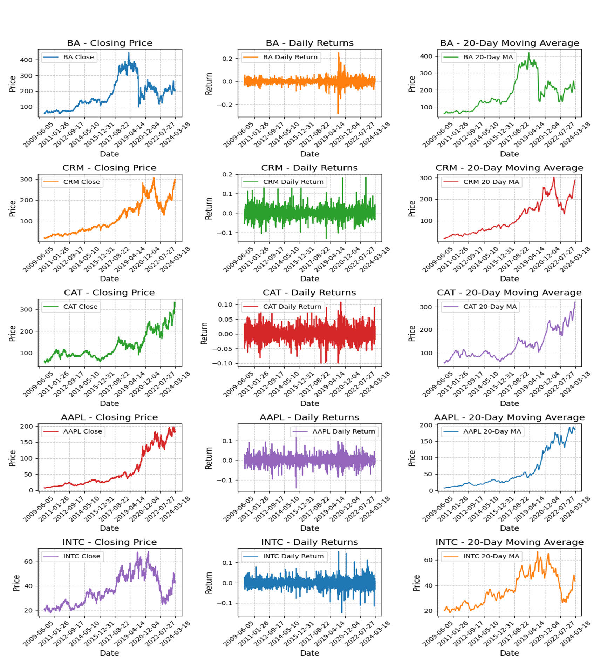
FIGURE 5.Analysis of top five volatile stocks of DOW JONES dataset in terms of closing price, moving average and daily returns.
TABLE 1.Descriptive statistics of DOW Jones stock’s historical data.
 | 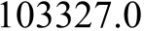 | 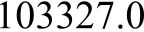 | 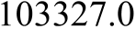 | 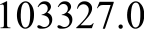 | 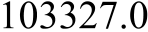 | 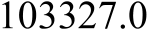
 | 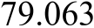 | 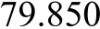 | 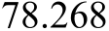 | 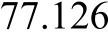 | 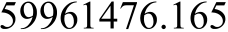 | 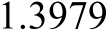
 | 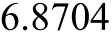 | 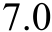 | 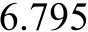 | 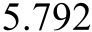 | 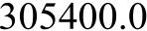 | 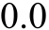
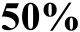 | 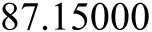 | 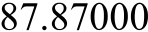 | 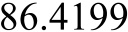 | 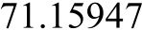 | 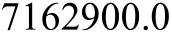 | 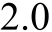
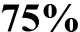
 | 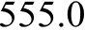 | 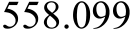 | 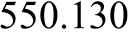 | 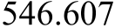 | 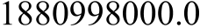 | 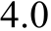

•Omega Ratio: This measure gives the volatility profile of the investment strategy managed by the trading agent.

Thisindicatorisderivedbydividingthecumulative return distributions into segments with losses and gains

42824 VOLUME 13, 2025

A. Sattar et al.: Novel RMS-Driven DRL for Optimized Portfolio Management in Stock Trading
TABLE 2.Symbols of utilized stocks and their abbreviations.

 |  |  | 
 |  | 
 |  | 
 |  |  | 
 |  | 
 |  |  | 
 |  | 
 |  |  | 
 |  |  | 

based on a set threshold. (r) R ∞ r  R ∞(1 −F (x)) dx r F (x) dx | (32)
Intheaboveequation,Fshowsthecumulativeproba-bilitydistributionfunctionofthereturnswhileristhe threshold for the target return.
•TailRatio:Thismeasureestablishedtherisk-adjusted value of the investment by taking into consideration the downside risk. It is a measure of the investment’s mean return over the best-performing tails (95% vs 5%). It is defined as:
Tailraio =R95  |R5| | (33)
Intheaboveequation,R95isthe95thpercentileofthe return distribution, R5is the 5th percentile of the return distribution
•SortinoRatio:LiketheSharpeRatio,theSortino measurestherisk-adjustedperformancebutwithan additionalconsiderationwhichisthatofbelow-target returns.
Sortino ratio =Rp −Rf DV | (34)
Intheaboveequation,Rpistheportfolioreturn,Rfis indicatingtherisk-freerate,whiletheDVisthetarget downside deviation.
C.RESULTS OF THE PROPOSED RMS MODELS AND ^DJI

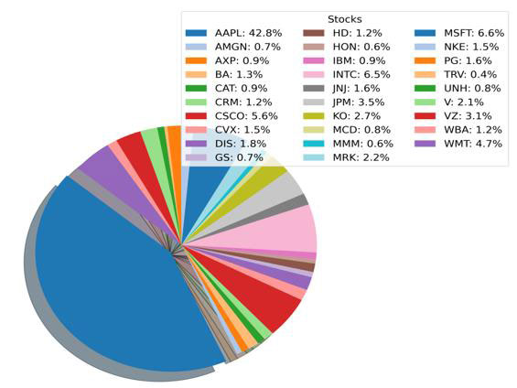
FIGURE 6.Percentage of trading volume of each stock in DOW jones.
profitable on average compared to other models showing the highest annualized return at 10% and a cumulative return of 27% outperforming PPO_RMS at 8% annualized return, and 22% cumulative returns and DDPG_RMS at 7% annualized and 19% cumulative returns. The DJI index performs a little bit less, with a yearly return of 5% and a total return of 13%. This lower performance highlights the relative strength of the proposed model, which outperforms the baseline index. Even intermsofrisk-adjustedreturnbasedontheSharperatio; A2C_RMS has a better risk-adjusted return of 0.66 in com-

BASELINE INDEX parison with the ^DJI baseline index having 0.42. The Calmar

To validate the performance of the proposed framework com-prisingallDRLagentsnamelyA2C_RMS,DDPG_RMS, andPPO_RMS,theyareinitiallytrainedandlateron,their performance is accessed through backtesting. Table 4 shows theresultsoftheproposedagentsintermsofdifferentmet-rics.ItisobservedfromTable4thatA2C_RMSismore

ratio and Omega ratio are significant in that A2C_RMS per-formsmoreeffectivelyintheaspectofbetterrisk-adjusted returnsandalsofarmoreefficientlyintermsofthenumber of positive returns compared to other models. Following on, ifthecomparisonhasbeencarriedoutintermsofMax drawdown,thenallagentexhibitsnearlyequalvaluese.g.,

VOLUME 13, 2025 42825

A. Sattar et al.: Novel RMS-Driven DRL for Optimized Portfolio Management in Stock Trading

A2C_RMSshows−0.21788Maxdrawdown.Likewise,the proposedmodelofA2C_RMSalsoworkswellintermsof theSortinoratioandOmegaratiowhichisabout0.96and 1.11.Moreexplicitly,themorecloselytheSortinoratiois neartooneormore,themoreeffectivethemodelisin producingreturnswithoutsubjectingtheportfoliotosevere negativerisk.Inthiscase,aratioof0.96indicatesthatthe A2C_RMS model is literally risk-neutral with respect to bad returns, which is normally beneficial for investors. Similarly, anomegaratioof1.11indicatesaquitesignificantability oftheproposedmodeltogeneratepositivereturnswhen contrasted to losses and shows that DRL models have a good ability to make trading decisions.
TABLE 3.Sources of collected indicators.

forPPO_RMS,Figure7(b)showsthedynamicsofthe portfoliovaluecomparedtothe^DJIindex.Ahigherand moreconsistentlyrisingPPO_RMSwouldbettercompare tothe^DJIlineindicatingbetteroverallperformanceand stability.Similarly,Figure7(c)showstheportfoliovalueof DDPG_RMS,however,itisobservedthatitsperformance isalittlebitlessincomparisonwithothermodelswiththe maximumportfoliovalueattheendofthetradingperiod being 1198754 respectively.
D.COMPARATIVE ANALYSIS OF PROPOSED MODELS WITH DIFFERENT INDICATORS
Inthisexperimentalsetup,theperformanceofproposed models is investigated by analyzing the impact of individual indicators namely daily news, consumer sentiment, and data

from earning Reports, and any data that is a combination of
 |  | these types. The examined concern and risk metrics include
 |  | the following: the Sharpe ratio, the Calmar ratio, the Tail ratio,
 |  | the Sortino ratio, and the Omega ratio. The graphs shown in
 |  | Figure 8 provide the results of this experimental setup. More
 | 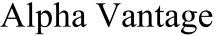 | precisely, Figure 8(a) and Figure 8(b) show the performance
 | 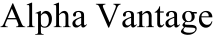 | ofA2C_RMSmodelsforeachinputdatatypealongwith
 | 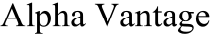 | theseratios.Forinstance,A2C_RMS_ALLseemstohave
 |  | comparableperformanceacrossalltheplots,showinghow
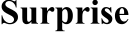 | 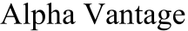 | comparableperformanceacrossalltheplots,showinghow
 |  | the model works when all the sources of data are considered.
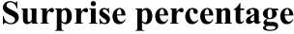 | 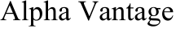 | the model works when all the sources of data are considered.
 |  | The second graph in Figure 8 (c) and Figure 8(d) shows the
 | 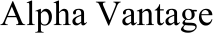 | results of DDPG_RMS models over different indicators indi-

Subsequently, the Calmar ratio is also good having a value of 0.48 with A2C_RMS, 0.43 with PPO_RMS, and 0.36 with DDPG_RMS.Thesevaluesarecomparativelylargerthan thebaseline^DJIindexhavingaCalmarratioof0.24. Inthecontextofstability,A2C_RMShasthebeststability at 0.3323, indicating greater consistency in performance than theotherDRLagentsdesignedforstocktrading.Follow-ingon,PPO_RMSissomewhatstableat0.2647,whereas DDPG_RMSaswellastheDJIBaselineIndexhavelower stabilityscoresof0.2139and0.069647,respectively.This stabilitymetricshowstheconsistencyofmodelsingener-atingreturnsanditisobservedthatA2C_RMShasgood performance not only in the case of good Sharpe, Omega, and Calmar ratios but also in good values of stability.
Inanutshell,itcanbelogicallydeducedthatthe A2C_RMS is more effective in achieving the majority of the metrics under consideration. This higher performance is pri-marily due to the actor-critic framework used by A2C_RMS anditsadvantagefunction.Figure7showsthegraphsof differentmodelsindicatingtheirportfoliovaluesoverthe testingdataduringbacktesting.Theportfoliovalueofall proposed models namely A2C_RMS and PPO_RMS models againstthebaseline^DJIindexduringbacktestingprovide aclearanalysisoftheseinvestmentstrategiesataglance. Forinstance,inA2C_RMS,i.e.Figure7(a)theportfolio returnsofA2C_RMSismuchlargerthanthebaseline^DJI indexwithamaximumvalueof1242380.Inthesameway,

vidually. This also presents the comparison of several metrics (Sharperatio,Calmarratio,Tailratio,Sortinoratio,Omega ratio). The indicators involve news sentiment, consumer sen-timent,earningreports,andallofthematonce.Theresults ofDDPGindicatethatwithallindicators,theDDPG_RMS performanceiscomparable.However,fromthegraphs,itis observed that DDPG_RMS shows more good performance if only daily news sentiment is modeled into the state represen-tation. This indicates that by involving this external element ofnewssentimentinthestaterepresentation,DDPG_RMS can obtain a more sophisticated knowledge of market dynam-ics,highlightingtheinteractionbetweensentiment-driven marketbehaviorsandstockpriceperformance.Itisalso observedthattheincorporationofothervariablessuchas consumersentimentanddatafromearningsreportsisalso beneficial,butitseemstoreducethemodel’sability(i.e. DDPG_RMS)toefficientlyanalyzeandmaketradingdeci-sions(particularlycumulativereturnsandannualreturnsis lessasobservedinFigure8(d)),potentiallyduetogreater noiseorcomplexityinthestaterepresentation.Following on, the third comparison has been made on PPO_RMS with the same experimental settings. Figure 8 (e) and Figure 8 (f) comparetheperformanceofdifferentPPO_RMSusingdif-ferent combinations of indicators. The performance measures include various risk-adjusted return metrics. The most com-monmeasuresaretheSharperatio,Calmarratio,Tailratio, Sortino ratio, and Omega ratio. It is observed from the results ofPPO_RMSthatwithacombinationofallfactors,the modelshowsgoodperformanceintermsofSharperatio,

42826 VOLUME 13, 2025

A. Sattar et al.: Novel RMS-Driven DRL for Optimized Portfolio Management in Stock Trading
TABLE 4.Results of the proposed RMS models and ^DJI baseline index.
 | 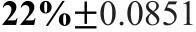 | 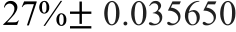 | 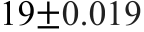
 | 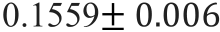 | 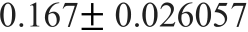 | 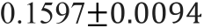
 | 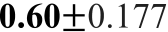 | 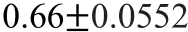 | 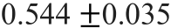
 | 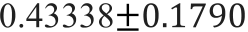 | 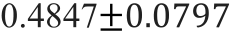 | 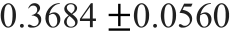
 | 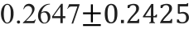 | 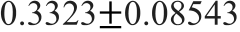 | 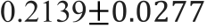
 | 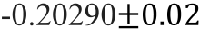 | 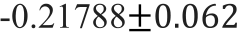 | 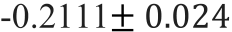
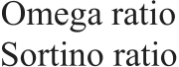 | 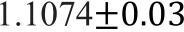 | 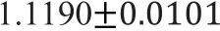 | 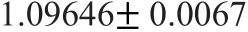
 | 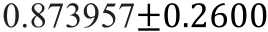 | 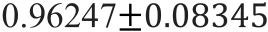 | 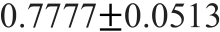
 | 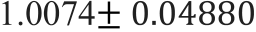 | 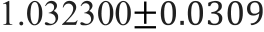 | 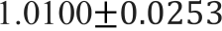
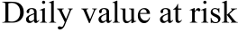 | 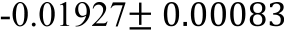 | 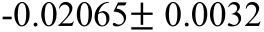 | 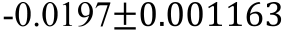

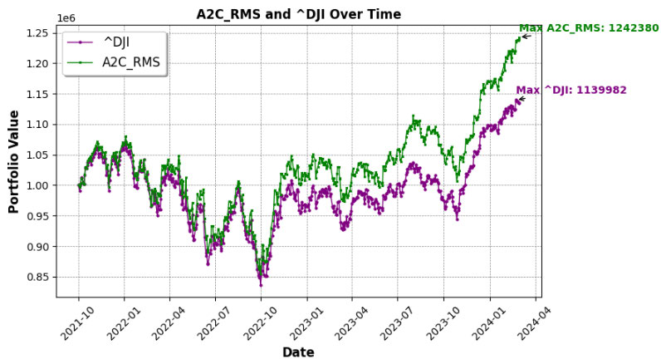

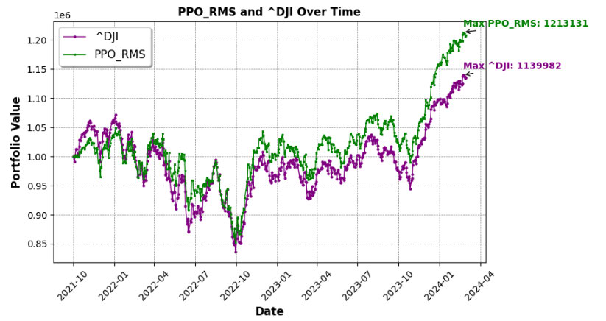

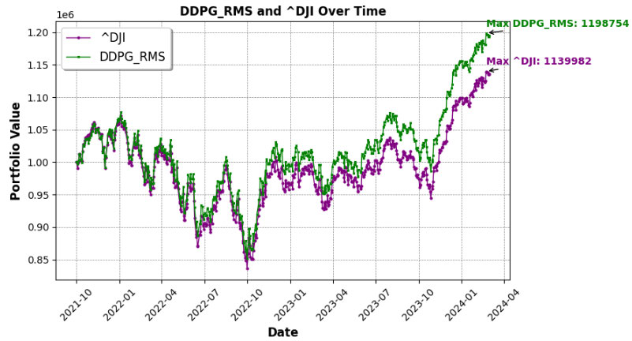
FIGURE 7.(a)Portfolio value of proposed A2C_RMS vs baseline ^DJI index during back testing (b) Portfolio value of proposed PPO_RMS vs baseline
^DJI index during back testing (c) Portfolio value of proposed DDPG_RMS vs baseline ^DJI index during back testing.

Calmar ratio, and returns (both annual and cumulative). The observed findings show that the PPO_RMS model performs betterwhenthestaterepresentationincludesawiderange ofelements,suchasdailynewssentiment,consumersenti-ment,andearningsreportdata.ThisshowsthatPPO_RMS iswell-suitedtodealingwithlargeanddiversedatainputs, usingitspolicyoptimizationapproachtoidentifycorrela-tionsandtrendsacrossmultiplesourcesofdata.Following on,theperformanceintermsofportfoliovaluehasalso

beenanalyzedsuchasFigure9showstheperformanceof A2C_RMS in optimizing portfolio with different indicators, Figure 10 shows the performance of DDPG_RMS in optimiz-ingportfoliowithdifferentindicatorsandFigure11shows theperformanceofPPO_RMSinoptimizingportfoliowith differentindicators.Fromtheanalysis,itcanbeconcluded thattheA2C_RMSmodel(FromFigure9)showsthegood valueofaportfoliooverthebacktestingperiodwhenonly news sentiment has been involved especially during the time

VOLUME 13, 2025 42827

A. Sattar et al.: Novel RMS-Driven DRL for Optimized Portfolio Management in Stock Trading

periodafter2022.Similarly,itisobservedthatwithonly datafromearningreports,theportfoliovaluesarenotas good,butontheotherhand,theconsumersentimentshows agoodimpact.Furthermore,fromFigure10,itisobserved

TABLE 5.Max drawdown analysis of proposed RL agent.

thatDDPG_RMSshowsgoodperformancewhendataof | 

earningreportsandnewssentimenthasbeenmodeledinto staterepresentation.However,performsalittlebitworsein caseswhenonlyconsumersentimenthasbeenutilizedin addition to daily historical stock data and technical indicators into the states of DDPG_RMS. In the last, i.e. from Figure 11, it is observed that the PPO_RMS model shows good results whenconsumersentimentisinvolved.Thedifferencesin performanceofallmodels,whendifferenttypesofdataare utilized,areduetotheirlearningmechanismsandtrading strategies. In the previous experimental setup as observed in Figure7,itisclearlydepictedthatbyacombinationofall factorsi.e.datafromearningreports,consumersentiment index,anddailynewssentimentswhenmodeledintothe staterepresentationthentheresultsofallmodelsaregood. However, during ablation studies when individual factors are considered the performance of A2C_RMS is observed good when only news sentiment is involved, but in the rest of the cases, the performance of individual indicators is averaged.
E.MAX DRAWDOWN ANALYSIS OF RL AGENTS ACROSS DIFFERENT DATA SOURCES
BasedontheMaxDrawdownanalysismadeonthepro-posed reinforcement learning (RL) agents, it can be observed fromTable5thattheperformanceoftheagentsdepends ondifferentdataindicators.IntermsofMaxdrawdown analysisondifferentdataindicators,theA2C_RMSmodel hasconsistentlytheleastmaximumdrawdown,which impliesthatitincursalessextremeloss.Inparticular,the DDPG_RMS algorithm shows a maximum drawdown value of −0.202 when all combinations of factors were involved i.e. A2C_RMS_ALL.Similarly,amaxdrawdownof−0.187is achievedwhendatafromearningreportsareincludedin thestaterepresentation.ItisnotedthatA2C_RMSand PPO_RMS are fairly comparable, however, DDPG_RMS has minor deviations. It has been observed that the suggested RL models have good maximum drawdown values and are more suited for real-world trading since they exhibit controlled risk.
TheproposedRMSmodelefficientlyreducespossible portfoliolossesunderseveremarketsituations,resulting inimprovedriskmanagementandpreservationofcapital. In addition, the combined comparative analysis of proposed agents over different conditions is also provided in Figure 12 to show the collective results of all ablation studies.
F.COMPARATIVE ANALYSIS WITH BASELINE METHODS USING BACKTESTING
ToverifytheeffectivenessoftheproposedRMS_based models,wecomparedthemtonon-reinforcementlearning techniques which include the Dow Jones Industrial Average (DJIA),optimizationmodelbasedonMean-variancewith

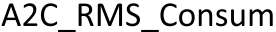
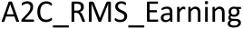

distinctobjectivefunctions[59],machinelearning-based HierarchicalRiskParitymethod[60],alongwithCritical Line Method [61]. The results of the proposed RL framework withthesebaselinealgorithmsareprovidedinFigure13(a) andinFigure13(b),MeanVar(Sharpe)demonstrates Sharpe-basedobjectives,andMeanVar(risk)impliesmax-imizingreturnforanobjectivewithtargetrisk,alongwith Mean Var (return) implies minimizing risk for a target return. Moreprecisely,inFigure13(b),thecomparativeanalysis has been done on the basis of Cumulative returns and Sharpe ratio, however, in Figure 13 (b), the comparison has been done on the basis of annual returns and the Sortino ratio
The reinforcement learning approach provided in this work yieldsencouragingresults,withimprovedSharperatioand cumulative returns as shown in Figure 13(b). The suggested tradingtechniqueproducedhighreturnswhilealsoatthe same time risk-adjusted returns, as evidenced by an improved Sharpe ratio.
G.DISCUSSIONS AND IMPLICATIONS
Algorithmicstockmarkettradingisoneofthecriticaland most favorable topics among researchers of finance because it helps investors optimize their portfolios by executing wise trading decisions.
These algorithmic trading approaches provide advantages over human traders, such as higher confidence, quicker exe-cution,andlackofemotionalbiases.Inexistingstudies, different trading strategies have been developed such as mean reversion[10],momentum-basedmethods[11],andrule-discoverytechniques[12].Nevertheless,thesemethodsfail to cope with the challenging environmental conditions of the stockmarketandfrequentlyshowgoodperformanceover specific timeframes. The latest trend in this area is the intro-ductionofRL-basedapproachestostockmarkettradingto address such issues. However, the primary challenge in stock tradingistoeffectivelypresentstatesanddevelopagents’understanding of the market, as well as to provide appropriate rewardstoencourageagentstolearntocreateprofitswhile simultaneouslymanagingrisk.Therefore,inthisresearch study,theproposedstockmarkettradingmodelincorpo-ratingDRLwiththeConsumerSentimentIndex(CSI), dailynewssentiment,historicalstockdata,technicalindi-cators, and traditional earnings reports has shown promising

42828 VOLUME 13, 2025

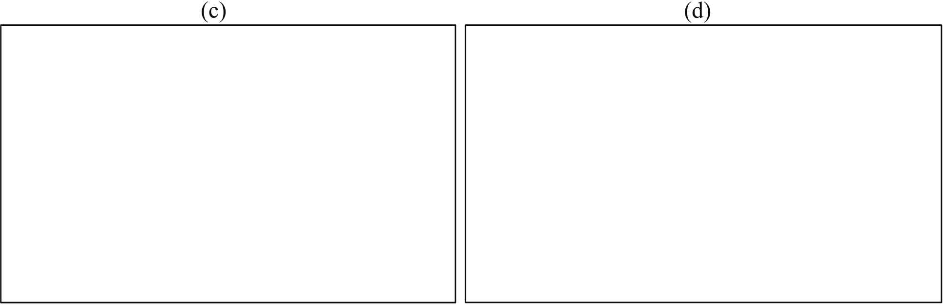
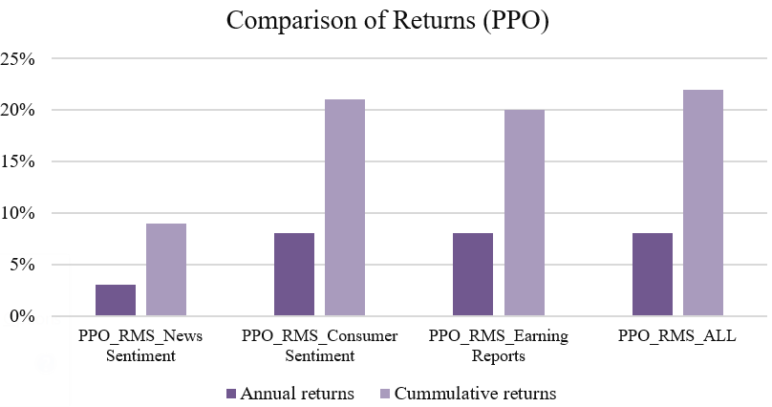
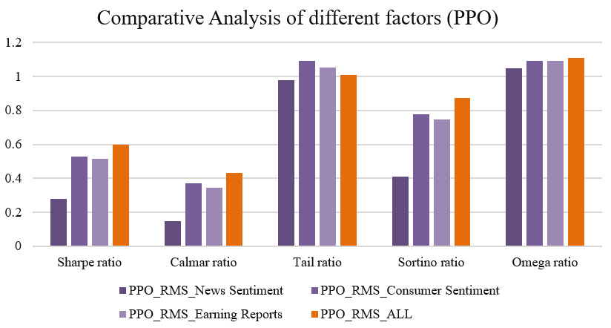
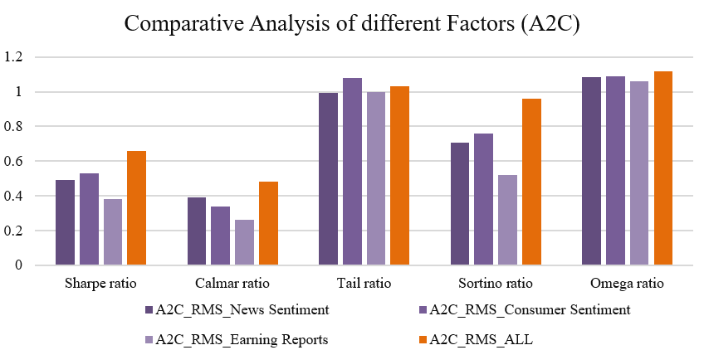
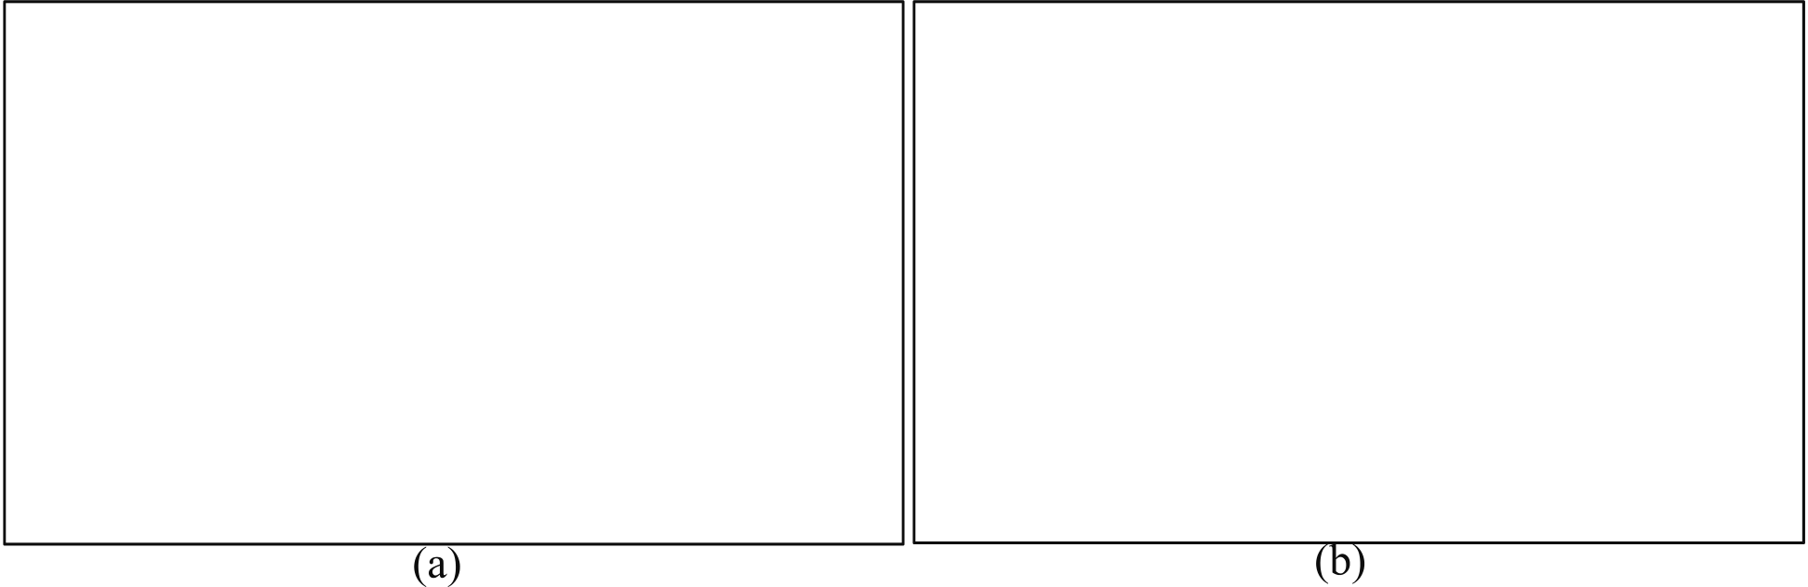
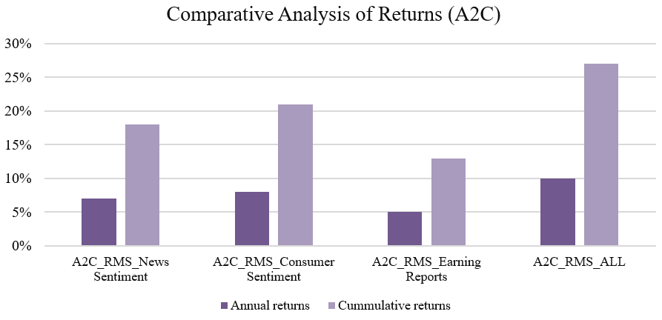
A. Sattar et al.: Novel RMS-Driven DRL for Optimized Portfolio Management in Stock Trading

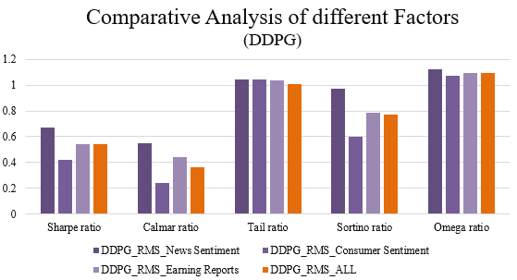

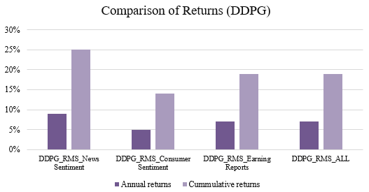

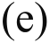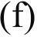
FIGURE 8.(a)Comparative Analysis of Individual Indicators using proposed A2C based RMS model (b)Comparative Analysis of Individual Indicators
using proposed DDPG based RMS model (c)Comparative Analysis of Individual Indicators using proposed PPO based RMS model.

potentialinimprovingthetradingmodel.Themostsignifi-cantfindingfromthisresearchisthatcombiningconsumer andnewssentimentinadditiontoearningreportscon-siderablyimprovestradingdecision-making.Thisinclusion providesacomprehensiveviewofthemarketbycom-biningconventionalfinancialindicators—suchasprofits andrevenuefromearningsreports,andwithpsychological andemotionalfactorsderivedfromnewssentimentsthat influenceinvestorpurchasingandinvestmentchoices.The variants of DRL proposed in this work including PPO_RMS, A2C_RMS,andDDPG_RMSunderscorethebenefitsof

includingsentimentdatawithriskmanagementapproaches such as by including Max Drawdown based penalty in reward function. Both these models give due importance to long-term strategicplanning,yettheyareabletoensureshort-term gainsaswell,therebygivinganedgeovertheconventional techniquesprovenbybetterrisk-adjustedreturnsandother parameters such as the Sharpe and Calmar ratios. This implies thattheproposedmodelsarenotonlyadvantageousbut thattheyaremorerobustinfluctuatingmarkets.Themost importantimplicationofthisresearchistheintroduction ofdifferentfactorsinthestaterepresentationoftrading

VOLUME 13, 2025 42829

 | A. Sattar et al.: Novel RMS-Driven DRL for Optimized Portfolio Management in Stock Trading
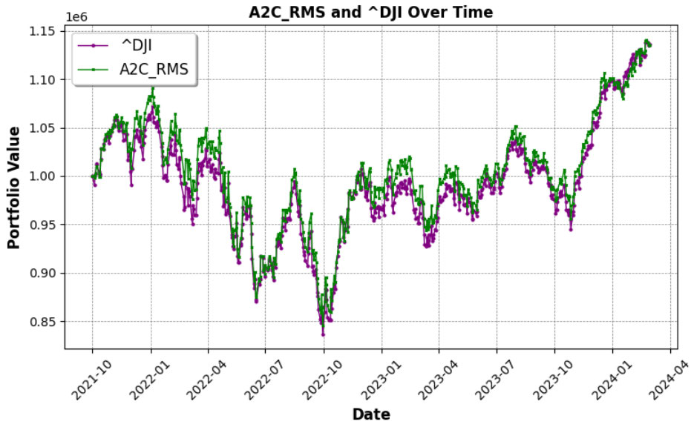 |  | 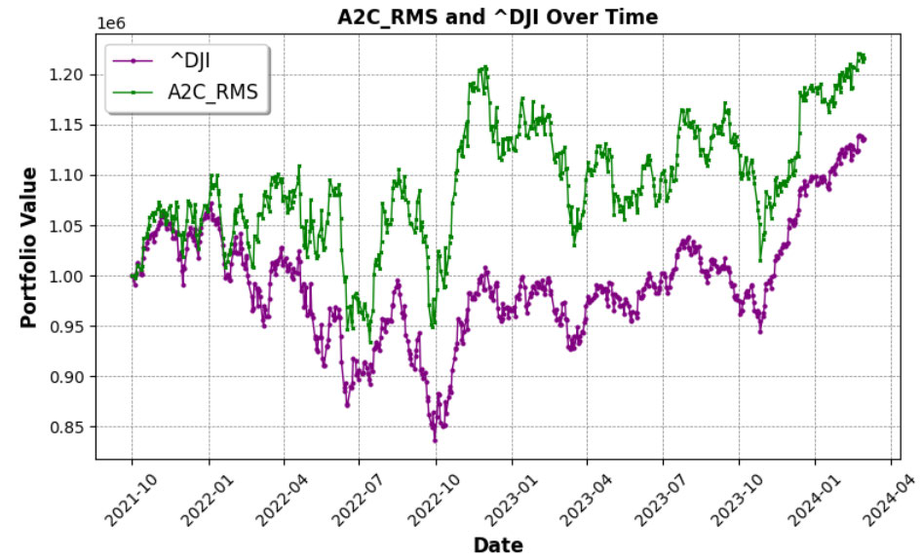
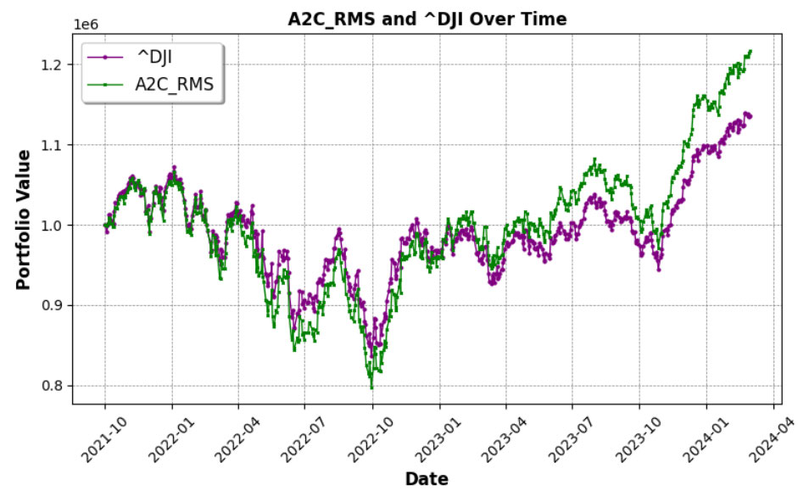
FIGURE 9.Portfolio value of proposed A2C_RMS vs baseline ^DJI index during back testing with data (a) of Earning Reports (b) news sentiment (c) Consumer sentiment.
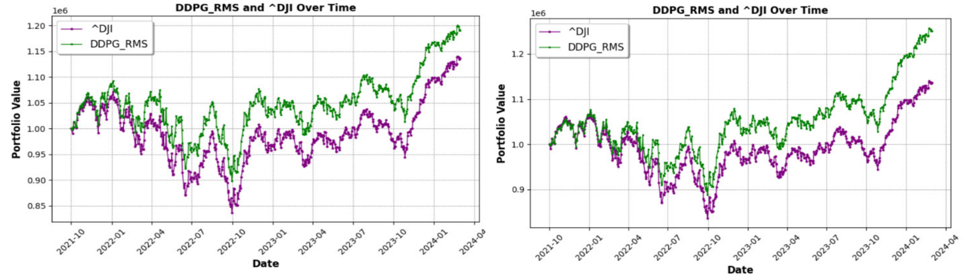
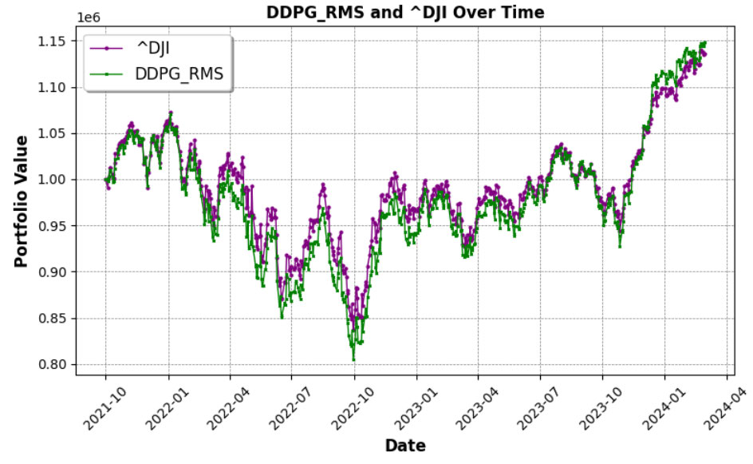
FIGURE 10.Portfolio value of proposed DDPG_RMS vs baseline ^DJI index during back testing with data (a) of Earning Reports (b) news sentiment (d) Consumer sentiment Index.
42830 VOLUME 13, 2025

A. Sattar et al.: Novel RMS-Driven DRL for Optimized Portfolio Management in Stock Trading
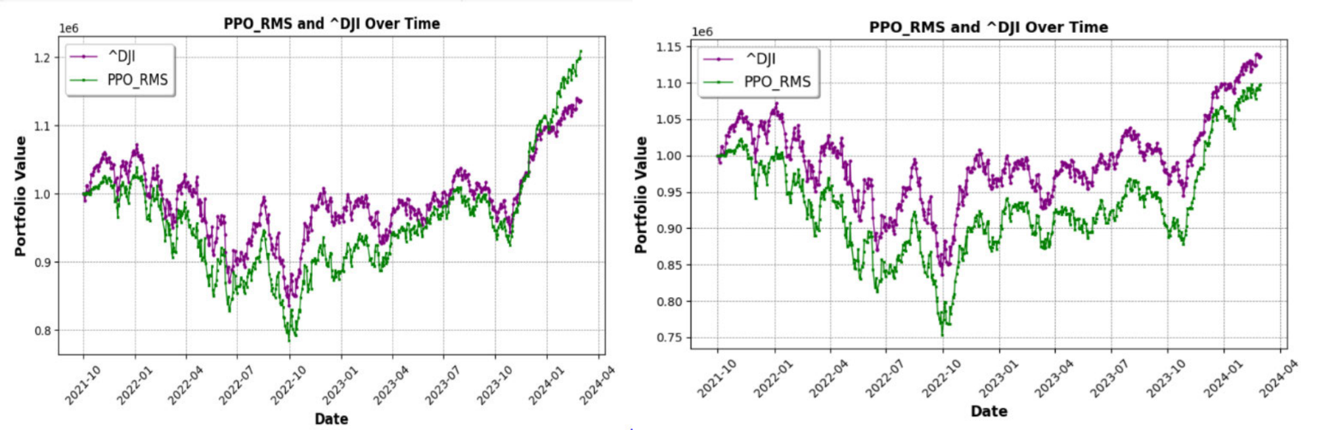
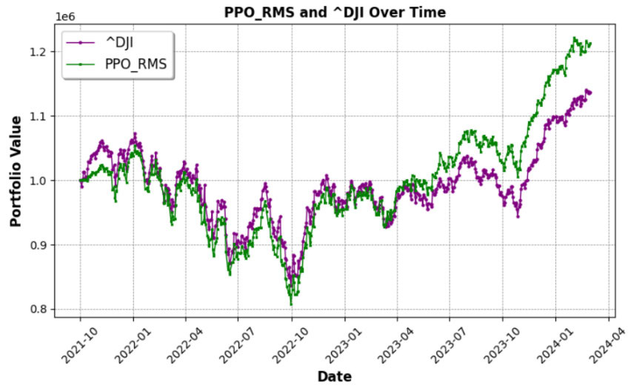
FIGURE 11.Portfolio value of proposed PPO_RMS vs baseline ^DJI index during back testing with data (a) of Earning Reports (b) news sentiment
(d) Consumer sentiment.

algorithms. In the past, most of the policies simply depended on historical data, andotherfactorsbutneglectedconsumer sentiment index and data from earning reports. However, this studyhasdemonstratedthatthereexistsalotofpotential ininvolvingthesefactorswhichcangiveanextralayerof insight to the algorithms and help them to predict the market trends better and also to respond to them better could become thefoundationforanewgenerationoftradingsystemsthat would function better in today’s global financial environment. Furthermore,thestudyrecommendsthatsentimentindices whencombinedwiththeearningsreportsmaybeusefulin risk management. Max Drawdown integrated into the reward function of the proposed models captures the need for trading strategiesnottoalwaysaimathighgainsbutlowlossesas well. The combination and/or integration of these two aspects is vital for traders and investors who want to get the most out oftheirprofitandatthesametime,minimizethelevelof

andbetterrepresentsrealmarkettrends.Inaddition,high-frequencydata(e.g.,minute-by-minuteortick-leveldata) iscomputationallyextensivetoprocessandrequiresmore training time. Overfitting to short-term market signals is risky because high-frequency models might become too dependent on microstructure noise. As a result, daily data enables the RL agent to generalize more accurately while remaining compu-tationally feasible. The RL-based methodology developed in thisstudyisfeasibleformanagerswhowanttomaximize dailytradingchoices.Theday-by-dayapproachprovides individual investors with an automatic decision-making tech-niquethatassistsinbalancingreturnsandriskwithout requiringongoingmarketmonitoring.Themodelistrans-formed into an evolving automated decision-making system thatchangeswiththeevolvingmarketconditionsandhelps managers in their portfolio decisions. The proposed RL-based strategy is able to adapt to continual updates using new data

risks. with online learning. Furthermore, the proposed model high-

Moreover,theproposedstudyisbasedonanintraday tradingstrategyinwhichdailystockdata(i.e.,end-of-day prices and relevant indicators) is employed. The rationale is

lightscrucialcriteriaformodelingtheproblemofportfolio optimization, such as the importance of consumer sentiment, thenewssentimentindex,anddatafromstockearnings

thatdailydataachievesanidealbalanceamonggranularity reports.

and stability. In comparison to high-frequency data (e.g., tick orminute-level),dailydataincludessubstantiallylessnoise

Furthermore, the proposed RL model has good advantages overfinancialstudiesthatachievethesametaskwithsome

VOLUME 13, 2025 42831

A. Sattar et al.: Novel RMS-Driven DRL for Optimized Portfolio Management in Stock Trading
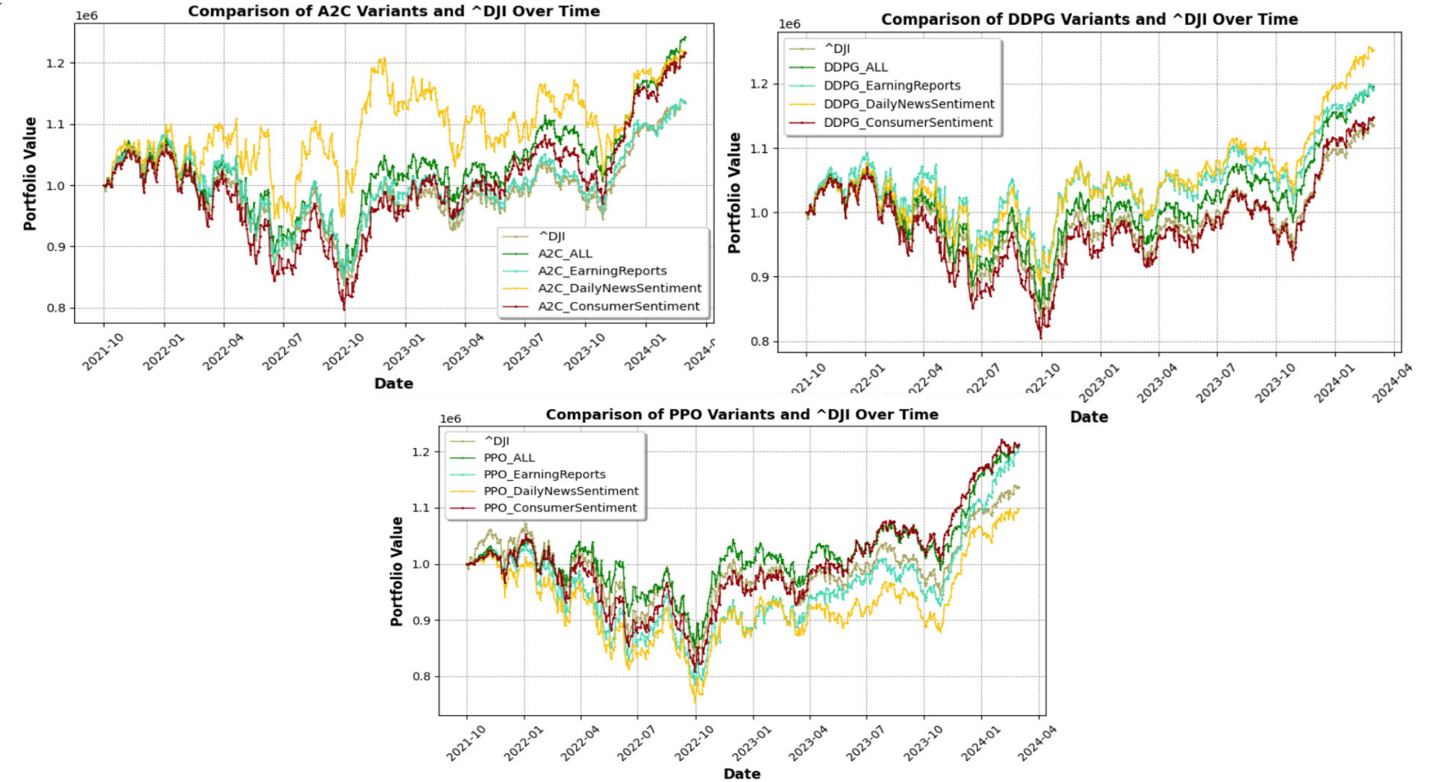
FIGURE 12.Combined comparison of proposed agents (A2C, DDPG, and PPO) on different indicators namely daily news sentiment, consumer sentiment
index, and earning reports.

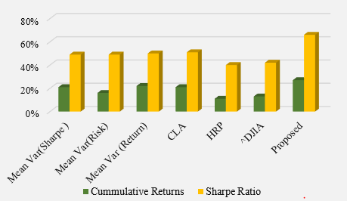

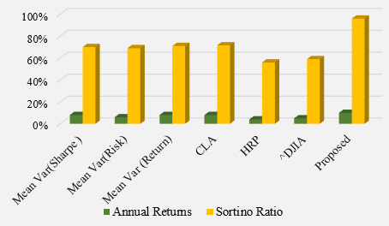

FIGURE 13.Comparison of proposed agents (A2C, DDPG, and PPO) with baseline methods (a) Cumulative returns and Sharpe ratio (b) Annual returns and Sortino ratio.

other simpler methods. Those simpler methods are although showgoodresultsbuttheyhavesomelimitationswhichis why the latest studies adopt the use of RL [62]. Several sim-ple methods such as mean reversion [10], momentum-based methods [11], and rule-discovery techniques [12] exist in the literature, but they have poor generalization and do not show good results in all market conditions [62]. Some methods are basedontwo-stepstrategiessuchasthepredictionofstock pricesusingsupervisedMLalgorithmsandlaterontrad-ing decisions are made based on predictions, however, there exists a major gap between both stages [62]. A comparative analysisofbaselinestrategiesbothinexistingstudies[1], [41],[63],[64],[65],[66]aswellasinthisresearch

(e.g. Figure 13) reveals the importance of RL over basic sim-ple methods. These RL models modify their learned strategy in response to environmental conditions in comparison with fixed static rule-based simple methods. We acknowledge that theseRL-basedmethodsrequiremorecomputationalcom-plexity in training in contrast to simple methods and are less interpretable but show good performance over these methods inthepresenceofcomplex,andnon-lineardependencies. Moreover,theprobleminthisstudyismadesimplerandis inlinewiththatofactualportfoliomanagersbyemploying intra-day (i.e. daily) data instead of high-frequency data. The primaryfocusofthisstudyisonalgorithmicallyimproving RL-basedmodelsinsteadofmakingproblemcomplexfor

42832 VOLUME 13, 2025

A. Sattar et al.: Novel RMS-Driven DRL for Optimized Portfolio Management in Stock Trading

stock trading by considering and exploiting the usage of dif-ferent factors such as earning reports, and consumer and news sentimentsinadditiontoRLagentfeedbackusingthepro-posedmax-drawdownpenalty-basedrewardfunction.Since these are overlooked in the existing literature of financial RL andthisstudyaimstofilltheseresearchgaps.Hence,itis animportantstepforwardinfurtheringandimprovingthe useofRLinstocktradingapplicationsandthusshowing goodresultsoverbaselinesimplemethodsasobservedin

Thesuggestedrewardfunction,withitsMaxDrawdown component, efficiently balances profitability and risk, result-ingineffectivetradingstrategies.Comparedtoallmodels, DDPG_RMS demonstrates good outcomes by demonstrating yearlyreturnsof10%,cumulativereturnsof27%,Sharpe ratio of 0.66, and Sortino ratio of 0.96. In general, the addi-tionofsentimentindiceswithtraditionalearningsenhances theDRL-basedtradingmodelsandcanbetermedamajor step forward in trading science by offering improved market

Figure 13. insightsandconsistentlyhighperformance.Futurestudies

However,thestudyhassomelimitationsthatshouldbe takenintoconsiderationforfuturework.Firstofall,back-testingwasconductedonasinglestockmarketofDOW Jones,whichinsomewaymightnotreflecttheresultsin other markets such as SP500 having different levels of volatil-ityintheirprices.Futureworkalsoincludesvalidatingthe model such as how it will perform when applied to real-time trading with live data and unanticipated events. Likewise, the findingsofthisstudyaremainlybasedontheU.S.stock marketsandtheresultsmightnotnecessarilygeneralizeto other country’s markets characterized by different conditions andenvironments.Onepossiblefutureworkentailfollow-ingthedevelopmentofthegivenmodelandapplyingitto

willincludeleveragingadditionalfactorstoimprovethe DRL’sstaterepresentation,suchasmacroeconomicindi-cators,eventsentiments(suchassentimentscenteredon political events such as elections or natural disasters events), andcorrelationrelationshipsacrossstocks.Furthermore, designing a better reward function, such
asutilizingtheSortinoratio,isapromisingfuturestudy direction.Similarly,investigatinghybridRLmodelsor addingensemblelearningapproachescanimprovestability as well as performance.
ACKNOWLEDGMENT
The authors would like to thank Prince Sultan University for

differentinternationalmarkets,consideringlocalsentiment their support.
indicators and the market environment. Finally, although this

studyincorporatessentimentanalysisandearningsreports, othervariablesincludinggeopolitics,macrosfactors,and technologydisruptionscanalsobeconsideredtofurther improve the performance. Further research could continue the development of this model by incorporating these other data sourceswiththeaimofimprovingthegeneralizabilityand

REFERENCES
[1]Y.Ansari,S.Gillani,M.Bukhari,B.Lee,M.Maqsood,andS.Rho,‘‘Amultifacetedapproachtostockmarkettradingusingreinforcement learning,’’ IEEE Access, vol. 12, pp. 90041–90060, 2024.
[2]L.D.Oyeniyi,C.E.Ugochukwu,andN.Z.Mhlongo,‘‘Analyzingthe impact of algorithmic trading on stock market behavior: A comprehensive review,’’WorldJ.Adv.Eng.Technol.Sci.,vol.11,no.2,pp. 437–453,

accuracy of the model. Apr. 2024.
[3]O.BustosandA.Pomares-Quimbaya,‘‘Stockmarketmovementfore-

V.CONCLUSION
Stockmarkettradingcontinuestobeanimportantpartof the worldwide economy, providing the potential for financial accumulationanddiversificationinaportfolio.Ingeneral, tradersusefinancialdomainknowledgeandfundamental

cast:Asystematicreview,’’ExpertSyst.Appl.,vol.156,Oct.2020, Art. no. 113464.
[4]I.K.Nti,A.F.Adekoya,andB.A.Weyori,‘‘Asystematicreviewof fundamentalandtechnicalanalysisofstockmarketpredictions,’’Artif. Intell. Rev., vol. 53, no. 4, pp. 3007–3057, Apr. 2020.
[5]B.Dhingra,S.Batra,V.Aggarwal,M.Yadav,andP.Kumar,‘‘Stock market volatility: A systematic review,’’ J. Model. Manage., vol. 19, no. 3,

analysis to arrive at informed trading decisions with the goal pp. 925–952, Nov. 2023.

of maximizing gains in the markets. Nevertheless, trading in thestockmarketisalwayscomplicatedandchallengingfor traders because of the unanticipated characteristics of market behavior,high-dimensionalinformation,andtheinteraction of numerous elements including news sentiments, consumer sentiment, macroeconomic variables, and stock micro-factors suchasearnings.Toaddressthis,anovelstrategyforstock market trading based on RMS factors i.e., enriching states of theDRLmodelwithnewssentiment,consumersentiment, earning reports in addition to daily historical data, technical indicators, and Max drawdown rewards has been proposed.
The findings indicate that these variables helped in learn-ingtheDRLmodelforanalyzingmarketmovementsand constructingbettertradingstrategies.Itcanbeconcluded thatthesuggestedRLmodels(PPO_RMS,A2C_RMS,and DDPG_RMS)outperformtheDJIindexaswellasbase-linemethodsoftradinge.g.,MeanVarianceOptimization.

[6]G. | Cohen, | ‘‘Technical |  | analysis | in | investing,’’ |  | 2, | Rev. | Pacific
Basin | Financial |  | Markets | Policies, | vol. | 26, | no. | 2, | Apr. | 2023,
Art. no. 2350013.
[7]G.Chen,K.A.Kim,J.R.Nofsinger,andO.M.Rui,‘‘Tradingper-formance, disposition effect, overconfidence, representativeness bias, and experienceofemergingmarketinvestors,’’J.Behav.Decis.Making, vol. 20, no. 4, pp. 425–451, Oct. 2007.
[8]X.Wu,H.Chen,J.Wang,L.Troiano,V.Loia,andH.Fujita,‘‘Adaptive stocktradingstrategieswithdeepreinforcementlearningmethods,’’Inf. Sci., vol. 538, pp. 142–158, Oct. 2020.
[9]F.G.D.C.Ferreira,A.H.Gandomi,andR.T.N.Cardoso,‘‘Artificial intelligenceappliedtostockmarkettrading:Areview,’’IEEEAccess, vol. 9, pp. 30898–30917, 2021.
[10]J.M.PoterbaandL.H.Summers,‘‘Meanreversioninstockprices: Evidenceandimplications,’’J.FinancialEcon.,vol.22,pp. 27–59, Aug. 1987.
[11]N. Jegadeesh and S. Titman, ‘‘Returns to buying winners and selling losers: Implications for stock market efficiency,’’ J. Finance, vol. 48, no. 1, p. 65, Mar. 1993.
[12]J.-L.WangandS.-H.Chan,‘‘Stockmarkettradingrulediscoveryusing patternrecognitionandtechnicalanalysis,’’ExpertSyst.Appl.,vol.33, no. 2, pp. 304–315, Aug. 2007.

VOLUME 13, 2025 42833

A. Sattar et al.: Novel RMS-Driven DRL for Optimized Portfolio Management in Stock Trading

[13]G. Sonkavde, D. S. Dharrao, A. M. Bongale, S. T. Deokate, D. Doreswamy, and S. K. Bhat, ‘‘Forecasting stock market prices using machine learning and deep learning models: A systematic review, performance analysis and discussionofimplications,’’Int.J.FinancialStud.,vol.11,no.3,p. 94,

[35]J. Shin, Y. Kaneko, A. S. M. Miah, N. Hassan, and S. Nishimura, ‘‘Anomaly detection in weakly supervised videos using multistage graphs and general deep learning based spatial–temporal feature enhancement,’’ IEEE Access, vol. 12, pp. 65213–65227, 2024.

Jul. 2023. [36]S. Banik, N. Sharma, M. Mangla, S. N. Mohanty, and S. Shitharth, ‘‘LSTM

[14]T.KabbaniandE.Duman,‘‘Deepreinforcementlearningapproach fortradingautomationinthestockmarket,’’IEEEAccess,vol.10, pp. 93564–93574, 2022.
[15]M. Nabipour, P. Nayyeri, H. Jabani, S. Shahab, and A. Mosavi, ‘‘Predicting stock market trends using machine learning and deep learning algorithms viacontinuousandbinarydata;acomparativeanalysis,’’IEEEAccess, vol. 8, pp. 150199–150212, 2020.
[16]D.JothimaniandS.S.Yadav,‘‘Stocktradingdecisionsusingensemble-based forecasting models: A study of the Indian stock market,’’ J. Banking Financial Technol., vol. 3, no. 2, pp. 113–129, Oct. 2019.
[17]Z.Zhang,S.Zohren,andS.Roberts,‘‘Deepreinforcementlearningfor trading,’’ 2019, arXiv:1911.10107.
[18]N. Bhavatarini, S. T. Ahmed, and S. M. Basha, Reinforcement Learning-Principles,ConceptsandApplications.Valbrembo,Italy:MileStone Research Publications, 2024.
[19]Y.Shi,W.Li,L.Zhu,K.Guo,andE.Cambria,‘‘Stocktradingrule discoverywithdoubledeepQ-network,’’Appl.SoftComput.,vol.107, Aug. 2021, Art. no. 107320.
[20]B.Kommey,O.J.Isaac,E.Tamakloe,andD.Opoku,‘‘Reinforcement learningreview:Pastacts,presentfactsandfutureprospects,’’ITJ.Res. Develop., vol. 8, no. 2, pp. 120–142, Feb. 2024.
[21]Y.Yu,‘‘Asurveyofdeepreinforcementlearninginfinancialmarkets,’’in Proc. 3rd Int. Academic Conf. Blockchain, Inf. Technol. Smart Finance (ICBIS), Jan. 2024, pp. 188–194.
[22]L.ChenandQ.Gao,‘‘Applicationofdeepreinforcementlearningon automated stock trading,’’ in Proc. IEEE 10th Int. Conf. Softw. Eng. Service Sci. (ICSESS), Oct. 2019, pp. 29–33.
[23]A.R.Azhikodan,A.G.K.Bhat,andM.V.Jadhav,‘‘Stocktradingbot usingdeepreinforcementlearning,’’inProc.5thICICSE,May2018, pp. 41–49.

based decision support system for swing trading in stock market,’’ Knowl.-Based Syst., vol. 239, Mar. 2022, Art. no. 107994.
[37]A.Shah,M.Gor,M.Sagar,andM.Shah,‘‘Astockmarkettrading framework based on deep learning architectures,’’ Multimedia Tools Appl., vol. 81, no. 10, pp. 14153–14171, Apr. 2022.
[38]M. Thakur and D. Kumar, ‘‘A hybrid financial trading support system using multi-category classifiers and random forest,’’ Appl. Soft Comput., vol. 67, pp. 337–349, Jun. 2018.
[39]Y.Huang,X.Wan,L.Zhang,andX.Lu,‘‘Anoveldeepreinforcement learning framework with BiLSTM-attention networks for algorithmic trad-ing,’’ Expert Syst. Appl., vol. 240, Apr. 2024, Art. no. 122581.
[40]B. Yang, T. Liang, J. Xiong, and C. Zhong, ‘‘Deep reinforcement learning basedontransformerandU-Netframeworkforstocktrading,’’Knowl.-Based Syst., vol. 262, Feb. 2023, Art. no. 110211.
[41]Y.Huang,C.Zhou,K.Cui,andX.Lu,‘‘Amulti-agentreinforcement learningframeworkforoptimizingfinancialtradingstrategiesbasedon TimesNet,’’ Expert Syst. Appl., vol. 237, Mar. 2024, Art. no. 121502.
[42]D. Kwak, S. Choi, and W. Chang, ‘‘Self-attention based deep direct recur-rent reinforcement learning with hybrid loss for trading signal generation,’’Inf. Sci., vol. 623, pp. 592–606, Apr. 2023.
[43]J. Zou, J. Lou, B. Wang, and S. Liu, ‘‘A novel deep reinforcement learning basedautomatedstocktradingsystemusingcascadedLSTMnetworks,’’Expert Syst. Appl., vol. 242, May 2024, Art. no. 122801.
[44]Y.KwonandZ.Lee,‘‘Ahybriddecisionsupportsystemforadaptive tradingstrategies:Combiningarule-basedexpertsystemwithadeep reinforcement learning strategy,’’ Decis. Support Syst., vol. 177, Feb. 2024, Art. no. 114100.
[45]M. Shin, J. Kim, and M. Kim, ‘‘Human learning from artificial intelligence: Evidencefromhumangoplayers’decisionsafterAlphaGo,’’inProc. Annu. Meeting Cogn. Sci. Soc., 2021, pp. 1795–1801.
[46]T. Chong, W.-K. Ng, and V. Liew, ‘‘Revisiting the performance of MACD andRSIoscillators,’’J.RiskFinancialManage.,vol.7,no.1,pp. 1–12,

[24]P.Liu,Y.Zhang,F.Bao,X.Yao,andC.Zhang,‘‘Multi-typedatafusion Feb. 2014.

framework based on deep reinforcement learning for algorithmic trading,’’Appl. Intell., vol. 53, no. 2, pp. 1683–1706, Jan. 2023.
[25]Y.Liu,D.Mikriukov,O.C.Tjahyadi,G.Li,T.R.Payne,Y.Yue, K. Siddique,andK.L.Man,‘‘Revolutionisingfinancialportfolioman-agement:Thenon-stationarytransformer’sfusionofmacroeconomic indicators and sentiment analysis in a deep reinforcement learning frame-work,’’ Appl. Sci., vol. 14, no. 1, p. 274, Dec. 2023.
[26]W.Wang,C.Su,andD.Duxbury,‘‘Investorsentimentandstock returns:Globalevidence,’’J.EmpiricalFinance,vol.63,pp. 365–391, Sep. 2021.
[27]M. Hiransha, E. A. Gopalakrishnan, V. K. Menon, and K. Soman, ‘‘NSE stock market prediction using deep-learning models,’’ Proc. Comput. Sci., vol. 132, pp. 1351–1362, Jan. 2018.
[28]Y.Ansari,‘‘Multi-clustergraph(MCG):Anovelclustering-basedmulti-relation graph neural networks for stock price forecasting,’’ IEEE Access, vol. 12, pp. 154482–154502, 2024.
[29]J.-H. Park, J.-H. Kim, and J.-H. Huh, ‘‘Deep reinforcement learning robots foralgorithmictrading:ConsideringstockmarketconditionsandU.S.

[47]M. Maitah, P. Procházka, M. Čermák, and K. Šrédl, ‘‘Commodity channel index: Evaluation of trading rule of agricultural commodities,’’ Int. J. Econ. Financial Issues, vol. 6, no. 1, pp. 176–178, Jan. 2016.
[48]I. Gurrib, ‘‘Performance of the average directional index as a market timing tool for the most actively traded USD based currency pairs,’’ Banks Bank Syst., vol. 13, no. 3, pp. 58–70, Aug. 2018.
[49]S.-K. Bormann,‘‘Sentiment indices on financial markets: What do they measure?’’ Economics Discussion Papers, Germany, Tech. Rep. 2013-58, 2013.
[50]D. E. Allen, M. McAleer, and A. K. Singh, ‘‘Daily market news sentiment and stock prices,’’ Appl. Econ., vol. 51, no. 30, pp. 3212–3235, Jun. 2019. [51]DailyNewsSentimentIndex.Accessed:Aug.30,2024.[Online].
Available: https://www.frbsf.org/research-and-insights/data-and-indicators/daily-news-sentiment-index/
[52]UniversityofMichigan,UniversityofMichigan:ConsumerSentiment [UMCSENT]. Federal Reserve Bank of St. Louis. Accessed: Feb. 28, 2025.
[Online]. Available: https://fred.stlouisfed.org/series/UMCSENT
[53]D.E.Hirst,L.Koonce,andS.Venkataraman,‘‘Managementearnings forecasts: A review and framework,’’ Accounting Horizons, vol. 22, no. 3,

interest rates,’’ IEEE Access, vol. 12, pp. 20705–20725, 2024. pp. 315–338, Sep. 2008.

[30]M. Metghalchi, N. Durmaz, P. Cloninger, and K. Farahbod, ‘‘Trading rules and excess returns: Evidence from Turkey,’’ Int. J. Islamic Middle Eastern Finance Manage., vol. 14, no. 4, pp. 713–731, Jul. 2021.
[31]K. Chourmouziadis and P. D. Chatzoglou, ‘‘An intelligent short term stock tradingfuzzysystemforassistinginvestorsinportfoliomanagement,’’Expert Syst. Appl., vol. 43, pp. 298–311, Jan. 2016.
[32]A.Z.Khan,P.Gupta,andM.K.Mehlawat,‘‘Afuzzyrule-basedsystem for portfolio selection using technical analysis,’’ IEEE Trans. Fuzzy Syst., vol. 32, no. 9, pp. 4861–4875, Sep. 2024.
[33]Y.Kim,W.Ahn,K.J.Oh,andD.Enke,‘‘Anintelligenthybridtrading systemfordiscoveringtradingrulesforthefuturesmarketusingrough setsandgeneticalgorithms,’’Appl.SoftComput.,vol.55,pp. 127–140, Jun. 2017.
[34]M.Bukhari,K.B.Bajwa,S.Gillani,M.Maqsood,M.Y.Durrani, I. Mehmood, H. Ugail, and S. Rho, ‘‘An efficient gait recognition method forknownandunknowncovariateconditions,’’IEEEAccess,vol.9, pp. 6465–6477, 2021.

[54]AlphaVantageAPI.Accessed:Aug.30,2024.[Online].Available: https://www.alphavantage.co/documentation/
[55]M.Magdon-IsmailandA.F.Atiya,‘‘Maximumdrawdown,’’RiskMag., vol. 17, pp. 99–102, Oct. 2004.
[56]D. Silver, G. Lever, N. Heess, T. Degris, D. Wierstra, and M. Riedmiller,‘‘Deterministicpolicygradientalgorithms,’’inProc.Int.Conf.Mach. Learn., Jun. 2014, pp. 387–395.
[57]R.S.SuttonandA.G.Barto,ReinforcementLearning:AnIntroduction. Cambridge, MA, USA: MIT Press, 2018.
[58]R.S.Sutton,D.McAllester,S.Singh,andY.Mansour,‘‘Policygradient methods for reinforcement learning with function approximation,’’ in Proc. Adv. Neural Inf. Process. Syst., vol. 12, Nov. 1999, pp. 1057–1063.
[59]A.Ang,‘‘Mean-varianceinvesting,’’ColumbiaBus.SchoolRes.
PaperSer.,NewYork,NY,USA,Tech.Rep.12/49,Aug.2012,doi:
[60]M.L.dePrado,‘‘Buildingdiversifiedportfoliosthatoutperform out-of-sample,’’J.PortfolioManag.,May2016.[Online].Available: http://dx.doi.org/10.2139/ssrn.2708678

42834 VOLUME 13, 2025

A. Sattar et al.: Novel RMS-Driven DRL for Optimized Portfolio Management in Stock Trading

[61]D.BaileyandM.L.dePrado,‘‘Anopen-sourceimplementationofthe critical-line algorithm for portfolio optimization,’’ Algorithms, vol. 6, no. 1, pp. 169–196, Mar. 2013.
[62]S. Sun, R. Wang, and B. An, ‘‘Reinforcement learning for quantitative trad-ing,’’ ACM Trans. Intell. Syst. Technol., vol. 14, no. 3, pp. 1–29, Jan. 2023. [63]X.-Y.Liu,H.Yang,J.Gao,andC.Wang,‘‘FinRL:Deepreinforcement learning framework to automate trading in quantitative finance,’’ in Proc. 2nd ACM Int. Conf. AI finance, Jan. 2021, pp. 1–9.
[64]T.ThéateandD.Ernst,‘‘Anapplicationofdeepreinforcementlearn-ingtoalgorithmictrading,’’ExpertSyst.Appl.,vol.173,Jul.2021, Art. no. 114632.
[65]S.Carta,A.Corriga,A.Ferreira,A.S.Podda,andD.R.Recupero,‘‘Amulti-layerandmulti-ensemblestocktraderusingdeeplearningand deepreinforcementlearning,’’Appl.Intell.,vol.51,no.2,pp. 889–905, Feb. 2021.
[66]B. | Jin, | ‘‘A | mean-VaR | based | deep | reinforcement | learning
frameworkforpracticalalgorithmictrading,’’IEEEAccess,vol.11, pp. 28920–28933, 2023.
ASMASATTARreceivedthePh.D.degreein
AssistantProfessorwiththeSoftwareEngineer-ing Department, Prince Sultan University, Riyadh, SaudiArabia.ShewasaDataScientistwith theH&MResearchGroup,Stockholm,Sweden, where she contributed to deep learning algorithms computersciencefromtheUniversityofPisa, Italy. She focused on deep learning approaches for graphs in context-aware recommendation systems withtheUniversityofPisa.Sheiscurrentlyan
forpredictiontasksinvolvingdynamicmulti-relationgraphs.Herresearch interests include machine learning, deep learning for graphs, and their appli-cations in recommender systems.

SAIRAGILLANIreceivedthePh.D.degreein
fessorwithSaudiElectronicUniversity,Jeddah, SaudiArabia.SheiscurrentlyaProfessorwith the University of Central Punjab, Lahore, Pakistan. Previously,shewasaResearchScholarwiththe Corvinno,TechnologyTransferCenterofInfor-information sciences from the Corvinus University of Budapest, Hungary. She joined the COMSATS InstituteofInformationTechnology,Islamabad, Pakistan,in2016.ShewasanAssistantPro-
mationTechnologyandServices,Budapest,Hungary,andaResearch Associate with the Center of Research in Networks and Telecom (CoReNet), CUST,Pakistan.Herresearchinterestsincludedatasciences,textmining, data mining, machine learning, vehicular networks, mobile edge computing, and the Internet of Things.
MARYAM BUKHARI is currently pursuing

thePh.D.degreeincomputersciencewith COMSATS University Islamabad, Attock, Pakistan. Her research interests include computer vision, deep learning and machine learning.
than30conferences/workshopsasaprogramcommitteemember.Hehas knowledge management, and computational intel-ligence.Hehaspublished300papersinrefereed journalsandconferenceproceedingsinthese areas. He has been involved in more than 20 con-ferences and workshops as various chairs and more SEUNGMINRHOis currently an Associate Pro-fessor with the Department of Industrial Security, Chung-Ang University. His current research inter-estsincludedatabase,bigdataanalysis,music retrieval,multimediasystems,machinelearning,
edited a number of international journal special issues as a guest editor, such asMultimediaSystems,InformationFusion,andEngineeringApplications of Artificial Intelligence.

 | AMNASARWARreceivedtheM.Sc.degreein |  | MUHAMMAD | FASEEH | received | the | B.S.
 | AMNASARWARreceivedtheM.Sc.degreein |  | andM.S.degreesincomputersciencefrom COMSATS University Islamabad, Pakistan. He is currentlypursuingthePh.D.degreewithJeju NationalUniversity,RepublicofKorea,show-casinghiscommitmenttoacademicexcellence. HeiscurrentlyaDedicatedComputerScien-tist.Hebringsawealthofexperiencefromboth the software development industry and academia, highlightinghisversatility.Hisresearchinterests
 | software engineering, with a strong focus on image
 | processingandmachinelearning-basedsystems.
 | She is currently a Lecturer with the Department of
 | Computer Science, WAH University, Pakistan. Her
 | researchinterestsincludeimageprocessing,nat- | include cutting-edge fields, such as AI-based intelligent systems, computer
 | urallanguageprocessing,computervision,deep | vision, data science, big data analytics, machine learning, and deep learning,
 | urallanguageprocessing,computervision,deep | reflectinghispassionforadvancingtechnologyandknowledgeinthese
 | learning, and machine learning.
 | learning, and machine learning. | domains.
VOLUME 13, 2025 | learning, and machine learning. | 42835

