Sleep Deprivation

This is an [R Markdown](http://rmarkdown.rstudio.com) Notebook. When you execute code within the notebook, the results appear beneath the code.

Try executing this chunk by clicking the *Run* button within the chunk or by placing your cursor inside it and pressing *Ctrl+Shift+Enter*.

Add a new chunk by clicking the *Insert Chunk* button on the toolbar or by pressing *Ctrl+Alt+I*.

When you save the notebook, an HTML file containing the code and output will be saved alongside it (click the *Preview* button or press *Ctrl+Shift+K* to preview the HTML file).

The preview shows you a rendered HTML copy of the contents of the editor. Consequently, unlike *Knit*, *Preview* does not run any R code chunks. Instead, the output of the chunk when it was last run in the editor is displayed.

library(s20x)  
#laptop:/  
setwd("C:/Users/Alex/Documents/GitHub/Engsci211Assignment2")  
#home computer:  
#setwd("I:/GitHub/Engsci 211/Engsci211Assignment2")  
sleepDep.df = read.table("sleepDeprivation.txt", header = TRUE)  
head(sleepDep.df)

## Deprived SleepHrs  
## 1 No 8  
## 2 No 6  
## 3 No 7  
## 4 Yes 6  
## 5 Yes 6  
## 6 Yes 7

#Deprived is already a factor with the states yes and no

### **Exploratory analysis**

I need both regression and analysis of variance

boxplot(SleepHrs ~ Deprived, data = sleepDep.df)

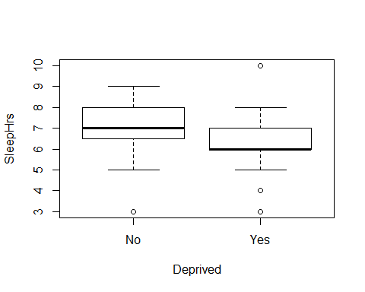

t.test(SleepHrs ~ Deprived, data = sleepDep.df)

##   
## Welch Two Sample t-test  
##   
## data: SleepHrs by Deprived  
## t = 4.0395, df = 68.827, p-value = 0.0001373  
## alternative hypothesis: true difference in means is not equal to 0  
## 95 percent confidence interval:  
## 0.5046684 1.4896173  
## sample estimates:  
## mean in group No mean in group Yes   
## 7.057143 6.060000

plot(SleepHrs ~ Deprived, data = sleepDep.df)



onewayPlot(SleepHrs ~ Deprived, data = sleepDep.df)

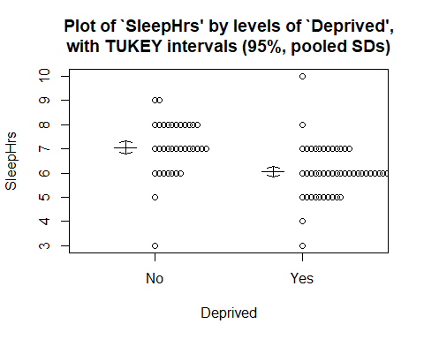

#ci = t.test(SleepHrs ~ Deprived, data = sleepDep.df)$conf.int

sleepDep.fit = lm(SleepHrs ~ Deprived, data = sleepDep.df)  
plot(sleepDep.fit)

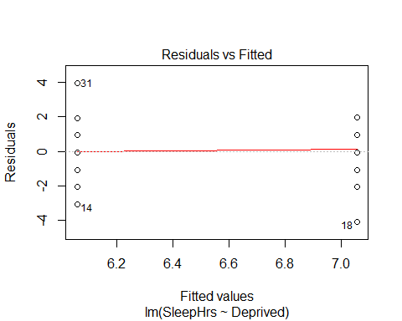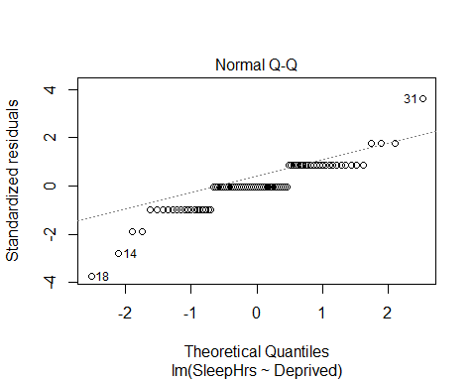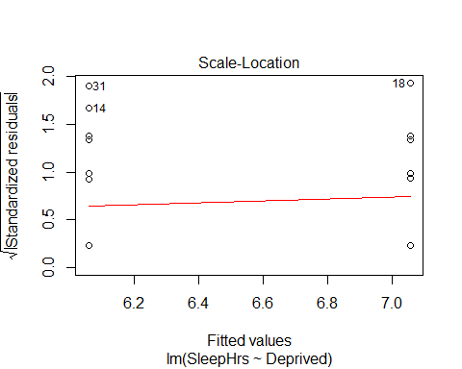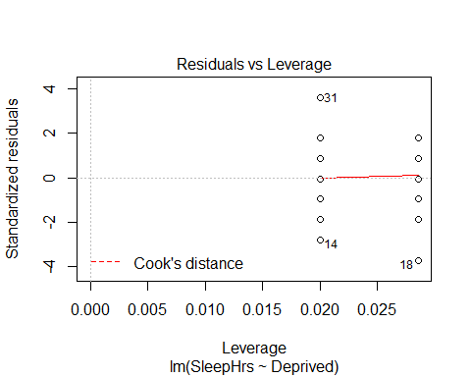

eovcheck(sleepDep.fit)

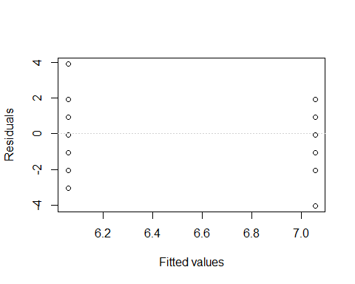

summary(sleepDep.fit)

##   
## Call:  
## lm(formula = SleepHrs ~ Deprived, data = sleepDep.df)  
##   
## Residuals:  
## Min 1Q Median 3Q Max   
## -4.057 -0.060 -0.060 0.940 3.940   
##   
## Coefficients:  
## Estimate Std. Error t value Pr(>|t|)   
## (Intercept) 7.0571 0.1862 37.903 < 2e-16 ***  
## DeprivedYes -0.9971 0.2428 -4.108 9.33e-05 ***  
## ---  
## Signif. codes: 0 '***' 0.001 '**' 0.01 '*' 0.05 '.' 0.1 ' ' 1  
##   
## Residual standard error: 1.102 on 83 degrees of freedom  
## Multiple R-squared: 0.1689, Adjusted R-squared: 0.1589   
## F-statistic: 16.87 on 1 and 83 DF, p-value: 9.329e-05

anova(sleepDep.fit)

## Analysis of Variance Table  
##   
## Response: SleepHrs  
## Df Sum Sq Mean Sq F value Pr(>F)   
## Deprived 1 20.471 20.4708 16.872 9.329e-05 ***  
## Residuals 83 100.706 1.2133   
## ---  
## Signif. codes: 0 '***' 0.001 '**' 0.01 '*' 0.05 '.' 0.1 ' ' 1

summary1way(sleepDep.fit)

## ANOVA Table:  
## Df Sum Squares Mean Square F-statistic p-value   
## Between Groups 1 20.47076 20.47076 16.87166 9e-05   
## Within Groups 83 100.70571 1.21332   
## Total 84 121.17647   
##   
## Numeric Summary:  
## Sample size Mean Median Std Dev Midspread  
## All Data 85 6.47059 6 1.20107 1.0  
## No 35 7.05714 7 1.16171 1.5  
## Yes 50 6.06000 6 1.05772 1.0  
##   
## Table of Effects: (GrandMean and deviations from GM)  
## typ.val No Yes   
## 6.47059 0.58655 -0.41059



#multipleComp(sleepDep.fit)

normcheck(sleepDep.fit)

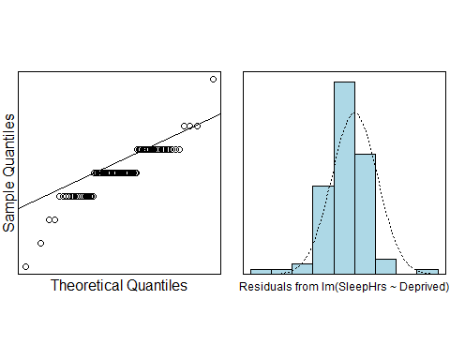

cooks20x(sleepDep.fit)

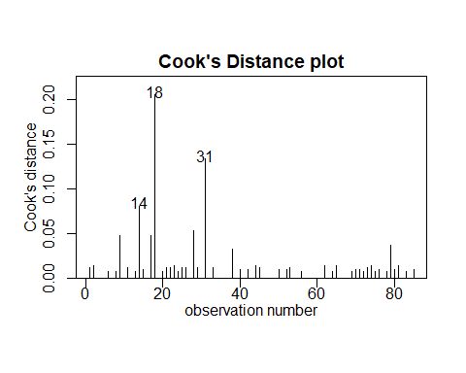

confint(sleepDep.fit)

## 2.5 % 97.5 %  
## (Intercept) 6.686820 7.4274653  
## DeprivedYes -1.479984 -0.5143015

modcheck(sleepDep.fit)

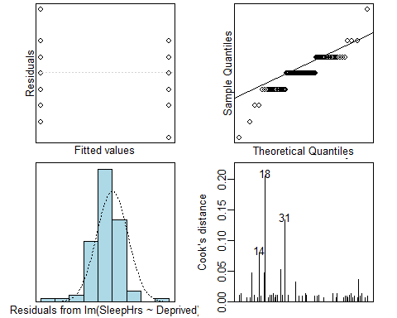

pred.df = data.frame(storage = c("Yes","No"))  
predict(sleepDep.fit,sleepDep.df,interval = "prediction")

## fit lwr upr  
## 1 7.057143 4.835208 9.279077  
## 2 7.057143 4.835208 9.279077  
## 3 7.057143 4.835208 9.279077  
## 4 6.060000 3.847343 8.272657  
## 5 6.060000 3.847343 8.272657  
## 6 6.060000 3.847343 8.272657  
## 7 6.060000 3.847343 8.272657  
## 8 6.060000 3.847343 8.272657  
## 9 7.057143 4.835208 9.279077  
## 10 7.057143 4.835208 9.279077  
## 11 7.057143 4.835208 9.279077  
## 12 7.057143 4.835208 9.279077  
## 13 6.060000 3.847343 8.272657  
## 14 6.060000 3.847343 8.272657  
## 15 6.060000 3.847343 8.272657  
## 16 7.057143 4.835208 9.279077  
## 17 7.057143 4.835208 9.279077  
## 18 7.057143 4.835208 9.279077  
## 19 6.060000 3.847343 8.272657  
## 20 6.060000 3.847343 8.272657  
## 21 7.057143 4.835208 9.279077  
## 22 7.057143 4.835208 9.279077  
## 23 7.057143 4.835208 9.279077  
## 24 6.060000 3.847343 8.272657  
## 25 7.057143 4.835208 9.279077  
## 26 7.057143 4.835208 9.279077  
## 27 7.057143 4.835208 9.279077  
## 28 7.057143 4.835208 9.279077  
## 29 7.057143 4.835208 9.279077  
## 30 6.060000 3.847343 8.272657  
## 31 6.060000 3.847343 8.272657  
## 32 6.060000 3.847343 8.272657  
## 33 7.057143 4.835208 9.279077  
## 34 6.060000 3.847343 8.272657  
## 35 7.057143 4.835208 9.279077  
## 36 6.060000 3.847343 8.272657  
## 37 6.060000 3.847343 8.272657  
## 38 6.060000 3.847343 8.272657  
## 39 6.060000 3.847343 8.272657  
## 40 6.060000 3.847343 8.272657  
## 41 7.057143 4.835208 9.279077  
## 42 6.060000 3.847343 8.272657  
## 43 7.057143 4.835208 9.279077  
## 44 7.057143 4.835208 9.279077  
## 45 7.057143 4.835208 9.279077  
## 46 6.060000 3.847343 8.272657  
## 47 6.060000 3.847343 8.272657  
## 48 6.060000 3.847343 8.272657  
## 49 6.060000 3.847343 8.272657  
## 50 6.060000 3.847343 8.272657  
## 51 7.057143 4.835208 9.279077  
## 52 6.060000 3.847343 8.272657  
## 53 7.057143 4.835208 9.279077  
## 54 7.057143 4.835208 9.279077  
## 55 6.060000 3.847343 8.272657  
## 56 6.060000 3.847343 8.272657  
## 57 7.057143 4.835208 9.279077  
## 58 7.057143 4.835208 9.279077  
## 59 6.060000 3.847343 8.272657  
## 60 6.060000 3.847343 8.272657  
## 61 6.060000 3.847343 8.272657  
## 62 7.057143 4.835208 9.279077  
## 63 6.060000 3.847343 8.272657  
## 64 6.060000 3.847343 8.272657  
## 65 7.057143 4.835208 9.279077  
## 66 6.060000 3.847343 8.272657  
## 67 6.060000 3.847343 8.272657  
## 68 6.060000 3.847343 8.272657  
## 69 6.060000 3.847343 8.272657  
## 70 6.060000 3.847343 8.272657  
## 71 6.060000 3.847343 8.272657  
## 72 6.060000 3.847343 8.272657  
## 73 7.057143 4.835208 9.279077  
## 74 7.057143 4.835208 9.279077  
## 75 6.060000 3.847343 8.272657  
## 76 6.060000 3.847343 8.272657  
## 77 6.060000 3.847343 8.272657  
## 78 6.060000 3.847343 8.272657  
## 79 6.060000 3.847343 8.272657  
## 80 6.060000 3.847343 8.272657  
## 81 7.057143 4.835208 9.279077  
## 82 7.057143 4.835208 9.279077  
## 83 6.060000 3.847343 8.272657  
## 84 6.060000 3.847343 8.272657  
## 85 6.060000 3.847343 8.272657