

**Faculty of engineering - Shoubra**

**Benha University**

in fulfillment of the requirements of

|  |  |
| --- | --- |
| **Department** | **Engineering Mathematics and Physics** |
| **Division** | **-----------------** |
| **Academic Year** | **2019-2020 Preparatory** |
| **Course name** | **Computer** |
| **Course code** | **ECE001** |

**Tobic: -**

**Artificial intelligence**

By:

|  |  |  |  |
| --- | --- | --- | --- |
|  | Name | Edu mail | B.N |
| 1 | علي مسعد على عليمى الاطرونى | ali195583@feng.bu.edu.eg | 530 |

**Approved by:**

|  |  |
| --- | --- |
| Examiners committee | Signature |
| Dr Ahmed Bayoumi |  |
| Dr Shady Elmashad |  |
| Dr Abdelhamid Attaby |  |

**GitHub link :**

**Introduction of Artificial intelligence**

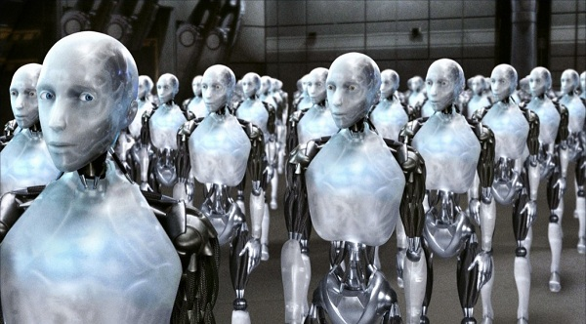

Artificial intelligence is one of the types of modern science that has spread widely in recent times, and has even entered into many industrial and research fields, led by robots and smart services for governments and companies.

Artificial intelligence is defined as one of the branches of computer science, and that is the behavior and characteristics that different computer programs depend on, and is in line with human mental capabilities in various works. Among the most important of these capabilities is the ability of the machine to teach and make the right decisions.

The role of artificial intelligence in business has become more important and necessary to maintain competitiveness. By applying powerful artificial intelligence technologies, organizations have the ability to move faster, make more informed decisions, increase operational efficiency, and build stronger engagement with customers and employees, all while creating innovative and new products and services.

**Some Application of Artificial intelligence**

It is used in a wide range of areas such as: expert systems, medical diagnostics, Internet search engines, natural language processing, video games, stock trading, law, image discrimination and analysis, toys, scientific discoveries, automatic control, and voice recognition.

**Source Code**

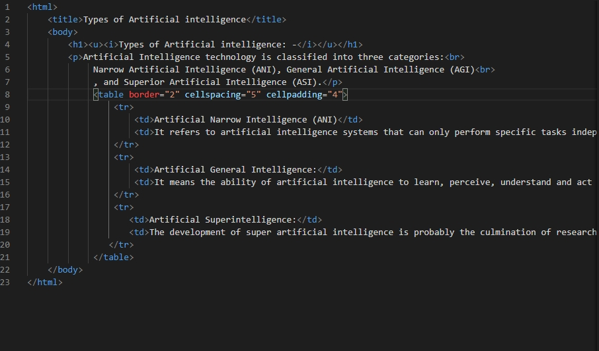

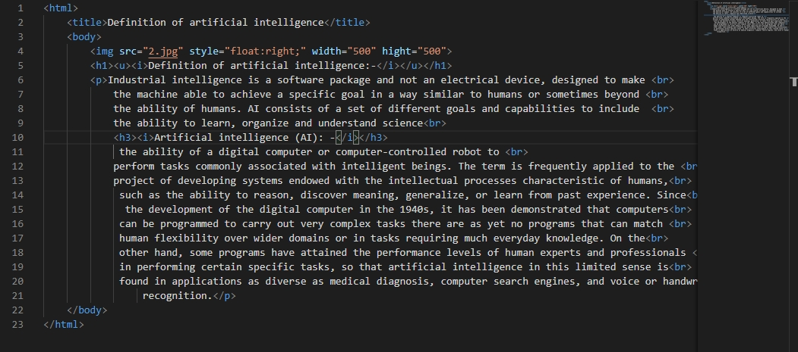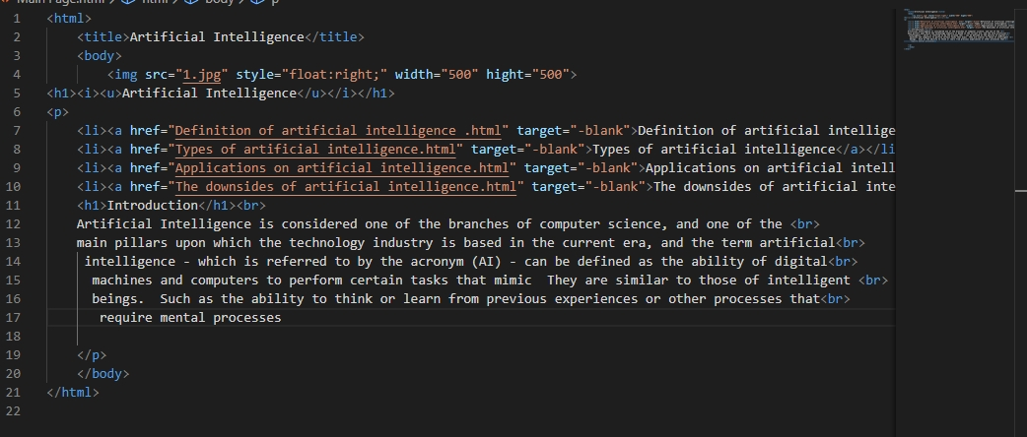

**Screenshots**

