Holy Angel University

School of Engineering and Architecture

LINE FOLLOWING ROBOT

MICROPROCS LAB

Submitted by:

Canlas, Alyssa Jade

Mallari, Jazmine Claire

Sarmiento, Shaina

Sison, Jony Jane

Submitted to:

Engr. Gerard C. Cortez

**CODE**

/* Robot Line Follow  
  
 This sketch demonstrates the line following capabilities  
 of the Arduino Robot. On the floor, place some black  
 electrical tape along the path you wish the robot to follow.  
 To indicate a stopping point, place another piece of tape  
 perpendicular to the path.  
  
 Circuit:  
 * Arduino Robot  
  
 created 1 May 2013  
 by X. Yang  
 modified 12 May 2013  
 by D. Cuartielles  
  
 This example is in the public domain  
 */  
  
#include <ArduinoRobot.h> // include the robot library  
#include <Wire.h>  
  
long timerOrigin; // used for counting elapsed time  
  
void setup() {  
  // initialize the Robot, SD card, display, and speaker  
  Robot.begin();  
  Robot.beginTFT();  
  Robot.beginSD();  
  Robot.beginSpeaker();  
  
  // show the logots on the TFT screen  
  Robot.displayLogos();  
  
  Robot.drawBMP("lf.bmp", 0, 0); // display background image  
  
  Robot.playFile("chase.sqm");  // play a song from the SD card  
  
  // add the instructions  
  Robot.text("Line Following\n\n place the robot on\n the track and \n see it run", 5, 5);  
  Robot.text("Press the middle\n button to start...", 5, 61);  
  Robot.waitContinue();  
  
  // These are some general values that work for line following  
  // uncomment one or the other to see the different behaviors of the robot  
  //Robot.lineFollowConfig(14, 9, 50, 10);  
  Robot.lineFollowConfig(11, 7, 60, 5);  
  
  
  //set the motor board into line-follow mode  
  Robot.setMode(MODE_LINE_FOLLOW);  
  
  // start  
  Robot.fill(255, 255, 255);  
  Robot.stroke(255, 255, 255);  
  Robot.rect(0, 0, 128, 80); // erase the previous text  
  Robot.stroke(0, 0, 0);  
  Robot.text("Start", 5, 5);  
  
  Robot.stroke(0, 0, 0); // choose color for the text  
  Robot.text("Time passed:", 5, 21); // write some text to the screen  
  
  timerOrigin = millis(); // keep track of the elapsed time  
  
  while (!Robot.isActionDone()) { //wait for the finish signal  
    Robot.debugPrint(millis() - timerOrigin, 5, 29); // show how much time has passed  
  }  
  
  Robot.stroke(0, 0, 0);  
  Robot.text("Done!", 5, 45);  
}  
void loop() {  
  //nothing here, the program only runs once. Reset the robot  
  //to do it again!  
}

**SCHEMATIC DIAGRAM FOR LINE FOLLOWING ROBOT**

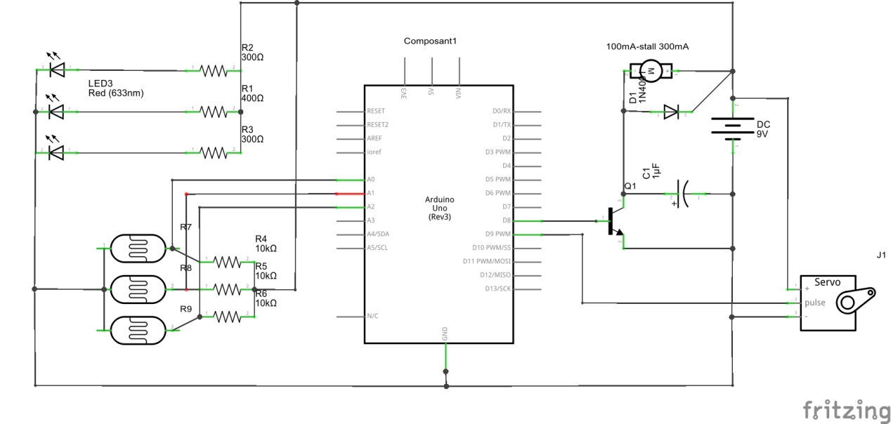

**PARTS REQUIRED**  
  
1. Chasis  
  
2. Arduino Nano  
  
3. Mini Breadboard  
  
4. HC SR-04 kit  
  
5. Motor Driver ( L298N )  
  
6. Rocker Switch  
  
7. 8pcs M-F Jumper Wires  
  
8. 7pcs M-M Jumper Wires

9. 2pcs 18650 Batteries  
  
10. Battery Holder  
  
Tools :  
  
1. Soldering Iron  
  
2.Cordless Drill  
  
3. Wire Cutter / Stripper  
  
4. Glue Gun

**LINE FOLLOWER ROBOT**

A line follower robot is a robot which follows a certain path controlled by a feed back mechanism. Line follower is an autonomous robot which follows either black line in white are or white line in black area. Robot must be able to detect particular line and keep following it.

For special situations such as cross overs where robot can have more than one path which can be followed, predefined path must be followed by the robot.

In the following section, we will discuss the [Line follower robot](https://www.pantechsolutions.net/robotics/line-follower-robot) which follows black line in white area and take right turn whenever cross overs or Y shaped turn arrives.

#### Building a basic line follower robot

Building a basic Line Follower Robot involves the following steps.

* Designing the mechanical part or the body of the robot
* Defining the kinematics of the robots
* Designing the control of the robot

[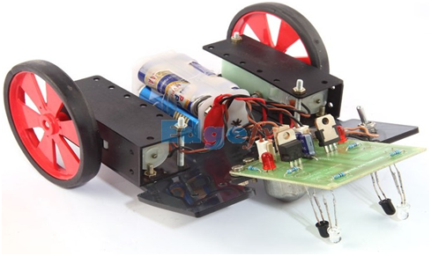](https://www.elprocus.com/wp-content/uploads/2013/09/A-Line-Follower-Robot.png)

A Line Follower Robot by [Edgefx Kits](https://www.elprocus.comline-following-robotic-vehicle/" \t "https://www.elprocus.com/line-follower-robot-basics-controlling/_blank)

The mechanical part or body of the robot can be designed using AutoCAD or Workspace. A basic Line follower robot can consist of a base at the two ends of which the wheels are mounted. A rectangular sheet of hard plastic can be used as the base. Further a rigid body like a cylinder can be added along with other shaped bodies inter connected with each other by joints, and each with its defined motion in particular direction.  The Line follower robot can be a wheeled mobile robot with a fixed base, a legged mobile robot with multiple rigid bodies interconnected by joints.

The next step involves defining the Kinematics of the robot. Kinematic analysis of the robot involves the description of its motion with respect to a fixed coordinate system. It is concerned mainly with the movement of the robot and with motion of each body in case of a legged robot. It generally involves the dynamics of the robot motion. The whole trajectory of the robot is set using the Kinematic analysis. This can be done using Workspace software.The control of the robot is the most important aspect of its working.  Here the term control refers to the robot motion control, i.e. controlling the movement of the wheels. A basic line follower robot follows certain path and the motion of the robot along this path is controlled by controlling the rotation of wheels, which are placed on the shafts of the two motors. So, the basic control is achieved by controlling the motors.  The control circuitry involves the use of sensors to sense the path and [the microcontroller](https://www.edgefxkits.com/line-following-robotic-vehicle-using-microcontroller" \t "https://www.elprocus.com/line-follower-robot-basics-controlling/_blank) or any other device to control the motor operation through the motor drivers, based on the sensor output.

### 2 Ways of controlling a line Follower Robot

* **Without using Microcontrollers**

[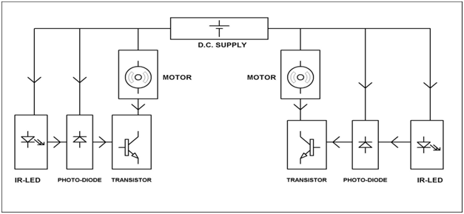](https://www.elprocus.com/wp-content/uploads/2013/09/Block-Diagram-of-the-Control-System.png)

Block Diagram of the control System (by [Edgefx Kits](https://www.elprocus.comline-following-robotic-vehicle/" \t "https://www.elprocus.com/line-follower-robot-basics-controlling/_blank))

It consists of an IR-LED and Photodiode arrangement for each motor which is controlled by the switching on and off of the transistor. The IR LED on getting proper biasing emits Infra red light. This IR light is reflected in case of a white surface and the reflected IR light is incident on the photodiode. The resistance of the photodiode decreases, which leads to an increase in current through it and thus the voltage drop across it. The photodiode is connected to the base of the transistor and as a result of increased voltage across the photodiode, the transistor starts conducting and thus the motor connected to the collector of the transistor gets enough supply to start rotating. In case of a black color on the path encountered by one of the sensor arrangement, the IR light is not reflected and the photodiode offers more resistance, causing the transistor to stop conduction and eventually the motor stops rotating. Thus the whole system can be controlled using a simple LED-Photodiode-Transistor arrangement.

* **With using Microcontrollers**

### Working principle:

The line fallowing robot is one of the self-operating robots. That detects and fallows a line drawn on the area. The line is indicated by white line on a block surface or block line on a white surface. This system must be sense by the line. This application is depends upon the sensors. Here we are using two sensors for path detection purpose. That is proximity sensor and IR sensor. The proximity sensor used for path detection and IR sensor used for obstacle detection. These sensors mounted at front end of the robot. The microcontroller is an intelligent device the whole circuit is controlled by the microcontroller.

[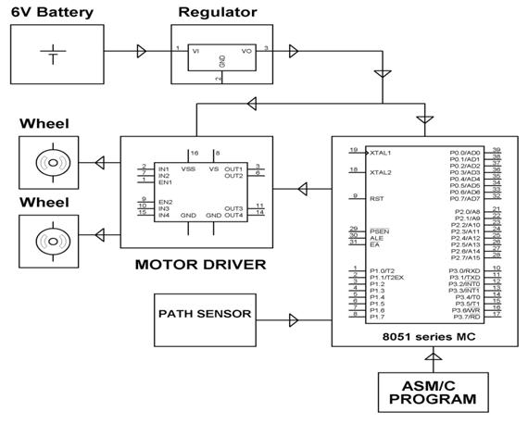](https://www.elprocus.com/wp-content/uploads/2013/09/Block-Diagram-of-Line-Following-Robotic-Vehicle-with-Microcontroller.jpg)

Block Diagram of Line Following Robotic Vehicle with Microcontroller by [Edgefx Kits](https://www.edgefxkits.com/line-following-robotic-vehicle-using-microcontroller" \t "https://www.elprocus.com/line-follower-robot-basics-controlling/_blank)

**Different types of line controlled robotic vehicles:**

There are two types of line controlled robotic vehicles

* Mobile based line controlled robotic vehicle
* RF based line controlled robotic vehicle

### Applications of line follower robot:

* **Industrial Applications**: These robots can be used as automated equipment carriers in industries replacing traditional conveyer belts.
* **Automobile applications**: These robots can also be used as [automatic cars](https://www.edgefxkits.com/wireless-power-driven-car-or-train" \t "https://www.elprocus.com/line-follower-robot-basics-controlling/_blank) running on roads with embedded magnets.
* **Domestic applications**: These can also be used at homes for domestic purposes like floor cleaning etc.
* **Guidance applications**: These can be used in public places like shopping malls, museums etc to provide path guidance.

**Advantages:**

* Robot movement is automatic
* It is used for long distance applications
* Simplicity of building
* Fit and forget system
* Used in home, industrial automations etc.

## Connection Circuit diagram with [Arduino and Line follower sensor](https://www.pantechsolutions.net/robotics/line-follower-robot)

