LAB TASK 8:
TASK 1:-Create the Bus Topology like given figure:
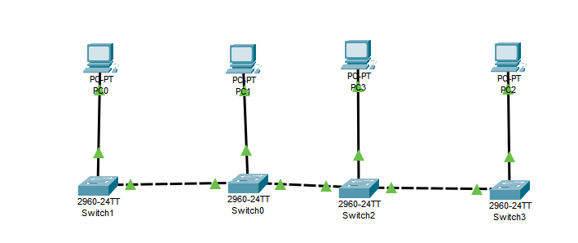
Open Packet Tracer and follow these steps:
· Add 4 PCs:
- Go to the End Devices section in the bottom toolbar.
- Drag and drop 4 PCs (PC0, PC1, PC2, PC3) onto the workspace.
· Add 4 Switches:
- Go to the Switches section.
- Drag and drop 4 switches (Switch0, Switch1, Switch2, Switch3) onto the workspace.
· Connect the Devices:
- Select a straight-through copper cable from the connections tab.
- Connect PC0 to Switch0
- Connect PC1 to Switch1
- Connect PC2 to Switch2
- Connect PC3 to Switch3
· Assign IP Addresses to PCs:
- · Click on PC0, go to the Desktop tab, then click on IP Configuration.
  - Set IP Address: 192.168.1.10
  - Subnet Mask: 255.255.255.0
- Click on PC1, go to IP Configuration.
  - Set IP Address: 192.168.1.11
  - Subnet Mask: 255.255.255.0
- Click on PC2, go to IP Configuration.
  - Set IP Address: 192.168.1.12
  - Subnet Mask: 255.255.255.0
- Click on PC3, go to IP Configuration.
  - Set IP Address: 192.168.1.13
  - Subnet Mask: 255.255.255.0
- Test Connectivity (Ping Test):
  - Ping all PCs from each PC to verify the communication.
- Take Screenshots:
  - Capture a screenshot of the Bus Topology and the ping results..

Task 2:-
• Open Cisco Packet Tracer
- Launch the Packet Tracer application.
• Add 2 PCs
- From the End Devices section, drag and drop 2 PCs onto the workspace. Name them PC0 and PC1.
• Connect the PCs
- Use Copper Straight-Through Cable to connect the PCs directly:
  - Connect PC0 to PC1.
• Assign IP Addresses
For each PC, do the following:
• PC0:
- • IP Address: 192.168.1.10
- Sub-net Mask: 255.255.255.0
PC1:
- IP Address: 192.168.1.11
- Sub-net Mask: 255.255.255.0
• Test Connectivity (Ping Test):
- Ping PC1 from PC0 and PC0 from PC1 to verify the communication.
• Take Screenshots:
- Capture a screenshot of the connection and the ping results.

