CL2001  Data Structures Lab  - [Subject] | Lab 5  - Recursion and Backtracking

National University of Computer and Emerging Sciences
Fall 2025

Lab Content

- Recursion and its base condition
- Types of Recursions
- Issues in Recursion
- Backtracking

Recursion and its base condition
A recursive function solves a problem by solving smaller versions of itself. Each recursive call reduces the problem's size, moving it closer to a simple, solvable case.
The base condition is a critical part of recursion. It tells the function when to stop calling itself. Without a base condition, the function would call itself infinitely, leading to a stack overflow error. An example is shown below:

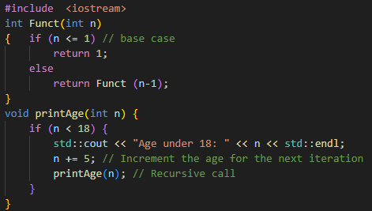

Key Points: In the above example, base case for n < = 1 is defined and larger value of number can be solved by converting to smaller one till base case is reached.

Types of Recursions
Recursion can be categorized into three main types based on how the function calls are made. Each type has its own structure and use case in problem-solving. These include:
- Direct and Indirect Recursion
- Tailed and non-tailed recursion
- Nested Recursion

Direct and Indirect Recursions
Recursion occurs when a function calls itself. If a function directly calls itself, it is direct recursion. When function A calls function B, and B calls A, it becomes indirect recursion. Both must include a base condition to avoid infinite loops.
Sample Code (Direct Recursion)
void X()
{
// Some code....
X();
// Some code...
}
Here, X() calls itself directly within its own body. This is a classic example of direct recursion.

Func A

Sample Code (Indirect Recursion)

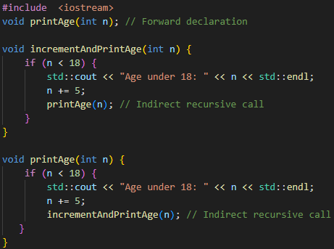
Func B
Func A

Key Points: In this example, incrementAndPrintAge() calls printAge(), and printAge() calls back incrementAndPrintAge(). This forms an indirect recursion cycle between two functions.

Tailed and Non-Tailed Recursions
Recursion can be classified based on the position of the recursive call. If the recursive call is the last operation in the function, it's called tail recursion. If there's more work to do after the recursive call returns, it's known as non-tail recursion.

Sample Code (Tail Recursion)
void Funct (int a)
{
if (a < 1) return; // base case

cout << a;

// recursive call

Funct(a/2);
}
In this case, the recursive call is the last operation performed, which makes it tail recursion, potentially more efficient due to compiler optimizations.

Sample Code (Non-Tail Recursion)
void Funct (int a)
{
if (a < 1) return; // base case

// recursive call

return Funct(a/2);
}
Here, the recursive call is not the final action — the function waits for the result, making it non-tail recursion.

Nested Recursions
Nested recursion occurs when a function's parameter itself is a recursive call, meaning recursion happens inside another recursive call. This type of recursion is more complex and harder to trace compared to direct or tail recursion.
Sample Code
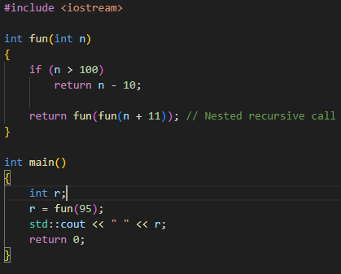

Backtracking
Backtracking is a recursive problem-solving technique that tries out all possible solutions and "backs up" as soon as it determines that a path won't lead to a valid solution. It is particularly useful in constraint-based problems like mazes, puzzles, and the N-Queens problem.

Sample Pseudocode
void findSolutions(n, other params) {
if (found a solution) {
solutionsFound = solutionsFound + 1;
displaySolution()
}
if (solutionsFound >= solutionTarget) {
System.exit(0);
return
}
for (val = first to last) {
if (isValid(val, n)) {
applyValue(val, n);
findSolutions(n+1, other params);
removeValue(val, n);
}
}
This pseudocode outlines the core structure of a backtracking algorithm: check for solution, try a possible value, explore deeper recursively, and undo the move if it fails.

Maze (Rat in a Maze) - Code Example
This simplified version of the maze problem demonstrates how backtracking helps explore all possible paths from the source to destination and stops once a valid path is found by avoiding obstacles.
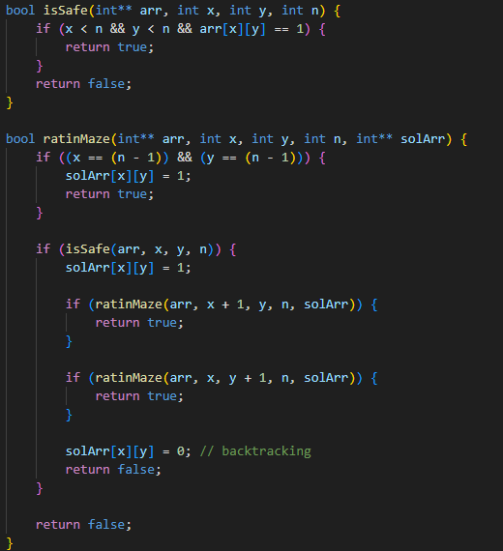

A Maze is given as N*N binary matrix of blocks where source block is the upper left most block i.e., maze[0][0] and destination block is lower rightmost block i.e., maze[N-1][N-1]. A rat starts from source and must reach the destination. The rat can move only in two directions: forward and down.
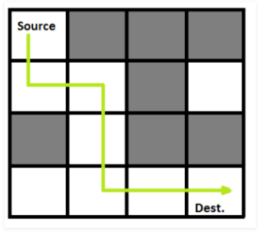
In the maze matrix, 0 means the block is a dead end and 1 means the block can be used in the path from source to destination. Note that this is a simple version of the typical Maze problem. For example, a more complex version can be that the rat can move in 4 directions, and a more complex version can be with a limited number of moves.

N Queen Problem - Code Example
The N-Queens problem is a classic example of backtracking where the goal is to place queens on a chessboard without threatening each other. The backtracking algorithm places queens row-by-row, and backtracks if it encounters a conflict.

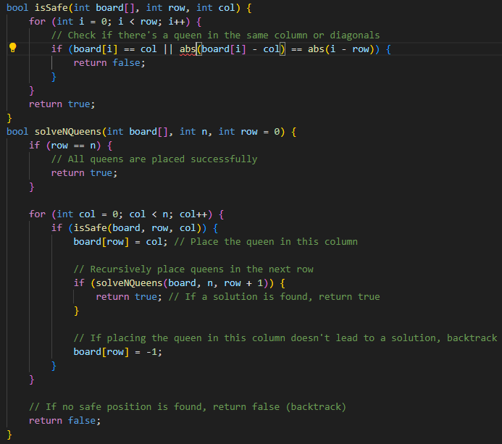

LAB TASKS

