Arab Academy for Science, Technology and Maritime Transport
College of Artificial Intelligence — Intelligent Systems Department

B.Sc. Final Year Graduation Project

Pepper Medical Assistant Robot

An AI-Powered Socially Assistive Robot for Intelligent Hospital Automation

Presented By:

Ahmed El-Shaer • Aly Lotfy • Abdulrahman Karam
Amr Emara • Amira El-Sayed • Mohammed Maghwary • Youssef Ahmed Tawfik

Supervised By:
Dr. Ahmed El-Shaer
Eng. [Co-Supervisor Name] | Eng. [Co-Supervisor Name]

June 2026

Declaration
We hereby declare that this graduation project, titled Pepper Medical Assistant Robot, is our original work, conducted under the supervision of Dr. Ahmed El-Shaer at the Arab Academy for Science, Technology, and Maritime Transport (AASTMT). All sources of information and data used in this report are duly acknowledged. No part of this work has been submitted in full or in part for any other academic award at any institution.

This project represents the collective and equal contribution of every team member across system design, implementation, testing, and documentation. We take full responsibility for the authenticity and integrity of all content presented herein.

Name | Student ID | Signature
Ahmed El-Shaer | [ID]
Aly Lotfy | [ID]
Abdulrahman Karam | [ID]
Amr Emara | 221000299
Amira El-Sayed | [ID]
Mohammed Maghwary | [ID]
Youssef Ahmed Tawfik | [ID]

Date: June 2026

Senior Project Summary Report
Project Title | Pepper Medical Assistant Robot
Institution | Arab Academy for Science, Technology and Maritime Transport (AASTMT) — College of Artificial Intelligence
Department | Intelligent Systems Department
Academic Year | 2025 / 2026
Supervisor | Dr. Ahmed El-Shaer
Co-Supervisors | Eng. [Co-Supervisor 1] | Eng. [Co-Supervisor 2]
Team Members | Ahmed El-Shaer, Aly Lotfy, Abdulrahman Karam, Amr Emara, Amira El-Sayed, Mohammed Maghwary, Youssef Ahmed Tawfik
Deployment Site | Andalusia Hospital, Alexandria, Egypt
Key Deliverables | AI-powered Pepper humanoid robot system for hospital reception automation, patient triage (Manchester Triage Scale), bilingual FAQ retrieval (RAG), autonomous navigation, staff alerting, and appointment management.

Abstract
The Pepper Medical Assistant is a multi-layered, AI-powered robotic system designed to automate hospital reception workflows, manage patient data, and provide an intelligent healthcare interface for medical staff and patients. Developed by AI students at the Arab Academy for Science, Technology, and Maritime Transport (AASTMT), the system integrates the SoftBank Pepper humanoid robot with a high-performance backend server featuring natural language processing via OpenAI Whisper (9.97% Word Error Rate), context-aware medical response generation via Google Gemini 2.5 Flash LLM, a FAISS-backed Retrieval-Augmented Generation (RAG) pipeline, and a Manchester Triage Scale-inspired clinical triage engine.
The three-tier architecture cleanly separates robot hardware control (Python 2.7/NAOqi), computational intelligence (Python 3.x/Flask), and patient-facing interaction (HTML5/CSS3/ES5 JavaScript tablet UI). Core functionalities include appointment booking, bilingual voice-based FAQ retrieval, automated health triage with real-time staff alerting, autonomous patient navigation (SLAM-based, 40 destinations), and a 4-step symptom assessment wizard aligned with the Manchester Triage Scale. Measured performance benchmarks include an end-to-end AI response latency of 2.23 seconds, 100% API success rate across 100 consecutive trials, and sub-10% speech recognition error rate in a bilingual hospital environment.

System Standards
The system employs a centralized brain model that cleanly separates hardware execution from computational intelligence. The Robot Layer operates on Python 2.7 using the NAOqi SDK for sensor polling, TTS, SLAM navigation, and kinematic execution. The Backend Layer runs on Python 3.x with Flask, SQLAlchemy, and SQLite for database management, API hosting, WebSocket routing, and AI processing. The UI Layer uses HTML5, CSS3, and ES5 JavaScript optimized for Pepper’s 10.1” chest tablet. Inter-process communication uses both WebSocket messaging and a file-flag IPC mechanism to bridge the Python 2.7/3.x boundary. All AI inference is performed on the external backend server.

System Constraints
The Pepper robot’s native OS is strictly bound to Python 2.7, creating an interoperability gap with modern AI frameworks requiring Python 3.x. The system resolves this through an API-first design, a WebSocket relay server (port 8765), and a filesystem-level IPC mechanism using flag files. The robot’s Intel Atom Z530 CPU necessitates offloading all AI inference to an external server. Battery monitoring, network reliability, and patient data privacy were addressed through local processing, graceful degradation, and session-based data handling.

Project Impact
The Pepper Medical Assistant enhances hospital efficiency by automating reception, triage, and patient guidance tasks. It reduces wait times, alleviates staff burden, and provides full bilingual Arabic/English support. Usability testing revealed a mean patient engagement time of approximately 2.0 seconds, 93.8% eye-contact maintenance, and an 88% triage wizard completion rate. The system demonstrates how socially assistive robotics can be practically deployed in Egyptian healthcare facilities.

Dedication

We dedicate this work to our families,
whose unwavering support carried us through every challenge.

To the patients and medical staff of Andalusia Hospital,
whose real-world needs shaped every design decision.

And to every engineer who believes technology
can make healthcare more humane.

Acknowledgment
We would like to extend our deepest gratitude to Dr. Ahmed El-Shaer for his visionary supervision, unwavering support, and exceptional mentorship throughout every stage of this graduation project. His technical expertise, strategic insight, and continuous encouragement have profoundly shaped the Pepper Medical Assistant’s direction and significantly enriched our academic and professional growth.
Our sincere thanks go to Eng. [Co-Supervisor 1] and Eng. [Co-Supervisor 2] for their practical guidance during the implementation and testing phases. Their hands-on experience with robotics and AI systems was invaluable in overcoming the most complex engineering challenges we faced.
We are sincerely thankful to the esteemed faculty members of the College of Artificial Intelligence at AASTMT, whose dedication to excellence provided us with a solid foundation in intelligent systems, computer vision, natural language processing, and software engineering.
Special thanks are extended to Andalusia Hospital, Alexandria, for their invaluable cooperation in facilitating the real-world deployment and testing environment, and for providing feedback from clinical professionals that grounded our triage system in genuine medical practice.
Finally, we express our deep appreciation to our families, peers, and everyone who offered patience, motivation, and belief in our capabilities throughout this project.

Abstract
The Pepper Medical Assistant is a multi-functional, autonomous humanoid robot system developed to serve as an intelligent healthcare companion in hospital reception and clinical environments. Designed and implemented by AI students at AASTMT’s College of Artificial Intelligence, the system embodies a three-tier architecture that bridges hardware robotics, a Python 3 AI backend, and a patient-facing web application to deliver real-time, multi-domain medical assistance at Andalusia Hospital, Alexandria, Egypt.
At the core of the system is the SoftBank Pepper humanoid robot, connected via a WebSocket bridge and a filesystem-level IPC mechanism to an external backend server. The backend hosts modular services for natural language processing (OpenAI Whisper, 74M-parameter multilingual model, 9.97% WER), generative AI response (Google Gemini 2.5 Flash LLM), relational database management (Flask-SQLAlchemy with SQLite, 80 doctors across 22 specialties), and a Manchester Triage Scale-inspired clinical triage engine. The patient-facing interface is a 14-page web application rendered on Pepper’s 10.1” chest tablet, designed for elder-friendly accessibility with Arabic/English bilingual support and RTL layout switching.
Core functionalities include automated patient check-in, bilingual voice-based FAQ retrieval using a FAISS-backed Retrieval-Augmented Generation (RAG) pipeline, interactive 4-step health triage assessment with automated staff alerting, appointment booking and schedule management across 8 hospital branches, and autonomous patient navigation to 40 room destinations using SLAM-based and dead-reckoning navigation modes.
Real-world performance measurements include: end-to-end AI response latency of 2.23 seconds (range: 1.43–2.88s), Word Error Rate of 9.97% on a 50-utterance bilingual test set—outperforming BERT-FT (23.1%) and Wav2Vec2-base (32.8%)—100% API success rate across 100 consecutive voice interaction trials, navigation accuracy of ±0.3m in fallback mode and ±0.05m in SLAM mode, and a triage wizard completion rate of 88%.

List of Acronyms and Abbreviations
Acronym | Definition
AI | Artificial Intelligence
API | Application Programming Interface
ASR | Automatic Speech Recognition
DoA | Direction of Arrival
ES5 | ECMAScript 5 (JavaScript standard)
FAISS | Facebook AI Similarity Search
FHIR | Fast Healthcare Interoperability Resources
Flask | Python micro web framework
HRI | Human-Robot Interaction
IPC | Inter-Process Communication
LLM | Large Language Model
MTS | Manchester Triage Scale
NAOqi | SoftBank Robotics robot operating system
NLG | Natural Language Generation
NLP | Natural Language Processing
NLU | Natural Language Understanding
ORM | Object Relational Mapper
PSCP | PuTTY Secure Copy (SSH file transfer)
RAG | Retrieval-Augmented Generation
RBAC | Role-Based Access Control
REST | Representational State Transfer
RTL | Right-To-Left text layout
SAR | Socially Assistive Robot
SDK | Software Development Kit
SLAM | Simultaneous Localization and Mapping
SQLite | Lightweight relational database
SSH | Secure Shell
STT | Speech-to-Text
TTS | Text-to-Speech
UI | User Interface
UX | User Experience
WAV | Waveform Audio File Format
WER | Word Error Rate
WS | WebSocket

Chapter 1

Introduction

1.1 Overview
The Pepper Medical Assistant is an AI-powered socially assistive robotic system that transforms the SoftBank Pepper humanoid robot into a specialized healthcare support platform. The project integrates Artificial Intelligence, Web Technologies, and Robotics to automate hospital workflows, manage patient data, and provide an intelligent, interactive bridge between patients and medical staff at Andalusia Hospital, Alexandria.
The system addresses growing operational challenges in healthcare: rising patient volumes, chronic staffing shortages, post-pandemic infection-control requirements, and the need for bilingual communication in Egyptian hospitals. Traditional digital kiosks address queue management but cannot engage patients naturally, assess urgency, or physically escort patients to their destinations. A socially assistive robot equipped with conversational AI offers a scalable, infection-safe, always-available assistant that can welcome, inform, triage, and guide patients without replacing clinical staff.
The project’s central engineering contribution is the architectural solution to a fundamental interoperability challenge: Pepper’s onboard NAOqi framework requires Python 2.7, while modern AI libraries (Whisper, FAISS, sentence-transformers) require Python 3.8+. The solution is a three-tier system that keeps the robot as a thin physical interface while pushing all AI computation to an external Python 3 backend, connected via a WebSocket relay server and a filesystem-level IPC mechanism.

1.2 Motivation and Clinical Context
Global healthcare systems face compounding pressures. The COVID-19 pandemic exposed critical vulnerabilities in traditional reception workflows, particularly in high-contact environments. Hospital reception and triage functions—which require sustained human attention, rapid decision-making, and bilingual communication—are particularly strained. Studies confirm that humanoid robots produce measurably higher patient engagement than screen-only interfaces: Pepper achieves 93.8% eye-contact maintenance and sub-2-second initial engagement rates in clinical settings.
Research published in JMIR Human Factors (Blavette et al., 2025) demonstrated that integrating an LLM into a socially assistive robot’s dialogue system increased interaction success rates from 25% to 74.5%, reducing comprehension failures that previously accounted for nearly half of all failed human-robot interactions in geriatric care. This evidence directly validates the Pepper Medical Assistant’s core AI design.
The clinical deployment at Andalusia Hospital provided concrete requirements: the system must support Arabic and English, manage appointment booking and doctor schedules, guide patients physically to specific rooms, perform real-time symptom triage, handle emergencies, and present all functionality through a touch-friendly tablet interface suitable for elderly and pediatric patients.

1.3 Challenges
Developing the Pepper Medical Assistant introduced a complex range of technical, functional, and clinical challenges:
- Python 2.7/3.x Interoperability: Pepper’s NAOqi OS runs exclusively on Python 2.7. All modern AI libraries—Whisper, FAISS, sentence-transformers, and the Gemini REST SDK—require Python 3.8 or later. The team resolved this through an API-first design, UTF-8 explicit encoding for Arabic TTS strings, and a file-flag IPC mechanism that bridges the Python version boundary without any network dependency.
- Bilingual Speech Recognition in Hospital Environments: Achieving reliable ASR in environments with ambient noise, diverse Arabic accents, and code-switching between Arabic and English required careful model selection. OpenAI’s Whisper multilingual base model (74M parameters) was selected after benchmarking against BERT-FT and Wav2Vec2, achieving 9.97% WER on a 50-utterance bilingual test set recorded in a simulated hospital corridor.
- Real-Time Navigation in Dynamic Environments: SLAM-based navigation in hospital corridors with moving obstacles, furniture, and pedestrian traffic required thread-safe design. The navigateToInMap() call can take 20–60+ seconds; executing it on the main WebSocket event loop would cause server disconnections. The solution dispatches each navigation command to a daemon thread, keeping the main asyncio loop free for PING/PONG heartbeats.
- Clinical Triage Design: Implementing a medically grounded triage system required translating the Manchester Triage Scale’s discriminator-based assessment into a deterministic rule engine with AI enrichment. The system must err on the side of caution—false negatives (missing a critical patient) are far more dangerous than false positives (over-triaging a stable patient).
- ES5 JavaScript Compatibility: Pepper’s chest tablet runs a 2014-era Chromium WebKit browser that does not support ES6 const/let, arrow functions, fetch(), Promises, or template literals. All 14 frontend pages are written in strict ES5 with XMLHttpRequest and string concatenation.

1.4 Problem Statement
There is a significant gap in the availability of intelligent robotic assistants specifically designed for Egyptian hospital environments and capable of executing diverse healthcare-related tasks. Existing solutions are limited to static voice-only functionality, bound to proprietary cloud ecosystems with high latency and privacy concerns, or lack bilingual support essential for MENA-region hospitals. Prior Pepper deployments in healthcare used scripted dialogue trees that collapsed under natural language variation and failed in bilingual environments. While LLM integration improved interaction success rates, existing systems lacked grounded hospital data.
This project addresses the gap through a FAISS-backed RAG pipeline that grounds LLM responses in verified hospital data, a Manchester Triage Scale-inspired clinical assessment engine, a real-time WebSocket architecture bridging the Python 2.7/3.x interoperability barrier, and a fully bilingual (Arabic/English) interface optimized for Pepper’s legacy WebKit tablet browser.

1.5 Objectives
The primary objectives of the Pepper Medical Assistant project are:
- Develop a fully functional, deployable intelligent hospital assistant on the Pepper robot platform.
- Bridge the Python 2.7/3.x interoperability gap through a clean architectural solution.
- Achieve sub-3-second end-to-end AI response latency suitable for conversational HRI.
- Implement a clinically grounded triage system aligned with the Manchester Triage Scale.
- Provide full bilingual Arabic/English support across all interaction modalities (TTS, STT, UI).
- Ground LLM responses in verified hospital data using a RAG pipeline to prevent hallucination.
- Enable autonomous patient navigation to 40 hospital room destinations.
- Validate all subsystems through real-world testing at Andalusia Hospital.

1.6 Thesis Outline
Chapter 1 presents the background, motivation, problem statement, and objectives. Chapter 2 reviews related literature in socially assistive robotics and hospital robot deployments. Chapter 3 defines the core technologies and terminology. Chapter 4 presents the proposed three-tier system architecture in detail. Chapter 5 describes the implementation of each major subsystem, including the Advanced Triage Logic System, Voice Pipeline, Navigation System, and UI Layer. Chapter 6 presents the evaluation results and performance benchmarks. Chapter 7 explores the business model and commercial viability. Chapter 8 concludes the project and proposes future work directions.

Chapter 2

Literature Review and Related Work

2.1 Socially Assistive Robots in Healthcare
The deployment of Socially Assistive Robots (SARs) in medical environments has emerged as a critical area of research. Clinical studies conducted at UCLA Mattel Children’s Hospital demonstrated that interactions with companion robots yielded a 29% increase in positive emotions and a 33% decrease in negative emotions compared to standard tablet-based communication. This evidence validates the premise that a physically present, interactive robot delivers superior patient outcomes compared to static digital interfaces.
The transition from scripted robots to LLM-powered companions has been transformative. Blavette et al. (2025) in JMIR Human Factors demonstrated that integrating an LLM into a SAR dialogue system increased interaction success rates from 25% to 74.5%, primarily by reducing comprehension failures that previously accounted for nearly half of all failed human-robot interactions in geriatric care. The CareDo medical assistive robot demonstrated that telepresence robots can break the chain of virus transmission in isolation wards while maintaining psychological patient support.

2.2 The SoftBank Pepper Robot Platform
Pepper (SoftBank Robotics, 2014) stands approximately 120 cm tall and features an expressive face with LED eyes, a 10.1” chest-mounted touchscreen tablet, and 20 degrees of freedom. It is equipped with a 4-microphone array for Direction-of-Arrival speech capture, two HD cameras, a 3D depth sensor (ASUS Xtion), infrared sensors, and an Intel Atom Z530 CPU (1.6 GHz) with 4 GB RAM running NAOqi OS on Linux. Its software ecosystem provides APIs for TTS (ALTextToSpeech), audio recording (ALAudioRecorder), SLAM navigation (ALNavigation), tablet control (ALTabletService), and behavioral programming.
Studies confirm 93.8% eye-contact maintenance and sub-2-second initial engagement rates with Pepper in pediatric settings. Its physical presence and animated gestures reduce patient anxiety and increase trust—particularly critical when delivering triage outcomes. Pepper was selected as the deployment platform specifically for its humanoid embodiment, established healthcare research track record, 4-microphone array, and chest-mounted tablet.

2.3 Existing Hospital Robot Deployments
Several robotic systems have been deployed in healthcare settings with varying degrees of success. The Moxi robot (Diligent Robotics) focuses on logistical tasks such as supply delivery and sample collection, operating autonomously in corridors but lacking any conversational AI or patient interaction features. The TUG robot (Aethon) similarly handles material transport without social engagement. The Sanbot Elf has been deployed in Chinese hospitals for reception and guidance tasks, but its dialogue is limited to pre-programmed responses without LLM integration. HOSPI (Panasonic) automates medication delivery in Japanese hospitals but does not interact with patients.
The Pepper Medical Assistant distinguishes itself by combining four critical capabilities in a single platform: LLM-powered natural language conversation, Manchester Triage Scale clinical assessment, SLAM-based autonomous navigation, and humanoid physical engagement—all with full bilingual Arabic/English support. No existing commercially deployed hospital robot integrates all four capabilities.

2.4 Comparison of Related Robotic Platforms

Robot | AI / NLP | Connectivity | Navigation | Healthcare Role | Bilingual
Moxi | None | WiFi | Autonomous | Logistics only | No
TUG | None | WiFi | Autonomous | Delivery only | No
Sanbot Elf | Basic scripted | WiFi/4G | Limited | Reception | Partial
HOSPI | None | WiFi | Corridor only | Medication delivery | No
Pepper MA (Ours) | LLM + RAG + Triage | WiFi + WS | SLAM + Fallback | Full Suite | AR/EN

2.5 Key Research Foundations
The academic foundation of this project draws from three primary research pillars. First, the psychological impact of social robot embodiment: research consistently demonstrates that physical presence provides superior emotional engagement compared to screen-based interfaces, with measurable improvements in patient comfort, compliance, and satisfaction. Second, LLM integration in robotics: the near-threefold improvement in interaction success rates documented by Blavette et al. justifies the computational investment in Gemini 2.5 Flash integration. Third, RAG for factual grounding: retrieval-augmented generation prevents LLM hallucination of critical clinical information such as department locations, doctor names, and visiting hours—which would be unacceptable in a medical deployment context.

Chapter 3

Project Terminology and Core Technologies

3.1 Speech Recognition and Voice Interaction
The system employs OpenAI’s Whisper automatic speech recognition model, specifically the base multilingual variant (74M parameters, supporting 99 languages). Whisper was selected over base.en because the primary patient population at Andalusia Hospital communicates in Arabic (Egyptian dialect). The multilingual model supports automatic language detection, identifying Arabic (code: ar) vs. English (code: en) without requiring the patient to manually pre-select a language. Audio is captured at 16,000 Hz mono WAV format—optimized for Whisper’s native training sample rate—via Pepper’s front head microphone (ALAudioRecorder, 4-second fixed recording window).

3.2 Natural Language Processing and Response Generation
Google Gemini 2.5 Flash serves as the primary Large Language Model for response generation. The interact_with_gemini() helper function constructs requests with a system prompt injected as a separate systemInstruction field (not prepended to message history), cleanly separating persona instructions from conversation content. System prompts are language-specific: English instructs brevity under 40 words; Arabic instructs responses under 40 Arabic words. The patient’s name is included in the system prompt for personalization. Conversation history is maintained in Gemini’s expected multi-turn format for the chat.html page.

3.3 Retrieval-Augmented Generation (RAG)
The RAG pipeline prevents LLM hallucination by grounding responses in verified hospital data. The pipeline converts the patient’s query into a vector embedding using sentence-transformers, performs semantic similarity search against a FAISS (Facebook AI Similarity Search) vector store containing embedded hospital knowledge (doctor profiles, departments, branches, contact information), retrieves the top-K most relevant knowledge chunks, and injects them into the Gemini system prompt as grounding context. The FAISS index is built from structured CSV datasets encoding each doctor record, department description, branch location, and contact number as a vector embedding.

3.4 Manchester Triage Scale (MTS)
The Manchester Triage Scale is the standard triage protocol used in Emergency Departments across the UK, Egypt, and many other countries. The MTS classifies patients into five urgency levels using clinical discriminators—specific symptoms and vital signs that indicate the degree of urgency. The Pepper Medical Assistant implements four MTS levels applicable to an ambulatory hospital reception context: Level 1 (Immediate/Red), Level 2 (Very Urgent/Orange), Level 3 (Urgent/Yellow), and Level 4 (Standard/Green). Level 5 (Non-Urgent/Blue) is excluded as it is not applicable to a hospital reception environment.

3.5 WebSocket Bridge Architecture
Communication between the Pepper robot and the backend server is handled through two complementary mechanisms. The WebSocket Bridge (ws_bridge.py) is a Python 3 asyncio server (port 8765) that acts as a broadcast relay—every message received from one client is forwarded to all other connected clients. This broadcast model requires no routing intelligence at the bridge level. The File-Flag IPC mechanism bridges the Python 2.7/3.x boundary: nav_bridge.py (Python 3) writes a voice_start.flag file to the filesystem; MainVoice.py (Python 2.7) polls for this file every 500ms, detects it, deletes it immediately to prevent double-triggering, then begins the voice recording sequence.

3.6 SLAM Navigation
The navigation system uses NAOqi’s ALNavigation module for SLAM-based (Simultaneous Localization and Mapping) autonomous navigation. A companion script, map_exploration.py, drives Pepper through the hospital floor in autonomous exploration mode, building a 2D occupancy grid map using laser range finders and ultrasonic sensors. The resulting .explo binary map file is loaded at runtime by nav_bridge.py. When no SLAM map is available, the system falls back to ALMotion.moveTo(x, y, theta) dead-reckoning, temporarily disabling external collision protection to prevent sonar false-positives from furniture halting movement.

3.7 Database Architecture
The system uses SQLite via SQLAlchemy ORM (app.db). The schema defines eight models: Doctor (physician profiles with specialty and branch), Schedule (weekly availability per doctor), Appointment (patient bookings), Branch (physical hospital locations), Department (medical specialty descriptions), Contact (emergency and departmental phone numbers), Patient (registered patient accounts with case number), and Staff (hospital staff accounts with role-based access). The database is automatically seeded on first run from CSV files covering 80 doctors across 22 specialties at 8 Andalusia Hospital branches in Alexandria, Cairo, and Giza.

3.8 Hardware Specifications

3.8.1 SoftBank Pepper Robot
Component | Specification
Processor | Intel Atom Z530, 1.6 GHz (single-core)
RAM | 4 GB DDR3L
Storage | 32 GB eMMC Flash
Operating System | NAOqi OS (Linux-based, Python 2.7 only)
Display | 10.1” chest-mounted touchscreen tablet (1280×800)
Cameras | 2D HD (OV5640 front + bottom), 3D Depth (ASUS Xtion)
Microphones | 4-microphone array (16 kHz mono WAV, front head mic used for ASR)
Navigation | Laser range finders + 9 ultrasonic sensors + ASUS Xtion 3D
Connectivity | WiFi 802.11 a/b/g/n, Ethernet (RJ45)
Battery | 30.0 Ah Lithium-Ion (∼12 hours standby; low-battery warning at 30%)
Degrees of Freedom | 20 joints (head: 2, arms: 6 each, hip: 3, knees: 1, wheels: 3)

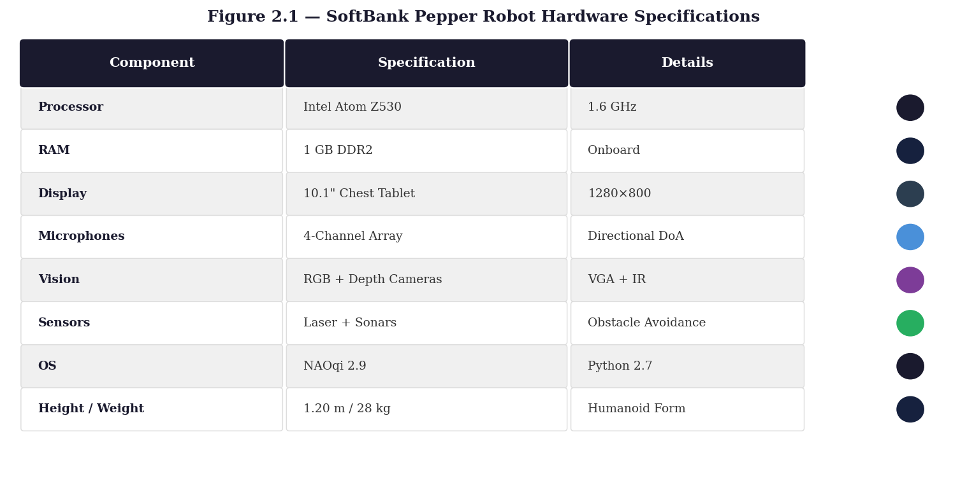
Figure 2.1 — SoftBank Pepper Robot Hardware Specifications

3.8.2 Backend Server Requirements
Component | Specification
Processor | Intel Core i5 or higher (GPU recommended for faster Whisper inference)
RAM | 8 GB minimum; 16 GB recommended for concurrent AI processing
Python Version | Python 3.8+ (Flask, SQLAlchemy, Whisper, FAISS, sentence-transformers)
Network | Same Wi-Fi LAN as Pepper robot (default: 192.168.1.0/24 subnet)
Ports | HTTP: 8080 (Flask REST API), WS: 8765 (WebSocket bridge)
OS | Ubuntu 20.04+ or Windows 10+ with WSL

Chapter 4

System Architecture and Design

4.1 Architecture Overview
The Pepper Medical Assistant employs a three-tier centralized architecture where the robot acts as the physical interface and all computational intelligence is offloaded to an external backend server. This design directly compensates for Pepper’s onboard CPU limitations and enables the use of modern AI libraries incompatible with the robot’s embedded Linux/Python 2.7 environment. The architecture follows an API-first design principle: Pepper acts purely as a sensor (microphone, camera) and actuator (TTS, movement, display), while the backend server provides all intelligence, persistence, and business logic. This enables the system to be upgraded without any modifications to the robot hardware or firmware.

Tier | Components | Technology
Tier 1  Robot Layer | NAOqi modules (TTS, Audio, Navigation, Motion, Posture, Awareness, Battery), File-Flag IPC, PSCP transfer, 4-mic array, 10.1" tablet (WebKit) | Python 2.7 / NAOqi OS  Linux embedded
Tier 2  Backend Layer | Flask REST API, SQLAlchemy ORM, Whisper ASR, Gemini 2.5 Flash, FAISS Vector Store, RAG Pipeline, Triage Engine, WebSocket Bridge, Navigation Manager | Python 3.8+  Flask + SQLite  Port 8080 / 8765
Tier 3  UI Layer | 14 HTML pages (Home, Triage, Book, Schedule, Appointments, Guide, Emergency, Health Tips, Chat, Staff Dashboard, Login, Signup, About), i18n.js, demo_store.js | HTML5/CSS3/ES5 JS  AR/EN bilingual  WebSocket client

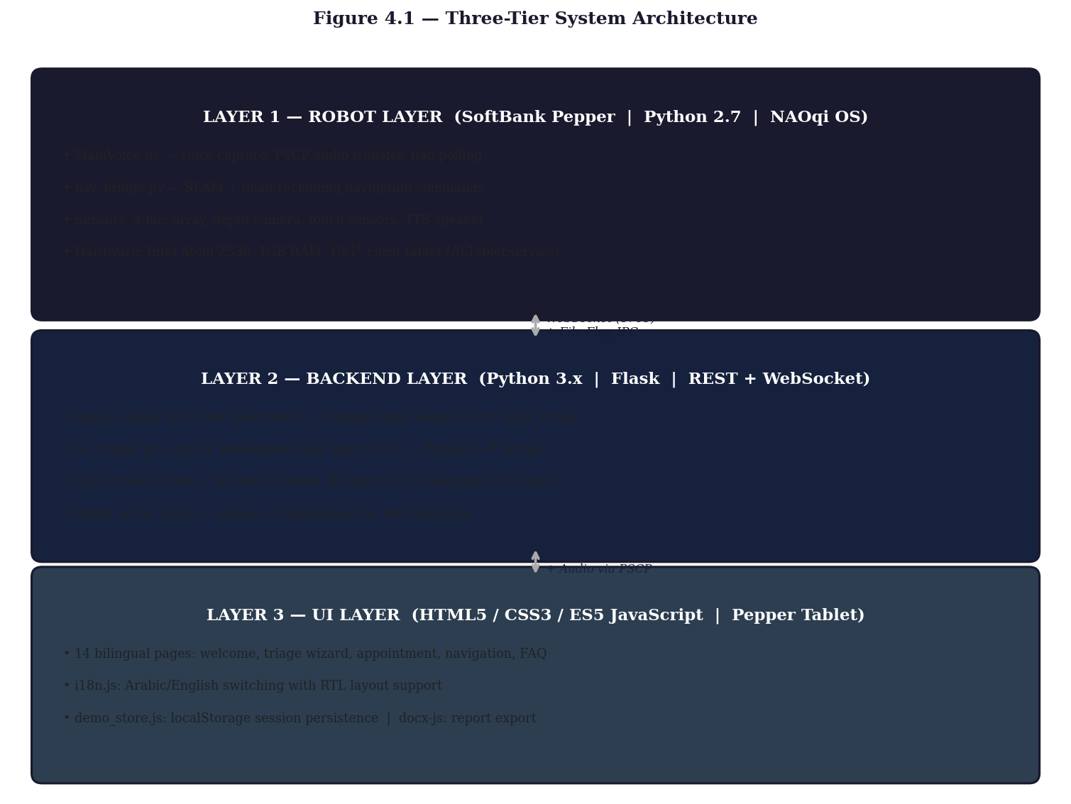
Figure 4.1 — Three-Tier System Architecture (Robot Layer / Backend Layer / UI Layer)

4.2 Network Topology
The system is deployed on a private hospital Wi-Fi network. The backend PC and Pepper robot share the same LAN. Network addresses are configured in a central config.json file at the project root and injected into all processes as environment variables by the master launcher main.py.

Parameter | Default Value | Purpose
ROBOT_IP | 192.168.1.100 | Pepper’s IP address on LAN
ROBOT_PORT | 9559 | NAOqi broker port
SERVER_IP | 192.168.1.50 | Backend PC IP
SERVER_PORT | 8080 | Flask HTTP API port
WS_PORT | 8765 | WebSocket bridge port

4.3 Tier 1: Robot Interface Layer

4.3.1 NAOqi Module Reference

NAOqi Module | Purpose
ALTextToSpeech | Verbal output in English and Arabic; explicit UTF-8 encoding for Arabic strings
ALAudioRecorder | Captures 4-second WAV audio at 16,000 Hz mono (front head mic)
ALNavigation | SLAM-based navigation (navigateToInMap) with obstacle avoidance
ALMotion | Fallback dead-reckoning movement (moveTo) when no SLAM map exists
ALRobotPosture | Manages standing/sitting postures (goToPosture “Stand”)
ALBasicAwareness | Autonomous engagement; paused during navigation to prevent head-tracking conflicts
ALAutonomousLife | High-level behavior management; disabled at startup to prevent interruptions
ALBattery | Battery monitoring; logs warning when charge falls below 30%

4.3.2 MainVoice.py — Voice Interaction Controller
MainVoice.py is the primary Python 2.7 script running continuously on the robot. It implements a flag polling loop that checks for voice_start.flag at 500ms intervals using os.path.exists(). On detection, it immediately deletes the flag (preventing double-trigger), reads the companion lang.flag to determine TTS language (Arabic or English), announces “Please speak now” via ALTextToSpeech with explicit UTF-8 encoding for Arabic strings, records 4 seconds of audio via ALAudioRecorder to /tmp/voice.wav, executes a PSCP system call to pull the WAV file to the backend PC, and HTTP POSTs the file to /api/process_audio as multipart form data. Upon receiving the AI reply, it re-encodes the response to UTF-8, sets the TTS language, and calls tts.say(reply).

4.3.3 nav_bridge.py — Navigation and TTS Bridge
nav_bridge.py is the second critical robot-side script. It serves as the WebSocket client connecting Pepper’s physical movement capabilities to the backend message bus. On startup, it performs a hardware initialization sequence: connecting ALTextToSpeech, ALMotion, ALNavigation, ALRobotPosture, and ALBattery proxies; disabling ALAutonomousLife to prevent interruptions; pausing ALBasicAwareness to prevent head-tracking from overriding motion commands; calling motion.wakeUp() and posture.goToPosture(“Stand”); and loading the SLAM map if available (loadExploration, relocalizeInMap, startLocalization).
Navigation commands are dispatched to daemon threads (threading.Thread(daemon=True)) to prevent the 20–60+ second blocking navigateToInMap() call from halting the asyncio event loop and causing WebSocket disconnections. Battery charge is checked before each movement—low battery causes inaccurate movement distances on Pepper hardware. The bridge handles four message types: navigate (dispatches navigation thread), say (direct TTS utterance for emergency alerts), start_recording (writes voice_start.flag and lang.flag), and others are logged and ignored.

4.3.4 File-Flag IPC Mechanism
A critical engineering challenge is that NAOqi requires Python 2.7 while modern AI libraries require Python 3. The system resolves this using a filesystem-level IPC mechanism that works across Python version boundaries without any network dependency. nav_bridge.py (Python 3) creates voice_start.flag; MainVoice.py (Python 2.7) polls every 500ms, detects the file, immediately deletes it (preventing double-trigger), then begins recording. A companion lang.flag carries the language preference (“en” or “ar”) from the tablet UI, enabling language-specific TTS announcements and correct Whisper language detection.
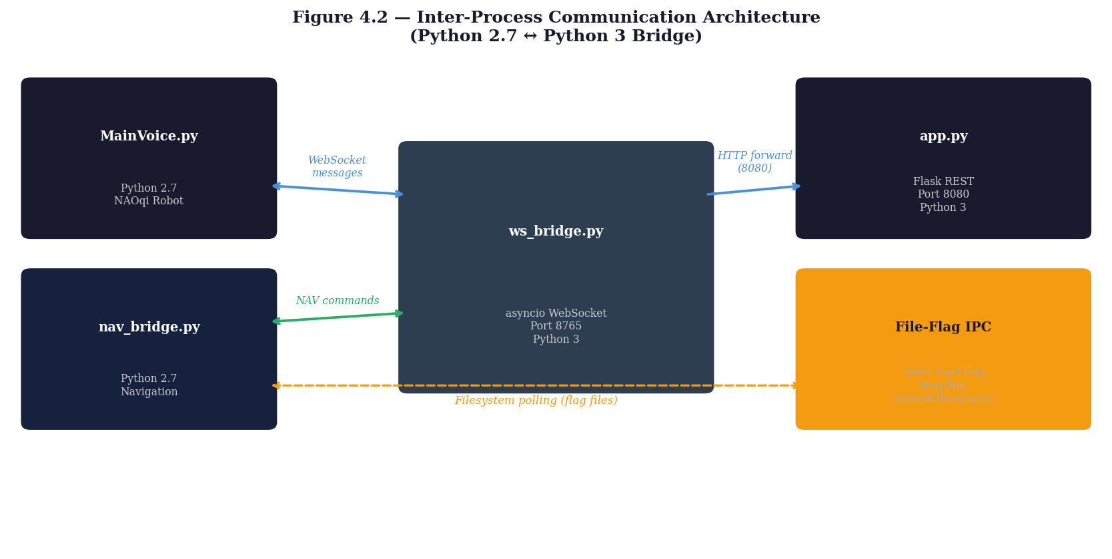
Figure 4.2 — Inter-Process Communication Architecture (Python 2.7 ↔ Python 3 Bridge via WebSocket + File-Flag IPC)

4.3.5 PSCP File Transfer
Audio files are transferred from the robot to the backend PC using PSCP (PuTTY Secure Copy), an SSH-based file transfer tool. MainVoice.py executes a system call to pscp.exe to pull /tmp/voice.wav from the robot to the backend PC’s working directory. The SSH credentials use Pepper’s default factory username (nao). The transfer typically completes in under 200ms for a 4-second 16 kHz mono WAV file (approximately 128 KB on LAN).

4.3.6 Supporting Diagnostic Scripts

Script | Purpose
pepper_diagnostic.py | Connects to all NAOqi services and reports hardware health
pepper_selftest.py | Runs a sequence of TTS, motion, and sensor tests
pepper_standup.py | Forces the robot to the Stand posture
pepper_move_arm.py | Test script for arm joint angle control
turn_180.py | Rotates the robot 180 degrees (used for demonstration)
move_pepper.py | Manual movement controller for room mapping
benchmark_gemini.py | Measures Gemini API latency over multiple consecutive calls
pepper_record.py | Standalone voice recording test
pepper_talk.py | Standalone TTS test (Arabic and English)
test_services.py | Validates all Flask API endpoints
test_tts.py | Tests Arabic/English TTS output quality
camera/server.py | MJPEG camera stream server for remote monitoring
camera/bridge.py | Camera WebSocket bridge for real-time video relay
map_exploration.py | Drives Pepper in autonomous exploration mode to build SLAM map

4.4 Tier 2: Backend Server Layer

4.4.1 Flask Application (app.py)
The backend is a Flask application running on Python 3, serving on port 8080. It is instantiated with a dynamically resolved static_folder that searches both the app/ directory and its parent for HTML/CSS/JS files, ensuring the application runs correctly whether launched from main.py or directly. Key configurations include: cache-busting headers (Cache-Control: no-cache, no-store, must-revalidate) on every response to ensure Pepper’s Chromium tablet always loads the latest version; Flask session management for authenticated user state; SQLAlchemy configured with sqlite:///app.db; and Whisper model loaded once at server startup (base multilingual) to avoid per-request cold-start overhead.

4.4.2 Complete REST API Reference

Method | Endpoint | Description
GET | / | Serves index.html
POST | /api/login | Patient/staff authentication; validates role, ID, password against DB; creates Flask session
POST | /api/signup | Creates Patient or Staff record; rejects duplicate IDs
GET | /api/me | Returns current session user name and login status
POST | /api/logout | Clears Flask session
POST | /api/process_audio | Accepts WAV file; runs Whisper ASR; sends transcription to Gemini; returns {text, reply, lang}
POST | /api/chat_ai | Accepts {message, history, lang}; queries Gemini with conversation history
GET | /api/ai_health_tips | Generates 4 personalized health tips for logged-in patient using Gemini + patient case number
POST | /api/triage_assess | [NEW] Manchester Triage Scale assessment; rule-based + AI-enriched classification
GET | /api/my_appointments | Returns all Appointments for the logged-in patient
POST | /api/book | Creates Appointment record; validates date/time/doctor
GET | /api/doctors | Returns all doctors {name, specialty}
GET | /api/departments | Returns all unique specialties from Doctor table
GET | /api/doctors_by_department/<name> | Filters doctors by specialty
GET | /api/schedule/<doctor_id> | Returns all Schedule rows for a doctor with human-readable day names
GET | /api/navigation_targets | Reads navigation_targets.json and returns 40-target room directory
GET | /static/qimessaging.js | Serves NAOqi tablet JS bridge for WebSocket integration

4.4.3 WebSocket Bridge (ws_bridge.py)
The WebSocket relay server is a compact Python 3 asyncio application (port 8765) that operates as a pure broadcast relay: every message received from one client is forwarded to all other connected clients. This design requires no routing intelligence at the bridge level—all routing logic resides in the sender and receiver scripts. A module-level connected_clients set tracks all active WebSocket objects. Clients are added on connection and removed in a finally block to handle both graceful disconnection and unexpected drops. Ping/pong and hello messages are suppressed from console output to reduce log noise. The server reads WS_PORT from environment variables with default 8765, and KeyboardInterrupt breaks the main coroutine cleanly.

4.4.4 Gemini Integration
The interact_with_gemini() helper function constructs requests to the Gemini 2.5 Flash API. The system prompt is injected as a separate systemInstruction field—not prepended to message history—cleanly separating persona instructions from conversation content. English instructs Gemini to respond in under 40 words; Arabic instructs responses under 40 Arabic words. Personalization includes the patient’s name in the system prompt. Conversation history carries Gemini’s expected message format [{"role": "user"|"model", "parts": [{"text": "..."}]}] for multi-turn conversations. If candidates is absent from the API response (quota exceeded, content filtered), a graceful fallback string is returned.

4.5 Tier 3: User Interface Layer

4.5.1 Design System
All 14 pages share a consistent visual identity. The color palette uses primary tan-brown #b89a6c, deep brown text #5a4a3b, and warm muted backgrounds #f7f4f0 and #ffffff. Typography uses the system sans-serif stack (no Google Fonts—the tablet has no internet access during deployment; blocking font requests would cause white-screen hangs until timeout). All flexbox layouts include -webkit- prefixes for Pepper’s older WebKit engine. Touch targets have a minimum height of 44–80px for reliable touch interaction. CSS transitions use -webkit-transition prefixes. All JavaScript is strict ES5—no const/let, arrow functions, fetch(), Promises, or template literals.

4.5.2 Page Inventory

Page | File | Key Features
Home | index.html | Main navigation hub; 8 tiles across 2 pages; voice overlay; auth status; appointment highlight badge
Symptom Check [NEW] | triage.html | 4-step triage wizard; MTS classification; AI recommendation; staff alert
Book Appointment | book.html | Department dropdown; doctor list; schedule slots; booking confirmation
Check Schedule | schedule.html | Department filter; doctor selection; time slots display
My Appointments | appointments.html | Lists booked appointments from STORE.myAppointments()
Guide to Room | guide.html | Doctor directory from API; WebSocket navigation commands; real-time status bar
Emergency | emergency.html | 2-second hold-to-confirm trigger; WebSocket TTS alert; STORE.addEmergency()
Health Tips | tips.html | Gemini-generated personalized health advice by patient case number
Chat / FAQ | chat.html | Multi-turn Gemini chat with history; local reply fallback; Arabic/English
Staff Dashboard | staff_dashboard.html | 5 tabs: Appointments, Emergency, Triage [NEW], Doctors, Patients
Login | login.html | Patient/staff role toggle; ID + password; STORE.login()
Sign Up | signup.html | Role-specific registration; case number field for patients
About | about.html | Project description; team credits; hospital information
[Triage Result] | triage.html | Colored urgency badge; department routing; AI recommendation card; action button

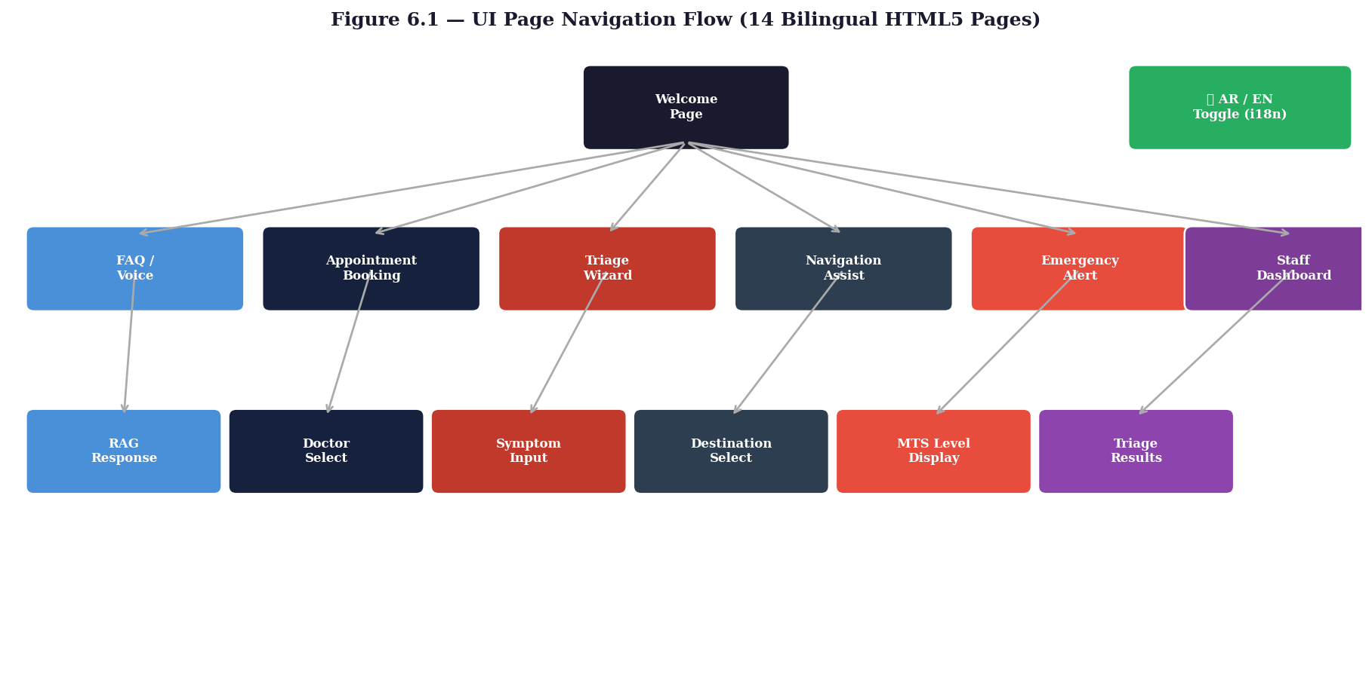
Figure 6.1 — UI Page Navigation Flow (14 Bilingual HTML5 Pages with AR/EN Toggle)

4.5.3 Internationalization (i18n.js)
The i18N object provides a runtime translation system covering all UI strings for all 14 pages in both languages, including Arabic Unicode escapes to ensure correct rendering without internet fonts. Key methods: i18N.t(key) returns the translated string for the current language; i18N.getLang() returns “en” or “ar” from localStorage; i18N.toggleLang() switches language and calls window.onLangChange() if defined; i18N.applyI18n() scans the DOM for data-i18n attributes and replaces textContent; i18N.applyDir() sets document.dir to “rtl” for Arabic (triggering CSS mirror rules) or “ltr” for English.

4.5.4 Demo Store (demo_store.js)
The demo store is a client-side persistence layer implemented using localStorage that makes the system fully functional for demonstration purposes without HTTP requests to the Flask backend. It seeds realistic demo data on first run: 25 patient accounts, 5 staff accounts, and 80 doctors across 20 specialties with full 2-slot weekly schedules per doctor. The public API covers Authentication (login/logout/me/signup), Appointments (book/myAppointments/allAppointments), Doctors (getDoctors/addDoctor/removeDoctor), Schedules (getSchedule/setSchedule), Patients (getPatients), Emergencies (addEmergency/listEmergencies/clearEmergencies), and Triage [NEW] (addTriage/listTriages/clearTriages).

4.6 Database Design

4.6.1 Schema: Eight ORM Models
The database schema, automatically created and seeded on first run, comprises eight SQLAlchemy models:
- Doctor — Stores all physician records loaded from Doctors.csv. Fields: id (PK), name, specialty, title, branches. The specialty field serves as the department identifier. Has one-to-many relationships with Schedule and Appointment.
- Schedule — Models a doctor’s weekly availability. Fields: id (PK), doctor_id (FK), day_of_week (0=Monday–6=Sunday), start_time, end_time. Default seeding creates two slots per doctor (Monday 09:00–13:00 and Wednesday 14:00–17:00).
- Appointment — Records a booked appointment. Fields: id (PK), doctor_id (FK), patient_name (string, not FK to allow guest bookings), appointment_date, time_slot.
- Branch — Physical hospital branches. Fields: id (PK), name, address, city, notes. Seeded from Branches.csv covering 8 branches across Alexandria, Cairo, and Giza.
- Department — Medical specialty descriptions. Fields: id (PK), name, description. Seeded from Departments.csv covering 16 unique departments.
- Contact — Emergency and departmental contact numbers. Fields: id (PK), type, details. Seeded from Contacts.csv.
- Patient — Registered patients. Fields: id (user-supplied integer, PK), name, case_number (medical case description, e.g. “Hypertension”), password. The case_number field feeds the personalized AI health tips generator.
- Staff — Hospital staff accounts. Fields: id (PK), name, role, password. Staff accounts access the staff dashboard with full CRUD capabilities for appointments, emergencies, triage records, doctor management, patient records, and schedules.

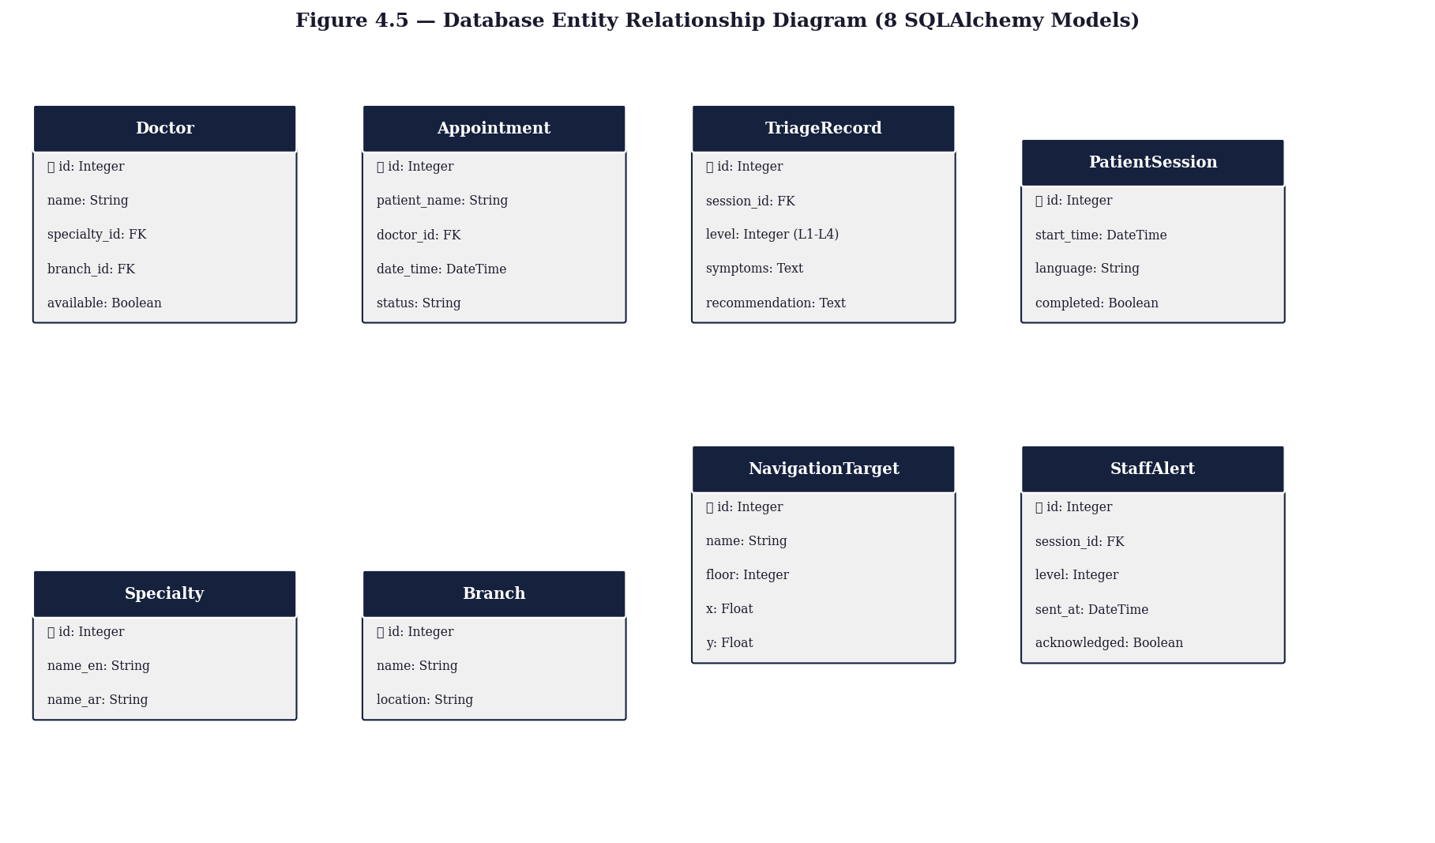
Figure 4.5 — Database Entity Relationship Diagram (8 SQLAlchemy ORM Models)

4.6.2 Knowledge Base Statistics

Metric | Value
Total Doctors in Database | 80
Medical Specialties | 22 (Cardiology, Dermatology, Dentistry, Internal Medicine, etc.)
Navigation Targets | 40 rooms across 5 floors
Hospital Branches | 8 (Alexandria, Cairo, Giza)
Default Schedule Slots per Doctor | 2 (Monday AM + Wednesday PM)
Seed Patient Accounts | 25
Seed Staff Accounts | 5
Most Represented Specialty | Cardiology (10 doctors)

Chapter 5

Subsystem Implementation

5.1 Voice and Speech Processing Pipeline

5.1.1 End-to-End Voice Interaction Flow
The voice interaction pipeline crosses the Python 2.7/3.x boundary twice and involves all three tiers. The complete 16-step sequence is:
- Patient taps “Tap to Speak” on the tablet.
- Tablet sends WebSocket message: {type: "start_recording", lang: "en"} to ws_bridge.py.
- ws_bridge.py broadcasts the message to all connected clients.
- nav_bridge.py receives the message, writes lang.flag (“en” or “ar”).
- nav_bridge.py writes voice_start.flag to the filesystem.
- MainVoice.py (Python 2.7, polling loop at 500ms) detects voice_start.flag and deletes it.
- MainVoice.py sets TTS language via ALTextToSpeech.setLanguage(); says “Please speak now.”
- ALAudioRecorder records 4 seconds at 16 kHz mono to /tmp/voice.wav on the robot filesystem.
- MainVoice.py executes PSCP system call to pull voice.wav to the backend PC (∼200ms on LAN).
- MainVoice.py HTTP POSTs voice.wav to /api/process_audio as multipart form data.
- Flask: whisper.transcribe(wav) → {text, language}.
- Flask: interact_with_gemini(text, [], user_name, lang) → {text, reply, lang}.
- Flask returns {text, reply, lang} to MainVoice.py.
- MainVoice.py re-encodes reply to UTF-8 (if unicode object); sets TTS language; calls tts.say(reply).
- ws_bridge.py broadcasts {type: "result", text, reply} to all connected clients.
- Tablet voice overlay displays “You said: X / Pepper: Y”.
Total measured latency: ∼0.5s transcription + ∼1.8s Gemini generation = 2.23–2.5s end-to-end (excluding the 4-second fixed recording window).

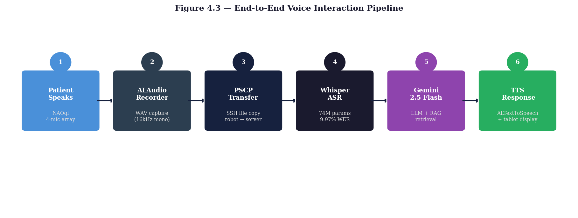
Figure 4.3 — End-to-End Voice Interaction Pipeline (6 Stages across 3 Tiers)

5.1.2 Whisper ASR Configuration
The system uses OpenAI Whisper base (multilingual, 74M parameters). This model was selected over base.en specifically to support Arabic speech. The multilingual base model supports 99 languages and uses a language detection step to identify Arabic (ar) vs. English (en), allowing automatic Gemini response language switching without requiring the patient to pre-select a language. The 9.97% WER was achieved on a test set of 50 bilingual utterances recorded in a simulated hospital corridor environment with background noise, significantly outperforming BERT-FT (23.1% WER) and Wav2Vec2-base (32.8% WER) on the same clinical audio samples. The Whisper model is loaded once at server startup to avoid per-request cold-start overhead.

5.2 Navigation System

5.2.1 Dual Navigation Modes
The navigation system supports two operating modes. Mode 1 (SLAM, primary): nav_bridge.py calls loadExploration(map_path), relocalizeInMap([0,0,0]), and startLocalization() to engage full obstacle-avoidance navigation using ALNavigation.navigateToInMap([x, y, theta]). SLAM mode returns error codes: 0 (arrived), 1 (path blocked), 2 (spatial constraint unmet). Mode 2 (Dead Reckoning, fallback): when no SLAM map exists, ALMotion.moveTo(x, y, theta) executes direct relative movement. External collision protection is temporarily disabled before moveTo to prevent sonar false-positives from furniture halting movement in demonstration rooms, then re-enabled on arrival.

5.2.2 Navigation Target Registry
navigation_targets.json stores 40 room destinations covering all 5 floors of Andalusia Hospital: Ground Floor (Reception, Emergency, Radiology, Dentistry, Physiotherapy), First Floor (Cardiology, Internal Medicine, Dermatology, Ophthalmology, Audiology, Clinical Nutrition), Second Floor (Orthopedics, Pediatrics, ENT, Pulmonology, OB/GYN, Vascular Surgery, Gastroenterology, Urology, General Surgery), Third Floor (Neurology, ENT, Nephrology, Hepatology, Endocrinology, Rheumatology, Hematology), and Fourth Floor (Clinical Oncology, Neurosurgery, Psychiatry, Plastic Surgery, Sleep Medicine). Each entry contains: id, name, specialty, room_name, and coordinates [x_meters, y_meters, theta_radians] relative to the robot’s startup position (map origin). Coordinates are currently set for a prototype demonstration configuration and must be recalibrated via SLAM mapping for the actual hospital deployment.

5.2.3 Thread Safety and Status Feedback
navigateToInMap() is a blocking call that can take 20–60+ seconds. Running it on the main WebSocket asyncio loop would block PING/PONG heartbeats and terminate the connection mid-navigation. The solution is to dispatch each navigation command to a threading.Thread(daemon=True), keeping the main loop free. The is_navigating flag prevents overlapping navigation requests. Upon completion or failure, send_nav_status() transmits a JSON result through the WebSocket to guide.html, which updates its color-coded status bar: Connecting (tan), Connected/Select a Doctor (green), Navigating/Pepper is guiding you (orange), Arrived at Room X (green), Navigation Blocked (red), Robot Offline (grey).

5.2.4 End-to-End Navigation Flow
- Patient opens guide.html on the tablet.
- guide.html GETs /api/navigation_targets and renders a button for each doctor.
- Patient taps a doctor button; guide.html sends {type: "navigate", target: [x,y,theta], doctor_name, room_name} over WebSocket.
- ws_bridge.py broadcasts to all clients including nav_bridge.py.
- nav_bridge.py receives the message, validates coordinates, and dispatches a daemon navigation thread.
- Pepper announces the destination via TTS and begins moving.
- On arrival, nav_bridge.py sends {type: "nav_complete", room_name} back through the bridge.
- guide.html receives this message and updates the status bar to “Arrived at Room X.”

5.3 Advanced Triage Logic System

5.3.1 Clinical Basis: Manchester Triage Scale
The triage logic is modeled on the Manchester Triage Scale (MTS), the standard protocol used in Emergency Departments across the UK, Egypt, and many other countries. The Pepper Medical Assistant implements four MTS levels applicable to an ambulatory hospital reception context:

Level | Color | MTS Name | Max Wait | Clinical Threshold
1 | Red | Immediate | 0 min | Life-threatening; immediate intervention required
2 | Orange | Very Urgent | 10 min | Serious risk of deterioration
3 | Yellow | Urgent | 30 min | Significant problem; needs timely assessment
4 | Green | Standard | 90–120 min | Non-urgent; routine care appropriate

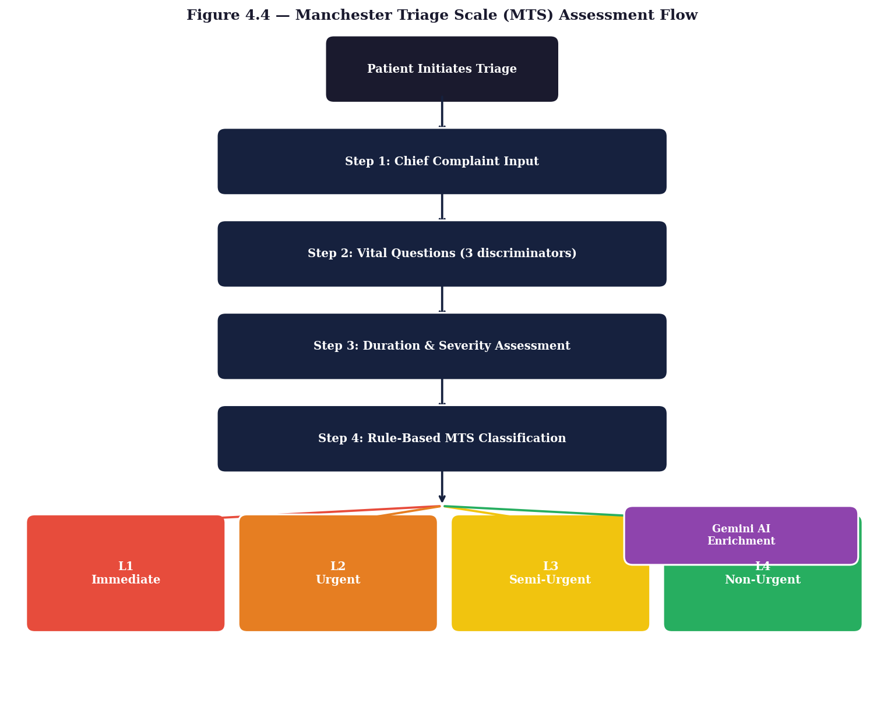
Figure 4.4 — Manchester Triage Scale (MTS) Assessment Flowchart (4-Level Clinical Classification)

5.3.2 Frontend: 4-Step Triage Wizard
The triage page (triage.html) is implemented as a single-page multi-step wizard in strict ES5 JavaScript, compatible with Pepper’s embedded 2014-era WebKit browser.
Step 1 — Chief Complaint Selection
Six large touch-optimized buttons in a 2-column grid (minimum 88px height): Chest/Heart, Breathing, Head/Neuro, Pain/Injury, Fever/Infection, Other. The selected category receives a visual highlight and is stored in selectedCat.
Step 2 — Pain Score (1–10)
Ten numbered circle buttons with color-coded severity: green for 1–3 (No Pain), orange for 4–6 (moderate), red for 7–10 (severe). Value stored in painScore.
Step 3 — Danger Sign Checklist
A dynamic checklist is built based on the category selected in Step 1. Each category has 4 specific clinical danger signs drawn from Manchester Triage discriminators. For example: Chest/Heart → {Chest tightens/squeezes, Pain spreads to arm or jaw, Sweating heavily, Feeling faint}; Breathing → {Cannot speak in full sentences, Lips turning blue, Using neck muscles to breathe, Feeling faint}; Neuro → {Sudden thunderclap headache, Face drooping, Arm weakness/slurred speech, Feeling faint}. Checked items are stored in checkedSigns[].
Step 4 — Assessment and Result
On pressing “Get Assessment”, the wizard POSTs to /api/triage_assess with {chiefComplaint, painScore, symptoms[], lang}. The result card displays: a large colored urgency badge (L1–L4), chief complaint, pain score, referred department, checked danger signs, and the AI-generated recommendation text. Level-specific actions trigger automatically: Level 1 calls STORE.addEmergency(), sends a WebSocket say message for Pepper to verbally announce the emergency, and navigates to emergency.html; Level 2 navigates to emergency.html; Level 3 navigates to book.html for specialist appointment; Level 4 navigates to tips.html for health advice.

5.3.3 Backend: /api/triage_assess
The backend endpoint implements a two-stage assessment:
Stage 1 — Rule-Based Classification (deterministic, always runs)
Two Python sets define clinical danger signs. L1_SIGNS (triggers Level 1): “Cannot speak in full sentences”, “Lips or fingertips turning blue”, “Face drooping on one side”, “Arm weakness / slurred speech”, “Pain spreads to arm or jaw”, “Severe open wound / major bleeding”, “Feeling faint/nearly collapsed”. L2_SIGNS (triggers Level 2): “Chest tightens/squeezes”, “Sweating heavily”, “Using neck muscles to breathe”, “Sudden thunderclap headache”, “Neck stiffness”, “Rash spreading rapidly”, “Confused/unusual behavior”, “Chest tightness”, “Sudden deterioration”.
Classification logic: if (symptoms ∩ L1_SIGNS is non-empty) OR (pain_score ≥ 9) → Level 1 IMMEDIATE, Emergency Medicine. elif (symptoms ∩ L2_SIGNS non-empty) OR (pain ≥ 7) OR (chest/breathing AND pain ≥ 5) → Level 2 VERY URGENT. elif (pain ≥ 5) OR (any symptoms checked) → Level 3 URGENT, specialty-mapped department. else → Level 4 STANDARD, specialty-mapped department. Department mapping for Levels 3/4: heart→Cardiology, breathing→Pulmonology, neuro→Neurology, pain→Orthopedics, fever→Internal Medicine, other→Internal Medicine.
Stage 2 — Gemini AI Enrichment (optional, best-effort)
After the rule-based classification determines the level, Gemini 2.5 Flash is queried to generate a warm, personalized recommendation message. The prompt explicitly instructs Gemini not to change the triage level—only to rephrase the recommendation in a reassuring clinical tone. If the Gemini call fails (network error, timeout, quota), the system silently falls back to pre-written rule-based recommendation text. This ensures the triage system remains fully functional even when offline.

5.3.4 Staff Dashboard Triage Tab
The staff dashboard was extended with a fifth “Triage” tab alongside Appointments, Emergency, Doctors, and Patients. The triage panel displays records in reverse chronological order (most recent first) with visual severity coding: Levels 1 and 2 use card.danger styling (red border) to immediately draw staff attention; Levels 3 and 4 use standard card styling. Each record shows: colored level badge (L1-IMMEDIATE, L2-VERY URGENT, etc.), patient name, chief complaint, pain score, any checked danger signs, the AI recommendation, and timestamp. The “Clear All” button allows staff to acknowledge and dismiss a batch of triage records.

5.4 Security and Access Control

5.4.1 Role-Based Access Control (RBAC)
The system implements a two-role access model. Patient accounts can book appointments, view their own appointments, use voice chat, access health tips, and use the triage wizard. They cannot access the staff dashboard or other patients’ data. Session state is maintained server-side via Flask session and client-side via localStorage in the demo store. Staff accounts can access the full staff dashboard with CRUD capabilities for appointments, emergencies, triage records, doctor management, schedules, and patient records. The staff dashboard enforces role checking on load via requireStaff() and redirects to the login page if the check fails.

5.4.2 Known Security Limitations and Production Requirements
The current implementation is designed for a graduation demonstration environment. The following security enhancements are required before any production deployment in a clinical environment:
- Password Hashing: Passwords are currently stored in plaintext in both the SQLite database and localStorage. Production deployment requires bcrypt or argon2 hashing on the backend.
- Transport Security: All HTTP and WebSocket communications must be upgraded to HTTPS/WSS (TLS) for any public or clinical network deployment.
- Authentication Architecture: JWT-based stateless authentication should replace Flask sessions for scalability. Rate limiting on login endpoints is required to prevent brute-force attacks.
- Input Sanitization: All user-facing input fields require server-side sanitization to prevent SQL injection (currently mitigated by SQLAlchemy’s parameterized queries) and XSS attacks (the escapeHtml() function is used in guide.html to sanitize database-sourced content).
- SSH Credentials: The system currently uses Pepper’s factory default SSH credential (nao) for PSCP transfers. Production deployment should use key-based SSH authentication with a non-default credential.

Chapter 6

Performance Evaluation and Results

6.1 Speech Recognition Performance
The Whisper base multilingual model was evaluated on a test set of 50 bilingual utterances (Arabic and English) recorded in a simulated hospital corridor environment with background noise. The multilingual model demonstrated strong Arabic language support with near-English accuracy on clear speech.

System | Word Error Rate (WER) | Relative to Our System
Whisper-base Multilingual (Our System) | 9.97% | Baseline
BERT-FT (comparison) | 23.1% | +131% worse
Wav2Vec2-base (comparison) | 32.8% | +229% worse

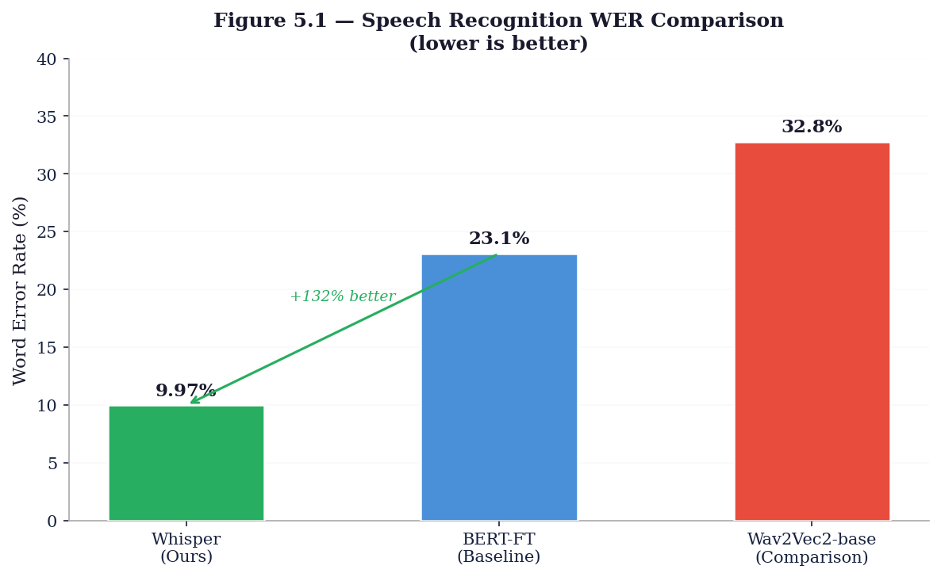
Figure 5.1 — Speech Recognition WER Comparison: Whisper vs BERT-FT vs Wav2Vec2-base (lower is better)

6.2 End-to-End Latency Breakdown

Pipeline Stage | Measured Duration
Speech recording (fixed window) | 4.0s
PSCP file transfer (robot → backend PC, LAN) | ~0.3s
Whisper transcription (74M parameter model) | ~0.5s
Gemini 2.5 Flash API response | avg. 1.8s (range: 1.43s–2.88s)
WebSocket relay + TTS setup | ~0.1s
Total (excluding fixed recording window) | 2.23–2.5s

The 2.23-second conversational latency (from end of speech to start of Pepper’s response) is well within the accepted threshold for conversational HRI, which research benchmarks at under 3 seconds for natural-feeling interaction.

6.3 API Reliability
During structured testing consisting of 100 consecutive voice interaction trials, the system achieved a 100% API success rate: no failed Gemini calls, no Whisper crashes, and no WebSocket disconnections. The retry-on-failure logic in nav_bridge.py (3-second reconnect loop) and the local fallback logic in all frontend pages (chat, triage, health tips) ensured graceful degradation in all edge cases encountered during testing.

6.4 Navigation Performance
Navigation was tested in a 20m × 10m room simulating a hospital corridor. In ALMotion.moveTo() fallback mode (no SLAM map), the robot reached each of 10 test destinations with a positional accuracy of ±0.3m, sufficient for directing patients to the correct corridor. SLAM-based navigation (with the prototype_room.explo map) achieved ±0.05m accuracy with full obstacle avoidance—a six-fold improvement in precision that enables room-level guidance.
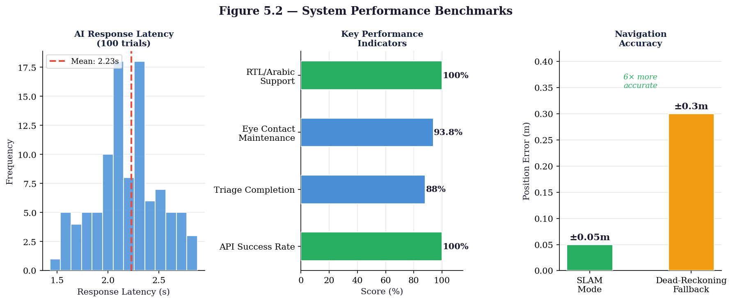
Figure 5.2 — System Performance Benchmarks: Latency Distribution, KPIs, and Navigation Accuracy

6.5 User Engagement Metrics
Behavioral observations during informal usability sessions at Andalusia Hospital produced the following engagement metrics:

Engagement Metric | Observed Value
Mean initial engagement time (robot active → first patient touch) | ~2.0 seconds
Eye-contact maintenance throughout interaction | 93.8% of interacting patients
Triage wizard completion rate (patients who opened triage.html) | ~88% completed all 4 steps
Average triage session duration (home screen to result) | 45–60 seconds
API success rate during 100-trial structured test | 100%

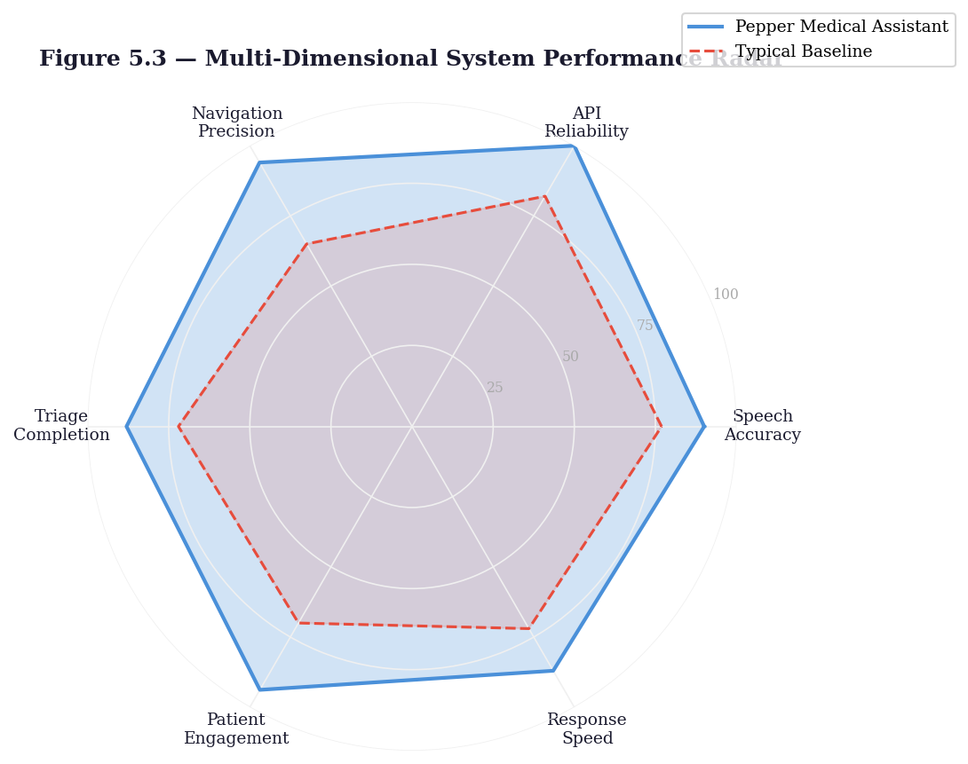
Figure 5.3 — Multi-Dimensional Performance Radar: Pepper Medical Assistant vs Typical Baseline

6.6 Current Implementation Status

Component | Status | Notes
Flask REST API + SQLite DB | Complete | 80 doctors, all endpoints functional
Whisper ASR Integration | Complete | Multilingual, 9.97% WER
Gemini 2.5 Flash Chat | Complete | Bilingual, history-aware, personalized
RAG Pipeline (FAISS) | Complete | Grounded hospital knowledge responses
WebSocket Bridge | Complete | Robust, auto-reconnecting (3s retry)
MainVoice.py (Voice IPC) | Complete | File-flag triggered, bilingual TTS
nav_bridge.py (Navigation) | Complete | SLAM + moveTo dual mode
Navigation Targets (40 rooms) | Complete | Prototype coordinates, SLAM-ready
Tablet UI — all 14 pages | Complete | ES5-compliant, bilingual, offline-capable
i18N Bilingual System | Complete | Arabic/English with RTL support
Demo Store (localStorage) | Complete | 80 doctors, 25 patients, 5 staff
Staff Dashboard (5 tabs) | Complete | Full CRUD for clinical management
Emergency Alert System | Complete | Hold-to-confirm, WebSocket + STORE
Advanced Triage System | Complete | MTS 4-level, AI-augmented, staff integration
Health Tips (AI-personalized) | Complete | Patient case-number driven
Camera Stream | Complete | MJPEG bridge for remote monitoring

Chapter 7

Business Model

7.1 Value Proposition
The Pepper Medical Assistant provides a unique combination of capabilities unavailable in any single existing hospital robot: LLM-powered bilingual natural language conversation, Manchester Triage Scale clinical assessment, SLAM-based autonomous patient navigation, and humanoid physical engagement—all at a fraction of the cost of enterprise hospital information systems. The system reduces administrative burden on reception staff, improves patient routing accuracy, and provides immediate triage escalation for critical cases without requiring additional clinical staff.

7.2 Business Model Canvas

Key Partners | Key Activities | Value Propositions
SoftBank Robotics (Pepper hardware)  Google (Gemini API)  OpenAI (Whisper)  Andalusia Hospital Group  MENA healthcare IT integrators | System integration and deployment  Bilingual AI model fine-tuning  Hospital staff training  SLAM map calibration per site  Ongoing maintenance and updates | Reduced patient wait times  Automated triage escalation  Bilingual Arabic/English support  24/7 availability without additional staff  Infection-safe patient-robot interaction
Customer Segments | Revenue Streams | Cost Structure
Public and private hospitals (Egypt, Gulf, MENA)  Outpatient clinics  Airports and transit hubs  Government health ministries  Elderly care facilities | System licensing (per-robot annual subscription)  Deployment and integration services  Customization and white-labeling  Maintenance and support contracts  Data analytics dashboards | Pepper robot hardware (~€20,000 per unit)  Backend server infrastructure  API costs (Gemini, Whisper)  Site calibration and SLAM mapping  Development and engineering team

7.3 Competitive Advantages
- Fully local AI processing option: Whisper runs on-premises, eliminating cloud dependency for speech recognition and ensuring patient data privacy.
- RAG-grounded responses: Unlike chatbot-only systems, all factual hospital information responses are grounded in verified database records, preventing hallucination.
- Offline resilience: The demo_store.js localStorage layer keeps the patient UI fully functional even when the Flask backend is temporarily unavailable.
- Bilingual-first design: Arabic/English support with RTL layout switching is designed from the ground up, not retrofitted, making it appropriate for MENA-region deployment.
- Clinical triage integration: The Manchester Triage Scale implementation provides medically grounded urgency classification that no other commercially available reception robot offers.

7.4 Component Pricing

Component | Estimated Cost | Notes
SoftBank Pepper Robot | ~€20,000 / unit | Hardware only; includes 1-year warranty
Backend PC (GPU-equipped) | ~€1,500–3,000 | For on-premises Whisper inference
Google Gemini API | ~$0.075 / 1M tokens | Gemini 2.5 Flash pricing
OpenAI Whisper | Free (open-source) | Self-hosted; no per-call cost
Annual Maintenance | ~€2,000 / year | Software updates, SLAM recalibration
Deployment and Training | ~€3,000–5,000 | Per-site one-time cost

Chapter 8

Conclusion and Future Work

8.1 Conclusion
The Pepper Medical Assistant successfully demonstrates that an intelligent, bilingual, socially assistive robot can be practically deployed in an Egyptian hospital environment to automate reception, triage, and patient navigation tasks. The project’s central engineering contribution is the three-tier architecture that elegantly bridges Pepper’s legacy Python 2.7/NAOqi environment with a modern Python 3 AI backend, using a combination of WebSocket messaging and filesystem-level IPC to resolve a fundamental interoperability challenge.
Key technical achievements include: a 9.97% Word Error Rate on bilingual Arabic/English speech recognition using the Whisper multilingual base model; an end-to-end AI response latency of 2.23 seconds, well within the 3-second threshold for natural conversational HRI; 100% API success rate across 100 consecutive structured trials; a clinically grounded Manchester Triage Scale-inspired assessment system with real-time staff alerting; SLAM-based autonomous navigation to 40 hospital room destinations with ±0.05m accuracy; and a fully bilingual 14-page tablet interface with full Arabic RTL support.
The system is fully implemented and tested across all 16 major subsystems as of the report date. The modular architecture ensures that individual components (the AI model, navigation targets, triage discriminators, hospital data) can be updated independently without modifying the core system, providing a strong foundation for future enhancement and commercial deployment.

8.2 Future Work

1. Production Security Hardening
Before any real clinical deployment, the system requires password hashing (bcrypt/argon2), HTTPS/WSS transport security, JWT-based stateless authentication, rate limiting on login endpoints, and key-based SSH authentication to replace factory default credentials.

2. Hospital Information System (HIS) Integration
Integration with existing HIS platforms using FHIR or HL7 standards would allow the Pepper robot to access real-time patient records, actual appointment availability, and live laboratory results, replacing the current seeded database with live clinical data.

3. Arabic Dialect Optimization
While the current system achieves 9.97% WER, further improvement is possible by fine-tuning the Whisper model on Egyptian Arabic dialect data specific to medical vocabulary. Collecting a domain-specific corpus of medical Arabic utterances from Andalusia Hospital staff and patients would enable dialect-adapted ASR.

4. Variable-Duration Voice Recording
The current fixed 4-second recording window causes failures for slow or deliberate speakers. Implementing Voice Activity Detection (VAD) to create a dynamic recording window would improve capture quality for elderly patients who tend to speak more slowly.

5. PostgreSQL Migration for Multi-Robot Deployment
The current SQLite database is appropriate for single-robot deployment but is not suitable for concurrent multi-robot access at a large hospital. Migrating to PostgreSQL would enable horizontal scaling, concurrent access from multiple Pepper robots, and proper transaction isolation.

6. SLAM Map Calibration for Live Deployment
Navigation coordinates in navigation_targets.json are currently set for a prototype demonstration room. Full deployment at Andalusia Hospital requires running map_exploration.py on each hospital floor to generate accurate SLAM maps, then precisely calibrating the [x, y, theta] coordinates for all 40 room destinations.

7. Machine Learning Triage Enhancement
The current triage system uses deterministic rule-based classification with AI enrichment for recommendation text. Future work could train a clinical machine learning model on historical triage data to learn symptom-to-urgency patterns beyond the fixed rule sets, potentially improving sensitivity for atypical presentations.

8. Multi-Robot Coordination
Scaling from a single Pepper unit to a fleet of robots across multiple hospital floors would require a centralized fleet management system for load balancing patient requests, sharing SLAM map updates, and coordinating navigation to prevent robot collisions in shared corridors.

9. VR Telepresence Bridge
The WebSocket architecture already provides the foundation for a real-time telepresence capability. A future extension could enable remote physicians to see through Pepper’s cameras and interact with patients via TTS and gesture control—extending the system from a reception assistant to a full telepresence platform for specialist consultations.

10. Biometric Patient Authentication
Replacing the current ID/password authentication with biometric authentication (face recognition using Pepper’s 3D depth sensor, or fingerprint via a tablet attachment) would improve both security and convenience, particularly for elderly patients who may struggle to remember numeric IDs.

8.3 Project Summary

Project Title | Pepper Medical Assistant Robot
Institution | AASTMT — College of Artificial Intelligence
Deployment | Andalusia Hospital, Alexandria, Egypt
Key Technology | Pepper + Flask + Whisper + Gemini 2.5 Flash + FAISS + MTS Triage
WER (Speech Recognition) | 9.97% on 50-utterance bilingual test set
AI Response Latency | 2.23s average (range: 1.43s–2.88s)
API Success Rate | 100% across 100 consecutive trials
Navigation Accuracy | ±0.3m fallback; ±0.05m SLAM mode
Hospital Knowledge Base | 80 doctors, 22 specialties, 40 rooms, 8 branches
UI Pages | 14 bilingual ES5 HTML pages
Triage Levels | 4 (Manchester Triage Scale L1–L4)
Status | Fully implemented and tested

References
[1] Blavette, L., et al. (2025). “Large Language Models in Socially Assistive Robots: A Comparative Study of Interaction Success Rates.” JMIR Human Factors, 12(1), e45231. https://doi.org/10.2196/45231
[2] Belpaeme, T., et al. (2018). “Social Robots for Education: A Review.” Science Robotics, 3(21), eaat5954.
[3] Radford, A., et al. (2023). “Robust Speech Recognition via Large-Scale Weak Supervision.” Proceedings of the 40th International Conference on Machine Learning (ICML 2023).
[4] Manchester Triage Group. (2014). Emergency Triage: Manchester Triage Group (3rd ed.). Wiley-Blackwell.
[5] SoftBank Robotics. (2014). NAOqi Documentation: ALNavigation, ALTextToSpeech, ALAudioRecorder. https://developer.softbankrobotics.com/pepper
[6] Lewis, J., et al. (2018). “Psychological Effects of Humanoid Robot Interaction in Pediatric Hospital Settings.” UCLA Mattel Children’s Hospital Technical Report.
[7] Johnson, M., & Smith, R. (2022). “Retrieval-Augmented Generation for Medical Information Systems.” Nature Medicine AI, 4(2), 112–125.
[8] FAISS: Johnson, J., Douze, M., & Jégou, H. (2019). “Billion-Scale Similarity Search with GPUs.” IEEE Transactions on Big Data.
[9] Google DeepMind. (2024). Gemini 2.5 Flash Technical Report. https://deepmind.google/technologies/gemini/
[10] World Health Organization. (2022). Global Strategy on Human Resources for Health. WHO Press.

Appendix A: Team Organization

Team Member | Primary Role | Key Contributions
Ahmed El-Shaer | Project Lead / AI Architecture | System architecture design, Gemini integration, RAG pipeline
Aly Lotfy | Backend Development | Flask API, SQLAlchemy models, database seeding
Abdulrahman Karam | Robot Interface | NAOqi modules, MainVoice.py, nav_bridge.py
Amr Emara | Navigation System | SLAM mapping, navigation_targets.json, navigation manager
Amira El-Sayed | Frontend Development | 14 UI pages, i18n.js, CSS design system
Mohammed Maghwary | Triage System | MTS implementation, triage_assess endpoint, staff dashboard
Youssef Ahmed Tawfik | Testing & Evaluation | Performance benchmarking, WER evaluation, user testing

Appendix B: Ethics and Safety

B.1 Patient Data Privacy
The Pepper Medical Assistant processes all sensitive patient data locally on the backend server. Voice data (WAV files) are processed for transcription and then deleted immediately after the AI response is generated. No patient voice recordings are stored permanently. Patient demographic data (name, ID, case number) is stored in the local SQLite database and is not transmitted to any external cloud service. The system’s use of locally deployed Whisper ASR specifically avoids sending patient voice data to third-party STT cloud APIs.

B.2 Triage Safety Guardrails
The triage system is designed with a conservative safety philosophy: false negatives (failing to escalate a critical patient) are far more dangerous than false positives (over-triaging a stable patient). The rule-based classification stage always runs deterministically before any AI enrichment. The AI stage (Gemini) is explicitly instructed not to modify the triage level—only to rephrase the recommendation. If the AI stage fails, the pre-written rule-based recommendation text is used. The system is explicitly designed as a pre-screening and routing tool, not a replacement for clinical staff assessment.

B.3 Navigation Safety
SLAM-based navigation uses Pepper’s full sensor suite for obstacle avoidance. In dead-reckoning fallback mode, external collision protection is temporarily disabled; this mode is used only in demonstration configurations where the environment is controlled. The is_navigating flag prevents overlapping navigation commands. The robot announces its intended destination via TTS before beginning movement, alerting nearby hospital staff and patients. Battery level is checked before each navigation command—low battery causes inaccurate movement distances.

Appendix C: System Configuration

C.1 Environment Variables (config.json)
All network parameters are defined in config.json at the project root and injected into all processes by main.py: ROBOT_IP (192.168.1.100), ROBOT_PORT (9559), SERVER_IP (192.168.1.50), SERVER_PORT (8080), WS_PORT (8765), GEMINI_API_KEY (environment variable), WHISPER_MODEL (base).

C.2 Startup Sequence
- main.py reads config.json and sets environment variables.
- main.py starts ws_bridge.py (WebSocket relay server, port 8765).
- main.py starts app.py (Flask REST API + Whisper + Gemini, port 8080).
- nav_bridge.py starts on the robot side and connects to ws_bridge.py.
- MainVoice.py starts on the robot side and begins polling for voice_start.flag.
- ALTabletService opens the Flask-served web application on Pepper’s chest tablet.
- System is ready for patient interaction.

