**Final Project:**

Course: Web Development

Professor: Dr. Omar Shalash

Professor Assistant: Eng. Nagy k. Aly

Project: Apple Store Web Application

**Group:**

Student 1: Aly Ahmed Lotfy

Reg Num: 221000412

Term: 2

Student 2: Amr Emara

Reg Num: 221000299

College: College of Artificial Intelligence

Student 3: Youssef El-Deeb

Reg Num: 221003952

Student 4: Yasser Abdel-Nasser

Reg Num: 22100xxxx

University: Arab Academy for Science Technology and Maritime Transport

**Outline of the Documentation**

1. Introduction and Objectives
2. File Structure
3. Screenshots of Running Applications
4. Functional and Non-Functional Requirements
5. Sequence Diagram for Each Request
6. GitHub Repository
7. Conclusion

**Introduction and Objectives:**

The Apple Store web application is a comprehensive platform designed to replicate the premium in-store experience of an Apple Store in a digital environment. With the increasing reliance on e-commerce, this project aims to provide users with an engaging and seamless online shopping experience. The application features an extensive catalog of Apple products, including the latest iPhones, MacBooks, AirPods, and Apple Watches, ensuring users have access to detailed information and specifications for each item.

The development of this application leverages a range of web technologies to create a robust and user-friendly platform. Using native HTML, CSS, and Bootstrap, the front-end of the application is designed to be visually appealing and responsive, adapting to different screen sizes and devices. Vanilla JavaScript is utilized to add interactivity and dynamic content updates, enhancing the user experience.

The key objectives of the Apple Store web application are:

**User-Friendly Interface:**

The application is designed with a focus on simplicity and ease of use. Users can effortlessly navigate through different sections, explore various products, and access detailed descriptions, images, and prices. The intuitive design ensures that users, regardless of their technical proficiency, can comfortably use the platform.

**Smooth Navigation:**

The site architecture is structured to facilitate quick and efficient navigation. Users can move between pages with minimal load times, ensuring a seamless browsing experience. Each product category and individual product page is easily accessible from the homepage, reducing the number of clicks needed to find specific items.

**Secure User Authentication:**

Ensuring the security and privacy of user data is a top priority. The application includes secure registration and login functionalities, where user credentials are encrypted and securely stored. Authentication mechanisms are implemented to protect user accounts and personal information, providing users with confidence in the safety of their data.

**Comprehensive Product Display:**

Each product page is designed to provide exhaustive information about the item, including high-quality images, detailed specifications, and pricing. This allows users to make informed purchasing decisions without the need to visit a physical store.

**Interactive User Experience:**

The application incorporates interactive elements such as animations, dynamic content updates, and form validations. These features enhance user engagement and ensure that the website is not only functional but also enjoyable to use.

**Responsive Design:**

With the increasing use of mobile devices for online shopping, the application is designed to be fully responsive. It adjusts seamlessly to various screen sizes and resolutions, providing an optimal viewing experience on desktops, tablets, and smartphones.

**File Structure:**

Each HTML file represents a different page or functionality within the application:

1. airmax.html: This page provides details about the Apple AirMax product, including images, descriptions, and pricing.
2. airpodspro.html: This page focuses on the Apple AirPods Pro, showcasing its features, specifications, and pricing.
3. apples8.html: This page displays information about the Apple Series 8, including product details and images.
4. Contact.html: This page allows users to get in touch with the store. It includes a contact form for user inquiries and feedback.
5. index.html: The homepage of the application, which serves as the main entry point for users. It provides an overview of available products and links to other pages.
6. iphone14.html: This page provides detailed information about the iPhone 14, including specifications, images, and pricing.
7. iphone15.html: Similar to the iPhone 14 page, this one focuses on the iPhone 15, offering comprehensive details about the product.
8. Login.html: This page contains the login form for existing users to access their accounts.
9. macair.html: This page features the MacBook Air, detailing its specifications, features, and pricing.
10. macbookpro.html: This page provides information about the MacBook Pro, including detailed specifications and pricing.
11. products.html: This page lists all the products available in the store, acting as a catalog for users to browse.
12. register.html: This page includes a registration form for new users to create an account on the platform.
13. Watch.html: This page is dedicated to the Apple Watch, providing details about its features, specifications, and pricing

**CSS File**

bootstrap.min.css: This is a minified version of the Bootstrap CSS framework. It is used to style the HTML pages and ensure a responsive and modern design. Bootstrap provides pre-defined classes for layout, typography, forms, buttons, and other UI components.

**JavaScript File**

Java.js: This JavaScript file contains the client-side logic for the application. It may include functionalities such as form validations, interactive elements, event handling, and dynamic content updates. JavaScript enhances the interactivity and responsiveness of the web pages.

**Images Directory**

Images: This directory contains various images used throughout the project. These images are likely product images, logo images, and other visual assets that enhance the appearance and user experience of the application

**Screenshot of Running Application:**

Include screenshots of the following pages:

**Home Page (index.html)**

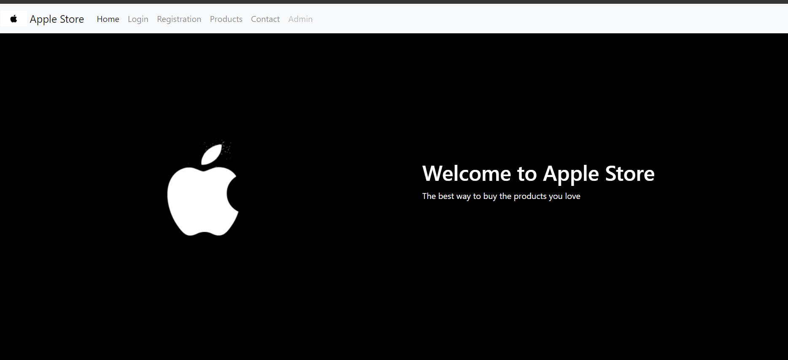

**Product Pages**

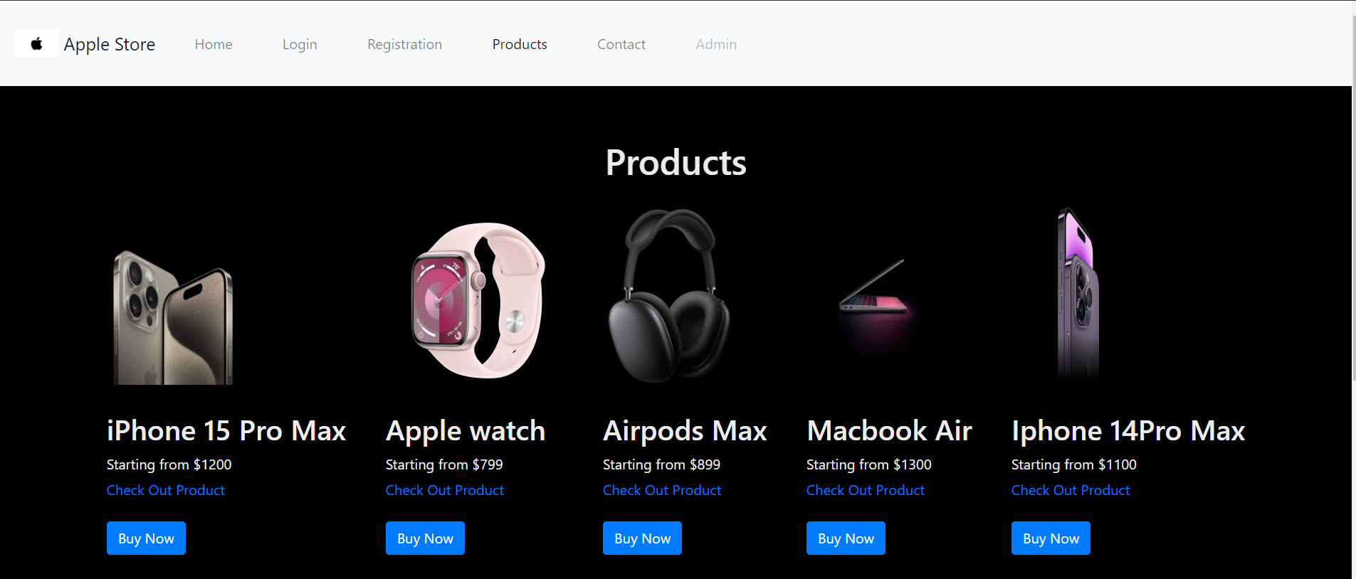

**iPhone 15 (iphone15.html)**

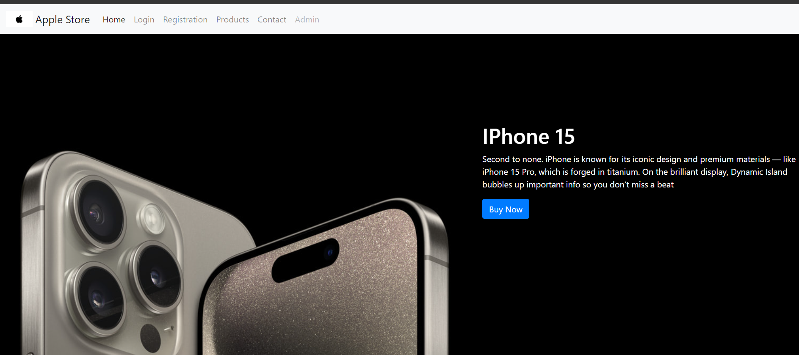

**MacBook Pro (macbookpro.html)**

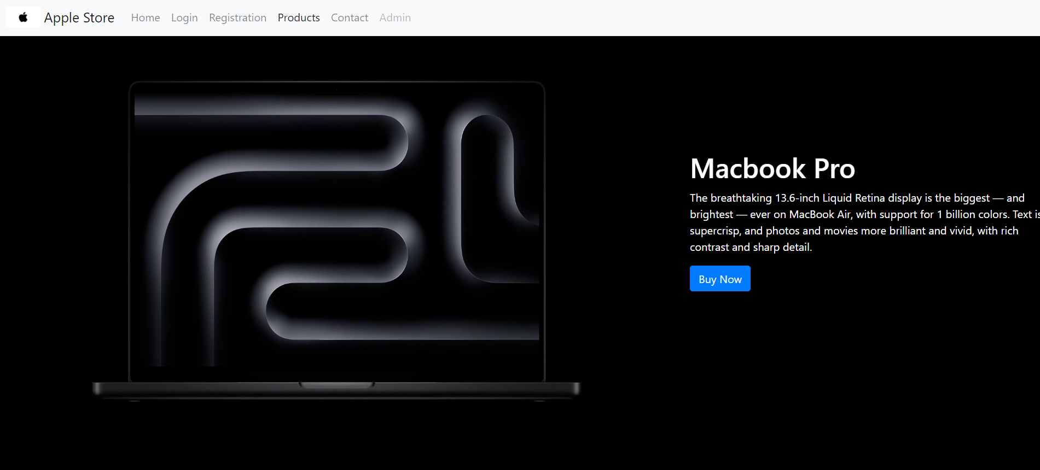

**Apple Watch (Watch.html)**

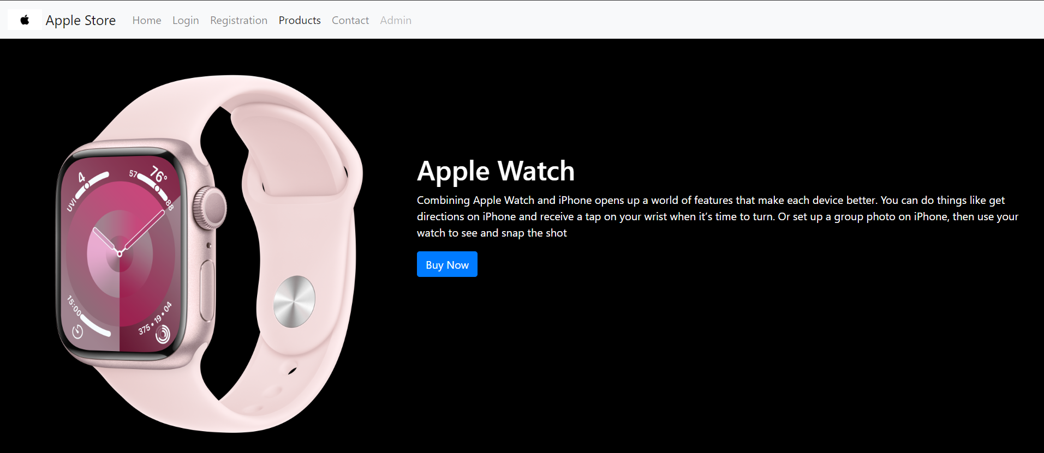

**Airpods Max (airmax.html)**

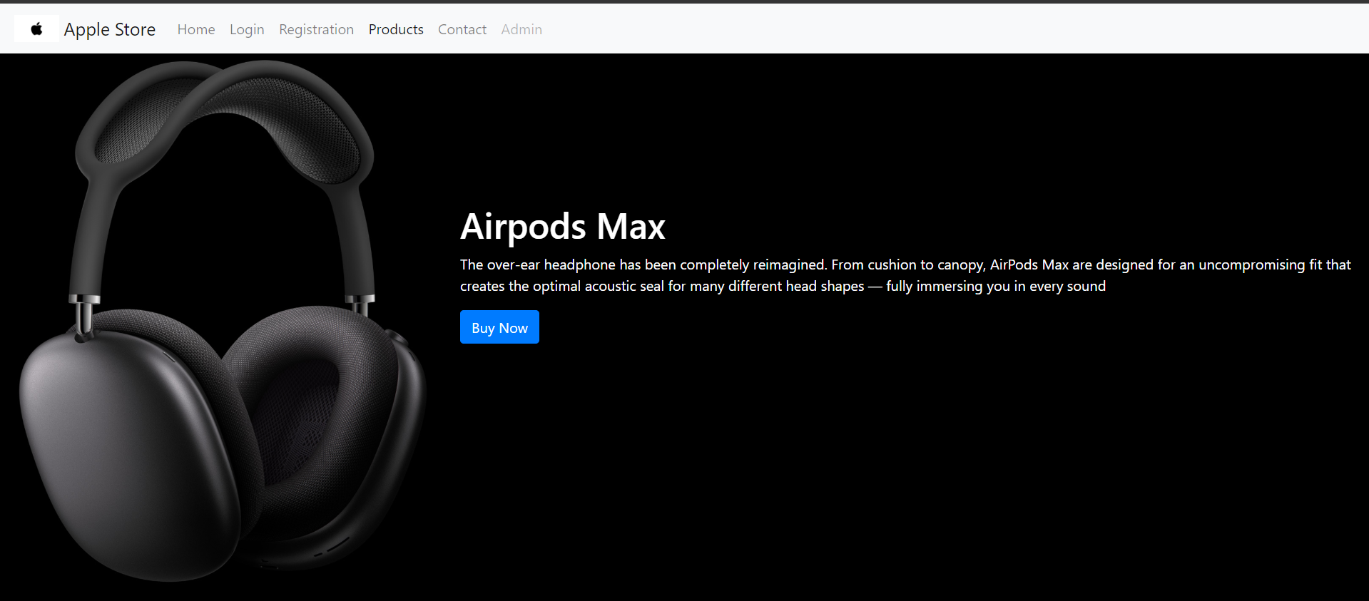

**Macbook Air (macair.html):**

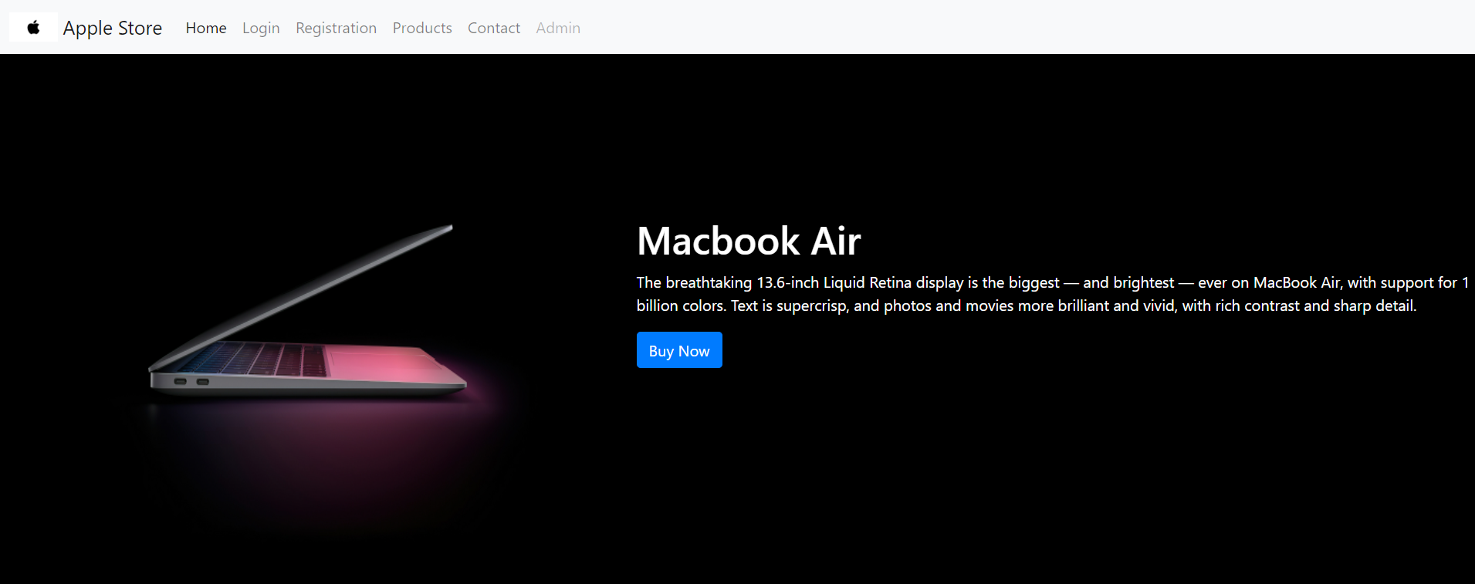

**IPhone 14 Pro Max (iphone14.html):**

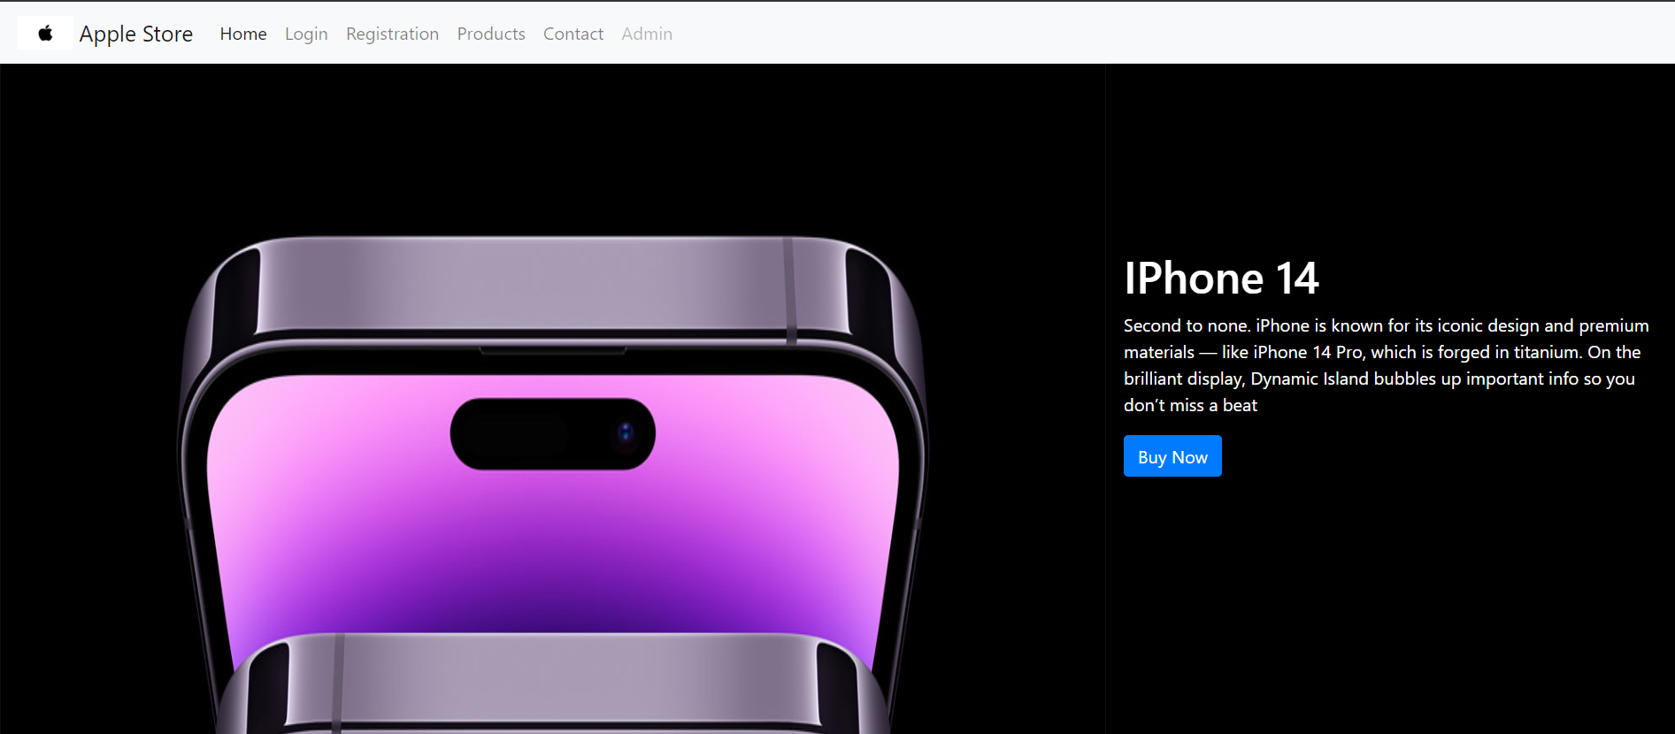

**Apple Watch Series 8 (apples8.html)**

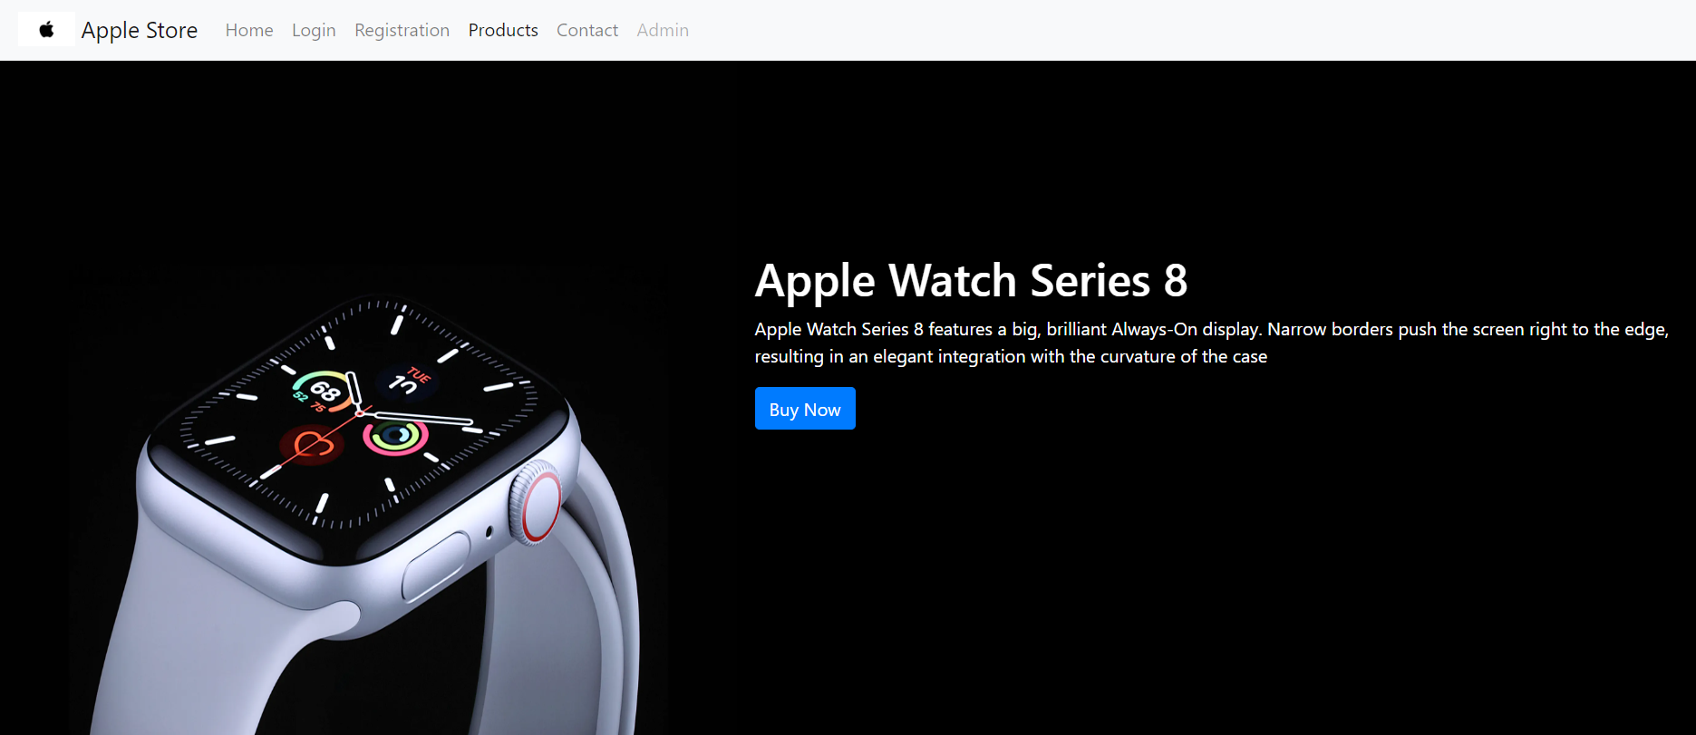

**Login Page (Login.html)**

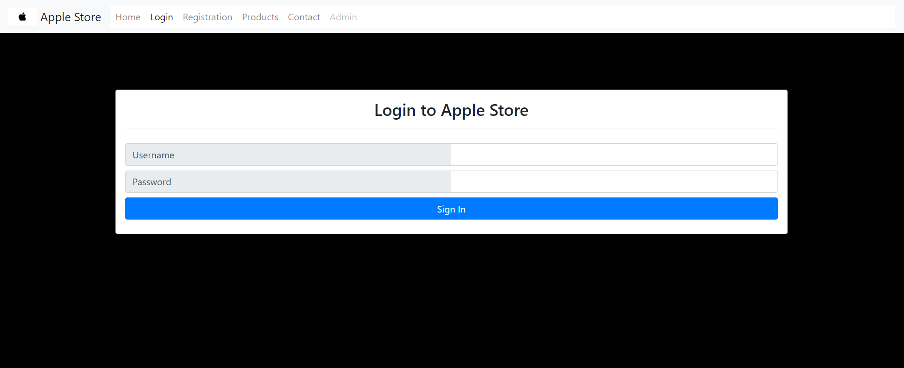

**Register Page (register.html)**

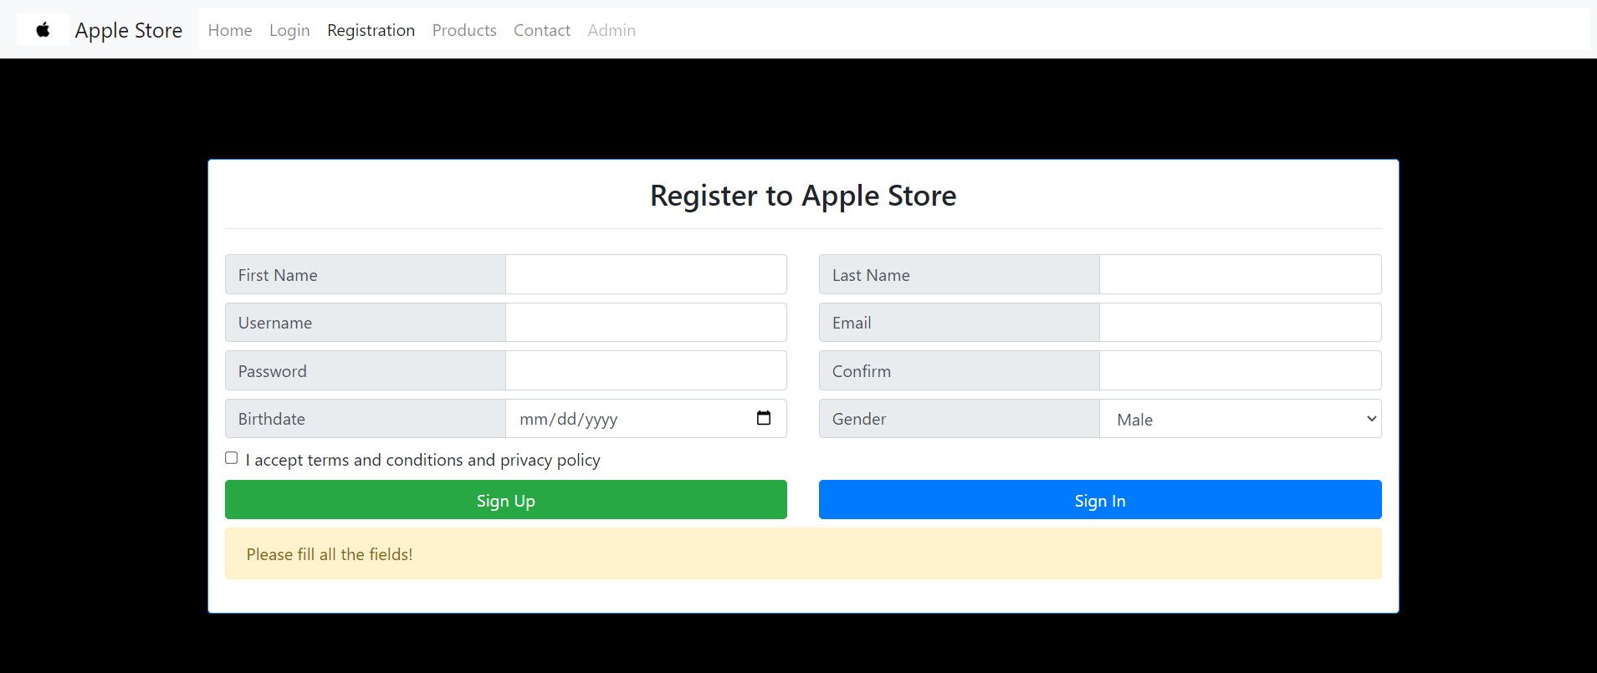

**Functional and Non-Functional Requirements:**

**Functional Requirements:**

Users can browse different products.

Users can view detailed information about each product.

Users can register and log in to the system.

Users can contact the store through the Contact page.

**Non-Functional Requirements:**

The application must be responsive and work on different devices.

The application should load quickly and efficiently.

The application must provide secure authentication for users.

**GitHub Repository:**

Link to GitHub Repository:

<https://github.com/AlyLotfy/web>

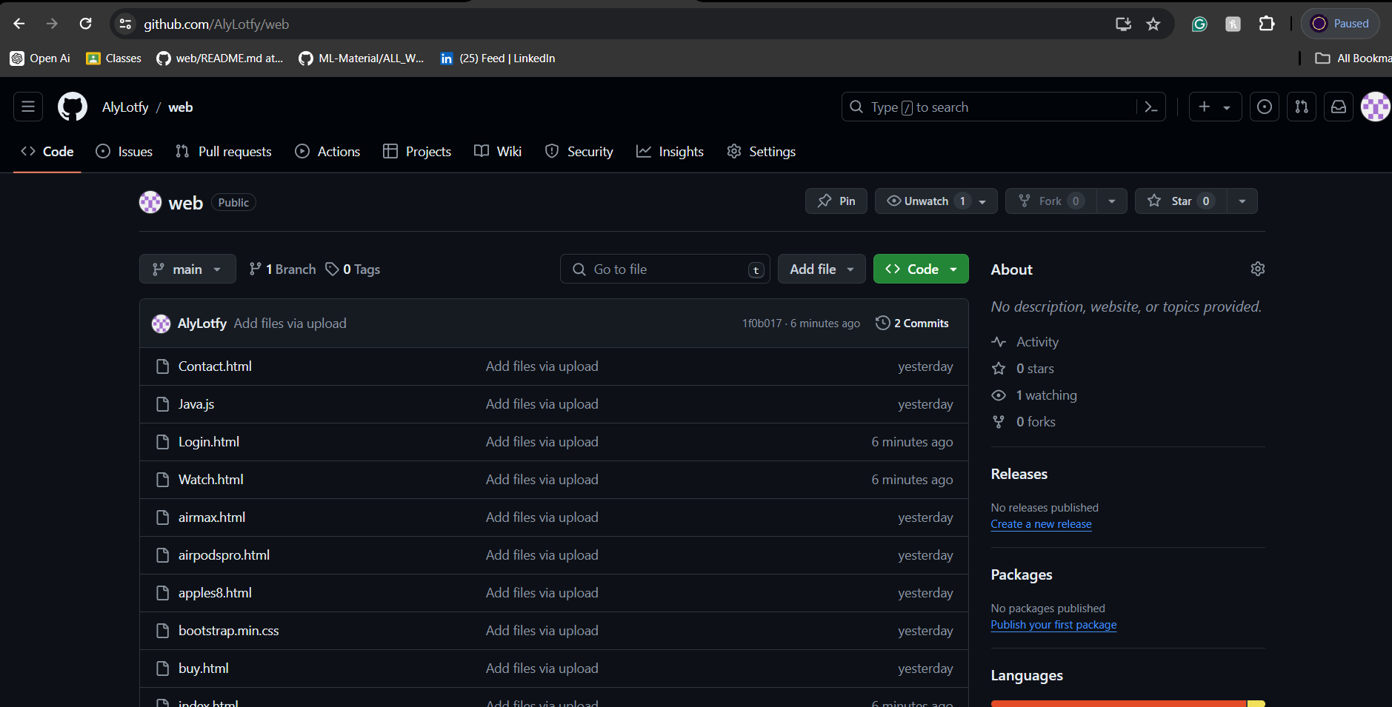

**Conclusion:**

The "Apple Store" web application project exemplifies the integration of various web development technologies to create a sophisticated and user-friendly e-commerce platform. The project's primary goal was to simulate the high-end, seamless shopping experience associated with Apple Stores, translating it into a digital format that meets contemporary users' expectations for online shopping.

From the outset, the project was designed with a strong focus on user experience. The user interface is clean and intuitive, allowing users to navigate through different product categories effortlessly. Each product page provides comprehensive details, including specifications, pricing, and high-quality images, enabling users to make informed purchasing decisions without needing to visit a physical store. This approach not only enhances user satisfaction but also encourages users to explore and engage with the site more deeply.

One of the critical aspects of the project was ensuring that the application is responsive and accessible across various devices. Given the increasing reliance on mobile devices for online shopping, the use of Bootstrap for responsive design was pivotal. This ensured that the application adapts seamlessly to different screen sizes, providing an optimal viewing experience on desktops, tablets, and smartphones alike. This responsiveness is crucial for maintaining a broad user base and ensuring that all users have a consistent and high-quality experience regardless of the device they use.

Security was another paramount consideration in this project. The application incorporates secure user authentication processes, including registration and login functionalities. User credentials are encrypted and stored securely, and robust validation mechanisms are in place to protect against unauthorized access and data breaches. These measures ensure that users can trust the platform with their personal information, fostering a sense of security and reliability.

Throughout the development process, the project adhered to best practices in coding and project management. The use of GitHub for version control allowed for efficient collaboration among team members, tracking changes, and maintaining a history of the project's development. This not only facilitated teamwork but also ensured that any issues could be quickly identified and resolved, maintaining the project's overall integrity and progress

In conclusion, the "Apple Store" web application project successfully demonstrates the application of modern web development practices to create a dynamic and engaging e-commerce platform. The project highlights the importance of user-centric design, responsive interfaces, secure authentication, and efficient project management. By achieving its primary objectives and laying a solid foundation for future enhancements, the project sets a benchmark for future web development endeavors, showcasing the potential of combining technical expertise with creative vision to deliver high-quality digital solutions