 **Cairo University**

**Faculty of Engineering**

**Assignment HW2**

|  |  |  |
| --- | --- | --- |
| Name | Section | B.N |
| Aly Ramzy Hassan | 1 | 36 |

SORTED

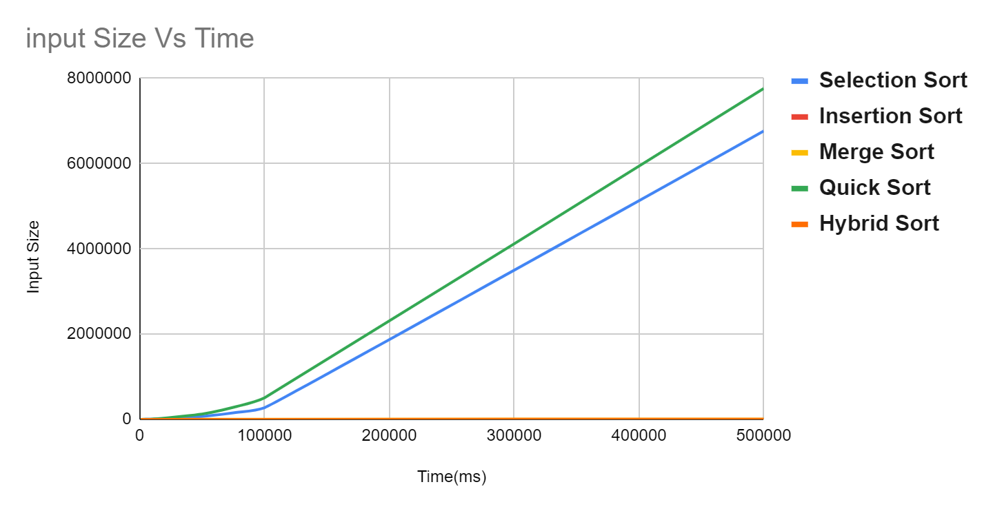

|  |  |  |  |  |  |
| --- | --- | --- | --- | --- | --- |
|  | Selection Sort | Insertion Sort | Merge Sort | Quick Sort | Hybrid Sort |
| 1000 | 3.511 | 0.008 | 1.597 | 5.028 | 0.181 |
| 5000 | 70.904 | 0.097 | 7.886 | 126.543 | 1.179 |
| 10000 | 276.1 | 0.104 | 16.008 | 505.498 | 2.474 |
| 50000 | 6778.94 | 0.357 | 81.621 | 12506.9 | 14.241 |
| 75000 | 15264.7 | 0.557 | 125.365 | 28178.3 | 24.73 |
| 100000 | 27217.6 | 0.75 | 161.081 | 50274.5 | 29.848 |
| 500000 | 676336 | 3.529 | 845.656 | 776336 | 198.672 |

UN SORTED

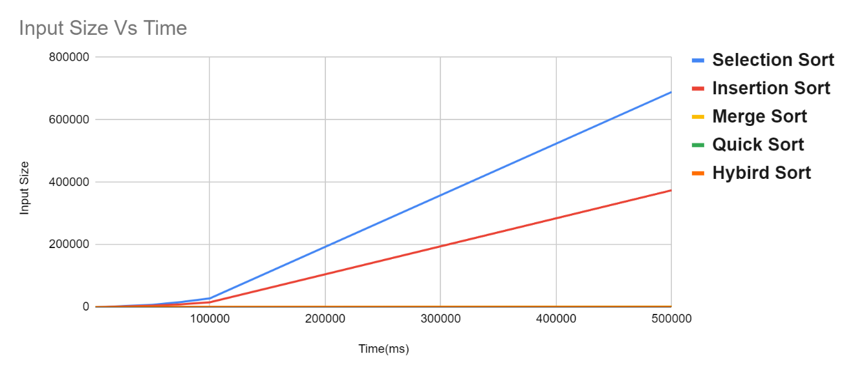

|  |  |  |  |  |  |
| --- | --- | --- | --- | --- | --- |
|  | Selection Sort | Insertion Sort | Merge Sort | Quick Sort | Hybrid Sort |
| 1000 | 3.768 | 1.532 | 1.677 | 0.231 | 0.299 |
| 5000 | 71.563 | 38.486 | 8.127 | 0.882 | 2.279 |
| 10000 | 274.909 | 149.457 | 17.438 | 1.618 | 4.3 |
| 50000 | 6805.1 | 3730.05 | 85.329 | 10.013 | 27.332 |
| 75000 | 15536.4 | 8485.21 | 142.039 | 15.834 | 41.524 |
| 100000 | 27203.5 | 14741.4 | 172.769 | 21.364 | 56.274 |
| 500000 | 688966 | 373914 | 898.538 | 124.33 | 301.632 |

Hybrid Sort:

I used combination of Merge sort and insertion sort because Merge sort is O(nlogn) and insertion sort is O(n^2),and at small size (100 as example) O(n^2) is better than O(nlogn) ,so in code I start with merge sort if size of the array is very large and when dividing into small array if the size of the small array is less than 100 I start using insertion sort ,and this lead to a sorting algorithm better than the original merge sort ( look at the time in the table ).

Hybrid Sort =>

If(size>100)

Merge sort

Else

Insertion Sort

Notes:

1-my code outputs the Sorting Algorithm name and Inputs Size

And time for UN Sorted and time for Sorted for each run of code

2-i used bash script to run all input sizes for all sorting algorithms

(attached with the files : script.sh)