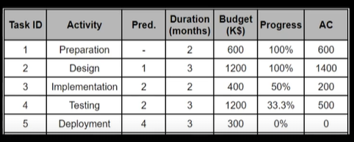

= 600+1200+(400/2) +(1200/3) = 2400$

AC = 600+1400+200+500 = 2700$

After 7 month the project is over budget and we are 1 month behind the schedule because task 3 should be done and start with task 4 with approximately 66%.

Task 2 is over budget with 200$, so if task 2 and task 4 where only the tasks that are over budget then the 200+100=300$

**CV= EV-AC**

**earned value** of the work performed and the **executed budget** (Actual Cost).

CV = 2400-2700=-300$

SV = EV(Earned value – PV(planned value) = 6 – 7 = 1

CPI = EV / AC = 2400 / 2700 = 0.89

SPI = EV / PV = 6 / 7 = 0.86